**Computer Architecture Practice - COM307P**

**Lab - 1**

**Double Precision Floating Point Number Adder Design**

**Done by : N Sree Dhyuti - CED19I027**

**Output :**

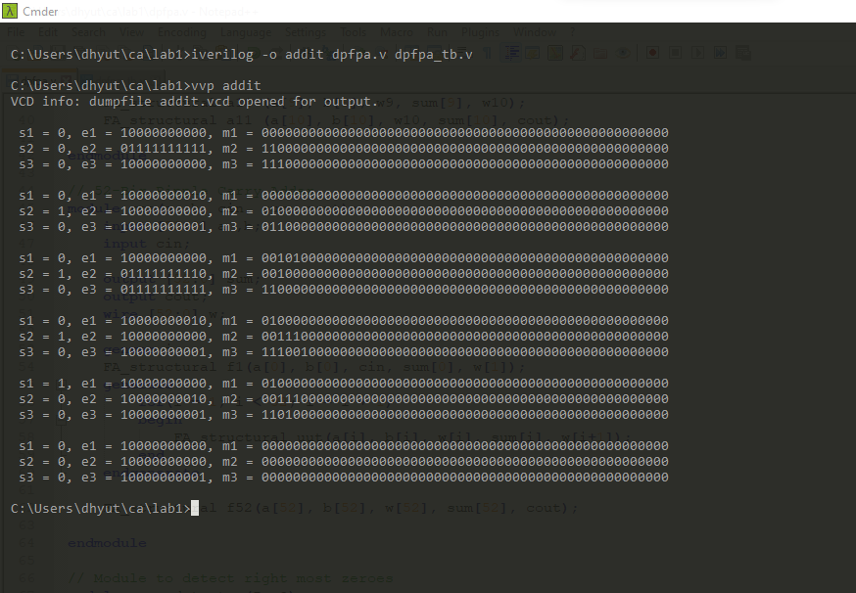

**THE END**