**Computer Architecture Practice - COM307P**

**Lab - 3**

**64-Bit Recursive Doubling based carry lookahead adder**

**Done by : N Sree Dhyuti - CED19I027**

**Output :**

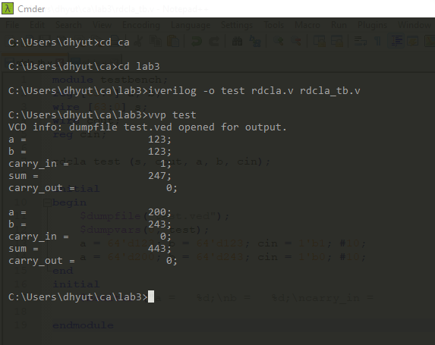

**THE END**