**Computer Architecture Practice - COM307P**

**Lab - 4**

**64-Bit Wallace Tree Multiplier**

**Done by : N Sree Dhyuti - CED19I027**

**Output :**

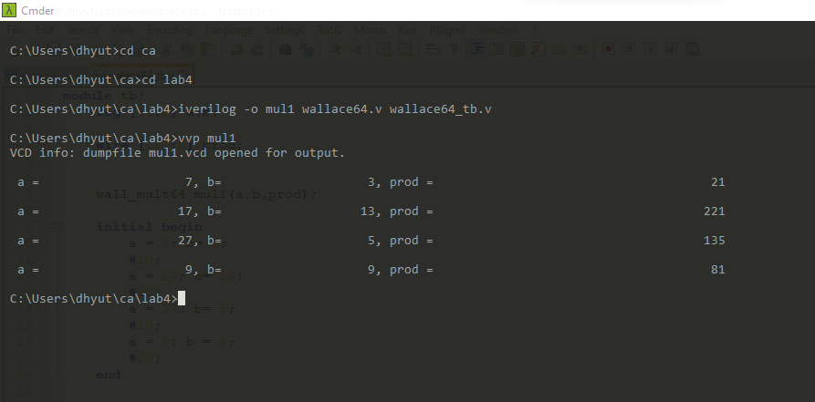

**THE END**