**Construct max heap and sort it using max heap.**

**300, 100, 250, 150, 345, 500, 890, 200**

Step 1: Construction of max heap

For constructing the max geap, we need to insert the entered elements in the following order as follows:

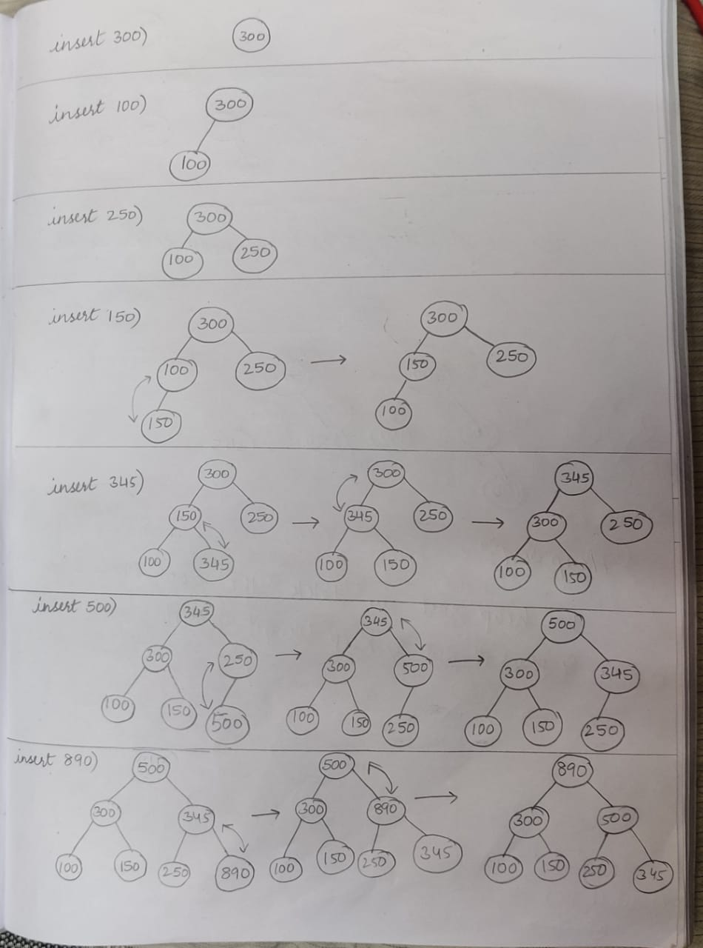

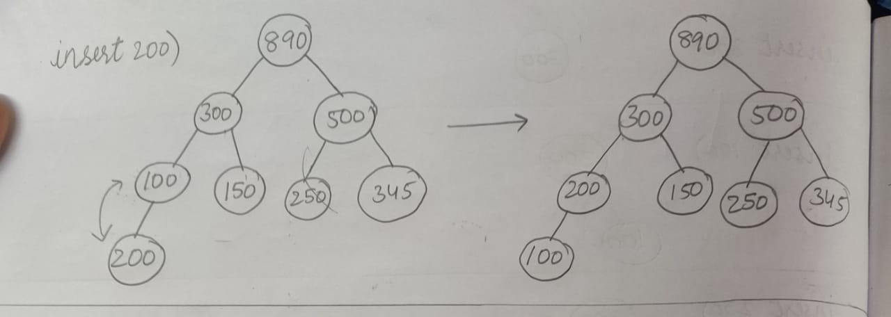

after inserting all elements in the heap, the final Max heap looks as shown below:

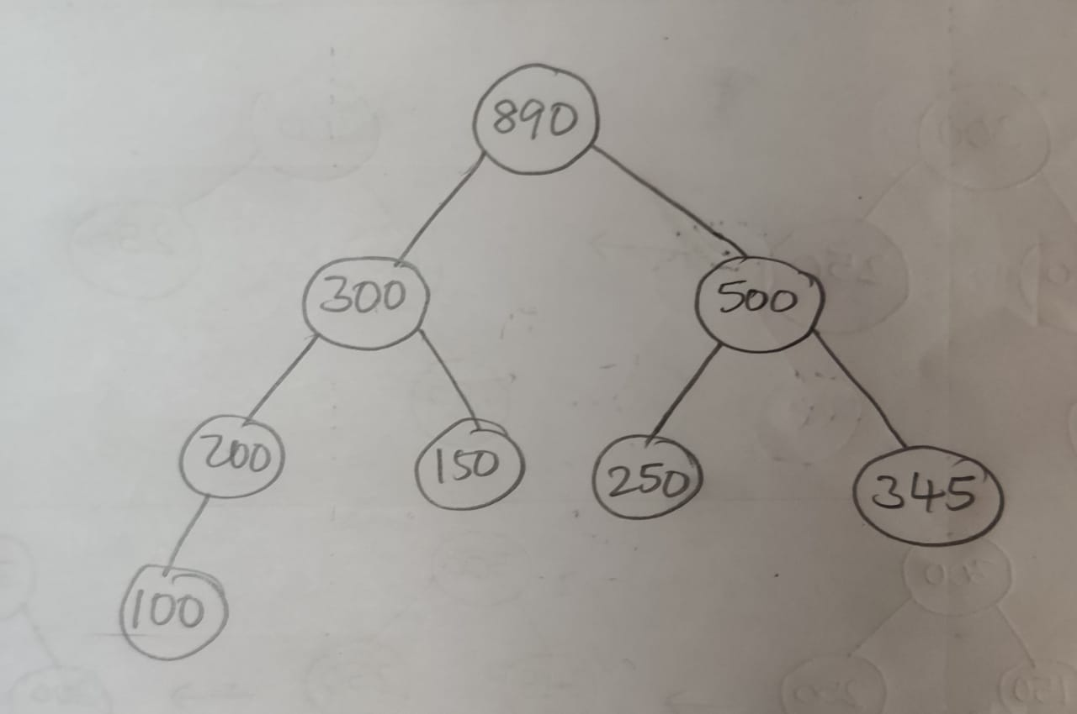

**HEAP SORT**

For heap sort, we first store the element in the root node separately , and then delete it from the heap and apply heapify property. We do this until the heap becomes empty

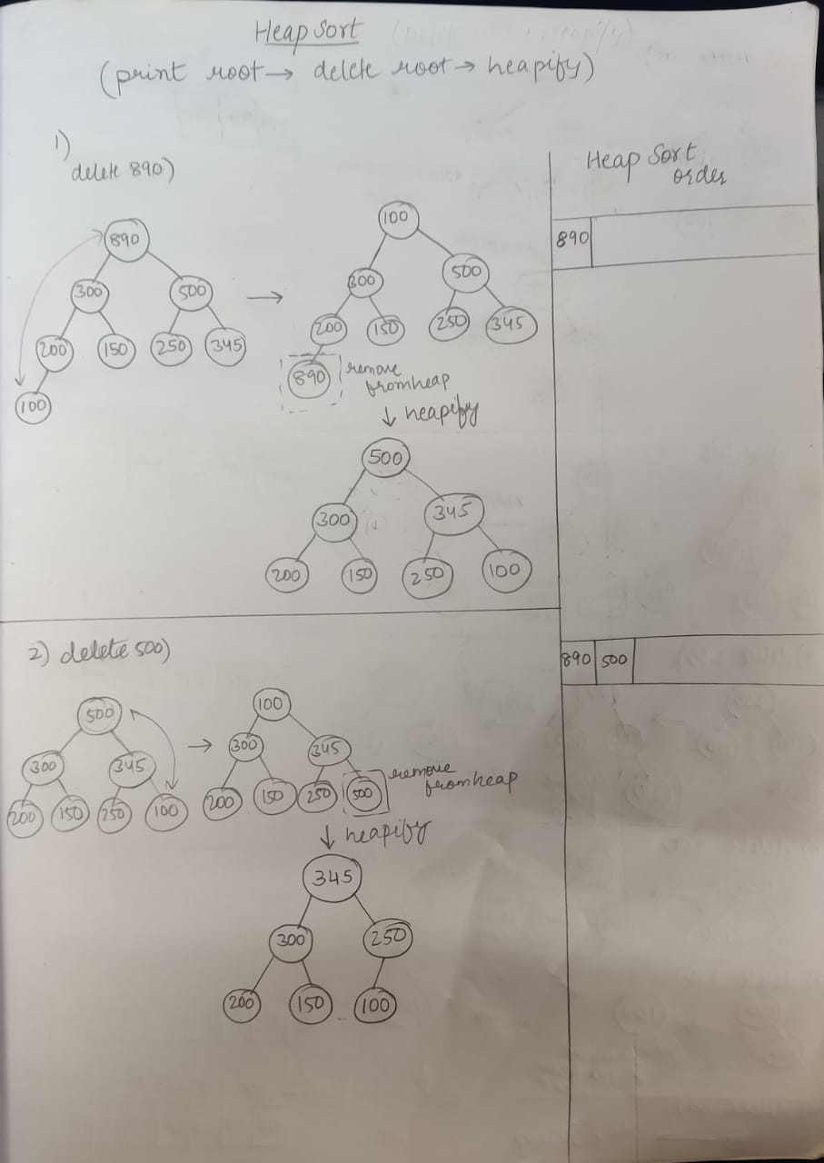

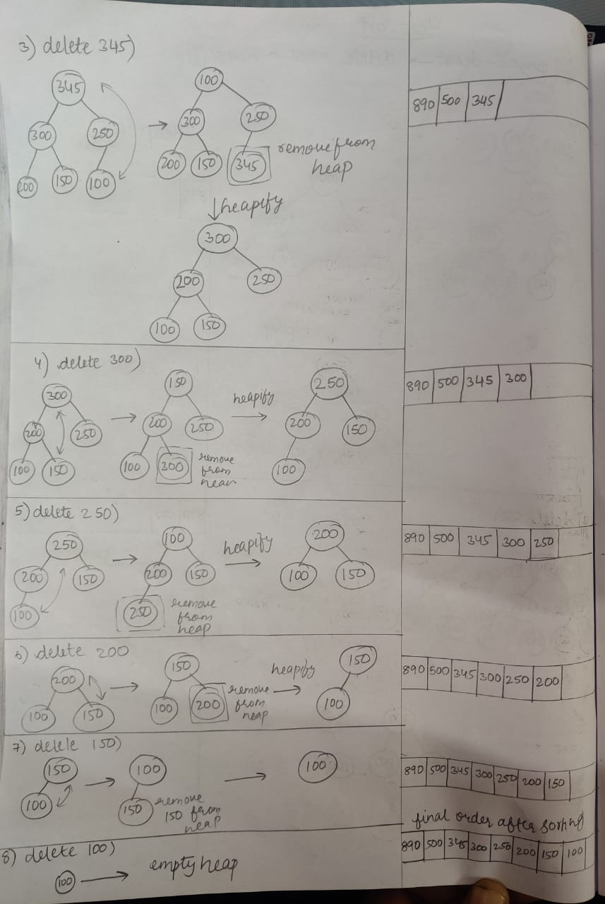

**So, after heap sort , the final order of the the given numbers is:**

**890 , 500 , 345 , 300 , 250 , 200 , 150 , 100.**