1. **Vector Addition**

**OBJECTIVE:**

1. Perform vector addition on ‘n’ double precision floating point numbers

**Serial Code:**

#include <stdio.h>

#include <math.h>

#include <stdlib.h>

#include "omp.h"

int main(){

int n;

scanf("%d", &n);

double v1[n], v2[n], ans[n];

for(int i = 0; i < n; i++){

v1[i] = (float)rand()/(float)(RAND_MAX/n);

v2[i] = (float)rand()/(float)(RAND_MAX/n);

}

for(int i = 0; i < n; i++){

ans[i] = 0;

}

for(int i = 0; i < n; i++){

ans[i] = v1[i] + v2[i];

}

printf("Serial Program Successfully Executed\n");

return 0;

}

**Output:**

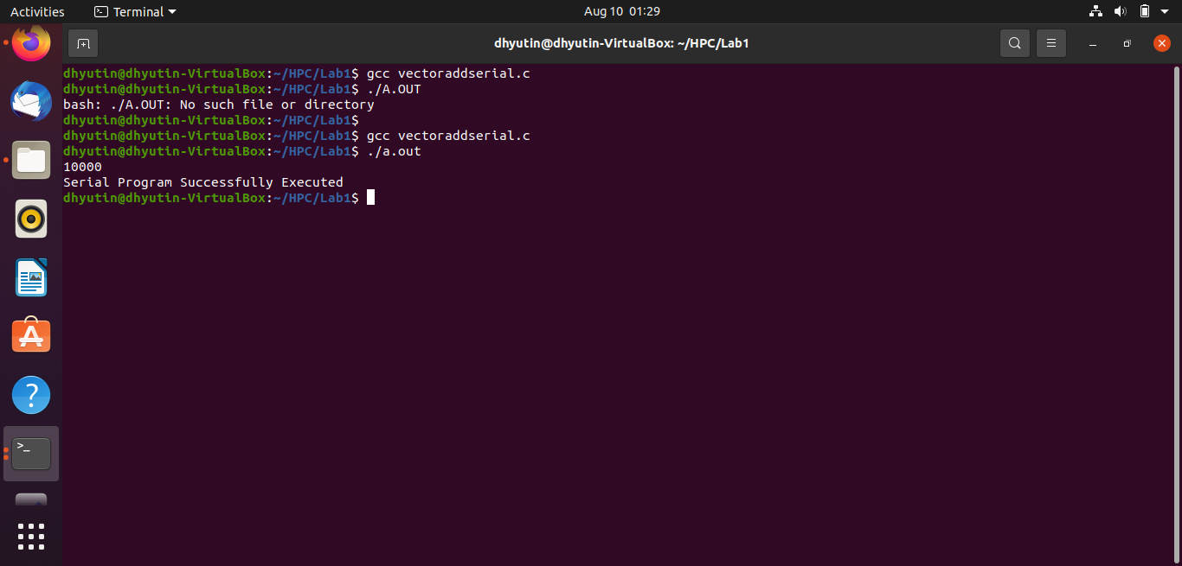

**Parallelized Code:**

#include <stdio.h>

#include <math.h>

#include <stdlib.h>

#include "omp.h"

int main(){

int n;

scanf("%d", &n);

double v1[n], v2[n], ans[n];

for(int i = 0; i < n; i++){

v1[i] = (float)rand()/(float)(RAND_MAX/n);

v2[i] = (float)rand()/(float)(RAND_MAX/n);

}

for(int i = 0; i < n; i++){

ans[i] = 0;

}

double wallclock_initial = omp_get_wtime();

#pragma omp parallel

{int id = omp_get_thread_num();

#pragma omp for

for(int i = 0; i < n; i++){

ans[i] = v1[i] + v2[i];

}

}

double wallclock_final = omp_get_wtime();

printf("Time : %lf\n", wallclock_final - wallclock_initial);

return 0;

}

**Output:**

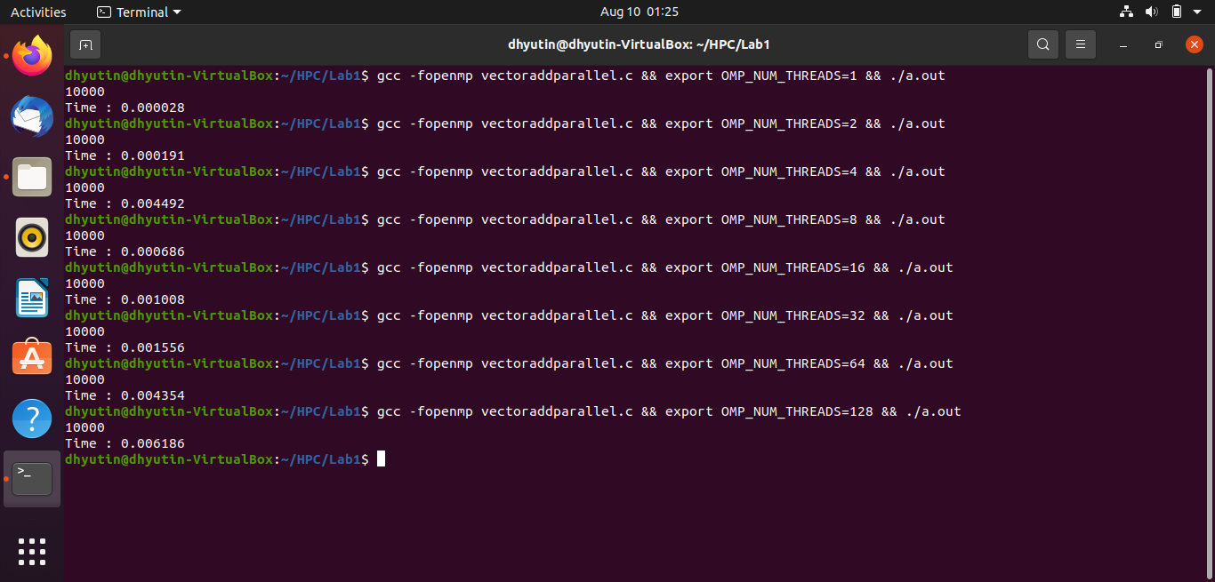

**Speedup V/S Number of Processors:**

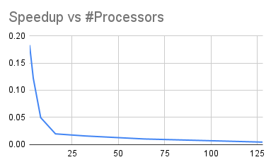

**Inference:**

It can be observed from the above graph that the speedup value is decreasing as the number of processors involved are increasing. This is contrary to the general pattern. One reason for this is that the selected ‘c program’ is not computationally expensive.

The code involved in this is just a simple ‘for-loop’ which fills a memory location with specific values.

One processor can do it at a certain rate, but when you use N processors simultaneously, the total memory bandwidth remains the same on Shared-Memory Multicore systems (i.e most PCs, laptops) and it increases on Distributed-Memory Multicore systems (high-end servers).

All their advantages can be explored in a better way in computationally expensive programs.

**Execution Time V/S Number of Threads:**

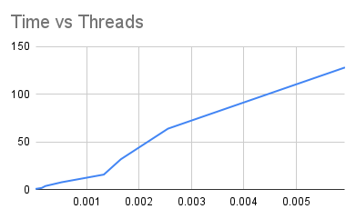

**Inference:**

It can be observed from the above graph that as the number of threads increases, the total execution time also increases. This is contrary to the general pattern. One reason for this is that the selected ‘c program’ is not computationally expensive.

The code involved in this is just a simple ‘for-loop’ which fills a memory location with specific values.

A clear advantage of using multiple threads can be observed when a computationally expensive program is parallelized.

For simple vector addition, one thread is sufficient to get optimum time.

**Parallelization Factor (f):**

| **#Threads** | **Execution Time** | **Speed UP** | **Efficiency (in %)** | **f** |
| --- | --- | --- | --- | --- |
| 1 | 0.000026 | 1 | 100 | n/a |
| 2 | 0.000142 | 0.1830985915 | 9.154929577 | -8.923076923 |
| 4 | 0.000213 | 0.1220657277 | 3.051643192 | -9.58974359 |
| 8 | 0.000525 | 0.04952380952 | 0.619047619 | -21.93406593 |
| 16 | 0.001328 | 0.01957831325 | 0.1223644578 | -53.41538462 |
| 32 | 0.001652 | 0.01573849879 | 0.04918280872 | -64.55583127 |
| 64 | 0.002551 | 0.01019208154 | 0.0159251274 | -98.65689866 |
| 128 | 0.005927 | 0.00438670491 | 0.003427113211 | -228.7486372 |

**Inference:**

It can be noticed that all the parallelization factor ‘f’ is in negative values. This is an indication that this code has taken the least amount of time while using a single thread. Anything more than that is not worth parallelizing and this f is negative.

**THE END**