**Matrix Multiplication**

**OBJECTIVE:**

1. Perform matrix multiplication on double precision floating point numbers of stored in n X n matrices

**Serial Code:**

#include <stdio.h>

#include <math.h>

#include <stdlib.h>

#include "omp.h"

int main(){

int n;

scanf("%d", &n);

double v1[n][n], v2[n][n], ans[n][n];

for(int i = 0; i < n; i++){

for(int j = 0; j < n; j++){

v1[i][j] = (float)rand()/(float)(RAND_MAX/n);

v2[i][j] = (float)rand()/(float)(RAND_MAX/n);

ans[i][j] = 0;

}

}

for(int i = 0; i < n; i++){

for(int j = 0; j < n; j++){

for(int k = 0; k < n; k++){

ans[i][j] += v1[i][k]*v2[k][j];

}

}

}

printf("Successfully Executed Serial Code\n");

return 0;

}

**Output:**

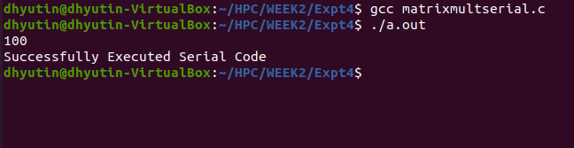

**Parallelized Code:**

#include <stdio.h>

#include <math.h>

#include <stdlib.h>

#include "omp.h"

int main(){

int n;

scanf("%d", &n);

double v1[n][n], v2[n][n], ans[n][n];

for(int i = 0; i < n; i++){

for(int j = 0; j < n; j++){

v1[i][j] = (float)rand()/(float)(RAND_MAX/n);

v2[i][j] = (float)rand()/(float)(RAND_MAX/n);

ans[i][j] = 0;

}

}

double wallclock_initial = omp_get_wtime();

#pragma omp parallel

{

int id = omp_get_thread_num();

#pragma omp for collapse(3)

for(int i = 0; i < n; i++){

for(int j = 0; j < n; j++){

for(int k = 0; k < n; k++){

ans[i][j] += v1[i][k]*v2[k][j];

}

}

}

}

double wallclock_final = omp_get_wtime();

printf("Time : %lf\n", wallclock_final - wallclock_initial);

return 0;

}

**Output:**

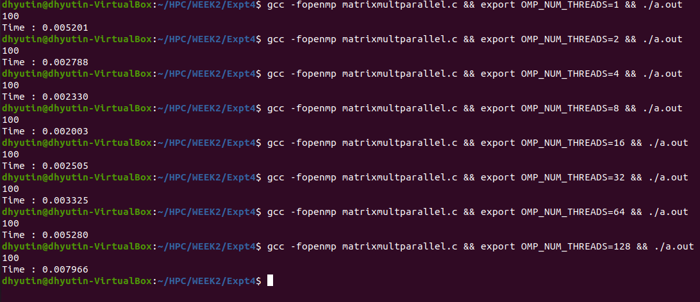

**Speedup V/S Number of Processors:**

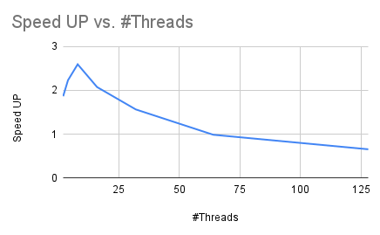

**Inference:**

It can be inferred from the above graph that Speedup value increases till 8 threads, and then it continues to decrease.

**Execution Time V/S Number of Threads:**

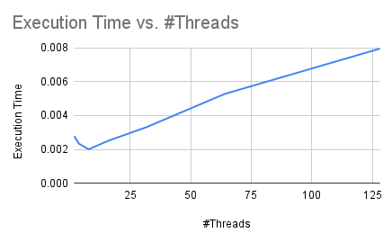

**Inference:**

Similar to the previous graph, it can be seen that we attain minimum execution time when we choose 8 threads to execute the program.

This means choosing 8 threads for this program will give us maximum time efficiency.

**Parallelization Factor (f):**

| **#Threads** | **Execution Time** | **Speed UP** | **Efficiency (in %)** | **f** |
| --- | --- | --- | --- | --- |
| 1 | 0.005201 | 1 | 100 | n/a |
| 2 | 0.002788 | 1.865494978 | 93.27474892 | 0.9278984811 |
| 4 | 0.00233 | 2.232188841 | 55.80472103 | 0.7360123053 |
| 8 | 0.002003 | 2.596605092 | 32.45756365 | 0.702722004 |
| 16 | 0.002505 | 2.076247505 | 12.97654691 | 0.5529193104 |
| 32 | 0.003325 | 1.564210526 | 4.888157895 | 0.3723353449 |
| 64 | 0.00528 | 0.9850378788 | 1.539121686 | -0.01543048803 |
| 128 | 0.007966 | 0.6528998243 | 0.5100779877 | -0.5358145844 |

**Inference:**

It can be noticed from the pattern of ‘f’ values that taking 2 threads will give utmost parallelization. Choosing 2 threads to execute this program will give the most efficient parallelization.

**THE END**