1. **Histogram Equalization**

**OBJECTIVE:**

Based on profiling results, apply OpenMP for Histogram Equalization

**Project Description:**

The project that I have taken up is Histogram Equalization. It takes an image as the input, reads through all the pixels to make a frequency histogram. Based on the histogram obtained, it tries to equalize the terms in the histogram. This results in the brightening of the image in the end.

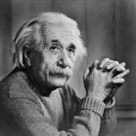 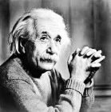

Input Output

**Profiling Inference:**

From the previous profiling, it is clear that most of the execution time is being taken by the “create_frequency_array()” function and the “final_step()” function, where in the “create_frequency_array()” function, we iterate through each pixel of the image and mark pixel frequencies. This is even by intuition deemed to take most of the time. The next is the “final()” function, where we update the final histogram values again to the image.

**Serial Code:**

**#include <iostream>**

**#include <fstream>**

**#include <sstream>**

**#include <math.h>**

**#include <vector>**

**using namespace std;**

**int array[1000][1000];**

**int arr[1000][1000];**

**vector<int> pf;**

**vector<float> pr;**

**vector<float> cpr;**

**vector<int> fin;**

**// Function that creates a frequency array of pixels in the image**

**vector<int> create_frequency_array(int numrows, int numcols){**

**for(int i = 0; i < 257; i++){**

**pf.push_back(0);**

**}**

**for(int row = 1; row <= numrows; row++){**

**for(int col = 1; col <= numcols; col++){**

**pf[256]++;**

**pf[array[row][col]]++;**

**}**

**}**

**return pf;**

**}**

**// Function to find individual probabilities of occurence of each of 256 values of pixel**

**vector<float> individual_probabilities(vector<int> pixel_frequency, int num_pixels){**

**for(int i = 0; i < 256; i++){**

**pr.push_back(0);**

**}**

**for(int i = 0; i < 256; i++){**

**pr[i] = ((float)pixel_frequency[i])/((float)num_pixels);**

**}**

**return pr;**

**}**

**// Function to find cumulative probability of each of 256 values of pixel**

**vector<float> cumulative_probability(vector<float> pr){**

**for(int i = 0; i < 256; i++){**

**cpr.push_back(0);**

**}**

**cpr[0] = pr[0];**

**for(int i = 1; i < 256; i++){**

**cpr[i] = pr[i] + cpr[i-1];**

**}**

**return cpr;**

**}**

**// Function to calculate C(r) X (L-1)**

**vector<int> cpr_into_max_pixel(vector<float> cpr){**

**for(int i = 0; i < 256; i++){**

**fin.push_back(0);**

**}**

**for(int i = 0; i < 256; i++){**

**fin[i] = round(cpr[i]*255);**

**}**

**return fin;**

**}**

**// Function to update with new pixel values**

**void final_step(int numrows, int numcols, vector<int> finall){**

**for(int row = 1; row <= numrows; row++){**

**for(int col = 1; col <= numcols; col++){**

**arr[row][col] = finall[array[row][col]];**

**}**

**}**

**}**

**int main()**

**{**

**int row = 0, col = 0, numrows = 0, numcols = 0,MAX=0;**

**ifstream infile("Images/casablanca.ascii.pgm");**

**stringstream ss;**

**string inputLine = "";**

**// First line : version**

**getline(infile,inputLine);**

**if(inputLine.compare("P2") != 0) cerr << "Version error" << endl;**

**else cout << "Version : " << inputLine << endl;**

**// Continue with a stringstream**

**ss << infile.rdbuf();**

**// Secondline : size of image**

**ss >> numcols >> numrows >> MAX;**

**//print total number of rows, columns and maximum intensity of image**

**cout << numcols << " columns and " << numrows << " rows" <<endl<<"Maximum Intensity "<< MAX <<endl;**

**//Initialize a new array of same size of image with 0**

**for(row = 0; row <= numrows; ++row){**

**array[row][0]=0;**

**//arr[row][0] = 0;**

**for(col = 0; col <= numcols; col++){**

**array[0][col] = 0;**

**//arr[0][col] = 0;**

**}**

**}**

**// Following lines : data**

**for(row = 1; row <= numrows; ++row)**

**{**

**for (col = 1; col <= numcols; ++col)**

**{**

**//original data store in new array**

**ss >> array[row][col];**

**}**

**}**

**// Histogram Equalization begins**

**// Step 1: Find frequencies of each pixel value**

**vector<int> pixel_frequency = create_frequency_array(numrows, numcols);**

**int num_pixels = pixel_frequency[256];**

**// Step 2: P(r)**

**vector<float> pr = individual_probabilities(pixel_frequency, num_pixels);**

**// Step 3: Cumulative Frequency**

**vector<float> cpr = cumulative_probability(pr);**

**// Step 4: C(r) X (L-1)**

**vector<int> finall = cpr_into_max_pixel(cpr);**

**// Step 5: Updare new image with respective updation**

**final_step(numrows, numcols, finall);**

**ofstream outfile;**

**//new file open to store the output image**

**outfile.open("AfterHistogramEqualization.ascii.pgm");**

**outfile<<"P2"<<endl;**

**outfile<<numcols<<" "<<numrows<<endl;**

**outfile<<"255"<<endl;**

**for(row = 1; row <= numrows; ++row)**

**{**

**for (col = 1; col <= numcols; ++col)**

**{**

**//store resultant pixel values to the output file**

**outfile << arr[row][col]<<" ";**

**}**

**}**

**outfile.close();**

**infile.close();**

**return 0 ;**

**}**

**Output:**

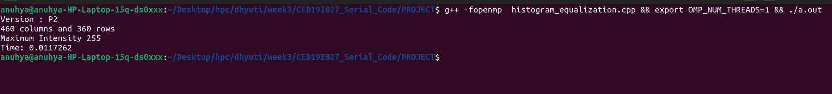

**Parallel Code:**

**#include <iostream>**

**#include <fstream>**

**#include <sstream>**

**#include <math.h>**

**#include <vector>**

**#include "omp.h"**

**using namespace std;**

**int array[1000][1000];**

**int arr[1000][1000];**

**vector<int> pf;**

**vector<float> pr;**

**vector<float> cpr;**

**vector<int> fin;**

**// Function that creates a frequency array of pixels in the image**

**vector<int> create_frequency_array(int numrows, int numcols){**

**#pragma omp parallel**

**{**

**#pragma omp for**

**for(int i = 0; i < 257; i++){**

**pf.push_back(0);**

**}**

**}**

**#pragma omp parallel**

**{**

**#pragma omp for**

**for(int row = 1; row <= numrows; row++){**

**for(int col = 1; col <= numcols; col++){**

**pf[256]++;**

**pf[array[row][col]]++;**

**}**

**}**

**}**

**return pf;**

**}**

**// Function to find individual probabilities of occurence of each of 256 values of pixel**

**vector<float> individual_probabilities(vector<int> pixel_frequency, int num_pixels){**

**for(int i = 0; i < 256; i++){**

**pr.push_back(0);**

**}**

**for(int i = 0; i < 256; i++){**

**pr[i] = ((float)pixel_frequency[i])/((float)num_pixels);**

**}**

**return pr;**

**}**

**// Function to find cumulative probability of each of 256 values of pixel**

**vector<float> cumulative_probability(vector<float> pr){**

**for(int i = 0; i < 256; i++){**

**cpr.push_back(0);**

**}**

**cpr[0] = pr[0];**

**for(int i = 1; i < 256; i++){**

**cpr[i] = pr[i] + cpr[i-1];**

**}**

**return cpr;**

**}**

**// Function to calculate C(r) X (L-1)**

**vector<int> cpr_into_max_pixel(vector<float> cpr){**

**for(int i = 0; i < 256; i++){**

**fin.push_back(0);**

**}**

**for(int i = 0; i < 256; i++){**

**fin[i] = round(cpr[i]*255);**

**}**

**return fin;**

**}**

**// Function to update with new pixel values**

**void final_step(int numrows, int numcols, vector<int> finall){**

**#pragma omp parallel**

**{**

**#pragma omp for**

**for(int row = 1; row <= numrows; row++){**

**for(int col = 1; col <= numcols; col++){**

**arr[row][col] = finall[array[row][col]];**

**}**

**}**

**}**

**}**

**int main()**

**{**

**int row = 0, col = 0, numrows = 0, numcols = 0,MAX=0;**

**ifstream infile("Images/casablanca.ascii.pgm");**

**stringstream ss;**

**string inputLine = "";**

**// First line : version**

**getline(infile,inputLine);**

**if(inputLine.compare("P2") != 0) cerr << "Version error" << endl;**

**else cout << "Version : " << inputLine << endl;**

**// Continue with a stringstream**

**ss << infile.rdbuf();**

**// Secondline : size of image**

**ss >> numcols >> numrows >> MAX;**

**//print total number of rows, columns and maximum intensity of image**

**cout << numcols << " columns and " << numrows << " rows" <<endl<<"Maximum Intensity "<< MAX <<endl;**

**//Initialize a new array of same size of image with 0**

**for(row = 0; row <= numrows; ++row){**

**array[row][0]=0;**

**//arr[row][0] = 0;**

**for(col = 0; col <= numcols; col++){**

**array[0][col] = 0;**

**//arr[0][col] = 0;**

**}**

**}**

**// Following lines : data**

**for(row = 1; row <= numrows; ++row)**

**{**

**for (col = 1; col <= numcols; ++col)**

**{**

**//original data store in new array**

**ss >> array[row][col];**

**}**

**}**

**// Histogram Equalization begins**

**double wallclock_initial = omp_get_wtime();**

**// Step 1: Find frequencies of each pixel value**

**vector<int> pixel_frequency = create_frequency_array(numrows, numcols);**

**int num_pixels = pixel_frequency[256];**

**// Step 2: P(r)**

**vector<float> pr = individual_probabilities(pixel_frequency, num_pixels);**

**// Step 3: Cumulative Frequency**

**vector<float> cpr = cumulative_probability(pr);**

**// Step 4: C(r) X (L-1)**

**vector<int> finall = cpr_into_max_pixel(cpr);**

**// Step 5: Updare new image with respective updation**

**final_step(numrows, numcols, finall);**

**ofstream outfile;**

**//new file open to store the output image**

**outfile.open("AfterHistogramEqualization.ascii.pgm");**

**outfile<<"P2"<<endl;**

**outfile<<numcols<<" "<<numrows<<endl;**

**outfile<<"255"<<endl;**

**for(row = 1; row <= numrows; ++row)**

**{**

**for (col = 1; col <= numcols; ++col)**

**{**

**//store resultant pixel values to the output file**

**outfile << arr[row][col]<<" ";**

**}**

**}**

**double wallclock_final = omp_get_wtime();**

**cout<<"Time: "<<wallclock_final-wallclock_initial<<endl;**

**outfile.close();**

**infile.close();**

**return 0 ;**

**}**

**Output:**

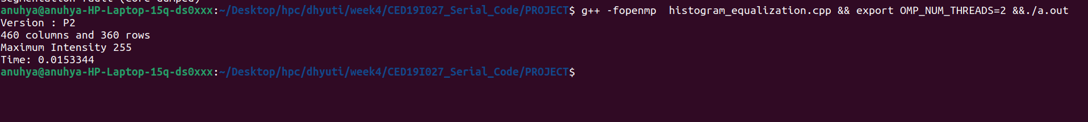

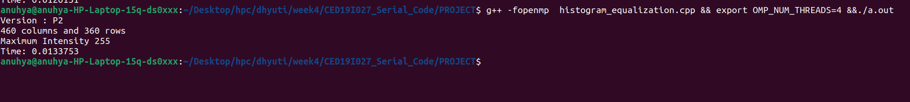

**Speedup V/S Number of Processors:**

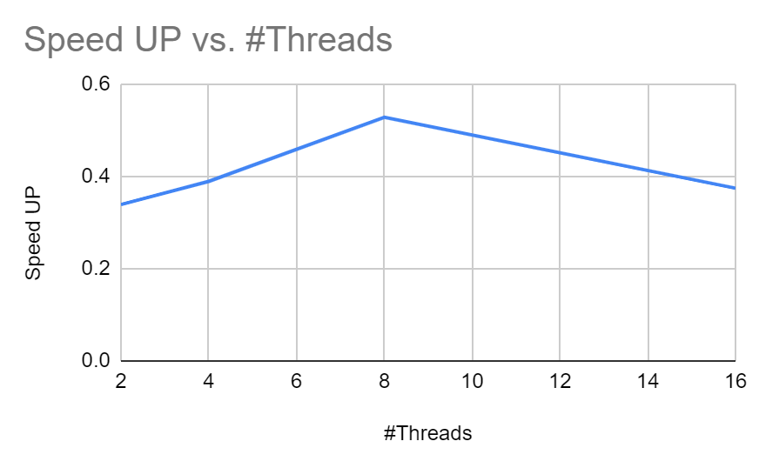

**Inference:**

It can be inferred from the above graph that Speedup value increases till 8 threads, and then it continues to decrease.

**Execution Time V/S Number of Threads:**

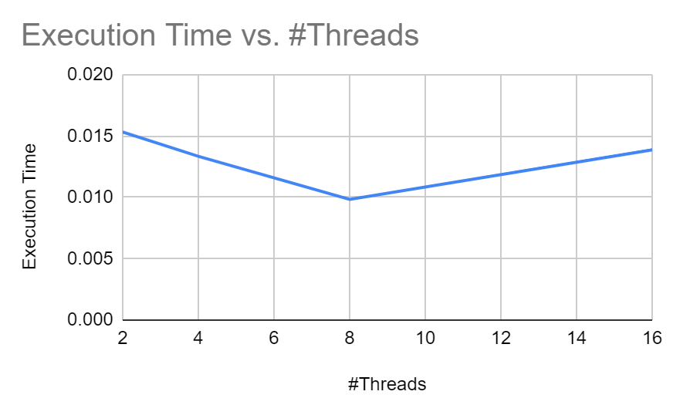

**Inference:**

Similar to the previous graph, it can be seen that we attain minimum execution time when we choose 8 threads to execute the program.

This means choosing 8 threads for this program will give us maximum time efficiency.

**Parallelization Factor (f):**

| **#Threads** | **Execution Time** | **Speed UP** | **Efficiency (in %)** | **f** |
| --- | --- | --- | --- | --- |
| 1 | 0.01172 | 1 | 100 | n/a |
| 2 | 0.0153344 | 0.3391720576 | 16.95860288 | 0.6167918089 |
| 4 | 0.0133573 | 0.3893750983 | 9.734377457 | -0.1862684869 |
| 8 | 0.0098456 | 0.5282562769 | 6.603203461 | 0.1827791321 |
| 16 | 0.01388 | 0.3747118156 | 2.341948847 | -0.1965870307 |

**Inference:**

It can be noticed from the pattern of ‘f’ values that taking 2 threads will give utmost parallelization. Choosing 2 threads to execute this program will give the most efficient parallelization.

**THE END**