1. **Matrix Addition and Matrix Multiplication**

**OBJECTIVE:**

1. Implement Matrix Addition And Matrix Multiplication using MPI.

**Serial Code:**

**Matrix Addition:**

**#include <stdio.h>**

**#include <math.h>**

**#include <stdlib.h>**

**#include "omp.h"**

**int main(){**

**int n;**

**scanf("%d", &n);**

**double v1[n][n], v2[n][n], ans[n][n];**

**for(int i = 0; i < n; i++){**

**for(int j = 0; j < n; j++){**

**v1[i][j] = (float)rand()/(float)(RAND_MAX/n);**

**v2[i][j] = (float)rand()/(float)(RAND_MAX/n);**

**ans[i][j] = 0;**

**}**

**}**

**for(int i = 0; i < n; i++){**

**for(int j = 0; j < n; j++){**

**ans[i][j] = v1[i][j] + v2[i][j];**

**}**

**}**

**printf("Successfully Executed Serial Code\n");**

**return 0;**

**}**

**Matrix Multiplication:**

#include <stdio.h>

#include <math.h>

#include <stdlib.h>

#include "omp.h"

int main**(){**

int n**;**

scanf**(**"%d"**,** **&**n**);**

double v1**[**n**][**n**],** v2**[**n**][**n**],** ans**[**n**][**n**];**

**for(**int i **=** 0**;** i **<** n**;** i**++){**

**for(**int j **=** 0**;** j **<** n**;** j**++){**

v1**[**i**][**j**]** **=** **(**float**)**rand**()/(**float**)(**RAND_MAX**/**n**);**

v2**[**i**][**j**]** **=** **(**float**)**rand**()/(**float**)(**RAND_MAX**/**n**);**

ans**[**i**][**j**]** **=** 0**;**

**}**

**}**

**for(**int i **=** 0**;** i **<** n**;** i**++){**

**for(**int j **=** 0**;** j **<** n**;** j**++){**

**for(**int k **=** 0**;** k **<** n**;** k**++){**

ans**[**i**][**j**]** **+=** v1**[**i**][**k**]\***v2**[**k**][**j**];**

**}**

**}**

**}**

printf**(**"Successfully Executed Serial Code\n"**);**

**return** 0**;**

**}**

**Output:**

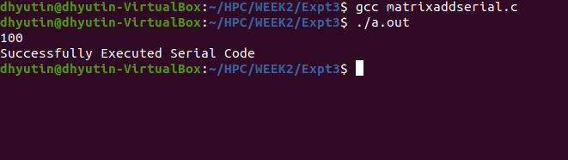

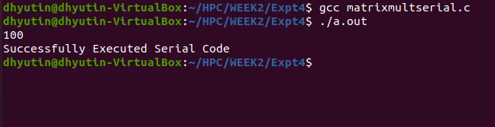

**Parallelized Code:**

**Matrix Addition and Multiplication done as one code:**

**#include <stdio.h>**

**#include <math.h>**

**#include <stdlib.h>**

**#include "omp.h"**

**int main(){**

**int n;**

**scanf("%d", &n);**

**double v1[n][n], v2[n][n], ans[n][n];**

**for(int i = 0; i < n; i++){**

**for(int j = 0; j < n; j++){**

**v1[i][j] = (float)rand()/(float)(RAND_MAX/n);**

**v2[i][j] = (float)rand()/(float)(RAND_MAX/n);**

**ans[i][j] = 0;**

**}**

**}**

**for(int i = 0; i < n; i++){**

**for(int j = 0; j < n; j++){**

**for(int k = 0; k < n; k++){**

**ans[i][j] += v1[i][k]*v2[k][j];**

**}**

**}**

**}**

**printf("Successfully Executed Serial Code\n");**

**return 0;**

**}**

**Output:**

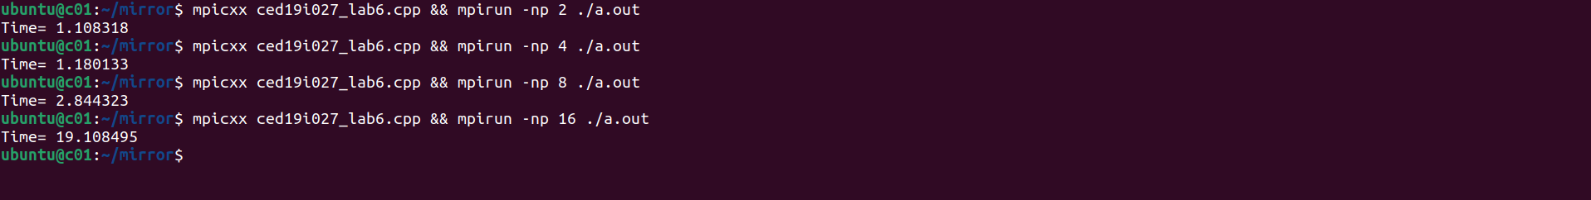

**Speedup V/S Number of Processors:**

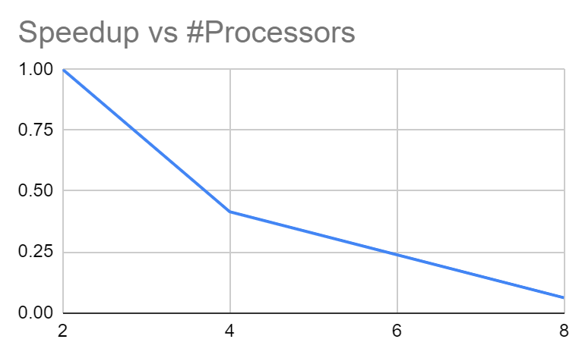

**Execution Time V/S Number of Threads:**

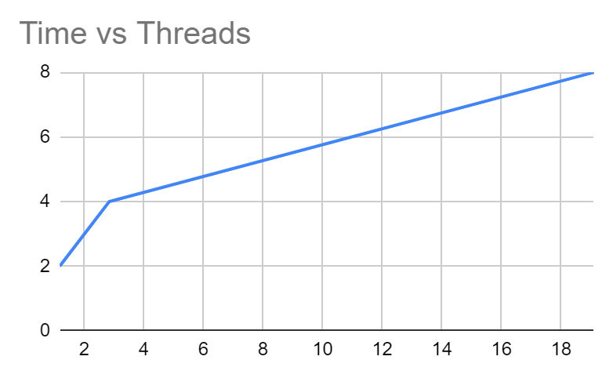

**Parallelization Factor (f):**

| **#Threads** | **Execution Time** | **Speed UP** | **Efficiency (in %)** | **f** |
| --- | --- | --- | --- | --- |
| 1 | n/a | n/a | n/a | n/a |
| 2 | 1.180133 | 1 | 100 | n/a |
| 4 | 2.844323 | 0.4149082224 | 10.37270556 | -1.880228754 |
| 8 | 19.108495 | 0.06175959959 | 0.7719949949 | -17.36207408 |

**Inference:**

In both matrix addition and multiplication, it can be observed that the parallelizing factor f is reducing as the number of threads increases. This indicates that parallelizing is only increasing our cost in this case. Therefore, using only one thread for matrix addition and multiplication would be optimal.

**THE END**