#### Consider defining a bean of type 'org.springframework.web.client.RestTemplate' in your configuration

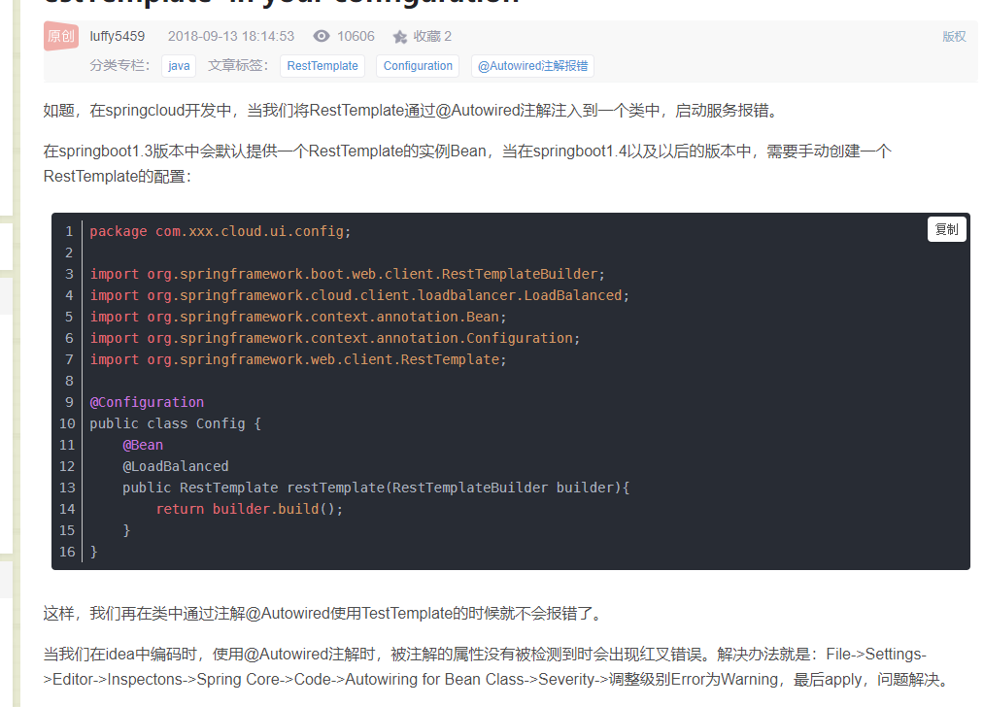

https://blog.csdn.net/feinifi/article/details/82692384