
INSTAGRAM

USER
ANALYTICS

BY Dixit Patel

Project Description:
The project aims to analyze user activity and engagement on Instagram, leveraging the provided database schema. The primary focus areas are marketing strategies and investor metrics. The marketing team's goals include rewarding loyal users, encouraging inactive users to post, declaring contest winners, researching hashtags, and identifying the best day for ad campaigns. On the other hand, for investor metrics, we'll assess user engagement and check for fake accounts to ensure Instagram's sustained performance and legitimacy.
Approach:
To achieve the project's objectives, I adopted a structured approach. Firstly, we understood the database schema to identify relevant tables and relationships. I formulated SQL queries to address each marketing and investor metric question. I then carefully selected appropriate aggregate functions, joins, and groupings to extract meaningful insights from the data. After executing the queries, I analyzed the results and generated reports to present the findings clearly.

Tech-Stack Used:
The project utilized PostgreSQL, a powerful open-source
relational database management system. I used
PostgreSQL to query and analyze the database, thanks to
its robust SQL support and data manipulation capabilities.
Additionally, I employed a PostgreSQL client (e.g.,
pgAdmin) to interact with the database efficiently and
validate query results and stored the results.
Insights:
Throughout the project, valuable insights were gained,
shedding light on user behavior and platform
performance. I identified the oldest users, allowing
personalized rewards for loyalty. By finding inactive users, I
enabled targeted promotional efforts. Contest winners
were accurately determined based on photo likes. The top
hashtags were extracted, assisting the partner brand's
marketing strategy. Furthermore, I discovered the best day
for launching ad campaigns by understanding user
registration patterns.
Results:
The project achieved its objectives by providing actionable insights for the marketing team and investor metrics for stakeholders. The marketing team can now reward loyal users and re-engage inactive ones strategically. They can confidently declare contest winners and make data-driven decisions on hashtag usage and ad campaign scheduling. For investors, I demonstrated that user engagement remains high, showcasing Instagram's sustained popularity. Additionally, I identified potential fake accounts for scrutiny, enhancing confidence in the platform's legitimacy and performance.
Overall, the project enabled data-driven decisionmaking, leading to improved marketing strategies and investor confidence in Instagram's continued success.
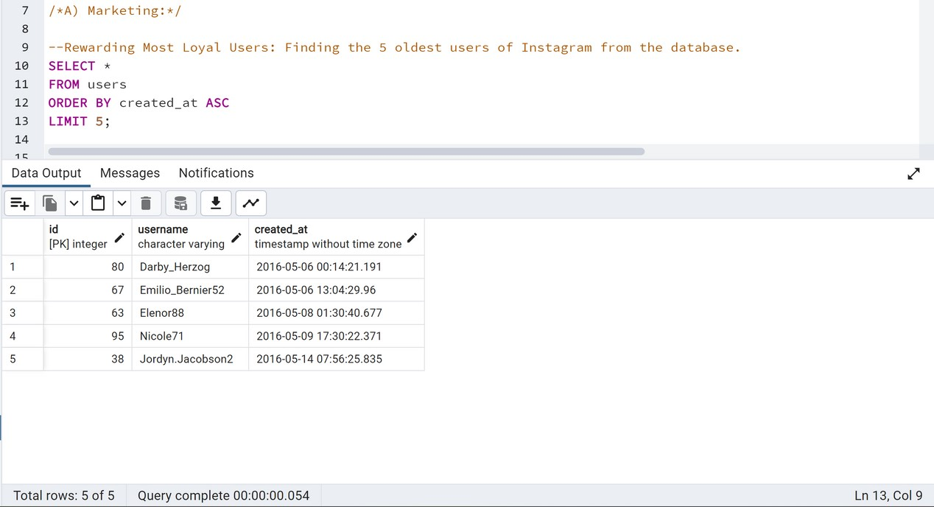
Results

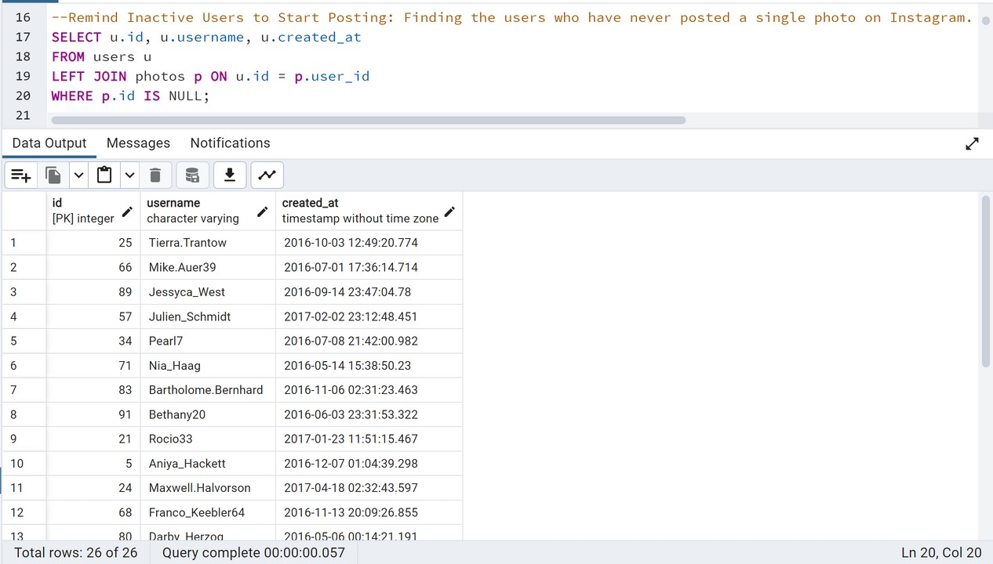
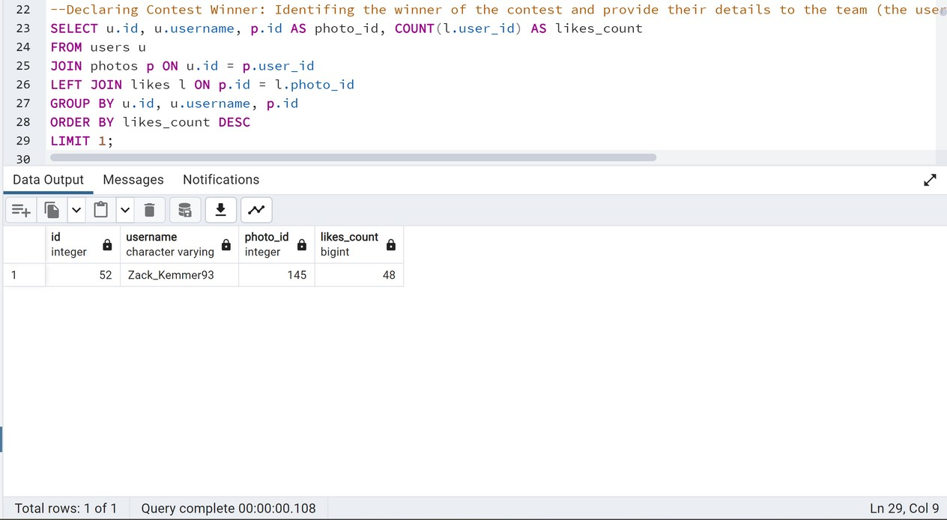
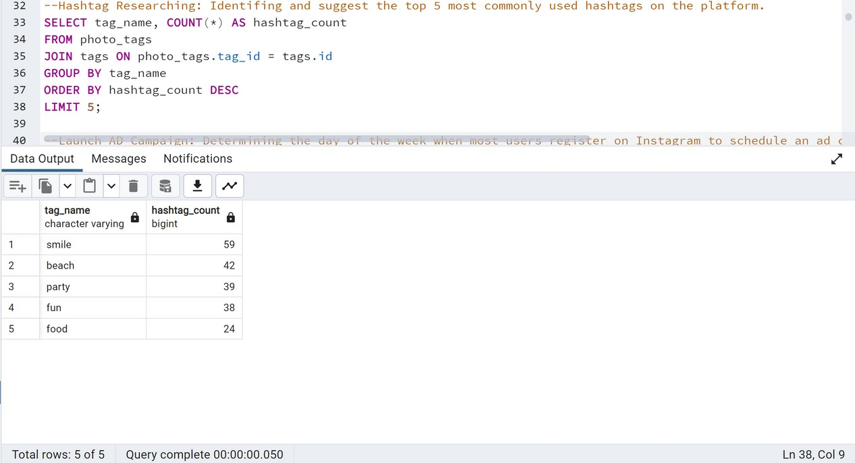
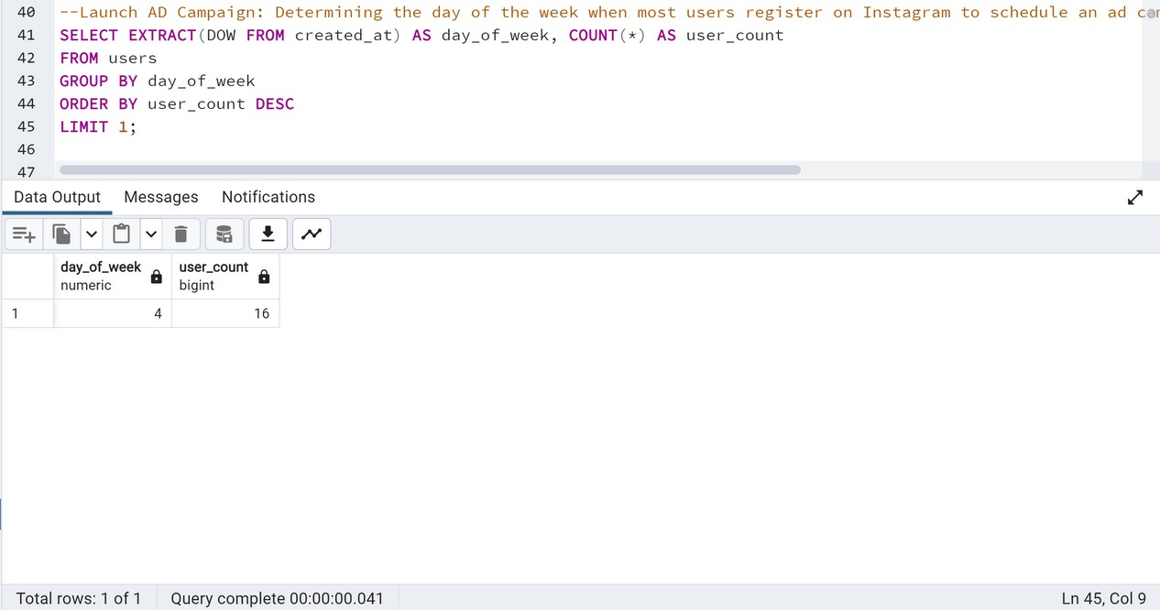
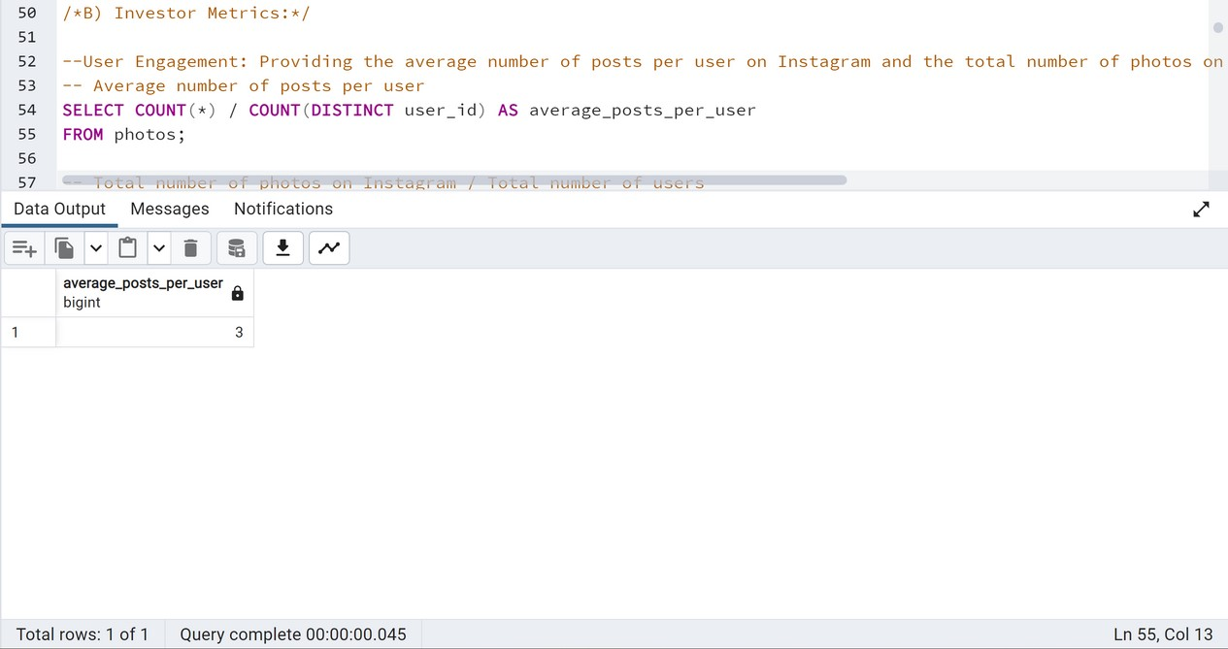
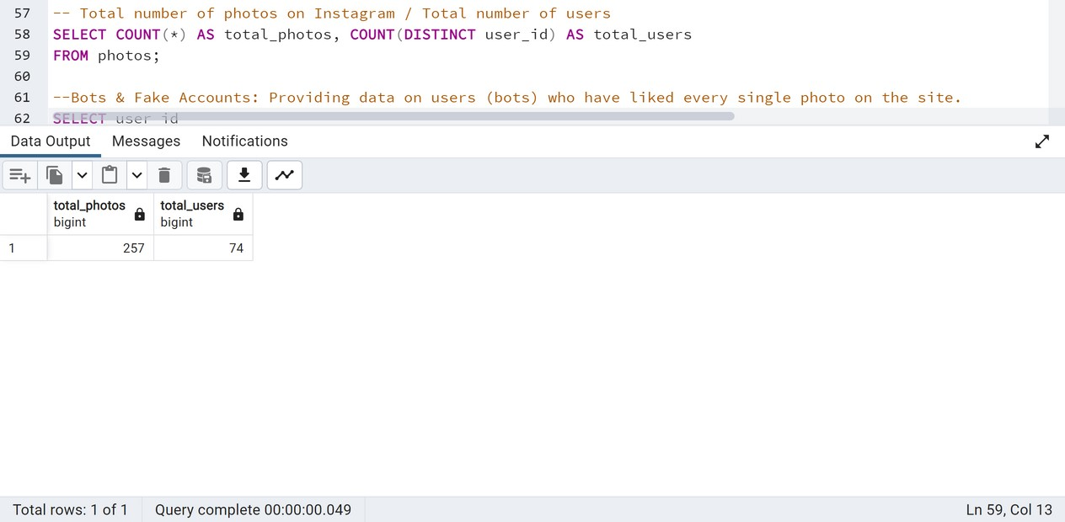
Thank You!

