Step 1: Character Interpretation
Earlier in this lesson you read two different interpretations of a scene featuring Lady Macbeth. You were asked to view a stage performance of the same scene in order to answer this question: How does this interpretation compare to the others? In a response of at least five sentences, comment on the stage interpretation and explain your impression of Lady Macbeth in this scene. Use specific examples from the clip to support your answer. Things to consider: her facial expressions, body language, and tone of voice.

Step 2: Setting Interpretation
Choose one of the provided scenes from Macbeth that you have previously studied in this course and locate or create an image that shows a fitting setting for that scene. In a response of at least five sentences, explain why you chose the image. Use examples from the play and the image to support your reasoning. Include the scene and the image along with your response.

In my interpertation I will be analyzing potter during his scence when he is drunk and the interpertation of that scence. This interpertation is a very good interpertation of the scence because the actor does a good job showing that he is drunk. First he pees in a bucket and is stubling around while doing so. Second he keeps complaining about the knocking at the door and stumbles trying to get there. Lastly we actually see him drinking thus ading to the persona that he is drunk.

In a response of at least five sentences, comment on the stage interpretation and explain your impression of Lady Macbeth in this scene.’

- Lady Macbeth was Described in this scene that she was one happy loving person. The way she looks and her different facial expression show that she thinks everything is going to be perfect. She totally supports Macbeth and is totally rooting for him.

LADY MACBETH.
What beast was't, then,
That made you break this enterprise to me?
When you durst do it, then you were a man;
And, to be more than what you were, you would
Be so much more the man. Nor time nor place
Did then adhere, and yet you would make both:
They have made themselves, and that their fitness now
Does unmake you.

MACBETH.
If we should fail?

LADY MACBETH.
We fail!
But screw your courage to the sticking-place,
And we'll not fail…
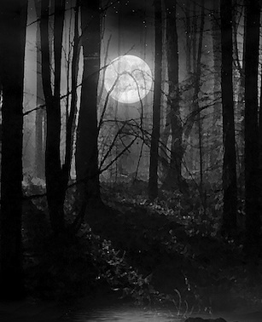

This picture that I chose i felt was a good one to represent the discussion between Lady Macbeth and Macbeth. This are both discussing their cruel ploy that they are doing to King Duncan, Macbeth starts to get anxious and worried about their plan. Lady Macbeth gets aggravated and angry with him because she thinks that he is going to chicken out and does have the nerve to go through with it. The picture I have here it shows that it is getting dark and scary outside the sunlight is going away, and this relates to lady Macbeth and Macbeth's situation because they are planning something evil and doing it in darkness, the “nice” Macbeth and Lady Macbeth show their true colors, pure evil.

