**Portfolio Site Report**

**Student Name: Spencer Shifrin  
Date: 1/23/2019**

**Portfolio Version: V1.0**

**Website URL: http://cis2.oc.ctc.edu/class/ag155.winter19/spencershifrin/CIS155/Project/V1/**

Complete this URL with your home page for your Project submission. This is the address you type in to the browser to get to your site’s home page. Note, you won’t be able to “drill down” from the cis2 class page since you secured your home directory with an index.html file. You must construct this URL by adding your folders and the home page file name to your personal URL on cis2.

http://cis2.oc.ctc.edu/

Do not upload this file to cis2; only submit it to Canvas.

Indicate which of the requested module outcomes were not included in your files and explain why:

**Note, all screen shots need to include the browser address bar.**

# index.html

Include a screenshot of your index.html rendered on cis2 (i.e. not a local file in a browser):

Include a validation screenshot of url-based validation of your index.html from cis2, using the w3 validator:

Explain/justify any remaining errors or warnings from the validation:

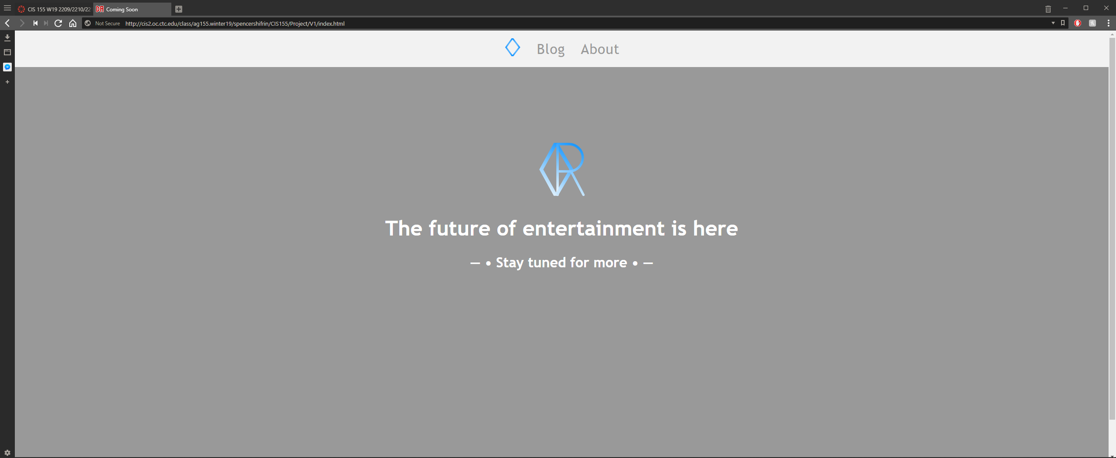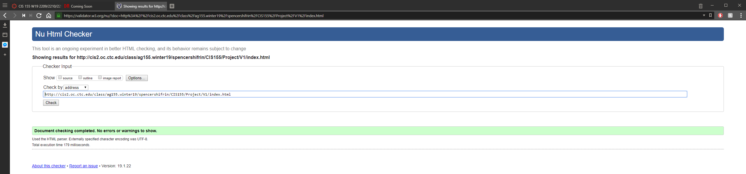

# about.html

Include a screenshot of your about.html rendered on cis2 (i.e. not a local file in a browser):

Include a validation screenshot of url-based validation of your about.html from cis2, using the w3 validator:

Explain/justify any remaining errors or warnings from the validation:

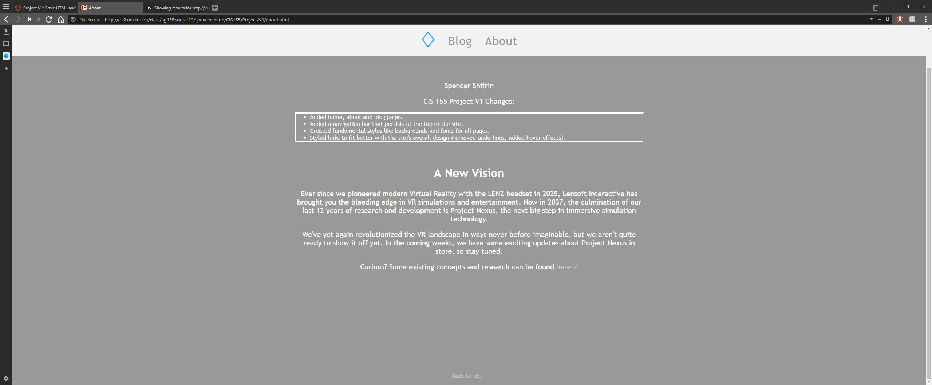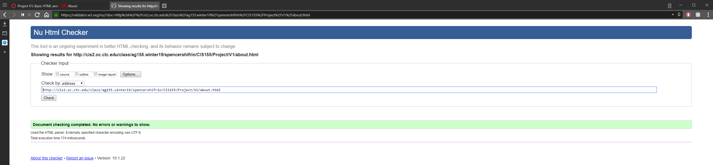

# styles.css

Include a validation screenshot of url-based validation of your styles.css from cis2, using the w3 validator:

Explain/justify any remaining errors or warnings from the validation:

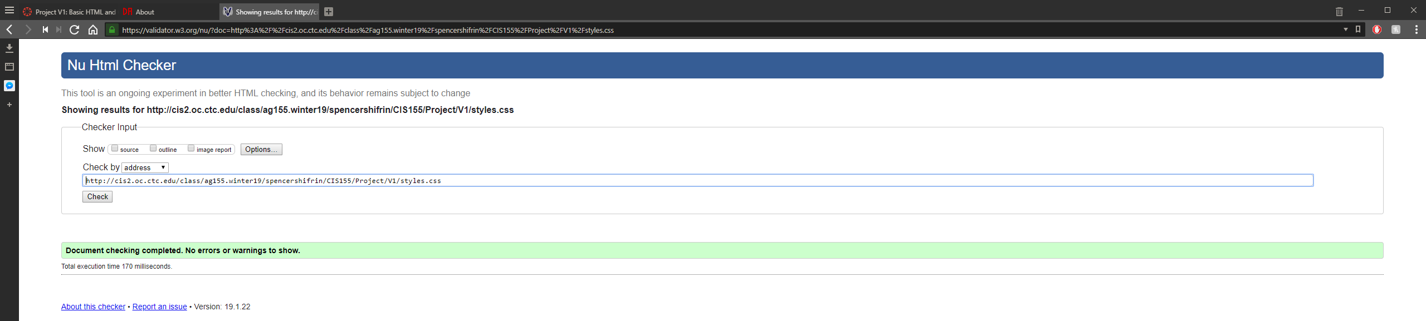

# Additional pages/code files

If you had any additional HTML or CSS files in which you put Module Outcomes, repeat the processes above for them as well.

# Checklist:

A checklist is provided below to help you ensure you have good structure and content:

* HTML5 doctype at the beginning of every HTML file
* Comments at the top of each file with your name, the date, the assignment, and an overview of the file’s purpose
* HTML and CSS both specify the UTF-8 character set appropriately
* HTML has an appropriate title and meta items for description, keyword, and author
* Navigation exists between the HTML pages, potentially with placeholders for planned future pages.
* Both pages share the same CSS file.
* HTML semantic tags are used in body to identify key elements such as header, nav, section, article, and footer.
* HTML and CSS code uses indentation to show containment of elements, content, and properties.

Also verify that you have added the required comments to note where the learning outcomes are exhibited.

Test your code locally prior to uploading it the cis2, but *test it again* on cis2. Cis2 is “case-sensitive” for file names, so if your code does not agree with your exact file names, images and links may stop working.