Project 1: Static Foundations
Feedback for Banhmigos Park Place
Student: Josh Caili Course: CSC 436, Fall 2026 Reviewed at: 1e55cf0
Repo: github.com/joshcaili/CSC436 Live: joshcaili-proj1.netlify.app

Grade: 77 / 100
Category | Points | Earned | One line
Semantic HTML | 20 | 16 | Valid, clean outline, great alt text; cards are divs, two fake buttons, a nav with no links
CSS layout | 25 | 18 | Flexbox and Grid both yours and purposeful; spacing depends on a stylesheet that never loads
Responsive design | 15 | 13 | Mobile-first (the only one so far), no horizontal scroll; desktop is just tablet, wider
JavaScript interaction | 15 | 12 | Filter is clean and idiomatic; one console error on load; five Add buttons do nothing
Repository and deployment | 15 | 11 | README complete, deploy works; all commits on the due date, junk files committed
Content and polish | 10 | 7 | Real restaurant, real menu, real photo; desktop layout looks unfinished
Total | 100 | 77 | Tight, correct fundamentals. One typo is quietly wrecking the layout.

How this review was made
Your instructor reviewed this project with Claude (Anthropic's AI) as a second set of eyes. Claude cloned the repo, read every line, loaded the live site at phone, tablet and desktop widths, ran the W3C validator, read the browser console, and clicked every filter button and every Add button. Every note and every point in this document was read and approved by your instructor. Same standard, same rubric, just more time spent looking at your code than one human has in a grading week.

The short version
The bones here are right. Your outline is one h1, then h2 per category, then h3 per item, and the validator has nothing to say. You wrote your own Flexbox and your own Grid, your media query is mobile-first (nobody else in the class did that), the filter JavaScript is the cleanest I have read this week, and the README has everything the brief asked for.
Now open the browser console on your live site. There is one red line: the Bootstrap stylesheet is blocked. The integrity hash on line 10 has three characters pasted twice, so the browser refuses to load the file. That means every Bootstrap class on your page (container, p-3, py-4, mb-3) does nothing. Your page has no max-width, so on a desktop it runs edge to edge. Your cards have zero padding, so the text touches the border. It is the console error the rubric mentions, and it is the reason the desktop looks unfinished. One typo, three categories.

What Claude measured
Check | Result
Horizontal scroll at 375 / 768 / 1280 px | None at any width
Console errors | 1: Bootstrap CSS blocked, integrity hash mismatch
Bootstrap stylesheet loaded | No
.menu-card computed padding | 0px (the p-3 class never applied)
main computed max-width | none (the container class never applied)
W3C HTML validator | 0 errors, 0 warnings
Heading order | h1 > h2 > h3, no skipped levels
Filter buttons | All 5 work; sections hide and show, status line updates
Add buttons | 5, no click handler, nothing happens
Links on the page | 0
Media query | 1, min-width: 700px (mobile-first)
Images | 1 used (4000 by 2250, 1.4 MB, shown at 500px); 1 committed and never referenced (2.4 MB)
Commits | 5, all on Sep 15 between 2:34 AM and 11:03 PM

The site at three widths
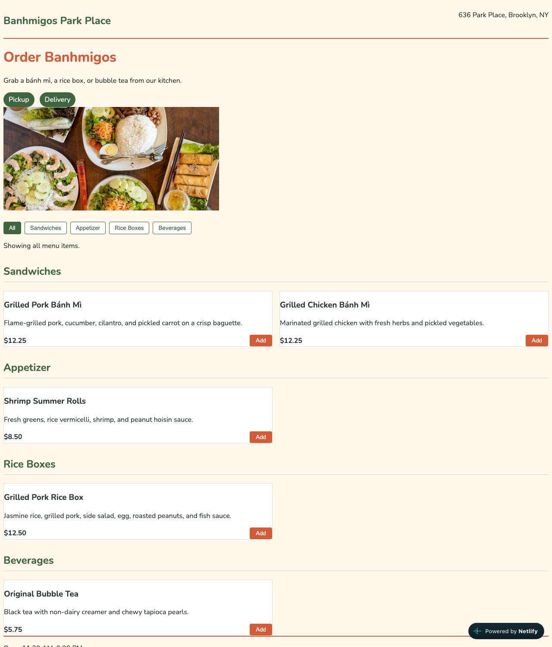
Desktop, 1280px. Content runs edge to edge and cards have no padding: the Bootstrap classes never applied.
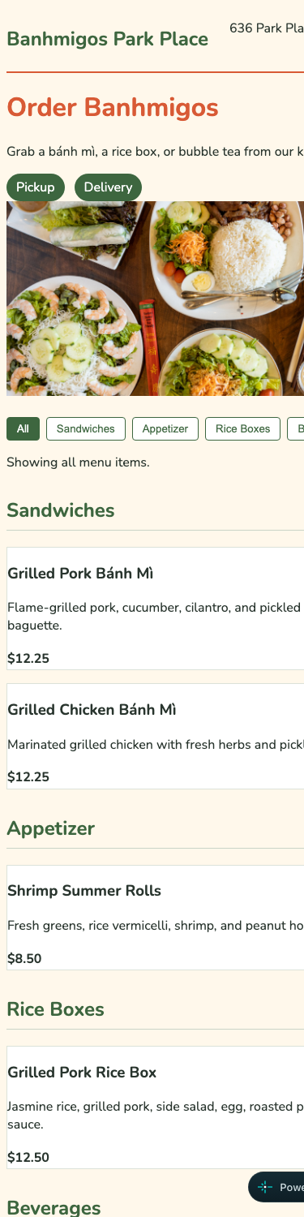  Phone, 375px. No horizontal scroll; filters wrap. | 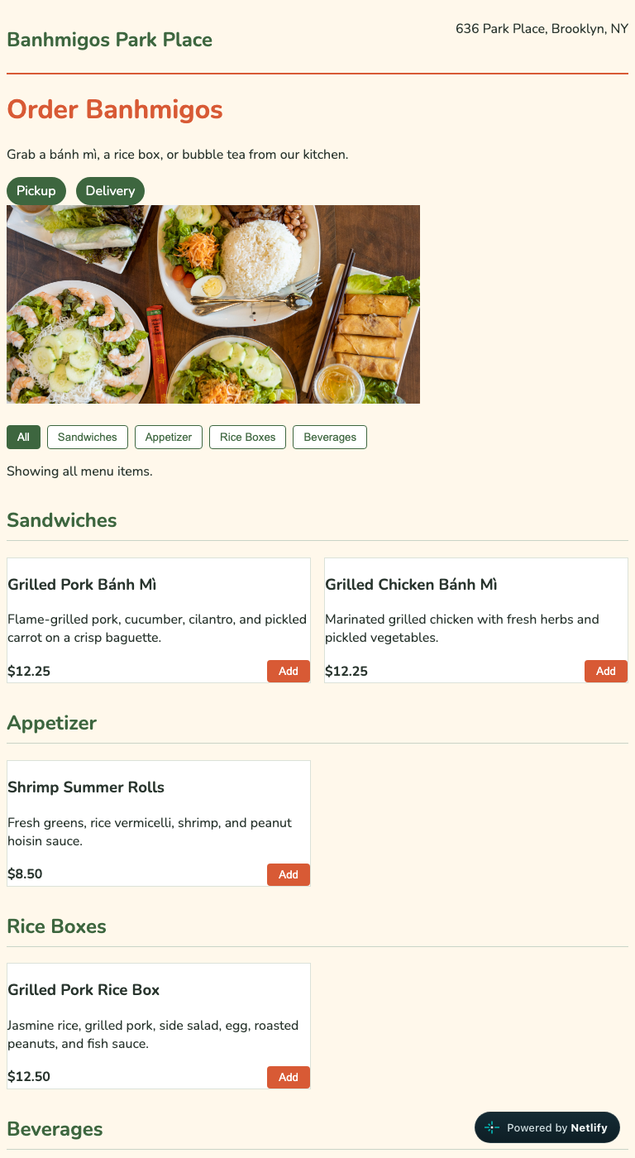  Tablet, 768px. Two-column menu grid.

Semantic HTML: 16 / 20

What is working
- header, main, nav, five sections, footer. One h1 (line 21), h2 per category, h3 per item. No skipped levels. Zero validator messages.
- The alt text on the photo (line 24), "Vietnamese rice, spring rolls, noodles, and fresh vegetables served on plates," is a real description. Most alt text in this class is two words.
- data-category on each section and data-filter on each button is the right way to connect markup to behavior.

What to change
- Menu cards are divs (line 39 and four more). Each card is a self-contained item with its own heading, description and price. That is the textbook definition of article.
- Pickup and Delivery are paragraphs dressed as buttons (line 23). Green pills that do not respond to anything. Either make them buttons that toggle a state, or make them plain text ("Pickup or delivery available"). Do not make something look clickable if it is not.
- Five Add buttons with no handler. Same principle. A button is a promise. Wire them up or remove them until they work.
- nav holds filter buttons, not navigation (lines 27 to 33). nav means "links to other places." A filter bar is a toolbar: a div with role="group" and aria-label="Filter menu". And your page has zero a elements anywhere, which is unusual for something called a nav.
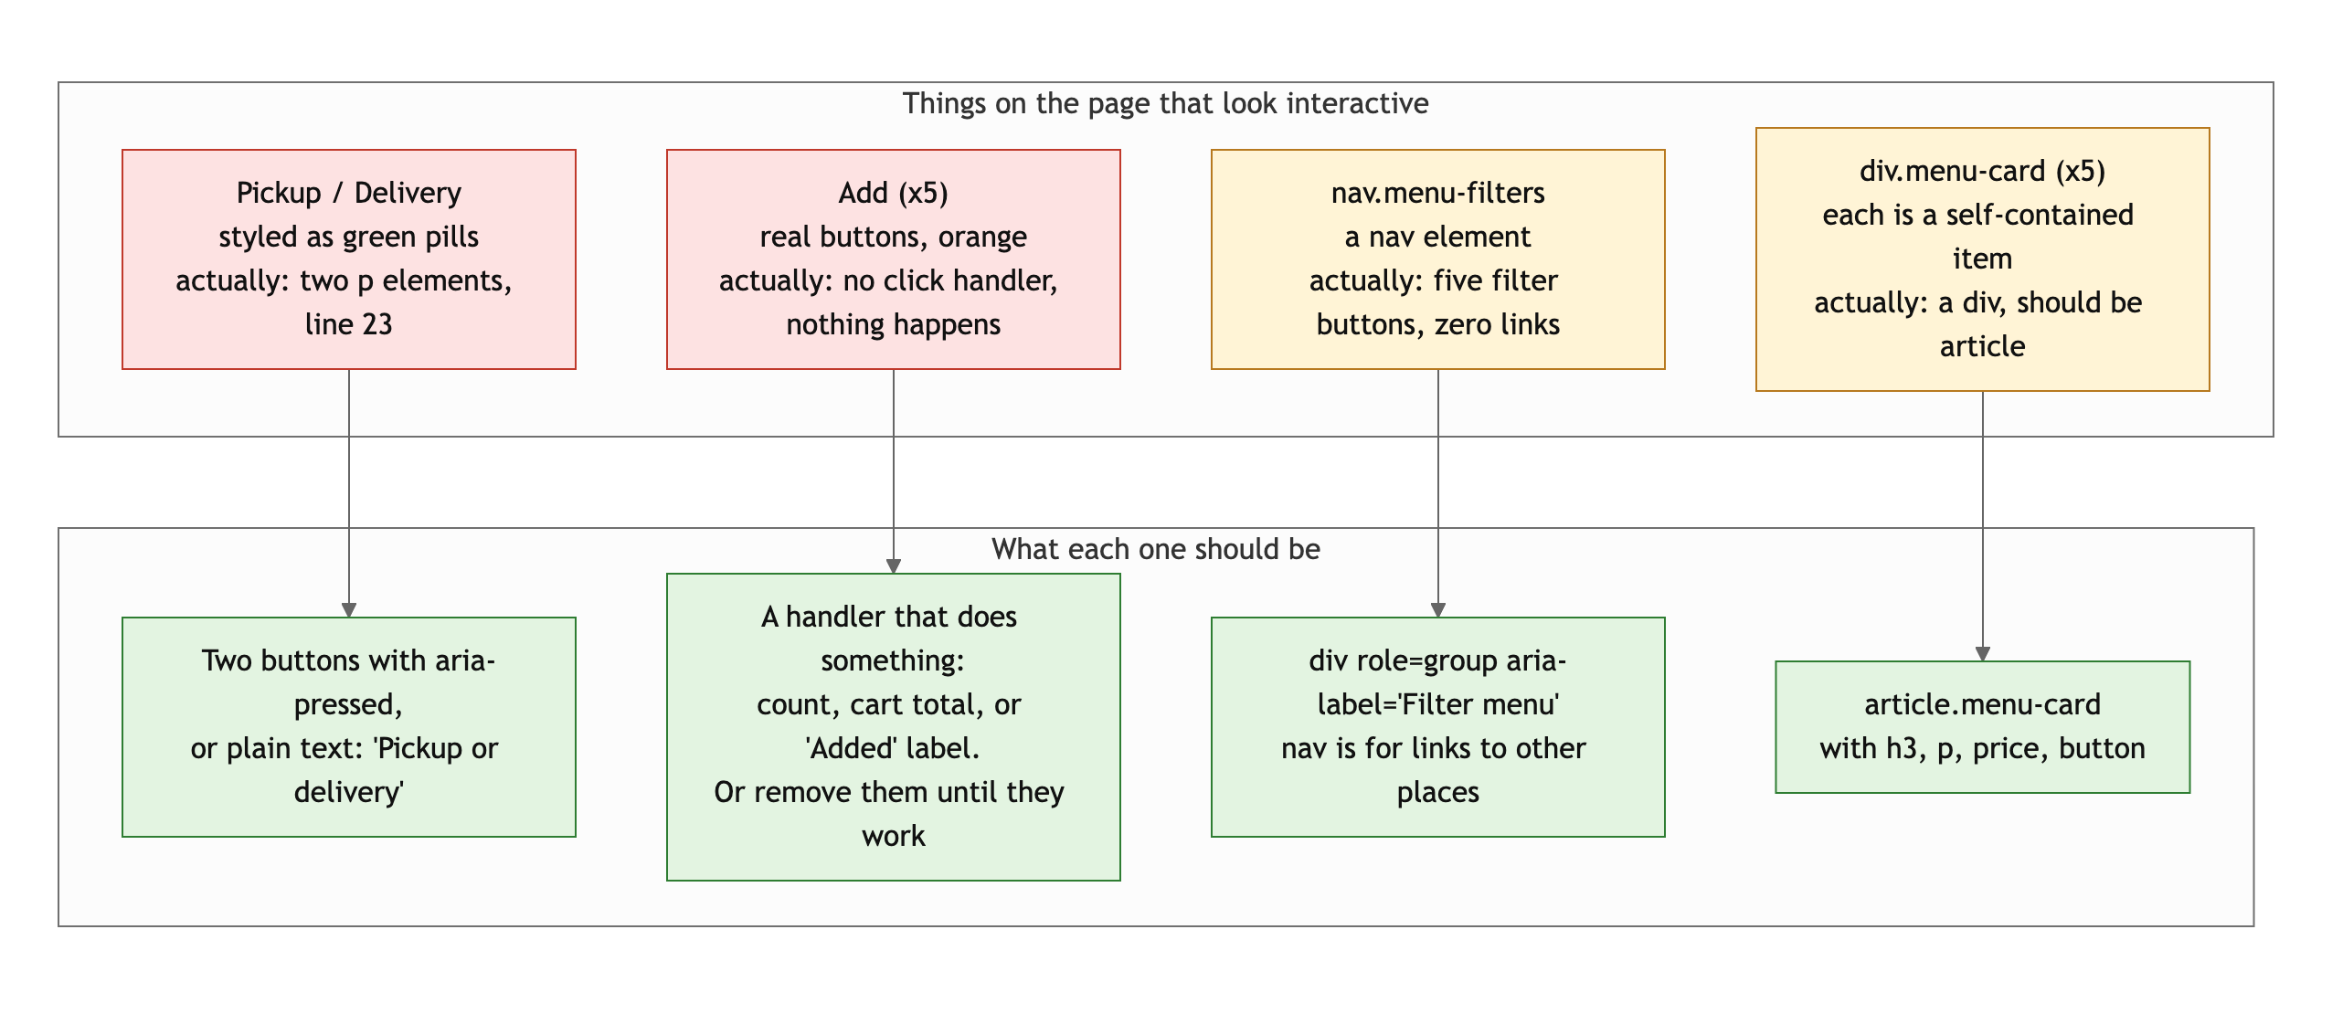
Diagram 1. Four things that look like one thing and are another, and what each should be.
- Small: the brand name is a p with class brand (line 15). Fine, but a site name in the header is conventionally a link to the home page.

CSS layout: 18 / 25

What is working
- Flexbox, yours, four times: the header (space-between puts the address on the right), the order pills, the wrapping filter bar, and the price-plus-button row in every card (styles.css lines 50 to 60, 70 to 75, 94 to 96). Each one is the right tool for that job.
- Grid, yours: .menu-grid goes from one column to two at 700px (lines 29 to 33 and 115 to 119). Simple and correct.
- The palette is coherent: cream background, forest green, one orange accent, and Nunito. It reads like a restaurant.

What to change
- Your spacing lives in a file that never loads. container, py-3, py-4, p-3, mb-1, mb-3 are all Bootstrap classes, and Bootstrap is blocked (see the console). So main has no max-width and no side padding, and .menu-card has padding: 0. At 1280px the page runs edge to edge and the card text touches the border. This is why the desktop looks unfinished. The brief says spacing and alignment must be deliberate, and right now they are accidental.
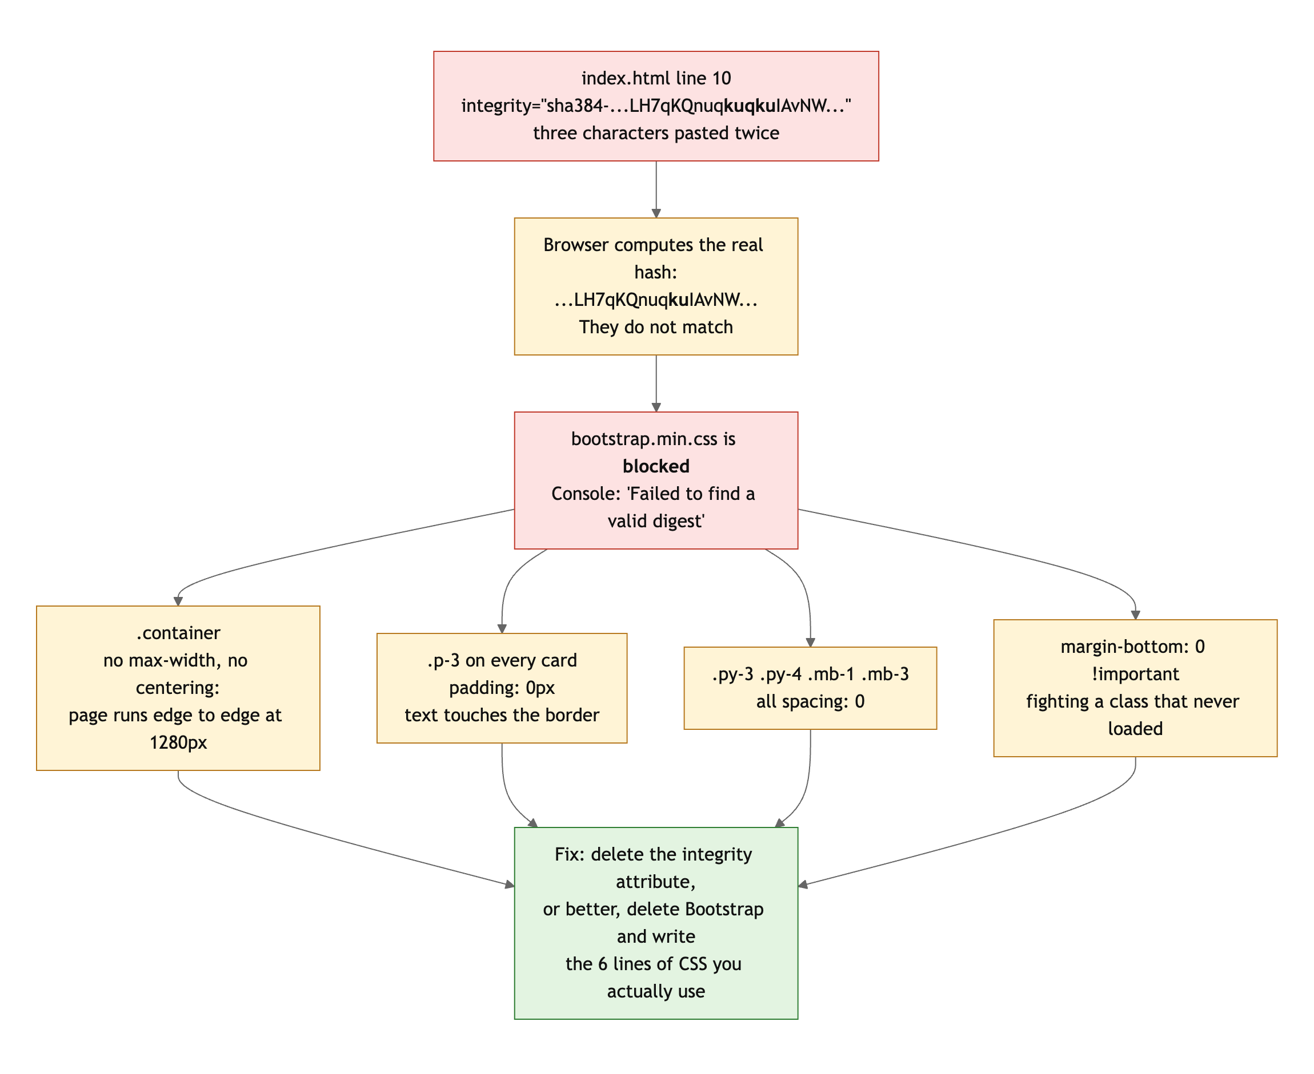
Diagram 2. One duplicated fragment in the integrity hash, and everything downstream of it.
The honest fix is to drop Bootstrap. You use four utility classes from a 200 KB framework. Replace them with six lines of your own:
main, header, footer { max-width: 1100px; margin: 0 auto; padding: 16px; }
.menu-card { padding: 16px; }

Then delete lines 10 and 91 of index.html, and the !important on styles.css line 36, which only exists to fight Bootstrap's mb-3.
- The grid stops at two columns. 1fr 1fr at 700px and up means two 600px-wide cards on a desktop. repeat(auto-fit, minmax(280px, 1fr)) gives you one, two, three columns as the screen allows, with no media query.
- Small: img { height: 240px } with max-width: 500px leaves the hero photo sitting alone on the left at desktop. Either let it fill the width or put it beside the intro text with Flexbox.

Responsive design: 13 / 15

What is working
- Mobile-first. Your base styles are the phone, and @media (min-width: 700px) adds the second column. That is exactly what the brief asked for and you are the only one who did it.
- No horizontal scroll at 375, 768 or 1280. The filter buttons wrap. The image is width: 100% with object-fit: cover so it never distorts.

What to change
- Desktop is just tablet, wider. One breakpoint, and above it nothing changes except the cards stretch. With the container fix above and auto-fit on the grid, desktop becomes a real layout for free.
- The header at 375px wraps "Banhmigos Park Place" onto two lines while the address sits beside it. Stack them on phones (flex-direction: column in the base styles, row at 700px).

JavaScript interaction: 12 / 15

What is working
- The filter is the cleanest JavaScript I have read this week. dataset.filter, a loop to reset the active class, classList.toggle with the boolean argument, a template literal for the status line (script.js lines 5 to 23). Twenty-three lines, no wasted motion, and every button works (Claude clicked all five).
- Updating #filter-message so the page says what it did is a detail most people skip.

What to change
- One console error on load. The rubric says "no console errors," and this one is yours: the Bootstrap integrity mismatch. It also happens to be the most consequential bug on the page. Check the console before every push.
- Five buttons that do nothing. The Add buttons have no handler. Even a tiny one (count items, change the label to "Added", or log to a cart array) makes them honest.
- Small, for accessibility: add aria-pressed="true" to the active filter button (toggle it with the class), and aria-live="polite" on #filter-message so screen readers hear the status change.

Repository and deployment: 11 / 15

What is working
- README has all four required items: title, description, how to run, live URL. Clean and short.
- Commit messages describe features: "added flexbox, grid & media queries", "basic menu filter". The log tells the story of the build. Live URL works in a private window and matches the repo.

What to change
- All five commits are on September 15, from 2:34 AM to 11:03 PM. They are real feature commits, so this is not the one-commit case, but the brief asked for history that shows the project developing over time. Two weeks were available. Start earlier next time, even if the first commits are small.
- Junk in the repo. .DS_Store is committed. An Emacs autosave file (#index.html#) was committed, broke the Netlify deploy, and had to be removed in the next commit. .gitignore has a stray "v" on line 1, so that line ignores a file named "v" instead of being a comment. And banh-mi.png (2.4 MB) is committed but nothing references it.
- The README says the site is built with Bootstrap. It is not, currently. See CSS.

Content and polish: 7 / 10

What is working
- A real restaurant, a real address, real menu items with real prices and Vietnamese diacritics in the right places. Five items is thin but every one is genuine. No lorem ipsum.
- The one photo is well chosen and well described.

What to change
- The desktop layout looks unfinished because of the blocked stylesheet. Edge-to-edge content, unpadded cards, a 500px photo stranded on the left. Fix the CSS issue and most of this goes away.
- The hero photo is 4000 by 2250 and 1.4 MB, shown at 500px. Resize it to about 1000px wide and it drops under 150 KB.
- Five menu items across four categories, three of which have one item each. A restaurant menu with one beverage looks like a placeholder. Two or three per category would fill the grid and make the filter feel useful.

Your next three moves
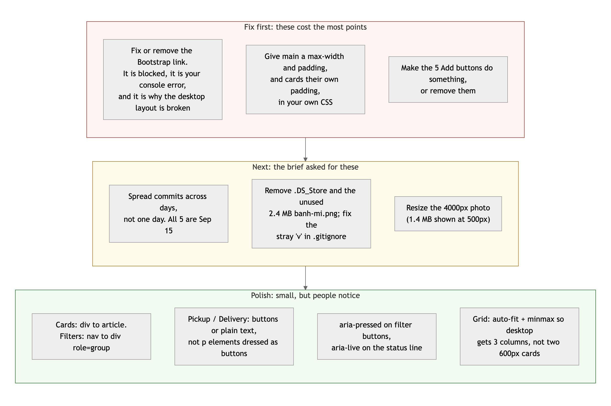
Diagram 3. Priority order. Top row first: it is where the points are.
- Open the console and fix the red line. Remove the Bootstrap tags and write the six lines of CSS above. Fifteen minutes, and it fixes the console error, the desktop layout, the card padding, and the !important.
- Make every clickable thing do something. Wire the Add buttons, and turn Pickup/Delivery into buttons or text.
- Clean the repo and start Project 2 earlier. Remove the junk files, fix .gitignore, and make your first commit the day the project is assigned.

Your fundamentals are the tightest in the class. What is missing is the last pass: open the site on a big screen, open the console, and look at what shipped.
This review lives in a pull request on your repo. It only adds feedback files and does not touch your code. Merge it, close it, or just read it. Questions go to office hours or the Brightspace board.

