Project 1: Static Foundations
Feedback for RNA in 3D
Student: Giovanny Rodríguez Course: CSC 436, Fall 2026 Reviewed at: cba619e
Repo: github.com/dreuxx/dreuxx-Static-Foundations Live: static-foundations.netlify.app

Grade: 90 / 100
Category | Points | Earned | One line
Semantic HTML | 20 | 19 | Skip link, labelled sections, figures with captions, a definition list, descriptive alt text, one h1; two validator errors, both about roles the JS adds later
CSS layout | 25 | 24 | Ten tokens used 58 times, 20 Flexbox and 6 Grid containers, clamp, focus-visible, reduced-motion, print; desktop-first queries
Responsive design | 15 | 15 | No horizontal scroll anywhere, every grid collapses, the menu closes on Escape and manages focus across the breakpoint
JavaScript interaction | 15 | 15 | A menu, keyboard-accessible tabs, and a real 3D projection of a real molecule, all verified
Repository and deployment | 15 | 8 | README complete, deploy matches repo byte for byte; the finished site arrived in one 6,590-line commit on the due date, messages say "start" and "end"
Content and polish | 10 | 9 | Real structure from the Protein Data Bank, cited sources, illustrations built from the coordinates; a comma decimal in an English page
Total | 100 | 90 | The best site in the class and the thinnest history. The gap between those two facts is what we need to talk about.

How this review was made
Your instructor reviewed this project with Claude (Anthropic's AI) as a second set of eyes. Claude cloned the repo, read every line of the HTML, the 1,075-line stylesheet, the script and the Python build tool, loaded the live site at phone, tablet and desktop widths, ran the W3C validator, worked every control on the page (the menu, the Escape key, the rotation slider, the rotate, highlight and reset buttons, all three tabs), diffed the live site against the repo, and read every commit including the two Spanish-language drafts from Sep 10. Every note and every point in this document was read and approved by your instructor. Same rubric, same standard, just more time spent looking at your code than one person has in a grading week.

The short version
There is nothing else like this in the class. The hero image, the fallback illustration and the interactive model are all derived from the same experimental record, PDB 1EHZ, through a Python script you included in the repo. The model projects 76 points in three dimensions, rotates them, sorts them back to front and redraws an SVG on every slider input. The tabs use a real roving tabindex with arrow keys. The menu closes on Escape and moves focus sensibly when the viewport crosses the breakpoint. There is a skip link, a reduced-motion rule, a print stylesheet, a noscript fallback, and a theme color. The validator finds two errors, both technicalities. No horizontal scroll at any width. The writing is clear and the sources are real.
The points came off in one place, and it is the place the brief warned about. Your Sep 10 commits are a genuine Spanish-language draft of this project: a skeleton, then sections, 445 lines in total. Five days later, at 16:53 on the due date, a commit called "end" adds 6,590 lines: the finished stylesheet, the finished script, the PDB file, nine SVGs, the build tool. Then "AI Translate" turns the Spanish into English, and "netlify" adds the URL. So the history shows a draft, a wall, and a finished site on the other side of it. The brief says the history should show the project developing, and it says the "explain every line" rule applies to everything you submitted. That is not a threat; it is the next conversation. The pipeline diagram in this document is the study guide.

What Claude measured
Check | Result
Horizontal scroll at 375 / 768 / 1280 px | None at any width
W3C HTML validator | 2 errors (hidden on an svg; tab buttons whose panels get role=tabpanel only from JS), 0 warnings, 20 info notes
Heading order | h1 > h2 > h3, no skipped levels; every section has aria-labelledby
Semantic elements | skip link, header, nav (ul of 3, aria-label), main, 5 section, 6 article, 6 figure with figcaption, dl, ol, footer
Media queries | 6: min-width 1400, max-width 1000 / 760 / 640, prefers-reduced-motion, print
Grids at 375 / 1280 | hero 1 / 2, explorer 1 / 2, concepts 1 / 3, type panels 1 / 2, sources 1 / 2
Custom properties | 10 defined in :root, used 58 times
Mobile menu at 375 | Opens (aria-expanded true, label flips to minus), closes on Escape, verified
Rotate 30 button / slider to 90 | Readout 30 then 90 degrees, model redrawn, verified
Highlight anticodon / Reset | aria-pressed false to true, status text changes, reset returns both, verified
Tabs | 3 tabs, aria-selected moves, panels hide and show, roving tabindex, verified
Console errors | 0
Page weight | 0.65 MB in the repo, mostly the 229 KB PDB download and a 104 KB SVG; no raster images
Commits | 6: Initial (1 line), start (80), start (365), end (6,590), AI Translate (172), netlify (22)
Live vs repo | Identical apart from the badge script Netlify injects
README | Title, description, structure, run locally, live URL: all there

The site at three widths
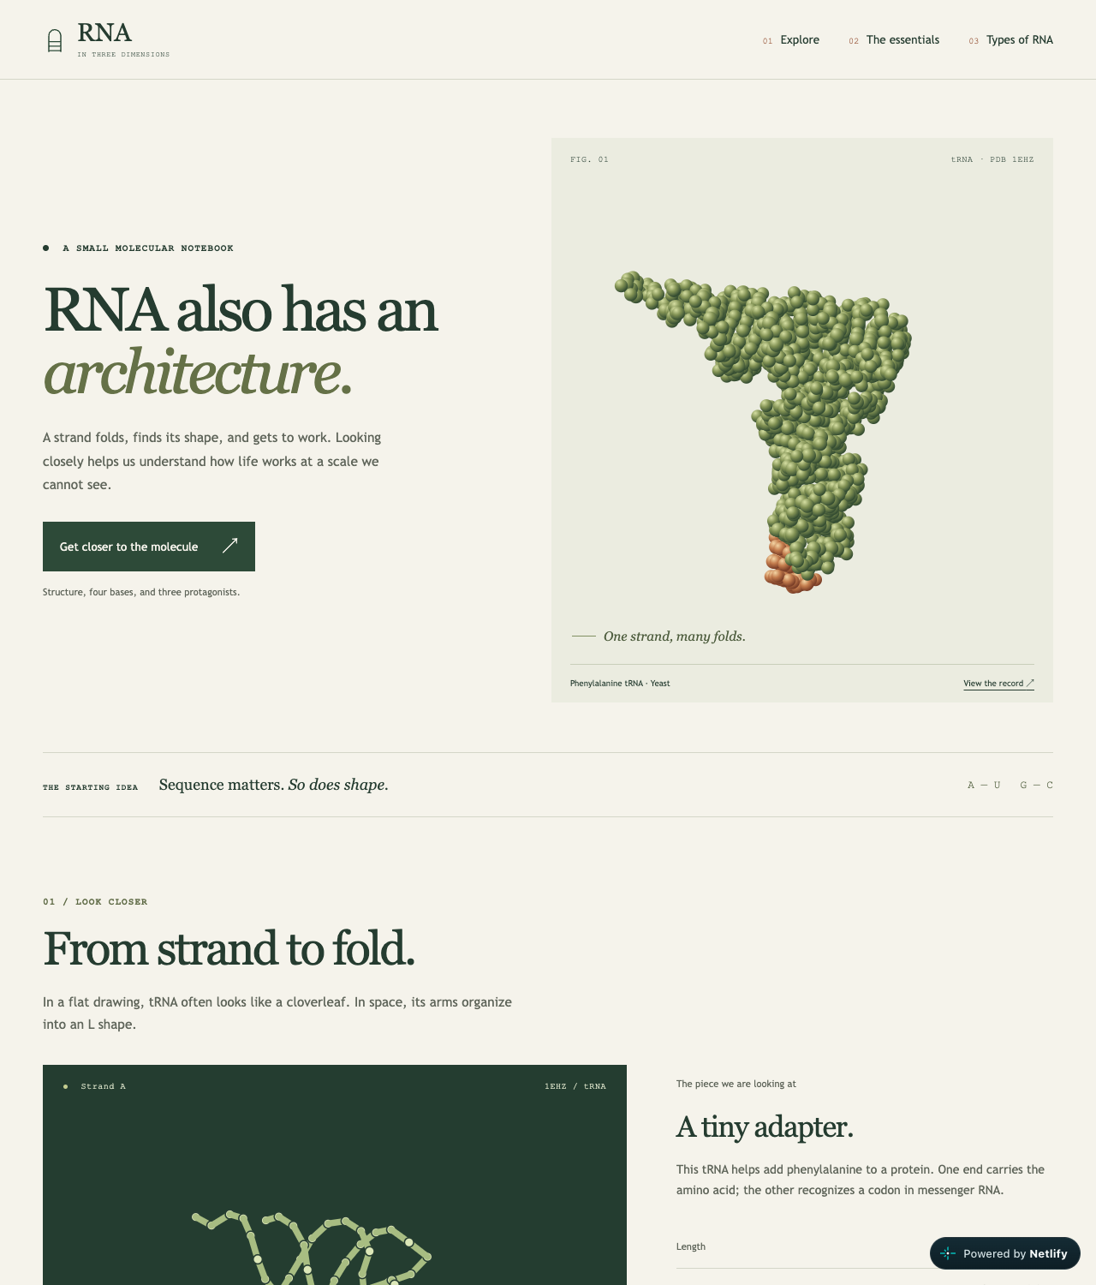
Desktop, 1280px. Two-column hero with the molecule figure; explorer beside its notes.
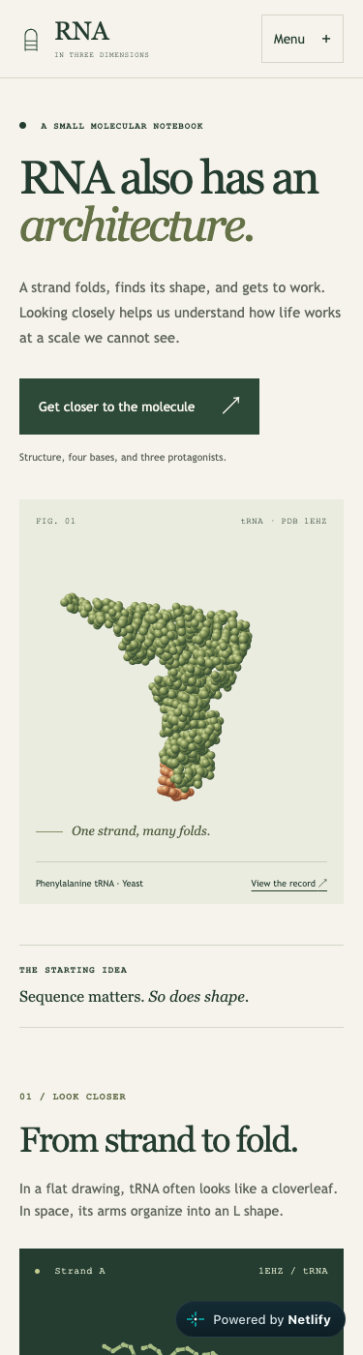  Phone, 375px. Menu button, one column, no horizontal scroll. | 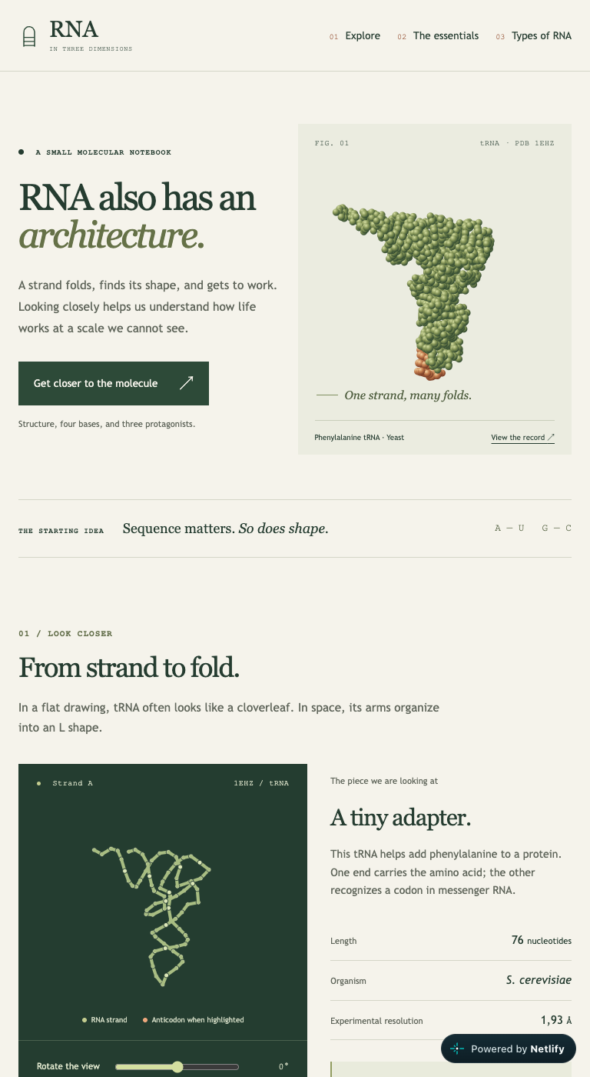  Tablet, 768px. Full nav; grids collapse to one column below 760px.

Semantic HTML: 19 / 20

What is working
- The document is built the way accessibility guides say to build one. A skip link to main with tabindex="-1" so it can receive focus (index.html lines 18 and 54). nav with aria-label and a list. Every section has aria-labelledby pointing at its own heading. The molecule figures use figure and figcaption. The specs use a dl. The sources are an ol. One h1, then h2 per section, h3 per card. Every image has alt text that describes what is in the picture, not just what it is.
- The interactive model is an svg with role="img", a title and a desc that the script updates as you rotate (lines 141 to 154). The status note has role="status" so the highlight announcement is read aloud. The menu button is a real button with aria-expanded and aria-controls. There is a noscript explaining what the static image is.

What to change
- Two validator errors, both fixable in the HTML (lines 146 and 364). hidden is not a valid attribute on svg per the validator; use a class and let the script clear it. And the tab buttons point at panels that only become role="tabpanel" after the script runs (script.js line 62), so the static HTML fails the "every tab needs a tabpanel" rule. Put role="tabpanel" and aria-labelledby on the three articles in the markup and delete lines 61 to 65 of the script. Zero errors, and the tabs are correct even before JavaScript loads.

CSS layout: 24 / 25

What is working
- A real design system in 1,075 lines. Ten custom properties for color and type (styles.css lines 1 to 12), used 58 times. Twenty Flexbox containers for the nav, the button rows, the legend, the figure headings. Six Grids: the hero, the explorer, the concept cards, the tab panels, the sources. clamp() on the display type. :focus-visible with a 3px rust outline on everything. A prefers-reduced-motion block and a print stylesheet (lines 1036 to 1047). The five !importants are all legitimate: [hidden], reduced motion, and print.
- The typography is the strongest in the class. Georgia display with a sans body and a mono eyebrow, consistent measure, a reading strip between sections. It looks like a printed notebook, which is the concept.

What to change
- Desktop-first. Four of the six queries are max-width (lines 764, 800, 873). The base rules are the 1280px layout and the queries take columns away. The brief asked for mobile-first, and with grids this clean the flip is mechanical: make the single-column rules the default and add the two- and three-column templates inside min-width queries.

Responsive design: 15 / 15

What is working
- No horizontal scroll at 375, 768 or 1280. Every grid drops to one column on the phone and every one of them does something different on the desktop. The nav wraps under 640px and the menu button appears only when JavaScript is present (.has-js .menu-toggle), so without JS the links are simply visible. The matchMedia listener closes the menu and moves focus when the viewport crosses 640px (script.js lines 36 to 43), which is the detail almost nobody handles. Full marks.

JavaScript interaction: 15 / 15

What is working
- Three interactions, each finished. The menu: setMenu writes aria-expanded, toggles a class, flips the + to a minus, closes on a link tap or Escape and returns focus to the button (lines 9 to 34). The tabs: aria-selected, roving tabIndex, ArrowLeft, ArrowRight, Home and End (lines 46 to 83). The model: drawModel rotates 76 points around the Y axis, projects them, sorts every line and circle by depth so the front of the strand draws over the back, rebuilds the SVG, and updates the readout, the aria-valuetext and the desc (lines 101 to 166). Claude clicked and dragged all of it. Zero console errors.
- The model only starts if rnaPoints exists and has exactly 76 entries (lines 196 to 198); otherwise the static SVG stays. That is a real fallback, not a comment saying there is one.
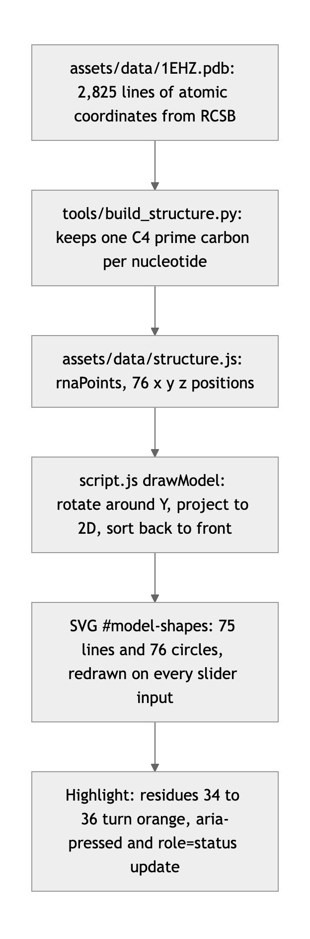
Diagram 1. From the Protein Data Bank record to the pixels on screen. This is the study guide for office hours.

What to change
- One word of Spanish survived the translation, and it is the one a screen reader says (script.js line 158). aria-valuetext is set to degrees + " grados". Every visible string was translated; this one was not, so an English screen-reader user hears "30 grados". Change it to "degrees".
- Small: drawModel rebuilds all 151 SVG elements as a string on every input event. For 76 points that is fine. For a bigger structure, keep the elements and update their attributes instead.

Repository and deployment: 8 / 15

What is working
- README has everything the brief asks for and more: goal, requirements, the live URL, the file structure, how to run it locally. .gitignore is sensible. The live site is public and matches the repo exactly. The Python tool and the PDB file are in the repo, which means the illustrations are reproducible; that is more than "real content," it is provenance.

What to change
- The history does not show the build. Two "start" commits on Sep 10 are a real Spanish draft of this project, 445 lines. Then nothing for five days. Then, at 16:53 on Sep 15, a commit called "end" adds 6,590 lines and 17 files: the entire stylesheet, the entire script, the PDB data, every SVG, the build tool. The brief says a single last-minute commit loses repository points and triggers a review of the work. This is that, with a draft in front of it. The draft is what keeps this from being the full penalty.
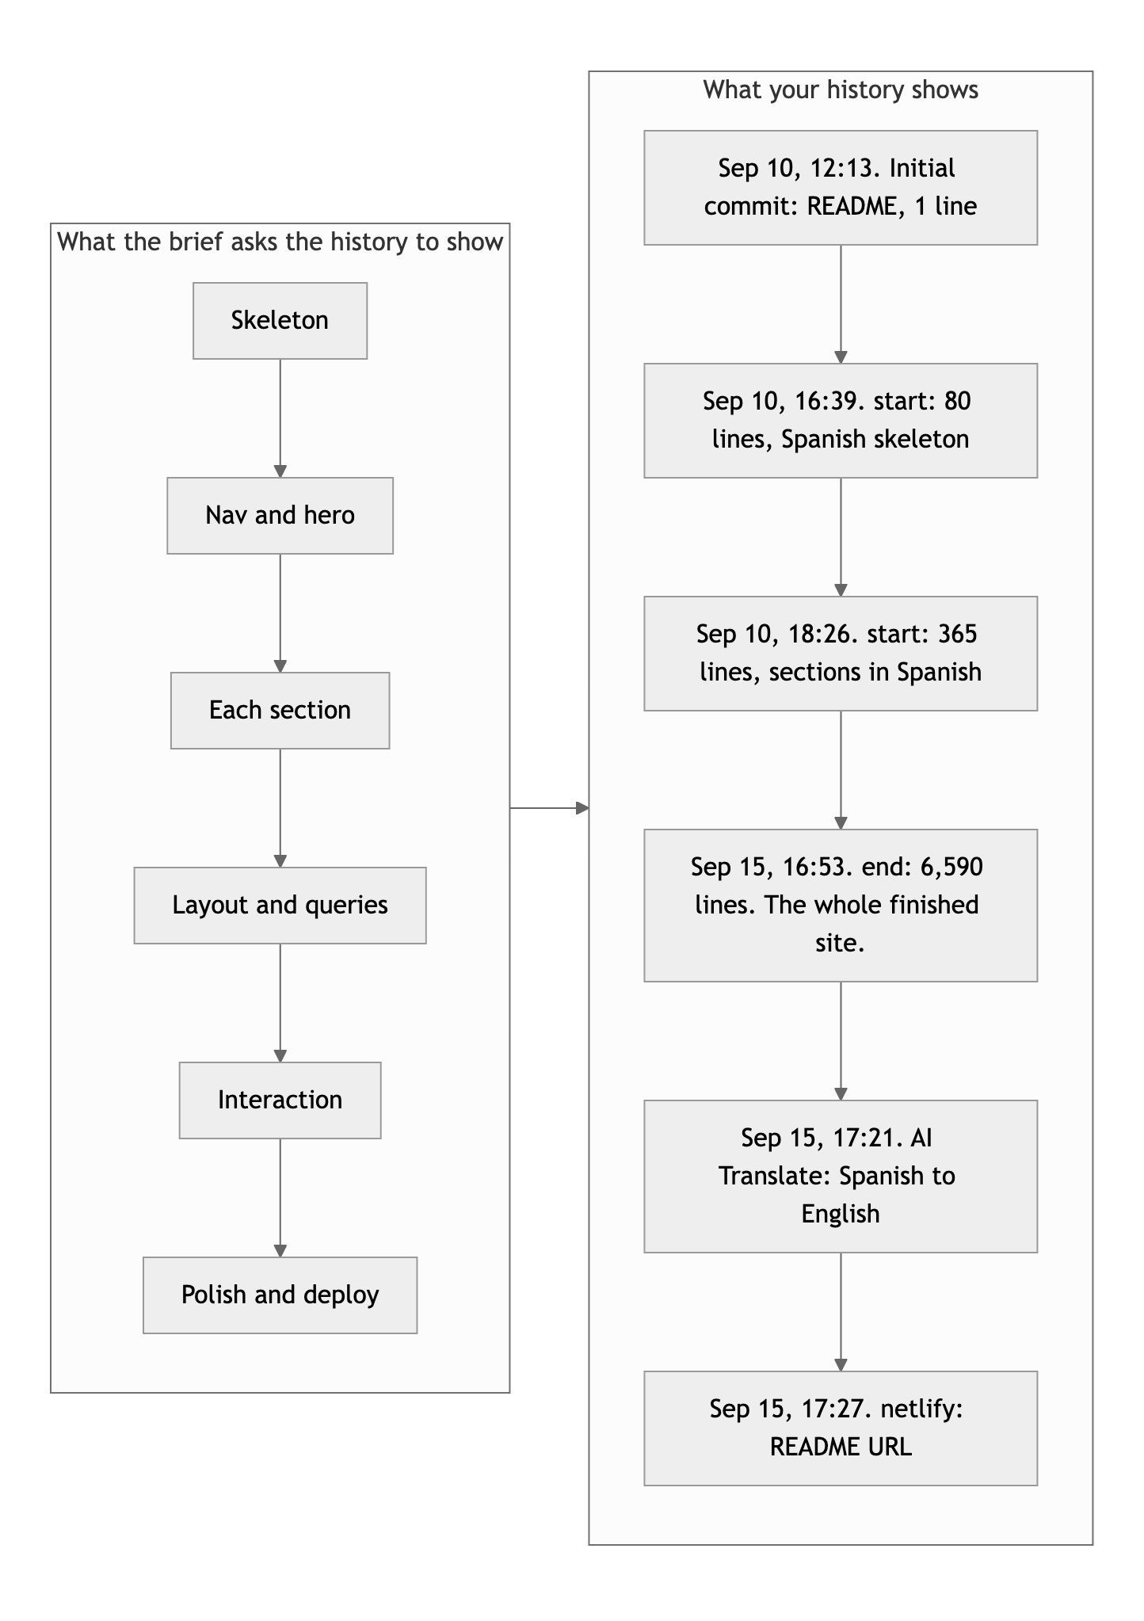
Diagram 2. The history the brief asks for, next to the one in the repo.
- The messages say nothing. "start", "start", "end". A message is for the person reading the history later, including you in a month. "Add tRNA model with rotation and highlight" costs ten seconds and is worth a point.
- The "AI Translate" commit is honest and that honesty is noted. Writing in Spanish and translating is completely fine. The brief's rule is about the code: you must be able to explain every line you submitted. See the next section.

Content and polish: 9 / 10

What is working
- The content is real in the strictest sense. The molecule is a specific crystal structure with a citation (Shi and Moore, 2000). The hero art and the fallback drawing are generated from its coordinates. The three concept cards and the three tab panels are accurate and short. The sources link the PDB entry, the NHGRI glossary and the NCBI Bookshelf. There are no raster images at all, so the page is fast and sharp at every density. The favicon, the theme color and the download link for the original coordinates are the details that make a site feel finished.

What to change
- "1,93 Å" (index.html line 214). Comma decimal, from the Spanish original. In English it is 1.93. Small, but it is in the specs table where a reader looks for precision.
- Small: the ids are still Spanish (#contenido, #explorar, #conceptos, #tipos, #fuentes). Nothing wrong with that, but the nav links in the URL bar will read as Spanish to an English visitor.

On the "explain every line" rule
The brief allows AI and requires that you can explain every line you submit. Nobody is accusing you of anything; the history simply does not show the site being built, and the site is well beyond what the class has seen, so the conversation is the check. Come to office hours ready to walk through these five, in your own words, without notes:
- The rotation (script.js lines 104 to 112). Why is x computed as x cos θ + z sin θ and z as −x sin θ + z cos θ? What happens to y? What is 320 + ... * scale doing?
- The depth sort (lines 153 to 156). Why sort by depth ascending before writing the markup? What would you see if you skipped it? Why is a line's depth the average of its two endpoints, and why does a circle get + 0.1?
- The breakpoint handler (lines 36 to 43). Walk through what happens to focus when a user has the mobile menu open and rotates a tablet to landscape.
- The roving tabindex (lines 49 to 59). Why does only the selected tab get tabIndex = 0? What does Tab do versus ArrowRight?
- The build tool (tools/build_structure.py). What is a C4′ carbon and why one per nucleotide? How does the script decide which atoms to keep?
If those five come easily, this is a 90 that was earned, and you should be proud of it.

Your next three moves
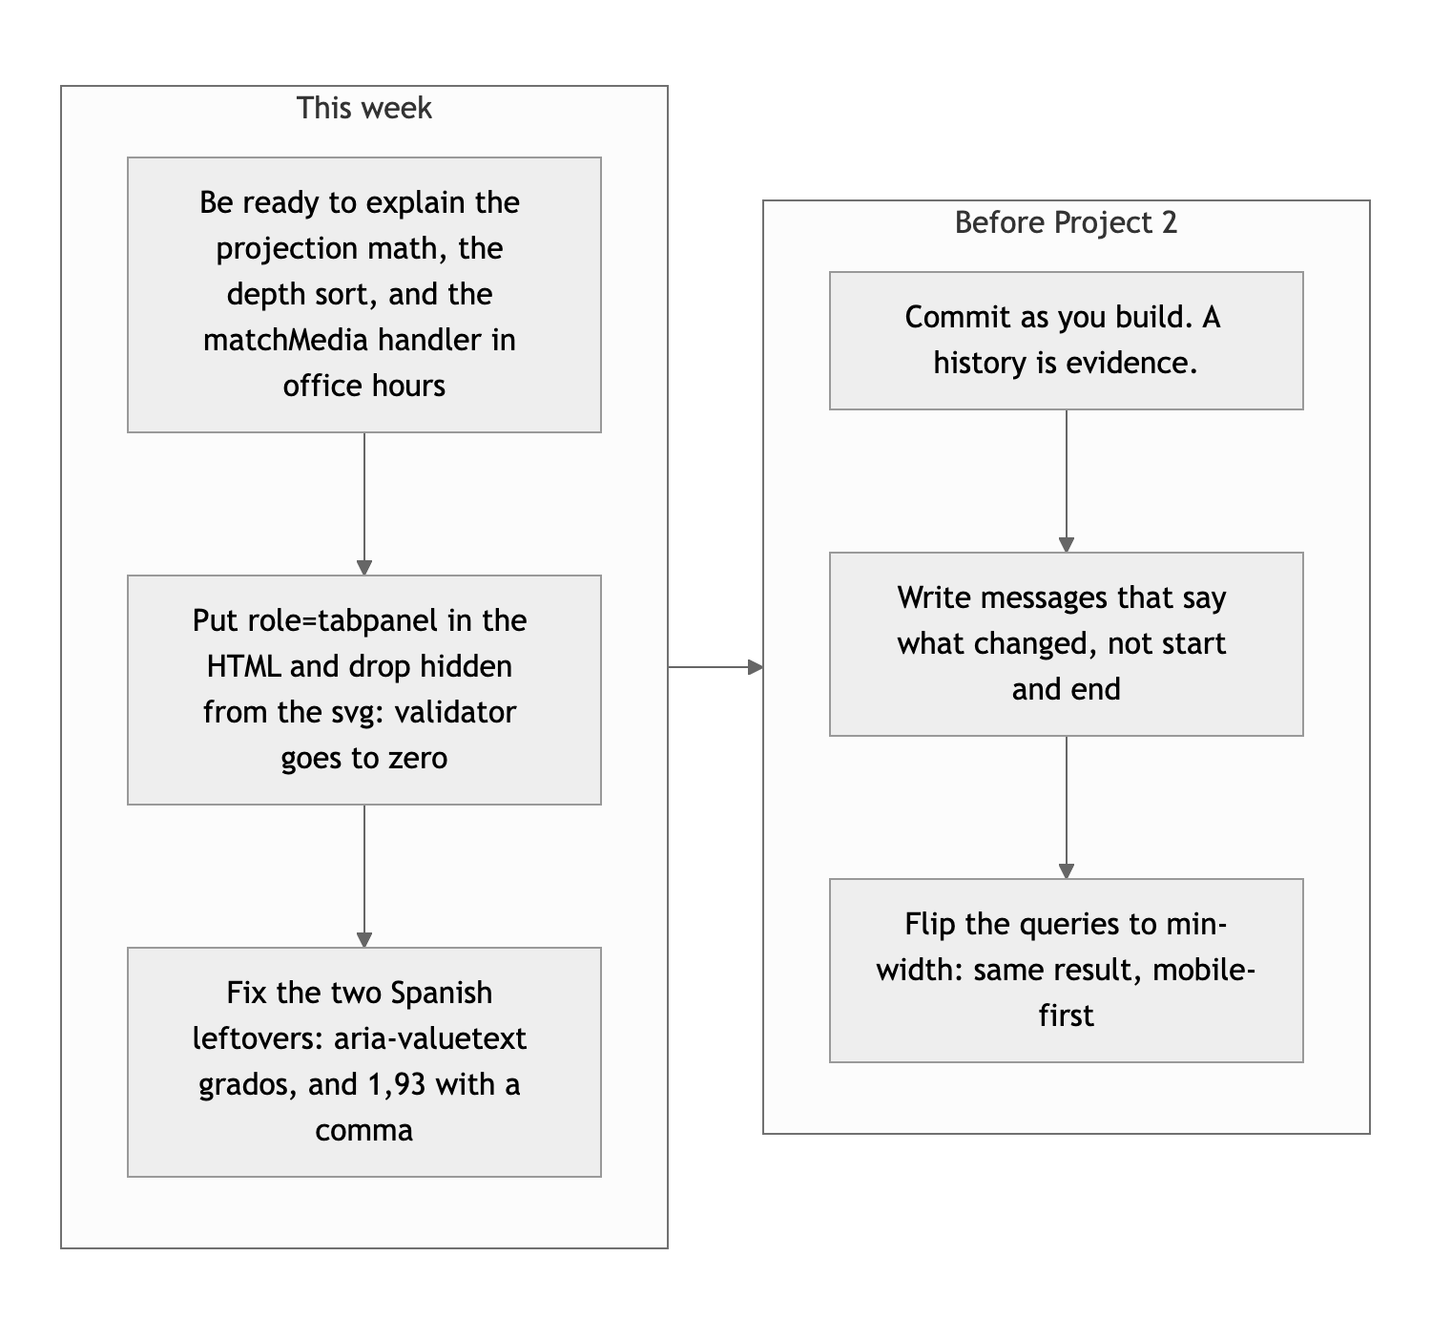
Diagram 3. This week, then before Project 2.
- Prepare the five explanations above. That is where the remaining question about this project lives, and it is the only thing on this list that is not a code edit.
- Zero the validator and fix the two leftovers. Roles in the markup, no hidden on the svg, "degrees", "1.93". Twenty minutes.
- For Project 2, commit every time something works. Ten commits that say what changed are worth more than one perfect one. The site earns the grade; the history keeps it.

This is a beautiful piece of work, Giovanny. Come show us how it was made.
This review lives in a pull request on your repo. It only adds feedback files and does not touch your code. Merge it, close it, or just read it. Questions go to office hours or the Brightspace board.

