Project 1: Static Foundations
Feedback for Hunterpedia
Student: Paul Basile Course: CSC 436, Fall 2026 Reviewed at: 5541740
Repo: github.com/paul-basile/static-foundations-436 Live: startling-toffee-977910.netlify.app

Grade: 70 / 100
Category | Points | Earned | One line
Semantic HTML | 20 | 12 | Real list nav, titles and alt text; but only nav and main, no h1, one validator error per page
CSS layout | 25 | 18 | Flexbox is real and well used; no Grid anywhere, and the brief required both
Responsive design | 15 | 13 | No horizontal scroll at any width, hamburger works; desktop-first, one dead rule
JavaScript interaction | 15 | 12 | Menu toggle works and is readable; it is a div, not a button, state tracked by hand
Repository and deployment | 15 | 8 | Deploy works; 85% of the site in one commit on the due date; README has 1 of 4 items
Content and polish | 10 | 7 | Real writing, real theme, best-optimized images in the class; wrong alt text, empty desktop
Total | 100 | 70 | The site has personality. Two of the six requirements were skipped.

How this review was made
Your instructor reviewed this project with Claude (Anthropic's AI) as a second set of eyes. Claude cloned the repo, read every line of all six pages and seven stylesheets, loaded the live site at phone, tablet and desktop widths, ran the W3C validator on every page, and opened and closed the hamburger menu. Every note and every point in this document was read and approved by your instructor. Same standard, same rubric, just more time spent looking at your code than one human has in a grading week.

The short version
Hunterpedia has a point of view. Each character gets a color world, the sticky nav follows you, the images are small and fast (you are the only student so far whose images are actually optimized), and the writing is yours. That is real.
But the brief listed six objectives, and two of them did not happen. Semantic structure: it asked for at least three content sections using semantic elements and one h1. Every page has exactly two semantic elements (nav and main), zero h1s, and a heading that jumps from h2 to h3. Flexbox and Grid, both: there is no display: grid in any of your seven CSS files. Those two lines of the brief are worth 45 points between them, and that is where most of this grade went. The credit you did earn in those categories is for the parts you built well: the list nav, the titles and alt text, and Flexbox that is genuinely correct. The rest of the deductions are small. Those two are not.

What Claude measured
Check | Result
Horizontal scroll at 375 / 768 / 900 / 1280 px | None at any width, even with overflow-x: hidden turned off
Hamburger menu at 375px | Opens, 5 links stack, closes
Console errors | 0
W3C HTML validator | 1 error on every page (6 total): script tag after </body>
h1 elements across 6 pages | 0
Semantic elements per page | nav, main. No header, section, article, footer
display: grid across 7 CSS files | 0
display: flex across 7 CSS files | 42 (7 per theme file)
Lines identical between gon and killua themes | 140 of 158
Image weight for the whole site | 558 KB across 11 images (excellent)
Commits | 4: two on Sep 13, two on Sep 15. The third is 1,250 lines across 24 files

The site at three widths
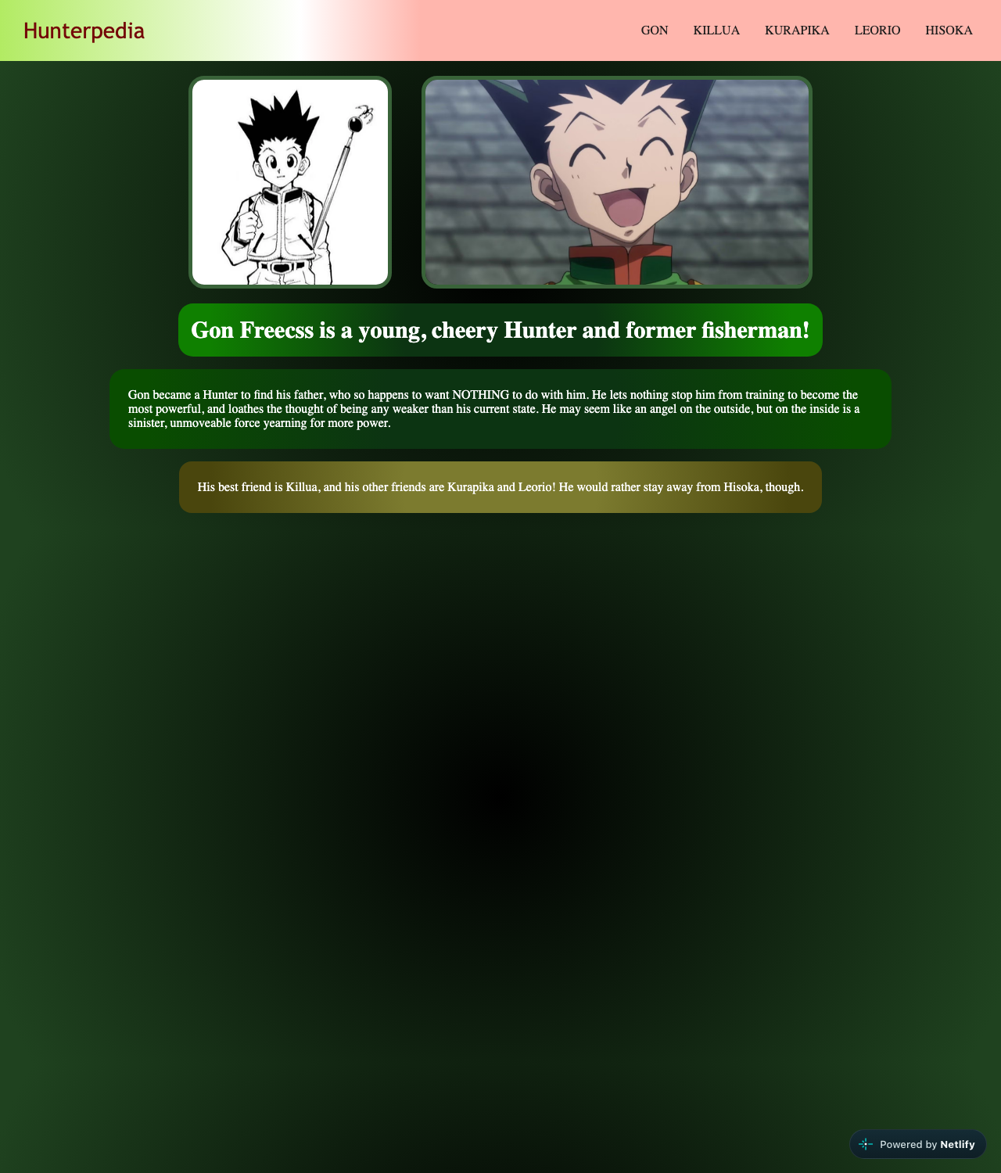
Gon's page at 1280px. Content fills the top third; the rest is gradient.
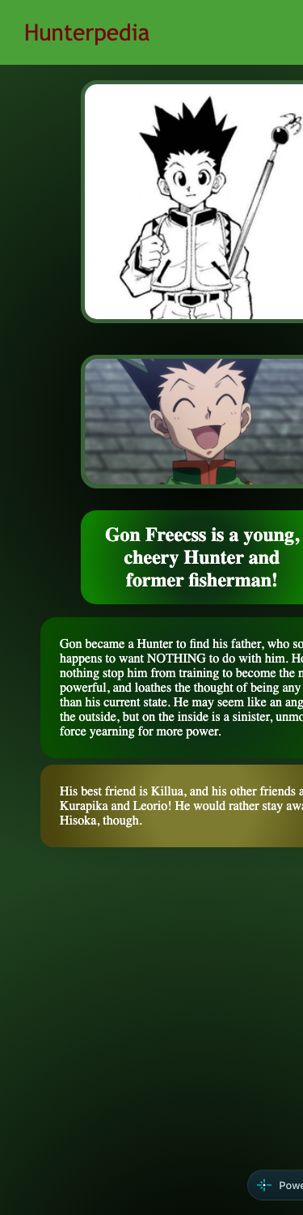  Gon's page at 375px. Images stack, no horizontal scroll. | 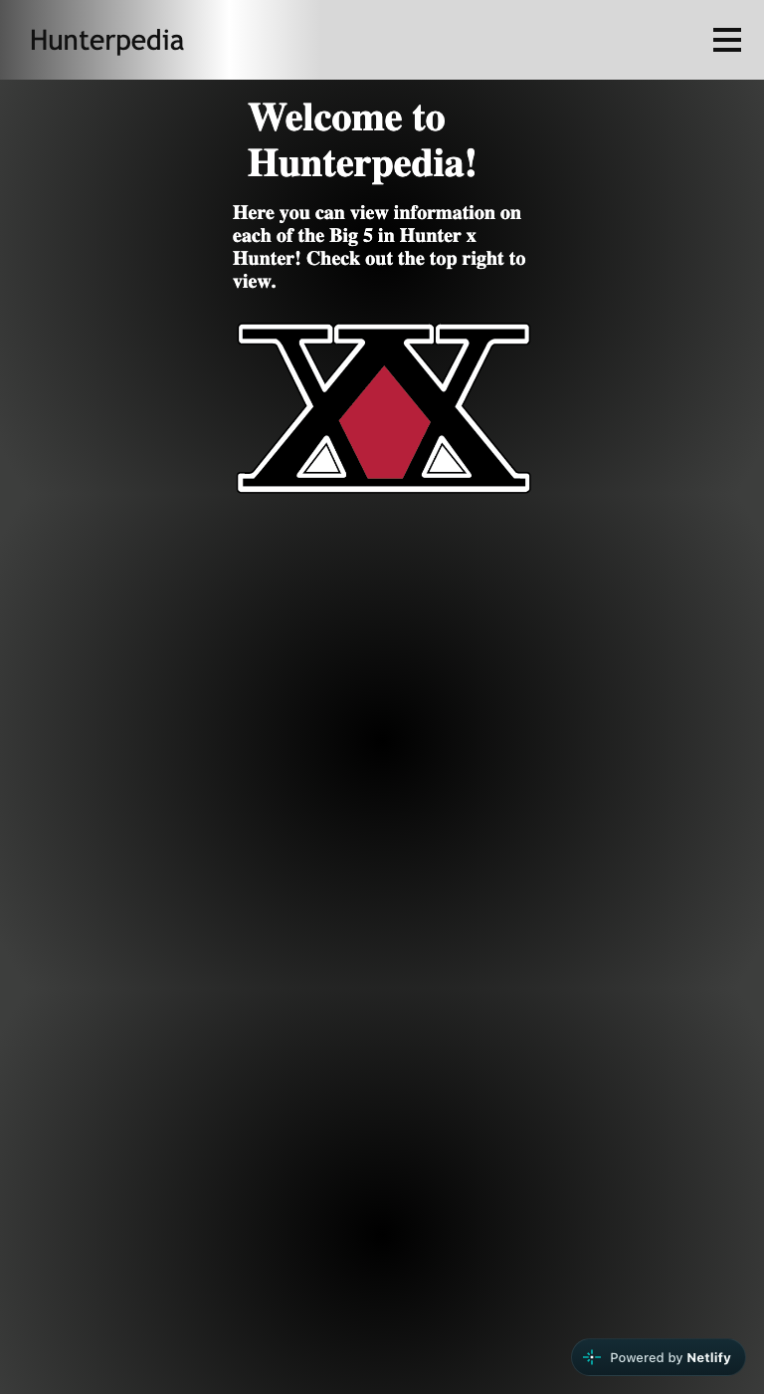  Home page at 768px. Hamburger menu, welcome text, logo.

Semantic HTML: 12 / 20

What is working
- The nav is a real ul > li > a (index.html lines 22 to 28). main wraps the content. Every page has lang, a viewport tag, and its own title ("Hunterpedia: Gon"). Every image has an alt.
- Using a real CSS reset (the-new-css-reset, credited in the file) is a mature choice.

What to change
- No h1, anywhere. The logo is an h2 (line 15) and "Welcome to Hunterpedia!" is an h3 (line 32), so every page's outline starts at level 2 and skips to 3. The validator flags it on all six pages. The site title in the nav should not be a heading at all (a span or just the link text). The page's actual title should be the h1: "Welcome to Hunterpedia!" on the home page, "Gon Freecss" on Gon's page.
- Two semantic elements per page. The brief asked for at least three distinct content sections using header, nav, main, section, article, footer. You have nav and main. Everything else is a div: div.container (line 12), div.logo, div.dropdown, div.content-container. The nav belongs inside a header. The character pages are a natural article. A footer with a credit line takes one minute. None of your CSS needs to change; the class names stay.
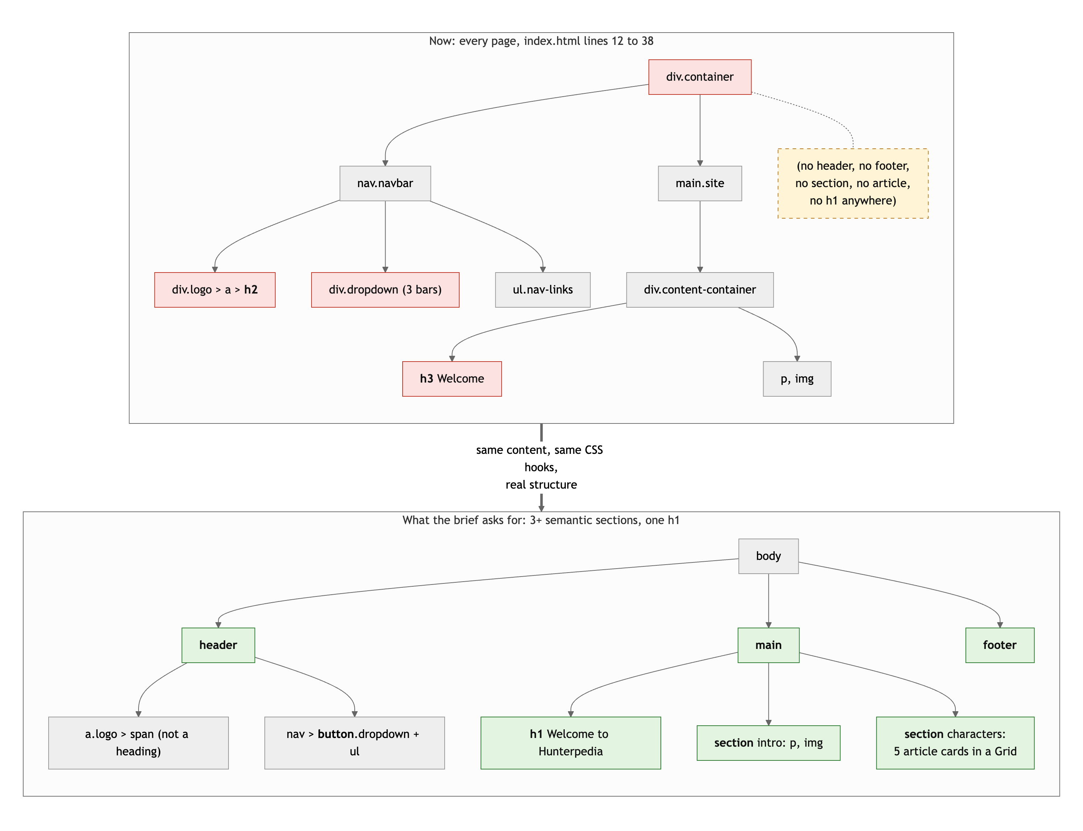
Diagram 1. The page skeleton now (top) and with the semantic elements the brief asks for (bottom).
- The script tag is outside body (line 41), on all six pages. Browsers forgive it, the validator does not, and it is the one error that shows up six times. Move it to just before </body>.
- The hamburger is a div (lines 17 to 21). A keyboard user cannot reach it, a screen reader does not know it is clickable. It should be a button with aria-label="Menu" and aria-expanded="false". The three bars can stay as spans inside it.
- Hisoka's alt text is Leorio's. page5-hisoka.html lines 32 to 33 say alt="Locked In" and alt="Leorio Paradinight" on two pictures of Hisoka. Copy-paste left a trail. And "MY GOAT KURAPIKA" (page3-kurapika.html line 33) is funny but alt text is for describing the image to someone who cannot see it.

CSS layout: 18 / 25

What is working
- Flexbox is doing real, correct work. The nav is justify-content: space-between with a flex logo group (home-theme.css lines 6 to 18), main is a centered column, .img-container is a row that becomes a column on phones (gon-theme.css lines 83 to 86 and 152 to 155). flex-basis: 100% to force the mobile menu onto its own line is exactly the right tool. You understand Flexbox.
- The per-character theming (background gradient, nav gradient, card colors, border color) is consistent and deliberate. The scale hover on images with a transition (lines 94 to 99) is a nice touch. position: sticky on the nav with z-index is correct.

What to change
- There is no Grid. Zero display: grid in seven files. The brief says "Flexbox and Grid, both. Each must do real layout work somewhere on the site." This is a hard requirement and it is the largest single deduction here. The good news: the home page is begging for it. Right now it says "check out the top right to view" instead of showing the characters. Replace that sentence with five character cards in a display: grid; grid-template-columns: repeat(auto-fit, minmax(180px, 1fr)), each card an article with the character's image and name linking to their page. That is Grid doing real work, a better home page, and a semantic section, all in one change.
- Six copies of the same stylesheet. gon-theme.css and killua-theme.css share 140 of 158 lines verbatim. Six files, 929 lines, and only the colors differ. The proof it is a problem: there is a typo, .nav-link a instead of .nav-links a (gon-theme.css line 125), and because it was copied, it is now wrong in six files. That rule never applies, so your mobile menu links are never centered or enlarged like you intended. The fix is custom properties: one site.css with all the layout, and a tiny per-page file that only sets --bg, --nav, --accent on body.
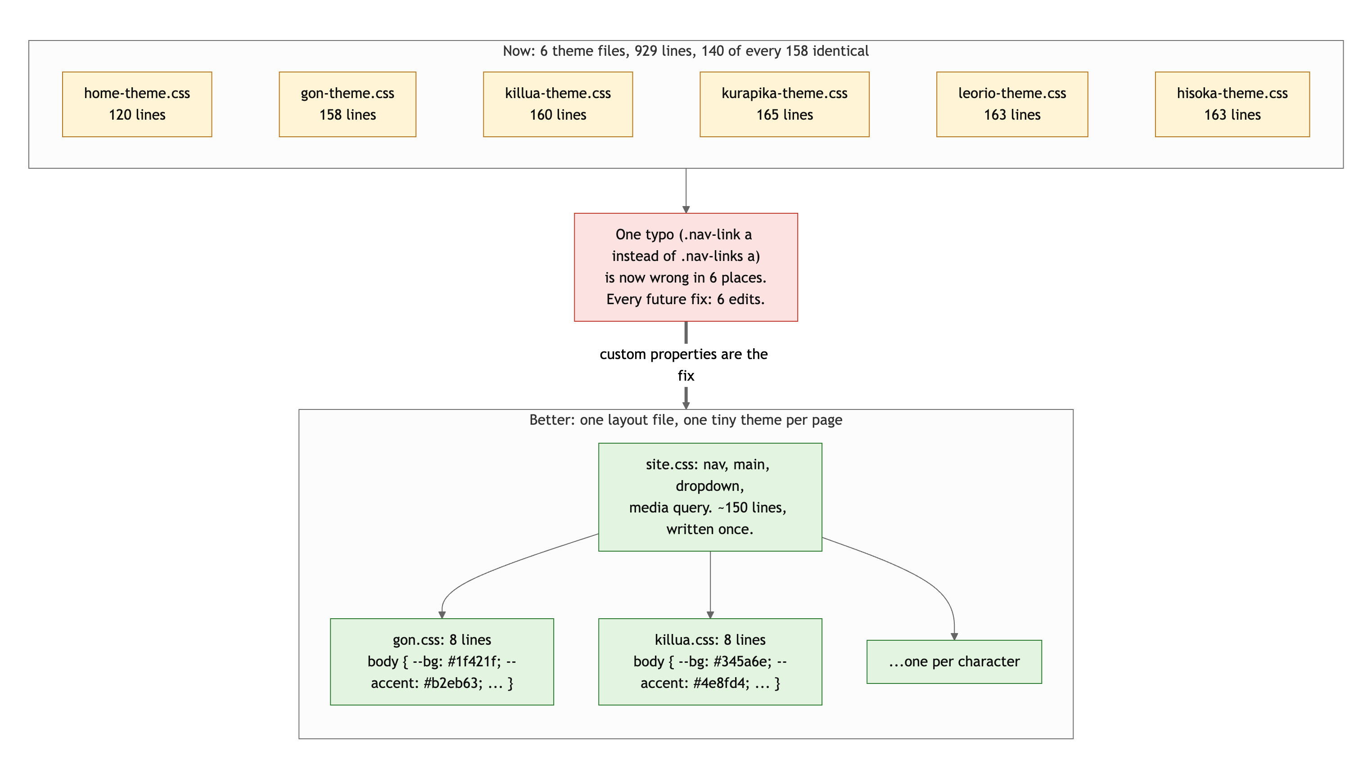
Diagram 2. Six copies of one stylesheet (top) versus one layout file plus a tiny theme per page (bottom).
- overflow-x: hidden on body (home-theme.css line 3) hides horizontal overflow instead of fixing it. Claude turned it off and measured: nothing overflows, so you do not need it. Delete it. If something ever does overflow, you want to see it.
- Small: transition: all (line 38) animates every property. Name the one you mean (background-color). Two semicolons on gon-theme.css line 80.

Responsive design: 13 / 15

What is working
- No horizontal scroll at 375, 768, 900 or 1280. Images go side by side on desktop and stack on phones. The nav collapses to a hamburger under 768px and the links stack full width. The site is genuinely usable on a phone.

What to change
- Desktop-first. The brief asked for mobile-first. Your base styles are the desktop and @media (max-width: 768px) undoes them. Flip it: phone styles as the default, @media (min-width: 769px) adds the row layout and the inline nav.
- The dead .nav-link a rule (see CSS) means the mobile menu you designed (centered, 28px) is not the one that ships. Fix the typo and look at it again on a phone.
- On desktop the content fills the top third of the screen and the bottom two thirds is gradient. Not a responsive bug, but see Polish.

JavaScript interaction: 12 / 15

What is working
- The menu toggle does what the brief asks: selects elements, listens for a click, changes the page. It works, Claude clicked it. Zero console errors. The code is short and readable.

What to change
- Tracking state by hand. menuOpen is a copy of something the DOM already knows. Two ways to do this in one line: navLinks.classList.toggle('open') with a .nav-links.open { display: block } rule, or navLinks.hidden = !navLinks.hidden. Either one removes the boolean, the if/else if, and the inline style.
- The inline style sticks. navLinks.style.display = "block" (nav.js line 7) writes an inline style that outranks your stylesheet. Open the menu on a phone, rotate to landscape or widen the window, and the desktop nav is now display: block instead of flex: the links stack vertically on desktop. A class toggle does not have this problem because the media query still wins.
- The toggle target is a div, so this interaction only works with a mouse or a finger. Make it a button (see HTML) and set aria-expanded in the handler.
- if (menuOpen == false) ... else if (menuOpen == true): a boolean only has two values, so the second check is always true when reached. if (menuOpen) {...} else {...}.

Repository and deployment: 8 / 15

What is working
- Live URL works in a private window and matches the repo (the only differences are Netlify rewriting .html links, which is Netlify's doing, not yours). Pages load at clean URLs.

What to change
- The history. Four commits: an initial commit and a skeleton on September 13, then "Finished base website." on September 15 with 1,250 lines across 24 files, then a one-line fix. About 85% of the project is in one commit on the due date. It is not the single-commit case the brief warns about, but it is close, and it means the log cannot show the site developing. Commit after each page, after the nav, after the media query. Aim for 10 to 20 commits on Project 2.
- README has one of four required items. Title, yes. Description, how to run locally, live URL: missing. "Project 1 for CSC 436." is not a description.
- Commit messages: the brief asked for present tense, "add nav", "fix card layout". Yours are sentences with periods ("Finished base website.", "Oops, forgot to tweak Gon's mobile theme"). Small habit, but it is the industry one.
- .vscode/settings.json is your editor's config, not the project's. Add it to your global gitignore.

Content and polish: 7 / 10

What is working
- The images are the best-optimized in the class. WebP, 558 KB for eleven images, nothing over 200 KB. Most students shipped multi-megabyte photos. You did not.
- Real writing with a voice ("who so happens to want NOTHING to do with him"), a real theme, a color identity per character, per-page titles. It reads like a fan made it, which is the point.

What to change
- Wrong alt text on the Hisoka page (see HTML). That is a copy-paste error a screen reader user would hear.
- The desktop layout stops at the top third. On a 1280 by 1500 screen, the content ends around 650px and the rest is gradient. Either center the content vertically (main { min-height: 100vh; justify-content: center }, you already have the flex column) or give the page more to do. The character-card grid on the home page is the natural fix.
- The home page tells people to "check out the top right" instead of linking to the characters. Never describe the UI; show it.
- No footer. One line with a credit and a "Hunter x Hunter is by Yoshihiro Togashi" note finishes the page.

Your next three moves
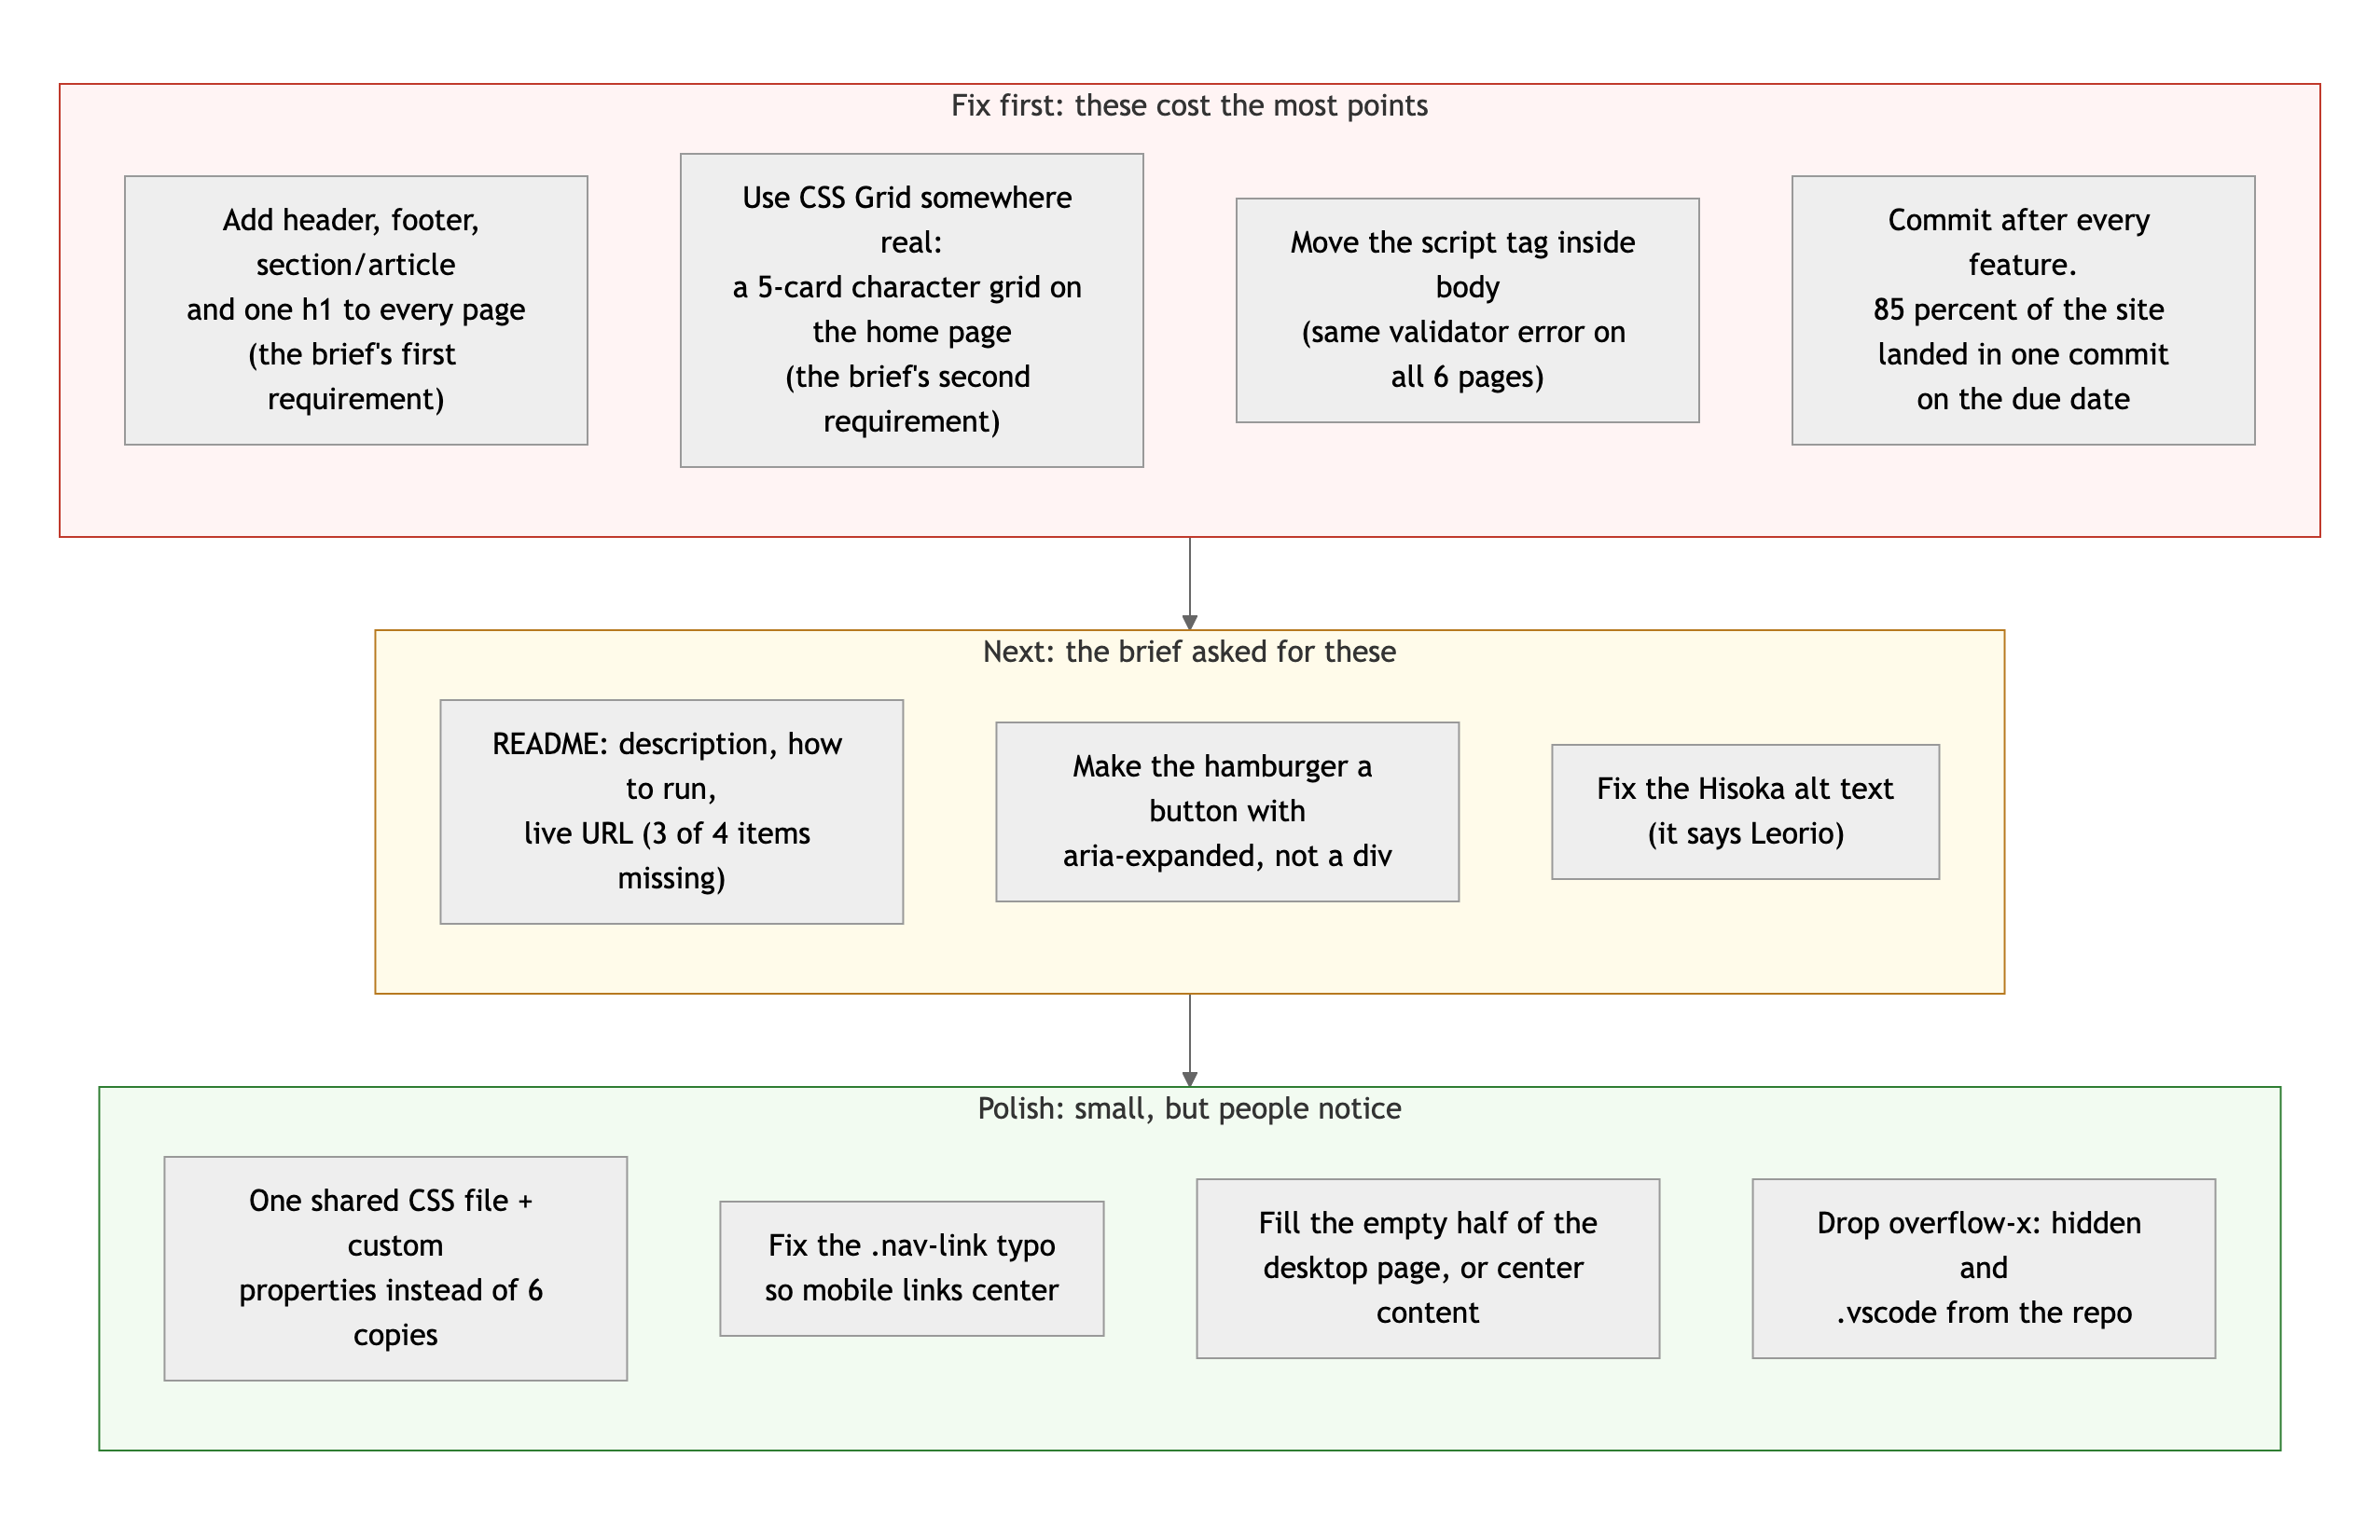
Diagram 3. Priority order. Top row first: it is where the points are.
- Build the character grid on the home page. Five article cards in a CSS Grid, each linking to a character page. This one change gives you Grid, a section, and a home page that actually works. Two hours.
- Fix the skeleton on every page. header around the nav, h1 for the page title, footer at the bottom, script tag inside body. Thirty minutes for six pages, and it clears every validator error.
- Read the brief before Project 2 and make a checklist. Two of the six objectives were missed here, and both were stated in bold. The site you built shows you can do the work. The checklist makes sure you do the assigned work.

You made something with a personality, and that is harder to teach than Grid. Now go back and hit the requirements.
This review lives in a pull request on your repo. It only adds feedback files and does not touch your code. Merge it, close it, or just read it. Questions go to office hours or the Brightspace board.

