

DAR AL-FIKR SCHOOLS

2026-2027
Malek Thiab
Algebra 2
Teacher’s Methodology– Course Outlines- Term I (2026-2027)
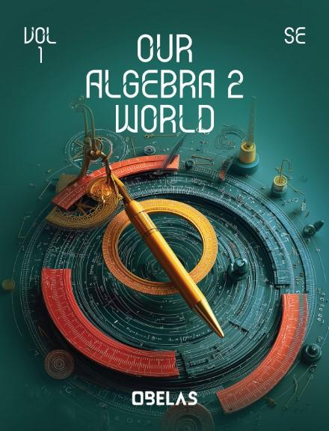

Course: Algebra 2
Credit: Half credit hour
Semester: 1st semester
Grade: 10th Grade
Number of periods: 6 periods a week.

Teacher’s profile:
- MALEK MOHAMMAD THIAB
- Bachelor’s degree in Mathematics
- Master’s in Mathematics
- Years of Experience: 14
- Email: m.thiab@fikr.edu.sa

Standards
Common Core State Standards of Mathematics (CCSSM)
Course Description (in general):
This course covers key mathematical concepts: solving equations and inequalities, linear equations, linear functions, and piecewise functions. Students will learn techniques for solving various equations and inequalities, focusing on both linear and non-linear types. Emphasis will be placed on understanding and graphing linear equations and functions, analyzing their properties, and applying different solving methods. The course also introduces piecewise functions, teaching students to define, graph, and use them in real-world scenarios. By the end, students will have a strong foundation in these topics, ready to apply these principles in practical and academic contexts.

Course Topics (chapters)
Unit 1: Linear Functions
Key Features of Functions
Transformations of Functions
Piecewise-Defined Functions
Arithmetic Sequences and Series
Solving Equations and Inequalities by Graphing
Linear Systems
Unit 2: Quadratic Functions and Equations
Vertex Form of a Quadratic Function
Standard Form of a Quadratic Function
Factored Form of a Quadratic Function
Overview of Complex Numbers
Completing the Square
The Quadratic Formula
Solving Linear-Quadratic Systems
Unit 3: Polynomial Functions
Graphing Polynomial Functions
Adding, Subtracting, and Multiplying Polynomials
Identities with Polynomials
Dividing Polynomials
Zeros of Polynomial Functions
Theorems on Polynomial Roots
Transformations of Polynomials
Unit 4: Rational Functions
Inverse Variation and the Reciprocal Functions
Graphing Rational Functions
Multiplying and Dividing Rational Expressions
Adding and Subtracting Rational Expressions
Solving Rational Equations

Textbook : My algebra 2 world
ISNB-13:978-0-328-93178-1
Learning Resources &materials: (optional)
- Zoom (Desktop, Laptop, or Tablet)
- Google Classroom-
- Online textbook
- Online interactive resources (Virtual experiments, Practice quizzes, performance worksheets,) (https://obelearn.online/)
Required Materials
- Desktop, Laptop, or Tablet
- A4 Notebook to take notes - Scientific Calculator - Blue-black Pens, ruler.

Homework
Three times a week according to the weekly plan.
Grading Scale:
A 90-100 B 80-89 C 70-79 D 60-69
F 59 or Below

Assessments

Assessments, throughout the semester, will be as follow:

Assessment | Time | Frequency / semester
Continuous/ Formative assessment (oral quiz, practical… etc.) | Varies | Each Period
Quizzes | 40 minutes | Every Two weeks
Final Exam | 2 hours | 1 test at the end of the semester

Students should expect the following evaluation methods:
(Online, Lab reports, Take home exam, Open-book, pop quizzes, research, projects etc.….)

Missed Assignments/Exam Procedure:

If a student will be absent from school, it’s his responsibility to reach out with the teacher to get the missing materials.

Course Policies:

Student Work: Students will be expected to complete assignments outside of class time on a regular basis. All students are expected to read class material, think critically and write effectively. Students are expected to use complete sentences, proper grammar, and correct spelling in every written performance.

Portfolio:
Students will be required to have their portfolio on course concepts and values. You will be expected to maintain a neatly organized portfolio for the duration of the class. Your portfolio will be filled with items you have created and assignments that reflect your mastery of course objectives. The teacher will give you regular guidance on how to construct and maintain your portfolio.

Group Activities:
You will be working in groups in some classes. Your group will be given cooperative learning activities to complete. You will be expected to be an active member of your group and participation points will be assessed accordingly. You will always be graded as an individual; however, your group may earn points together that will lead to a reward.

Extra Credit:
Opportunities for extra credit will be offered from time to time. Extra credit is extra work above and beyond the usual homework, not work used to cover up missing work.

Projects: You would be assigned a project for each chapter according to a paced timetable that will be shared with you from administration. The project should be done using the student's language and free of plagiarism and according to the assigned rubrics.

Homework: You would be assigned homework three times weekly. The way of your homework would be vary based on teacher’s vision and course standards

Classroom Rules
Being on Time | Respecting others
You should attend your class on time without delay | Respect your classmates' perspectives and remember there is no one opinion completely true.
Collaboration | Responsibility
You have your own thoughts, share them with your classmates and remember, team work leads to dream work. | Your tools and desk are your responsibility, therefore if made a mess clean it up.
Never give up | Be creative
All learners face issues when it comes to math. So, do your best and remember failure is another way to success. | Everyone has his own talent. So, you have to show others your abilities and your great thoughts.
Concentrate | Ask
We all have a role in our life and your role as a student to make your parents proud of you. Keep focusing on your goals. | Asking questions will help you understand the right way and clarify all your concerns.
Be active listener | Be helper
We have to ears and one tongue, read it one more time. That’s way you to listen more than take | The more your help others, the more you be appreciated among your classmates

Thanks a lot, good luck!

