Assignment 5 : Finite State Machine

**State Transition Table**

|  |  |  |  |  |  |  |  |  |  |  |
| --- | --- | --- | --- | --- | --- | --- | --- | --- | --- | --- |
| **Num** | **Name** | **Lights** | **Input** | | | | | | | |
| **0** | **1** | **2** | **3** | **4** | **5** | **6** | **7** |
| **0** | **waitWest** | **B10010100** | **goWest** | **goWest** | **goWest** | **goWest** | **goWEst** | **goWest** | **goWest** | **goWest** |
| **1** | **goWest** | **B10100001** | **goWest** | **goWest** | **waitSouth** | **waitSouth** | **wait_Walk_West** | **wait_Walk_West** | **waitSouth** | **waitSouth** |
| **2** | **waitSouth** | **B10100010** | **goSouth** | **goSouth** | **goSouth** | **goSouth** | **goSouth** | **goSouth** | **goSouth** | **goSouth** |
| **4** | **wait_Walk_South** | **B10010100** | **goWalk** | **goWalk** | **goWalk** | **goWalk** | **goWalk** | **goWalk** | **goWalk** | **goWalk** |
| **5** | **wait_Walk_West** | **B10100010** | **goWalk** | **goWalk** | **goWalk** | **goWalk** | **goWalk** | **goWalk** | **goWalk** | **goWalk** |
| **6** | **goWalk** | **B01100100** | **goWalk** | **button1_OFF** | **button1_OFF** | **button1_OFF** | **goWalk** | **button1_OFF** | **button1_OFF** | **button1_OFF** |
| **7** | **button1_OFF** | **B00100100** | **button1_ON** | **button1_ON** | **button1_ON** | **button1_ON** | **button1_ON** | **button1_ON** | **button1_ON** | **button1_ON** |
| **8** | **button1_ON** | **B01100100** | **button2_OFF** | **button2_OFF** | **button2_OFF** | **button2_OFF** | **button2_OFF** | **button2_OFF** | **button2_OFF** | **button2_OFF** |
| **9** | **button2_OFF** | **B00100100** | **button2_ON** | **button2_ON** | **button2_ON** | **button2_ON** | **button2_ON** | **button2_ON** | **button2_ON** | **button2_ON** |
| **10** | **button2_ON** | **B01100100** | button3_OFF | button3_OFF | button3_OFF | button3_OFF | button3_OFF | button3_OFF | button3_OFF | button3_OFF |
| **11** | **button3_OFF** | **B00100100** | **button3_ON** | **button3_ON** | **button3_ON** | **button3_ON** | **button3_ON** | **button3_ON** | **button3_ON** | **button3_ON** |
| **12** | **button3_ON** | **B01100100** | **goWalk** | **goWest** | **goSouth** | **goWest** | **goWalk** | **goWest** | **goSouth** | **goWest** |

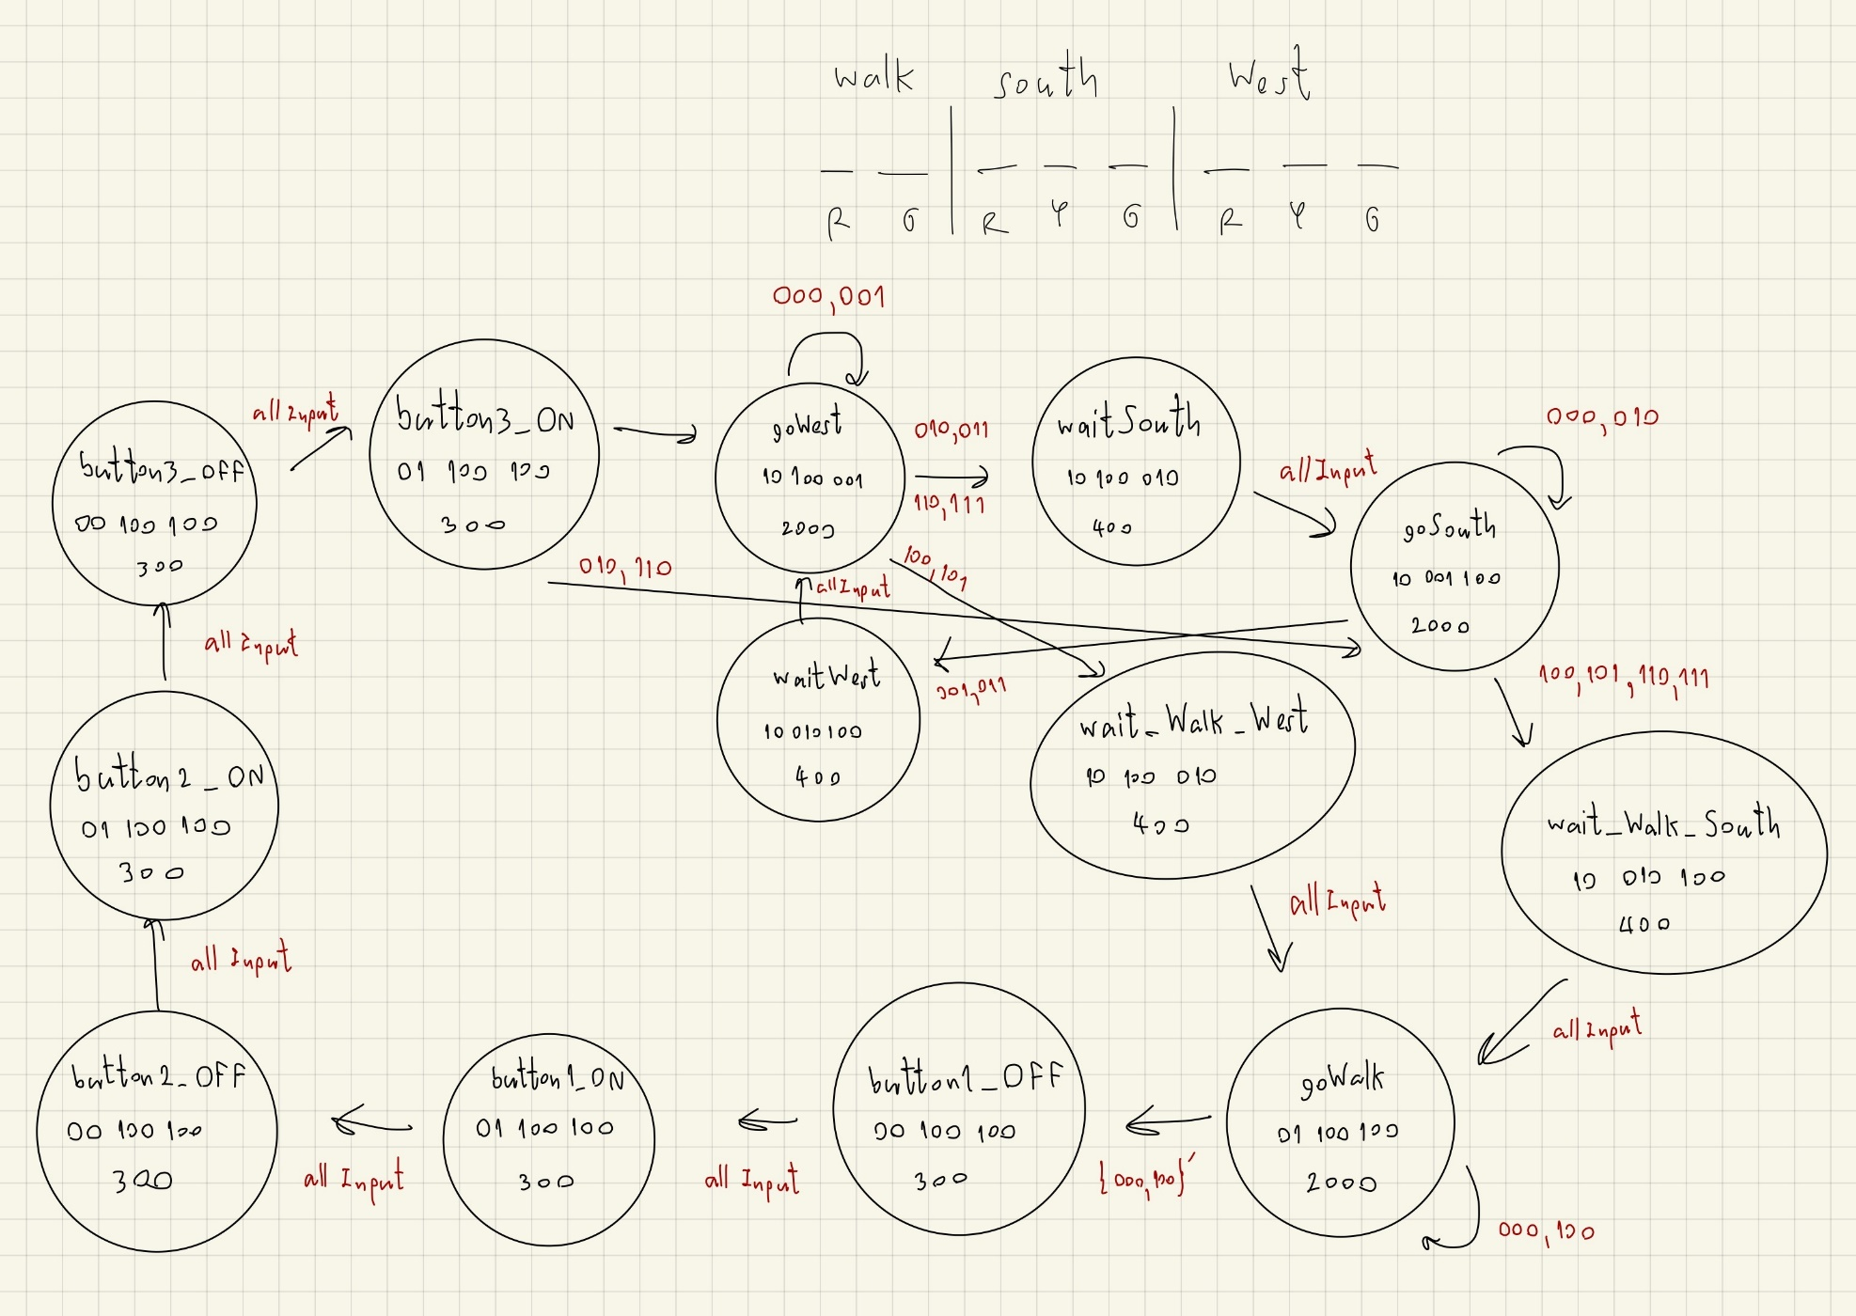

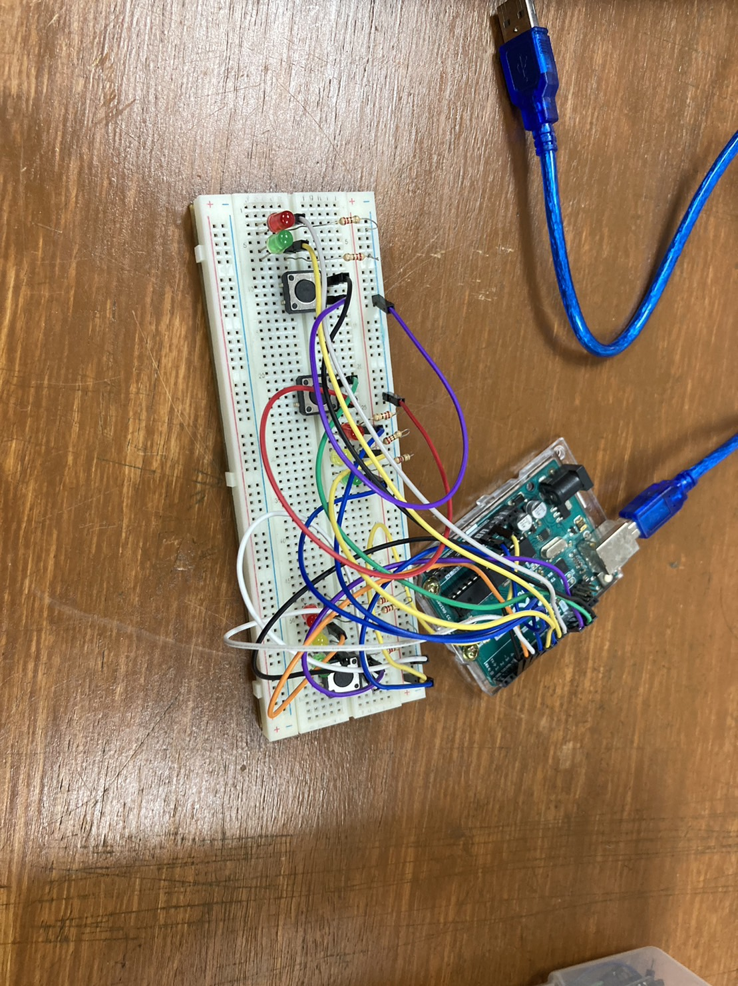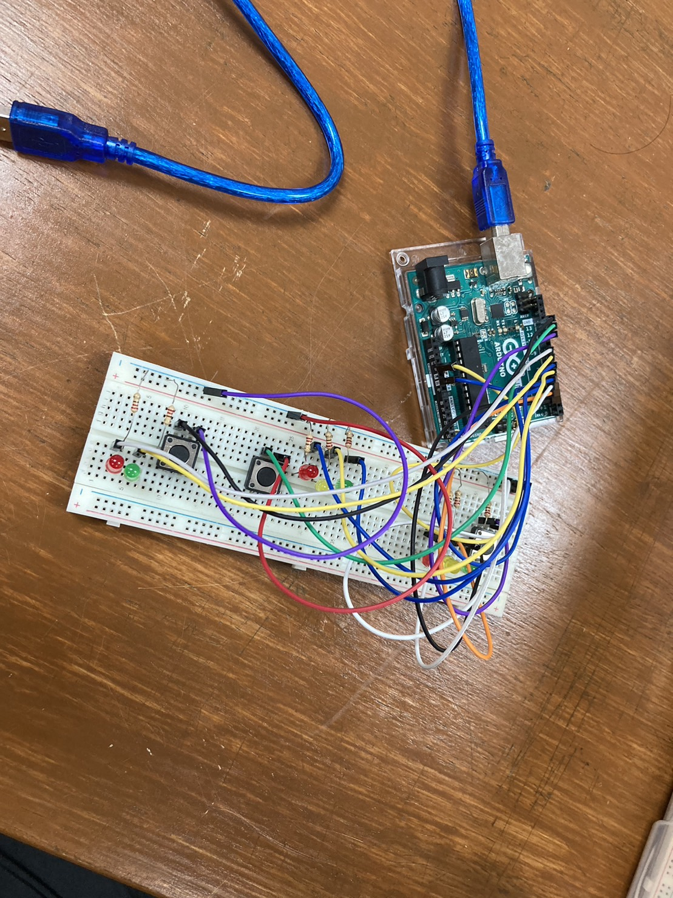

// West

#define LED_W_R 4

#define LED_W_Y 3

#define LED_W_G 2

#define WEST_BUTTON_PIN 11

// South

#define LED_S_R 7

#define LED_S_Y 6

#define LED_S_G 5

#define SOUTH_BUTTON_PIN 12

// Walk

#define LED_WALK_G 8

#define LED_WALK_R 9

#define WALK_BUTTON_PIN 13

// Input

#define waitWest 0

#define goWest 1

#define waitSouth 2

#define goSouth 3

#define wait_WALK_SOUTH 4

#define wait_WALK_WEST 5

#define goWalk 6

#define b1_OFF 7

#define b1_ON 8

#define b2_OFF 9

#define b2_ON 10

#define b3_OFF 11

#define b3_ON 12

กำหนด State

struct State

{

  unsigned long ST_Out;

  unsigned long Time;

  unsigned long Next[8];

};

typedef const struct State SType;

SType FSM[13] = {

    {B10010100, 400, {goWest, goWest, goWest, goWest, goWest, goWest, goWest, goWest}},                                            // waitWest

    {B10100001, 2000, {goWest, goWest, waitSouth, waitSouth, wait_WALK_WEST, wait_WALK_WEST, waitSouth, waitSouth}},               // goWest

    {B10100010, 400, {goSouth, goSouth, goSouth, goSouth, goSouth, goSouth, goSouth, goSouth}},                                    // waitSouth

    {B10001100, 2000, {goSouth, waitWest, goSouth, waitWest, wait_WALK_SOUTH, wait_WALK_SOUTH, wait_WALK_SOUTH, wait_WALK_SOUTH}}, // goSouth

    {B10010100, 400, {goWalk, goWalk, goWalk, goWalk, goWalk, goWalk, goWalk, goWalk}},                                            // wait_WALK_SOUTH

    {B10100010, 400, {goWalk, goWalk, goWalk, goWalk, goWalk, goWalk, goWalk, goWalk}},                                            // wait_WALK_WEST

    {B01100100, 2000, {goWalk, b1_OFF, b1_OFF, b1_OFF, goWalk, b1_OFF, b1_OFF, b1_OFF}},                                           // goWalk

    {B00100100, 300, {b1_ON, b1_ON, b1_ON, b1_ON, b1_ON, b1_ON, b1_ON, b1_ON}},                                                    // b1_OFF 1

    {B01100100, 300, {b2_OFF, b2_OFF, b2_OFF, b2_OFF, b2_OFF, b2_OFF, b2_OFF, b2_OFF}},                                            // b1_ON

    {B00100100, 300, {b2_ON, b2_ON, b2_ON, b2_ON, b2_ON, b2_ON, b2_ON, b2_ON}},                                                    // b2_OFF 2

    {B01100100, 300, {b3_OFF, b3_OFF, b3_OFF, b3_OFF, b3_OFF, b3_OFF, b3_OFF, b3_OFF}},                                            // b2_ON

    {B00100100, 300, {b3_ON, b3_ON, b3_ON, b3_ON, b3_ON, b3_ON, b3_ON, b3_ON}},                                                    // b3_OFF 3

    {B01100100, 300, {goWalk, goWest, goSouth, goWest, goWalk, goWest, goSouth, goWest}},                                          // b3_ON

};

unsigned long S = 0;

Setup PinLED, Button

void setup()

{

  Serial.begin(9600);

  pinMode(LED_W_G, OUTPUT);

  pinMode(LED_W_Y, OUTPUT);

  pinMode(LED_W_R, OUTPUT);

  pinMode(WEST_BUTTON_PIN, INPUT_PULLUP);

  pinMode(LED_S_G, OUTPUT);

  pinMode(LED_S_Y, OUTPUT);

  pinMode(LED_S_R, OUTPUT);

  pinMode(SOUTH_BUTTON_PIN, INPUT_PULLUP);

  pinMode(LED_WALK_G, OUTPUT);

  pinMode(LED_WALK_R, OUTPUT);

  pinMode(WALK_BUTTON_PIN, INPUT_PULLUP);

}

int West, South, Walk, input, inputPrev;

ส่วนกำหนดการแสดงผลให้โชว์LED

void loop()

{

  // West

  digitalWrite(LED_W_G, FSM[S].ST_Out & B00000001);

  digitalWrite(LED_W_Y, FSM[S].ST_Out & B00000010);

  digitalWrite(LED_W_R, FSM[S].ST_Out & B00000100);

  // South

  digitalWrite(LED_S_G, FSM[S].ST_Out & B00001000);

  digitalWrite(LED_S_Y, FSM[S].ST_Out & B00010000);

  digitalWrite(LED_S_R, FSM[S].ST_Out & B00100000);

  // Walk

  digitalWrite(LED_WALK_G, FSM[S].ST_Out & B01000000);

  digitalWrite(LED_WALK_R, FSM[S].ST_Out & B10000000);

  delay(FSM[S].Time);

  West = !digitalRead(WEST_BUTTON_PIN);

  South = !digitalRead(SOUTH_BUTTON_PIN);

  Walk = !digitalRead(WALK_BUTTON_PIN);

  input = Walk * 4 + South * 2 + West;

  if(S == 6){

    inputPrev = input;

  }

  if(S == 12){

    S = FSM[S].Next[inputPrev];

  }

  else{

    S = FSM[S].Next[input];

  }

  Serial.println(input);Serial.println(inputPrev);Serial.println("------------");

}