Curriculum vitae
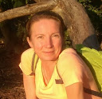
Personal data:
Name, surname: Anda BORISOVA
Date of birth: 17.05.1972
Address: Valguma 21-11, Riga, LV 1048, Latvia
Phone: + 371 28161544
E-mail: anda.borisova@gmail.com

Education and professional career:
1979-1989 Riga secondary school No 34 (with profound learning of English language )
1989-1994 Latvia University. Faculty of Economy. Speciality of Economical Cybernetics. Business Administration bachelour.
1989-1994 Latvia University. Faculty of Economy. Speciality of Economical Cybernetics..
Laboratory technician
1994-1997 Work as accountant assistant, administrator, economist in private companies.
1996- Establishing of public scientific-research center "Contra Cancrum Coli"
(www.coloncancer.lv).
Manager of creation of „Intestinal intubator with drain and irrigator” and „Colonoscope for colorectal cancer screening”, including the work on selection of scientific, technical and patent information.
2000 WIPO (World Intellectual Property Organization) Academy Diploma „Introduction to intellectual property”.
2010 Establishing and managing of scientific & technical company Teko Plus Medika, Ltd.
2010 - … Professional patent attorney of Latvia (private practice, patent agency)
2015 epi-CEIPI Basic Training in European Patent Law

Management.
Manager of 17 research projects, here are the main:
- ТОР-01-18 project. Aim: development and testings of working model of the self-moving diagnostic colonoscope. Results: in details are investigated the possibilities of intubation accoeding the „pull-and-push” principle. Costs: together with Latvia Ministry of Education and Science, EUR 29.012 . Terms: 01.04 -31.12.2001.
- ТОР-03-13 project. Aim: development, making and examination of the self-moving diagnostic colonoscope with distal end managed by air pressure. Results: the aim is achieved. Costs: together with Latvia Ministry of Education and Science EUR 128.867. Terms: 01.04.2003-01.04.2004.
- ТОР-05-26 project. Aim: Bench testings of safety and efficiency of functions of the Intestinal intubator with drain irrigator. Results: see on www.coloncancer.lv. Costs: together with Latvia Ministry of Education and Science EUR 134.710. Terms: 13.06.2005-13.06.2006.
- Project 2007.PSF/4-4/15. Aim: Preparing of the Individual project „The development of the industrial prototype of self-propelled colonoscope with instrumental channel; the preparation for clinical investigations”. Results: see the present project. Costs: together together with the Fund of society integration EUR 40.752. Terms: 02.10.2007 - 15.05.2008.

Intellectual property protection.
Independent (without foreign attorneys) filing & prosecuting of patents:
  - Latvia № 12248, 1999.
  - Latvia № 12474, 2001.
  - Eurasian PO № 002954, 2002.
  - Latvia № 12963, 2003.
  - Ukraine № 55487, 2003.
  - Australia № 773032, 2004.
  - Eurasian PO according to application № 200401150 from 2005.
  - Israel № 135503, 2006.
  - Canada № 2,304,776, 2006.
  - Ukraine № 80828, 2007.
  - China № 098809736.2, 2007.
  - Еuropean РО № 1615539, 2008.
and 20 more
Independent (without foreign attorneys) drafting and prosecuting patent applications:
- № ЕР 98949238.4, Еuropean РО, 2000.
- № JPA 2000-514560, Japan PO, 30.01.2001.
- № 09/509,377, USPTO, 28.08.2002.
- № 2003264913, Australia PO, 17.12.2004.
- № 150/DELNP/2005, India PO, 13.01.2005.
- № 2.493.909, Canada PO, 03.09.2005.
- № 03814535.9, China PO, 20.09.2005.
- № 10/518,218, USPTO, 13.04.2006.
- № P-08-44, Latvia PO, 20.03.2008.
and 30 more

Promotion.
- Web-site www.coloncancer.lv creation and renewals.
- Preparing and presentation of Center’s work on scientific forums and exhibitions:
2000 - 2nd European Symposium on Biomedical Engineering and Medical Physics, Patras
(Greece).
2001 - 1st International Congress Screening and Early Detection for a better Cancer
Management, Athens.
2002 - IV Genius International Fair of Inventions, Budapest.
2002 - InvestTechnology 2002, International Fair, Warsaw.
2002 - 18th UICC Cancer Congress, Oslo.
2002 - 2nd European Colorectal Cancer Conference, Rome.
2003 - Latvian I Gastroenterology Congress, Riga.
2003 - 11th UEGW (United European Gastroenterology Week), Madrid.
2004 - MEDICA 2004 Fresenius Erfindermesse, Dusseldorf.
2007 - Latvian Gastroenterology III Congress, Riga.
2010 – N.Pyrogov's Surgery Week, S.Petersburg
2014 – IARMM 3rd World Congress of Clinical Safety, Madrid

Language skills:
1. Russian – native,
2. Latvian – oral and writing advanced,
3. English - oral and writing advanced.

Driving licence A un B category.
Courses of balance-sheet accountants.
Free computer skills (with all popular MS Office programs, web page redaction programs and others).
Responsible, like to work, very executive and will be happy to learn everything new.

22 years in civil union. No children.
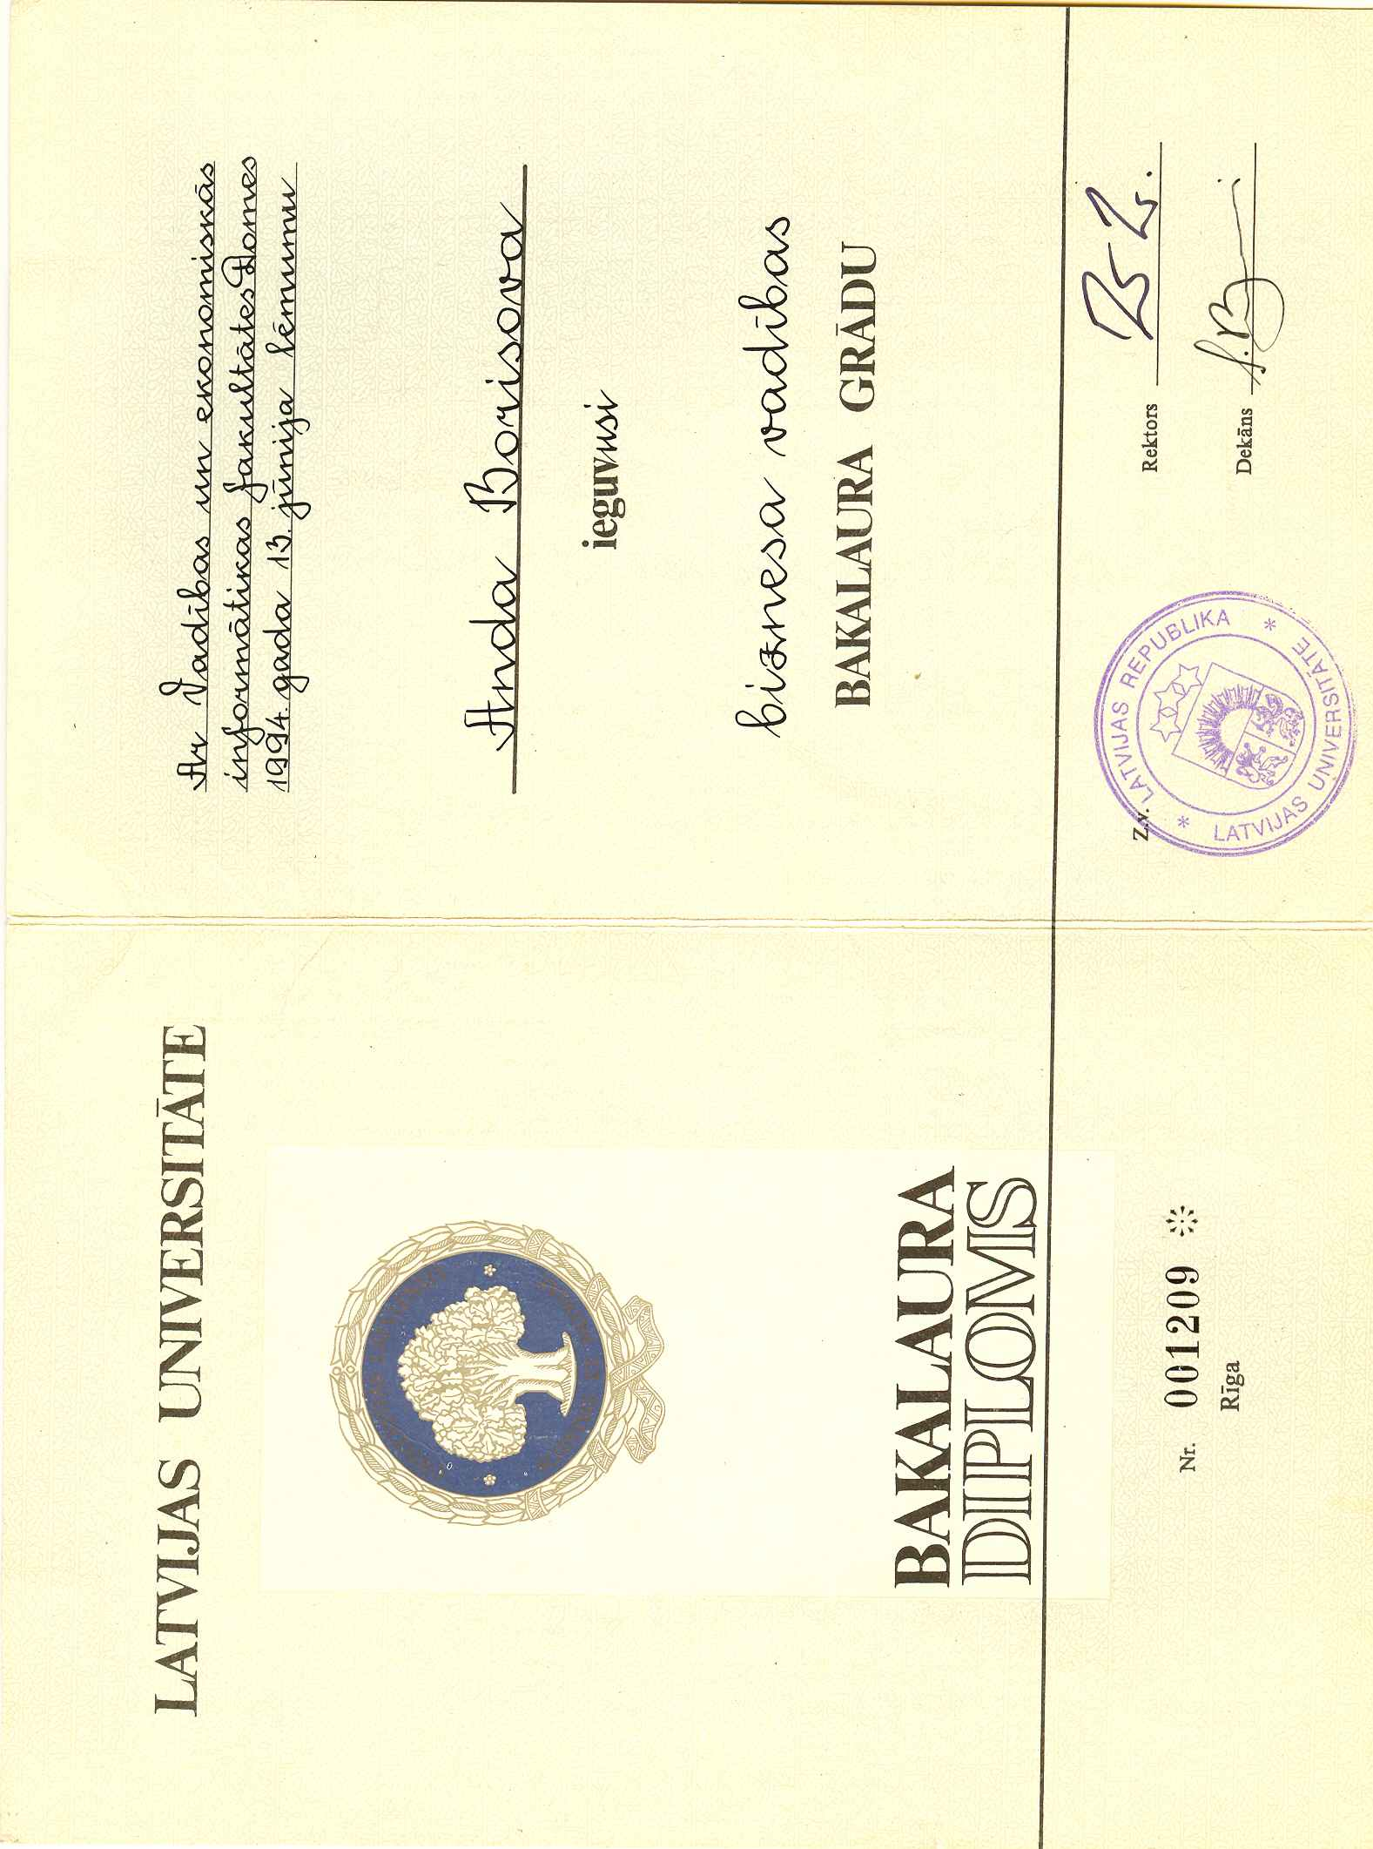

Diploma Translation

University of Latvia

Bachelor’s Diploma

No. 001209
Riga

======
Decision of the Council of the Faculty of Management and Economic Informatics from June 13, 1994.

Anda Borisova

received a bachelor's degree

Rector Signature
Seal
Dean Signature

