Important dates

* **Invited session proposal deadline:** February 15, 2020 23:59 CET
* **Paper Submission Opening:** March 1, 2020 23:59 CET
* **Final Submission Deadline:** April 1, 2020 23:59 CET
* **Assignment of Reviewers:** March 2, 2020 23:59 CET
* **Final Review deadline:** April 10, 2020 23:59 CET
* **Decision:**April 15, 2020 23:59 CET
* **Final paper upload:**May 1, 2020 23:59 CET

Venue

* The meetings will be held at: Monastero dei Benedettini, Piazza Dante Alighieri, 32, 95124 Catania CT, Italy. .
* Coordinates:

Gps:37.503638,15.080558  
Latitude: 37°30’15.54”N  
Longitude: 15° 4’46.99”E

<http://www.monasterodeibenedettini.it/>

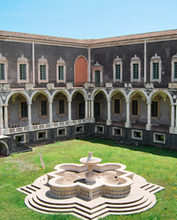

 How to reach the Venue?

* The monastery is one of the University of Catania’s buildings, and it is listed as UNESCO World Heritage Site. It is located in the city center.
* Monastero dei Benedettini is located in the city center of Catania (Sicily). The majorities of the selected hotels are walking distance from the venue (less than 10 min). A shuttle bus service will be provided at the beginning and at the end of the working day from some of the farthest accommodations.

