TRAVEL TO THE CITY

From the airport:

* The Fontanarossa Vincenzo Bellini Airport is only 7 km far from the city center, where the venue is located. You can reach the city center.

 By taxi:

* Taxi ranks are located outside the arrival terminal. A journey from the airport to the city center usually takes about 15-20 minutes. A fixed urban rate “Airport-City center” of 20 euro should be applied. Please, in order to be sure on the rate that will be applied ask information to the staff in charge before boarding the vehicle.

**For taxi info: Radio taxi +39 095 330966; Night service: +39 095 386794**

Bus:

* Buses (AMT Alibus) connect the airport to the city center and leave every 20 minutes from 5 am to midnight. Bus tickets can be bought at the currency exchange office or at a newspaper shop inside the airport terminal or directly from the bus driver. There is an Alibus stop at a walking distance from all selected accommodations (see table below).

|  |  |
| --- | --- |
| Hotel | Nearest bus stop |
| Principe | Stesicoro (8 min) |
| Royal | Stesicoro (7 min) |
| Centrum | Civita (5 min) |
| San Max | Viale (2 min) |
| Mediterraneo | Bellini Est (11 min) |
| Katane Place | Verga (6 min) |

City transport:

* Info about the public city transport routes and schedules can be find at the following website: <http://www.amt.ct.it/> or using the following app: [https://moovitapp.com](https://moovitapp.com/)

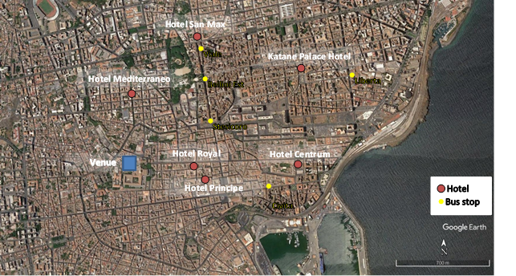

Accommodation:

The following hotels are less than 15-20 minutes’ walk from the venue of the meeting:

* Hotel Principe **** (2 min walking distance from the venue) Via Alessi 24, 95124 Catania CT

Process monitoring

Sensor networks Cyber-Physical

Systems Industrial IoT Smart Grid

Smart cities Home and building automation

Precise agriculture Bioinspired systems Environmental systems

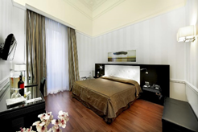

**Hotel Royal **** (**2 min walking distance from the venue) Via Antonino Di Sangiuliano, 337, 95124 Catania CT

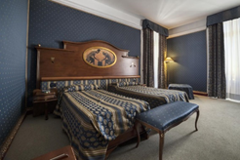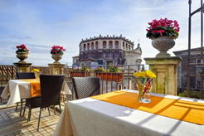

**Hotel Katane \*\*\*\***(21 min walking distance from the venue) Via Camillo Finocchiaro Aprile, 110, 95129 Catania CT

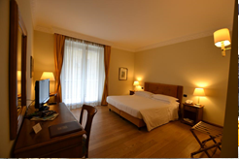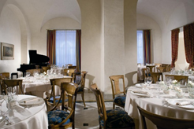

**Hotel Mediterraneo\*\*\***(14 min walking distance from the venue) Via Dottor Consoli, 27, 95124 Catania CT

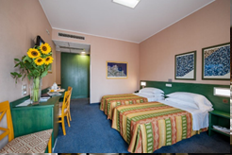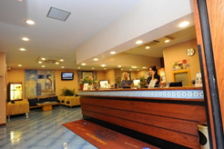

**Hotel Centrum \*\*\*** (13 min walking distance from the venue) Via Monsignor Ventimiglia, 37, 95131 Catania CT

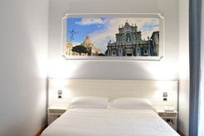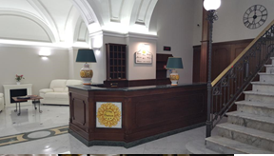

**Hotel San Max \*\*\***(16 min walking distance from the venue) Via Etnea, 329, 95125 Catania CT

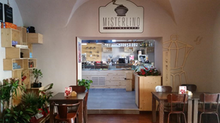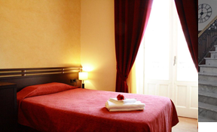

Additional information:

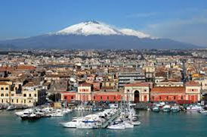

Catania is the second largest metropolitan city of Sicily. Over the centuries, it has faced earthquakes and volcanic eruptions; it has undergone alternating dominations and urban transformations. Here it is, at the beginning of the third millennium, with its vitality and its hardworking determination, ready to surprise you and make you fall in love, submerging you in intense flavors, Baroque stuccoes of UNESCO heritage and a myriad of unforgettable surroundings.

What to visit:

Baroque - Via Crociferi and Palazzo Biscari

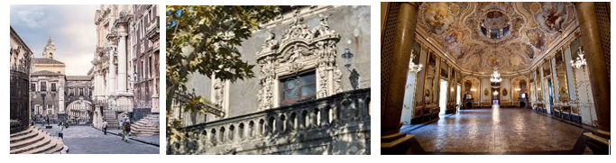

Greek-Roman monuments

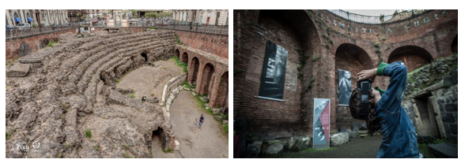

Vincenzo Bellini Theatre | San Giovanni Li Cuti –fish village | Ursino Castel The fish market

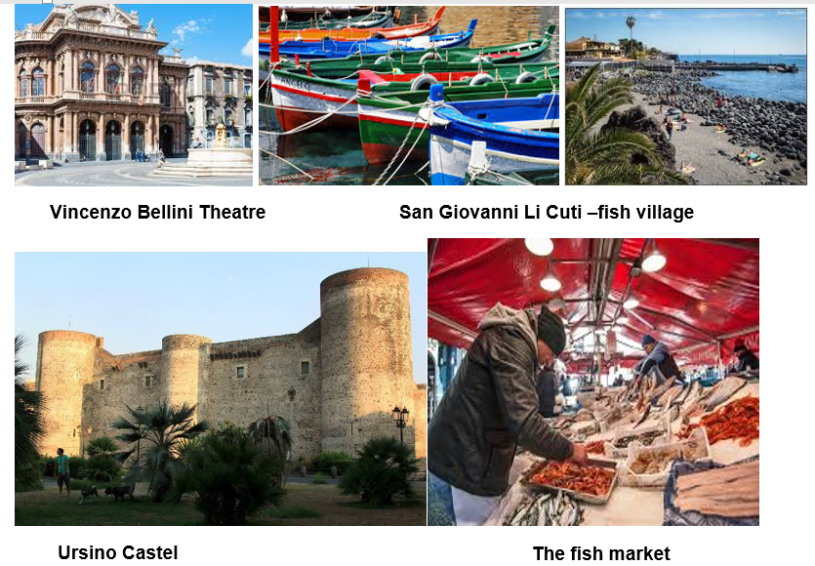

[http://www.visitsicily.info/ en/10cosea/catania/](http://www.visitsicily.info/en/10cosea/catania/)

<http://turismo.provincia.ct.it/English/>

<https://www.youtube.com/watch?v=YYN7gGlpLHk>

<https://www.visitsicily.travel/en/sicily/catania/#toggle-id-2>