GESTIONARE COMPANIE BANCARA

REALIZAT DE : DIACONESCU ALEXANDRA

GRUPA 244

1. Descrierea modelului real, a utilității acestuia și a regulilor de funcționare.

Proiectul consta in modelarea unei baze de date pentru sistemul de management al unei companii bancare ce ofera servicii bancare si financiare pentru clientii sai. Compania are sedii in diverse locatii si ofera o gama larga de produse si servicii bancare, cum ar fi conturi, credite pentru persoane fizice si juridice si plati internationale. In ceea ce priveste conturile bancare, clientii pot deschide conturi de economii sau conturi curente. In plus, compania ofera servicii de internet banking, prin intermediul carora clientii pot accesa conturile lor si pot efectua plati sau transferuri de bani. Creditele sunt disponibile la dobanzi variabile sau fixe. Clientii pot solicita credite pentru achizitionarea de bunuri, investitii sau pentru nevoi personale. Compania poate organiza si evenimente sau seminarii pentru educatia financiara a clientilor si pentru a le oferi mai multe informatii despre produsele si serviciile oferite. In functie de serviciile pe care le solicita, clientii pot deveni clienti private, si pot primi diverse oferte personalizate.

2.Realizați diagrama entitate-relație (ERD): entitățile, relațiile și atributele trebuie definite în limba română.

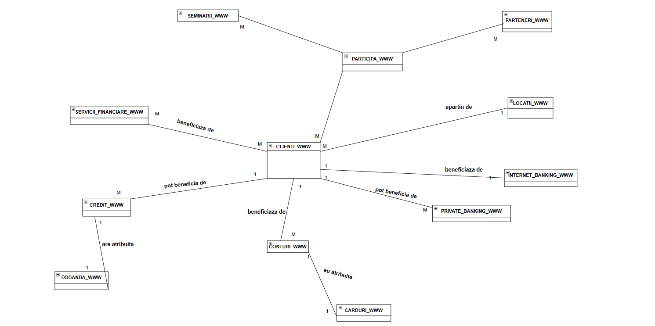

3.Pornind de la diagrama entitate-relație realizați diagrama conceptuală a modelului propus, integrând toate atributele necesare: entitățile, relațiile și atributele trebuie definite în limba română.

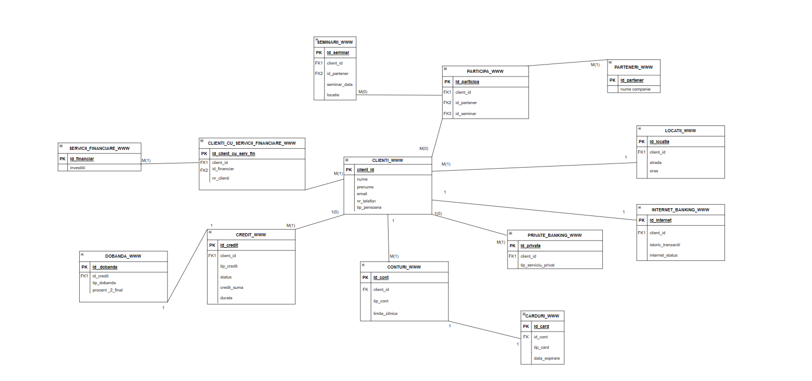

4.Implementați în Oracle diagrama conceptuală realizată: definiți toate tabelele, definind toate constrângerile de integritate necesare (chei primare, cheile externe etc).

SET FEEDBACK 1

SET LINESIZE 80

SET TRIMSPOOL ON

SET TAB OFF

SET PAGESIZE 100

SET ECHO OFF

--clienti--

CREATE TABLE clienti_www (

client_id NUMBER CONSTRAINT client_id_n NOT NULL,

nume VARCHAR2(30) CONSTRAINT nume_n NOT NULL,

prenume VARCHAR2(30) CONSTRAINT prenume_n NOT NULL,

email VARCHAR2(30) CONSTRAINT email_n NOT NULL,

numar_telefon NUMBER(10) CONSTRAINT numar_telefon_n NOT NULL,

tip_persoana VARCHAR2(30) CONSTRAINT tip_persoana_n NOT NULL,

CONSTRAINT client_id_pk PRIMARY KEY (client_id)

);

--servicii financiare--

CREATE TABLE servicii_financiare_www (

id_financiar NUMBER,

investitii VARCHAR(50),

CONSTRAINT id_financiar_pk PRIMARY KEY(id_financiar)

);

--clienti_cu_servicii_financiare--

CREATE TABLE clienti_cu_servicii_financiare_www(

id_client_cu_serv_fin NUMBER CONSTRAINT id_client_cu_serv_fin_n NOT NULL,

client_id NUMBER CONSTRAINT client_id_x NOT NULL,

id_financiar NUMBER CONSTRAINT id_financiar_x NOT NULL,

CONSTRAINT id_client_cu_serv_fin_pk PRIMARY KEY (id_client_cu_serv_fin)

);

ALTER TABLE clienti_cu_servicii_financiare_www

ADD (CONSTRAINT clienti_cu_servicii_financiare_fk1 FOREIGN KEY( client_id ) REFERENCES clienti_www( client_id ),

CONSTRAINT clienti_cu_servicii_financiare_fk2 FOREIGN KEY(id_financiar ) REFERENCES servicii_financiare_www( id_financiar )

);

--locatii--

CREATE TABLE locatii_www (

id_locatie NUMBER CONSTRAINT id_locatie_n NOT NULL,

client_id NUMBER,

strada VARCHAR(20) CONSTRAINT strada_id_n NOT NULL,

oras VARCHAR(20) CONSTRAINT oras_id_n NOT NULL,

CONSTRAINT id_locatie_pk PRIMARY KEY(id_locatie)

) ORGANIZATION INDEX;

ALTER TABLE locatii_www

ADD ( CONSTRAINT locatii_clienti_fk FOREIGN KEY(client_id) REFERENCES clienti_www(client_id));

--parteneri--

CREATE TABLE parteneri_www(

id_partener NUMBER CONSTRAINT id_partener_n NOT NULL,

nume_companie VARCHAR(30),

CONSTRAINT id_partener_pk PRIMARY KEY(id_partener)

);

--seminarii--

CREATE TABLE seminarii_www(

id_seminar NUMBER CONSTRAINT id_seminar_n NOT NULL,

client_id NUMBER,

id_partener NUMBER CONSTRAINT id_partener_nn NOT NULL,

seminar_data VARCHAR(20) CONSTRAINT seminar_data_n NOT NULL,

locatie VARCHAR(20) CONSTRAINT locatie_n NOT NULL,

CONSTRAINT id_seminar_pk PRIMARY KEY(id_seminar)

);

ALTER TABLE seminarii_www

ADD (CONSTRAINT seminarii_fk FOREIGN KEY(client_id) REFERENCES clienti_www(client_id),

CONSTRAINT parteneri_fk FOREIGN KEY(id_partener) REFERENCES parteneri_www(id_partener));

--credit--

CREATE TABLE credit_www(

id_credit NUMBER,

client_id NUMBER,

tip_credit VARCHAR(30),

status VARCHAR(20) ,

credit_suma VARCHAR(20),

durata VARCHAR(20),

CONSTRAINT id_credit_pk PRIMARY KEY(id_credit)

);

ALTER TABLE credit_www

ADD (CONSTRAINT credit_fk FOREIGN KEY(client_id) REFERENCES clienti_www(client_id));

--dobanda--

CREATE TABLE dobanda_www(

id_dobanda NUMBER ,

id_credit NUMBER ,

tip_dobanda VARCHAR(30) ,

procent_2_final VARCHAR(20),

CONSTRAINT id_dobanda_pk PRIMARY KEY(id_dobanda)

);

ALTER TABLE dobanda_www

ADD (CONSTRAINT dobanda_fk FOREIGN KEY( id_credit ) REFERENCES credit_www( id_credit ));

--conturi--

CREATE TABLE conturi_www(

id_cont NUMBER CONSTRAINT cont_n NOT NULL,

client_id NUMBER CONSTRAINT client_n NOT NULL,

tip_cont VARCHAR2(10) CONSTRAINT tip_cont_n NOT NULL,

limita_zilnica NUMBER CONSTRAINT limita_n NOT NULL,

CONSTRAINT id_cont_pk PRIMARY KEY(id_cont)

);

ALTER TABLE conturi_www

ADD (CONSTRAINT conturi_fk FOREIGN KEY( client_id ) REFERENCES clienti_www( client_id ));

--carduri--

CREATE TABLE carduri_www(

id_card NUMBER CONSTRAINT card_n NOT NULL,

id_cont NUMBER CONSTRAINT cont_nn NOT NULL,

tip_card VARCHAR2(10) CONSTRAINT tip_card_n NOT NULL,

data_expirare VARCHAR(20) CONSTRAINT data_exp_n NOT NULL,

CONSTRAINT id_card_pk PRIMARY KEY(id_card)

);

ALTER TABLE carduri_www

ADD (CONSTRAINT carduri_fk FOREIGN KEY( id_cont ) REFERENCES conturi_www(id_cont));

--private banking--

CREATE TABLE private_banking_www(

id_private NUMBER,

client_id NUMBER,

tip_serviciu_privat VARCHAR(50),

CONSTRAINT id_private_pk PRIMARY KEY(id_private)

);

ALTER TABLE private_banking_www

ADD (CONSTRAINT private_fk FOREIGN KEY( client_id ) REFERENCES clienti_www( client_id ));

--internet banking--

CREATE TABLE internet_banking_www(

id_internet NUMBER CONSTRAINT int_n NOT NULL,

client_id NUMBER CONSTRAINT cli_n NOT NULL,

istoric_tranzactii VARCHAR(2000),

internet_status VARCHAR(20) CONSTRAINT int_status_n NOT NULL,

CONSTRAINT id_internet_pk PRIMARY KEY(id_internet)

);

ALTER TABLE internet_banking_www

ADD (CONSTRAINT internet_fk FOREIGN KEY( client_id ) REFERENCES clienti_www( client_id ));

--participa--

CREATE TABLE participa_www(

id_participa NUMBER,

id_partener NUMBER,

client_id NUMBER,

id_seminar NUMBER,

CONSTRAINT id_participa_pk PRIMARY KEY(id_participa)

);

ALTER TABLE participa_www

ADD (CONSTRAINT participa_fk FOREIGN KEY( id_seminar ) REFERENCES seminarii_www( id_seminar ),

CONSTRAINT participa_fk1 FOREIGN KEY(id_partener ) REFERENCES parteneri_www( id_partener ),

CONSTRAINT participa_fk2 FOREIGN KEY( client_id ) REFERENCES clienti_www( client_id )

);

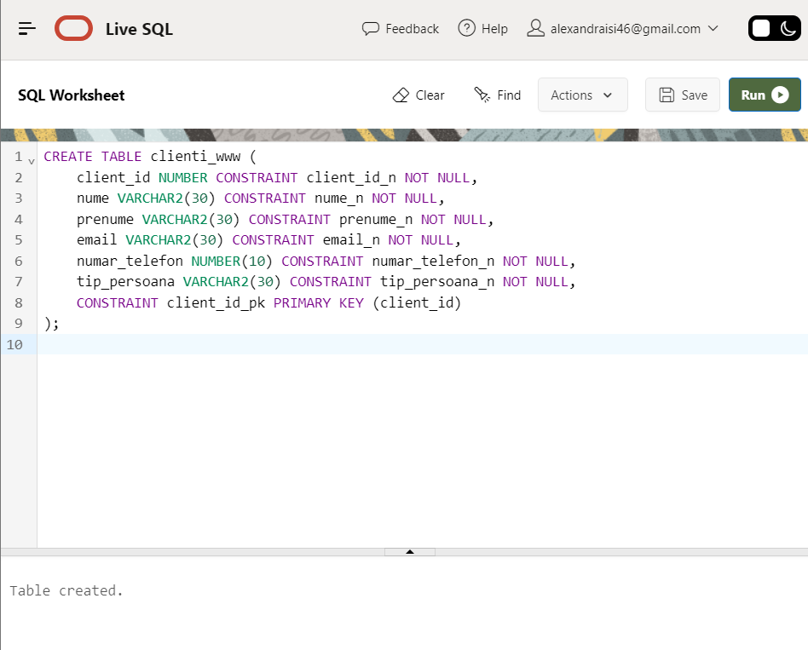

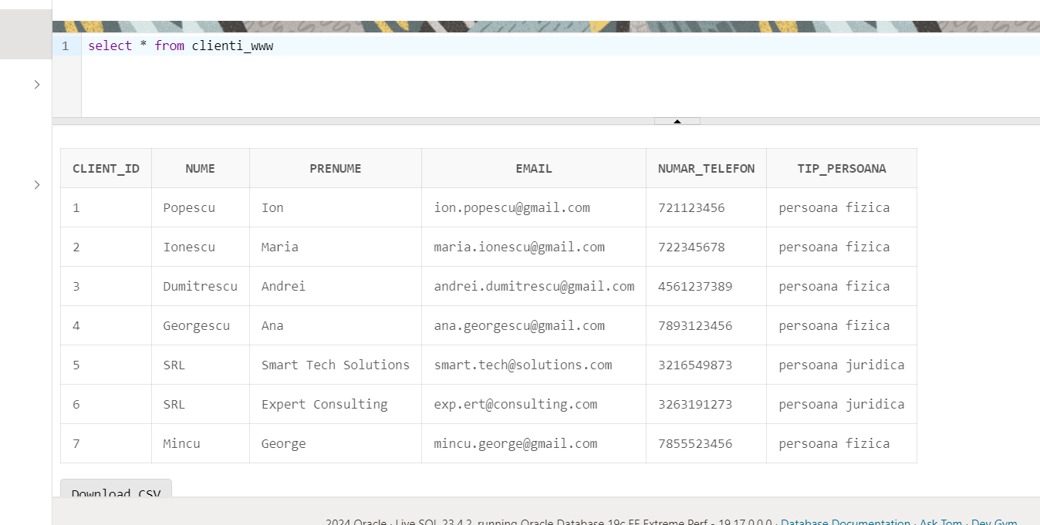

5. Adăugați informații coerente în tabelele create (minim 5 înregistrări pentru fiecare entitate independentă; minim 10 înregistrări pentru tabela asociativă).

CREATE SEQUENCE clienti_seq START WITH 1 INCREMENT BY 1;

INSERT INTO clienti_www (client_id, nume, prenume, email, numar_telefon, tip_persoana)

VALUES (clienti_seq.NEXTVAL, 'Popescu', 'Ion', 'ion.popescu@gmail.com', 0721123456, 'persoana fizica');

INSERT INTO clienti_www (client_id, nume, prenume, email, numar_telefon, tip_persoana)

VALUES (clienti_seq.NEXTVAL, 'Ionescu', 'Maria', 'maria.ionescu@gmail.com', 0722345678, 'persoana fizica');

INSERT INTO clienti_www (client_id, nume, prenume, email, numar_telefon, tip_persoana)

VALUES (clienti_seq.NEXTVAL, 'Dumitrescu', 'Andrei', 'andrei.dumitrescu@gmail.com', 4561237389, 'persoana fizica');

INSERT INTO clienti_www (client_id, nume, prenume, email, numar_telefon, tip_persoana)

VALUES (clienti_seq.NEXTVAL, 'Georgescu', 'Ana', 'ana.georgescu@gmail.com', 7893123456, 'persoana fizica');

INSERT INTO clienti_www (client_id, nume, prenume, email, numar_telefon, tip_persoana)

VALUES (clienti_seq.NEXTVAL, 'SRL', 'Smart Tech Solutions', 'smart.tech@solutions.com', 3216549873, 'persoana juridica');

INSERT INTO clienti_www (client_id, nume, prenume, email, numar_telefon, tip_persoana)

VALUES (clienti_seq.NEXTVAL, 'SRL', 'Expert Consulting', 'exp.ert@consulting.com', 3263191273, 'persoana juridica');

INSERT INTO clienti_www (client_id, nume, prenume, email, numar_telefon, tip_persoana)

VALUES (clienti_seq.NEXTVAL, 'Mincu', 'George', 'mincu.george@gmail.com', 7855523456, 'persoana fizica' );

CREATE SEQUENCE servicii_financiare_seq START WITH 10 INCREMENT BY 3;

INSERT INTO servicii_financiare_www (id_financiar, investitii)

VALUES (servicii_financiare_seq.NEXTVAL, 'Fonduri mutuale');

INSERT INTO servicii_financiare_www (id_financiar, investitii)

VALUES (servicii_financiare_seq.NEXTVAL, 'Investitii NASDAQ');

INSERT INTO servicii_financiare_www (id_financiar, investitii)

VALUES (servicii_financiare_seq.NEXTVAL, 'Investitii crypto');

INSERT INTO servicii_financiare_www (id_financiar, investitii)

VALUES (servicii_financiare_seq.NEXTVAL, 'Investitii in companii');

INSERT INTO servicii_financiare_www (id_financiar, investitii)

VALUES (servicii_financiare_seq.NEXTVAL, 'Investitii imobiliare');

INSERT INTO servicii_financiare_www (id_financiar, investitii)

VALUES (servicii_financiare_seq.NEXTVAL, 'Investitii BVB');

CREATE SEQUENCE clienti_cu_servicii_financiare_seq START WITH 500 INCREMENT BY 1;

INSERT INTO clienti_cu_servicii_financiare_www (id_client_cu_serv_fin, client_id, id_financiar)

VALUES (clienti_cu_servicii_financiare_seq.NEXTVAL, 1, 10);

INSERT INTO clienti_cu_servicii_financiare_www (id_client_cu_serv_fin, client_id, id_financiar)

VALUES (clienti_cu_servicii_financiare_seq.NEXTVAL, 2, 10);

INSERT INTO clienti_cu_servicii_financiare_www (id_client_cu_serv_fin, client_id, id_financiar)

VALUES (clienti_cu_servicii_financiare_seq.NEXTVAL, 3, 13);

INSERT INTO clienti_cu_servicii_financiare_www (id_client_cu_serv_fin, client_id, id_financiar)

VALUES (clienti_cu_servicii_financiare_seq.NEXTVAL, 3, 16);

INSERT INTO clienti_cu_servicii_financiare_www (id_client_cu_serv_fin, client_id, id_financiar)

VALUES (clienti_cu_servicii_financiare_seq.NEXTVAL, 4, 19);

INSERT INTO clienti_cu_servicii_financiare_www (id_client_cu_serv_fin, client_id, id_financiar)

VALUES (clienti_cu_servicii_financiare_seq.NEXTVAL, 5, 22);

INSERT INTO clienti_cu_servicii_financiare_www (id_client_cu_serv_fin, client_id, id_financiar)

VALUES (clienti_cu_servicii_financiare_seq.NEXTVAL, 6, 22);

INSERT INTO clienti_cu_servicii_financiare_www (id_client_cu_serv_fin, client_id, id_financiar)

VALUES (clienti_cu_servicii_financiare_seq.NEXTVAL, 7, 22);

INSERT INTO clienti_cu_servicii_financiare_www (id_client_cu_serv_fin, client_id, id_financiar)

VALUES (clienti_cu_servicii_financiare_seq.NEXTVAL, 2, 22);

INSERT INTO clienti_cu_servicii_financiare_www (id_client_cu_serv_fin, client_id, id_financiar)

VALUES (clienti_cu_servicii_financiare_seq.NEXTVAL, 3, 22);

CREATE SEQUENCE parteneri_seq START WITH 70 INCREMENT BY 1;

INSERT INTO parteneri_www (id_partener, nume_companie)

VALUES (parteneri_seq.NEXTVAL, 'BCR');

INSERT INTO parteneri_www (id_partener, nume_companie)

VALUES (parteneri_seq.NEXTVAL, 'BRD');

INSERT INTO parteneri_www (id_partener, nume_companie)

VALUES (parteneri_seq.NEXTVAL, 'ING');

INSERT INTO parteneri_www (id_partener, nume_companie)

VALUES (parteneri_seq.NEXTVAL, 'Raiffeisen Bank');

INSERT INTO parteneri_www (id_partener, nume_companie)

VALUES (parteneri_seq.NEXTVAL, 'Banca Transilvania');

INSERT INTO parteneri_www (id_partener, nume_companie)

VALUES (parteneri_seq.NEXTVAL, 'UniCredit Bank');

CREATE SEQUENCE seminarii_seq START WITH 50 INCREMENT BY 1;

INSERT INTO seminarii_www (id_seminar, client_id, id_partener, seminar_data, locatie)

VALUES (seminarii_seq.NEXTVAL, 1, 70,'01-Jan-22', 'Bucuresti');

INSERT INTO seminarii_www (id_seminar, client_id, id_partener, seminar_data, locatie)

VALUES (seminarii_seq.NEXTVAL, 2, 71, '15-Mar-22', 'Cluj-Napoca');

INSERT INTO seminarii_www (id_seminar, client_id, id_partener, seminar_data, locatie)

VALUES (seminarii_seq.NEXTVAL, 3, 72, '10-Apr-22', 'Timisoara');

INSERT INTO seminarii_www (id_seminar, client_id, id_partener, seminar_data, locatie)

VALUES (seminarii_seq.NEXTVAL, 4, 73, '25-Jun-22', 'Iasi');

INSERT INTO seminarii_www (id_seminar, client_id, id_partener, seminar_data, locatie)

VALUES (seminarii_seq.NEXTVAL, 5, 74, '05-Jul-22', 'Constanta');

INSERT INTO seminarii_www (id_seminar, client_id, id_partener, seminar_data, locatie)

VALUES (seminarii_seq.NEXTVAL, 6, 75, '20-Aug-22', 'Brasov');

INSERT INTO seminarii_www (id_seminar, client_id, id_partener, seminar_data, locatie)

VALUES (seminarii_seq.NEXTVAL,1, 75, '15-Nov-22', 'Sibiu');

CREATE SEQUENCE locatii_seq START WITH 80 INCREMENT BY 1;

INSERT INTO locatii_www (id_locatie, client_id, strada, oras)

VALUES (locatii_seq.NEXTVAL,1, 'Titulescu', 'Bucuresti');

INSERT INTO locatii_www (id_locatie, client_id, strada, oras)

VALUES (locatii_seq.NEXTVAL,2, 'Titulescu', 'Bucuresti');

INSERT INTO locatii_www (id_locatie, client_id, strada, oras)

VALUES (locatii_seq.NEXTVAL,3, 'Avram Iancu', 'Cluj-Napoca');

INSERT INTO locatii_www (id_locatie, client_id, strada, oras)

VALUES (locatii_seq.NEXTVAL, 4, 'Victoriei', 'Bucuresti');

INSERT INTO locatii_www (id_locatie, client_id, strada, oras)

VALUES (locatii_seq.NEXTVAL, 5, 'Icoanei', 'Iasi');

INSERT INTO locatii_www (id_locatie, client_id, strada, oras)

VALUES (locatii_seq.NEXTVAL, 6, 'Eroilor', 'Timisoara');

INSERT INTO locatii_www (id_locatie, client_id, strada, oras)

VALUES (locatii_seq.NEXTVAL, 7, 'Unirii', 'Bucuresti');

CREATE SEQUENCE participa_seq START WITH 100 INCREMENT BY 1;

INSERT INTO participa_www (id_participa, id_partener, client_id, id_seminar)

VALUES (participa_seq.NEXTVAL, 70, 1, 50);

INSERT INTO participa_www (id_participa, id_partener, client_id, id_seminar)

VALUES(participa_seq.NEXTVAL, 71, 2, 51);

INSERT INTO participa_www (id_participa, id_partener, client_id, id_seminar)

VALUES (participa_seq.NEXTVAL, 71, 3, 52);

INSERT INTO participa_www (id_participa, id_partener, client_id, id_seminar)

VALUES(participa_seq.NEXTVAL, 74, 4, 53);

INSERT INTO participa_www (id_participa, id_partener, client_id, id_seminar)

VALUES(participa_seq.NEXTVAL, 73, 5, 54);

INSERT INTO participa_www (id_participa, id_partener, client_id, id_seminar)

VALUES(participa_seq.NEXTVAL, 72, 6, 55);

INSERT INTO participa_www (id_participa, id_partener, client_id, id_seminar)

VALUES(participa_seq.NEXTVAL, 75, 1, 56);

INSERT INTO participa_www (id_participa, id_partener, client_id, id_seminar)

VALUES(participa_seq.NEXTVAL, 75, 2, 56);

INSERT INTO participa_www (id_participa, id_partener, client_id, id_seminar)

VALUES(participa_seq.NEXTVAL, 72, 3, 55);

INSERT INTO participa_www (id_participa, id_partener, client_id, id_seminar)

VALUES(participa_seq.NEXTVAL, 73, 4, 55);

INSERT INTO participa_www (id_participa, id_partener, client_id, id_seminar)

VALUES(participa_seq.NEXTVAL, 73, 7, 51);

CREATE SEQUENCE credit_seq START WITH 170 INCREMENT BY 1;

INSERT INTO credit_www (id_credit, client_id, tip_credit, status, credit_suma, durata)

VALUES (credit_seq.NEXTVAL,1,'investitii','Aprobat','10000', '2 ani');

INSERT INTO credit_www (id_credit, client_id, tip_credit, status, credit_suma, durata)

VALUES (credit_seq.NEXTVAL, 2, 'investitii', 'Aprobat', '500000', '5 ani');

INSERT INTO credit_www (id_credit, client_id, tip_credit, status, credit_suma, durata)

VALUES(credit_seq.NEXTVAL, 3, 'nevoi personale', 'Aprobat', '25000', '5 ani');

INSERT INTO credit_www (id_credit, client_id, tip_credit, status, credit_suma, durata)

VALUES(credit_seq.NEXTVAL, 4, 'over draft', 'In asteptare', '15000', '2 ani');

INSERT INTO credit_www (id_credit, client_id, tip_credit, status, credit_suma, durata)

VALUES(credit_seq.NEXTVAL, 5, 'investitii', 'Aprobat', '750000', '20 ani');

INSERT INTO credit_www (id_credit, client_id, tip_credit, status, credit_suma, durata)

VALUES(credit_seq.NEXTVAL, 6, NULL, NULL,NULL, NULL);

INSERT INTO credit_www (id_credit, client_id, tip_credit, status, credit_suma, durata)

VALUES(credit_seq.NEXTVAL, 7, NULL, NULL,NULL, NULL);

CREATE SEQUENCE dobanda_seq START WITH 150 INCREMENT BY 1;

INSERT INTO dobanda_www(id_dobanda, id_credit, tip_dobanda, procent_2_final)

VALUES (dobanda_seq.NEXTVAL,170,'variabila','5%');

INSERT INTO dobanda_www (id_dobanda, id_credit, tip_dobanda, procent_2_final)

VALUES (dobanda_seq.NEXTVAL, 171, 'fixa', '3.5%');

INSERT INTO dobanda_www (id_dobanda, id_credit, tip_dobanda, procent_2_final)

VALUES(dobanda_seq.NEXTVAL, 172, 'variabila', '6%');

INSERT INTO dobanda_www (id_dobanda, id_credit, tip_dobanda, procent_2_final)

VALUES(dobanda_seq.NEXTVAL, 173, 'fixa', '4.25%');

INSERT INTO dobanda_www (id_dobanda, id_credit, tip_dobanda, procent_2_final)

VALUES(dobanda_seq.NEXTVAL, 174, 'variabila', '5.75%');

INSERT INTO dobanda_www (id_dobanda, id_credit, tip_dobanda, procent_2_final)

VALUES(dobanda_seq.NEXTVAL, 175, NULL, NULL);

INSERT INTO dobanda_www (id_dobanda, id_credit, tip_dobanda, procent_2_final)

VALUES(dobanda_seq.NEXTVAL, 176, NULL, NULL);

CREATE SEQUENCE conturi_seq START WITH 180 INCREMENT BY 1;

INSERT INTO conturi_www (id_cont,client_id, tip_cont, limita_zilnica)

VALUES (conturi_seq.NEXTVAL,1,'economii','4000');

INSERT INTO conturi_www (id_cont, client_id, tip_cont, limita_zilnica)

VALUES (conturi_seq.NEXTVAL, 2, 'curent', '2000');

INSERT INTO conturi_www (id_cont, client_id, tip_cont, limita_zilnica)

VALUES(conturi_seq.NEXTVAL, 3, 'economii', '5000');

INSERT INTO conturi_www (id_cont, client_id, tip_cont, limita_zilnica)

VALUES(conturi_seq.NEXTVAL, 4, 'curent', '1000');

INSERT INTO conturi_www (id_cont, client_id, tip_cont, limita_zilnica)

VALUES(conturi_seq.NEXTVAL, 5, 'curent', '2000');

INSERT INTO conturi_www (id_cont, client_id, tip_cont, limita_zilnica)

VALUES(conturi_seq.NEXTVAL, 6, 'economii', '8000');

INSERT INTO conturi_www (id_cont, client_id, tip_cont, limita_zilnica)

VALUES(conturi_seq.NEXTVAL, 7, 'economii', '6000');

CREATE SEQUENCE carduri_seq START WITH 190 INCREMENT BY 1;

INSERT INTO CARDURI_www (id_card, id_cont, tip_card, data_expirare)

VALUES (carduri_seq.NEXTVAL,180,'debit','01-Jun-26');

INSERT INTO CARDURI_www (id_card, id_cont, tip_card, data_expirare)

VALUES (carduri_seq.NEXTVAL, 181, 'credit', '01-Dec-25');

INSERT INTO CARDURI_www (id_card, id_cont, tip_card, data_expirare)

VALUES(carduri_seq.NEXTVAL, 182, 'debit', '01-Sep-27');

INSERT INTO CARDURI_www (id_card, id_cont, tip_card, data_expirare)

VALUES(carduri_seq.NEXTVAL, 183, 'credit', '01-Apr-24');

INSERT INTO CARDURI_www (id_card, id_cont, tip_card, data_expirare)

VALUES(carduri_seq.NEXTVAL, 184, 'credit', '01-Feb-28');

INSERT INTO CARDURI_www (id_card, id_cont, tip_card, data_expirare)

VALUES(carduri_seq.NEXTVAL, 185, 'debit', '01-Nov-26');

INSERT INTO CARDURI_www (id_card, id_cont, tip_card, data_expirare)

VALUES(carduri_seq.NEXTVAL, 186, 'debit', '01-Nov-29');

CREATE SEQUENCE private_seq START WITH 200 INCREMENT BY 1;

INSERT INTO private_banking_www (id_private, client_id, tip_serviciu_privat)

VALUES (private_seq.NEXTVAL,1,'Gestionare portofoliu ');

INSERT INTO private_banking_www (id_private, client_id, tip_serviciu_privat)

VALUES (private_seq.NEXTVAL, 2, 'Consultanta pentru planificarea financiara');

INSERT INTO private_banking_www (id_private, client_id, tip_serviciu_privat)

VALUES (private_seq.NEXTVAL, 3, 'Servicii de investitii la nivel inalt');

INSERT INTO private_banking_www (id_private, client_id, tip_serviciu_privat)

VALUES (private_seq.NEXTVAL, 4, NULL);

INSERT INTO private_banking_www (id_private, client_id, tip_serviciu_privat)

VALUES (private_seq.NEXTVAL, 5, NULL);

INSERT INTO private_banking_www (id_private, client_id, tip_serviciu_privat)

VALUES (private_seq.NEXTVAL, 6, NULL);

INSERT INTO private_banking_www (id_private, client_id, tip_serviciu_privat)

VALUES (private_seq.NEXTVAL, 7, NULL);

CREATE SEQUENCE internet_seq START WITH 220 INCREMENT BY 1;

INSERT INTO internet_banking_www (id_internet, client_id, istoric_tranzactii,internet_status)

VALUES (internet_seq.NEXTVAL,1,'plata interna','activ');

INSERT INTO internet_banking_www (id_internet, client_id, istoric_tranzactii, internet_status)

VALUES (internet_seq.NEXTVAL, 2, 'plata interna', 'activ');

INSERT INTO internet_banking_www (id_internet, client_id, istoric_tranzactii, internet_status)

VALUES(internet_seq.NEXTVAL, 3, 'plata externa', 'activ');

INSERT INTO internet_banking_www (id_internet, client_id, istoric_tranzactii, internet_status)

VALUES(internet_seq.NEXTVAL, 4, 'plata online', 'activ');

INSERT INTO internet_banking_www (id_internet, client_id, istoric_tranzactii, internet_status)

VALUES(internet_seq.NEXTVAL, 5, 'plata externa', 'activ');

INSERT INTO internet_banking_www (id_internet, client_id, istoric_tranzactii, internet_status)

VALUES(internet_seq.NEXTVAL, 6, 'plata online', 'activ');

INSERT INTO internet_banking_www (id_internet, client_id, istoric_tranzactii, internet_status)

VALUES(internet_seq.NEXTVAL, 7, 'plata online', 'activ');

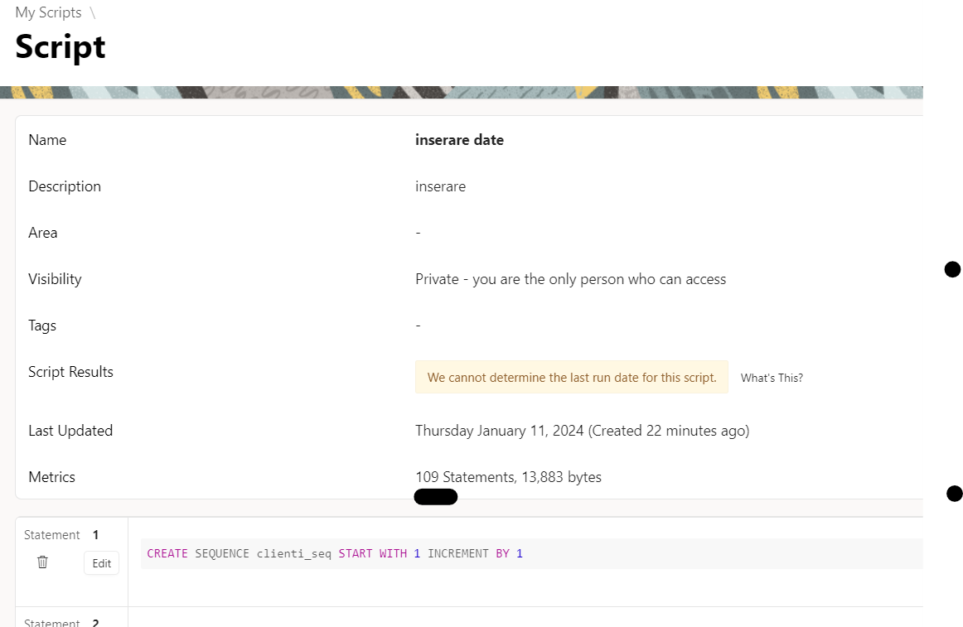

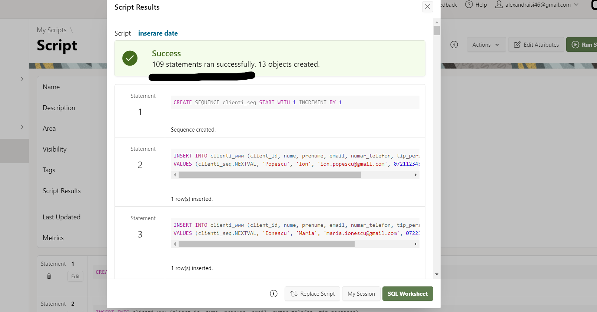

6. Scrie un subprogram stocat independent care creeaza un nou tabel numit clienti_yyy care retine primii 2 clienti din clienti_www si afiseaza numarul de telefon al fiecarui client, impreuna cu limita cardului si cu seminariile la care au participat.

CREATE OR REPLACE TYPE telefon_client AS VARRAY(5) OF VARCHAR2(30);

CREATE OR REPLACE TYPE locatie_client AS TABLE OF VARCHAR2(20);

CREATE TABLE clienti_yyy AS

SELECT client_id, nume

FROM clienti_www

WHERE ROWNUM <= 2;

ALTER TABLE clienti_yyy

ADD (telefon VARCHAR2(30), locatie VARCHAR2(20), limita NUMBER);

CREATE OR REPLACE FUNCTION f3(v_client clienti_yyy.client_id%TYPE, v_nume clienti_yyy.nume%TYPE)

RETURN VARCHAR2 IS

TYPE indexat_limita IS TABLE OF NUMBER(10) INDEX BY BINARY_INTEGER;

v_limita indexat_limita;

TYPE limita_client IS TABLE OF VARCHAR2(20);

v_telefon telefon_client := telefon_client();

v_locatie locatie_client := locatie_client();

BEGIN

SELECT numar_telefon BULK COLLECT INTO v_telefon

FROM clienti_www cl

WHERE cl.client_id = v_client;

SELECT limita_zilnica BULK COLLECT INTO v_limita

FROM conturi_www c

WHERE c.client_id = v_client;

SELECT oras BULK COLLECT INTO v_locatie

FROM locatii_www l

WHERE v_client = l.client_id;

FOR i IN 1 .. GREATEST(v_telefon.COUNT, v_locatie.COUNT)

LOOP

UPDATE clienti_yyy c

SET telefon = v_telefon(i),

locatie = NVL(v_locatie(i), c.locatie),

limita = NVL(v_limita(i), c.limita)

WHERE c.client_id = v_client;

IF SQL%ROWCOUNT = 1 THEN

COMMIT;

RETURN 'date updatate cu succes';

ELSE

RETURN 'nicio linie updatata.';

END IF;

END LOOP;

EXCEPTION

WHEN NO_DATA_FOUND THEN

RETURN 'fara date';

WHEN OTHERS THEN

RETURN 'eroare ' || SQLERRM;

END f3;

/

DECLARE

v_result VARCHAR2(100);

BEGIN

v_result := f3(2, 'Ionescu');

DBMS_OUTPUT.PUT_LINE(v_result);

FOR rec IN (SELECT * FROM clienti_yyy WHERE client_id = 2) LOOP

DBMS_OUTPUT.PUT_LINE('ID: ' || rec.client_id || ', telefon: ' || rec.telefon || ', Locatie: ' || rec.locatie || ', Limita: ' || rec.limita);

END LOOP;

END;

/

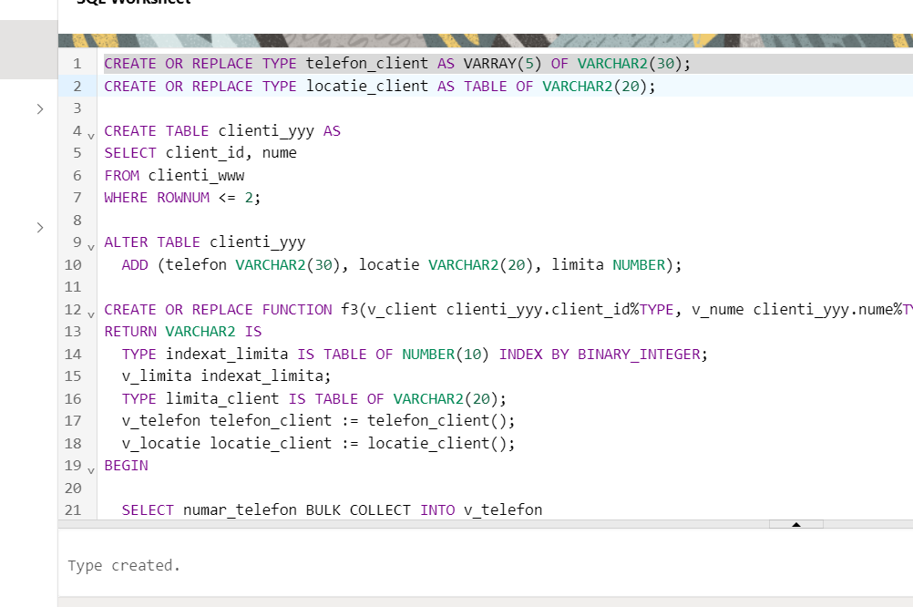

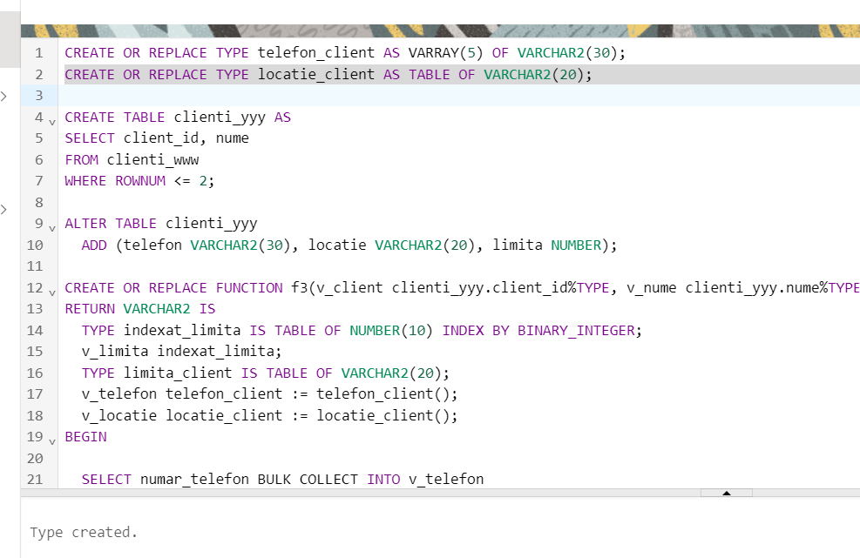

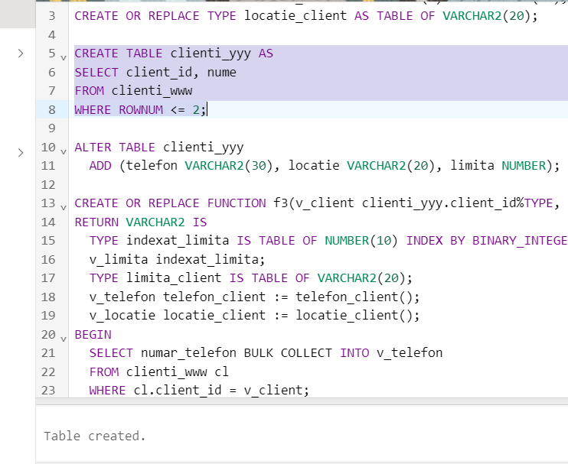

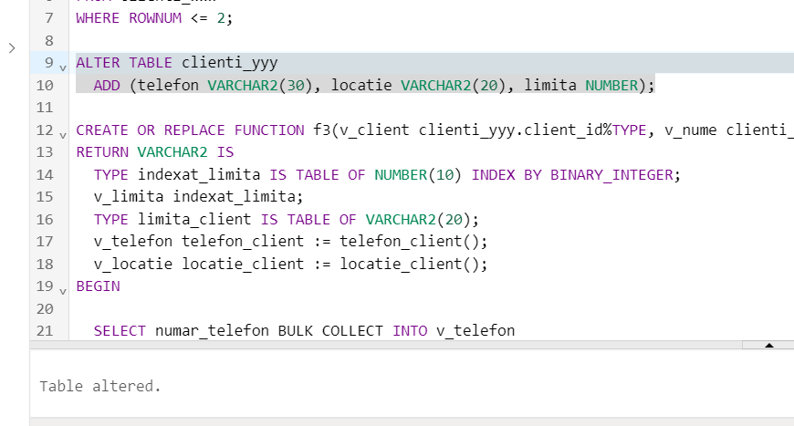

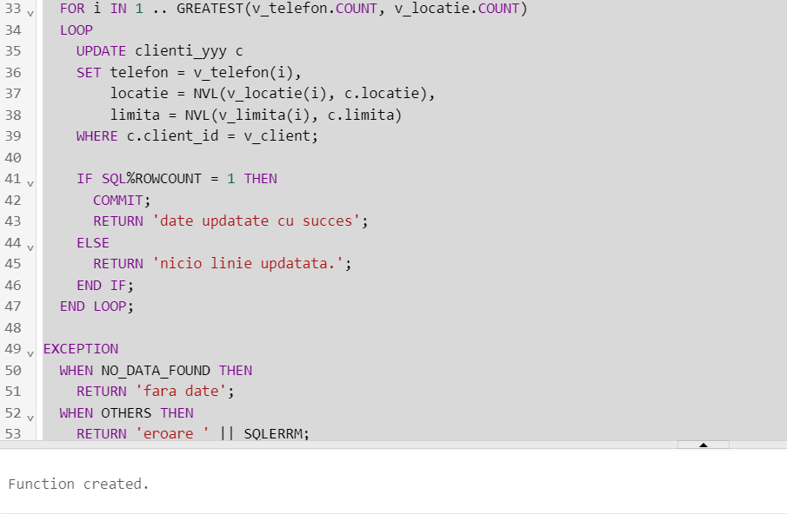

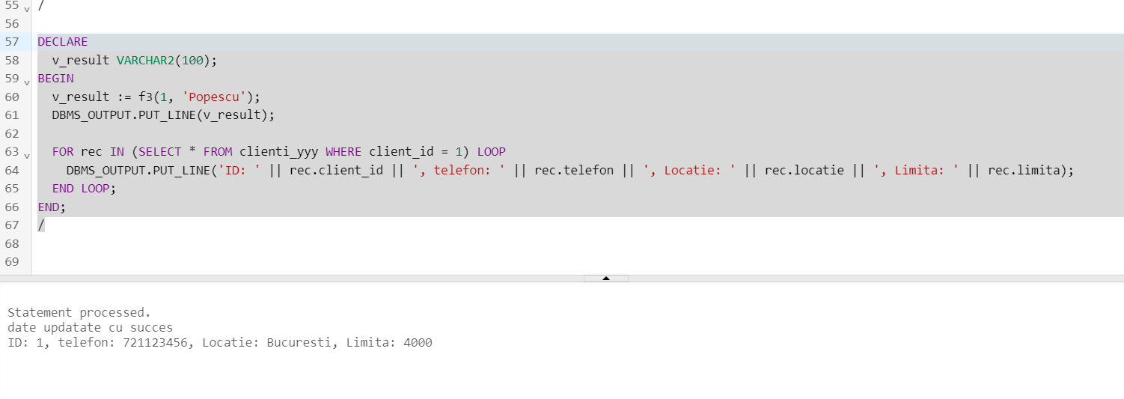

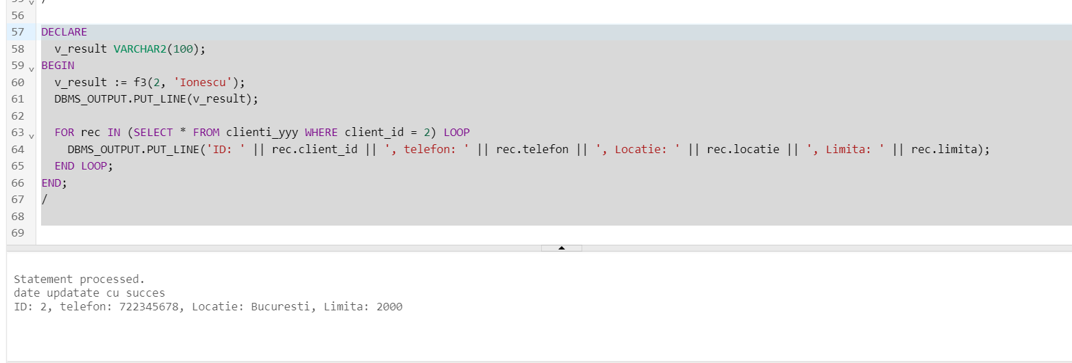

7. Pentru clientii care au participat la seminarul cu id ul 50 , care au un credit aprobat, sa se afiseze tipul creditului pe care il au si suma imprumutata.

CREATE OR REPLACE PROCEDURE suma_credit_nume

IS

v_tip_credit credit_www.tip_credit%TYPE;

v_suma credit_www.credit_suma%TYPE;

CURSOR seminar_cursor IS

SELECT p.client_id

FROM participa_www p

WHERE p.id_seminar = 50;

CURSOR credit_cursor(p_client_id participa_www.client_id%TYPE) IS

SELECT c.tip_credit, c.credit_suma

FROM credit_www c

WHERE c.client_id = credit_cursor.p_client_id

AND c.status = 'Aprobat';

BEGIN

FOR seminar_rec IN seminar_cursor

LOOP

DBMS_OUTPUT.PUT_LINE('Clientul ' || seminar_rec.client_id || ' a participat la seminarul cu ID-ul 50');

BEGIN

OPEN credit_cursor(seminar_rec.client_id);

LOOP

FETCH credit_cursor INTO v_tip_credit, v_suma;

EXIT WHEN credit_cursor%NOTFOUND;

DBMS_OUTPUT.PUT_LINE(' - Tipul creditului: ' || v_tip_credit || ', Suma imprumutata: ' || v_suma);

END LOOP;

CLOSE credit_cursor;

EXCEPTION

WHEN OTHERS THEN

DBMS_OUTPUT.PUT_LINE('eroare pentru clientul: ' || seminar_rec.client_id || ': ' || SQLERRM);

CLOSE credit_cursor;

END;

END LOOP;

END suma_credit_nume;

/

BEGIN

suma_credit_nume;

COMMIT;

END;

/

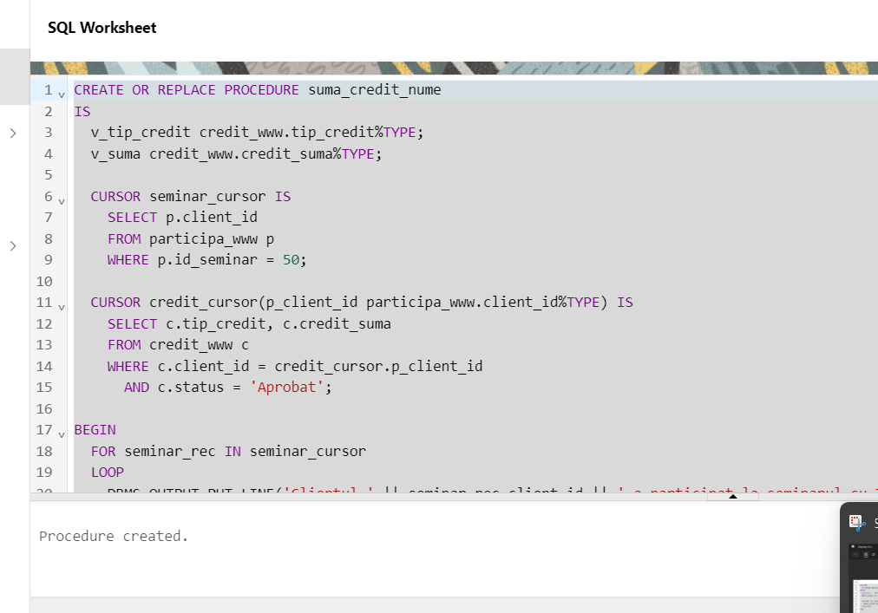

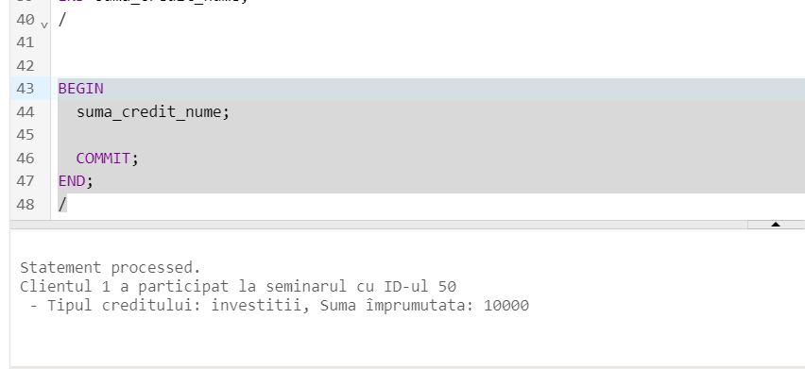

8. Definiti o functie stocata independent prin care sa obtineti numele,tipul serviciului privat si tipul contului clientilor, care beneficiaza de private banking si au limita zilnica mai mica sau egala cu 4000. Sa se trateze toate exceptiile. Apelati subprogramul pentru clientii cu id ul 1,3,4,6,10.

CREATE OR REPLACE FUNCTION f4(v_id clienti_www.client_id%TYPE)

RETURN VARCHAR IS

nume clienti_www.nume%TYPE;

serviciu private_banking_www.tip_serviciu_privat%TYPE;

cont conturi_www.tip_cont%TYPE;

limita conturi_www.limita_zilnica%TYPE;

serviciu_exceptie EXCEPTION;

limita_exceptie EXCEPTION;

serv_limita_exceptie EXCEPTION;

result VARCHAR2(4000);

BEGIN

SELECT c.nume, p.tip_serviciu_privat, co.tip_cont, co.limita_zilnica

INTO nume, serviciu, cont, limita

FROM clienti_www c, private_banking_www p, conturi_www co

WHERE c.client_id = v_id

AND c.client_id = co.client_id

AND c.client_id = p.client_id;

IF limita > 4000 THEN

IF serviciu IS NULL THEN

RAISE serv_limita_exceptie;

ELSE

RAISE limita_exceptie;

END IF;

END IF;

IF serviciu IS NULL THEN

RAISE serviciu_exceptie;

END IF;

result := 'Clientul ' || nume|| ' cu id ul ' || v_id || ' are un cont de ' || cont || ' cu limita zilnica de ' || limita || ' si beneficiaza de ' || serviciu;

RETURN result;

EXCEPTION

WHEN NO_DATA_FOUND THEN

RETURN 'Nu exista clienti cu id ul ' || v_id;

WHEN limita_exceptie THEN

RETURN 'Limita clientului cu id ul ' || v_id || ' depaseste 4000 lei';

WHEN serviciu_exceptie THEN

RETURN 'Clientul cu id ul ' || v_id|| ' nu beneficiaza de un serviciu privat';

WHEN serv_limita_exceptie THEN

RETURN 'Clientul cu id ul ' || v_id|| ' nu beneficiaza de un serviciu privat si are limita mai mare de 4000 lei';

END f4;

/

--apelare

DECLARE

result VARCHAR2(4000);

BEGIN

result := f4(1);

DBMS_OUTPUT.PUT_LINE(result);

END;

/

DECLARE

result VARCHAR2(4000);

BEGIN

result := f4(3);

DBMS_OUTPUT.PUT_LINE(result);

END;

/

DECLARE

result VARCHAR2(4000);

BEGIN

result := f4(4);

DBMS_OUTPUT.PUT_LINE(result);

END;

/

DECLARE

result VARCHAR2(4000);

BEGIN

result := f4(6);

DBMS_OUTPUT.PUT_LINE(result);

END;

/

DECLARE

result VARCHAR2(4000);

BEGIN

result := f4(10);

DBMS_OUTPUT.PUT_LINE(result);

END;

/

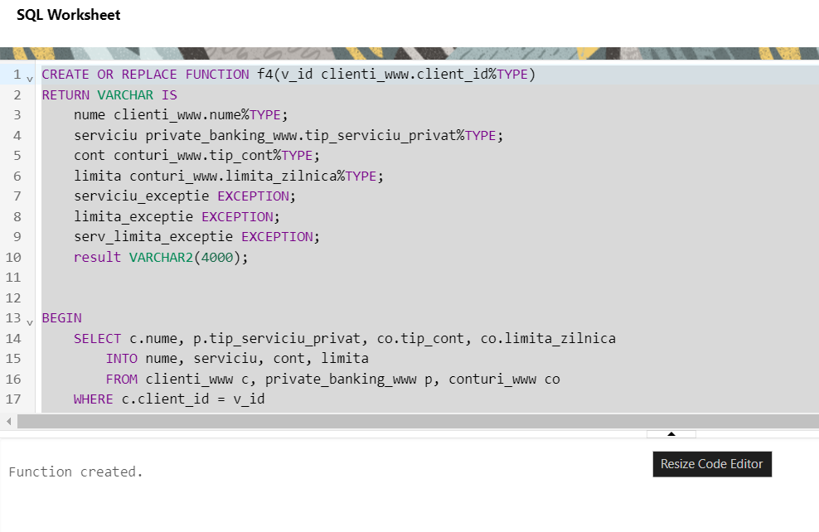

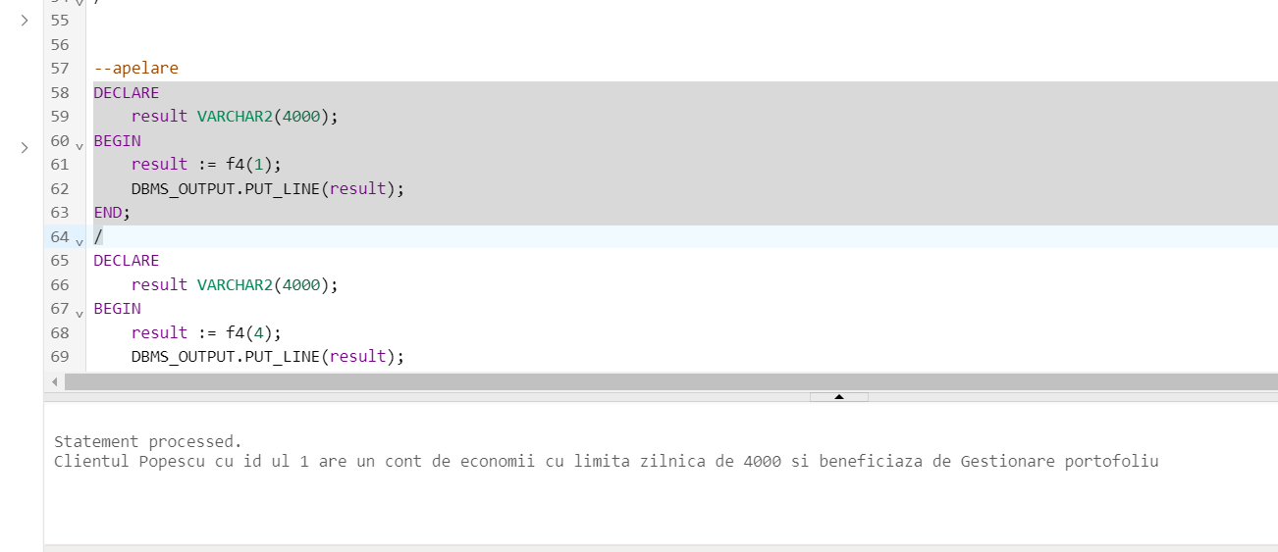

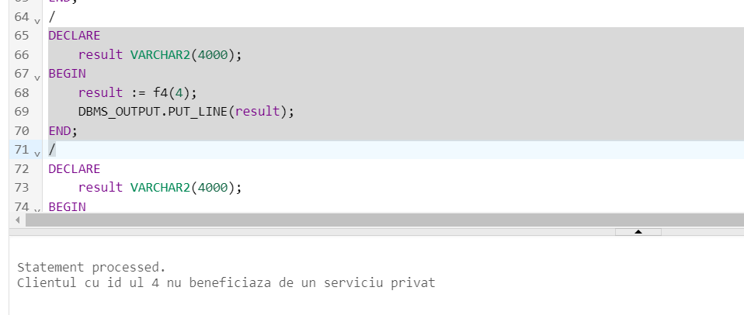

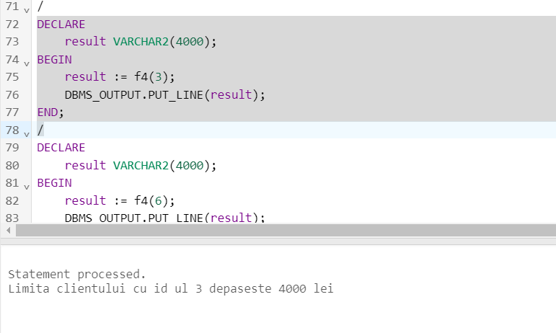

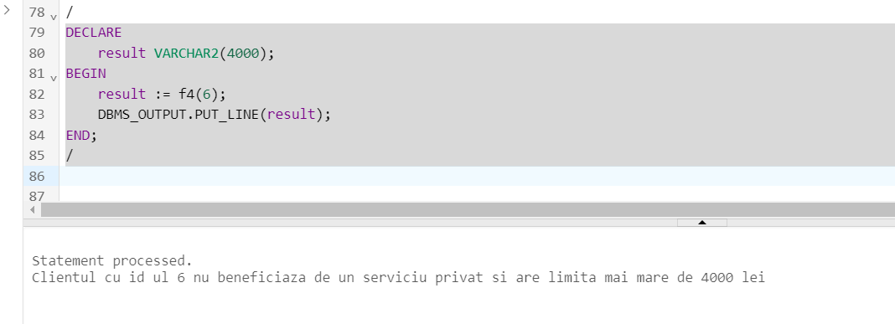

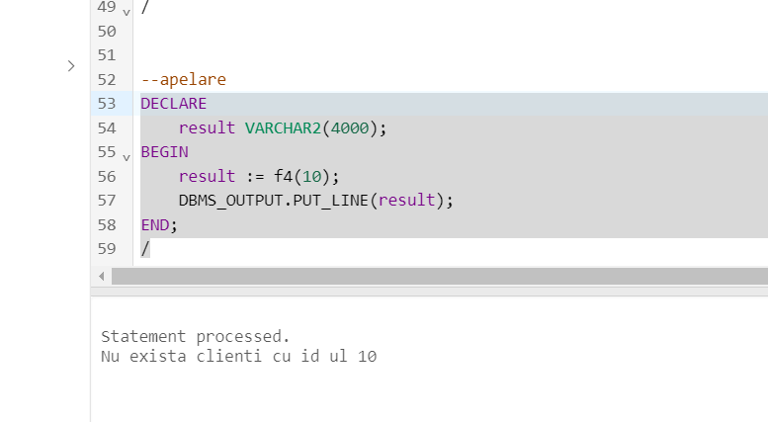

9.Definiti o procedura stocata independent care afiseaza numele clientilor care beneficiaza de un singur serviciu financiar, de servicii de tip private banking si care au un credit aprobat. Sa se testeze pentru clientii cu id ul 1, 4, 5,2,10 .

CREATE OR REPLACE PROCEDURE p1 (v_id clienti_www.client_id%type)

IS

v_nume clienti_www.nume%type;

exceptie_credit_privat EXCEPTION;

v_status_credit credit_www.status%type;

v_privat private_banking_www.tip_serviciu_privat%type;

exceptie_credit EXCEPTION;

exceptie_privat EXCEPTION;

BEGIN

SELECT c.nume, cr.status, p.tip_serviciu_privat

INTO v_nume, v_status_credit, v_privat

FROM clienti_www c, clienti_cu_servicii_financiare_www csf, servicii_financiare_www s, private_banking_www p, credit_www cr

WHERE c.client_id = csf.client_id

AND csf.id_financiar = s.id_financiar

AND c.client_id = cr.client_id

AND c.client_id = p.client_id

AND c.client_id = v_id

AND ROWNUM = 1;

IF v_status_credit IS NULL OR v_status_credit = 'In asteptare' THEN

IF v_privat IS NULL THEN

RAISE exceptie_credit_privat;

ELSE

RAISE exceptie_credit;

END IF;

END IF;

IF v_privat IS NULL THEN

RAISE exceptie_privat;

END IF;

DBMS_OUTPUT.PUT_LINE('Clientul cu id ul ' ||v_id|| ' se numeste: ' || v_nume);

EXCEPTION

WHEN TOO_MANY_ROWS THEN

DBMS_OUTPUT.PUT_LINE('clientul cu id ul ' || v_id || ' beneficiaza de mai multe servicii financiare');

WHEN NO_DATA_FOUND THEN

DBMS_OUTPUT.PUT_LINE('Nu exista clientul cu id ul ' || v_id );

WHEN exceptie_credit_privat THEN

DBMS_OUTPUT.PUT_LINE('Clientul cu id ul ' || v_id || ' nu are un credit aprobat si nu beneficiaza de un serviciu privat');

WHEN exceptie_credit THEN

DBMS_OUTPUT.PUT_LINE('Clientul cu id ul ' || v_id || ' nu are un credit aprobat');

WHEN exceptie_privat THEN

DBMS_OUTPUT.PUT_LINE('Clientul cu id ul ' || v_id || ' nu beneficiaza de un serviciu privat');

END p1;

/

BEGIN

p1(1);

END;

/

BEGIN

p1(4);

END;

/

BEGIN

p1(5);

END;

/

BEGIN

p1(2);

END;

/

BEGIN

p1(10);

END;

/

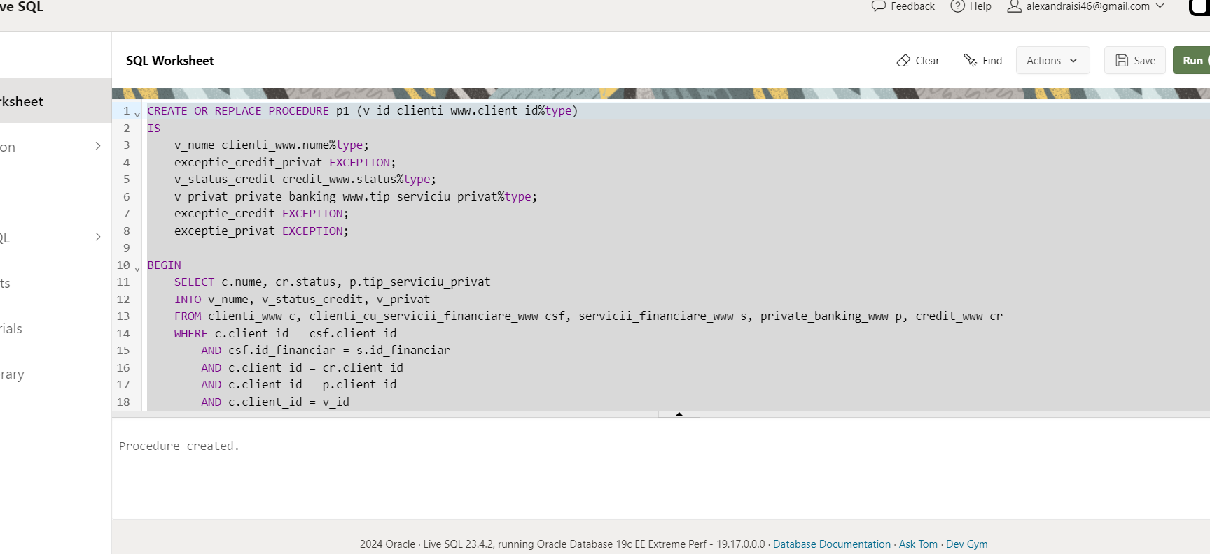

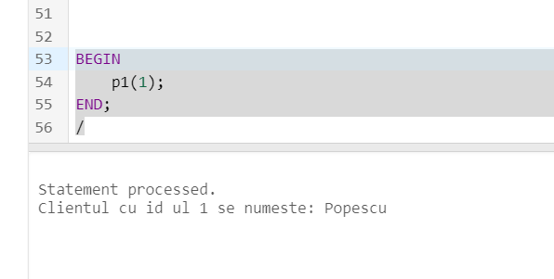

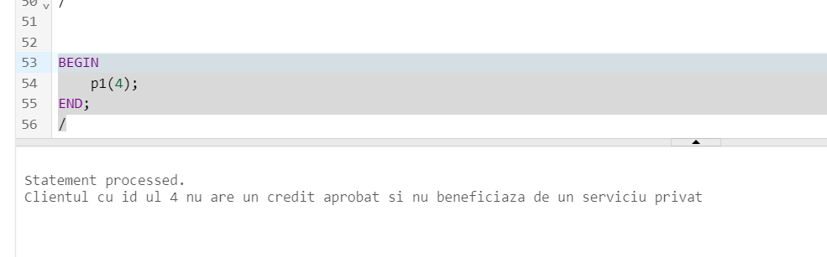

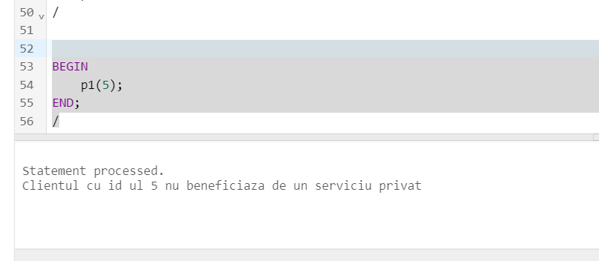

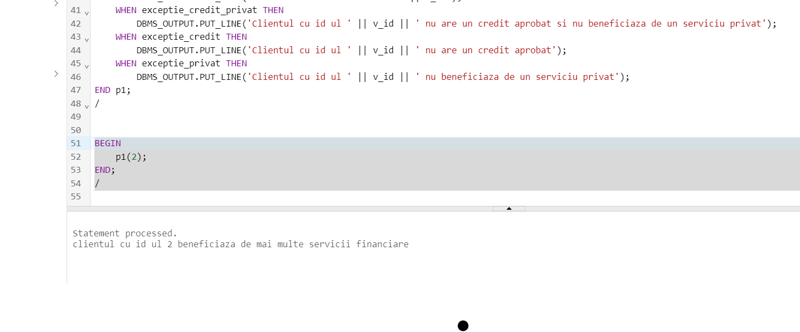

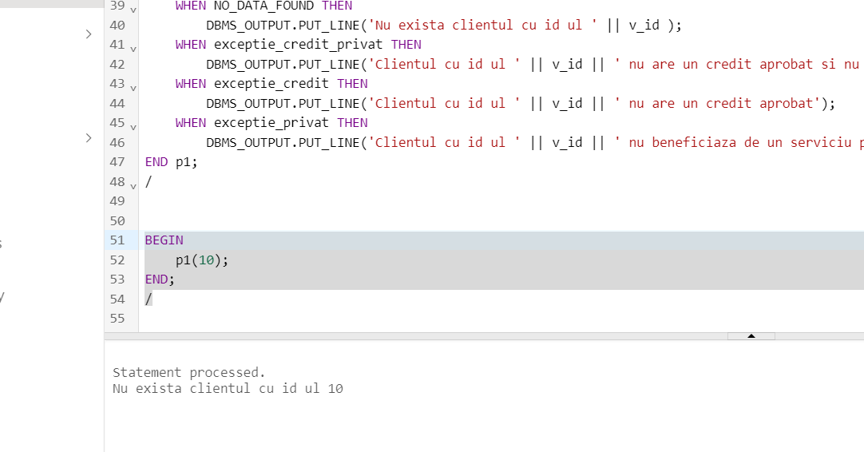

10.Creeaza un tabel "cl" care sa contina clientul cu numele Ionescu. Defineste un trigger care sa permita stergerea asupra tabelului cl doar de luni pana vineri. Declanseaza triggerul.

create table cl as

select nume

from clienti_www

where nume like '%Ionescu%';

CREATE OR REPLACE TRIGGER trg1

BEFORE DELETE ON cl

BEGIN

IF TO_CHAR(SYSDATE, 'DY') IN ('SAT', 'SUN') THEN

RAISE_APPLICATION_ERROR(-20001, 'tabelul nu poate fi sters');

END IF;

END;

/

select * from cl;

delete from cl;

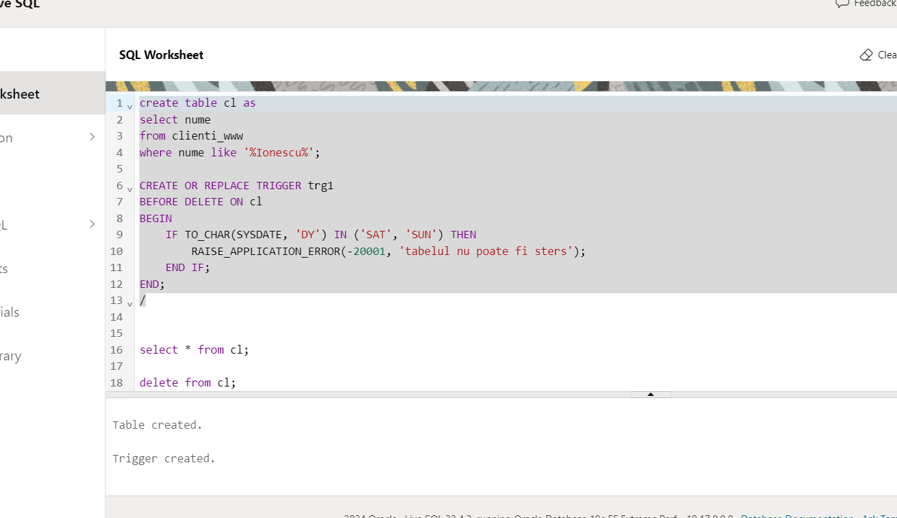

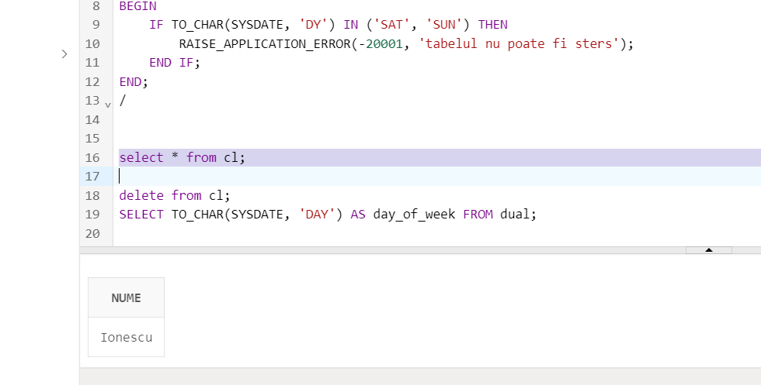

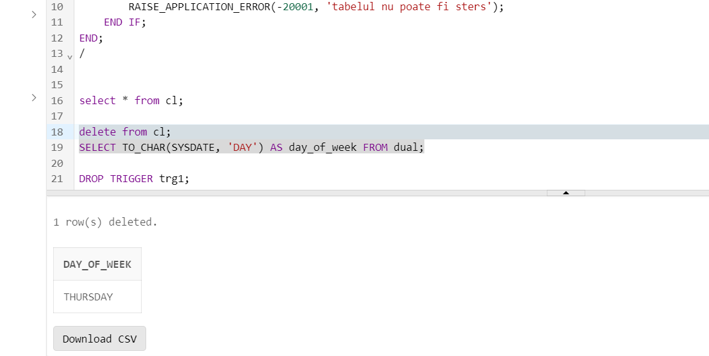

11. Definiti un trigger care sa nu permita marirea limitei unui cont din tabelul conturi_www.

create or replace trigger trg2

before update of limita_zilnica on conturi_www

for each row

begin

if(:new.limita_zilnica > :old.limita_zilnica) then

raise_application_error( - 20001, 'limita zilnica nu poate fi marita');

end if;

end;

/

update conturi_www

set limita_zilnica = limita_zilnica + 1000;

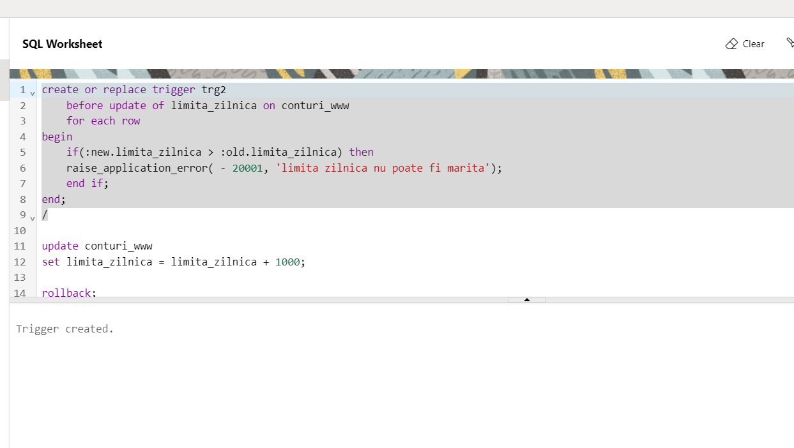

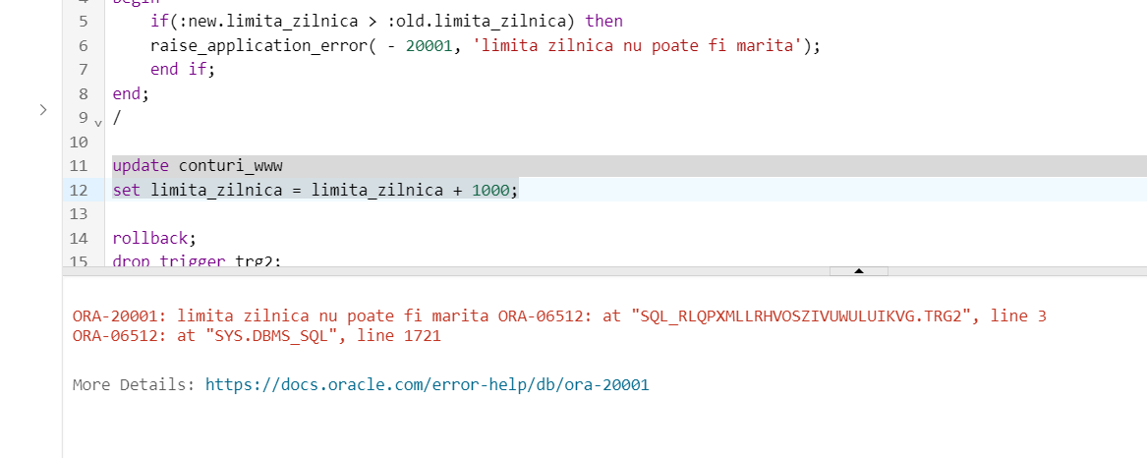

12. Creeaza tabelul "evidenta" cu urmatoarele campuri: eroare si data(data producerii evenimentului). Defineste un declansator care sa introduca date in tabelul "evidenta" dupa ce o eroare a aparut.

CREATE TABLE evidenta

( eroare varchar2(2000),

data Date);

CREATE OR REPLACE TRIGGER trg3

AFTER SERVERERROR ON SCHEMA

BEGIN

INSERT INTO evidenta

VALUES (DBMS_UTILITY.FORMAT_ERROR_STACK, SYSDATE);

END;

/

select 10/0 from dual;

drop table evidenta;

drop trigger trg3;

SELECT * FROM evidenta;

