**Robot’s Rover Preliminary Report Design**

**Table of contents**

|  |  |
| --- | --- |
| **Page** | **Title** |
|  | Robot’s Fever team |
|  | Team Task Sharing |
|  | Cansat requirements |
|  | Secondary mission description |
|  | Secondary mission stating |
|  | Preliminary budget |
|  | Detailed development budget |
|  | Cansat architecture and blueprints |
|  | Test schedule |

**Progress report**

**Progress statement**

**Task list**

**Detailed project status**

**Design Document**

**Team organisation and roles**

**Robot’s Fever team**

Our team in alphabetical order:

* Buzgan Paul – 17 years old – ”Dragoș Vodă” National College Câmpulung Moldovenesc
* Diaconu Călin - 18 years old – ”Dragoș Vodă” National College Câmpulung Moldovenesc
* Florescu Teodora - 17 years old – ”Dragoș Vodă” National College
* Hariga George - 17 years old – Military National College ”Ștefan cel Mare” Câmpulung Moldovenesc
* Savin Alexandru - 17 years old – Military National College ”Ștefan cel Mare” - Câmpulung Moldovenesc
* Ursachi Radu - 17 years old – ”Dragoș Vodă” National College Câmpulung Moldovenesc

Our team’s coordinator teacher is Măgurean Marius from Military National College ”Ștefan cel Mare” Câmpulung Moldovenesc

**Team Roles**

The CanSat Flight Operations Team in alphabetical order

|  |  |  |
| --- | --- | --- |
| No. | Department | Name |
|  | Mission Manager | Prof. Măgurean Marius |
| 2. | Design Team | Everybody  3 weekly meetings/2 hours/meeting |
| 3. | Construction Team | Buzgan Paul  Ursachi Radu  3 weekly meetings/3 hours/meeting  Indefined individual work |
| 4. | Integration Team | Buzgan Paul  Hariga George  Ursachi Radu  3 weekly meetings/2 hours/meeting  Indefined individual work |
| 5. | Software development | Diaconu Călin  Florescu Teodora  Hariga George  Savin Alexandru  5 weekly meetings/2 hours/meeting |
| 6. | Testing team | Buzgan Paul  Diaconu Călin  Ursachi Radu  Each time after task completed |
| 7. | Data gathering | Florescu Teodora  Buzgan Paul  During tests and contest  Data manipulation – 2 times/week |
| 8. | Presentation Team | Florescu Teodora  Savin Alexandru  1 weekly meeting, contest |

**Mission objectives**

Our secondary mission is to measure the betta and gamma radiation level in the launch area. In addition, the can will bring information about orientation, determined by an accelerometer, but also moisture which together with temperature and pressure can compute other indices (e.g. dewpoint). All this will be correlated with latitude, longitude, altitude and time they were taken, determined by a GPS module. Information will be stored on can’s memory card and transmitted in real time via radio. After landing, the GPS module will help locating, unless it can be pursued during the fall.

We’ve choosen this mission inspired by the Fukushima’s events that took place in 2011. One problem was to determine how the radioactive clouds evolved in time and to draw an exclusion zone (evacuation zone) without sending people to measure that. So, we figured out that we can construct a remote control device who will measure and gather the necessary data. Due to limited cost, an entire fleet of cansats can be sent and, in case of contamination, they will be abandoned.

**Cansat requirements**

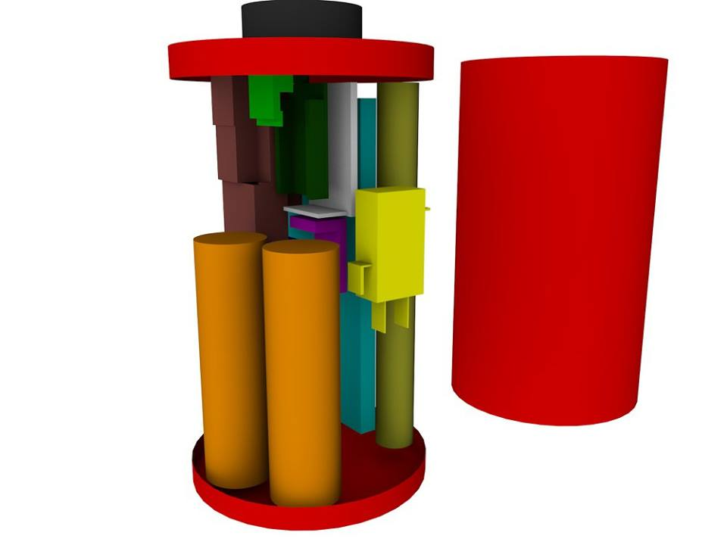In order to meet the cansat required seizes, we have designed a 3D model in Cinema 4D.

To be updated with specifics (antenna, gps antenna integration)

Total mass (item1 + item2 + ….item n estimation)

As detaliated in model, the battery is easy accessible and we have a master power switch.

As a beeper we have a phone’s speaker attached to our cansat. Moreover, we have a GPS sensor who tracks the cansat coordinates.

For our parachute to withstand a 1000N of force, we made the following calculations:

Nina’s formulas (to be completed……)

Acceleration 20g – how?

**Secondary mission description**

**Traducerea din formularul de aplicare**

**Secondary mission stating**