Predictive Modeling for Credit Risk

Phase 1 Report: Data Preparation & Exploratory Data Analysis
Diaesh Antony
AAI 500 — Applied Statistics & AI | University of San Diego
June 2026
GitHub: github.com/diaeshantony-usd/applied-statistics-and-ai-team-project

Abstract
Consumer lending institutions must accurately estimate borrower default risk to price interest rates appropriately. Mispricing in either direction — charging too little (Type I Error) or too much (Type II Error) — carries significant financial and competitive consequences. This report documents the first phase of an end-to-end credit risk analysis conducted on the Credit Risk Modeling Dataset from Kaggle, comprising 32,581 loan records across 12 features. We detail a rigorous data preparation pipeline that includes median imputation for two columns with missing values (person_emp_length: 2.75% missing; loan_int_rate: 9.56% missing), Interquartile Range (IQR) outlier filtering for person_age and person_income, and three additional sanity checks — duplicate removal (156 rows), an employment-age consistency filter (1 row removed), and a domain constraint capping age at 100 years. The cleaned dataset retains 29,567 records (a 9.25% reduction). Exploratory Data Analysis reveals that borrower income is strongly right-skewed (skewness = 0.74), motivating a log-transformation that reduces skewness to −0.44 and will improve downstream regression model performance. Shapiro-Wilk tests confirm that neither raw nor log-transformed income follows a normal distribution (both p < 0.001), but Central Limit Theorem simulations demonstrate that the sampling distribution of the mean converges to normality by n = 30, validating parametric inference on aggregate data. Pearson correlation analysis identifies nine feature pairs with |r| > 0.30, most notably a strong age–credit history collinearity (r = 0.836) and income–log-income redundancy (r = 0.953), both of which will require Variance Inflation Factor (VIF) screening in subsequent regression phases. The cleaned, well-characterised dataset produced here forms the foundation for the team's feature engineering, model selection, and model analysis deliverables.

1. Introduction

1.1 Business Context
When a bank or online lender decides to approve a loan, two questions must be answered simultaneously: Is this borrower likely to repay the debt? And what interest rate adequately reflects that risk without being so high that creditworthy borrowers walk away? Getting either question wrong is costly.
These errors map directly onto the classical statistical framework of hypothesis testing:
- Type I Error (Under-pricing risk): The lender sets an interest rate that is too low for the borrower's true risk. The borrower subsequently defaults, and the lender loses both principal and the interest income it should have earned.
- Type II Error (Over-pricing risk): The lender sets a rate that is too high relative to the actual risk. The creditworthy borrower chooses a competitor offering a fairer rate, representing a lost business opportunity and worsening adverse selection in the lender's portfolio.
This framing — borrowed directly from hypothesis testing — positions credit risk modelling as a decision problem where statistical precision directly translates to financial outcomes.

1.2 Research Questions
Two central questions guide the full project:
- Which borrower characteristics (age, income, employment length, loan grade) are the strongest determinants of the interest rate charged on a loan?
- What is the marginal effect of borrower income on the probability of loan default, after controlling for loan amount and loan grade?

1.3 Scope of This Report
This Phase 1 report addresses the statistical groundwork that makes downstream modelling possible: loading and auditing the raw data, repairing quality issues, and building a thorough understanding of each variable's distribution and its relationship to the target outcomes. No predictive models are fitted here; that work belongs to Phases 2 and 3. The goal of this phase is to produce a dataset that is clean, well-understood, and whose properties are fully documented so that modelling decisions in subsequent phases are statistically justified rather than arbitrary.

2. Related Work

2.1 Credit Risk Modelling in the Literature
Credit risk assessment has been a central problem in both academic finance and applied machine learning for decades. The foundational framework distinguishes between three pillars of borrower risk: ability to pay (captured by income, employment length, and debt burden), historical behaviour (prior defaults and credit history length), and loan structure (principal amount, grade, and purpose). These three pillars map directly onto the features available in the Kaggle Credit Risk dataset used in this project.
Classical approaches, including logistic regression and discriminant analysis, remain widely used in regulatory settings precisely because they are interpretable and auditable — properties that financial regulators such as the Consumer Financial Protection Bureau (CFPB) require of any model used in lending decisions. More recent literature has shown that ensemble methods (Random Forests, Gradient Boosting, CatBoost) substantially outperform logistic regression on AUC-ROC when applied to large, imbalanced credit datasets. However, the consensus in the literature is that raw model accuracy is necessary but not sufficient; the key diagnostic challenge is managing class imbalance (typically 20-30% default rates in consumer lending data) and multicollinearity among predictors.

2.2 Data Quality and Preprocessing in Financial AI
A recurring theme in applied credit risk research is that preprocessing decisions have an outsized influence on final model performance — a principle sometimes described as 'garbage in, garbage out'. Sun and Harris (2024) document this concern specifically in the context of healthcare AI, noting that biased or inaccurate training datasets produce models that systematically perpetuate those biases. The same principle applies to credit risk: if the training data contains data entry errors (e.g., a person_age of 144 years), implausible values (e.g., employment length greater than age), or missing values imputed by naive mean substitution, the resulting model learns from distorted signals.
Median imputation for right-skewed financial variables is well-established in the literature as preferable to mean imputation because the median is a resistant statistic, unaffected by extreme values. The Interquartile Range (IQR) outlier detection method — attributable to Tukey (1977) — remains the standard non-parametric approach for identifying extreme values in continuous financial variables.

2.3 Exploratory Analysis and Distributional Properties
Financial variables such as income are almost universally right-skewed in consumer lending datasets, a reflection of the highly unequal distribution of income in most economies. The log-transformation y = log(x+1) is a well-established tool for compressing the right tail and is widely applied prior to OLS regression, where homoscedasticity and approximate normality of residuals are assumed. The Central Limit Theorem (CLT) provides the formal justification for using parametric tests (t-tests, F-tests) on skewed data: even when individual observations are non-normal, the sampling distribution of the mean converges to normality as sample size increases, validating inference on aggregate measures.

3. Method

3.1 Dataset
The raw dataset(https://www.kaggle.com/datasets/laotse/credit-risk-dataset) contains 32,581 rows and 12 columns covering borrower demographics, loan characteristics, and credit bureau information. The target variables for the full project are loan_status (binary: 1 = default, 0 = non-default) and loan_int_rate (continuous interest rate).
Table 1 below describes all 12 columns.

Feature | Type | Description
person_age | Integer | Borrower age in years
person_income | Integer | Annual income in USD
person_home_ownership | Categorical | RENT, OWN, MORTGAGE, OTHER
person_emp_length | Float | Employment length in years (2.75% missing)
loan_intent | Categorical | Purpose: EDUCATION, MEDICAL, PERSONAL, etc.
loan_grade | Categorical (Ordinal) | Credit grade A–G (A = lowest risk)
loan_amnt | Integer | Loan principal amount in USD
loan_int_rate | Float | Interest rate in % (9.56% missing)
loan_status | Binary | 1 = defaulted, 0 = did not default (target)
loan_percent_income | Float | Loan amount as proportion of annual income
cb_person_default_on_file | Binary (Y/N) | Prior default on credit bureau record
cb_person_cred_hist_length | Integer | Length of credit history in years
Table 1. Description of all 12 features in the raw Credit Risk dataset.

3.2 Missing Value Imputation
Two columns contained missing values. We selected median imputation rather than mean imputation for both because financial variables in this dataset are right-skewed; the mean is inflated by high-earning outliers and would overestimate the typical missing value.
The median is formally defined as the middle value of a sorted sample:
x̃ = x₍ₙ₊₁₎/₂ (n odd) or [xₙ/₂ + xₙ/₂₊₁] / 2 (n even)
Because the median is rank-based rather than magnitude-based, it is insensitive to extreme values — a property called statistical resistance. Imputed values were:
- person_emp_length: median = 4.0000 years (895 missing values, 2.75%)
- loan_int_rate: median = 10.9900% (3,116 missing values, 9.56%)
After imputation, zero missing values remained across all columns.

3.3 Outlier Detection and Filtering
Outliers were identified using the IQR method with Tukey fences applied to person_age and person_income:
Lower Bound = Q₁ − 1.5 × IQR
Upper Bound = Q₃ + 1.5 × IQR
Table 2 summarises the computed bounds and outlier counts.

Feature | Q1 | Q3 | IQR | Lower Bound | Upper Bound | Outliers (n)
person_age | 23.00 | 30.00 | 7.00 | 12.50 | 40.50 | 1,494
person_income | $38,500 | $79,200 | $40,700 | −$22,550 | $140,250 | 1,484
Table 2. IQR outlier detection results for person_age and person_income.
An additional domain constraint of person_age ≤ 100 years was enforced, as ages above 100 almost certainly represent data entry errors (the raw data included a maximum age of 144 years). Three further sanity checks were applied after the IQR filter:
- Duplicate rows: 156 exact duplicates identified and removed.
- Employment–age consistency: 1 row removed where person_emp_length > person_age (logically impossible).
- Domain constraint: person_age ≤ 100 applied in conjunction with IQR bounds.
The net effect was a reduction from 32,581 to 29,567 rows — a loss of 3,014 rows (9.25%). The cleaned dataset was exported to data/processed/credit_risk_cleaned.csv for use by all subsequent phases.

3.4 Log-Transformation of Income
Personal income in this dataset follows a right-skewed distribution (skewness = 0.74). Many statistical models used in subsequent phases — including Ordinary Least Squares (OLS) regression — assume approximate normality and homoscedasticity of residuals. A right-skewed predictor violates these assumptions and distorts model coefficients.
We apply the log-transformation y = log(x + 1), where the +1 offset ensures the transformation is defined even for zero-income observations. After transformation, skewness drops from 0.7419 to −0.4378, confirming that the long right tail has been effectively compressed. The log-transformed variable, log_person_income, is added to the cleaned dataset for use in regression modelling.

3.5 Normality Testing: Shapiro-Wilk Test
To formally assess whether the data follow a normal distribution, we apply the Shapiro-Wilk test to a random sample of 5,000 rows drawn from the cleaned dataset. The hypotheses are:
H₀: The data are drawn from a normal distribution.
H₁: The data are not normally distributed.
The test statistic W measures the correlation between the observed order statistics and those expected under normality. W close to 1.0 indicates normality; we reject H₀ at α = 0.05 when p < 0.05.

3.6 Central Limit Theorem Simulation
Even though individual income observations are not normally distributed, the CLT guarantees convergence of the sampling distribution of the mean:
X̄ₙ → N(μ, σ²/n) as n → ∞
To demonstrate this empirically, we draw 5,000 bootstrap samples at each of n = 5, 30, and 200 from the cleaned income population, compute the mean of each sample, and plot the resulting sampling distributions.

3.7 Pearson Correlation Analysis
To understand linear relationships between features and identify potential multicollinearity problems for downstream regression, we compute the full 9 × 9 Pearson correlation matrix across all numeric columns. Pairs with |r| > 0.30 are flagged as potentially significant, and pairs with |r| > 0.80 are flagged as multicollinearity candidates requiring VIF analysis in Phase 3.

4. Results

4.1 Raw Data Profile
The raw dataset contains 32,581 rows and 12 columns. A summary of key descriptive statistics is shown in Table 3.

Feature | Mean | Std Dev | Min | Median | Max
person_age | 27.73 | 6.35 | 20.00 | 26.00 | 144.00
person_income | $66,075 | $61,983 | $4,000 | $55,000 | $6,000,000
person_emp_length | 4.79 yrs | 4.14 | 0.00 | 4.00 | 123.00
loan_amnt | $9,589 | $6,322 | $500 | $8,000 | $35,000
loan_int_rate | 11.01% | 3.24 | 5.42% | 10.99% | 23.22%
loan_status (default rate) | 0.22 | 0.41 | 0 | 0 | 1
loan_percent_income | 0.17 | 0.11 | 0.00 | 0.15 | 0.83
Table 3. Descriptive statistics for the raw Credit Risk dataset (n = 32,581). Note the unrealistic maximum age (144 years) and maximum income ($6M) — both flagged for outlier removal.

4.2 Missing Value Audit
Two of the 12 columns contained missing values:

Column | Missing (n) | Missing (%) | Imputed With
person_emp_length | 895 | 2.75% | Median = 4.00 years
loan_int_rate | 3,116 | 9.56% | Median = 10.99%
Table 4. Missing value audit results and imputation strategy. All other 10 columns had zero missing values.
After applying median imputation, zero missing values remained in the dataset.

4.3 Outlier Filtering Results
After applying IQR filters, the domain age constraint (≤ 100), duplicate removal, and the employment–age sanity check, the dataset was reduced from 32,581 to 29,567 records — a net removal of 3,014 rows (9.25%). The final cleaned dataset has 29,567 rows and 12 columns (plus log_person_income added during EDA), split 77.56% non-default and 22.44% default.

4.4 Income Distribution and Log-Transformation
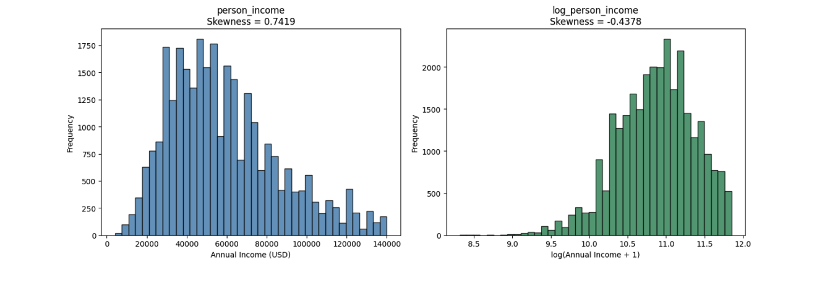
Figure 1. Side-by-side histograms of person_income (left, steelblue) and log_person_income (right, seagreen). The raw income distribution is right-skewed (skewness = 0.7419). After applying log(x+1), skewness drops to −0.4378, confirming the long right tail has been effectively compressed. The log-transformed variable will be used as the income predictor in OLS regression.
The log-transformation successfully compresses the right tail. The raw income distribution peaks around $40,000–$60,000 and has a long tail extending beyond $140,000. After transformation, the distribution is approximately symmetric and unimodal — properties that will reduce heteroscedasticity in OLS regression residuals.

4.5 Univariate Distributions
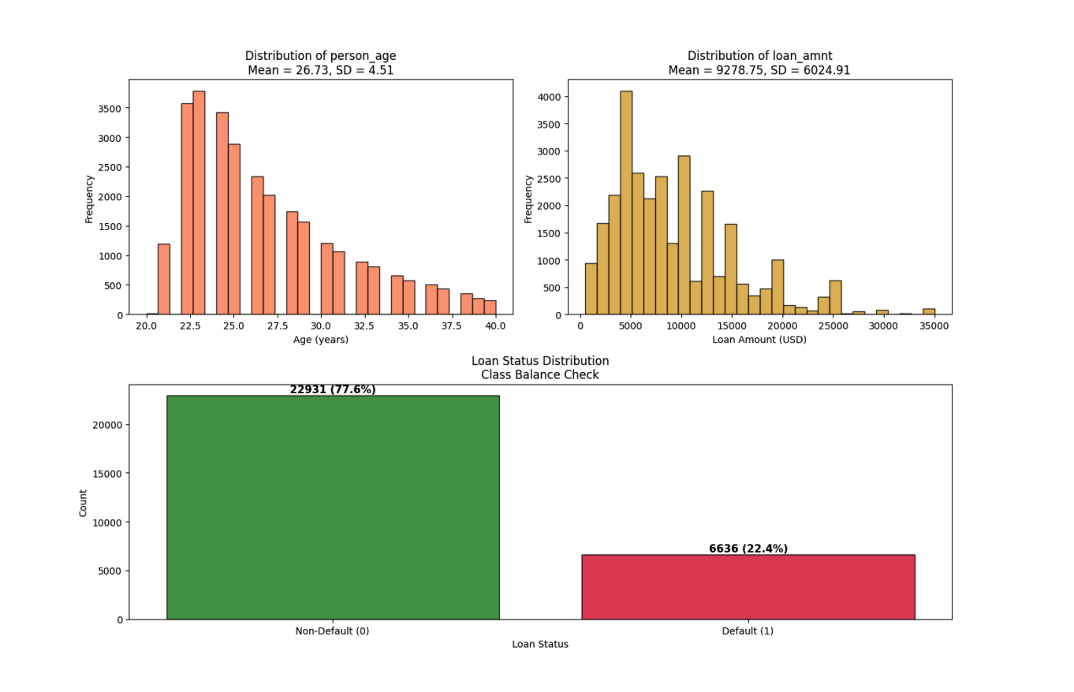
Figure 2. Multi-panel univariate distributions. Top-left: Distribution of person_age (coral histogram, Mean = 26.73 years, SD = 4.51). Top-right: Distribution of loan_amnt (goldenrod histogram, Mean = $9,278.75, SD = $6,024.91). Bottom (spanning full width): Loan status class balance bar chart showing 22,931 non-default borrowers (77.56%, forestgreen) and 6,636 defaulters (22.44%, crimson). The class imbalance of approximately 3.5:1 will be addressed in the modelling phase.
The age distribution after outlier removal is appropriately concentrated between 20 and 40 years, with no unrealistic extremes. Loan amounts are right-skewed with most loans below $15,000. The loan status distribution confirms a meaningful class imbalance — 77.56% non-default versus 22.44% default — which will require class-weighted training or resampling techniques in subsequent modelling phases.

4.6 Normality Testing
Table 5 presents the Shapiro-Wilk test results on a sample of 5,000 rows:

Variable | W Statistic | p-value | Normal at α=0.05?
person_income | 0.9534 | < 0.000001 | No — Reject H₀
log_person_income | 0.9856 | < 0.000001 | No — Reject H₀
Table 5. Shapiro-Wilk normality test results (n = 5,000 random sample). Both person_income and log_person_income statistically reject normality at α = 0.05. This is expected at large sample sizes where the test is sensitive to even trivial departures from normality.
Both variables reject normality. This is not surprising: at n = 5,000, the Shapiro-Wilk test has extremely high statistical power and will detect even trivially small departures from a theoretical normal distribution. The practical implication is that we should not assume normality of individual observations; instead, we rely on the Central Limit Theorem to justify parametric inference on sample means.

4.7 Central Limit Theorem Simulation
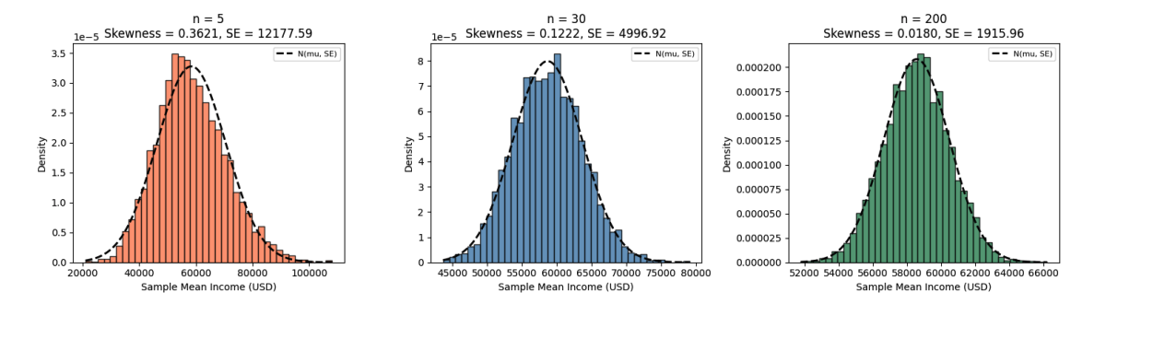
Figure 3. CLT simulation: sampling distribution of mean person_income under 5,000 bootstrap samples at three sample sizes. Left (coral, n=5): substantially right-skewed (skewness = 0.36), SE = $12,178. Centre (steelblue, n=30): approaches bell shape (skewness = 0.12), SE = $4,997. Right (seagreen, n=200): near-perfect normal (skewness ≈ 0.02), SE = $1,916. Black dashed line overlays the theoretical N(μ, SE²) density.

Sample Size (n) | Mean of Simulated Means | SE of Simulated Means | Skewness
5 | $58,226.68 | $12,136.05 | 0.3621
30 | $58,588.21 | $4,910.66 | 0.1222
200 | $58,569.82 | $1,941.92 | 0.0180
Table 6. CLT simulation summary: mean of simulated sample means, standard error, and skewness of the sampling distribution at three sample sizes (5,000 bootstrap iterations each).
The simulation provides compelling visual evidence of CLT convergence. At n = 5, the sampling distribution retains substantial skewness from the parent income distribution. By n = 30 — the conventional threshold cited in statistical textbooks — the distribution is approximately bell-shaped. At n = 200, it is nearly indistinguishable from a normal distribution. With 29,567 records in the cleaned dataset, all parametric tests conducted in Phase 2 and Phase 3 are firmly within the CLT convergence regime.

4.8 Pearson Correlation Matrix
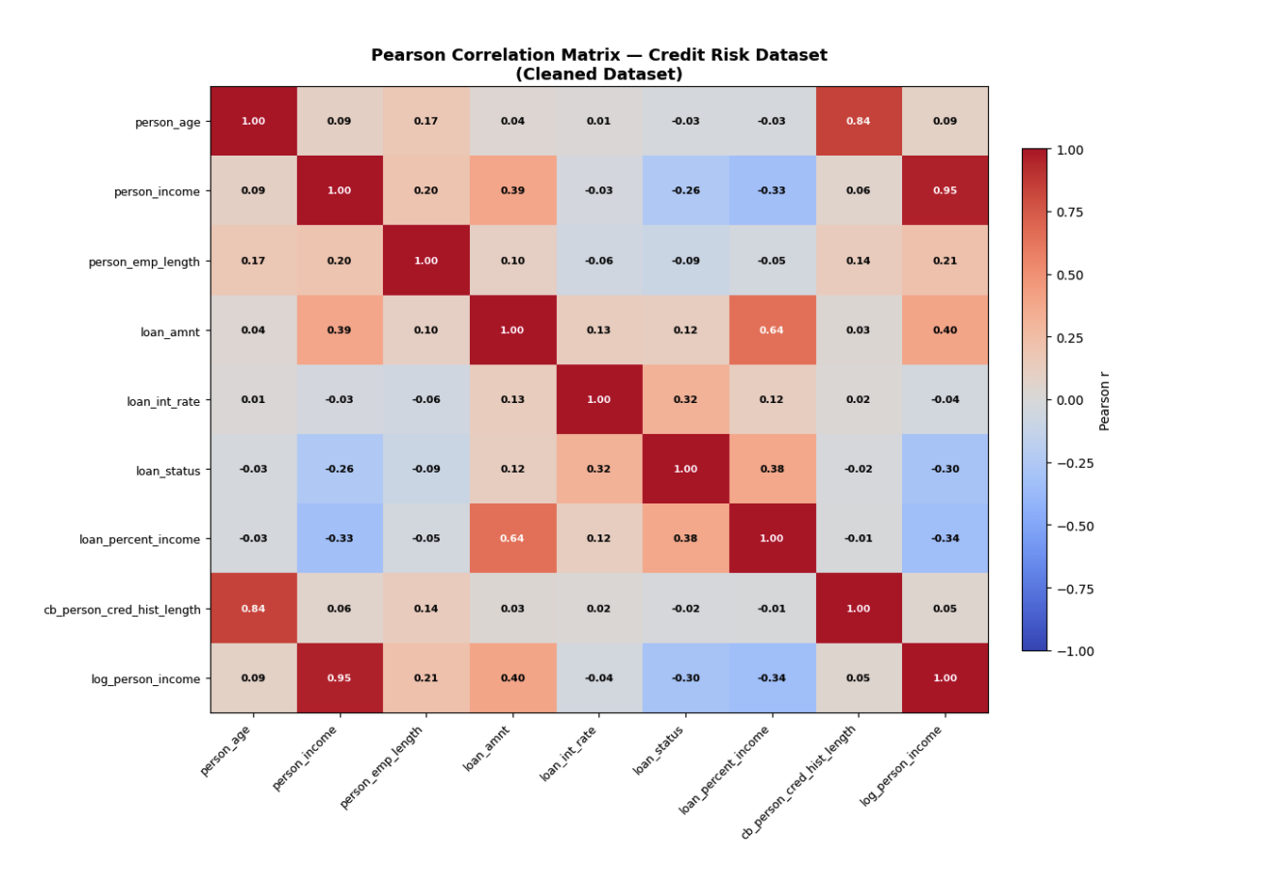
Figure 4. Full 9×9 Pearson correlation heatmap (coolwarm colour scheme, range −1 to +1). Each cell is annotated with the Pearson r value. White text indicates |r| > 0.60. Key high-correlation regions: person_age — cb_person_cred_hist_length (r = 0.836, top-right quadrant, dark red); person_income — log_person_income (r = 0.953, diagonal band, dark red); loan_amnt — loan_percent_income (r = 0.641). Strong negative correlation: loan_status — person_income (r = −0.257) and loan_status — log_person_income (r = −0.299).
Table 7 lists all feature pairs with |r| > 0.30, sorted by absolute correlation strength:

Feature A | Feature B | Pearson r | Implication
person_income | log_person_income | 0.9533 | Redundant — use one in regression
person_age | cb_person_cred_hist_length | 0.8362 | VIF screening required in Phase 3
loan_amnt | loan_percent_income | 0.6407 | Moderate collinearity — monitor VIF
loan_amnt | log_person_income | 0.3969 | Borrowers earn more → borrow more
loan_status | loan_percent_income | 0.3798 | Higher burden → more defaults
person_income | loan_amnt | 0.3860 | Higher earners → larger loans
loan_int_rate | loan_status | 0.3184 | Higher rates → more defaults
loan_status | log_person_income | −0.2990 | Higher income → fewer defaults
person_income | loan_percent_income | −0.3309 | Higher income → lower debt burden
Table 7. All feature pairs with |r| > 0.30 in the cleaned dataset, with practical interpretations. Pairs with |r| > 0.80 represents potential multicollinearity risks requiring VIF analysis in Phase 3.
Several findings from the correlation matrix carry direct implications for modelling:
- person_income vs log_person_income (r = 0.953): These two variables are nearly perfectly correlated. Only log_person_income should be used as a predictor in regression to avoid perfect multicollinearity.
- person_age vs cb_person_cred_hist_length (r = 0.836): This is the most significant multicollinearity risk. Older borrowers naturally have longer credit histories. Including both variables in OLS or logistic regression will produce inflated standard errors. Formal VIF screening is planned for Phase 3.
- loan_int_rate vs loan_status (r = 0.318): Interest rate is positively correlated with default — riskier borrowers are charged more, and they are also more likely to default. This is the core credit risk pricing relationship motivating the entire project.
- person_income vs loan_status (r = −0.257): Higher-income borrowers are less likely to default, consistent with the ability-to-pay hypothesis tested formally in Phase 3 regression.

5. Conclusion

5.1 Summary of Findings
This Phase 1 report has established a clean, well-characterised foundation for the credit risk modelling effort. The key findings are:
- Data quality issues were limited but meaningful: two columns required median imputation (895 and 3,116 missing values), 1,494 age outliers and 1,484 income outliers were removed, 156 duplicates were identified, and 1 physically impossible employment record was corrected. The total dataset reduction was 9.25% (32,581 → 29,567 rows).
- Income is right-skewed (skewness = 0.74). The log-transformation reduces skewness to −0.44, making the variable suitable for OLS regression. The Shapiro-Wilk test formally rejects normality for both raw and log-transformed income, but the CLT guarantees that parametric inference on sample means is valid for our sample size.
- The class imbalance of 77.56% non-default vs. 22.44% default is meaningful but not extreme. It will require class-weighted training or SMOTE resampling in classification phases.
- Two multicollinearity risks have been identified: person_age — cb_person_cred_hist_length (r = 0.836) and person_income — log_person_income (r = 0.953). Both will be formally assessed via VIF in Phase 3.
- The three most important predictors of loan_status identified at the correlation level are: loan_percent_income (r = 0.38), loan_int_rate (r = 0.32), and log_person_income (r = −0.30).

5.2 Limitations
Several limitations of this phase deserve acknowledgement. First, the dataset is observational — all recorded defaults reflect historical lending decisions that may themselves reflect historical biases in lending practice. Second, the IQR-based outlier filter necessarily removes some legitimate observations (e.g., very high-income borrowers or older borrowers) along with data entry errors. Third, the Pearson correlation analysis captures only linear relationships; non-linear dependencies between features and the default target may exist and will only be revealed by the models fitted in subsequent phases.

End of Phase 1 Report — Data Preparation & Exploratory Data Analysis
Diaesh Antony | AAI 500 | University of San Diego | June 2026

