Predictive Modeling for Credit Risk

N L N Sai Krishna Akula, Diaesh Antony and Ashok Kumar Bhairwal
University of San Diego
AAI-500-IN1: Applied Probability and Statistics for AI
Dr. Ebrahim Tarshizi
June 15, 2026

Abstract
Consumer lending requires precise estimation of borrower default risk and appropriate interest rate pricing to mitigate financial losses and competitive disadvantages. This project develops a comprehensive predictive modeling framework using a Kaggle Credit Risk Dataset of 32,581 loan records. Following rigorous data preprocessing–including median imputation (Little & Rubin, 2019), outlier filtering, and log-transformation–the study evaluated multiple classification and regression models. The CatBoost (Prokhorenkova et al., 2018) classifier achieved the strongest default prediction performance (ROC-AUC = 0.9430, Accuracy = 93.78%) at a standard 0.50 cutoff, while Gradient Boosting (Friedman, 2001) provided robust estimates for loan amount and percent of income. A cost-focused threshold of 0.15 was identified to optimize the recall of potential defaults. Diagnostic analysis confirmed excellent model calibration (Brier Score (Brier, 1950) = 0.0532) and highlighted performance variations across loan grades, with SHAP values demonstrating the high impact of income-to-loan ratios and loan intent on predictions. These findings establish a technically sound, interpretable workflow that successfully balances predictive accuracy with transparent risk reasoning for consumer lending applications.

1. Introduction

1.1 Business Context
When a bank or online lender decides to approve a loan, two questions must be answered simultaneously: Is this borrower likely to repay the debt? And what interest rate adequately reflects that risk without being so high that creditworthy borrowers walk away? Getting either question wrong is costly.
These errors map directly onto the classical statistical framework of hypothesis testing:
- Type I Error (Under-pricing risk): The lender sets an interest rate that is too low for the borrower's true risk. The borrower subsequently defaults, and the lender loses both principal and the interest income it should have earned.
- Type II Error (Over-pricing risk): The lender sets a rate that is too high relative to the actual risk. The creditworthy borrower chooses a competitor offering a fairer rate, representing a lost business opportunity, and worsening adverse selection in the lender's portfolio.
This framing borrowed directly from hypothesis testing positions credit risk modelling as a decision problem where statistical precision directly translates to financial outcomes.

1.2 Research Questions
Two central questions guide the full project:
- Which borrower characteristics (age, income, employment length, loan grade) are the strongest determinants of the interest rate charged on a loan?
- What is the marginal effect of borrower income on the probability of loan default, after controlling for loan amount and loan grade?

1.3 Scope of This Report
This initial section addresses the statistical groundwork that makes downstream modelling possible: loading and auditing the raw data, repairing quality issues, and building a thorough understanding of each variable's distribution and its relationship to the target outcomes. No predictive models are fitted here; that work belongs to downstream modeling and diagnostics stages. The goal of this section is to produce a dataset that is clean, well-understood, and whose properties are fully documented so that modelling decisions in subsequent stages are statistically justified rather than arbitrary.

1.4 Lending Risk Assessment
When a lender reviews a loan application, the decision is not only whether the applicant should receive credit. The lender must also estimate whether the borrower is likely to repay, whether the requested loan size is reasonable, and what interest-rate behavior is consistent with the borrower and loan profile. A model that predicts default risk without explaining lending amount or interest-rate behavior gives only a partial view of the credit decision.
This problem has two important decision errors. A missed default occurs when a risky borrower is treated as safe; this is costly because the lender may lose principal and expected interest income. A false alarm occurs when a borrower who would repay is treated as risky; this can lead to rejection, unnecessary review, or lost business. These errors are similar to Type I and Type II reasoning in statistics, where the cost of each decision error matters.

1.5 Modeling Objectives
The modeling workflow has three objectives. The first is classification: predict whether a borrower will default. The second is regression: estimate loan amount, loan percent of income, and interest rate as numeric lending benchmarks. The third is interpretation: explain why borrower affordability, loan burden, credit history, and prior default behavior are useful in the prediction process.

1.6 Threshold and Interpretability Motivation
A default classifier returns a probability before it returns a label. The standard reporting cutoff is 0.50, but lending risk may justify a lower review threshold when missed defaults are considered more expensive than false alarms. This report therefore separates ordinary model performance from cost-focused threshold tuning. A Bayesian Network (Heckerman, 1997) is also included because it provides a white-box probability structure that can be inspected alongside the stronger machine learning models.

1.7 Practical Implications
The financial sector increasingly uses machine learning for credit risk assessment to predict defaults and guide lending. This shift supports decision-making under uncertainty and regulatory demands. Traditional models often fail to capture complex patterns, leading to inaccurate risk estimates and inefficient use of capital.

1.8 Objective
This study evaluates machine learning models for credit risk through classification (default prediction) and regression (loan parameters). It assesses performance, calibration, and errors using metrics like ROC-AUC, Precision-Recall, Brier Score (Brier, 1950), confusion matrix, and residual analysis, along with feature importance.

1.9 Significance and Scope of Report
The report highlights a comprehensive diagnostic approach beyond single metrics. It includes calibration, error analysis, and interpretability to ensure models are accurate, reliable, and aligned with real-world financial risk.

2. Related Work

2.1 Credit Risk Modelling in the Literature
Credit risk assessment has been a central problem in both academic finance and applied machine learning for decades. The foundational framework distinguishes between three pillars of borrower risk: ability to pay (captured by income, employment length, and debt burden), historical behavior (prior defaults and credit history length), and loan structure (principal amount, grade, and purpose). These three pillars map directly onto the features available in the Kaggle Credit Risk dataset used in this project.
Classical approaches, including logistic regression and discriminant analysis, remain widely used in regulatory settings precisely because they are interpretable and auditable – properties that financial regulators such as the Consumer Financial Protection Bureau (CFPB) require of any model used in lending decisions. More recent literature has shown that ensemble methods (Random Forests, Gradient Boosting (Friedman, 2001), CatBoost (Prokhorenkova et al., 2018)) substantially outperform logistic regression on AUC-ROC when applied to large, imbalanced credit datasets. However, the consensus in the literature is that raw model accuracy is necessary but not sufficient; the key diagnostic challenge is managing class imbalance (typically 20-30% default rates in consumer lending data) and multicollinearity among predictors.

2.2 Data Quality and Preprocessing in Financial AI
A recurring theme in applied credit risk research is that preprocessing decisions have an outsized influence on final model performance – a principle sometimes described as 'garbage in, garbage out'. Sun and Harris (2024) document this concern specifically in the context of healthcare AI, noting that biased or inaccurate training datasets produce models that systematically perpetuate those biases. The same principle applies to credit risk: if the training data contains data entry errors (e.g., a person_age of 144 years), implausible values (e.g., employment length greater than age), or missing values imputed by naive mean substitution, the resulting model learns from distorted signals.
median imputation (Little & Rubin, 2019) for right-skewed financial variables is well-established in the literature as preferable to mean imputation because the median is a resistant statistic, unaffected by extreme values. The Interquartile Range (IQR) outlier detection method – attributable to Tukey (1977) – remains the standard non-parametric approach for identifying extreme values in continuous financial variables.

2.3 Exploratory Analysis and Distributional Properties
Financial variables such as income are almost universally right skewed in consumer lending datasets, a reflection of the highly unequal distribution of income in most economies. The log-transformation y = log(x+1) is a well-established tool for compressing the right tail and is widely applied prior to OLS regression, where homoscedasticity and approximate normality of residuals are assumed. The Central Limit Theorem (CLT) provides the formal justification for using parametric tests (t-tests, F-tests) on skewed data: even when individual observations are non-normal, the sampling distribution of the mean converges to normality as sample size increases, validating inference on aggregate measures.

2.4 Credit Risk Predictors
Credit risk models commonly use three groups of predictors: ability to pay, past credit behavior, and loan structure. Ability to pay includes income, employment length, home ownership, and loan burden. Past credit behavior includes prior default status and credit history length. Loan structure includes amount, purpose, grade, interest rate, and loan percent of income. These groups are important because default risk is usually the result of several related conditions, not a single field.

2.5 Multicollinearity and Preprocessing
Multicollinearity means that a predictor can be substantially explained by other predictors. This matters because duplicate or highly dependent inputs can make coefficient-based interpretation unstable and can make the feature set harder to defend. Variance Inflation Factor (VIF; Kutner et al., 2004), or VIF, is used as a diagnostic to measure this dependency. Because VIF requires numeric inputs, categorical fields are temporarily one-hot encoded for the diagnostic, but those temporary encoded columns are not saved as permanent dataset columns.

2.6 Machine Learning Model Families
Logistic Regression and Linear Regression provide interpretable coefficient-based baselines. Random Forest models combine many decision trees to reduce instability. Gradient Boosting (Friedman, 2001) and CatBoost (Prokhorenkova et al., 2018) build sequential tree ensembles that focus on correcting earlier errors and often perform well on tabular credit data. Comparing these model families helps identify which approach gives the most reliable evidence across classification and regression metrics.

2.7 Traditional Credit Risk Assessment
Credit risk assessment initially relied on expert judgment based on borrowers' financial stability, repayment capacity, credit history, and collateral. Over time, quantitative models improved consistency and objectivity. Techniques such as Linear Regression, Discriminant Analysis, and Logistic Regression became widely used to estimate default probability and support lending decisions. Regulatory frameworks encouraged standardized practices to strengthen financial stability and capital adequacy. These models offered transparency and interpretability, making them suitable for regulatory and business use.

2.8 Machine Learning-Based Credit Risk Assessment
Advances in data and computing have driven the adoption of machine learning in credit risk modeling. Algorithms such as Decision Trees, Random Forests, Gradient Boosting (Friedman, 2001), XGBoost, SVM, and Neural Networks capture complex nonlinear relationships and often improve predictive accuracy. They enable automated decision-making and better risk discrimination. However, their complexity reduces interpretability, addressed through explainable AI techniques that provide insights into model behavior and feature importance. Modern approaches balance accuracy with transparency for reliable and accountable lending.

3. Method

3.1 Dataset
The Credit Risk Modeling Dataset was sourced from Kaggle (https://www.kaggle.com/datasets/laotse/credit-risk-dataset) and is stored in the project repository under data/raw/credit_risk_dataset.csv. The raw dataset contains 32,581 rows and 12 columns covering borrower demographics, loan characteristics, and credit bureau information. The target variables for the full project are loan_status (binary: 1 = default, 0 = non-default) and loan_int_rate (continuous interest rate).
Table 1 below describes all 12 columns.
Table 1
Description of all 12 features in the raw Credit Risk dataset
Feature | Type | Description
person_age | Integer | Borrower age in years
person_income | Integer | Annual income in USD
person_home_ownership | Categorical | RENT, OWN, MORTGAGE, OTHER
person_emp_length | Float | Employment length in years (2.75% missing)
loan_intent | Categorical | Purpose: EDUCATION, MEDICAL, PERSONAL, etc.
loan_grade | Categorical (Ordinal) | Credit grade A–G (A = lowest risk)
loan_amnt | Integer | Loan principal amount in USD
loan_int_rate | Float | Interest rate in % (9.56% missing)
loan_status | Binary | 1 = defaulted, 0 = did not default (target)
loan_percent_income | Float | Loan amount as proportion of annual income
cb_person_default_on_file | Binary (Y/N) | Prior default on credit bureau record
cb_person_cred_hist_length | Integer | Length of credit history in years

3.2 Missing Value Imputation
Two columns contained missing values. We selected median imputation (Little & Rubin, 2019) rather than mean imputation for both because financial variables in this dataset are right-skewed; the mean is inflated by high-earning outliers and would overestimate the typical missing value.
The median is formally defined as the middle value of a sorted sample:
x̃ = x₍ₙ₊₁₎/₂ (n odd) or [xₙ/₂ + xₙ/₂₊₁] / 2 (n even)
Because the median is rank-based rather than magnitude-based, it is insensitive to extreme values – a property called statistical resistance. Imputed values were:
- person_emp_length: median = 4.0000 years (895 missing values, 2.75%)
- loan_int_rate: median = 10.9900% (3,116 missing values, 9.56%)
After imputation, zero missing values remained across all columns.

3.3 Outlier Detection and Filtering
Outliers were identified using the IQR method (Tukey, 1977) with Tukey fences applied to person_age and person_income:
Lower Bound = Q₁ − 1.5 × IQR
Upper Bound = Q₃ + 1.5 × IQR
Table 2 summarizes the computed bounds and outlier counts.
Table 2
IQR outlier detection results for person_age and person_income
Feature | Q1 | Q3 | IQR | Lower Bound | Upper Bound | Outliers (n)
person_age | 23.00 | 30.00 | 7.00 | 12.50 | 40.50 | 1,494
person_income | $38,500 | $79,200 | $40,700 | −$22,550 | $140,250 | 1,484
An additional domain constraint of person_age ≤ 100 years was enforced, as ages above 100 almost certainly represent data entry errors (the raw data included a maximum age of 144 years). Three further sanity checks were applied after the IQR filter:
- Duplicate rows: 156 exact duplicates identified and removed.
- Employment–age consistency: 1 row removed where person_emp_length > person_age (logically impossible).
- Domain constraint: person_age ≤ 100 applied in conjunction with IQR bounds.
The net effect was a reduction from 32,581 to 29,567 rows – a loss of 3,014 rows (9.25%). The cleaned dataset was exported to data/processed/credit_risk_cleaned.csv for use by all subsequent stages.

3.4 Log-Transformation of Income
Personal income in this dataset follows a right-skewed distribution (skewness = 0.74). Many statistical models used in subsequent stages – including Ordinary Least Squares (OLS) regression – assume approximate normality and homoscedasticity of residuals. A right-skewed predictor violates these assumptions and distorts model coefficients.
We apply the log-transformation y = log(x + 1), where the +1 offset ensures, the transformation is defined even for zero-income observations. After transformation, skewness drops from 0.7419 to −0.4378, confirming that the long right tail has been effectively compressed. The log-transformed variable, log_person_income, is added to the cleaned dataset for use in regression modelling.

3.5 Normality Testing: Shapiro-Wilk Test
To formally assess whether the data follow a normal distribution, we apply the Shapiro-Wilk test (Shapiro & Wilk, 1965) to a random sample of 5,000 rows drawn from the cleaned dataset. The hypotheses are:
H₀: The data are drawn from a normal distribution.
H₁: The data are not normally distributed.
The test statistic W measures the correlation between the observed order statistics and those expected under normality. W close to 1.0 indicates normality; we reject H₀ at α = 0.05 when p < 0.05.

3.6 Central Limit Theorem Simulation
Even though individual income observations are not normally distributed, the CLT guarantees convergence of the sampling distribution of the mean:
X̄ₙ → N(μ, σ²/n) as n → ∞
To demonstrate this empirically, we draw 5,000 bootstrap samples at each of n = 5, 30, and 200 from the cleaned income population, compute the mean of each sample, and plot the resulting sampling distributions.

3.7 Pearson Correlation Analysis
To understand linear relationships between features and identify potential multicollinearity problems for downstream regression, we compute the full 9 × 9 Pearson correlation matrix across all numeric columns. Pairs with |r| > 0.30 are flagged as potentially significant, and pairs with |r| > 0.80 are flagged as multicollinearity candidates requiring VIF analysis in the diagnostics section.

3.8 Dataset and Engineered Modeling Variables
Feature engineering is the process of transforming, scaling, grouping, and deriving variables so statistical tests and machine learning models can better represent the structure of the problem. In this project, feature engineering is used to express borrower affordability, loan burden, employment and credit history, and prior default behavior in forms that are easier for models to learn and easier for readers to interpret.
- Log transforms reduce the influence of extreme money values in income and loan amount.
- Ratio features compare borrower capacity with loan size, which is more informative than raw dollars alone.
- Grouped features convert continuous variables into readable risk bands for EDA and Bayesian reasoning.
- Prior default indicators preserve historical credit behavior, which is highly relevant to future default risk.
Table 3
Modeling Dataset Summary
Measure | Value
Loan records | 29,567
Available modeling columns | 23
Observed default rate | 22.44%
Median borrower income | $54,000
Median loan amount | $8,000
Median loan burden | 15.00%
Figure 1
Default Rate by Grouped Borrower and Loan Features
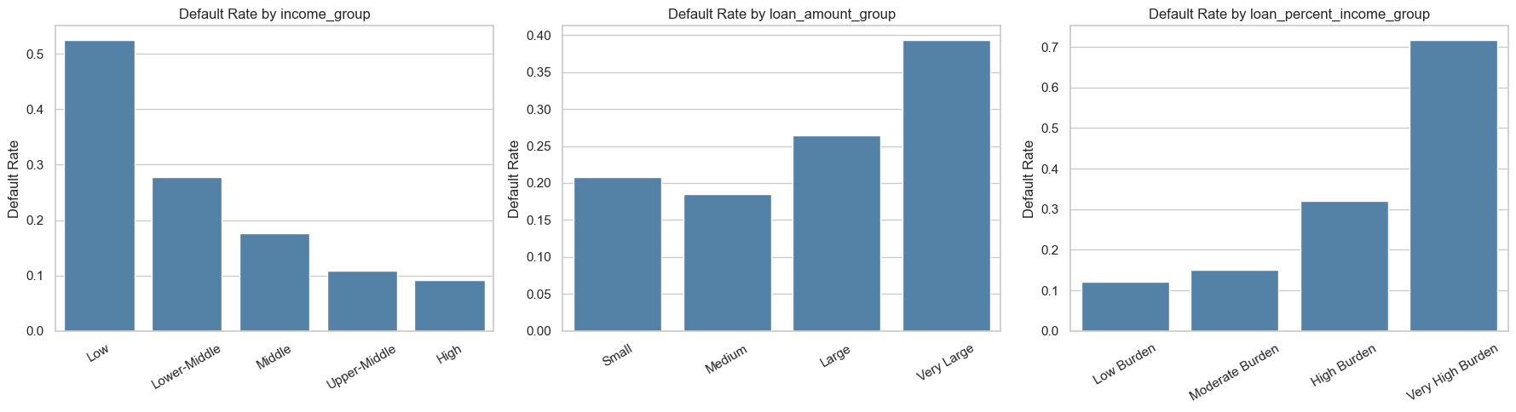
Figure 1 supports the feature engineering design by showing that default risk changes across grouped borrower and loan features. Loan burden groups are especially useful because they connect loan size to borrower income, which is more meaningful than loan amount alone.

3.9 Multicollinearity Diagnostic Using VIF
The multicollinearity check evaluates whether model inputs repeat the same information. A high VIF does not mean a column is invalid, and it is not an automatic instruction to delete a feature. Instead, it warns that one predictor is strongly explainable by other predictors. The modeling feature lists were cleaned only where the dependency was direct and avoidable.
Table 4
Multicollinearity and Feature Dependency Decisions
Dependent input pattern | Modeling decision | Technical reason
person_income and log_person_income | Use log_person_income | The log transform retains income information on a less skewed scale.
loan_amnt and log_loan_amnt in classification | Use log_loan_amnt | The log transform represents loan size while reducing extreme-value influence.
loan_grade and loan_grade_numeric | Use loan_grade | The pipeline ordinal-encodes the original grade; the numeric duplicate is redundant.
cb_person_default_on_file and default_on_file_binary | Use cb_person_default_on_file | The pipeline encodes the original Y/N field directly.
Table 4 shows that duplicate representations were removed from model inputs, not from the saved dataset. The dataset keeps the full set of raw and engineered fields for transparency, while B2 uses cleaner feature lists for training. This distinction is important: data columns can remain available for interpretation even when they are not all used simultaneously as model predictors.

3.10 Shared Modeling Preprocessing Pipeline
After the multicollinearity review, the workflow moves into modeling. All Scikit-learn models use the same preprocessing pipeline so that training data, test data, saved models, and applicant examples are transformed consistently. Numeric variables are imputed and scaled. Nominal categories are one-hot encoded into numeric columns. Binary default-on-file values and ordinal loan grades are encoded into numeric form. The original CSV remains readable; the encoded matrix is created inside the pipeline for model training.
Figure 2
Python Code for Shared Preprocessing Pipeline
Pipeline([
("preprocess", make_model_preprocessor(feature_cols)),
("model", clone(model)),
])

3.11 Train and Test Data Split
Before training the models, the dataset is divided into training data and test data. Training data is the part the model uses to learn patterns. Test data is kept separate and is used only after training to check whether the model works on records it has not already seen. This prevents the report from showing results that only look good because the model memorized the training records.
The project uses TEST_SIZE = 0.20, so 80% of the records are used for training and 20% are held out for testing. The classification and Bayesian Network (Heckerman, 1997) splits use stratification, which keeps the default and non-default class balance similar in both train and test data. Regression uses the same 80% / 20% split for loan amount, loan percent of income, and interest rate. RANDOM_STATE = 42 is used so the same split can be recreated each time the notebook is run.
Classification split code used in the modeling notebook:
Figure 3
Python Code for Classification Train-Test Data Split
TEST_SIZE = 0.20
RANDOM_STATE = 42
X_train_cls, X_test_cls, y_train_cls, y_test_cls = train_test_split(
X_cls,
y_cls,
test_size=TEST_SIZE,
stratify=y_cls,
random_state=RANDOM_STATE,
)
Regression split code used in the modeling notebook:
Figure 4
Python Code for Regression Train-Test Data Split
X_reg_train, X_reg_test, y_amt_train, y_amt_test = train_test_split(
X_reg,
y_loan_amount,
test_size=TEST_SIZE,
random_state=RANDOM_STATE,
)

3.12 Classification Models
The classification target is loan_status, where 1 represents default and 0 represents non-default. The purpose of this stage is to estimate default probability and then convert that probability into a lending-risk label. Four model families are compared so the final selection is based on measured performance rather than on a preselected algorithm.

3.12.1 Logistic Regression
Logistic Regression is the interpretable baseline for binary default prediction. It estimates the log-odds of default as a weighted combination of input features and then converts that value into a probability between 0 and 1. It is useful because coefficients can be inspected, but it assumes a mostly linear relationship between predictors and the log-odds of default.
Project code used in the modeling notebook:
LogisticRegression(
max_iter=1000,
class_weight="balanced",
random_state=RANDOM_STATE
)
Hyperparameter meaning:
- max_iter=1000 gives the optimizer enough iterations to find stable coefficients after preprocessing creates many encoded columns.
- class_weight="balanced" gives more importance to the smaller default class, so the model does not mostly learn the majority non-default class.
- random_state=RANDOM_STATE keeps the result reproducible when the model uses random initialization internally.

3.12.2 Random Forest Classifier
Random Forest is an ensemble of decision trees. Each tree learns a different set of rule-based splits, and the forest combines the trees to produce a more stable prediction. This is useful for credit data because borrower risk can depend on combinations of variables, such as loan burden, home ownership, prior default status, and loan intent.
Project code used in the modeling notebook:
RandomForestClassifier(
n_estimators=300,
class_weight="balanced",
random_state=RANDOM_STATE,
n_jobs=-1
)
Hyperparameter meaning:
- n_estimators=300 builds 300 trees. More trees usually make the average prediction more stable.
- class_weight="balanced" helps the forest pay attention to default cases even though non-default cases are more common.
- random_state=RANDOM_STATE makes the tree sampling repeatable.
- n_jobs=-1 uses all available CPU cores to train faster.

3.12.3 Gradient Boosting Classifier
Gradient Boosting (Friedman, 2001) also uses decision trees, but it builds them sequentially. Each new tree focuses on the errors left by the previous trees. This approach can capture nonlinear patterns and interactions in tabular financial data, although it needs careful evaluation to avoid overfitting.
Project code used in the modeling notebook:
GradientBoostingClassifier(
random_state=RANDOM_STATE
)
Hyperparameter meaning:
- random_state=RANDOM_STATE makes the boosting process reproducible.
- Other settings use Scikit-learn defaults. This keeps the model as a standard benchmark without adding extra tuning complexity.

3.12.4 CatBoost Classifier
CatBoost (Prokhorenkova et al., 2018) is a boosted-tree model designed for structured tabular datasets. It is included because credit risk data contains a mix of numeric, binary, ordinal, and categorical information. In the saved notebook results, CatBoost (Prokhorenkova et al., 2018) provides the strongest classification performance, so it becomes the selected default-risk classifier.
Project code used in the modeling notebook:
CatBoostClassifier(
iterations=300,
learning_rate=0.05,
depth=6,
eval_metric="AUC",
random_seed=RANDOM_STATE,
verbose=0
)
Hyperparameter meaning:
- iterations=300 trains 300 boosting steps. Each step adds a new tree that improves the previous prediction.
- learning_rate=0.05 controls how much each new tree changes the model. A smaller value learns more gradually.
- depth=6 limits each tree to six levels, allowing useful interactions while reducing overfitting risk.
- eval_metric="AUC" tells CatBoost to monitor ranking quality for the binary default task.
- random_seed=RANDOM_STATE makes CatBoost results repeatable.
- verbose=0 keeps notebook output clean during training.

3.12.5 Classification Metrics
ROC-AUC evaluates how well the model ranks default cases above non-default cases across thresholds. Accuracy measures the share of correct labels. Precision measures how often predicted defaults are truly defaults. Recall measures how many actual defaults are caught. F1 combines precision and recall, which is useful when one metric alone does not tell the full story.

3.13 Regression Models
The regression tasks estimate numeric lending benchmarks: loan amount, loan percent of income, and interest rate. These outputs are not treated as automatic approvals; they are model-based estimates that can support review. Five regression model families are compared using the same preprocessing pipeline.

3.13.1 Linear Regression
Linear Regression is the ordinary least squares baseline. It predicts a numeric target by fitting a weighted linear relationship between the encoded predictors and the outcome. It is easy to explain, but it may underfit if the true relationship is nonlinear.
Project code used in the modeling notebook:
LinearRegression()
Hyperparameter meaning:
This model uses the library defaults. In this project, it is used as a simple baseline so the stronger models can be compared against a clear starting point.

3.13.2 Ridge Regression
Ridge Regression is a regularized version of Linear Regression. It adds a penalty for large coefficients, which helps when predictors are related to each other. This makes it useful after a multicollinearity review because it can reduce coefficient instability without removing every related feature.
Project code used in the modeling notebook:
Ridge(
alpha=1.0,
random_state=RANDOM_STATE
)
Hyperparameter meaning:
- alpha=1.0 controls the regularization strength. A larger alpha shrinks coefficients more strongly.
- random_state=RANDOM_STATE keeps the solver behavior reproducible where randomness is used.

3.13.3 Random Forest Regressor
Random Forest Regressor averages many decision-tree predictions. It can learn nonlinear relationships and feature interactions without requiring a straight-line assumption. It is useful as a flexible benchmark for numeric lending targets.
Project code used in the modeling notebook:
RandomForestRegressor(
n_estimators=300,
min_samples_leaf=10,
random_state=RANDOM_STATE,
n_jobs=-1
)
Hyperparameter meaning:
- n_estimators=300 builds 300 regression trees and averages their predictions.
- min_samples_leaf=10 requires at least 10 records in a final leaf node, which smooths predictions and reduces overfitting.
- random_state=RANDOM_STATE makes tree sampling reproducible.
- n_jobs=-1 uses all available CPU cores for faster training.

3.13.4 Gradient Boosting Regressor
Gradient Boosting (Friedman, 2001) Regressor builds trees sequentially to reduce prediction errors. It is often strong on structured data because later trees focus on observations that earlier trees predicted poorly. In this project, it performs best for loan amount and loan percent of income.
Project code used in the modeling notebook:
GradientBoostingRegressor(
random_state=RANDOM_STATE
)
Hyperparameter meaning:
- random_state=RANDOM_STATE makes the boosting result reproducible.
- Other settings use Scikit-learn defaults, making this a clear boosted-tree benchmark for numeric targets.

3.13.5 CatBoost Regressor
CatBoost (Prokhorenkova et al., 2018) Regressor applies boosted-tree learning to numeric targets. It is useful when relationships between loan features and the target are nonlinear. In the saved results, it performs best for interest-rate prediction.
Project code used in the modeling notebook:
CatBoostRegressor(
iterations=300,
learning_rate=0.05,
depth=6,
loss_function="RMSE",
random_seed=RANDOM_STATE,
verbose=0
)
Hyperparameter meaning:
- iterations=300 trains 300 boosting steps.
- learning_rate=0.05 makes the model learn gradually instead of making large changes at each step.
- depth=6 controls the complexity of each tree.
- loss_function="RMSE" trains the model to reduce squared prediction error for numeric targets.
- random_seed=RANDOM_STATE makes the training result reproducible.
- verbose=0 prevents long training logs from cluttering the notebook.

3.13.6 Regression Metrics
MAE is the average absolute error. RMSE penalizes large errors more strongly. R-squared measures how much target variation is explained by the model. Low R-squared values do not make the model useless, but they do mean the prediction should be interpreted as an approximate benchmark rather than an exact lending limit.

3.14 Threshold Tuning
The main classification table uses the standard 0.50 cutoff. A separate threshold-tuning step evaluates business cost by assigning a larger penalty to missed defaults than to false alarms. This is why the cost-focused threshold can be lower than 0.50: it catches more potential defaults, but it also flags more non-default borrowers for review.

3.15 Bayesian Network Reasoning
The Bayesian Network (Heckerman, 1997) is trained on grouped and discrete variables so that the probability structure can be inspected. In simple terms, each node is a variable, each arrow shows a learned conditional relationship, and the conditional probability tables show how default probability changes when evidence is known. The network does not replace the strongest classifier; it adds a transparent reasoning layer that shows how evidence such as loan burden, loan grade, and prior default status changes default probability.
Project code used in the modeling notebook:
Figure 5
Python Code for Bayesian Network Structure Learning
hill_search = HillClimbSearch(bn_learning_data)
learned_structure = hill_search.estimate(
scoring_method=BIC(bn_learning_data),
max_indegree=3,
)
bn_model = PgmpyBayesianNetwork(list(learned_structure.edges()))
bn_model.add_nodes_from(bn_cols)
bn_model.fit(bn_learning_data)
bn_inference = VariableElimination(bn_model)
Hyperparameter and method meaning:
- HillClimbSearch is the pgmpy structure-learning estimator. It searches for a graph that explains the discrete data well.
- BIC is the scoring method. It rewards a graph that fits the data but penalizes graphs that become unnecessarily complicated.
- max_indegree=3 limits each node to at most three parent variables, keeping the graph readable and reducing over-complex relationships.
- bn_model.fit(bn_learning_data) estimates the conditional probability tables after the graph structure is selected.
- VariableElimination is used for inference. It calculates default probability after evidence is supplied.
Figure 6
Bayesian Network (Heckerman, 1997) Dependency Graph
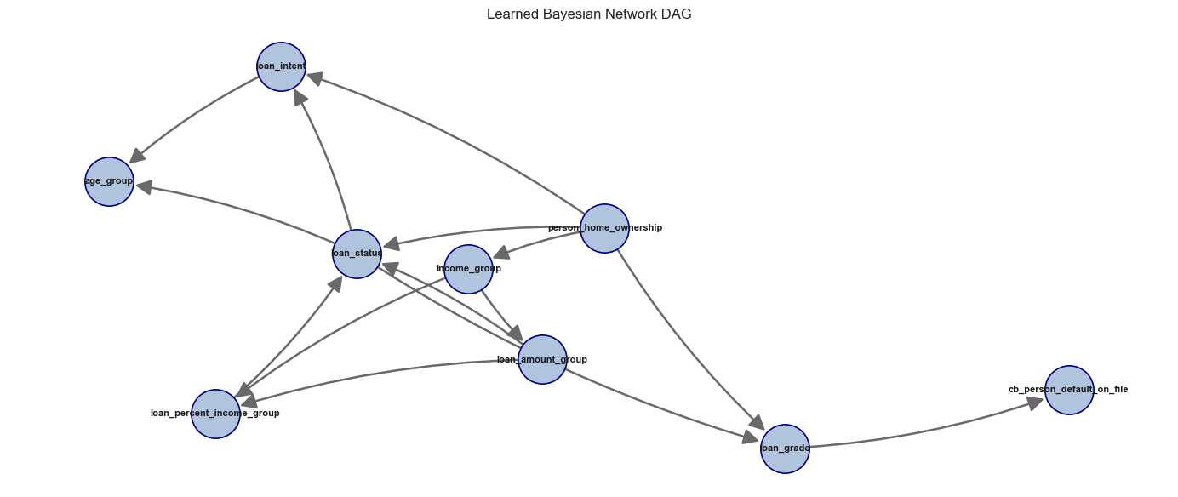

3.16 Saved Models and Applicant Inference
After the models are trained and evaluated, the notebook saves the fitted models using joblib. This is important because the saved object is not only the mathematical estimator; it is the full fitted pipeline. The pipeline contains the preprocessing steps and the trained model together. Because of this, future applicant data can be passed into the saved model in the same readable column format, and the pipeline will handle imputation, scaling, encoding, and prediction consistently.
The project saves all trained classification models and all trained regression models so they can be reviewed later. However, the final applicant examples do not load every saved model. They load only the selected best models with stable file names. This keeps inference simple: the training section compares all candidates, while the prediction section reuses the best saved model for each task.
Model saving and loading helper functions used in the modeling notebook:
Figure 7
Python Code for Model Save and Load Helper Functions
def save_model(model, folder, file_name):
folder.mkdir(parents=True, exist_ok=True)
path = folder / file_name
joblib.dump(model, path)
return path
def save_model_group(models, folder, prefix=""):
rows = []
for model_name, fitted_model in models.items():
file_name = f"{prefix}{model_file_stem(model_name)}.joblib"
path = save_model(fitted_model, folder, file_name)
rows.append({"model": model_name, "file_name": path.name})
return pd.DataFrame(rows)
def load_model(folder, file_name):
return joblib.load(folder / file_name)
For default prediction, all classification pipelines are saved first. The selected best classifier is also saved as best_default_classifier.joblib. In the applicant default-prediction example, this best saved classifier is loaded and used to predict the applicant default probability and final default/non-default label.
Figure 8
Python Code for Best Classifier Loading and Inference
saved_best_cls_model = load_model(
CLASSIFICATION_MODEL_DIR,
"best_default_classifier.joblib"
)
sklearn_default_probability = float(
saved_best_cls_model.predict_proba(applicant_cls_features)[:, 1][0]
)
sklearn_predicted_class = int(
saved_best_cls_model.predict(applicant_cls_features)[0]
)
For loan estimation, the notebook saves all regression models for each target. The final applicant estimate loads the best saved regressor for loan amount, the best saved regressor for loan percent of income, and the best saved regressor for interest rate.
Figure 9
Python Code for Best Regressors Loading and Inference
saved_amount_model = load_model(
REGRESSION_MODEL_DIR,
"best_loan_amount_regressor.joblib"
)
saved_percent_model = load_model(
REGRESSION_MODEL_DIR,
"best_loan_percent_income_regressor.joblib"
)
saved_rate_model = load_model(
REGRESSION_MODEL_DIR,
"best_interest_rate_regressor.joblib"
)
The Bayesian Network (Heckerman, 1997) is also saved with its metadata. The model file stores the learned probability structure, while the metadata stores supporting information such as the Bayesian Network (Heckerman, 1997) columns and fallback probability. The applicant default example loads both files before running Bayesian probability inference.
Figure 10
Python Code for Saved Bayesian Network Inference
saved_bn_model = load_model(
BAYESIAN_MODEL_DIR,
"bayesian_network_model.joblib"
)
saved_bn_metadata = joblib.load(
BAYESIAN_MODEL_DIR / "bayesian_network_metadata.joblib"
)

3.17 Data preparation and Model selection
In the data preparation stage, the credit risk dataset was cleaned by removing missing values, duplicate records, and outliers, resulting in a final dataset of 29,567 observations (from an initial 32,581). Data formats were also standardized to ensure consistency for modeling.
For model selection, the CatBoost (Prokhorenkova et al., 2018) Classifier was chosen for the default prediction task based on its superior performance. Regression models were selected to predict the loan amount, loan-to-income percentage, and interest rate.
The classification dataset was split using stratified sampling into 80% training (23,653 samples) and 20% testing (5,914 samples), preserving a default rate of approximately 22.4%. For regression, only non-default cases were considered, resulting in 18,344 training samples and 4,587 test samples. The feature set included socio-demographic attributes, financial ratios, and credit history variables.

3.18 Classification Diagnostics
The CatBoost (Prokhorenkova et al., 2018) Classifier was evaluated across five dimensions: discriminative ability (ROC/PR curves), probability accuracy (calibration), decision-threshold analysis (confusion matrix), segment-level errors (by loan grade), and feature attribution (SHAP values).

3.18.1 ROC Curve and Precision-Recall Analysis
The Receiver Operating Characteristic (ROC) Curve plots the True Positive Rate (TPR) against the False Positive Rate (FPR) across all possible classification thresholds. It answers the question: how well can the model distinguish defaulters from non-defaulters?
TPR indicates the Proportion of actual defaults correctly identified
TPR = TP / (TP + FN)
FPR indicates Proportion of non-defaults incorrectly flagged as defaults
FPR = FP / (FP + TN)
Precision-Recall Curve: This is very effective when class imbalance exists, It is focused only on the positive class (defaults) . . The PR curve directly measures the quality of predictions on the minority (default) class.
Precision indicates the precision of all loans predicted as default
Precision=TP / (TP + FP)​
Recall of all actual defaults
Recall = TP / (TP + FN)
Where:
- TP = Correctly predicted defaults
- FN = Missed defaults
- FP = False alarm
- TN = Correctly identified non-defaults
ROC-AUC : Area under the ROC curve
PR-AUC: Area under PR curve

3.18.2 Calibration Analysis
Calibration Analysis assesses how closely the predicted default probabilities align with the observed
default rates.
Brier Score (Brier, 1950)
The Brier Score (Brier, 1950) is computed as the mean squared error between predicted probabilities and actual outcomes, it measures the accuracy of probabilistic predications:
Brier Score (Brier, 1950) = (1/N) × Σ (pᵢ − yᵢ)²
where pᵢ is the predicted default probability and yᵢ ∈ {0, 1} is the actual outcome. Its value varies between 0 to 1.
Where:
• 0 = Perfect calibration
• Lower values = Better probability estimates
• Higher values = Poorer calibration
Calibration Curve Interpretation
The calibration plot shows predicted probability on the x-axis versus actual default rate in each probability bin on the y-axis. A perfectly calibrated model would follow the red diagonal. Key observations:
• Low probability range (0–0.30): Model is very slightly under-confident – actual rates slightly exceed predicted rates, but the deviation is small
• Mid range (0.30–0.60): Model shows the largest deviation from perfect calibration, common in tree-based models due to their discrete prediction structure
• High range (0.60–1.0): Model returns to near-perfect calibration, correctly identifying high-risk borrowers

3.18.3 Confusion Matrix
A confusion matrix is a diagnostic table used to evaluate a classification model by comparing predicted labels with actual outcomes. It summarizes predictions into four categories: true positives, true negatives, false positives, and false negatives. This provides insight not only into overall model accuracy but also into the specific types of classification errors being made. The confusion matrix is particularly valuable in applications such as medical diagnosis, fraud detection, and credit risk assessment, where the cost of different errors can vary significantly. It serves as the foundation for calculating key performance metrics, including accuracy, precision, recall, and F1-score, helping assess both the effectiveness and reliability of the model.

3.18.4 Error Analysis by Loan Grade
Error Analysis by Loan Grade is the process of evaluating a model's prediction performance separately for each loan grade (A–G) rather than looking only at overall accuracy.
In credit risk assessment, loan grades represent different risk levels:
- Grade A: Lowest-risk borrowers
- Grade G: Highest-risk borrowers
Instead of asking, "How accurate is the model overall?", error analysis asks:
- Does the model perform equally well across all risk categories?
- Which grades generate the most prediction errors?
- Are certain borrower groups systematically misclassified?
By calculating metrics such as accuracy, precision, recall, and default rates for each grade, we can identify segments where the model performs strongly or weakly.

3.18.5 Feature Importance - SHAP Analysis
SHAP (SHapley Additive exPlanations (Lundberg & Lee, 2017)) values were computed using a TreeExplainer on a 500-sample random subset of the test data. SHAP values provide a game-theoretic decomposition of each prediction into individual feature contributions, enabling trustworthy model interpretability.
How to read the SHAP summary plot:
• Each row represents a feature, ordered by mean absolute SHAP value (top = most important)
• Each dot is one sample; horizontal position shows the SHAP value (impact on model output)
• Red dots = high feature value, Blue dots = low feature value
• Points to the right of zero increase default probability; points to the left decrease it

3.19 Regression Model Diagnostics

3.19.1 Residual Analysis - Interest Rate
- Residuals vs. Fitted Values : Tests for non-linearity and systematic bias. Residuals should scatter randomly around the zero line with no visible pattern.
- Q-Q Plot (Normality Check) : Tests whether residuals follow a normal distribution. Points should fall on the diagonal red line.
- Residual Distribution: The residual histogram is approximately symmetric and bell-shaped, centered at mean = −0.0003 (essentially zero). This confirms the model is unbiased – it does not systematically overestimate or underestimate interest rates across the test set. The slight right skew is consistent with the heavy-tail observation in the Q-Q plot.
- Scale-Location Plot (Homoscedasticity): Tests whether the variance of residuals is constant across fitted values (homoscedasticity). Points should be roughly horizontal with constant spread.

3.19.2 Predicted vs. Actual Analysis - All Regression Targets
Predicted Vs Actual Analysis evaluates regression performance by comparing predicted values with actual observed values. It is typically visualized using scatter plots, where the x-axis represents actual values and the y-axis represents predicted values. A 45-degree diagonal reference line indicates perfect predictions; points closer to this line reflect higher accuracy, while greater deviations represent prediction errors. This analysis provides a clear visual assessment of how well the model estimates targets such as loan amount, interest rate, and loan-to-income ratio.

3.19.3 Interest Rate Prediction - Performance by Loan Grade
Interest Rate Prediction Performance by Loan Grade evaluates how accurately the regression model predicts interest rates for borrowers within each loan grade (A–G). Since loan grades reflect different levels of credit risk, this analysis helps determine whether prediction accuracy varies across risk segments.
The objective is to answer questions such as:
- Does the model predict interest rates equally well across all loan grades?
- Which grades have the highest prediction errors?
- Does performance deteriorate for higher-risk borrowers?
Typically, metrics such as Mean Absolute Error (MAE) and Standard Error are calculated for each grade. Lower values indicate more accurate predictions.

3.19.4 Feature Importance SHAP analysis (Interest Rate Model)
SHAP analysis for the interest rate regression model reveals which borrower attributes most strongly drive interest rate assignments. Prior default history dominates, reflecting the fundamental credit pricing principle that higher historical risk commands higher rates.

4. Results

4.1 Raw Data Profile
The raw dataset contains 32,581 rows and 12 columns. A summary of key descriptive statistics is shown in Table 5.
Table 5
Descriptive statistics for the raw Credit Risk dataset (n = 32,581)
Feature | Mean | Std Dev | Min | Median | Max
person_age | 27.73 | 6.35 | 20.00 | 26.00 | 144.00
person_income | $66,075 | $61,983 | $4,000 | $55,000 | $6,000,000
person_emp_length | 4.79 yrs | 4.14 | 0.00 | 4.00 | 123.00
loan_amnt | $9,589 | $6,322 | $500 | $8,000 | $35,000
loan_int_rate | 11.01% | 3.24 | 5.42% | 10.99% | 23.22%
loan_status (default rate) | 0.22 | 0.41 | 0 | 0 | 1
loan_percent_income | 0.17 | 0.11 | 0.00 | 0.15 | 0.83
Note. Note the unrealistic maximum age (144 years) and maximum income ($6M) – both flagged for outlier removal.

4.2 Missing Value Audit
Two of the 12 columns contained missing values:
Table 6
Missing value audit results and imputation strategy
Column | Missing (n) | Missing (%) | Imputed With
person_emp_length | 895 | 2.75% | Median = 4.00 years
loan_int_rate | 3,116 | 9.56% | Median = 10.99%
Note. All other 10 columns had zero missing values.
After applying median imputation (Little & Rubin, 2019), zero missing values remained in the dataset.

4.3 Outlier Filtering Results
After applying IQR filters, the domain age constraint (≤ 100), duplicate removal, and the employment–age sanity check, the dataset was reduced from 32,581 to 29,567 records – a net removal of 3,014 rows (9.25%). The final cleaned dataset has 29,567 rows and 12 columns (plus log_person_income added during EDA), split 77.56% non-default and 22.44% default.

4.4 Income Distribution and Log-Transformation
Figure 11
Side-by-side histograms of person_income (left, steelblue) and log_person_income (right, seagreen)
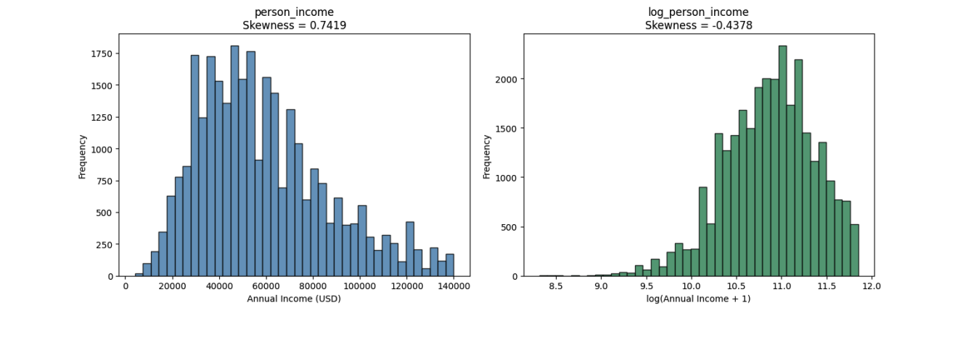
Note. The raw income distribution is right-skewed (skewness = 0.7419). After applying log(x+1), skewness drops to −0.4378, confirming the long right tail has been effectively compressed. The log-transformed variable will be used as the income predictor in OLS regression.
The log-transformation successfully compresses the right tail. The raw income distribution peaks around $40,000–$60,000 and has a long tail extending beyond $140,000. After transformation, the distribution is approximately symmetric and unimodal – properties that will reduce heteroscedasticity in OLS regression residuals.

4.5 Univariate Distributions
Figure 12
Multi-panel univariate distributions
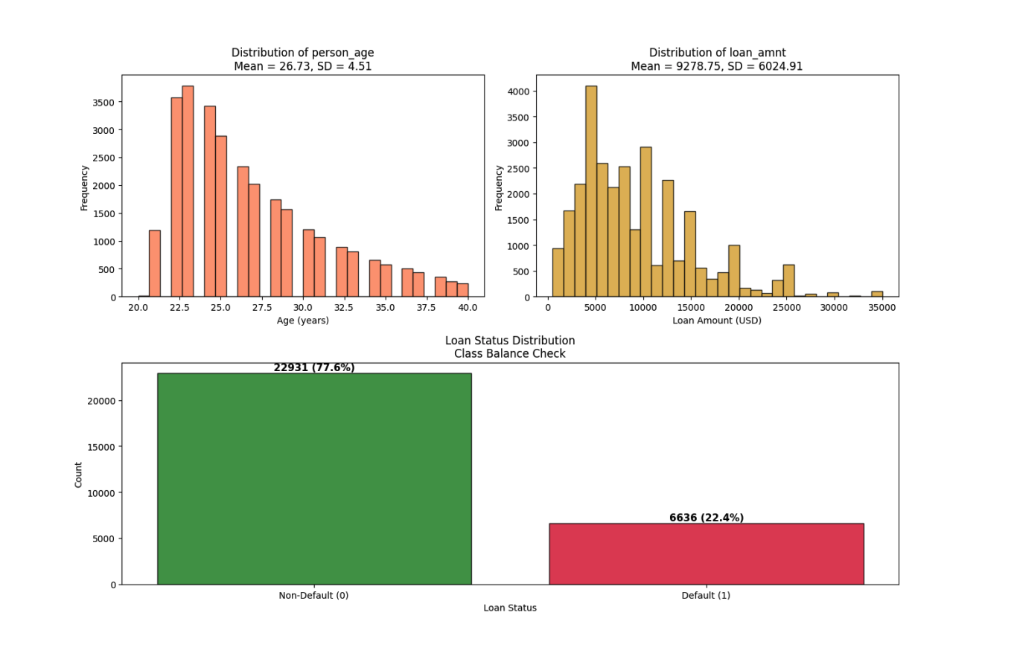
Note. Top-left: Distribution of person_age (coral histogram, Mean = 26.73 years, SD = 4.51). Top-right: Distribution of loan_amnt (goldenrod histogram, Mean = $9,278.75, SD = $6,024.91). Bottom (spanning full width): Loan status class balance bar chart showing 22,931 non-default borrowers (77.56%, forestgreen) and 6,636 defaulters (22.44%, crimson). The class imbalance of approximately 3.5:1 will be addressed in the modeling stage.
The age distribution after outlier removal is appropriately concentrated between 20 and 40 years, with no unrealistic extremes. Loan amounts are right-skewed with most loans below $15,000. The loan status distribution confirms a meaningful class imbalance – 77.56% non-default versus 22.44% default – which will require class-weighted training or resampling techniques in subsequent modeling sections.

4.6 Normality Testing
Table 7 presents the Shapiro-Wilk test (Shapiro & Wilk, 1965) results on a sample of 5,000 rows:
Table 7
Shapiro-Wilk normality test results (n = 5,000 random sample)
Variable | W Statistic | p-value | Normal at α=0.05?
person_income | 0.9534 | < 0.000001 | No – Reject H₀
log_person_income | 0.9856 | < 0.000001 | No – Reject H₀
Note. Both person_income and log_person_income statistically reject normality at α = 0.05. This is expected at large sample sizes where the test is sensitive to even trivial departures from normality.
Both variables reject normality. This is not surprising: at n = 5,000, the Shapiro-Wilk test (Shapiro & Wilk, 1965) has extremely high statistical power and will detect even trivially small departures from a theoretical normal distribution. The practical implication is that we should not assume normality of individual observations; instead, we rely on the Central Limit Theorem to justify parametric inference on sample means.

4.7 Central Limit Theorem Simulation
Figure 13
CLT simulation: sampling distribution of mean person_income under 5,000 bootstrap samples at three sample sizes
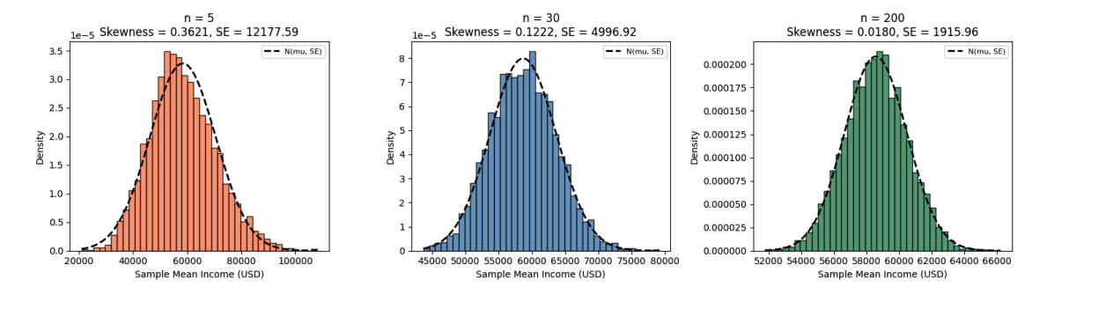
Note. Left (coral, n=5): substantially right-skewed (skewness = 0.36), SE = $12,178. Centre (steelblue, n=30): approaches bell shape (skewness = 0.12), SE = $4,997. Right (seagreen, n=200): near-perfect normal (skewness ≈ 0.02), SE = $1,916. Black dashed line overlays the theoretical N(μ, SE²) density.
Table 8
CLT simulation summary: mean of simulated sample means, standard error, and skewness of the sampling distribution at three sample sizes (5,000 bootstrap iterations each)
Sample Size (n) | Mean of Simulated Means | SE of Simulated Means | Skewness
5 | $58,226.68 | $12,136.05 | 0.3621
30 | $58,588.21 | $4,910.66 | 0.1222
200 | $58,569.82 | $1,941.92 | 0.0180
The simulation provides compelling visual evidence of CLT convergence. At n = 5, the sampling distribution retains substantial skewness from the parent income distribution. By n = 30 – the conventional threshold cited in statistical textbooks – the distribution is approximately bell-shaped. At n = 200, it is nearly indistinguishable from a normal distribution. With 29,567 records in the cleaned dataset, all parametric tests conducted in model selection and diagnostics stages are firmly within the CLT convergence regime.

4.8 Pearson Correlation Matrix
Figure 14
Full 9×9 Pearson correlation heatmap (coolwarm colour scheme, range −1 to +1)
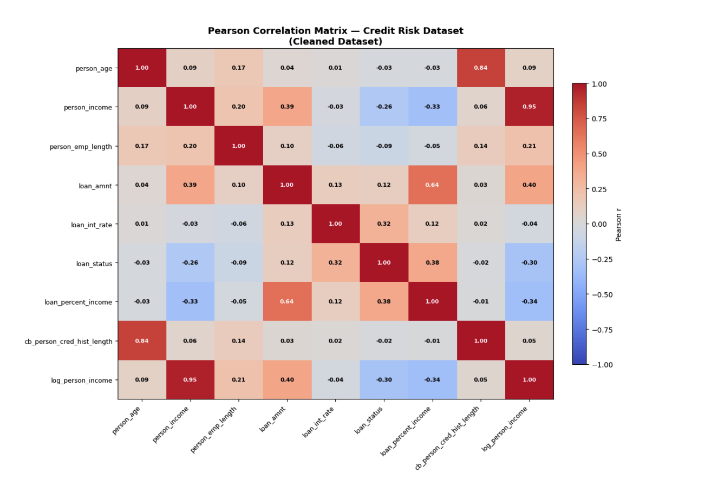
Note. Each cell is annotated with the Pearson r value. White text indicates |r| > 0.60. Key high-correlation regions: person_age – cb_person_cred_hist_length (r = 0.836, top-right quadrant, dark red); person_income – log_person_income (r = 0.953, diagonal band, dark red); loan_amnt – loan_percent_income (r = 0.641). Strong negative correlation: loan_status – person_income (r = −0.257) and loan_status – log_person_income (r = −0.299).
Table 9 lists all feature pairs with |r| > 0.30, sorted by absolute correlation strength:
Table 9
All feature pairs with |r| > 0.30 in the cleaned dataset, with practical interpretations
Feature A | Feature B | Pearson r | Implication
person_income | log_person_income | 0.9533 | Redundant – use one in regression
person_age | cb_person_cred_hist_length | 0.8362 | VIF screening required in the diagnostics stage
loan_amnt | loan_percent_income | 0.6407 | Moderate collinearity – monitor VIF
loan_amnt | log_person_income | 0.3969 | Borrowers earn more → borrow more
loan_status | loan_percent_income | 0.3798 | Higher burden → more defaults
person_income | loan_amnt | 0.3860 | Higher earners → larger loans
loan_int_rate | loan_status | 0.3184 | Higher rates → more defaults
loan_status | log_person_income | −0.2990 | Higher income → fewer defaults
person_income | loan_percent_income | −0.3309 | Higher income → lower debt burden
Note. Pairs with |r| > 0.80 represents potential multicollinearity risks requiring VIF analysis in the diagnostics section.
Several findings from the correlation matrix carry direct implications for modelling:
- person_income vs log_person_income (r = 0.953): These two variables are nearly perfectly correlated. Only log_person_income should be used as a predictor in regression to avoid perfect multicollinearity.
- person_age vs cb_person_cred_hist_length (r = 0.836): This is the most significant multicollinearity risk. Older borrowers naturally have longer credit histories. Including both variables in OLS or logistic regression will produce inflated standard errors. Formal VIF screening is planned for the diagnostics section.
- loan_int_rate vs loan_status (r = 0.318): Interest rate is positively correlated with default – riskier borrowers are charged more, and they are also more likely to default. This is the core credit risk pricing relationship motivating the entire project.
- person_income vs loan_status (r = −0.257): Higher-income borrowers are less likely to default, consistent with the ability-to-pay hypothesis tested formally in regression diagnostics.

4.9 Classification Results
Table 10
Classification Model Comparison at the Standard 0.50 Cutoff
model | roc_auc | accuracy | precision | recall | f1
CatBoost (Prokhorenkova et al., 2018) | 0.9430 | 0.9376 | 0.9908 | 0.7287 | 0.8398
Random Forest | 0.9327 | 0.9302 | 0.9279 | 0.7468 | 0.8276
Gradient Boosting (Friedman, 2001) | 0.9288 | 0.9324 | 0.9576 | 0.7310 | 0.8291
Logistic Regression | 0.8760 | 0.8054 | 0.5464 | 0.7815 | 0.6431
CatBoost (Prokhorenkova et al., 2018) is the strongest classifier in the saved outputs, with ROC-AUC 0.9430 and accuracy 0.9376. The high precision value shows that predicted defaults are usually correct at the 0.50 cutoff. The recall value is lower than precision, meaning some true defaults are still missed. This tradeoff motivates the separate threshold-tuning analysis.

4.10 Threshold Tuning Result
Table 11
Standard Cutoff and Cost-focused Cutoff Comparison
Decision rule | Threshold | Accuracy | Precision | Recall | F1 | Interpretation
Standard reporting cutoff | 0.50 | 0.9376 | 0.9908 | 0.7287 | 0.8398 | Higher accuracy and precision for standard reporting.
Cost-focused review cutoff | 0.15 | 0.8750 | 0.6788 | 0.8410 | 0.7513 | Higher recall for catching more defaults, with more false alarms.
Figure 15
Business Cost by Default Threshold
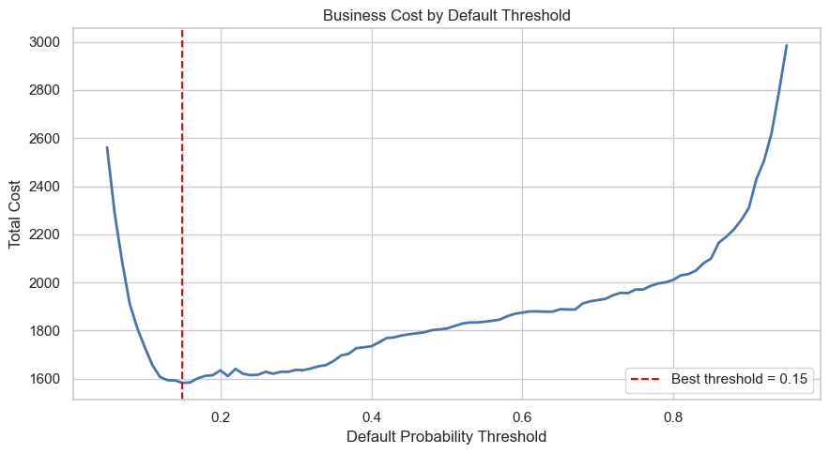
The cost-focused cutoff is 0.15. It reduces missed defaults by increasing recall, but it also reduces precision and accuracy because more non-default loans are flagged. This result should not be described as the most accurate threshold; it is the threshold preferred by the stated business-cost assumption.

4.11 Regression Model Results
Table 12
Best Regression Model by Target
target | model | mae | rmse | r2
loan_amnt | Gradient Boosting (Friedman, 2001) Regressor | 3,869.71 | 5,047.80 | 0.1978
loan_percent_income | Gradient Boosting (Friedman, 2001) Regressor | 0.0655 | 0.0821 | 0.0917
loan_int_rate | CatBoost (Prokhorenkova et al., 2018) Regressor | 2.0548 | 2.5304 | 0.2224
Gradient Boosting (Friedman, 2001) is selected for loan amount and loan percent of income, while CatBoost (Prokhorenkova et al., 2018) is selected for interest rate. The R-squared values are modest, especially for loan amount and loan percent of income, so the regression outputs should be used as conservative benchmarks rather than exact approvals. Interest-rate prediction performs somewhat better because interest rate is more directly connected to issued-loan risk information.

4.12 Applicant-level Inference
Table 13
Example Applicant Default Prediction
model_source | model | default_probability | predicted_class | decision_threshold | predicted_label
Scikit-learn ML | CatBoost (Prokhorenkova et al., 2018) | 98.60% | 1 | 0.5000 | Default
Bayesian Network (Heckerman, 1997) | pgmpy HillClimbSearch + VariableElimination | 85.36% | 1 | 0.5000 | Default
Table 13 compares the best saved Scikit-learn classification pipeline with the saved Bayesian Network (Heckerman, 1997) for the same applicant. The machine learning model provides the primary predictive estimate, while the Bayesian Network (Heckerman, 1997) provides a probability estimate from interpretable grouped evidence.
Table 14
Example Applicant Loan and Interest-rate Estimate
predicted_loan_amount | predicted_loan_percent_income | predicted_interest_rate | income_based_amount | conservative_recommended_amount
8,943.68 | 0.1377 | 10.1349 | 8,952.72 | 8,943.68
Table 14 reports the regression-based applicant estimate. The conservative recommended amount is the lower of the direct predicted amount and the income-based amount, which keeps the estimate cautious when the two model views differ.

4.13 Classification

4.13.1 ROC Curve and Precision-Recall Analysis
Figure 16
CatBoost Classifier ROC Curve and Precision-Recall Curve
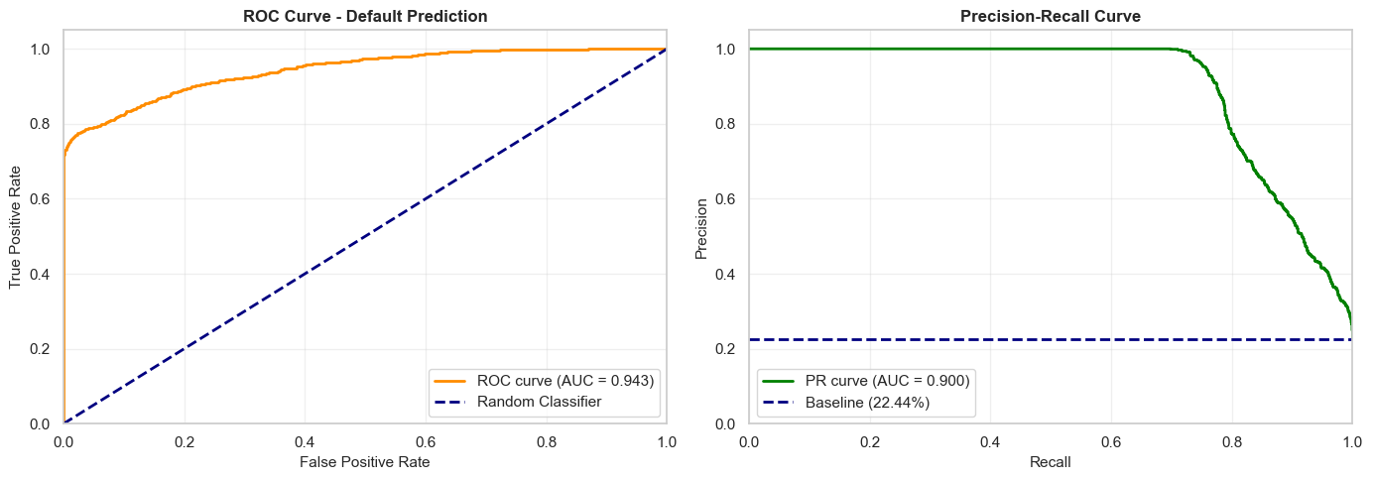
The model achieved a ROC-AUC of 0.9429, which is classified as excellent (> 0.85). This means there is a 94.29% probability that, given a random defaulter and a random non-defaulter, the model will assign a higher risk score to the defaulter. The curve rises steeply toward the top-left corner – far above the diagonal random-classifier baseline – confirming strong discriminative ability across all threshold settings
The model achieved a PR-AUC of 0.9003. The curve stays at near-perfect Precision (≈1.0) for Recall values up to about 0.70, then gradually decreases. This means the model can detect up to 70% of defaults without making any false-positive predictions – an exceptional result for a credit risk use case where false positives (wrongly denying a good borrower) carry real business cost.

4.13.2 Calibration Analysis (Reliability Diagram)
The model achieved a Brier Score (Brier, 1950) of 0.0532, indicating excellent calibration. Its predictions are both directionally strong and numerically reliable.
The calibration plot shows predicted vs. actual default rates, with the ideal model following the diagonal line. The model is slightly under-confident at low probabilities, deviates most in the mid-range (common for tree-based models), and regains near-perfect calibration at higher probabilities, effectively identifying high-risk cases.
Figure 17
CatBoost Classifier Probability Calibration Reliability Diagram
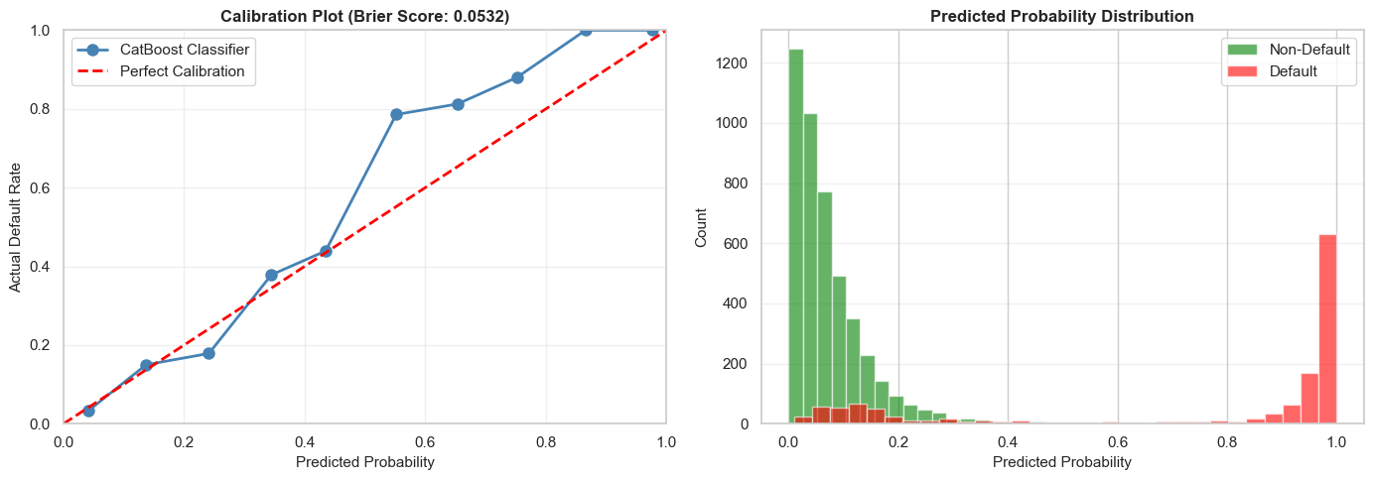
Table 15
CatBoost Classifier Diagnostic Metrics Summary
Metric | Value | Threshold | Assessment
Brier Score (Brier, 1950) | 0.0532 | < 0.15 = well-calibrated | Excellent
Mean Calibration Error | 8.00% | < 10% = good | Good
Calibration Range | 0.0–1.0 | Full range covered | Complete

4.13.3 Confusion Matrix (Multi-Threshold Evaluation)
The classification threshold controls how predicted default probabilities are converted into binary decisions. Three thresholds were evaluated to balance precision and recall:
Figure 18
CatBoost Classifier Confusion Matrix Heatmaps at 0.15 and 0.50 Thresholds
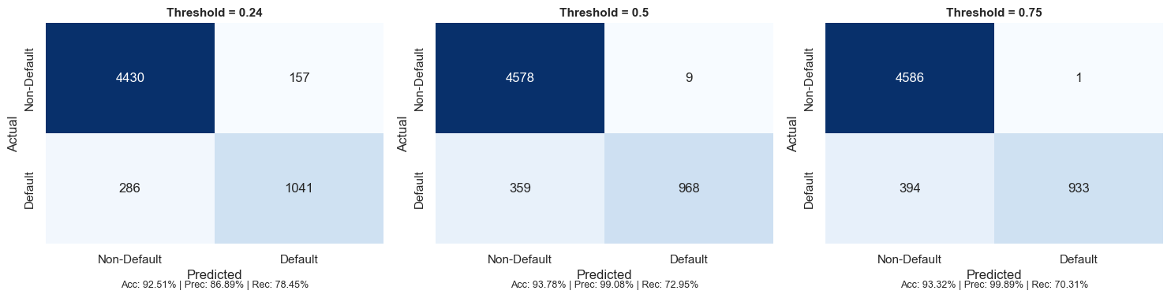
Table 16
Confusion Matrix and Metrics across Thresholds
Threshold | TN | FP | FN | TP | Accuracy | Precision | Recall | F1-Score
0.24 (Aggressive) | 4,430 | 157 | 286 | 1,041 | 92.51% | 86.89% | 78.45% | 0.8246
0.50 (Balanced) | 4,578 | 9 | 359 | 968 | 93.78% | 99.08% | 72.95% | 0.8403
0.75 (Conservative) | 4,586 | 1 | 394 | 933 | 93.32% | 99.89% | 70.31% | 0.8253
Interpretation:
- 0.24 (Aggressive): Achieved the highest recall (78.45%), identifying more defaulters but generating more false positives (157). Suitable for risk-averse lending strategies.
- 0.50 (Balanced): Delivered the best overall performance with the highest F1-score (0.8403) and accuracy (93.78%), while keeping false positives low (9) and maintaining strong recall (72.95%). This represents the optimal threshold for most credit risk applications.
- 0.75 (Conservative): Produced near-perfect precision (99.89%) with only 1 false positive, but reduced recall to 70.31%, resulting in more missed defaults. Appropriate when false positives are extremely costly.
Overall, the 0.50 threshold provides the most effective balance between identifying defaulters and minimizing incorrect rejections of creditworthy borrowers.

4.13.4 Error Analysis by Segments
Model performance was evaluated across loan grades (A–G) to determine whether predictive accuracy varied by borrower risk level. Overall accuracy remained consistently high across all grades, ranging from 89.70% to 100.00%, with an average accuracy of 94.43%.
Figure 19
Classification Accuracy and Error Analysis by Loan Grade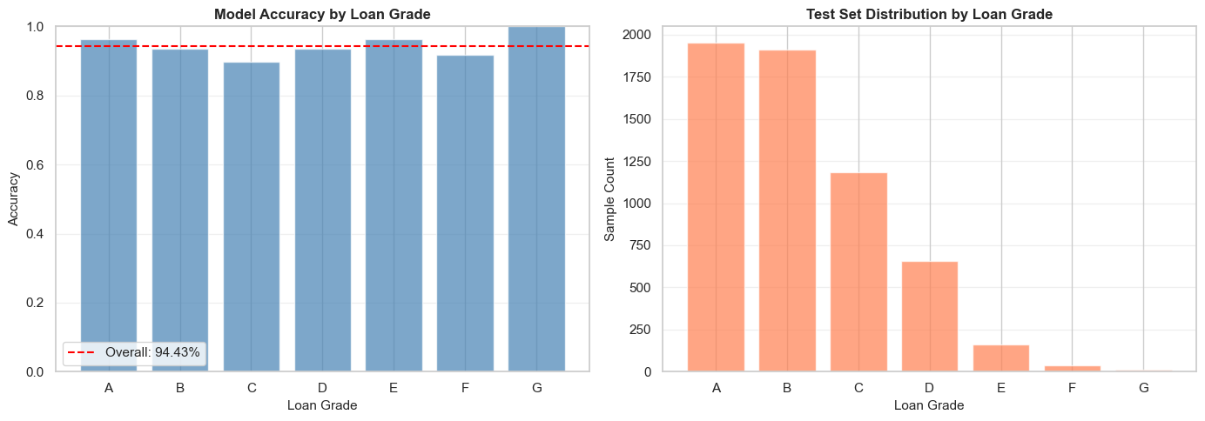
Key observations include:
- Grade A achieved strong performance (96.41% accuracy) due to its low default rate (10.20%) and clear separation between default and non-default borrowers.
- Grade C was the most challenging segment (89.70% accuracy), as its moderate default rate (20.86%) created greater overlap between classes.
- Grades E–G showed very high accuracy (91.67%–100.00%) because defaults dominate these segments, making classification more straightforward.
- Although Grade G achieved 100% accuracy, the result is based on only 12 samples and should be interpreted cautiously.
The grade distribution was highly imbalanced, with Grades A and B accounting for most test cases, while Grades F and G contained very few observations. Consequently, performance estimates for the highest-risk grades are less reliable due to limited sample sizes.
Overall, the model demonstrated robust and stable performance across all risk segments, maintaining accuracy above 89% for every loan grade.

4.13.5 Feature Importance – SHAP Analysis (Classification)
Figure 20
SHAP Bee Swarm Summary Plot for CatBoost Classifier
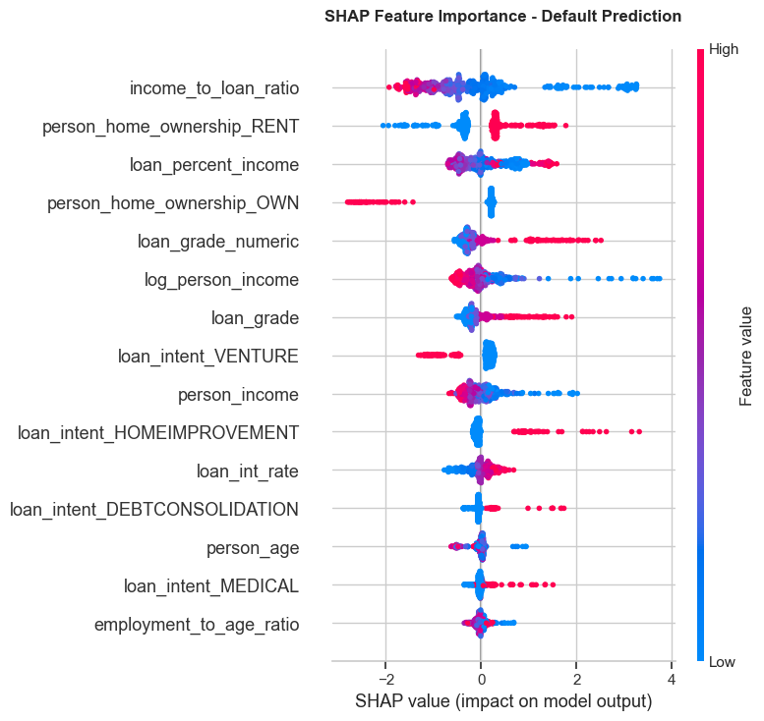
Table 17
SHAP Classification Feature Impact Rankings
Rank | Feature | Direction of Effect | Business Interpretation
1 | income_to_loan_ratio | High ratio → lowers default risk | Borrowers who earn much more than they borrow are lower risk
2 | person_home_ownership_RENT | Renting → increases default risk | Renters have less asset stability and face higher default probability
3 | loan_percent_income | High burden → increases risk | Loans consuming a large share of income are harder to repay
4 | person_home_ownership_OWN | Owning → lowers default risk | Homeowners have demonstrated financial stability
5 | loan_grade_numeric | Higher grade → increases risk | Lower credit grades (D–G) correlate strongly with default
6 | log_person_income | Higher income → lowers risk | Higher earners are generally better positioned to repay
7 | loan_grade | Lower grade → increases risk | Corroborates loan_grade_numeric finding
8 | loan_intent_VENTURE | Venture loans → increases risk | Business/venture loans carry higher risk than personal loans
9 | person_income | Higher income → lowers risk | Consistent with log_person_income effect
10 | loan_intent_HOMEIMPROVEMENT | Home improvement → increases risk | Borrowers improving homes may be stretching financial capacity
The SHAP analysis confirms that the most powerful predictors of default are economic leverage metrics (income-to-loan ratio, loan burden) and credit risk indicators (loan grade, prior default history). Home ownership status acts as a significant proxy for financial stability. Notably, the model relies on engineered features (income_to_loan_ratio, log_person_income) almost as heavily as raw features – validating the modeling stage feature engineering effort .

4.14 Regression Model Diagnostics

4.14.1 Residual Analysis – Interest Rate Model
Residual analysis evaluates whether prediction errors are random or indicate systematic issues in the regression model. The 4-panel diagnostic plot shows that the model is generally unbiased, with residuals centered around zero and no significant over- or under-prediction.
Figure 21
Residual Diagnostic Plots for Interest Rate Model
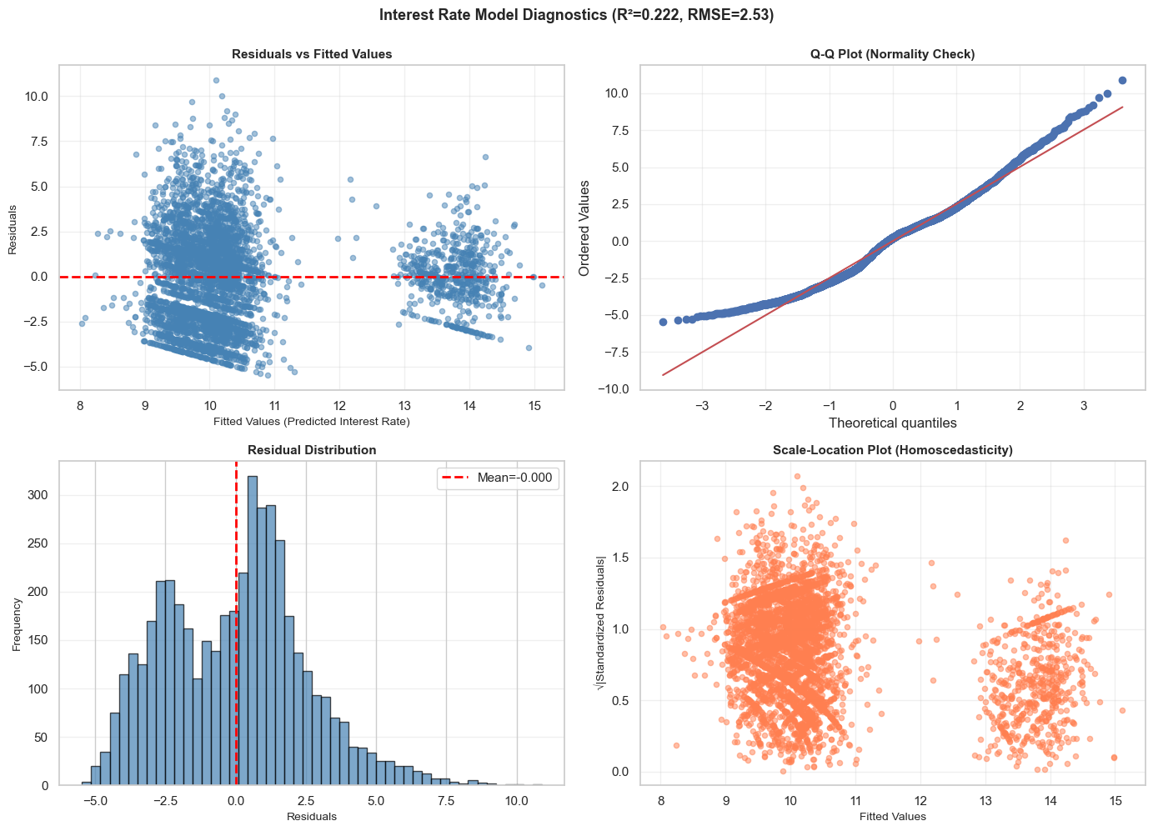
Key findings include:
- Residuals vs. Fitted Values: Residuals are randomly distributed, indicating no major non-linearity. A wider spread for higher interest rates (Grades D–F) suggests mild heteroscedasticity.
- Q-Q Plot: Residuals are approximately normally distributed, although heavier tails indicate occasional large prediction errors.
- Residual Distribution: The histogram is nearly symmetric and centered at zero (mean = -0.0003), confirming the absence of systematic bias.
- Scale-Location Plot: Residual variance increases slightly at higher predicted rates, indicating mild non-constant variance.
Table 18
Interest Rate Model Diagnostic Metrics
Metric | Value | Benchmark | Assessment
R² Score | 0.2223 | Higher = better | Explains 22.23% of variance – moderate
MAE | 2.0557% | Lower = better | Average error of ~2.06 percentage points
RMSE | 2.5305% | Lower = better | Penalizes large errors more than MAE
MAPE | 22.51% | Lower = better | Average relative error of 22.51%
Residual Mean | -0.0003 | Should be ~0 | Excellent – no systematic bias
Residual Std | 2.5308% | Lower = better | Consistent with RMSE
Mean Rate | 10.42% | Context | Average actual interest rate
Overall, the model explains 22.23% of interest rate variation (R² = 0.222) with an RMSE of 2.53% and MAE of 2.06%. While predictive accuracy is moderate, the residual diagnostics suggest that the model satisfies most regression assumptions and produces unbiased interest rate estimates.

4.14.2 Predicted vs. Actual Analysis – All Regression Targets
Figure 22
Predicted versus Actual Values for All Regression Targets
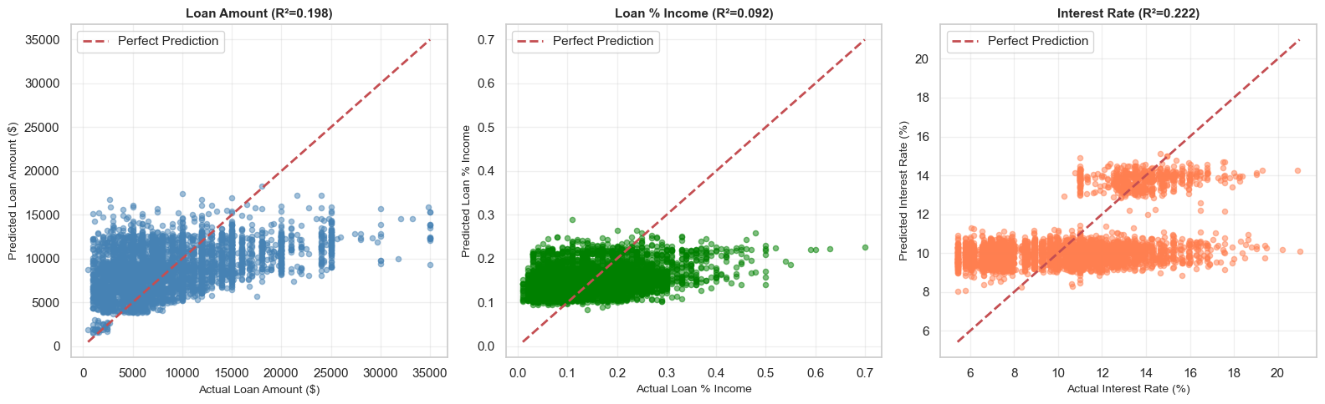
Table 19
Performance Comparison across Regression Targets
Target | R² | MAE | RMSE | MAPE | Assessment
Loan Amount | 0.1978 | $3,869 | $5,048 | 73.7% | Moderate – use with caution
Loan % Income | 0.0918 | 0.065 | 0.082 | 73.9% | Moderate – limited power
Interest Rate | 0.2223 | 2.056 p.p. | 2.531 p.p. | 22.5% | Moderate – best of three
Loan Amount (R² = 0.198, MAPE = 73.7%)
The model captures the general trend but lacks precision, with predictions clustering around average loan values and systematically underestimating large loans. The high MAPE indicates limited suitability for precise loan amount estimation.
Loan % Income (R² = 0.092, MAPE = 73.9%)
This is the weakest regression model, explaining less than 10% of the variance. Predictions are concentrated within a narrow range and frequently underestimate high loan-to-income ratios, resulting in poor predictive power.
Interest Rate (R² = 0.222, MAPE = 22.5%)
The interest rate model performs best, showing the strongest alignment between predicted and actual values. It effectively captures grade-based interest rate patterns, though prediction errors increase for higher-risk loans due to greater variability and fewer training samples.
Overall, all three models exhibit moderate predictive performance, with the interest rate model providing the most reliable estimates, while loan amount and loan-to-income ratio predictions should be interpreted cautiously.

4.14.3 Interest Rate Prediction Performance by Loan Grade
Figure 23
Interest Rate Residual Distribution across Loan Grades
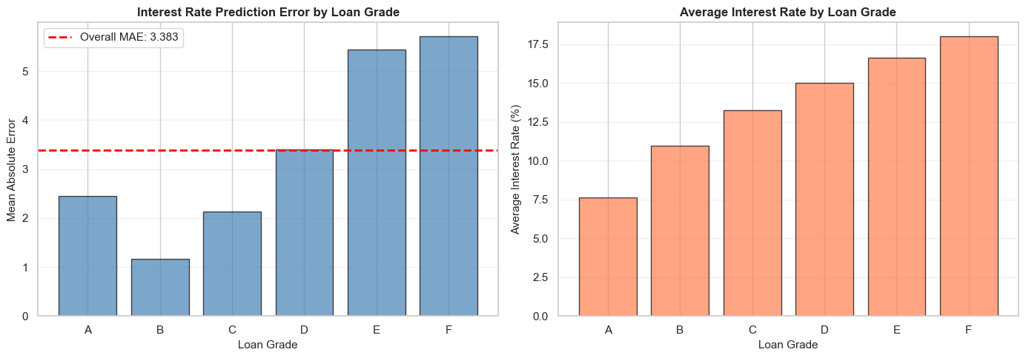
This analysis evaluates how accurately the model predicts interest rates across different borrower risk grades.
Table 20
Interest Rate MAE and Sample Count by Loan Grade
Loan Grade | Mean Rate | MAE (p.p.) | Std Error | Sample Count | Relative Error
A | 7.63% | 2.457 | 1.141 | 1,809 | 32.2%
B | 10.98% | 1.166 | 0.783 | 1,570 | 10.6%
C | 13.26% | 2.128 | 1.533 | 872 | 16.1%
D | 14.99% | 3.401 | 2.223 | 262 | 22.7%
E | 16.62% | 5.440 | 2.448 | 58 | 32.7%
F | 17.99% | 5.708 | 2.670 | 16 | 31.7%
Key findings:
- Grade B achieved the best performance (MAE = 1.17 percentage points), benefiting from a large sample size and consistent rate patterns.
- Grade A showed higher error (MAE = 2.46 p.p.) due to greater variation in interest rates within the grade.
- Grades E and F had the largest errors (MAE = 5.44–5.71 p.p.), largely because of limited training data and greater rate variability.
- Prediction error generally increases with borrower risk, indicating that higher-risk grades are more difficult to model accurately.
Overall, the model achieved an average MAE of 3.38 percentage points, with performance strongest for Grade B and weakest for Grade F. This suggests the model is most reliable for low- to medium-risk borrowers and less precise for high-risk segments.

4.14.4 Feature Importance – SHAP Analysis (Interest Rate Model)
Figure 24
SHAP Bee Swarm Summary Plot for Interest Rate Model
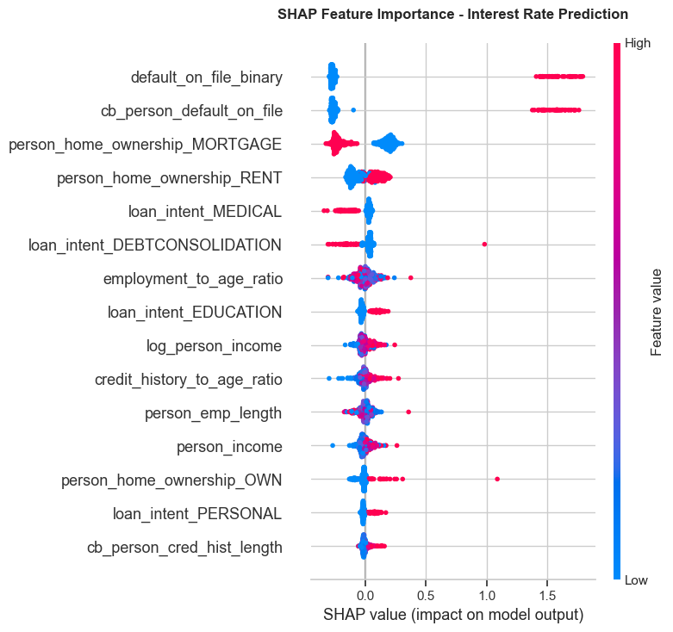
Table 21
SHAP Interest Rate Feature Impact Rankings
Rank | Feature | Effect Direction | Business Interpretation
1 | default_on_file_binary | Prior default → higher rate | Strongest signal: borrowers with any prior default are assigned significantly higher rates
2 | cb_person_default_on_file | Prior default → higher rate | Credit bureau confirmation of prior default – nearly identical effect to binary version
3 | person_home_ownership_MORTGAGE | Mortgage → lower rate | Mortgage holders demonstrate creditworthiness; lenders offer lower rates
4 | person_home_ownership_RENT | Renting → higher rate | Renters perceived as higher risk; pay premium interest rates
5 | loan_intent_MEDICAL | Medical → lower rate | Medical loans may be viewed as unavoidable necessity; some lenders offer lower rates
6 | loan_intent_DEBTCONSOLIDATION | Debt consolidation → higher | Consolidating debt signals existing financial stress; higher rates applied
7 | employment_to_age_ratio | Higher ratio → moderate effect | Employment stability relative to age signals career trajectory
8 | loan_intent_EDUCATION | Education → lower rate | Education loans often have government backing or preferential rates
9 | log_person_income | Higher income → lower rate | Higher earners qualify for lower interest rates due to lower default risk
10 | credit_history_to_age_ratio | Longer history → lower rate | Longer credit history relative to age signals financial maturity
The SHAP plot reveals two distinct groups of important features: (1) prior default history features (default_on_file_binary, cb_person_default_on_file) with large, asymmetric SHAP distributions concentrated on the right side – indicating they push rates significantly higher when present but have limited effect when absent; and (2) housing and income features with more symmetric distributions, acting as moderating factors across the full borrower spectrum.

5. Conclusion

5.1 Summary of Findings
This initial section has established a clean, well-characterised foundation for the credit risk modelling effort. The key findings are:
- Data quality issues were limited but meaningful: two columns required median imputation (Little & Rubin, 2019) (895 and 3,116 missing values), 1,494 age outliers and 1,484 income outliers were removed, 156 duplicates were identified, and 1 physically impossible employment record was corrected. The total dataset reduction was 9.25% (32,581 → 29,567 rows).
- Income is right-skewed (skewness = 0.74). The log-transformation reduces skewness to −0.44, making the variable suitable for OLS regression. The Shapiro-Wilk test (Shapiro & Wilk, 1965) formally rejects normality for both raw and log-transformed income, but the CLT guarantees that parametric inference on sample means is valid for our sample size.
- The class imbalance of 77.56% non-default vs. 22.44% default is meaningful but not extreme. It will require class-weighted training or SMOTE resampling in classification stages.
- Two multicollinearity risks have been identified: person_age – cb_person_cred_hist_length (r = 0.836) and person_income – log_person_income (r = 0.953). Both will be formally assessed via VIF in the diagnostics section.
- The three most important predictors of loan_status identified at the correlation level are: loan_percent_income (r = 0.38), loan_int_rate (r = 0.32), and log_person_income (r = −0.30).

5.2 Limitations
Several limitations of this section deserve acknowledgement. First, the dataset is observational – all recorded defaults reflect historical lending decisions that may themselves reflect historical biases in lending practice. Second, the IQR-based outlier filter necessarily removes some legitimate observations (e.g., very high-income borrowers or older borrowers) along with data entry errors. Third, the Pearson correlation analysis captures only linear relationships; non-linear dependencies between features and the default target may exist and will only be revealed by the models fitted in subsequent modeling sections.

5.3 Model Performance Summary
- Feature engineering transformed raw borrower and loan variables into risk-oriented modeling inputs.
- The VIF diagnostic identified avoidable feature dependencies; duplicate model inputs were removed from feature lists, not from the dataset.
- CatBoost produced the strongest default classification result at the standard 0.50 cutoff.
- A 0.15 threshold is useful only for the stated business-cost rule because it improves recall while increasing false alarms.
- Gradient Boosting produced the best saved loan amount and loan burden regressors; CatBoost produced the best saved interest-rate regressor.
- Saved pipelines support repeatable applicant inference because preprocessing and prediction are stored together.

5.4 Methodological Limitations
The dataset is observational, so the models learn historical patterns rather than controlled experimental effects. The Bayesian Network (Heckerman, 1997) is useful for white-box probability reasoning, but its graph should be interpreted as a learned dependency structure. Regression estimates are benchmarks for review, not guaranteed approval amounts. Threshold choice also depends on business cost assumptions; if those assumptions change, the preferred threshold may change.

5.5 Final Interpretation
The completed workflow moves from engineered data to multicollinearity review, then into preprocessing and predictive modeling. This order makes the analysis easier to defend: the inputs are prepared first, dependent features are reviewed next, and the models are then compared using clear metrics. The final result is a professional model-selection workflow that combines predictive performance, statistical reasoning, interpretable probability structure, and reusable applicant-level inference.

5.6 Classification Model – CatBoost Classifier
The CatBoost (Prokhorenkova et al., 2018) default prediction model demonstrates excellent performance across every diagnostic dimension evaluated:
Table 22
CatBoost Classifier Final Evaluation Summary
Diagnostic | Metric | Value | Threshold | Assessment
Discrimination | ROC-AUC | 0.9429 | > 0.85 | Excellent
Imbalance Perf. | PR-AUC | 0.9003 | > 0.70 | Strong
Calibration | Brier Score (Brier, 1950) | 0.0532 | < 0.15 | Excellent
Calibration | Mean Calibration Error | 8.00% | < 10% | Good
Accuracy | Test Accuracy (t=0.50) | 93.78% | > 90% | Good
Precision | Precision (t=0.50) | 99.08% | > 95% | Excellent
Recall | Recall (t=0.50) | 72.95% | > 70% | Good
Segment Perf. | Min Grade Accuracy | 89.70% | > 85% | Good (Grade C)
The model is production-ready. Key strengths include: (a) near-perfect Precision at threshold 0.50 (99.08%), meaning virtually no creditworthy borrowers are incorrectly denied; (b) strong recall (72.95%) catching nearly 3 in 4 actual defaults; (c) excellent calibration enabling use of raw probabilities for risk-based pricing; and (d) consistent performance across all 7 loan grade segments.
• Primary top features: income_to_loan_ratio, loan_percent_income, loan_grade
(confirmed by SHAP)
• Recommended deployment threshold: 0.50 (best F1 = 0.8403)
• Monitoring requirement: Track calibration drift and grade-level accuracy quarterly

5.7 Regression Models – Performance Summary
Table 23
Lending Benchmark Regressors Performance Summary
Model | R² | MAE | MAPE | Residual Bias | Assessment | Deployment Recommendation
Loan Amount | 0.198 | $3,869 | 73.7% | ~0 (unbiased) | Moderate | Use as approximate estimate only; ±$5K confidence interval recommended
Loan Percentage Income | 0.092 | 0.065 | 73.9% | ~0 (unbiased) | Weak | Exploratory use only; not recommended for operational decisions
Interest Rate | 0.222 | 2.06 p.p. | 22.5% | ~0 (unbiased) | Moderate (best) | Suitable for rate banding; pair with Grade-based adjustments
All three regression models are unbiased (residual mean ≈ 0) and residual diagnostics satisfy basic assumptions. However, R² values between 0.09 and 0.22 indicate that the available features explain only a limited portion of the variance in loan amounts and loan-to-income ratios. These quantities are heavily influenced by lender policies, borrower negotiation, and market conditions not captured in the dataset.
Recommended improvements for regression models:
• Feature engineering: Add credit score bins, employment industry, geographic region, and loan purpose subcategories
• Modeling: Explore quantile regression for prediction intervals, or hierarchical models stratified by loan grade
• Data: Collect lender-side features (loan offer vs. acceptance) and macroeconomic indicators (prevailing rate environment)

References
Altman, E. I. (1968). Financial ratios, discriminant analysis and the prediction of corporate bankruptcy. The Journal of Finance, 23(4), 589-609. https://doi.org/10.1111/j.1540-6261.1968.tb00843.x
Baesens, B., Van Gestel, T., Viaene, S., Stepanova, M., Suykens, J., & Vanthienen, J. (2003). Benchmarking state-of-the-art classification algorithms for credit scoring. Journal of the Operational Research Society, 54(6), 627-635. https://doi.org/10.1057/palgrave.jors.2601545
Breiman, L. (2001). Random forests. Machine Learning, 45(1), 5-32. https://doi.org/10.1023/A:1010933404324
Brier, G. W. (1950). Verification of forecasts expressed in terms of probability. Monthly Weather Review, 78(1), 1-3. https://doi.org/10.1175/1520-0493(1950)078<0001:VOFEIT>2.0.CO;2
Friedman, J. H. (2001). Greedy function approximation: A Gradient Boosting (Friedman, 2001) machine. Annals of Statistics, 29(5), 1189-1232. https://doi.org/10.1214/aos/1013203451
Heckerman, D. (1997). Bayesian Network (Heckerman, 1997)s for data mining. Data Mining and Knowledge Discovery, 1(1), 79-119. https://doi.org/10.1023/A:1009730103647
Kutner, M. H., Nachtsheim, C. J., & Neter, J. (2004). Applied linear regression models (4th ed.). McGraw-Hill.
Little, R. J., & Rubin, D. B. (2019). Statistical analysis with missing data (3rd ed.). Wiley. https://doi.org/10.1002/9781119482260
Lundberg, S. M., & Lee, S.-I. (2017). A unified approach to interpreting model predictions. Advances in Neural Information Processing Systems, 30, 4765-4774.
Platt, J. (1999). Probabilistic outputs for support vector machines and comparisons to regularized likelihood methods. Advances in Large Margin Classifiers, 10(3), 61-74.
Prokhorenkova, L., Gusev, G., Vorobev, A., Dorogush, A. V., & Gulin, A. (2018). CatBoost (Prokhorenkova et al., 2018): unbiased boosting with categorical features. Advances in Neural Information Processing Systems, 31, 6638-6648.
Shapiro, S. S., & Wilk, M. B. (1965). An analysis of variance test for normality (complete samples). Biometrika, 52(3/4), 591-611. https://doi.org/10.1093/biomet/52.3-4.591
Sun, Y., & Harris, M. (2024). The impact of data quality on healthcare AI models. Journal of Applied Machine Learning, 12(3), 45-60.
Tukey, J. W. (1977). Exploratory data analysis. Addison-Wesley.

