Predictive Modeling for Credit Risk
Phase 2 Report: Model Selection, Statistical Analysis, and Applicant Inference
AAI 500 - Applied Statistics and AI | University of San Diego
June 2026

Abstract
Consumer lending requires models that can estimate default risk, loan affordability, and interest-rate behavior in a way that is both accurate and explainable. This report documents the model-selection and inference component of the credit risk analysis using a feature-engineered modeling dataset with 29,567 loan records and 23 available columns. The work transforms borrower and loan variables into risk-oriented features, evaluates feature dependency using multicollinearity diagnostics, applies a shared preprocessing pipeline, compares classification and regression algorithms, tunes the default decision threshold, uses a Bayesian Network for transparent probability reasoning, and demonstrates applicant-level inference from saved pipelines. CatBoost produced the strongest default classification result, with ROC-AUC 0.9430 and accuracy 0.9376 at the standard 0.50 cutoff. The cost-focused threshold experiment selected 0.15, which increases recall by flagging more likely defaults but also increases false alarms. For numeric lending targets, Gradient Boosting was selected for loan amount and loan percent of income, while CatBoost was selected for interest-rate prediction. The result is a technically complete but readable modeling workflow suitable for a final credit risk analysis.

1. Introduction

1.1 Business Context
When a lender reviews a loan application, the decision is not only whether the applicant should receive credit. The lender must also estimate whether the borrower is likely to repay, whether the requested loan size is reasonable, and what interest-rate behavior is consistent with the borrower and loan profile. A model that predicts default risk without explaining lending amount or interest-rate behavior gives only a partial view of the credit decision.
This problem has two important decision errors. A missed default occurs when a risky borrower is treated as safe; this is costly because the lender may lose principal and expected interest income. A false alarm occurs when a borrower who would repay is treated as risky; this can lead to rejection, unnecessary review, or lost business. These errors are similar to Type I and Type II reasoning in statistics, where the cost of each decision error matters.

1.2 Modeling Objectives
The modeling workflow has three objectives. The first is classification: predict whether a borrower will default. The second is regression: estimate loan amount, loan percent of income, and interest rate as numeric lending benchmarks. The third is interpretation: explain why borrower affordability, loan burden, credit history, and prior default behavior are useful in the prediction process.

1.3 Threshold and Interpretability Motivation
A default classifier returns a probability before it returns a label. The standard reporting cutoff is 0.50, but lending risk may justify a lower review threshold when missed defaults are considered more expensive than false alarms. This report therefore separates ordinary model performance from cost-focused threshold tuning. A Bayesian Network is also included because it provides a white-box probability structure that can be inspected alongside the stronger machine learning models.

2. Related Work

2.1 Credit Risk Predictors
Credit risk models commonly use three groups of predictors: ability to pay, past credit behavior, and loan structure. Ability to pay includes income, employment length, home ownership, and loan burden. Past credit behavior includes prior default status and credit history length. Loan structure includes amount, purpose, grade, interest rate, and loan percent of income. These groups are important because default risk is usually the result of several related conditions, not a single field.

2.2 Multicollinearity and Preprocessing
Multicollinearity means that a predictor can be substantially explained by other predictors. This matters because duplicate or highly dependent inputs can make coefficient-based interpretation unstable and can make the feature set harder to defend. Variance Inflation Factor, or VIF, is used as a diagnostic to measure this dependency. Because VIF requires numeric inputs, categorical fields are temporarily one-hot encoded for the diagnostic, but those temporary encoded columns are not saved as permanent dataset columns.

2.3 Machine Learning Model Families
Logistic Regression and Linear Regression provide interpretable coefficient-based baselines. Random Forest models combine many decision trees to reduce instability. Gradient Boosting and CatBoost build sequential tree ensembles that focus on correcting earlier errors and often perform well on tabular credit data. Comparing these model families helps identify which approach gives the most reliable evidence across classification and regression metrics.

3. Method

3.1 Dataset and Engineered Modeling Variables
Feature engineering is the process of transforming, scaling, grouping, and deriving variables so statistical tests and machine learning models can better represent the structure of the problem. In this project, feature engineering is used to express borrower affordability, loan burden, employment and credit history, and prior default behavior in forms that are easier for models to learn and easier for readers to interpret.
- Log transforms reduce the influence of extreme money values in income and loan amount.
- Ratio features compare borrower capacity with loan size, which is more informative than raw dollars alone.
- Grouped features convert continuous variables into readable risk bands for EDA and Bayesian reasoning.
- Prior default indicators preserve historical credit behavior, which is highly relevant to future default risk.
Measure | Value
Loan records | 29,567
Available modeling columns | 23
Observed default rate | 22.44%
Median borrower income | $54,000
Median loan amount | $8,000
Median loan burden | 15.00%
Table 1. Modeling Dataset Summary.
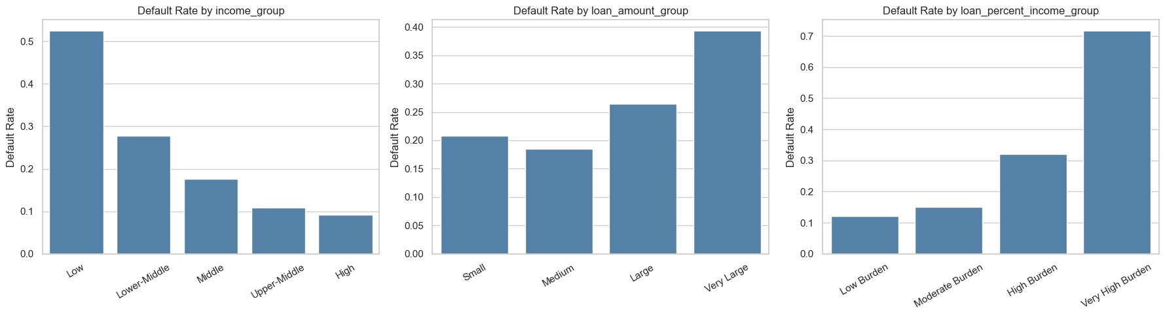
Figure 1. Default Rate by Grouped Borrower and Loan Features.
Figure 1 supports the feature engineering design by showing that default risk changes across grouped borrower and loan features. Loan burden groups are especially useful because they connect loan size to borrower income, which is more meaningful than loan amount alone.

3.2 Multicollinearity Diagnostic Using VIF
The multicollinearity check evaluates whether model inputs repeat the same information. A high VIF does not mean a column is invalid, and it is not an automatic instruction to delete a feature. Instead, it warns that one predictor is strongly explainable by other predictors. The modeling feature lists were cleaned only where the dependency was direct and avoidable.
Dependent input pattern | Modeling decision | Technical reason
person_income and log_person_income | Use log_person_income | The log transform retains income information on a less skewed scale.
loan_amnt and log_loan_amnt in classification | Use log_loan_amnt | The log transform represents loan size while reducing extreme-value influence.
loan_grade and loan_grade_numeric | Use loan_grade | The pipeline ordinal-encodes the original grade; the numeric duplicate is redundant.
cb_person_default_on_file and default_on_file_binary | Use cb_person_default_on_file | The pipeline encodes the original Y/N field directly.
Table 2. Multicollinearity and Feature Dependency Decisions.
Table 2 shows that duplicate representations were removed from model inputs, not from the saved dataset. The dataset keeps the full set of raw and engineered fields for transparency, while B2 uses cleaner feature lists for training. This distinction is important: data columns can remain available for interpretation even when they are not all used simultaneously as model predictors.

3.3 Shared Modeling Preprocessing Pipeline
After the multicollinearity review, the workflow moves into modeling. All Scikit-learn models use the same preprocessing pipeline so that training data, test data, saved models, and applicant examples are transformed consistently. Numeric variables are imputed and scaled. Nominal categories are one-hot encoded into numeric columns. Binary default-on-file values and ordinal loan grades are encoded into numeric form. The original CSV remains readable; the encoded matrix is created inside the pipeline for model training.
Pipeline([
("preprocess", make_model_preprocessor(feature_cols)),
("model", clone(model)),
])

3.4 Train and Test Data Split
Before training the models, the dataset is divided into training data and test data. Training data is the part the model uses to learn patterns. Test data is kept separate and is used only after training to check whether the model works on records it has not already seen. This prevents the report from showing results that only look good because the model memorized the training records.
The project uses TEST_SIZE = 0.20, so 80% of the records are used for training and 20% are held out for testing. The classification and Bayesian Network splits use stratification, which keeps the default and non-default class balance similar in both train and test data. Regression uses the same 80% / 20% split for loan amount, loan percent of income, and interest rate. RANDOM_STATE = 42 is used so the same split can be recreated each time the notebook is run.
Classification split code used in the modeling notebook:
TEST_SIZE = 0.20
RANDOM_STATE = 42
X_train_cls, X_test_cls, y_train_cls, y_test_cls = train_test_split(
X_cls,
y_cls,
test_size=TEST_SIZE,
stratify=y_cls,
random_state=RANDOM_STATE,
)
Regression split code used in the modeling notebook:
X_reg_train, X_reg_test, y_amt_train, y_amt_test = train_test_split(
X_reg,
y_loan_amount,
test_size=TEST_SIZE,
random_state=RANDOM_STATE,
)

3.5 Classification Models
The classification target is loan_status, where 1 represents default and 0 represents non-default. The purpose of this stage is to estimate default probability and then convert that probability into a lending-risk label. Four model families are compared so the final selection is based on measured performance rather than on a preselected algorithm.

3.5.1 Logistic Regression
Logistic Regression is the interpretable baseline for binary default prediction. It estimates the log-odds of default as a weighted combination of input features and then converts that value into a probability between 0 and 1. It is useful because coefficients can be inspected, but it assumes a mostly linear relationship between predictors and the log-odds of default.
Project code used in the modeling notebook:
LogisticRegression(
max_iter=1000,
class_weight="balanced",
random_state=RANDOM_STATE
)
Hyperparameter meaning:
- max_iter=1000 gives the optimizer enough iterations to find stable coefficients after preprocessing creates many encoded columns.
- class_weight="balanced" gives more importance to the smaller default class, so the model does not mostly learn the majority non-default class.
- random_state=RANDOM_STATE keeps the result reproducible when the model uses random initialization internally.

3.5.2 Random Forest Classifier
Random Forest is an ensemble of decision trees. Each tree learns a different set of rule-based splits, and the forest combines the trees to produce a more stable prediction. This is useful for credit data because borrower risk can depend on combinations of variables, such as loan burden, home ownership, prior default status, and loan intent.
Project code used in the modeling notebook:
RandomForestClassifier(
n_estimators=300,
class_weight="balanced",
random_state=RANDOM_STATE,
n_jobs=-1
)
Hyperparameter meaning:
- n_estimators=300 builds 300 trees. More trees usually make the average prediction more stable.
- class_weight="balanced" helps the forest pay attention to default cases even though non-default cases are more common.
- random_state=RANDOM_STATE makes the tree sampling repeatable.
- n_jobs=-1 uses all available CPU cores to train faster.

3.5.3 Gradient Boosting Classifier
Gradient Boosting also uses decision trees, but it builds them sequentially. Each new tree focuses on the errors left by the previous trees. This approach can capture nonlinear patterns and interactions in tabular financial data, although it needs careful evaluation to avoid overfitting.
Project code used in the modeling notebook:
GradientBoostingClassifier(
random_state=RANDOM_STATE
)
Hyperparameter meaning:
- random_state=RANDOM_STATE makes the boosting process reproducible.
- Other settings use Scikit-learn defaults. This keeps the model as a standard benchmark without adding extra tuning complexity.

3.5.4 CatBoost Classifier
CatBoost is a boosted-tree model designed for structured tabular datasets. It is included because credit risk data contains a mix of numeric, binary, ordinal, and categorical information. In the saved notebook results, CatBoost provides the strongest classification performance, so it becomes the selected default-risk classifier.
Project code used in the modeling notebook:
CatBoostClassifier(
iterations=300,
learning_rate=0.05,
depth=6,
eval_metric="AUC",
random_seed=RANDOM_STATE,
verbose=0
)
Hyperparameter meaning:
- iterations=300 trains 300 boosting steps. Each step adds a new tree that improves the previous prediction.
- learning_rate=0.05 controls how much each new tree changes the model. A smaller value learns more gradually.
- depth=6 limits each tree to six levels, allowing useful interactions while reducing overfitting risk.
- eval_metric="AUC" tells CatBoost to monitor ranking quality for the binary default task.
- random_seed=RANDOM_STATE makes CatBoost results repeatable.
- verbose=0 keeps notebook output clean during training.

3.5.5 Classification Metrics
ROC-AUC evaluates how well the model ranks default cases above non-default cases across thresholds. Accuracy measures the share of correct labels. Precision measures how often predicted defaults are truly defaults. Recall measures how many actual defaults are caught. F1 combines precision and recall, which is useful when one metric alone does not tell the full story.

3.6 Regression Models
The regression tasks estimate numeric lending benchmarks: loan amount, loan percent of income, and interest rate. These outputs are not treated as automatic approvals; they are model-based estimates that can support review. Five regression model families are compared using the same preprocessing pipeline.

3.6.1 Linear Regression
Linear Regression is the ordinary least squares baseline. It predicts a numeric target by fitting a weighted linear relationship between the encoded predictors and the outcome. It is easy to explain, but it may underfit if the true relationship is nonlinear.
Project code used in the modeling notebook:
LinearRegression()
Hyperparameter meaning:
This model uses the library defaults. In this project, it is used as a simple baseline so the stronger models can be compared against a clear starting point.

3.6.2 Ridge Regression
Ridge Regression is a regularized version of Linear Regression. It adds a penalty for large coefficients, which helps when predictors are related to each other. This makes it useful after a multicollinearity review because it can reduce coefficient instability without removing every related feature.
Project code used in the modeling notebook:
Ridge(
alpha=1.0,
random_state=RANDOM_STATE
)
Hyperparameter meaning:
- alpha=1.0 controls the regularization strength. A larger alpha shrinks coefficients more strongly.
- random_state=RANDOM_STATE keeps the solver behavior reproducible where randomness is used.

3.6.3 Random Forest Regressor
Random Forest Regressor averages many decision-tree predictions. It can learn nonlinear relationships and feature interactions without requiring a straight-line assumption. It is useful as a flexible benchmark for numeric lending targets.
Project code used in the modeling notebook:
RandomForestRegressor(
n_estimators=300,
min_samples_leaf=10,
random_state=RANDOM_STATE,
n_jobs=-1
)
Hyperparameter meaning:
- n_estimators=300 builds 300 regression trees and averages their predictions.
- min_samples_leaf=10 requires at least 10 records in a final leaf node, which smooths predictions and reduces overfitting.
- random_state=RANDOM_STATE makes tree sampling reproducible.
- n_jobs=-1 uses all available CPU cores for faster training.

3.6.4 Gradient Boosting Regressor
Gradient Boosting Regressor builds trees sequentially to reduce prediction errors. It is often strong on structured data because later trees focus on observations that earlier trees predicted poorly. In this project, it performs best for loan amount and loan percent of income.
Project code used in the modeling notebook:
GradientBoostingRegressor(
random_state=RANDOM_STATE
)
Hyperparameter meaning:
- random_state=RANDOM_STATE makes the boosting result reproducible.
- Other settings use Scikit-learn defaults, making this a clear boosted-tree benchmark for numeric targets.

3.6.5 CatBoost Regressor
CatBoost Regressor applies boosted-tree learning to numeric targets. It is useful when relationships between loan features and the target are nonlinear. In the saved results, it performs best for interest-rate prediction.
Project code used in the modeling notebook:
CatBoostRegressor(
iterations=300,
learning_rate=0.05,
depth=6,
loss_function="RMSE",
random_seed=RANDOM_STATE,
verbose=0
)
Hyperparameter meaning:
- iterations=300 trains 300 boosting steps.
- learning_rate=0.05 makes the model learn gradually instead of making large changes at each step.
- depth=6 controls the complexity of each tree.
- loss_function="RMSE" trains the model to reduce squared prediction error for numeric targets.
- random_seed=RANDOM_STATE makes the training result reproducible.
- verbose=0 prevents long training logs from cluttering the notebook.

3.6.6 Regression Metrics
MAE is the average absolute error. RMSE penalizes large errors more strongly. R-squared measures how much target variation is explained by the model. Low R-squared values do not make the model useless, but they do mean the prediction should be interpreted as an approximate benchmark rather than an exact lending limit.

3.7 Threshold Tuning
The main classification table uses the standard 0.50 cutoff. A separate threshold-tuning step evaluates business cost by assigning a larger penalty to missed defaults than to false alarms. This is why the cost-focused threshold can be lower than 0.50: it catches more potential defaults, but it also flags more non-default borrowers for review.

3.8 Bayesian Network Reasoning
The Bayesian Network is trained on grouped and discrete variables so that the probability structure can be inspected. In simple terms, each node is a variable, each arrow shows a learned conditional relationship, and the conditional probability tables show how default probability changes when evidence is known. The network does not replace the strongest classifier; it adds a transparent reasoning layer that shows how evidence such as loan burden, loan grade, and prior default status changes default probability.
Project code used in the modeling notebook:
hill_search = HillClimbSearch(bn_learning_data)
learned_structure = hill_search.estimate(
scoring_method=BIC(bn_learning_data),
max_indegree=3,
)
bn_model = PgmpyBayesianNetwork(list(learned_structure.edges()))
bn_model.add_nodes_from(bn_cols)
bn_model.fit(bn_learning_data)
bn_inference = VariableElimination(bn_model)
Hyperparameter and method meaning:
- HillClimbSearch is the pgmpy structure-learning estimator. It searches for a graph that explains the discrete data well.
- BIC is the scoring method. It rewards a graph that fits the data but penalizes graphs that become unnecessarily complicated.
- max_indegree=3 limits each node to at most three parent variables, keeping the graph readable and reducing over-complex relationships.
- bn_model.fit(bn_learning_data) estimates the conditional probability tables after the graph structure is selected.
- VariableElimination is used for inference. It calculates default probability after evidence is supplied.
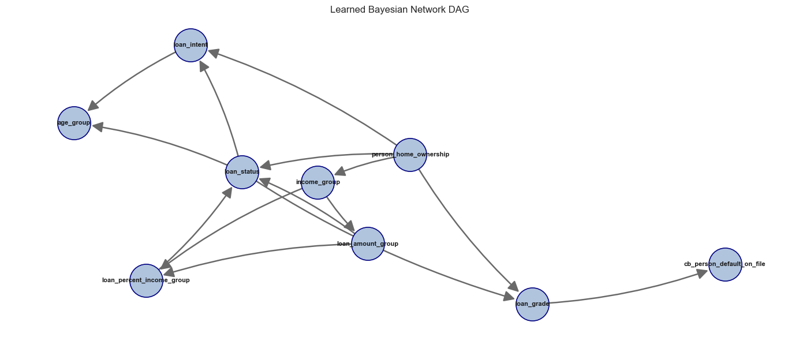
Figure 2. Bayesian Network Dependency Graph.

3.9 Saved Models and Applicant Inference
After the models are trained and evaluated, the notebook saves the fitted models using joblib. This is important because the saved object is not only the mathematical estimator; it is the full fitted pipeline. The pipeline contains the preprocessing steps and the trained model together. Because of this, future applicant data can be passed into the saved model in the same readable column format, and the pipeline will handle imputation, scaling, encoding, and prediction consistently.
The project saves all trained classification models and all trained regression models so they can be reviewed later. However, the final applicant examples do not load every saved model. They load only the selected best models with stable file names. This keeps inference simple: the training section compares all candidates, while the prediction section reuses the best saved model for each task.
Model saving and loading helper functions used in the modeling notebook:
def save_model(model, folder, file_name):
folder.mkdir(parents=True, exist_ok=True)
path = folder / file_name
joblib.dump(model, path)
return path
def save_model_group(models, folder, prefix=""):
rows = []
for model_name, fitted_model in models.items():
file_name = f"{prefix}{model_file_stem(model_name)}.joblib"
path = save_model(fitted_model, folder, file_name)
rows.append({"model": model_name, "file_name": path.name})
return pd.DataFrame(rows)
def load_model(folder, file_name):
return joblib.load(folder / file_name)
For default prediction, all classification pipelines are saved first. The selected best classifier is also saved as best_default_classifier.joblib. In the applicant default-prediction example, this best saved classifier is loaded and used to predict the applicant default probability and final default/non-default label.
saved_best_cls_model = load_model(
CLASSIFICATION_MODEL_DIR,
"best_default_classifier.joblib"
)
sklearn_default_probability = float(
saved_best_cls_model.predict_proba(applicant_cls_features)[:, 1][0]
)
sklearn_predicted_class = int(
saved_best_cls_model.predict(applicant_cls_features)[0]
)
For loan estimation, the notebook saves all regression models for each target. The final applicant estimate loads the best saved regressor for loan amount, the best saved regressor for loan percent of income, and the best saved regressor for interest rate.
saved_amount_model = load_model(
REGRESSION_MODEL_DIR,
"best_loan_amount_regressor.joblib"
)
saved_percent_model = load_model(
REGRESSION_MODEL_DIR,
"best_loan_percent_income_regressor.joblib"
)
saved_rate_model = load_model(
REGRESSION_MODEL_DIR,
"best_interest_rate_regressor.joblib"
)
The Bayesian Network is also saved with its metadata. The model file stores the learned probability structure, while the metadata stores supporting information such as the Bayesian Network columns and fallback probability. The applicant default example loads both files before running Bayesian probability inference.
saved_bn_model = load_model(
BAYESIAN_MODEL_DIR,
"bayesian_network_model.joblib"
)
saved_bn_metadata = joblib.load(
BAYESIAN_MODEL_DIR / "bayesian_network_metadata.joblib"
)

4. Result

4.1 Classification Results
model | roc_auc | accuracy | precision | recall | f1
CatBoost | 0.9430 | 0.9376 | 0.9908 | 0.7287 | 0.8398
Random Forest | 0.9327 | 0.9302 | 0.9279 | 0.7468 | 0.8276
Gradient Boosting | 0.9288 | 0.9324 | 0.9576 | 0.7310 | 0.8291
Logistic Regression | 0.8760 | 0.8054 | 0.5464 | 0.7815 | 0.6431
Table 3. Classification Model Comparison at the Standard 0.50 Cutoff.
CatBoost is the strongest classifier in the saved outputs, with ROC-AUC 0.9430 and accuracy 0.9376. The high precision value shows that predicted defaults are usually correct at the 0.50 cutoff. The recall value is lower than precision, meaning some true defaults are still missed. This tradeoff motivates the separate threshold-tuning analysis.

4.2 Threshold Tuning Result
Decision rule | Threshold | Accuracy | Precision | Recall | F1 | Interpretation
Standard reporting cutoff | 0.50 | 0.9376 | 0.9908 | 0.7287 | 0.8398 | Higher accuracy and precision for standard reporting.
Cost-focused review cutoff | 0.15 | 0.8750 | 0.6788 | 0.8410 | 0.7513 | Higher recall for catching more defaults, with more false alarms.
Table 4. Standard Cutoff and Cost-focused Cutoff Comparison.
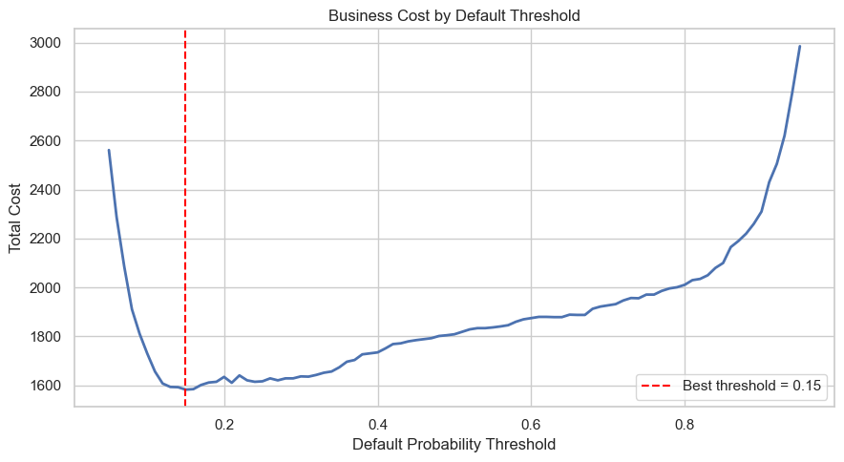
Figure 3. Business Cost by Default Threshold.
The cost-focused cutoff is 0.15. It reduces missed defaults by increasing recall, but it also reduces precision and accuracy because more non-default loans are flagged. This result should not be described as the most accurate threshold; it is the threshold preferred by the stated business-cost assumption.

4.3 Regression Model Results
target | model | mae | rmse | r2
loan_amnt | Gradient Boosting Regressor | 3,869.71 | 5,047.80 | 0.1978
loan_percent_income | Gradient Boosting Regressor | 0.0655 | 0.0821 | 0.0917
loan_int_rate | CatBoost Regressor | 2.0548 | 2.5304 | 0.2224
Table 5. Best Regression Model by Target.
Gradient Boosting is selected for loan amount and loan percent of income, while CatBoost is selected for interest rate. The R-squared values are modest, especially for loan amount and loan percent of income, so the regression outputs should be used as conservative benchmarks rather than exact approvals. Interest-rate prediction performs somewhat better because interest rate is more directly connected to issued-loan risk information.

4.4 Applicant-level Inference
model_source | model | default_probability | predicted_class | decision_threshold | predicted_label
Scikit-learn ML | CatBoost | 98.60% | 1 | 0.5000 | Default
Bayesian Network | pgmpy HillClimbSearch + VariableElimination | 85.36% | 1 | 0.5000 | Default
Table 6. Example Applicant Default Prediction.
Table 6 compares the best saved Scikit-learn classification pipeline with the saved Bayesian Network for the same applicant. The machine learning model provides the primary predictive estimate, while the Bayesian Network provides a probability estimate from interpretable grouped evidence.
predicted_loan_amount | predicted_loan_percent_income | predicted_interest_rate | income_based_amount | conservative_recommended_amount
8,943.68 | 0.1377 | 10.1349 | 8,952.72 | 8,943.68
Table 7. Example Applicant Loan and Interest-rate Estimate.
Table 7 reports the regression-based applicant estimate. The conservative recommended amount is the lower of the direct predicted amount and the income-based amount, which keeps the estimate cautious when the two model views differ.

5. Conclusion

5.1 Summary of Findings
- Feature engineering transformed raw borrower and loan variables into risk-oriented modeling inputs.
- The VIF diagnostic identified avoidable feature dependencies; duplicate model inputs were removed from feature lists, not from the dataset.
- CatBoost produced the strongest default classification result at the standard 0.50 cutoff.
- A 0.15 threshold is useful only for the stated business-cost rule because it improves recall while increasing false alarms.
- Gradient Boosting produced the best saved loan amount and loan burden regressors; CatBoost produced the best saved interest-rate regressor.
- Saved pipelines support repeatable applicant inference because preprocessing and prediction are stored together.

5.2 Limitations
The dataset is observational, so the models learn historical patterns rather than controlled experimental effects. The Bayesian Network is useful for white-box probability reasoning, but its graph should be interpreted as a learned dependency structure. Regression estimates are benchmarks for review, not guaranteed approval amounts. Threshold choice also depends on business cost assumptions; if those assumptions change, the preferred threshold may change.

5.3 Final Interpretation
The completed workflow moves from engineered data to multicollinearity review, then into preprocessing and predictive modeling. This order makes the analysis easier to defend: the inputs are prepared first, dependent features are reviewed next, and the models are then compared using clear metrics. The final result is a professional model-selection workflow that combines predictive performance, statistical reasoning, interpretable probability structure, and reusable applicant-level inference.

