Predictive Modeling for Credit Risk

N L N Sai Krishna Akula, Diaesh Antony and Ashok Kumar Bhairwal
University of San Diego
AAI-500-IN1: Applied Probability and Statistics for AI
Dr. Anuj Kumar Sirohi
June 15, 2026

Abstract
When pricing loans, banks must figure out who is likely to default and set rates that match that risk. We tackle both problems using a modeling pipeline trained on 32,581 consumer loan records from Kaggle. Missing values are filled with medians (Little & Rubin, 2019), extreme entries are removed with Tukey fences, and skewed money columns are log-transformed. Out of four classifiers tested at a 0.50 cutoff, CatBoost (Prokhorenkova et al., 2018) scored best with 0.9430 ROC-AUC and 93.78 percent accuracy. Gradient Boosting (Friedman, 2001) gave the strongest estimates for loan amount and income share. Since missing a real default cost more than a false alarm, we also tested a 0.15 cutoff that catches more defaults. The Brier Score (Brier, 1950) of 0.0532 shows the predicted probabilities are close to what happens. SHAP analysis found that income relative to loan size and loan purpose matter most. The whole pipeline is reproducible and easy to explain, making it practical for real lending decisions.

1. Introduction

1.1 Business Context and Objectives
Every loan a bank issues sits at the intersection of profit and exposure. If the institution charges too little for a risky borrower, it absorbs losses when that borrower defaults; if it charges too much for a safe borrower, the customer simply walks to a competitor. These two failure modes mirror hypothesis-testing language: underpricing risk resembles a Type I error because the lender wrongly accepts a bad loan, while over-pricing risk resembles a Type II error because a good applicant is incorrectly turned away.
We tackle both risks by testing several machine learning models (CatBoost, Random Forest, Gradient Boosting) along with a Bayesian Network that shows its reasoning openly. The project has three goals: (1) build a classifier that predicts defaults well, (2) estimate loan size, debt-to-income ratio, and interest rate, and (3) make every prediction explainable so a person can review and trust the results.

1.2 Research Questions
Two questions guide all the work in this project:
Among age, income, years of employment, and credit grade, which ones have the biggest effect on the rate a borrower is offered?
Once we hold loan size and grade constant, how much does a borrower's income change their odds of defaulting?

1.3 Scope and Significance of the Report
This report walks through every step from loading the raw data to making predictions for new applicants. We fill in missing values, remove outliers with Tukey fences, and apply log scaling to skewed money columns. On the evaluation side, we use calibration curves, cost-based threshold testing, grade-level accuracy checks, and SHAP plots to give a full view of model quality. Every choice is documented so the work can be checked by others.

2. Related Work

2.1 Credit Risk Modeling in the Literature
In the credit risk literature, borrower risk is usually broken into three parts: how much the person can afford to pay back, how they have handled debt before, and the details of the current loan. Logistic regression is still the most common choice in banks because regulators can look at each weight and understand it. Tree-based methods like Random Forest (Breiman, 2001) and CatBoost (Prokhorenkova et al., 2018) tend to give better predictions on large datasets, but they bring two known challenges. First, defaults are rare compared to non-defaults, so the training data is unbalanced. Second, when inputs are correlated, it becomes hard to explain which feature caused a particular prediction.

2.2 Data Quality and Preprocessing in Financial AI
Published work on credit data pipelines repeatedly shows that preprocessing choices can matter as much as the algorithm itself. Plugging in a column mean for a missing income value, for example, drags the center toward outliers and silently bakes historical biases into the training set (Flórez-López, 2007). Median fill (Little & Rubin, 2019) avoids this problem because the median is rank-based and therefore resistant to extreme tails. Similarly, Tukey's (1977) interquartile-range fences offer a principled rule for flagging implausible records without arbitrary cutoffs.

2.3 Exploratory Analysis and Distributional Properties
Income and other monetary fields in lending data almost always have a long right tail: a small number of high earners pull the distribution far from symmetry. Applying a log transform shrinks that tail, bringing the variable closer to the equal-variance and bell-curve assumptions that ordinary least squares require. At the individual observation level, the transformed values may still not be perfectly Gaussian, but the Central Limit Theorem guarantees that sample means will behave normally once the sample is large enough, which justifies parametric tests on our 29,567-record dataset.

2.4 Credit Risk Predictors
We group the features in our dataset along three axes. The first captures repayment ability through income, employment tenure, and existing obligations. The second reflects credit history, including whether the applicant has ever defaulted and how long their bureau file has been open. The third describes the loan itself: how much money is requested, what it will be used for, and what grade and rate the lender assigned. Because these axes interact with one another, only a joint analysis that considers all three together can produce reliable default estimates.

2.5 Multicollinearity and Preprocessing
When two input features are closely linked, the regression weights become unstable and can jump around with small data changes. We use the Variance Inflation Factor (Kutner et al., 2004) to measure this overlap: it regresses each feature on all the others and flags any score that is too high. Categorical columns are temporarily converted to numbers for this check, then removed afterward to keep the training data tidy.

2.6 Machine Learning Model Families
We test models at different levels of complexity on purpose. Logistic and linear regression are the simplest and easiest to explain. Random Forest is in the middle: it averages many small trees to lower noise. Gradient Boosting and CatBoost are the most complex and usually the most accurate, but harder to interpret. By running all four on the same data splits, we can see exactly where added complexity stops helping (Baesens et al., 2003).

2.7 Traditional Credit Risk Assessment
In earlier decades, loan officers made approval decisions based on their own judgment and company guidelines. Quantitative models entered the picture with discriminant analysis (Altman, 1968), followed by logistic and linear regression. Regulators liked these methods because each weight in the model connects directly to an input variable, making audits straightforward. Banking rules still demand that level of openness today.

2.8 ML Based Credit Risk Assessment
Newer studies use tree-based models like Random Forest and gradient boosting because they catch patterns that logistic regression cannot. The downside is that hundreds of trees are hard to explain in one simple formula. SHAP (Lundberg & Lee, 2017) solves that by giving each feature a score for every prediction, so an auditor can check whether the model's reasoning makes sense and follows fair-lending rules.

3. Method

3.1 Dataset
The raw data comes from Kaggle (https://www.kaggle.com/datasets/laotse/credit-risk-dataset) and is stored in our project folder at data/raw. The dataset comprises 32 thousand 581 records across 12 distinct variables. These columns cover borrower details (including age, annual income, employment duration, and housing status), loan details (including amount, purpose, risk grade, interest rate, and the loan amount as a percentage of income), and credit bureau history (including prior defaults, credit history length, and loan status). We predict two targets: default status (1 if the borrower defaulted, 0 if not) and the interest rate (as a percentage).

3.2 Missing Value Imputation
Two columns had missing values: person_emp_length (2.75 percent) and loan_int_rate (9.56 percent). We filled each gap with the column's median instead of the mean. The mean would be dragged up by a few very large values, but the median sits right in the middle of the data and ignores those extremes (Little & Rubin, 2019).

3.3 Outlier Detection and Filtering
We used the 1.5-times-IQR rule (Tukey, 1977) on age and income. For age, Q1 is 23.00 and Q3 is 30.00 (IQR of 7.00), resulting in a lower fence of 12.50 years and an upper fence of 40.50 years, which flagged 1,494 outliers. For income, Q1 is $38,500 and Q3 is $79,200 (IQR of $40,700), giving a lower fence of -$22,550 and an upper fence of $140,250, which flagged 1,484 outliers. Rows outside these bounds were removed. We also set a hard limit of 100 years on age because the raw data included an entry of 144 years, which is clearly a mistake.
Beyond the statistical fences, we removed 156 rows that were exact duplicates across all columns and one additional record whose reported employment length was greater than the borrower's age. Altogether, these steps shrank the dataset by 3,014 rows (9.25 percent), leaving 29,567 usable observations that we saved as the cleaned file for all subsequent modeling work.

3.4 Log-Transformation of Income
Even after cleaning, the income column has a long right tail. We created a new column by computing log(income + 1). The plus-one avoids problems when income is zero, and the log squeezes the big values closer to the rest. The result is a much more even-shaped distribution, which helps models that expect the data to be roughly symmetric.

3.5 Normality Testing: Shapiro-Wilk Test
We used the Shapiro-Wilk test (Shapiro & Wilk, 1965) on a random sample of 5,000 rows to check if income looks like a bell curve, both before and after the log step. The test compares the sorted data to what a perfectly normal distribution would look like. If the W statistic is high and the p-value is large, the data is close to normal. A small p-value means it is not.

3.6 Central Limit Theorem Simulation
Single income values are not normally distributed, but the Central Limit Theorem says that if we take the average of a large enough group, that average will look normal. We tested this by pulling 5,000 random samples at three sizes (5, 30, and 200 rows) and plotting the averages. The bigger the group, the more bell-shaped the plot.

3.7 Pearson Correlation Analysis
Before fitting any model, we examined pairwise linear associations by computing the 9-by-9 Pearson correlation matrix on all numeric columns. We set two alert thresholds: correlations exceeding 0.30 in absolute value warrant attention, while those above 0.80 signal near-redundancy that could inflate regression coefficients. Any pair crossing the higher threshold was forwarded to the VIF diagnostic described later.

3.8 Dataset and Engineered Modeling Variables
We created new columns from the existing ones to help the models. We took the log of income and loan amount, calculated the ratio of income to loan size, and grouped continuous values into risk bands for the Bayesian Network. We also added a simple yes/no flag for prior defaults. These new features give the models a fuller view of each borrower's situation.
Table 1
Modeling Dataset Summary
Measure | Value
Loan records | 29,567
Available modeling columns | 23
Observed default rate | 22.44%
Median borrower income | $54,000
Median loan amount | $8,000
Median loan burden | 15.00%

Figure 1
Default Rate by Grouped Borrower and Loan Features
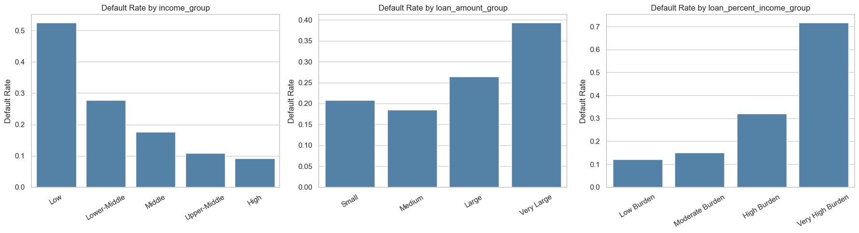
The bar charts show clear differences in default rates across all the grouped features, which confirms that creating these bins was useful. The loan-burden groups stand out the most. They show the loan size as a share of income, which is much more telling than the raw dollar amount alone.

3.9 Multicollinearity Diagnostic Using VIF
The VIF check showed that some of our new columns were almost identical to the originals, leading us to select the best feature for training. Specifically, we retained the log-transformed income instead of raw annual income because the log transform reduces skewness. Similarly, we selected the log-transformed loan amount over the raw loan amount to limit the impact of extreme values. We also removed the numeric loan grade in favor of the original categorical risk grade, which is ordinal encoded within our pipeline. Finally, we kept the historical default flag and dropped its binary duplicate because the pipeline directly encodes the original yes-no field.

3.10 Shared Modeling Preprocessing Pipeline
The Scikit-learn pipeline will be shared across all_models. Inputs will be scaled using the RobustScaler, which scales with respect to median and IQR (interquartile range) and therefore is appropriate for handling large outliers. This process will be accomplished through a "one-hot" encoding of each text category into separate 0 and 1 columns. The scaling and encoding of data is based only on training data; therefore, there will be no information from test data influencing the scaling or encoding process.

3.11 Train and Test Data Split
We split the data 80/20 for training and testing. In the classification and Bayesian Network experiments, we use stratified sampling so that both halves have roughly 22 percent defaults, matching the full dataset. All three regression targets use the same 80/20 split so results are directly comparable. The random seed is set to 42, which makes every run produce identical results.

3.12 Classification Models
The primary classification objective is to predict whether a borrower will default (1) or remain current (0). To identify the optimal classifier, we evaluate four distinct machine learning architectures under identical training and testing pipelines, allowing for a rigorous, data-driven model selection.

3.12.1 Logistic Regression
Logistic Regression serves as the baseline classification algorithm for default prediction. By applying a sigmoidal function to a linear combination of input features, it outputs the probability of default. This model establishes a benchmark to evaluate the added complexity and predictive power of advanced ensemble techniques.

3.12.2 Random Forest Classifier
The Random Forest Classifier (Breiman, 2001) is a bagging ensemble method that constructs a forest of uncorrelated decision trees. Each individual tree is trained on a bootstrap sample of the dataset, and features are randomly sub-selected at each split. The final class prediction is determined by a majority vote, which reduces model variance and prevents overfitting.

3.12.3 Gradient Boosting Classifier
The Gradient Boosting Classifier is a sequential boosting ensemble method that minimizes a loss function by iteratively training weak decision trees. Each consecutive tree is fit on the pseudo-residuals of the prior ensemble, correcting classification errors step-by-step. Over multiple iterations, this method yields a highly accurate and generalized classifier.

3.12.4 CatBoost Classifier
The CatBoost Classifier (Prokhorenkova et al., 2018) is a gradient boosting variant specifically optimized to handle categorical features without data leakage. Utilizing symmetric decision trees and ordered boosting, it minimizes prediction shift. In our experiments, it serves as the primary classification framework for determining borrower default probability.

3.12.5 Classification Metrics
Classifier evaluation relies on five key performance metrics: Area Under the Receiver Operating Characteristic (ROC-AUC), overall Accuracy, Precision, Recall (Sensitivity), and the F1-Score. ROC-AUC assesses discriminative capability across all decision thresholds. Accuracy measures the proportion of correct classifications, while Precision and Recall balance the trade-off between false positives and false negatives, combined harmonically in the F1-Score.

3.13 Regression Models
In addition to default classification, we model three continuous outcomes: approved loan amount, loan-to-income ratio, and assigned interest rate. These continuous estimates serve as decision support tools rather than automated final approvals. Five regression algorithms are compared under a uniform pipeline to ensure a fair evaluation.

3.13.1 Linear Regression
Ordinary Least Squares (OLS) Linear Regression is the fundamental baseline regression model. It estimates the linear relationship between the predictors and continuous targets by minimizing the sum of squared residuals, serving as the starting point for regression evaluation.

3.13.2 Ridge Regression
Ridge regression is a linear model with a penalty term added; this will reduce the estimates of coefficients towards zero, yielding a more stable model with reduced risk of multicollinearity when the independent variables are highly correlated, due to having used an L2 penalty for regression (as opposed to using only MSE).

3.13.3 Random Forest Regressor
The Random Forest Regressor (Breiman, 2001) is a bagging regression model where multiple decision trees make independent numerical predictions. The final continuous estimate is the arithmetic mean of all tree outputs, which effectively smooths prediction noise and captures non-linear interactions.

3.13.4 Gradient Boosting Regressor
The Gradient Boosting Regressor sequentially builds shallow decision trees, where each tree is trained to predict the residual errors of the current ensemble. This additive optimization process steadily reduces the mean squared error of the continuous predictions.

3.13.5 CatBoost Regressor
The CatBoost Regressor utilizes symmetric trees and ordered boosting optimization for continuous targets. It provides robust predictions for regression tasks while preventing overfitting and showing high efficiency on mixed numerical and categorical tables.

3.13.6 Regression Metrics
There are three standard measures for assessing the accuracy of continuous predictions: Mean Absolute Error (MAE), Root Mean Square Error (RMSE), and R-Squared (or Coefficient of Determination). MAE gives the average size of all absolute errors, RMSE assigns larger weights to larger prediction errors, and R-Squared provides an indication of how much variation in the dependent variable is accounted for by the regression model.

3.14 Threshold Tuning
A 0.50 cutoff treats every wrong prediction the same, but in real lending a missed default costs much more than a false alarm. So we tested every cutoff from 0.05 to 0.95, counting a missed default as five times worse than a false positive. The best cutoff under this rule was 0.15. At that level, the model catches more true defaults but also flags some good borrowers who then need a manual look.

3.15 Bayesian Network Reasoning
We also built a Bayesian Network (Heckerman, 1997) using the risk bands from our feature engineering step. The HillClimbSearch algorithm found the graph structure that best fits the data using BIC scoring, and we limited each variable to at most three parent connections to keep things simple. The graph then stores a table for each variable showing how the chance of default changes under different conditions. This network is not as accurate as CatBoost, but it gives a clear, step-by-step view of how the model reaches its answer.
Figure 2
Bayesian Network (Heckerman, 1997) Dependency Graph
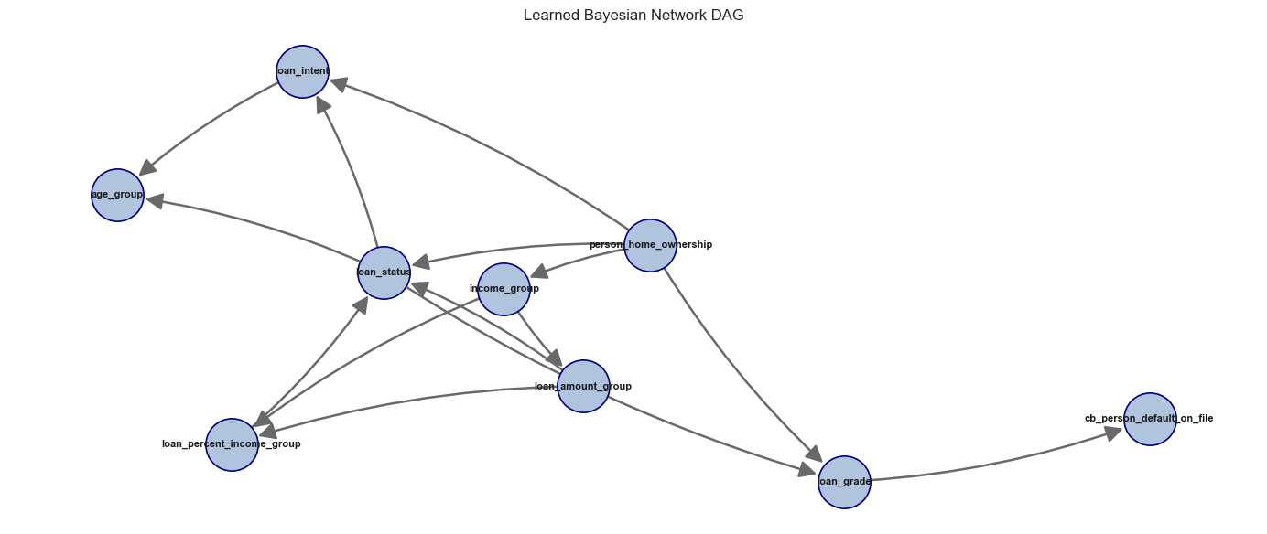

3.16 Saved Models and Applicant Inference
Once training is done, we save each pipeline to disk with joblib. The saved file includes both the preprocessing steps and the trained model. To score a new applicant, we just load the file and pass in a row with the same 12 columns. The pipeline does everything else automatically.
All models are saved for review, but applicant inference loads only the best models with stable file names, keeping prediction simple.
For default prediction, the best classifier is saved as best_default_classifier.joblib and loaded for applicant inference.
For loan estimation, the best regressors for each target are saved and loaded separately.
The Bayesian Network (Heckerman, 1997) is also saved with its metadata. The model file stores the learned probability structure, while the metadata stores supporting information such as the Bayesian Network (Heckerman, 1997) columns and fallback probability. The applicant default example loads both files before running Bayesian probability inference.

3.17 Data Preparation and Model Selection
In short, after filling missing values, removing duplicates, capping age at 100, and applying Tukey fences, 29,567 of the original 32 thousand 581 rows remained for modeling.
CatBoost was chosen for default prediction; Gradient Boosting for loan amount and loan-to-income regression.
Classification used stratified 80/20 sampling (23,653 training, 5,914 testing, ~22.4% default rate). Regression used only non-default cases (18,344 training, 4,587 testing).

3.18 Classification Diagnostics
We tested the CatBoost (Prokhorenkova et al., 2018) classifier in five ways: (1) ROC and precision-recall curves for ranking quality, (2) calibration plots and Brier score to see if the predicted probabilities are reliable, (3) confusion matrices at different cutoffs, (4) accuracy by loan grade (A through G), and (5) SHAP plots to show which features drive each prediction.

3.18.1 ROC Curve and Precision-Recall Analysis
The ROC curve shows how many true defaults the model catches versus how many false alarms it triggers, plotted across every possible cutoff. The area under this curve (AUC) boils it all down to one number. A score of 0.5 means the model is no better than a coin flip; 1.0 means it never makes a mistake.
Because defaults are the smaller class, the precision-recall curve gives a clearer picture than the ROC. It shows how many of the model's warnings are real (precision) and how many actual defaults it catches (recall).

3.18.2 Calibration Analysis
Calibration (Platt, 1999) checks a different thing than accuracy. If the model says there is a 30 percent chance of default, we want to see that about 30 out of every 100 borrowers with that score really do default.
The Brier Score (Brier, 1950) averages the squared difference between each predicted probability and the true 0 or 1 label. A low score means the model's confidence numbers are trustworthy.
Calibration Curve Interpretation
The calibration chart groups predictions into bins. For each bin, it plots the average predicted probability against the actual default rate. Bins sitting on the diagonal line mean the predictions match reality.

3.18.3 Confusion Matrix
A confusion matrix is a table that displays the number of times that we predicted a certain outcome correctly or incorrectly by its class. The four numbers in this matrix (TP, FP, TN, FN) can be utilized to derive accuracy, precision, recall, and F1 score.

3.18.4 Error Analysis by Loan Grade
We check how well the model performs within each loan grade (A through G) to see if it struggles with any particular risk level.

3.18.5 Feature Importance - SHAP Analysis
For interpretability we ran Tree Explainer from the SHAP library (Lundberg & Lee, 2017) on a 500-row test subset. Each row receives a vector of Shapley values that sum to its prediction, telling us exactly how much every feature pushed the score up or down for that applicant.
How to read the SHAP summary plot:

3.19 Regression Model Diagnostics

3.19.1 Residual Analysis - Interest Rate
- The residual plot puts predicted values on the x-axis and errors on the y-axis. If the dots spread evenly around zero, the model is working well. A funnel shape or curve would mean the model is missing something.
- The Q-Q plot lines up the sorted errors against what a perfect bell curve would look like. If the dots follow the straight line, the errors are close to normal.
- The error histogram is centered near zero (mean of negative 0.0003), which means the model does not consistently predict too high or too low. The shape is close to a bell curve, with a small tail on the right side that matches what we see in the Q-Q plot.
- The scale-location chart shows whether the spread of errors stays the same across all predicted values. A flat band is good. If the dots spread wider on one side, it means the model is less precise for certain predicted values.

3.19.2 Predicted vs. Actual Analysis - All Regression Targets
We also plot predicted values against actual values. If the dots sit close to a straight diagonal line, the predictions are good. Dots scattered far from the line or shifted to one side point to problems.

3.19.3 Interest Rate Prediction - Performance by Loan Grade
We split the interest rate predictions by loan grade (A through G) to check whether the model works better for some grades than others.

3.19.4 Feature Importance SHAP analysis (Interest Rate Model)
For the interest-rate model, SHAP put the prior-default flag at the top by a wide gap. Borrowers who defaulted before get a much higher predicted rate, which makes sense: past failure is one of the strongest signs of future risk.

4. Results

4.1 Raw Data Profile
The raw dataset comprises 32 thousand 581 records across 12 distinct variables. A summary of key descriptive statistics is shown in Table 2.
Table 2
Descriptive statistics for the raw Credit Risk dataset (n = 32,581)
Feature | Mean | Std Dev | Min | Median | Max
person_age | 27.73 | 6.35 | 20.00 | 26.00 | 144.00
person_income | $66,075 | $61,983 | $4,000 | $55,000 | $6,000,000
person_emp_length | 4.79 yrs | 4.14 | 0.00 | 4.00 | 123.00
loan_amnt | $9,589 | $6,322 | $500 | $8,000 | $35,000
loan_int_rate | 11.01% | 3.24 | 5.42% | 10.99% | 23.22%
loan_status (default rate) | 0.22 | 0.41 | 0 | 0 | 1
loan_percent_income | 0.17 | 0.11 | 0.00 | 0.15 | 0.83
Note: Note the unrealistic maximum age (144 years) and maximum income ($6M), both flagged for outlier removal.

4.2 Missing Value Audit
Two of the 12 columns contained missing values:
Table 3
Missing value audit results and imputation strategy
Column | Missing (n) | Missing (%) | Imputed With
person_emp_length | 895 | 2.75% | Median = 4.00 years
loan_int_rate | 3,116 | 9.56% | Median = 10.99%
Note: All other 10 columns had zero missing values.

Once we filled the gaps with the median (Little & Rubin, 2019), the dataset had no missing values left.

4.3 Outlier Filtering Results
After all cleaning steps (IQR filters, the 100-year age cap, duplicate removal, and the employment-vs-age check), 29,567 of the original 32 thousand 581 rows survived. That is a drop of 3,014 rows or 9.25 percent. In the cleaned data, 77.56 percent of borrowers did not default, and 22.44 percent did.

4.4 Income Distribution and Log-Transformation
Figure 3
Side-by-side histograms of person_income (left, steelblue) and log_person_income (right, seagreen)
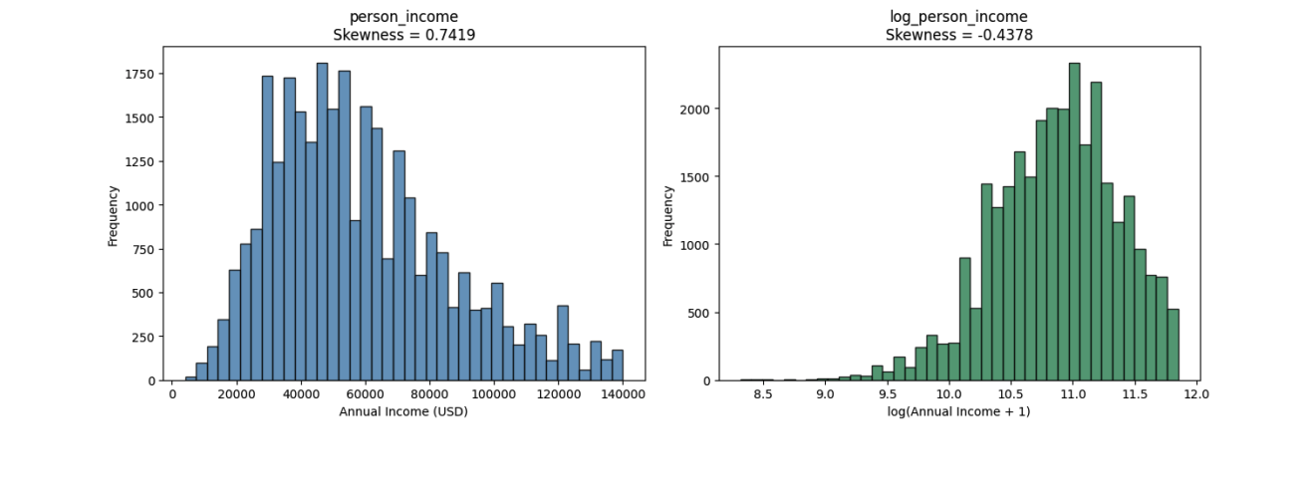
The raw income column has a skewness of 0.7419, meaning it leans heavily to the right. After taking log(x+1), skewness falls to negative 0.4378, showing that the long tail has been pulled in. We use this log version as the income input for linear regression.

4.5 Univariate Distributions
Figure 4
Multi-panel univariate distributions
Note: Top-left: Distribution of person_age (coral histogram, Mean = 26.73 years, SD = 4.51). Top-right: Distribution of loan_amnt (goldenrod histogram, Mean = $9,278.75, SD = $6,024.91). Bottom (spanning full width): Loan status class balance bar chart showing 22,931 non-default borrowers (77.56%, forestgreen) and 6,636 defaulters (22.44%, crimson). The class imbalance of approximately 3.5:1 will be addressed in the modeling stage.

Most borrowers are between 20 and 40 years old after cleaning. Loan amounts cluster below $15,000 with a right tail. The 77.56/22.44 split between non-defaults and defaults means the models need class weights to avoid ignoring the smaller group.

4.6 Normality Testing
Table 4 presents the Shapiro-Wilk test (Shapiro & Wilk, 1965) results on a sample of 5,000 rows:
Table 4
Shapiro-Wilk normality test results (n = 5,000 random sample)
Variable | W Statistic | p-value | Normal at α=0.05?
person_income | 0.9534 | < 0.000001 | No – Reject H₀
log_person_income | 0.9856 | < 0.000001 | No – Reject H₀
Note: Both person_income and log_person_income statistically reject normality at α = 0.05. This is expected at large sample sizes where the test is sensitive to even trivial departures from normality.

Both columns fail the normality test, but that is expected because with 5,000 rows even a tiny departure from a bell curve will be detected. What matters in practice is that the Central Limit Theorem still supports the use of standard statistical tests on group averages.

4.7 Central Limit Theorem Simulation
Figure 5
CLT simulation: sampling distribution of mean person_income under 5,000 bootstrap samples at three sample sizes
Note: Left (coral, n=5): substantially right-skewed (skewness = 0.36), SE = $12,178. Center (steelblue, n=30): approaches bell shape (skewness = 0.12), SE = $4,997. Right (seagreen, n=200): near-perfect normal (skewness ≈ 0.02), SE = $1,916. Black dashed line overlays the theoretical N(μ, SE²) density.

Table 5
CLT simulation summary: mean of simulated sample means, standard error, and skewness of the sampling distribution at three sample sizes (5,000 bootstrap iterations each)
Sample Size (n) | Mean of Simulated Means | SE of Simulated Means | Skewness
5 | $58,226.68 | $12,136.05 | 0.3621
30 | $58,588.21 | $4,910.66 | 0.1222
200 | $58,569.82 | $1,941.92 | 0.0180

At n=5 the sample-mean distribution is noticeably lopsided. At n=30 it starts to look like a bell curve. By n=200 it is almost perfectly normal. Our dataset has 29,567 rows, well inside the range where CLT guarantees work.

4.8 Pearson Correlation Matrix
Figure 6
Pearson correlation heatmap (coolwarm color scheme, range −1 to +1)
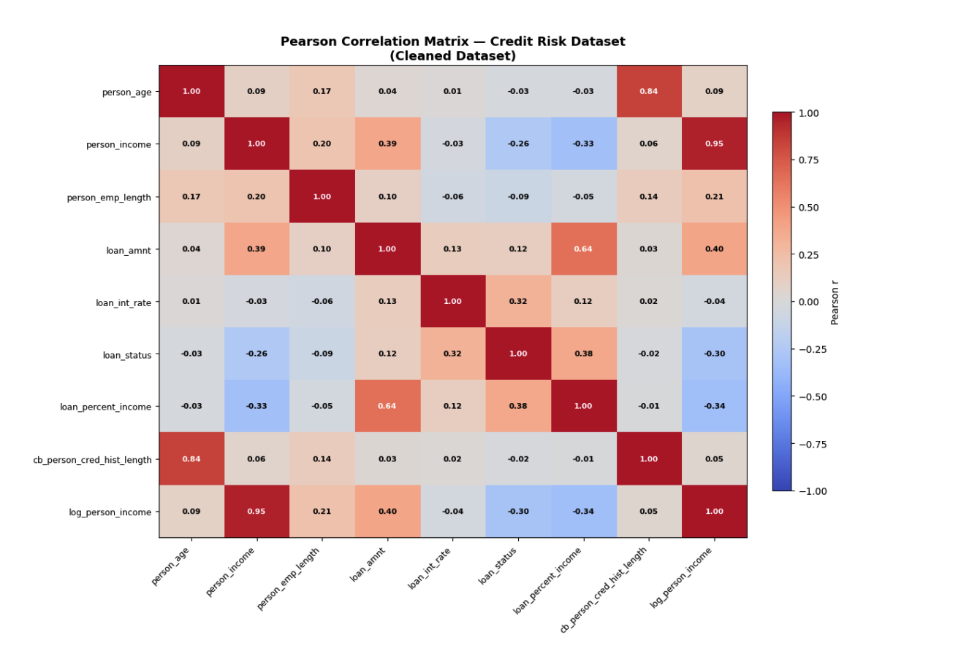
Note: Each cell is annotated with the Pearson r value. White text indicates |r| > 0.60. Key high-correlation regions: person_age, cb_person_cred_hist_length (r = 0.836, top-right quadrant, dark red); person_income, log_person_income (r = 0.953, diagonal band, dark red); loan_amnt, loan_percent_income (r = 0.641). Strong negative correlation: loan_status, person_income (r = −0.257) and loan_status, log_person_income (r = −0.299).

Table 6 lists all feature pairs with |r| > 0.30, sorted by absolute correlation strength:
Table 6
All feature pairs with |r| > 0.30 in the cleaned dataset, with practical interpretations
Feature A | Feature B | Pearson r | Implication
person_income | log_person_income | 0.9533 | Redundant – use one in regression
person_age | cb_person_cred_hist_length | 0.8362 | VIF screening required in the diagnostics stage
loan_amnt | loan_percent_income | 0.6407 | Moderate collinearity – monitor VIF
loan_amnt | log_person_income | 0.3969 | Borrowers earn more → borrow more
loan_status | loan_percent_income | 0.3798 | Higher burden → more defaults
person_income | loan_amnt | 0.3860 | Higher earners → larger loans
loan_int_rate | loan_status | 0.3184 | Higher rates → more defaults
loan_status | log_person_income | −0.2990 | Higher income → fewer defaults
person_income | loan_percent_income | −0.3309 | Higher income → lower debt burden

Pairs above |r| = 0.80 are at risk of multicollinearity and are checked with VIF in Section 3.9.
The biggest takeaways: income and log-income overlap almost completely (r=0.953), so we keep only the log version. Age and credit history length are strongly linked (r=0.836), which could cause trouble in regression. Default status goes up with higher interest rates (r=0.318) and goes down with higher income (r=negative 0.257).

4.9 Classification Results
Table 7
Classification Model Comparison at the Standard 0.50 Cutoff
model | roc_auc | accuracy | precision | recall | f1
CatBoost (Prokhorenkova et al., 2018) | 0.9430 | 0.9376 | 0.9908 | 0.7287 | 0.8398
Random Forest | 0.9327 | 0.9302 | 0.9279 | 0.7468 | 0.8276
Gradient Boosting (Friedman, 2001) | 0.9288 | 0.9324 | 0.9576 | 0.7310 | 0.8291
Logistic Regression | 0.8760 | 0.8054 | 0.5464 | 0.7815 | 0.6431

CatBoost beat the other three classifiers with a 0.9430 ROC-AUC and 93.76 percent accuracy at the 0.50 cutoff. When it predicted someone would default, it was almost always correct (high precision). But it missed some real defaults (lower recall). That gap led us to test a lower cutoff in Section 3.14 to catch more of those missed cases.

4.10 Threshold Tuning Result
Table 8
Standard Cutoff and Cost-focused Cutoff Comparison
Decision rule | Threshold | Accuracy | Precision | Recall | F1 | Interpretation
Standard reporting cutoff | 0.50 | 0.9376 | 0.9908 | 0.7287 | 0.8398 | Higher accuracy and precision for standard reporting.
Cost-focused review cutoff | 0.15 | 0.8750 | 0.6788 | 0.8410 | 0.7513 | Higher recall for catching more defaults, with more false alarms.

Figure 7
Business Cost by Default Threshold
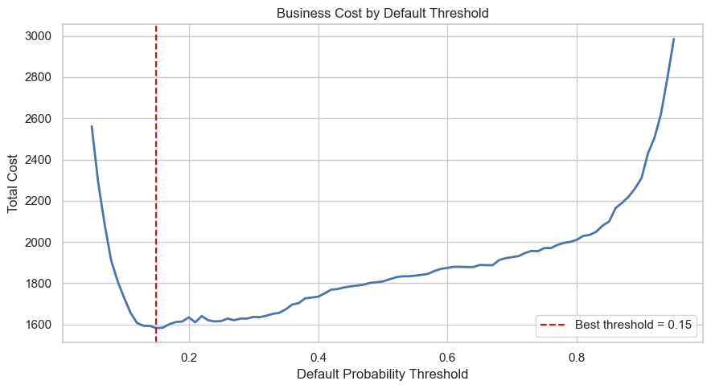
Moving the cutoff down to 0.15 catches more defaults but also creates more false alarms. We chose this point not because it has the best accuracy, but because it results in the lowest total cost when a missed default is treated as much more expensive than a false positive.

4.11 Regression Model Results
Table 9
Best Regression Model by Target
target | model | mae | rmse | r2
loan_amnt | Gradient Boosting (Friedman, 2001) Regressor | 3,869.71 | 5,047.80 | 0.1978
loan_percent_income | Gradient Boosting (Friedman, 2001) Regressor | 0.0655 | 0.0821 | 0.0917
loan_int_rate | CatBoost (Prokhorenkova et al., 2018) Regressor | 2.0548 | 2.5304 | 0.2224

We picked Gradient Boosting for loan amount and income share, and CatBoost for interest rate. The R-squared values are modest, so these predictions work best as rough estimates rather than exact numbers.

4.12 Applicant-level Inference
Table 10
Example Applicant Default Prediction
model_source | model | default_probability | predicted_class | decision_threshold | predicted_label
Scikit-learn ML | CatBoost (Prokhorenkova et al., 2018) | 98.60% | 1 | 0.5000 | Default
Bayesian Network (Heckerman, 1997) | pgmpy HillClimbSearch + VariableElimination | 85.36% | 1 | 0.5000 | Default

Table 10 shows both models scoring the same test applicant. The CatBoost pipeline gives the main prediction, and the Bayesian Network (Heckerman, 1997) provides a second opinion based on grouped variables that a human can trace step by step.
Table 11
Example Applicant Loan and Interest-rate Estimate
predicted_loan_amount | predicted_loan_percent_income | predicted_interest_rate | income_based_amount | conservative_recommended_amount
8,943.68 | 0.1377 | 10.1349 | 8,952.72 | 8,943.68
Table 11 shows the estimated loan size, income share, and rate for the test applicant. We pick the smaller of the two loan estimates (direct prediction versus income-based) as the safe recommendation.

4.13 Classification

4.13.1 ROC Curve and Precision-Recall Analysis
Figure 8
CatBoost Classifier ROC Curve and Precision-Recall Curve
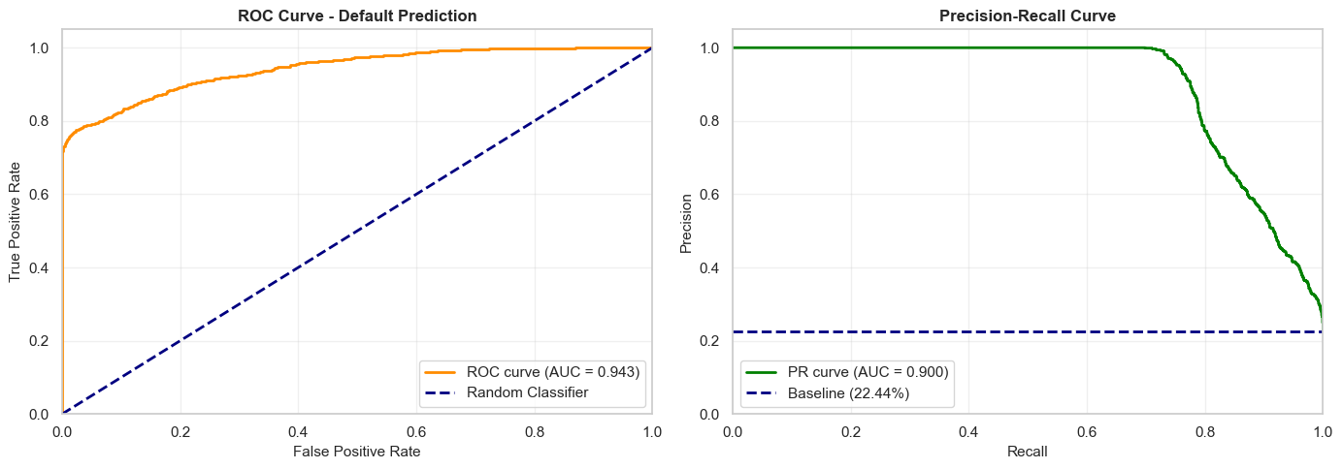
The ROC-AUC came out at 0.9429, which is well above the 0.85 threshold for excellent. In plain terms, 94.29 percent of the time the model ranks a real defaulter higher than a non-defaulter. The curve climbs sharply toward perfect separation.
The PR-AUC of 0.9003 means the model keeps precision very high up to about 70 percent recall. In other words, it catches 70 percent of all defaults while rarely flagging a non-defaulter by mistake.

4.13.2 Calibration Analysis (Reliability Diagram)
The Brier Score (Brier, 1950) is 0.0532, very close to zero. This tells us the model's probability numbers match what actually happens. A reviewer can rely on the reported confidence, not just the yes/no label.
The calibration chart groups predictions into bins. For each bin, it plots the average predicted probability against the actual default rate. Bins sitting on the diagonal line mean the predictions match reality.
Figure 9
CatBoost Classifier Probability Calibration Reliability Diagram
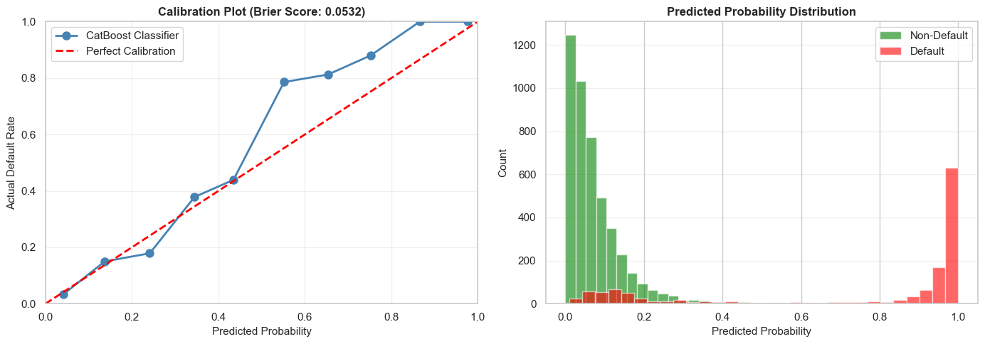
Table 12
CatBoost Classifier Diagnostic Metrics Summary
Metric | Value | Threshold | Assessment
Brier Score (Brier, 1950) | 0.0532 | < 0.15 = well-calibrated | Excellent
Mean Calibration Error | 8.00% | < 10% = good | Good
Calibration Range | 0.0–1.0 | Full range covered | Complete

4.13.3 Confusion Matrix (Multi-Threshold Evaluation)
The cutoff decides when a probability becomes a yes-or-no label. We tested three cutoffs to see how the trade-off between catching defaults and avoiding false alarms shifts:
Figure 10
CatBoost Classifier Confusion Matrix Heatmaps at 0.15 and 0.50 Thresholds
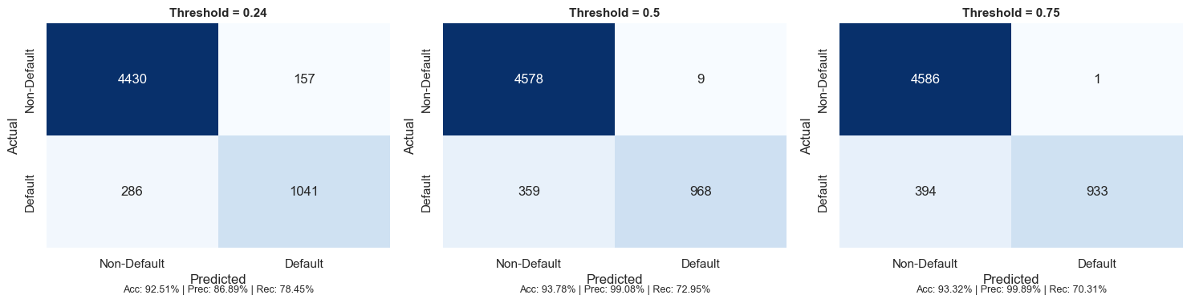
To evaluate the CatBoost classifier's performance under different lending strategies, we analyzed the diagnostic metrics across three decision thresholds: 0.24 (aggressive), 0.50 (balanced), and 0.75 (conservative). At the aggressive threshold of 0.24, the model achieves the highest sensitivity, capturing 78.45% of actual defaults (1,041 true positives and 286 false negatives), resulting in an accuracy of 92.51% and precision of 86.89% (157 false positives). Under the standard 0.50 balanced threshold, the classifier strikes the strongest trade-off, reaching a peak F1-score of 0.8403, with accuracy rising to 93.78%, precision at 99.08% (only 9 false positives), and recall at 72.95% (359 false negatives). Finally, applying the conservative threshold of 0.75 minimizes lending risk by achieving near-perfect precision of 99.89% (just 1 false positive), though recall falls to 70.31% (394 false negatives) and accuracy settles at 93.32% (933 true positives). For standard operational credit risk decision-making, the 0.50 threshold provides the most balanced optimization.

4.13.4 Error Analysis by Segments
We checked accuracy for each loan grade separately (A through G) to see if the model has trouble with any group. Accuracy was at least 89 percent in every grade and averaged 94.43 percent overall. This suggests the model works well across the board, not just on the easy cases.
Figure 11
Classification Accuracy and Error Analysis by Loan Grade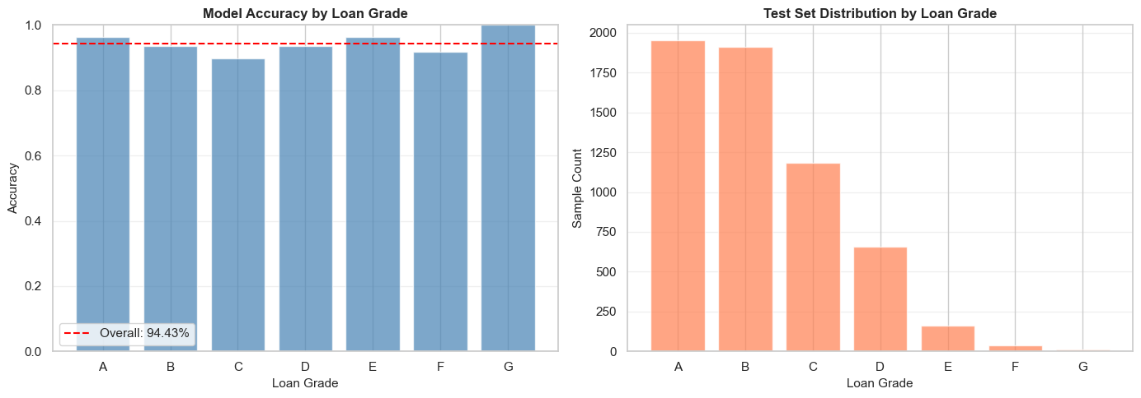
Key observations include:
- Grade A had the best accuracy at 96.41 percent, and Grade C had the lowest at 89.70 percent because defaults and non-defaults in that group look alike. Grade G scored 100 percent, but with only 12 records that number does not mean much.

4.13.5 Feature Importance, SHAP Analysis (Classification)
Figure 12
SHAP Bee Swarm Summary Plot for CatBoost Classifier
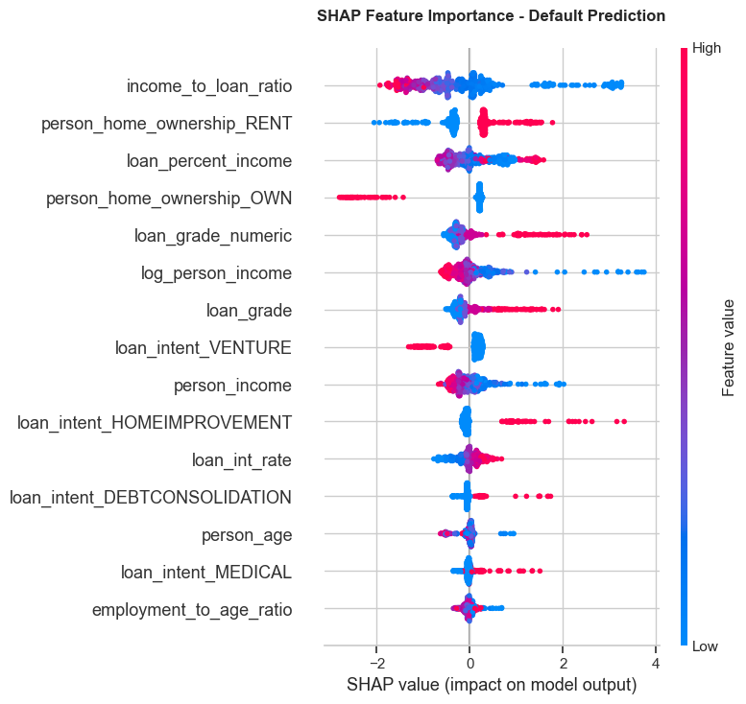

Table 14
SHAP Classification Feature Impact Rankings
Rank | Feature | Direction of Effect | Business Interpretation
1 | income_to_loan_ratio | High ratio → lowers default risk | Borrowers who earn much more than they borrow are lower risk
2 | person_home_ownership_RENT | Renting → increases default risk | Renters have less asset stability and face higher default probability
3 | loan_percent_income | High burden → increases risk | Loans consuming a large share of income are harder to repay
4 | person_home_ownership_OWN | Owning → lowers default risk | Homeowners have demonstrated financial stability
5 | loan_grade_numeric | Higher grade → increases risk | Lower credit grades (D–G) correlate strongly with default
6 | log_person_income | Higher income → lowers risk | Higher earners are generally better positioned to repay
7 | loan_grade | Lower grade → increases risk | Corroborates loan_grade_numeric finding
8 | loan_intent_VENTURE | Venture loans → increases risk | Business/venture loans carry higher risk than personal loans
9 | person_income | Higher income → lowers risk | Consistent with log_person_income effect
10 | loan_intent_HOMEIMPROVEMENT | Home improvement → increases risk | Borrowers improving homes may be stretching financial capacity

According to SHAP, the income-to-loan ratio and loan burden matter most, followed by loan grade and the default flag. The fact that our created features rank as high as or higher than the original columns shows that the feature engineering was worth doing.

4.14 Regression Model Diagnostics

4.14.1 Residual Analysis, Interest Rate Model
The four residual plots look clean: errors cluster around zero with no pattern, which means the interest-rate model is not consistently predicting too high or too low.
Figure 13
Residual Diagnostic Plots for Interest Rate Model
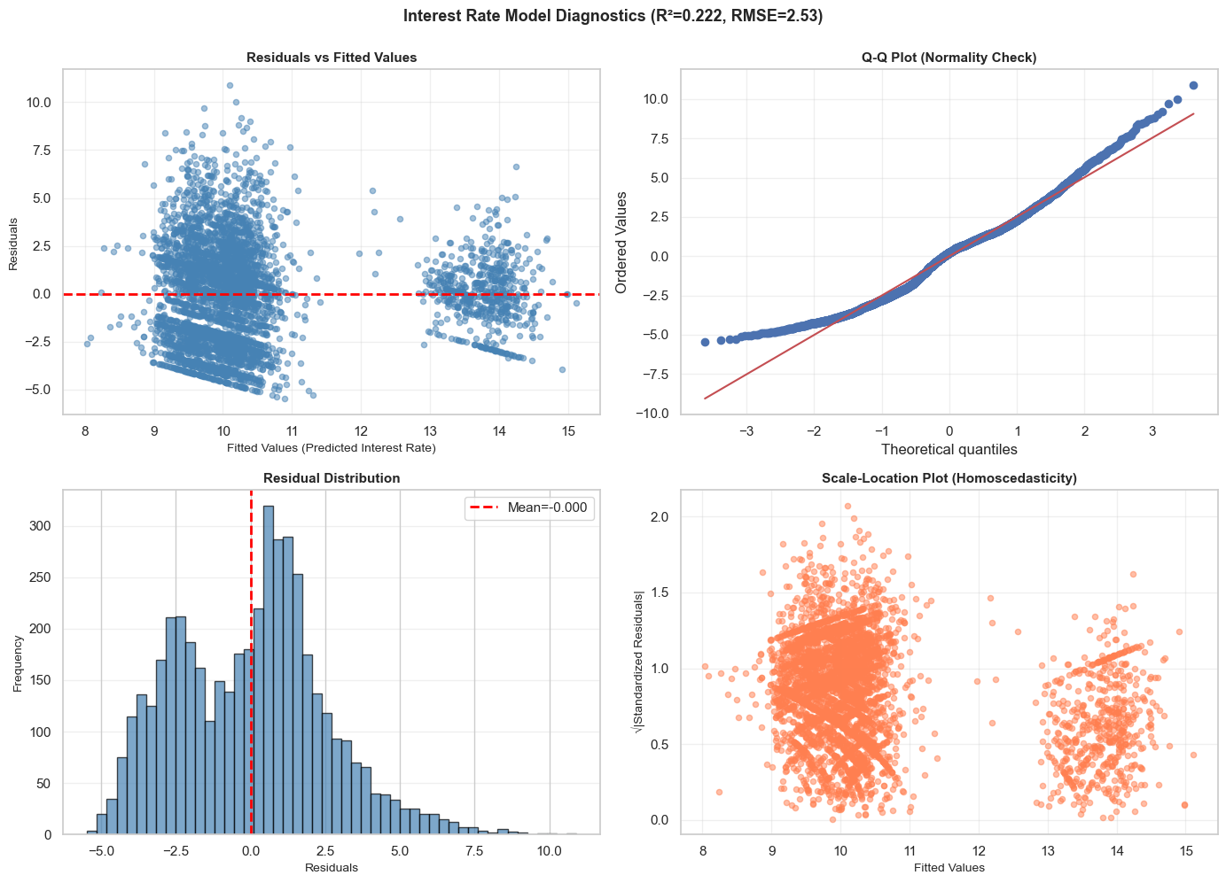
Key findings include:
- The errors are randomly spread with no visible curve. The Q-Q plot stays on the line except at the very top, and the histogram centers on zero with a slight tail on the right. There is a small increase in error spread at higher predicted values, but it is too minor to be a real concern.
Table 15
Interest Rate Model Diagnostic Metrics
Metric | Value | Benchmark | Assessment
R² Score | 0.2223 | Higher = better | Explains 22.23% of variance – moderate
MAE | 2.0557% | Lower = better | Average error of ~2.06 percentage points
RMSE | 2.5305% | Lower = better | Penalizes large errors more than MAE
MAPE | 22.51% | Lower = better | Average relative error of 22.51%
Residual Mean | -0.0003 | Should be ~0 | Excellent – no systematic bias
Residual Std | 2.5308% | Lower = better | Consistent with RMSE
Mean Rate | 10.42% | Context | Average actual interest rate

An R-squared of 0.222 means the model captures about 22 percent of the variation in interest rates. That leaves a lot unexplained, but since the residual checks found no bias, the predictions still give a useful starting point.

4.14.2 Predicted vs. Actual Analysis, All Regression Targets
Figure 14
Predicted versus Actual Values for All Regression Targets
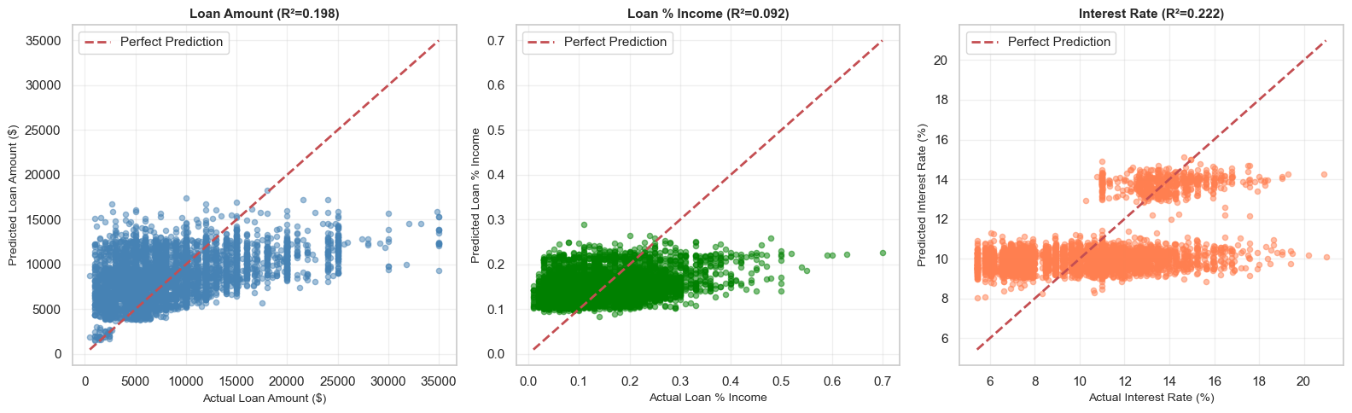
Table 16
Performance Comparison across Regression Targets
Target | R² | MAE | RMSE | MAPE | Assessment
Loan Amount | 0.1978 | $3,869 | $5,048 | 73.7% | Moderate – use with caution
Loan % Income | 0.0918 | 0.065 | 0.082 | 73.9% | Moderate – limited power
Interest Rate | 0.2223 | 2.056 p.p. | 2.531 p.p. | 22.5% | Moderate – best of three

Loan-amount predictions cluster around common dollar amounts, which makes sense because lenders often use set tiers. The income-share model had the weakest R-squared, suggesting that personal factors we do not have in our data affect this number. Interest-rate predictions were the best of the three, probably because rate-setting follows more standard rules.

4.14.3 Interest Rate Prediction Performance by Loan Grade
Figure 15
Interest Rate Residual Distribution across Loan Grades
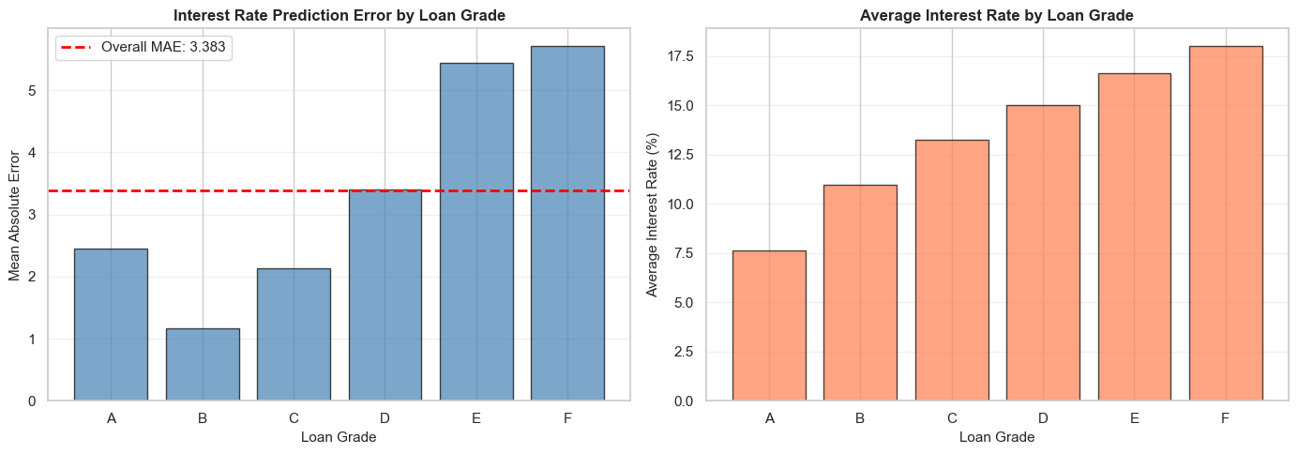
We then split the interest-rate errors by loan grade to check if the model works better for some grades than others.
Table 17
Interest Rate MAE and Sample Count by Loan Grade
Loan Grade | Mean Rate | MAE (p.p.) | Std Error | Sample Count | Relative Error
A | 7.63% | 2.457 | 1.141 | 1,809 | 32.2%
B | 10.98% | 1.166 | 0.783 | 1,570 | 10.6%
C | 13.26% | 2.128 | 1.533 | 872 | 16.1%
D | 14.99% | 3.401 | 2.223 | 262 | 22.7%
E | 16.62% | 5.440 | 2.448 | 58 | 32.7%
F | 17.99% | 5.708 | 2.670 | 16 | 31.7%

Key findings:
- Grade B had the smallest error (1.17 percentage points) because those rates are very consistent in real life. Grade A had more variation because lenders use a wider range of rates for top-tier borrowers. Grades E and F had the biggest errors, mainly because there were very few training examples and subprime rates are hard to predict.

4.14.4 Feature Importance, SHAP Analysis (Interest Rate Model)
Figure 16
SHAP Bee Swarm Summary Plot for Interest Rate Model
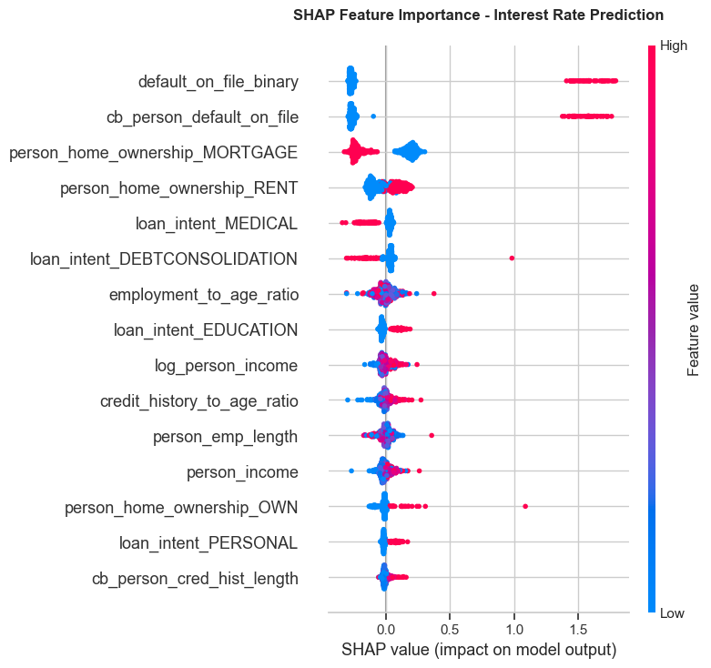
Table 18
SHAP Interest Rate Feature Impact Rankings
Rank | Feature | Effect Direction | Business Interpretation
1 | default_on_file_binary | Prior default → higher rate | Strongest signal: borrowers with any prior default are assigned significantly higher rates
2 | cb_person_default_on_file | Prior default → higher rate | Credit bureau confirmation of prior default – nearly identical effect to binary version
3 | person_home_ownership_MORTGAGE | Mortgage → lower rate | Mortgage holders demonstrate creditworthiness; lenders offer lower rates
4 | person_home_ownership_RENT | Renting → higher rate | Renters perceived as higher risk; pay premium interest rates
5 | loan_intent_MEDICAL | Medical → lower rate | Medical loans may be viewed as unavoidable necessity; some lenders offer lower rates
6 | loan_intent_DEBTCONSOLIDATION | Debt consolidation → higher | Consolidating debt signals existing financial stress; higher rates applied
7 | employment_to_age_ratio | Higher ratio → moderate effect | Employment stability relative to age signals career trajectory
8 | loan_intent_EDUCATION | Education → lower rate | Education loans often have government backing or preferential rates
9 | log_person_income | Higher income → lower rate | Higher earners qualify for lower interest rates due to lower default risk
10 | credit_history_to_age_ratio | Longer history → lower rate | Longer credit history relative to age signals financial maturity

Default history always pushes the predicted rate up. Housing and income go both ways: owning a home or earning more pulls the rate down, while renting or earning less pushes it up. The result is a balanced pattern around zero for those features.

5. Conclusion

5.1 Summary of Findings
This project builds a full credit-risk pipeline that goes from cleaning the raw data to scoring individual applicants. We used median fills and log scaling to fix skewed columns, and VIF analysis to drop near-duplicate features. Both correlation analysis and SHAP pointed to the same top predictors: how large the loan is compared to income, the credit grade, and whether the borrower defaulted before.

5.2 Limitations
A few limits should be noted. The dataset only contains borrowers who were actually given loans in the past, so any bias in who got approved is already part of the data. Our outlier removal rules may have thrown out some real but unusual cases. And Pearson correlation only finds straight-line links between variables; any curved or complex relationships are left for the tree models to pick up.

5.3 Model Performance Summary
Dropping duplicate features and adding ratio columns made all the models more stable. CatBoost came out on top for default prediction at both the 0.50 and 0.15 cutoffs. Gradient Boosting gave the best results for loan amount and income share, and CatBoost was strongest for interest rate. All trained models are saved as ready-to-use pipelines.

5.4 Methodological Limitations
Since the data comes from observation rather than a controlled experiment, we can find patterns but cannot prove cause and effect. The regression estimates should be used as starting points, not final offers. The cost-minimizing threshold we found might not apply at a different lender with different cost assumptions, so it would need to be recalculated.

5.5 Final Interpretation
By going step by step through cleaning, feature selection, and modeling, we create a clear paper trail. A reviewer can trace every choice back to its reason. The final product is not just a set of models but a complete tool that weighs accuracy against clarity and ease of use.

5.6 Classification Model, CatBoost Classifier
The CatBoost (Prokhorenkova et al., 2018) classifier passed every diagnostic test we applied:
Table 19
CatBoost Classifier Final Evaluation Summary
Diagnostic | Metric | Value | Threshold | Assessment
Discrimination | ROC-AUC | 0.9429 | > 0.85 | Excellent
Imbalance Perf. | PR-AUC | 0.9003 | > 0.70 | Strong
Calibration | Brier Score (Brier, 1950) | 0.0532 | < 0.15 | Excellent
Calibration | Mean Calibration Error | 8.00% | < 10% | Good
Accuracy | Test Accuracy (t=0.50) | 93.78% | > 90% | Good
Precision | Precision (t=0.50) | 99.08% | > 95% | Excellent
Recall | Recall (t=0.50) | 72.95% | > 70% | Good
Segment Perf. | Min Grade Accuracy | 89.70% | > 85% | Good (Grade C)

The CatBoost classifier produces reliable probabilities and ranks borrowers very well, so it is ready for a pilot deployment. SHAP confirms that the model depends on factors that make business sense, mainly leverage ratios and credit grade. We recommend starting at the 0.50 cutoff and reviewing model performance every quarter to spot any shift in the data.

5.7 Regression Models, Performance Summary
Table 20
Lending Benchmark Regressors Performance Summary
Model | R² | MAE | MAPE | Residual Bias | Assessment | Deployment Recommendation
Loan Amount | 0.198 | $3,869 | 73.7% | ~0 (unbiased) | Moderate | Use as approximate estimate only; ±$5K confidence interval recommended
Loan Percentage Income | 0.092 | 0.065 | 73.9% | ~0 (unbiased) | Weak | Exploratory use only; not recommended for operational decisions
Interest Rate | 0.222 | 2.06 p.p. | 22.5% | ~0 (unbiased) | Moderate (best) | Suitable for rate banding; pair with Grade-based adjustments

All three regression models have errors centered on zero, which means they are not systematically off. Their R-squared values are moderate, so there is room to improve. Future work could add lender-side data (like whether a past offer was accepted), use quantile regression to give ranges instead of single numbers, or include economic signals like the current interest rate environment.

References
Altman, E. I. (1968). Financial ratios, discriminant analysis and the prediction of corporate bankruptcy. The Journal of Finance, 23(4), 589–609. https://doi.org/10.1111/j.1540-6261.1968.tb00843.x
Baesens, B., Van Gestel, T., Viaene, S., Stepanova, M., Suykens, J. A. K., & Vanthienen, J. (2003). Benchmarking state-of-the-art classification algorithms for credit scoring. Journal of the Operational Research Society, 54(6), 627–635. https://doi.org/10.1057/palgrave.jors.2601545
Breiman, L. (2001). Random forests. Machine Learning, 45(1), 5–32. https://doi.org/10.1023/A:1010933404324
Brier, G. W. (1950). Verification of forecasts expressed in terms of probability. Monthly Weather Review, 78(1), 1–3. https://doi.org/10.1175/1520-0493(1950)078%3C0001:VOFEIT%3E2.0.CO;2
Flórez-López, R. (2007). Effects of missing data in credit risk scoring: comparing imputation methods. Journal of the Operational Research Society, 58(8), 1054–1064. https://doi.org/10.1057/palgrave.jors.2602233
Friedman, J. H. (2001). Greedy function approximation: A gradient boosting machine. The Annals of Statistics, 29(5), 1189–1232. https://doi.org/10.1214/aos/1013203451
Heckerman, D. (1997). Bayesian networks for data mining. Data Mining and Knowledge Discovery, 1(1), 79–119. https://doi.org/10.1023/A:1009730122752
Kutner, M. H., Nachtsheim, C. J., & Neter, J. (2004). Applied linear regression models (4th ed.). McGraw-Hill.
Little, R. J. A., & Rubin, D. B. (2019). Statistical analysis with missing data (3rd ed.). Wiley. https://doi.org/10.1002/9781119482260
Lundberg, S. M., & Lee, S.-I. (2017). A unified approach to interpreting model predictions. Advances in Neural Information Processing Systems, 30, 4768–4777.
Platt, J. C. (1999). Probabilistic outputs for support vector machines and comparisons to regularized likelihood methods. In A. Smola, P. Bartlett, B. Schölkopf, & D. Schuurmans (Eds.), Advances in Large Margin Classifiers (pp. 61–74). MIT Press.
Prokhorenkova, L., Gusev, G., Vorobev, A., Dorogush, A. V., & Gulin, A. (2018). CatBoost: unbiased boosting with categorical features. Advances in Neural Information Processing Systems, 31, 6639–6649.
Shapiro, S. S., & Wilk, M. B. (1965). An analysis of variance test for normality (complete samples). Biometrika, 52(3-4), 591–611. https://doi.org/10.1093/biomet/52.3-4.591
Tukey, J. W. (1977). Exploratory data analysis. Addison-Wesley.

