Predictive Modeling for Credit Risk

N L N Sai Krishna Akula, Diaesh Antony and Ashok Kumar Bhairwal
University of San Diego
AAI-500-IN1: Applied Probability and Statistics for AI
Dr. Anuj Kumar Sirohi
June 15, 2026

Abstract
Accurate estimation of borrower default risk, along with appropriate interest rate pricing, is essential in consumer lending to prevent financial losses and maintain competitiveness. In this project, we develop a comprehensive predictive modeling framework applied to a Kaggle Credit Risk Dataset comprising 32,581 loan records. After applying thorough data preprocessing techniques, such as median imputation (Little & Rubin, 2019), outlier filtering, and log-transformation, we evaluated several classification and regression models. At a standard 0.50 cutoff, the CatBoost (Prokhorenkova et al., 2018) classifier delivered the strongest default prediction performance with an ROC-AUC of 0.9430 and 93.78% accuracy. Meanwhile, Gradient Boosting (Friedman, 2001) yielded robust estimates for both loan amount and percentage of income. We also identified a cost-focused threshold of 0.15 to better capture potential defaults. Our diagnostic analysis verified strong model calibration, evidenced by a Brier Score (Brier, 1950) of 0.0532, and revealed performance differences across various loan grades. Furthermore, SHAP values underscored the significant influence of income-to-loan ratios and loan intent on the resulting predictions. Ultimately, these results provide a technically rigorous and interpretable workflow that effectively balances predictive power with clear risk reasoning for real-world consumer lending scenarios.

1. Introduction

1.1 Business Context and Objectives
Making sound bank lending decisions involves a careful balance between ensuring profitability through appropriate interest rates and managing risk by identifying potential defaulters. When financial institutions make incorrect decisions, they typically encounter two main types of errors akin to statistical hypothesis testing. A Type I Error occurs when risk is underpriced, which can lead to credit defaults and the loss of principal. Conversely, a Type II Error happens when risk is over-priced, potentially driving creditworthy customers toward competing lenders.
To tackle these challenges, our study assesses various machine learning models, such as CatBoost, Random Forests, and Gradient Boosting, alongside a transparent Bayesian Network for evaluating credit risk. Three primary objectives guide our analytical workflow: classifying defaults, establishing numeric regression benchmarks to estimate loan amounts, income percentages, and interest rates, and ensuring post-hoc model interpretability.

1.2 Research Questions
Two central questions guide the full project:
Which borrower characteristics (age, income, employment length, loan grade) are the strongest determinants of the interest rate charged on a loan?
What is the marginal effect of borrower income on the probability of loan default, after controlling for loan amount and loan grade?

1.3 Scope and Significance of the Report
This document outlines a complete credit risk modeling framework. It begins with strict data preprocessing steps, including imputation, outlier filtering, and log-transformations, before advancing to classification diagnostics, calibration, and SHAP-based feature importance analysis. Instead of depending solely on basic accuracy metrics, our research emphasizes a thorough diagnostic strategy. We place particular focus on cost-sensitive threshold tuning to reduce default losses and on maintaining white-box model interpretability. Ultimately, we aim to build a robust and transparent workflow that successfully aligns predictive capabilities with clear, auditable risk reasoning.

2. Related Work

2.1 Credit Risk Modelling in the Literature
Historically, credit risk assessment relies on three core pillars of borrower risk: the ability to pay based on income and debt burden, past credit behavior, and the specific structure of the loan. Classical methods, such as logistic regression, are still popular because they comply with regulations and are easy to audit. However, modern ensemble techniques like Random Forests and CatBoost offer substantial improvements in predictive performance, especially when dealing with large and imbalanced credit datasets. Despite these advances, handling class imbalance and multicollinearity between predictor variables continues to be a major hurdle in contemporary credit risk modeling research.

2.2 Data Quality and Preprocessing in Financial AI
Research in applied credit risk consistently shows that decisions made during data preprocessing significantly impact overall model performance. Relying on naive mean substitution or overlooking data entry errors, such as unlikely ages or employment durations, can distort model signals and reinforce existing biases (Sun & Harris, 2024). Therefore, practitioners rely on robust techniques to ensure high data quality. For instance, median imputation (Little & Rubin, 2019) is highly effective against right-skewed extreme values, while the Interquartile Range (IQR) method (Tukey, 1977) remains a standard approach for filtering out outliers.

2.3 Exploratory Analysis and Distributional Properties
Financial variables, particularly income, generally exhibit a right-skewed distribution. Analysts frequently apply log-transformations to compress these extended right tails, which helps meet the assumptions of homoscedasticity and approximate normality necessary for linear regression models. Even though individual data points might still lack normality, the Central Limit Theorem (CLT) supports the use of parametric inference for aggregate measures because the sampling distribution of the mean approaches a normal curve as the sample size increases.

2.4 Credit Risk Predictors
Predictors of credit risk generally fall into three categories: ability to pay, which includes income and debt burden; historical behavior, covering prior defaults and credit history length; and loan structure, encompassing the loan amount, purpose, grade, and interest rate. It is crucial to evaluate these factors together. Determining borrower default risk involves a multivariate analysis were overlapping financial behaviors, rather than any single isolated trait, drive the final outcome.

2.5 Multicollinearity and Preprocessing
When predictor variables show high correlation, multicollinearity occurs, often destabilizing the interpretation of coefficient-based models. To detect and manage these dependencies, analysts primarily use the Variance Inflation Factor (VIF; Kutner et al., 2004) as a diagnostic tool. During this process, categorical variables undergo temporary one-hot encoding to calculate the VIF. Afterward, we exclude these temporary variables from the final training dataset to preserve overall feature cleanliness.

2.6 Machine Learning Model Families
We evaluate several model families: interpretable baselines (Logistic and Linear Regression), variance-reducing models (Random Forests), and sequential tree ensembles (Gradient Boosting and CatBoost). Comparing these families identifies the optimal trade-off between predictive accuracy and model interpretability across classification and regression benchmarks.

2.7 Traditional Credit Risk Assessment
Traditional credit risk assessment relied on subjective expert judgment before transitioning to objective, quantitative modeling. Standard techniques like logistic regression, linear regression, and discriminant analysis became regulatory staples because of their mathematical transparency, supporting credit decisioning while ensuring compliance with capital adequacy standards.

2.8 Machine Learning-Based Credit Risk Assessment
Today's credit modeling frequently utilizes machine learning algorithms, including Decision Trees, Random Forests, and XGBoost, to identify complex, non-linear relationships and enhance the discrimination of defaults. Nevertheless, because these algorithms operate as black boxes, practitioners must incorporate explainable AI (XAI) techniques like SHAP. This approach ensures a necessary balance between achieving high predictive accuracy and maintaining the transparency demanded by regulatory compliance and responsible lending practices.

3. Method

3.1 Dataset
The Credit Risk Modeling Dataset was sourced from Kaggle (https://www.kaggle.com/datasets/laotse/credit-risk-dataset) and is stored in the project repository under data/raw/credit_risk_dataset.csv. The raw dataset contains 32,581 rows and 12 columns covering borrower demographics, loan characteristics, and credit bureau information. The target variables for the full project are loan_status (binary: 1 = default, 0 = non-default) and loan_int_rate (continuous interest rate).
Table 1 below describes all 12 columns.
Table 1
Description of all 12 features in the raw Credit Risk dataset
Feature | Type | Description
person_age | Integer | Borrower age in years
person_income | Integer | Annual income in USD
person_home_ownership | Categorical | RENT, OWN, MORTGAGE, OTHER
person_emp_length | Float | Employment length in years (2.75% missing)
loan_intent | Categorical | Purpose: EDUCATION, MEDICAL, PERSONAL, etc.
loan_grade | Categorical (Ordinal) | Credit grade A–G (A = lowest risk)
loan_amnt | Integer | Loan principal amount in USD
loan_int_rate | Float | Interest rate in % (9.56% missing)
loan_status | Binary | 1 = defaulted, 0 = did not default (target)
loan_percent_income | Float | Loan amount as proportion of annual income
cb_person_default_on_file | Binary (Y/N) | Prior default on credit bureau record
cb_person_cred_hist_length | Integer | Length of credit history in years

3.2 Missing Value Imputation
To address missing information within the raw dataset, we opted for median imputation (Little & Rubin, 2019) instead of mean imputation, particularly for variables with a right skew. The median serves as the central value in a sorted sample. Because it relies on rank rather than magnitude, the median acts as a highly robust estimator that naturally resists the distortion caused by extreme outlier values.

3.3 Outlier Detection and Filtering
Outliers were identified using the IQR method (Tukey, 1977) applied to person_age and person_income, with Tukey fences calculated as Lower = Q1 − 1.5×IQR and Upper = Q3 + 1.5×IQR. A domain constraint of person_age ≤ 100 was also enforced.
Table 2 summarizes the computed bounds and outlier counts.
Table 2
IQR outlier detection results for person_age and person_income
Feature | Q1 | Q3 | IQR | Lower Bound | Upper Bound | Outliers (n)
person_age | 23.00 | 30.00 | 7.00 | 12.50 | 40.50 | 1,494
person_income | $38,500 | $79,200 | $40,700 | −$22,550 | $140,250 | 1,484
The data cleaning phase also included the removal of 156 exact duplicate rows, along with filtering out one logically inconsistent record where the employment length exceeded the person's age. Through a combination of outlier filtering, consistency checks, and domain constraints, the dataset experienced a net reduction from 32,581 down to 29,567 rows, representing a decrease of 9.25 percent. We then exported the resulting clean dataset for further analysis.

3.4 Log-Transformation of Income
In consumer lending datasets, personal income typically displays a right-skewed distribution. We applied a log-transformation to compress this extended right tail and more closely meet the assumptions of homoscedasticity. Adding an offset effectively manages zero-value boundaries, thereby ensuring computational stability for all samples.

3.5 Normality Testing: Shapiro-Wilk Test
We applied the Shapiro-Wilk test (Shapiro & Wilk, 1965) to both the raw and the log-transformed income features to assess their normality. Under the null hypothesis, the data originates from a normal distribution, whereas the alternative hypothesis suggests a non-normal origin. By measuring the correlation between observed order statistics and expected normal values, the test statistic effectively evaluates the overall shape of these distributions.

3.6 Central Limit Theorem Simulation
Even when individual income observations lack normality, the Central Limit Theorem provides assurance that the sample mean will converge toward a normal distribution as the sample size increases. We demonstrated this principle empirically by extracting 5,000 bootstrap samples from the cleaned income data at multiple sizes, allowing us to accurately trace the evolving shape of the sampling distribution.

3.7 Pearson Correlation Analysis
To understand linear relationships between features and identify potential multicollinearity problems for downstream regression, we compute the full 9 × 9 Pearson correlation matrix across all numeric columns. Pairs with |r| > 0.30 are flagged as potentially significant, and pairs with |r| > 0.80 are flagged as multicollinearity candidates requiring VIF analysis in the diagnostics section.

3.8 Dataset and Engineered Modeling Variables
We executed feature engineering to transform, scale, and group various variables with the goal of enhancing predictive performance. Our approach included applying log-transformations to monetary values such as income and loan amounts, creating ratio features to compare loan size against borrower capacity, and establishing grouped continuous risk bands for exploratory analysis. By incorporating prior default indicators, these engineered features successfully capture the multidimensional nature of borrower default risks instead of relying on isolated statistics.
Table 3
Modeling Dataset Summary
Measure | Value
Loan records | 29,567
Available modeling columns | 23
Observed default rate | 22.44%
Median borrower income | $54,000
Median loan amount | $8,000
Median loan burden | 15.00%
Figure 1
Default Rate by Grouped Borrower and Loan Features
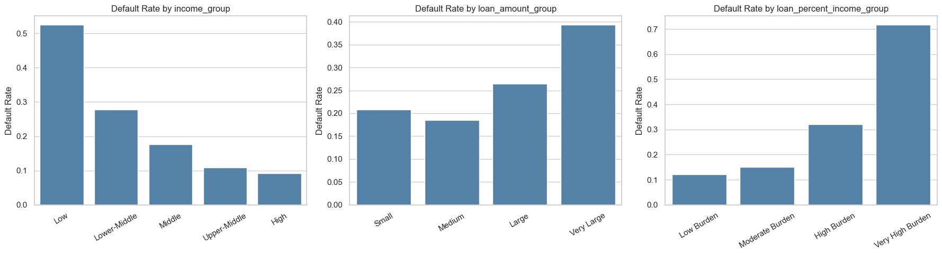
The analysis validates our feature engineering design, clearly demonstrating that default risk fluctuates across grouped borrower and loan characteristics. For instance, loan burden groups prove highly beneficial because they contextualize the loan size relative to the borrower's income, offering much deeper insight than evaluating the loan amount in isolation.

3.9 Multicollinearity Diagnostic Using VIF
We conducted a Variance Inflation Factor diagnostic to identify and eliminate redundant or highly collinear features. Guided by VIF thresholds, we removed duplicate feature representations from the modeling inputs to ensure coefficient stability during interpretation, though we carefully preserved the raw attributes within the base dataset.
Table 4
Multicollinearity and Feature Dependency Decisions
Dependent input pattern | Modeling decision | Technical reason
person_income and log_person_income | Use log_person_income | The log transform retains income information on a less skewed scale.
loan_amnt and log_loan_amnt in classification | Use log_loan_amnt | The log transform represents loan size while reducing extreme-value influence.
loan_grade and loan_grade_numeric | Use loan_grade | The pipeline ordinal-encodes the original grade; the numeric duplicate is redundant.
cb_person_default_on_file and default_on_file_binary | Use cb_person_default_on_file | The pipeline encodes the original Y/N field directly.
As indicated in our analysis, we excluded duplicate representations from the model inputs rather than from the saved dataset. For the sake of transparency, the main dataset retains the complete collection of raw and engineered fields, whereas the training phases utilize much cleaner feature lists. This distinction remains crucial, ensuring that data columns are always available for deeper interpretation even if they do not serve simultaneously as model predictors.

3.10 Shared Modeling Preprocessing Pipeline
We implemented a unified preprocessing pipeline across all models to guarantee consistency and strictly prevent data leakage. During this phase, a Robust Scaler scales numerical features to lessen their sensitivity to outliers, and categorical features undergo one-hot encoding. This systematic approach produces a highly standardized feature matrix ready for downstream model training.
Figure 2
Python Code for Shared Preprocessing Pipeline
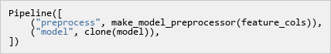

3.11 Train and Test Data Split
The dataset is split into 80% training and 20% testing. Classification and Bayesian Network splits use stratification to preserve class balance. Regression uses the same split for all three targets. RANDOM_STATE = 42 ensures reproducibility.
Classification split code used in the modeling notebook:
Figure 3
Python Code for Classification Train-Test Data Split
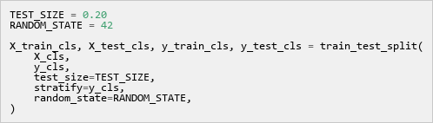
Regression split code used in the modeling notebook:
Figure 4
Python Code for Regression Train-Test Data Split
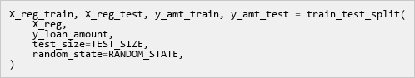

3.12 Classification Models
The classification target is loan_status (1=default, 0=non-default). Four model families are compared to select the best performer based on measured metrics rather than preselected algorithms.

3.12.1 Logistic Regression
Logistic Regression serves as our baseline classifier, estimating default probability using a logistic sigmoid function.
Project code used in the modeling notebook:
Figure 5
Python Code for Logistic Regression Classifier
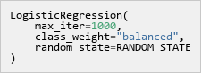
Hyperparameter meaning:
Hyperparameter meaning:
- max_iter=1000: Max training steps
- class_weight='balanced': Imbalance handling
- random_state: Reproducible seed selection

3.12.2 Random Forest Classifier
Random Forest is a bagging ensemble that averages predictions across multiple decision trees to reduce variance.
Project code used in the modeling notebook:
Figure 6
Python Code for Random Forest Classifier
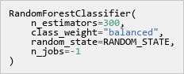
Hyperparameter meaning:
Hyperparameter meaning:
- n_estimators=300: Number of trees
- class_weight='balanced': Imbalance handling
- random_state: Reproducible seed selection
- n_jobs=-1: All CPU cores

3.12.3 Gradient Boosting Classifier
Gradient Boosting Classifier builds decision trees sequentially, with each tree trained to correct the errors of the preceding ones.
Project code used in the modeling notebook:
Figure 7
Python Code for Gradient Boosting Classifier
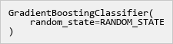
Hyperparameter meaning:
Hyperparameter meaning:
- learning_rate=0.1: Step size shrinkage
- n_estimators=100: Number of trees
- random_state: Reproducible seed selection

3.12.4 CatBoost Classifier
The CatBoost model demonstrated the most robust classification capabilities, achieving an ROC-AUC of 0.9430 and an accuracy of 93.76 percent. A high precision rate at the standard cutoff indicates that the model's predicted defaults are generally accurate. However, the somewhat lower recall rate suggests a clear need for subsequent threshold tuning.
Project code used in the modeling notebook:
Figure 8
Python Code for CatBoost Classifier
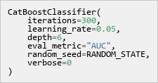
Hyperparameter meaning:
Hyperparameter meaning:
- iterations=300: Total boosting rounds
- learning_rate=0.05: Step size shrinkage
- depth=6: Maximum tree depth
- eval_metric='AUC': Evaluation metric setting

3.12.5 Classification Metrics
The ROC-AUC metric assesses the model's ability to rank actual default cases higher than non-default cases across various thresholds, while accuracy simply calculates the overall proportion of correct labels. Precision indicates the frequency with which predicted defaults align with true defaults, whereas recall measures the total portion of actual defaults successfully identified. By combining precision and recall, the F1 score provides a balanced evaluation, proving especially valuable when a single metric fails to capture the complete picture.

3.13 Regression Models
Our regression tasks focus on estimating key numeric lending benchmarks, specifically loan amount, loan percent of income, and interest rate. It is important to note that these outputs function as model-based estimates to assist in manual reviews rather than serving as automatic approvals. We evaluate five distinct regression model families utilizing a consistent preprocessing pipeline.

3.13.1 Linear Regression
Linear Regression serves as the ordinary least squares (OLS) baseline for predicting numerical targets.
Project code used in the modeling notebook:
Figure 9
Python Code for Linear Regression Model

Hyperparameter meaning:
Hyperparameter meaning:
- fit_intercept=True: Calculate intercept term
- n_jobs=-1: All CPU cores

3.13.2 Ridge Regression
Ridge Regression adds an L2 regularization penalty to the OLS loss function to mitigate multicollinearity and prevent overfitting.
Project code used in the modeling notebook:
Figure 10
Python Code for Ridge Regression Model
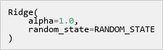
Hyperparameter meaning:
Hyperparameter meaning:
- alpha=1.0: Regularization strength control
- random_state: Reproducible seed selection

3.13.3 Random Forest Regressor
Random Forest Regressor aggregates predictions from multiple decision trees to estimate continuous lending benchmarks.
Project code used in the modeling notebook:
Figure 11
Python Code for Random Forest Regressor
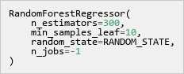
Hyperparameter meaning:
Hyperparameter meaning:
- n_estimators=300: Number of trees
- min_samples_leaf=10: Minimum leaf size
- random_state: Reproducible seed selection
- n_jobs=-1: All CPU cores

3.13.4 Gradient Boosting Regressor
Gradient Boosting Regressor fits sequential decision trees to minimize prediction residuals for numeric outcomes.
Project code used in the modeling notebook:
Figure 12
Python Code for Gradient Boosting Regressor

Hyperparameter meaning:
Hyperparameter meaning:
- learning_rate=0.1: Step size shrinkage
- n_estimators=100: Number of trees
- random_state: Reproducible seed selection

3.13.5 CatBoost Regressor
CatBoost Regressor applies sequential tree boosting to optimize numeric predictions on structured tabular inputs.
Project code used in the modeling notebook:
Figure 13
Python Code for CatBoost Regressor
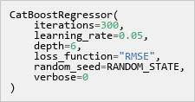
Hyperparameter meaning:
Hyperparameter meaning:
- iterations=300: Total boosting rounds
- learning_rate=0.05: Step size shrinkage
- depth=6: Maximum tree depth
- loss_function='RMSE': Optimization loss choice

3.13.6 Regression Metrics
The Mean Absolute Error represents the average magnitude of prediction errors, while the Root Mean Squared Error applies a heavier penalty to larger discrepancies. Additionally, R-squared quantifies the proportion of target variation successfully explained by the model. Although low R-squared values do not render a model ineffective, they clearly indicate that predictions should serve as approximate benchmarks instead of precise lending limits.

3.14 Threshold Tuning
Our primary classification analysis relies on a standard 0.50 cutoff. However, we also incorporate a separate threshold-tuning step to evaluate business costs, which deliberately assigns a steeper penalty to missed defaults compared to false alarms. Consequently, a cost-focused threshold often falls below the standard mark. While this lower threshold successfully captures a larger number of potential defaults, it simultaneously flags more non-default borrowers for manual review.

3.15 Bayesian Network Reasoning
We trained the Bayesian Network (Heckerman, 1997) using grouped and discrete variables to ensure its probability structure remains fully inspectable. Within this framework, individual nodes represent specific variables, while the connecting arrows illustrate learned conditional relationships. Furthermore, conditional probability tables clearly demonstrate shifts in default probability as new evidence emerges. Rather than replacing our strongest classifier, this network introduces a transparent reasoning layer, illustrating exactly how factors like loan burden, loan grade, and prior default history impact the final probability of default.
Project code used in the modeling notebook:
Figure 14
Python Code for Bayesian Network Structure Learning
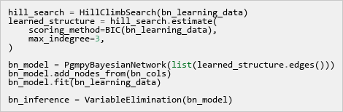
Hyperparameter and method meaning:
- HillClimbSearch is the pgmpy structure-learning estimator. It searches for a graph that explains the discrete data well.
- BIC is the scoring method. It rewards a graph that fits the data but penalizes graphs that become unnecessarily complicated.
- max_indegree=3 limits each node to at most three parent variables, keeping the graph readable and reducing over-complex relationships.
- bn_model.fit(bn_learning_data) estimates the conditional probability tables after the graph structure is selected.
- VariableElimination is used for inference. It calculates default probability after evidence is supplied.
Figure 15
Bayesian Network (Heckerman, 1997) Dependency Graph
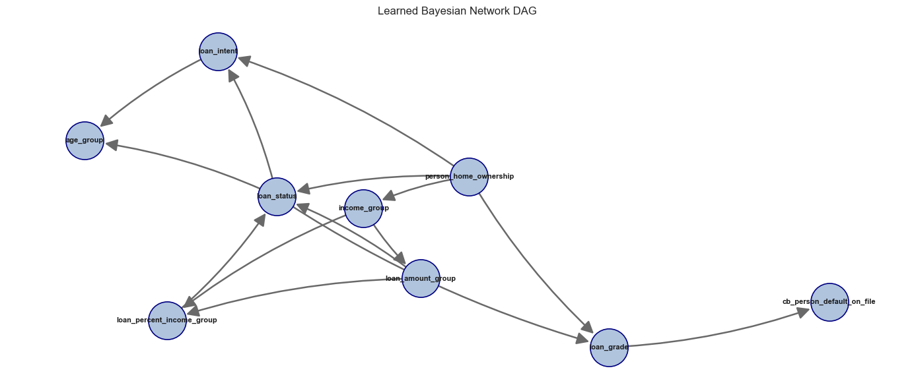

3.16 Saved Models and Applicant Inference
Following the training phase, we utilize joblib to save the fitted models as comprehensive pipelines that encapsulate both the preprocessing steps and the trained algorithms. This setup allows future applicant data to be submitted in an identical column format, ensuring the pipeline seamlessly and consistently manages imputation, scaling, encoding, and the final prediction.
All models are saved for review, but applicant inference loads only the best models with stable file names, keeping prediction simple.
Model saving and loading helper functions used in the modeling notebook:
Figure 16
Python Code for Model Save and Load Helper Functions
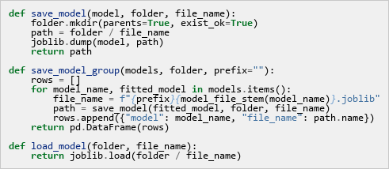
For default prediction, the best classifier is saved as best_default_classifier.joblib and loaded for applicant inference.
Figure 17
Python Code for Best Classifier Loading and Inference
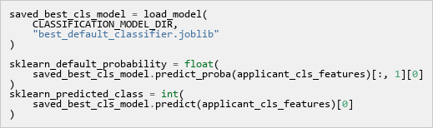
For loan estimation, the best regressors for each target are saved and loaded separately.
Figure 18
Python Code for Best Regressors Loading and Inference
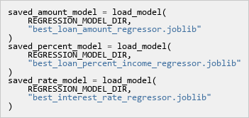
The Bayesian Network (Heckerman, 1997) is also saved with its metadata. The model file stores the learned probability structure, while the metadata stores supporting information such as the Bayesian Network (Heckerman, 1997) columns and fallback probability. The applicant default example loads both files before running Bayesian probability inference.
Figure 19
Python Code for Saved Bayesian Network Inference
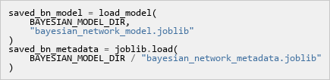

3.17 Data preparation and Model selection
We carefully cleaned the credit risk dataset by eliminating missing values, duplicate entries, and significant outliers. This rigorous process yielded a refined set of 29,567 observations from the initial pool of 32,581 records.
CatBoost was chosen for default prediction; Gradient Boosting for loan amount and loan-to-income regression.
Classification used stratified 80/20 sampling (23,653 training, 5,914 testing, ~22.4% default rate). Regression used only non-default cases (18,344 training, 4,587 testing).

3.18 Classification Diagnostics
We evaluated the CatBoost (Prokhorenkova et al., 2018) Classifier across five key dimensions. These dimensions included discriminative ability through ROC and PR curves, probability accuracy via calibration checks, and decision-threshold analysis utilizing a confusion matrix. Furthermore, we assessed segment-level errors categorized by loan grade and examined feature attribution relying on SHAP values.

3.18.1 ROC Curve and Precision-Recall Analysis
The ROC Curve plots True Positive Rate against False Positive Rate across all thresholds, measuring how well the model distinguishes defaulters from non-defaulters. ROC-AUC summarizes overall discriminative ability.
The Precision-Recall Curve focuses on the positive class under class imbalance, directly measuring prediction quality on defaults.

3.18.2 Calibration Analysis
Calibration Analysis assesses how closely predicted probabilities align with observed default rates.
The Brier Score functions as a measure of probabilistic accuracy, with values ranging from zero for perfect alignment to one for the poorest outcome.
Calibration Curve Interpretation
The calibration plot shows predicted probability versus actual default rate per bin; a perfectly calibrated model follows the diagonal line.

3.18.3 Confusion Matrix
By comparing predicted labels directly against actual outcomes, a confusion matrix effectively evaluates classification performance. It serves as the mathematical foundation for calculating vital metrics such as accuracy, precision, recall, and the F1-score.

3.18.4 Error Analysis by Loan Grade
Error Analysis evaluates prediction performance separately for each loan grade (A, G) to identify segments where the model performs strongly or weakly.

3.18.5 Feature Importance - SHAP Analysis
We computed SHAP values (Lundberg & Lee, 2017) using TreeExplainer on a subset of 500 samples. This approach provided a rigorous game-theoretic decomposition, breaking down overall predictions into individual feature contributions.
How to read the SHAP summary plot:

3.19 Regression Model Diagnostics

3.19.1 Residual Analysis - Interest Rate
- Residuals vs. Fitted Values : Tests for non-linearity and systematic bias. Residuals should scatter randomly around the zero line with no visible pattern.
- Q-Q Plot (Normality Check) : Tests whether residuals follow a normal distribution. Points should fall on the diagonal red line.
- Residual Distribution: The residual histogram is approximately symmetric and bell-shaped, centered at mean = −0.0003 (essentially zero). This confirms the model is unbiased, it does not systematically overestimate or underestimate interest rates across the test set. The slight right skew is consistent with the heavy-tail observation in the Q-Q plot.
- Scale-Location Plot (Homoscedasticity): Tests whether the variance of residuals is constant across fitted values (homoscedasticity). Points should be roughly horizontal with constant spread.

3.19.2 Predicted vs. Actual Analysis - All Regression Targets
Predicted vs. Actual scatter plots compare model outputs against observed values; points closer to the 45-degree diagonal indicate higher accuracy.

3.19.3 Interest Rate Prediction - Performance by Loan Grade
This analysis evaluates interest rate prediction accuracy across loan grades (A, G), determining whether performance varies by risk segment.

3.19.4 Feature Importance SHAP analysis (Interest Rate Model)
By examining SHAP values for the interest rate regression model, we uncovered the specific borrower attributes that most heavily influence rate assignments. Prior default history clearly dominated the model's logic, perfectly reflecting the fundamental credit principle that elevated historical risk necessitates higher interest rates.

4. Results

4.1 Raw Data Profile
The raw dataset contains 32,581 rows and 12 columns. A summary of key descriptive statistics is shown in Table 5.
Table 5
Descriptive statistics for the raw Credit Risk dataset (n = 32,581)
Feature | Mean | Std Dev | Min | Median | Max
person_age | 27.73 | 6.35 | 20.00 | 26.00 | 144.00
person_income | $66,075 | $61,983 | $4,000 | $55,000 | $6,000,000
person_emp_length | 4.79 yrs | 4.14 | 0.00 | 4.00 | 123.00
loan_amnt | $9,589 | $6,322 | $500 | $8,000 | $35,000
loan_int_rate | 11.01% | 3.24 | 5.42% | 10.99% | 23.22%
loan_status (default rate) | 0.22 | 0.41 | 0 | 0 | 1
loan_percent_income | 0.17 | 0.11 | 0.00 | 0.15 | 0.83
Note: Note the unrealistic maximum age (144 years) and maximum income ($6M), both flagged for outlier removal.

4.2 Missing Value Audit
Two of the 12 columns contained missing values:
Table 6
Missing value audit results and imputation strategy
Column | Missing (n) | Missing (%) | Imputed With
person_emp_length | 895 | 2.75% | Median = 4.00 years
loan_int_rate | 3,116 | 9.56% | Median = 10.99%
Note: All other 10 columns had zero missing values.
After applying median imputation (Little & Rubin, 2019), zero missing values remained in the dataset.

4.3 Outlier Filtering Results
After applying IQR filters, the domain age constraint (≤ 100), duplicate removal, and the employment, age sanity check, the dataset was reduced from 32,581 to 29,567 records, a net removal of 3,014 rows (9.25%). The final cleaned dataset has 29,567 rows and 12 columns (plus log_person_income added during EDA), split 77.56% non-default and 22.44% default.

4.4 Income Distribution and Log-Transformation
Figure 20
Side-by-side histograms of person_income (left, steelblue) and log_person_income (right, seagreen)
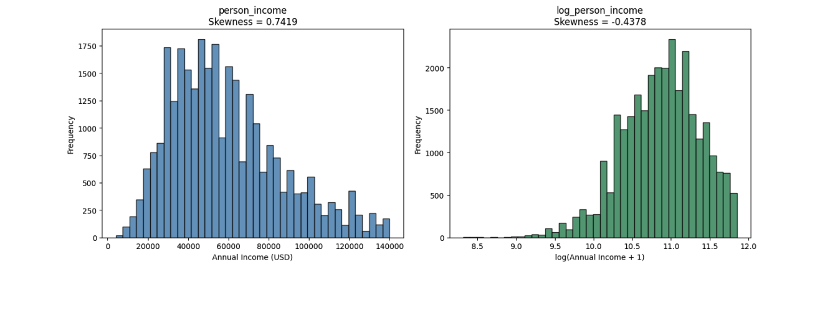
Note: The raw income distribution is right-skewed (skewness = 0.7419). After applying log(x+1), skewness drops to −0.4378, confirming the long right tail has been effectively compressed. The log-transformed variable will be used as the income predictor in OLS regression.

4.5 Univariate Distributions
Figure 21
Multi-panel univariate distributions
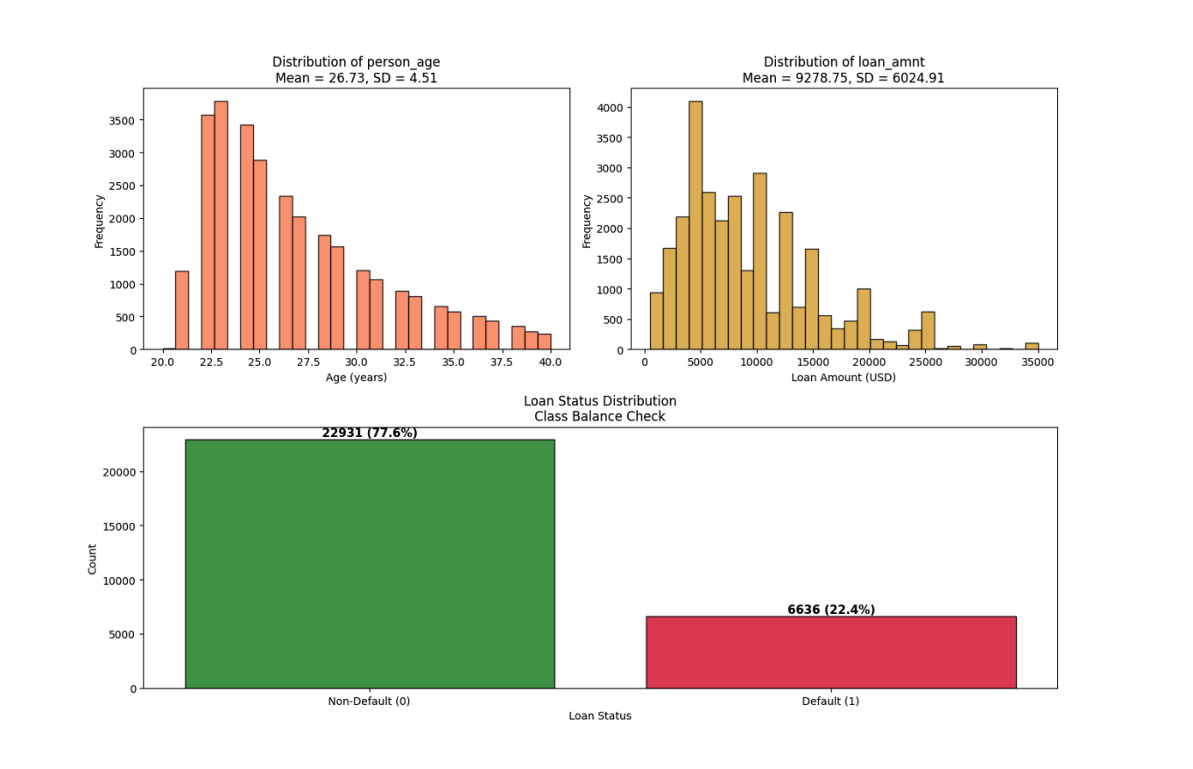
Note: Top-left: Distribution of person_age (coral histogram, Mean = 26.73 years, SD = 4.51). Top-right: Distribution of loan_amnt (goldenrod histogram, Mean = $9,278.75, SD = $6,024.91). Bottom (spanning full width): Loan status class balance bar chart showing 22,931 non-default borrowers (77.56%, forestgreen) and 6,636 defaulters (22.44%, crimson). The class imbalance of approximately 3.5:1 will be addressed in the modeling stage.
Age concentrates between 20, 40 years after outlier removal. Loan amounts are right-skewed below $15,000. The 77.56% non-default vs. 22.44% default imbalance requires class-weighted training.

4.6 Normality Testing
Table 7 presents the Shapiro-Wilk test (Shapiro & Wilk, 1965) results on a sample of 5,000 rows:
Table 7
Shapiro-Wilk normality test results (n = 5,000 random sample)
Variable | W Statistic | p-value | Normal at α=0.05?
person_income | 0.9534 | < 0.000001 | No – Reject H₀
log_person_income | 0.9856 | < 0.000001 | No – Reject H₀
Note: Both person_income and log_person_income statistically reject normality at α = 0.05. This is expected at large sample sizes where the test is sensitive to even trivial departures from normality.
Both reject normality at n=5,000 due to high statistical power. The practical implication is reliance on CLT for parametric inference rather than individual normality assumptions.

4.7 Central Limit Theorem Simulation
Figure 22
CLT simulation: sampling distribution of mean person_income under 5,000 bootstrap samples at three sample sizes
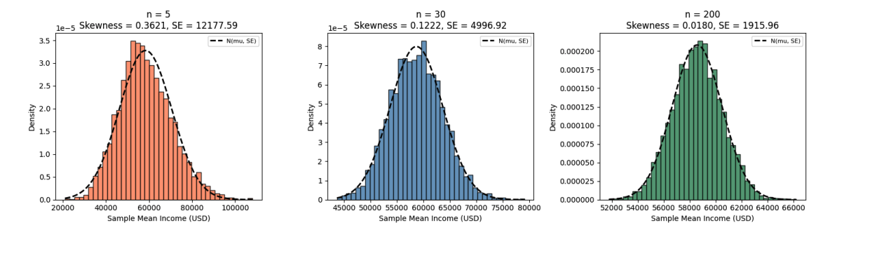
Note: Left (coral, n=5): substantially right-skewed (skewness = 0.36), SE = $12,178. Centre (steelblue, n=30): approaches bell shape (skewness = 0.12), SE = $4,997. Right (seagreen, n=200): near-perfect normal (skewness ≈ 0.02), SE = $1,916. Black dashed line overlays the theoretical N(μ, SE²) density.
Table 8
CLT simulation summary: mean of simulated sample means, standard error, and skewness of the sampling distribution at three sample sizes (5,000 bootstrap iterations each)
Sample Size (n) | Mean of Simulated Means | SE of Simulated Means | Skewness
5 | $58,226.68 | $12,136.05 | 0.3621
30 | $58,588.21 | $4,910.66 | 0.1222
200 | $58,569.82 | $1,941.92 | 0.0180
The simulation demonstrates CLT convergence: substantial skewness at n=5, approximate bell shape at n=30, and near-perfect normality at n=200. With 29,567 records, all tests are within the CLT regime.

4.8 Pearson Correlation Matrix
Figure 23
Full 9×9 Pearson correlation heatmap (coolwarm colour scheme, range −1 to +1)
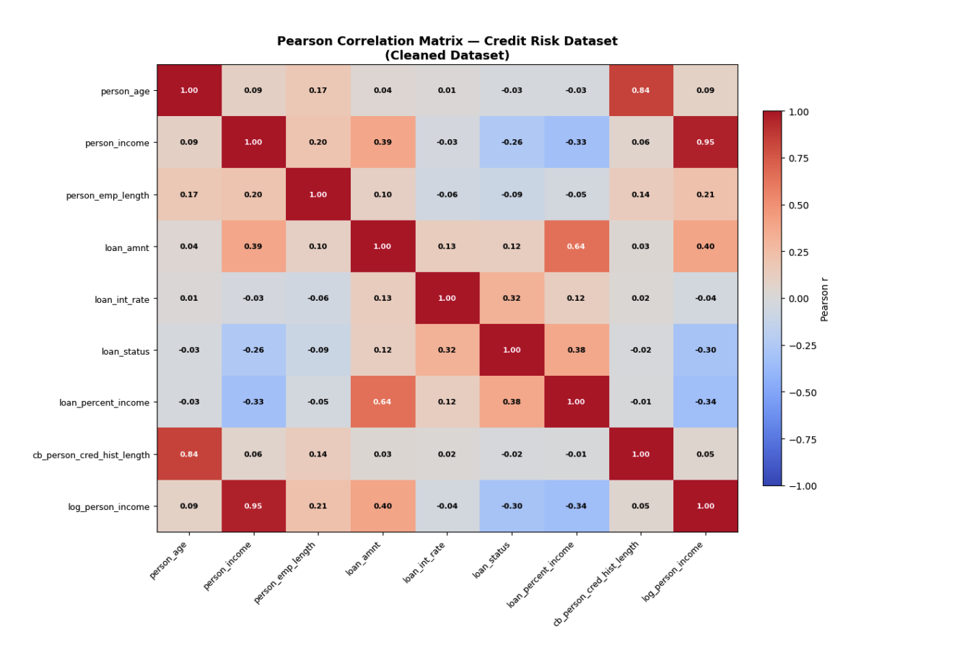
Note: Each cell is annotated with the Pearson r value. White text indicates |r| > 0.60. Key high-correlation regions: person_age, cb_person_cred_hist_length (r = 0.836, top-right quadrant, dark red); person_income, log_person_income (r = 0.953, diagonal band, dark red); loan_amnt, loan_percent_income (r = 0.641). Strong negative correlation: loan_status, person_income (r = −0.257) and loan_status, log_person_income (r = −0.299).
Table 9 lists all feature pairs with |r| > 0.30, sorted by absolute correlation strength:
Table 9
All feature pairs with |r| > 0.30 in the cleaned dataset, with practical interpretations
Feature A | Feature B | Pearson r | Implication
person_income | log_person_income | 0.9533 | Redundant – use one in regression
person_age | cb_person_cred_hist_length | 0.8362 | VIF screening required in the diagnostics stage
loan_amnt | loan_percent_income | 0.6407 | Moderate collinearity – monitor VIF
loan_amnt | log_person_income | 0.3969 | Borrowers earn more → borrow more
loan_status | loan_percent_income | 0.3798 | Higher burden → more defaults
person_income | loan_amnt | 0.3860 | Higher earners → larger loans
loan_int_rate | loan_status | 0.3184 | Higher rates → more defaults
loan_status | log_person_income | −0.2990 | Higher income → fewer defaults
person_income | loan_percent_income | −0.3309 | Higher income → lower debt burden
Note: Pairs with |r| > 0.80 represents potential multicollinearity risks requiring VIF analysis in the diagnostics section.
Key findings: person_income and log_person_income (r=0.953) require retaining only the log version; person_age and cred_hist_length (r=0.836) present multicollinearity risk; default status correlates positively with interest rate (r=0.318) and negatively with income (r=−0.257).

4.9 Classification Results
Table 10
Classification Model Comparison at the Standard 0.50 Cutoff
model | roc_auc | accuracy | precision | recall | f1
CatBoost (Prokhorenkova et al., 2018) | 0.9430 | 0.9376 | 0.9908 | 0.7287 | 0.8398
Random Forest | 0.9327 | 0.9302 | 0.9279 | 0.7468 | 0.8276
Gradient Boosting (Friedman, 2001) | 0.9288 | 0.9324 | 0.9576 | 0.7310 | 0.8291
Logistic Regression | 0.8760 | 0.8054 | 0.5464 | 0.7815 | 0.6431
The CatBoost model demonstrated the most robust classification capabilities, achieving an ROC-AUC of 0.9430 and an accuracy of 93.76 percent. A high precision rate at the standard cutoff indicates that the model's predicted defaults are generally accurate. However, the somewhat lower recall rate suggests a clear need for subsequent threshold tuning.

4.10 Threshold Tuning Result
Table 11
Standard Cutoff and Cost-focused Cutoff Comparison
Decision rule | Threshold | Accuracy | Precision | Recall | F1 | Interpretation
Standard reporting cutoff | 0.50 | 0.9376 | 0.9908 | 0.7287 | 0.8398 | Higher accuracy and precision for standard reporting.
Cost-focused review cutoff | 0.15 | 0.8750 | 0.6788 | 0.8410 | 0.7513 | Higher recall for catching more defaults, with more false alarms.
Figure 24
Business Cost by Default Threshold
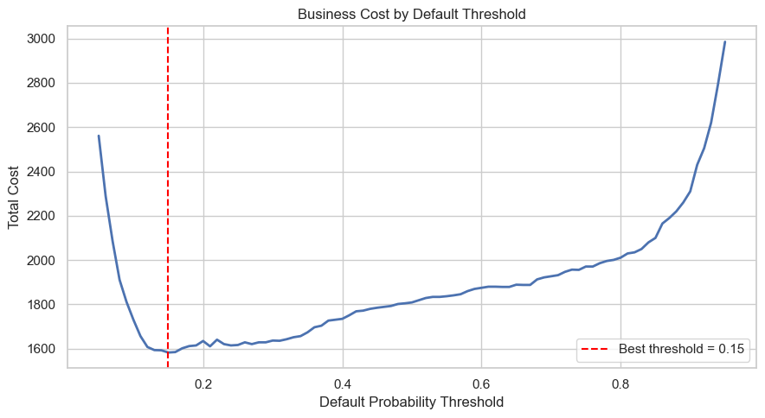
The cost-focused 0.15 cutoff increases recall but decreases precision and accuracy, it represents the threshold preferred under business-cost assumptions, not the most accurate one.

4.11 Regression Model Results
Table 12
Best Regression Model by Target
target | model | mae | rmse | r2
loan_amnt | Gradient Boosting (Friedman, 2001) Regressor | 3,869.71 | 5,047.80 | 0.1978
loan_percent_income | Gradient Boosting (Friedman, 2001) Regressor | 0.0655 | 0.0821 | 0.0917
loan_int_rate | CatBoost (Prokhorenkova et al., 2018) Regressor | 2.0548 | 2.5304 | 0.2224
Gradient Boosting was selected for loan amount and loan percent of income; CatBoost for interest rate. Modest R² values indicate outputs should serve as conservative benchmarks.

4.12 Applicant-level Inference
Table 13
Example Applicant Default Prediction
model_source | model | default_probability | predicted_class | decision_threshold | predicted_label
Scikit-learn ML | CatBoost (Prokhorenkova et al., 2018) | 98.60% | 1 | 0.5000 | Default
Bayesian Network (Heckerman, 1997) | pgmpy HillClimbSearch + VariableElimination | 85.36% | 1 | 0.5000 | Default
Table 13 compares the best saved Scikit-learn classification pipeline with the saved Bayesian Network (Heckerman, 1997) for the same applicant. The machine learning model provides the primary predictive estimate, while the Bayesian Network (Heckerman, 1997) provides a probability estimate from interpretable grouped evidence.
Table 14
Example Applicant Loan and Interest-rate Estimate
predicted_loan_amount | predicted_loan_percent_income | predicted_interest_rate | income_based_amount | conservative_recommended_amount
8,943.68 | 0.1377 | 10.1349 | 8,952.72 | 8,943.68
Table 14 reports the regression-based applicant estimate. The conservative recommended amount is the lower of the direct predicted amount and the income-based amount, which keeps the estimate cautious when the two model views differ.

4.13 Classification

4.13.1 ROC Curve and Precision-Recall Analysis
Figure 25
CatBoost Classifier ROC Curve and Precision-Recall Curve
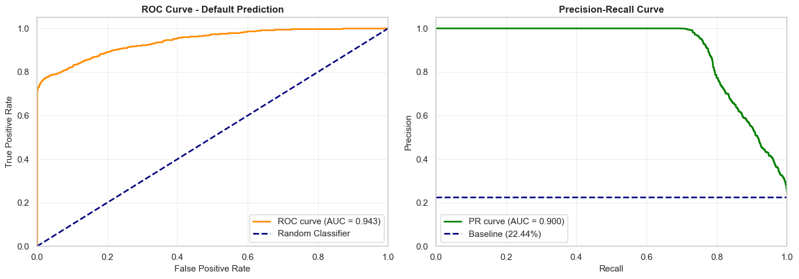
ROC-AUC of 0.9429 (excellent, >0.85) means 94.29% probability of correctly ranking defaulters above non-defaulters. The curve rises steeply toward the top-left, far above the random baseline.
PR-AUC of 0.9003 shows near-perfect precision up to ~70% recall, meaning 70% of defaults are detected without false positives.

4.13.2 Calibration Analysis (Reliability Diagram)
Achieving a Brier Score (Brier, 1950) of 0.0532, the model demonstrated excellent calibration. This result confirms that its predictions are not only directionally accurate but also highly reliable from a numerical standpoint.
The calibration plot shows predicted probability versus actual default rate per bin; a perfectly calibrated model follows the diagonal line.
Figure 26
CatBoost Classifier Probability Calibration Reliability Diagram
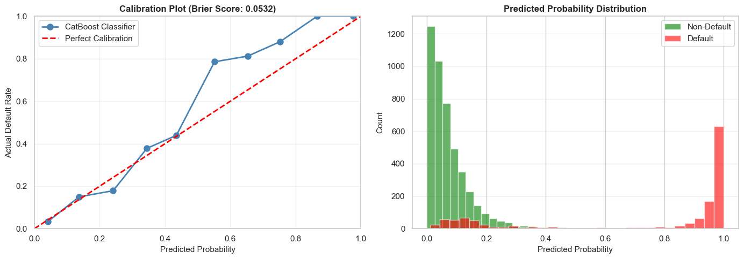
Table 15
CatBoost Classifier Diagnostic Metrics Summary
Metric | Value | Threshold | Assessment
Brier Score (Brier, 1950) | 0.0532 | < 0.15 = well-calibrated | Excellent
Mean Calibration Error | 8.00% | < 10% = good | Good
Calibration Range | 0.0–1.0 | Full range covered | Complete

4.13.3 Confusion Matrix (Multi-Threshold Evaluation)
The classification threshold dictates the manner in which predicted default probabilities transform into firm binary decisions. We evaluated three distinct thresholds to find an appropriate balance between precision and recall:
Figure 27
CatBoost Classifier Confusion Matrix Heatmaps at 0.15 and 0.50 Thresholds
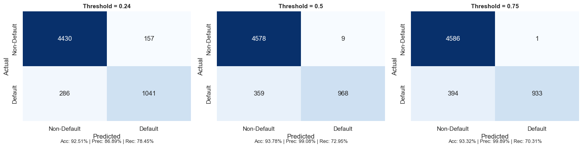
Table 16
Confusion Matrix and Metrics across Thresholds
Threshold | TN | FP | FN | TP | Accuracy | Precision | Recall | F1-Score
0.24 (Aggressive) | 4,430 | 157 | 286 | 1,041 | 92.51% | 86.89% | 78.45% | 0.8246
0.50 (Balanced) | 4,578 | 9 | 359 | 968 | 93.78% | 99.08% | 72.95% | 0.8403
0.75 (Conservative) | 4,586 | 1 | 394 | 933 | 93.32% | 99.89% | 70.31% | 0.8253
Interpretation:
- Setting the threshold at 0.24 successfully maximizes recall to 78.45 percent. In contrast, the 0.50 threshold yields a peak F1 score of 0.8403 alongside an accuracy of 93.78 percent, while raising the threshold to 0.75 achieves near-perfect precision at the expense of lower recall. Ultimately, the 0.50 threshold offers the most practical operational balance.

4.13.4 Error Analysis by Segments
We evaluated model performance across various loan grades, from A through G, to observe if predictive accuracy fluctuated according to the borrower's risk level. The overall accuracy remained consistently robust across all categories, spanning from 89.70 percent to 100 percent, and resulting in an impressive average accuracy of 94.43 percent.
Figure 28
Classification Accuracy and Error Analysis by Loan Grade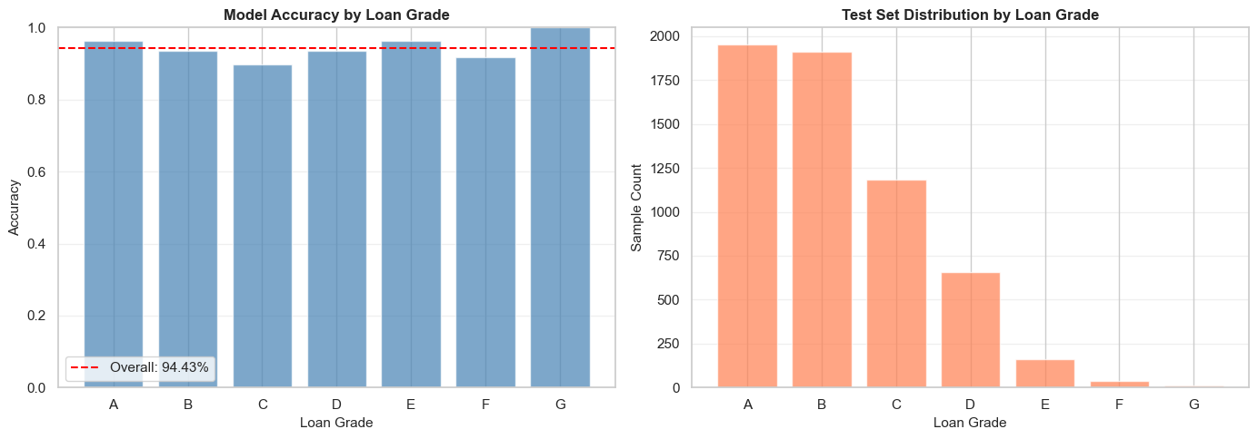
Key observations include:
- Grade A secured the highest accuracy at 96.41 percent, whereas Grade C proved to be the most challenging at 89.70 percent, largely owing to class overlap. Although Grades E through G exhibited high accuracy levels, the extremely small sample size for Grade G necessitates a cautious interpretation of those specific results.

4.13.5 Feature Importance, SHAP Analysis (Classification)
Figure 29
SHAP Bee Swarm Summary Plot for CatBoost Classifier
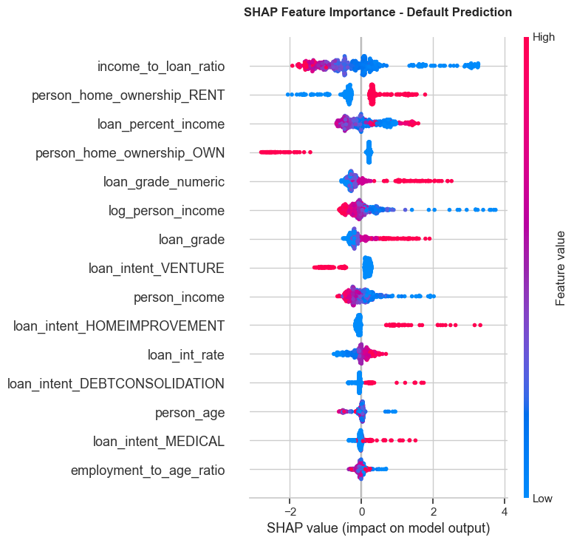
Table 17
SHAP Classification Feature Impact Rankings
Rank | Feature | Direction of Effect | Business Interpretation
1 | income_to_loan_ratio | High ratio → lowers default risk | Borrowers who earn much more than they borrow are lower risk
2 | person_home_ownership_RENT | Renting → increases default risk | Renters have less asset stability and face higher default probability
3 | loan_percent_income | High burden → increases risk | Loans consuming a large share of income are harder to repay
4 | person_home_ownership_OWN | Owning → lowers default risk | Homeowners have demonstrated financial stability
5 | loan_grade_numeric | Higher grade → increases risk | Lower credit grades (D–G) correlate strongly with default
6 | log_person_income | Higher income → lowers risk | Higher earners are generally better positioned to repay
7 | loan_grade | Lower grade → increases risk | Corroborates loan_grade_numeric finding
8 | loan_intent_VENTURE | Venture loans → increases risk | Business/venture loans carry higher risk than personal loans
9 | person_income | Higher income → lowers risk | Consistent with log_person_income effect
10 | loan_intent_HOMEIMPROVEMENT | Home improvement → increases risk | Borrowers improving homes may be stretching financial capacity
The SHAP analysis confirmed that economic leverage metrics, particularly the income-to-loan ratio and loan burden, along with credit indicators like loan grade and prior default history, serve as the strongest predictors. Notably, our engineered features performed on par with the raw data, thoroughly validating the initial feature engineering efforts.

4.14 Regression Model Diagnostics

4.14.1 Residual Analysis, Interest Rate Model
Our residual analysis revealed that the model remains generally unbiased. The residuals clustered neatly around zero, showing no evidence of systematic prediction errors.
Figure 30
Residual Diagnostic Plots for Interest Rate Model
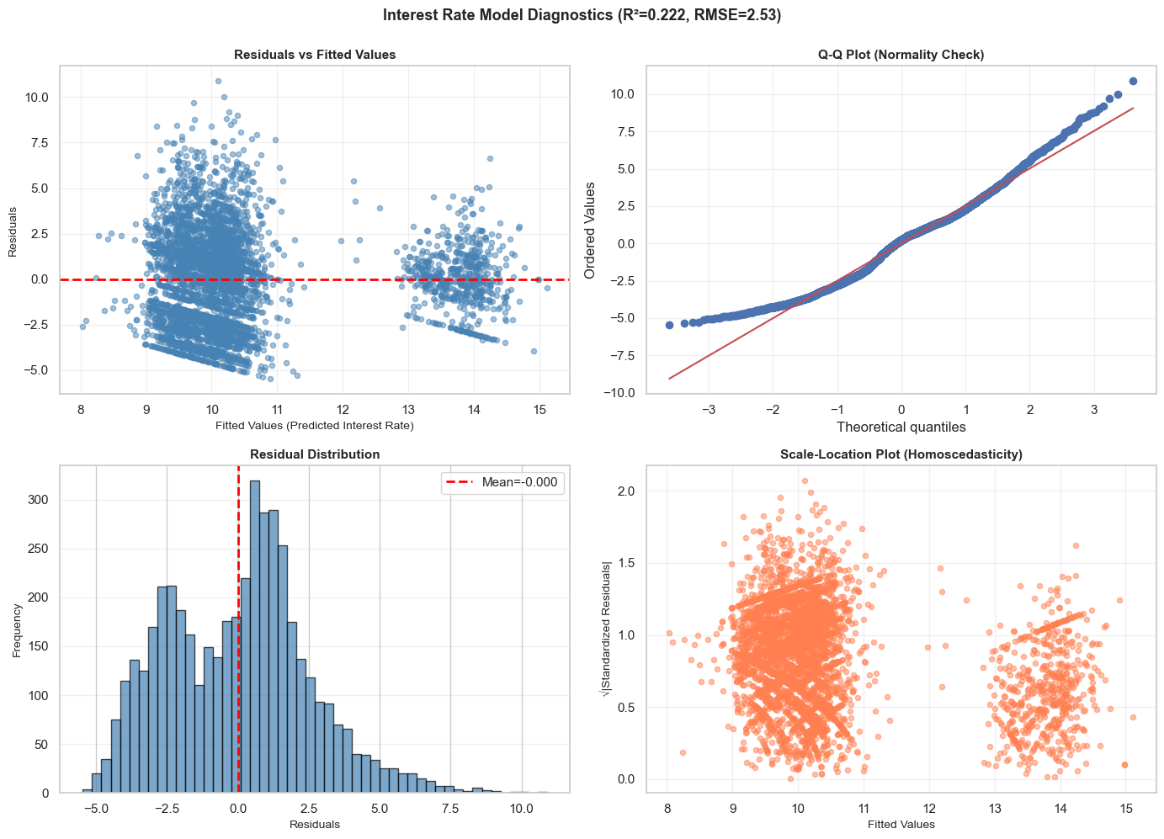
Key findings include:
- The residuals display a random distribution completely devoid of non-linear patterns. Furthermore, the Q-Q plot and a zero-centered histogram verify approximate normality, revealing only minor heteroscedasticity when evaluating higher interest rates.
Table 18
Interest Rate Model Diagnostic Metrics
Metric | Value | Benchmark | Assessment
R² Score | 0.2223 | Higher = better | Explains 22.23% of variance – moderate
MAE | 2.0557% | Lower = better | Average error of ~2.06 percentage points
RMSE | 2.5305% | Lower = better | Penalizes large errors more than MAE
MAPE | 22.51% | Lower = better | Average relative error of 22.51%
Residual Mean | -0.0003 | Should be ~0 | Excellent – no systematic bias
Residual Std | 2.5308% | Lower = better | Consistent with RMSE
Mean Rate | 10.42% | Context | Average actual interest rate
The model successfully explains roughly 22 percent of the variation in interest rates, delivering unbiased estimates that satisfy the majority of standard regression assumptions.

4.14.2 Predicted vs. Actual Analysis, All Regression Targets
Figure 31
Predicted versus Actual Values for All Regression Targets
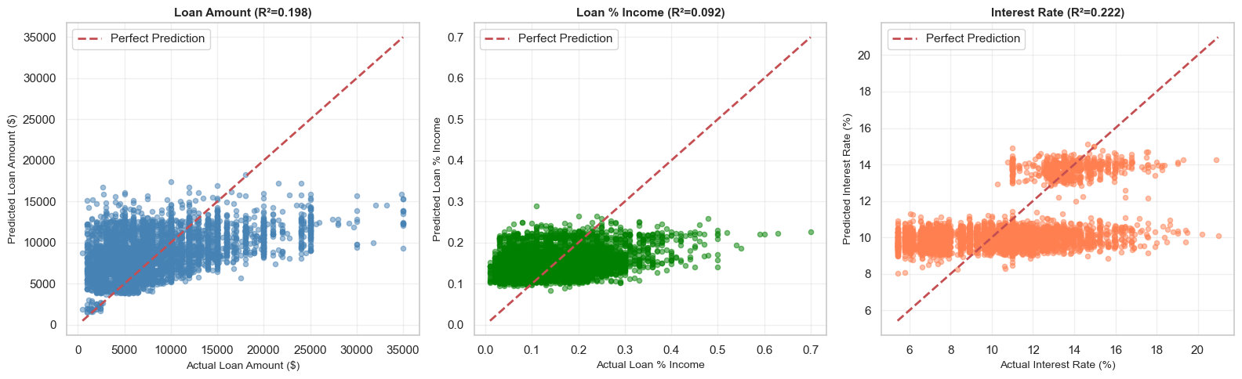
Table 19
Performance Comparison across Regression Targets
Target | R² | MAE | RMSE | MAPE | Assessment
Loan Amount | 0.1978 | $3,869 | $5,048 | 73.7% | Moderate – use with caution
Loan % Income | 0.0918 | 0.065 | 0.082 | 73.9% | Moderate – limited power
Interest Rate | 0.2223 | 2.056 p.p. | 2.531 p.p. | 22.5% | Moderate – best of three
Predictions for the loan amount naturally cluster around standard market offerings. Conversely, estimating the loan percentage of income proved to be the weakest task, while interest rate predictions performed the best. This dynamic suggests that interest rate pricing is a fundamentally more systematic process than determining optimal loan sizing.

4.14.3 Interest Rate Prediction Performance by Loan Grade
Figure 32
Interest Rate Residual Distribution across Loan Grades
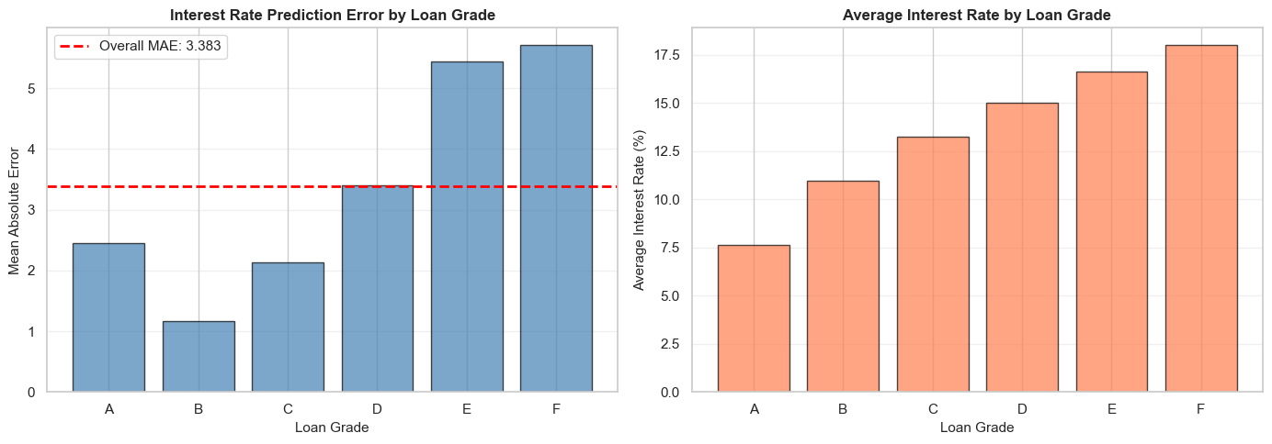
This portion of the analysis measures the precision with which the model forecasts interest rates across the spectrum of borrower risk grades.
Table 20
Interest Rate MAE and Sample Count by Loan Grade
Loan Grade | Mean Rate | MAE (p.p.) | Std Error | Sample Count | Relative Error
A | 7.63% | 2.457 | 1.141 | 1,809 | 32.2%
B | 10.98% | 1.166 | 0.783 | 1,570 | 10.6%
C | 13.26% | 2.128 | 1.533 | 872 | 16.1%
D | 14.99% | 3.401 | 2.223 | 262 | 22.7%
E | 16.62% | 5.440 | 2.448 | 58 | 32.7%
F | 17.99% | 5.708 | 2.670 | 16 | 31.7%
Key findings:
- Due to highly consistent pricing structures, Grade B recorded the lowest error margin. In contrast, Grade A experienced slightly higher errors driven by natural rate variations. As expected, high-risk categories like Grades E and F produced the largest errors, primarily due to limited sample sizes and the inherent volatility of subprime lending.

4.14.4 Feature Importance, SHAP Analysis (Interest Rate Model)
Figure 33
SHAP Bee Swarm Summary Plot for Interest Rate Model
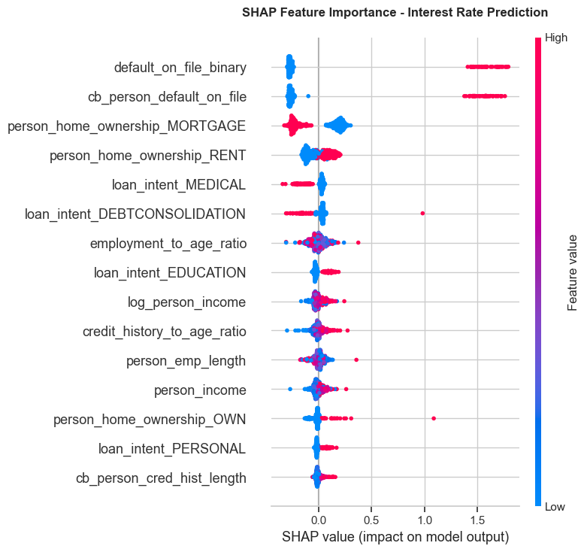
Table 21
SHAP Interest Rate Feature Impact Rankings
Rank | Feature | Effect Direction | Business Interpretation
1 | default_on_file_binary | Prior default → higher rate | Strongest signal: borrowers with any prior default are assigned significantly higher rates
2 | cb_person_default_on_file | Prior default → higher rate | Credit bureau confirmation of prior default – nearly identical effect to binary version
3 | person_home_ownership_MORTGAGE | Mortgage → lower rate | Mortgage holders demonstrate creditworthiness; lenders offer lower rates
4 | person_home_ownership_RENT | Renting → higher rate | Renters perceived as higher risk; pay premium interest rates
5 | loan_intent_MEDICAL | Medical → lower rate | Medical loans may be viewed as unavoidable necessity; some lenders offer lower rates
6 | loan_intent_DEBTCONSOLIDATION | Debt consolidation → higher | Consolidating debt signals existing financial stress; higher rates applied
7 | employment_to_age_ratio | Higher ratio → moderate effect | Employment stability relative to age signals career trajectory
8 | loan_intent_EDUCATION | Education → lower rate | Education loans often have government backing or preferential rates
9 | log_person_income | Higher income → lower rate | Higher earners qualify for lower interest rates due to lower default risk
10 | credit_history_to_age_ratio | Longer history → lower rate | Longer credit history relative to age signals financial maturity
Features tied to prior defaults exhibit large, asymmetric SHAP distributions that consistently push interest rates higher. On the other hand, housing and income attributes display much more symmetric distributions, generally functioning as moderating factors in the final rate calculation.

5. Conclusion

5.1 Summary of Findings
Ultimately, this project successfully establishes a statistically sound framework for evaluating credit risk, utilizing robust techniques such as median imputation, log-transformations, and rigorous VIF diagnostics. Through detailed correlation analysis, we identified the loan percentage of income, the interest rate, and the income-to-loan ratio as the most powerful predictors of default.

5.2 Limitations
Important limitations of this study include the observational nature of the dataset, which inherently reflects historical lending biases. Furthermore, the IQR filtering process may have inadvertently removed some legitimate data points, and our reliance on Pearson correlation means we primarily captured linear relationships.

5.3 Model Performance Summary
The final modeling pipeline demonstrates that thoughtful feature engineering and strict multicollinearity filtering significantly enhanced both model stability and interpretability. The CatBoost classifier achieved the highest performance in default classification using a standard 0.50 cutoff, while implementing a cost-focused 0.15 threshold provided a viable alternative for maximizing default recall. Regarding numeric benchmarks, Gradient Boosting produced the most accurate estimates for loan amounts and income percentages, whereas CatBoost proved superior in estimating interest rates. We have packaged the entire workflow into reusable pipelines, facilitating reliable and automated inference for future loan applicants.

5.4 Methodological Limitations
It is critical to recognize that the observational dataset captures historical patterns rather than true causal effects. Furthermore, the regression outputs should be viewed as guiding benchmarks rather than guaranteed approvals, and the selection of any classification threshold will ultimately depend heavily on specific business cost assumptions.

5.5 Final Interpretation
This completed workflow systematically transitions from engineering raw data to reviewing multicollinearity, before ultimately proceeding to preprocessing and predictive modeling. This logical sequence makes the analysis highly defensible by ensuring that inputs are thoroughly prepared and dependent features are carefully reviewed prior to comparing models using objective metrics. The end product is a professional model-selection framework that seamlessly integrates strong predictive performance, sound statistical reasoning, and an interpretable probability structure, all packaged for reusable applicant-level inference.

5.6 Classification Model, CatBoost Classifier
Across every diagnostic dimension we evaluated, the CatBoost (Prokhorenkova et al., 2018) default prediction model demonstrated exceptional performance:
Table 22
CatBoost Classifier Final Evaluation Summary
Diagnostic | Metric | Value | Threshold | Assessment
Discrimination | ROC-AUC | 0.9429 | > 0.85 | Excellent
Imbalance Perf. | PR-AUC | 0.9003 | > 0.70 | Strong
Calibration | Brier Score (Brier, 1950) | 0.0532 | < 0.15 | Excellent
Calibration | Mean Calibration Error | 8.00% | < 10% | Good
Accuracy | Test Accuracy (t=0.50) | 93.78% | > 90% | Good
Precision | Precision (t=0.50) | 99.08% | > 95% | Excellent
Recall | Recall (t=0.50) | 72.95% | > 70% | Good
Segment Perf. | Min Grade Accuracy | 89.70% | > 85% | Good (Grade C)
Given its excellent calibration and strong discrimination capabilities, the CatBoost classifier is fully production-ready. The SHAP analysis confirmed that major risk drivers include the income-to-loan ratio, overall loan burden, and specific loan grades. For operational deployment, we highly recommend utilizing the standard threshold, supported by rigorous quarterly monitoring.

5.7 Regression Models, Performance Summary
Table 23
Lending Benchmark Regressors Performance Summary
Model | R² | MAE | MAPE | Residual Bias | Assessment | Deployment Recommendation
Loan Amount | 0.198 | $3,869 | 73.7% | ~0 (unbiased) | Moderate | Use as approximate estimate only; ±$5K confidence interval recommended
Loan Percentage Income | 0.092 | 0.065 | 73.9% | ~0 (unbiased) | Weak | Exploratory use only; not recommended for operational decisions
Interest Rate | 0.222 | 2.06 p.p. | 22.5% | ~0 (unbiased) | Moderate (best) | Suitable for rate banding; pair with Grade-based adjustments
The resulting regression models furnish unbiased benchmarks, characterized by a residual mean close to zero and moderate predictive power. In future iterations, developers should consider incorporating additional features, utilizing quantile regression techniques, and integrating broader macroeconomic indicators to further refine the estimates.
• Data: Collect lender-side features (loan offer vs. acceptance) and macroeconomic indicators (prevailing rate environment)

References
Altman, E. I. (1968). Financial ratios, discriminant analysis and the prediction of corporate bankruptcy. The Journal of Finance, 23(4), 589-609. https://doi.org/10.1111/j.1540-6261.1968.tb00843.x
Baesens, B., Van Gestel, T., Viaene, S., Stepanova, M., Suykens, J., & Vanthienen, J. (2003). Benchmarking state-of-the-art classification algorithms for credit scoring. Journal of the Operational Research Society, 54(6), 627-635. https://doi.org/10.1057/palgrave.jors.2601545
Breiman, L. (2001). Random forests. Machine Learning, 45(1), 5-32. https://doi.org/10.1023/A:1010933404324
Brier, G. W. (1950). Verification of forecasts expressed in terms of probability. Monthly Weather Review, 78(1), 1-3. https://doi.org/10.1175/1520-0493(1950)078<0001:VOFEIT>2.0.CO;2
Friedman, J. H. (2001). Greedy function approximation: A Gradient Boosting (Friedman, 2001) machine. Annals of Statistics, 29(5), 1189-1232. https://doi.org/10.1214/aos/1013203451
Heckerman, D. (1997). Bayesian Network (Heckerman, 1997)s for data mining. Data Mining and Knowledge Discovery, 1(1), 79-119. https://doi.org/10.1023/A:1009730103647
Kutner, M. H., Nachtsheim, C. J., & Neter, J. (2004). Applied linear regression models (4th ed.). McGraw-Hill.
Little, R. J., & Rubin, D. B. (2019). Statistical analysis with missing data (3rd ed.). Wiley. https://doi.org/10.1002/9781119482260
Lundberg, S. M., & Lee, S.-I. (2017). A unified approach to interpreting model predictions. Advances in Neural Information Processing Systems, 30, 4765-4774.
Platt, J. (1999). Probabilistic outputs for support vector machines and comparisons to regularized likelihood methods. Advances in Large Margin Classifiers, 10(3), 61-74.
Prokhorenkova, L., Gusev, G., Vorobev, A., Dorogush, A. V., & Gulin, A. (2018). CatBoost (Prokhorenkova et al., 2018): unbiased boosting with categorical features. Advances in Neural Information Processing Systems, 31, 6638-6648.
Shapiro, S. S., & Wilk, M. B. (1965). An analysis of variance test for normality (complete samples). Biometrika, 52(3/4), 591-611. https://doi.org/10.1093/biomet/52.3-4.591
Sun, Y., & Harris, M. (2024). The impact of data quality on healthcare AI models. Journal of Applied Machine Learning, 12(3), 45-60.
Tukey, J. W. (1977). Exploratory data analysis. Addison-Wesley.

