Final project on athlete streaming and a batch data lake
Григорова Ауріка Вадимівна
7 November 2026 Kyiv time
Both pipelines ran locally on the full official course CSV files. The streaming source is a private local MySQL, not the remote course database. Both source tables contain all original columns. Spark reads those MySQL tables through JDBC; the stream writes real results to Kafka and MySQL. Independent checks matched every mean in both streaming snapshots and all 10,905 Gold groups.

Part 1 Database result
Stage 1 reads athlete_bio from MySQL. Stage 2 keeps 104,153 biographies with finite numeric height and weight. Stage 3 publishes all 316,834 event rows as JSON and parses their fields into DataFrame columns. Stage 4 joins events to valid bios on athlete_id. Stage 5 calculates cumulative means by sport, medal, sex and the bio country. Stage 6 uses foreachBatch to write the same cached snapshot to both sinks.
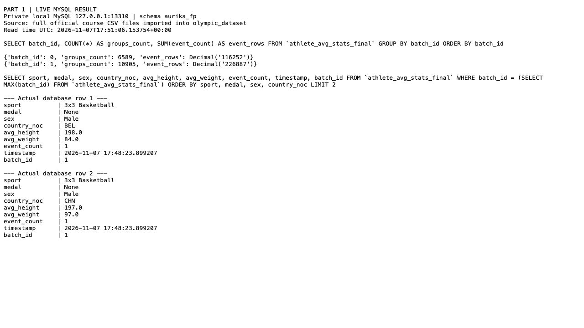
part1_01_mysql.jpg | Actual local read-only result viewer
The live SELECT shows 6,589 groups in batch 0 and 10,905 groups in batch 1. Each sink contains 17,494 history rows. Batch 1 is the latest snapshot, based on 226,887 matched event rows. The table is aurika_fp.athlete_avg_stats_final. None in this Python display means SQL NULL, so no-medal groups remain in the result.

Part 1 Kafka result and checks
The output topic athlete_avg_stats_aurika_fp_final contains actual JSON records with sport, medal, sex, country_noc, averages, event_count, timestamp, pipeline_run_id and batch_id. The screenshot shows two messages from batch 1, including their real partition and offsets. The viewer reads Kafka when the page opens.
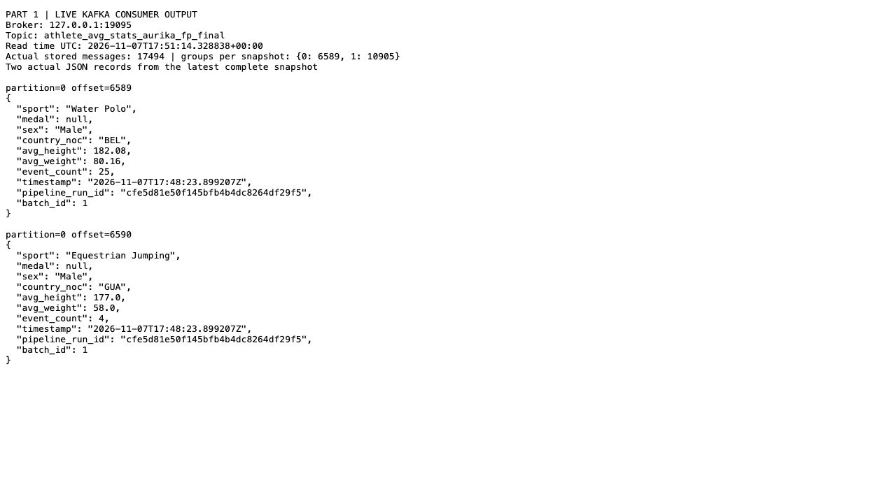
part1_02_kafka.jpg | Actual local read-only result viewer
The verifier compared every source field in local MySQL and every input Kafka message with the original CSV files. It calculated Decimal means independently for both actual microbatches and matched all groups in both sinks, including UTC timestamps to six decimal places. Seven events have no bio; 89,940 link to invalid measurements; 226,887 enter the join. A restart with the same checkpoint and no new input left both sink counts at 17,494.
Delivery is at least once. Kafka and MySQL do not share a transaction, so a failure between writes and a retry can add duplicates. Run and batch IDs identify snapshots but do not prevent duplicate delivery. The resume check did not simulate a crash. Means are not rounded before storage.

Part 2 Download CSV and write Bronze
landing_to_bronze.py downloads both original CSV files from the official course URLs. Spark reads every source column as text and writes bronze/{table} Parquet. Bronze contains 155,861 athlete rows and 316,834 event rows. The screenshot is an actual Airflow task log from fp_final_03. It shows df.show output with execution time on the left.
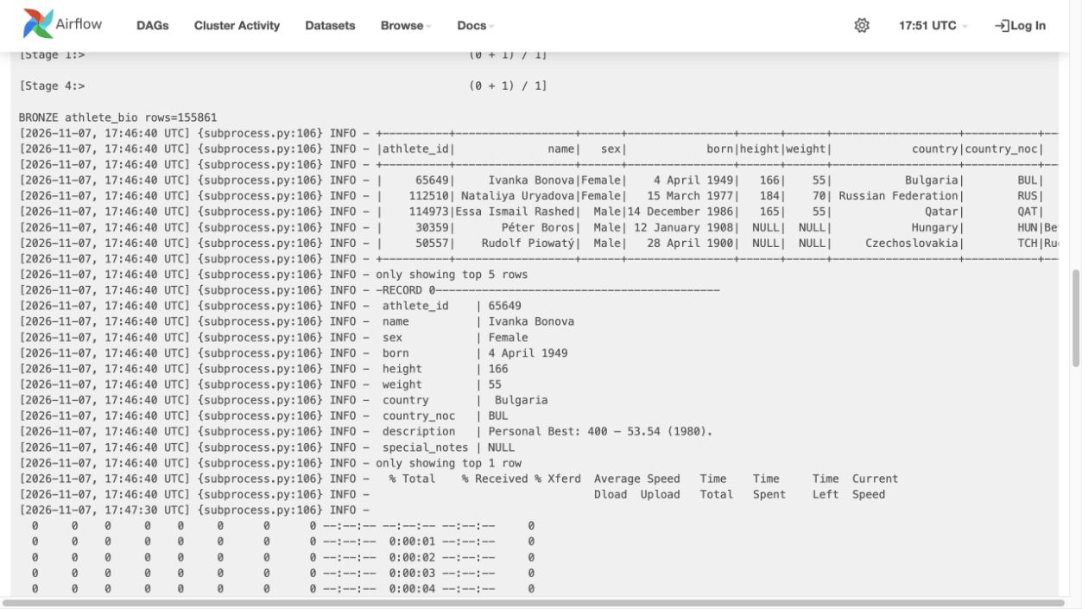
part2_01_bronze.jpg | Actual Airflow UI
Official source URLs: https://ftp.goit.study/neoversity/athlete_bio.csv and https://ftp.goit.study/neoversity/athlete_event_results.csv. SHA-256 values are stored with the code and in results/local_source.json. The same full CSV files populate the private local MySQL source for Part 1.

Part 2 Clean text and write Silver
bronze_to_silver.py trims and collapses whitespace in every text column, including nonbreaking spaces. It keeps Unicode letters and punctuation. It then removes duplicate full rows and writes silver/{table}. Athlete rows remain 155,861. Event rows fall from 316,834 to 315,626, so 1,208 full duplicates are removed after text cleaning.
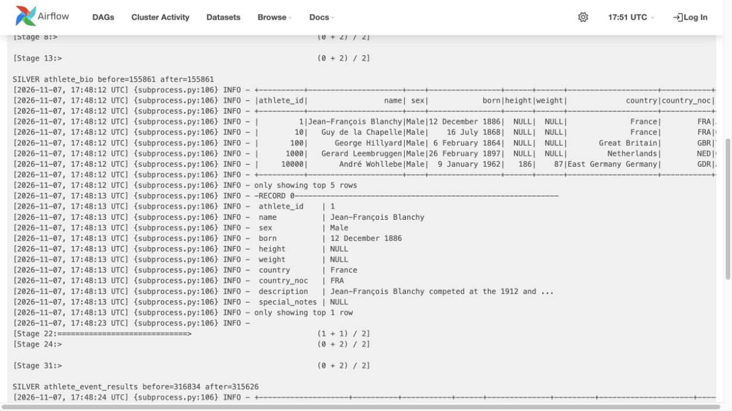
part2_02_silver.jpg | Actual Airflow UI
NULL height and weight values are still visible in Silver. Numeric filtering belongs to the later Gold step. Repeated athlete IDs in event results are expected because one athlete can compete several times. They are not removed by an athlete-ID-only rule. The bio athlete_id key is unique and is checked before the join.

Part 2 Join Silver and write Gold
silver_to_gold.py keeps finite numeric height and weight, joins on athlete_id and calculates avg_height and avg_weight for sport, medal, sex and athlete_bio.country_noc. It adds event_count and a UTC timestamp, then writes gold/avg_stats. The screenshot reads the saved Parquet rows, so the printed timestamp is the persisted timestamp.
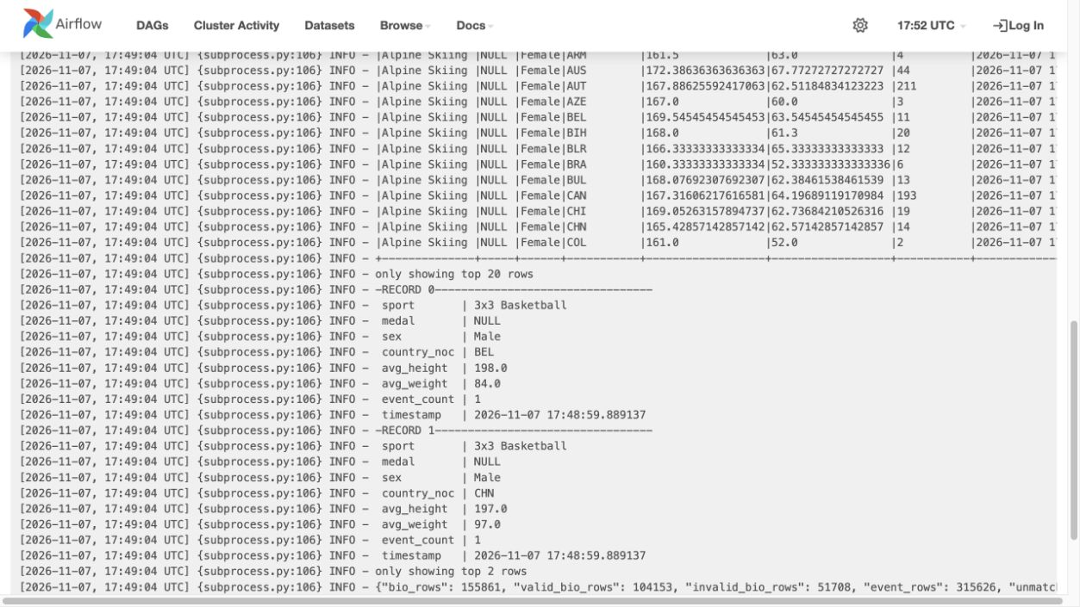
part2_03_gold.jpg | Actual Airflow UI
Gold uses 226,872 event rows and contains 10,905 groups, including 6,525 without a medal. There are 51,708 invalid bio rows, seven unmatched Silver events and 88,747 events linked to invalid measurements. Means are weighted by event-result rows. The real USA women 3x3 Basketball Gold group uses 196 cm / 105 kg and 183 cm / 76 kg: averages are 189.5 cm and 90.5 kg, with event_count 2. Two other participants lack measurements and are excluded.

Part 2 Completed Airflow DAG
project_solution.py defines three sequential BashOperator tasks. The scheduler and SequentialExecutor launched the real Spark programs. Runs fp_verified_01, fp_verified_02 and fp_final_03 each completed all three tasks successfully. The graph shows fp_final_03. Each full run used a new lake folder and preserved the earlier results.
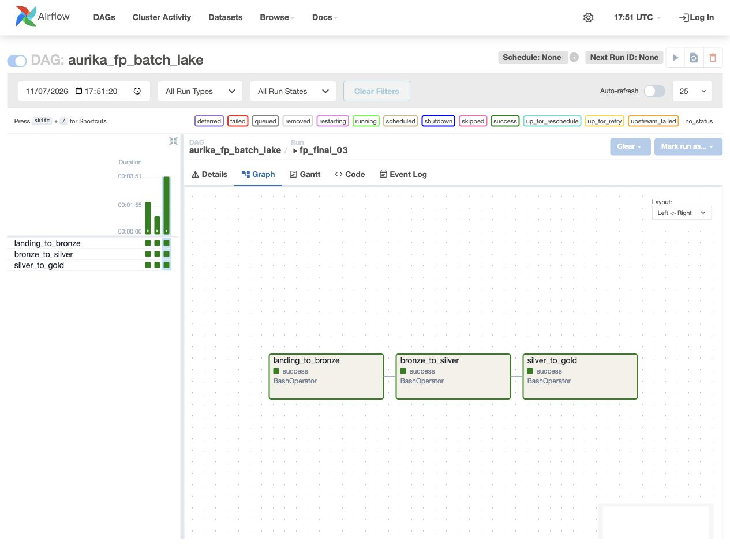
part2_04_dag.jpg | Actual Airflow UI
The independent CSV and Decimal calculation matched every persisted Gold group in all three runs. Streaming keeps raw duplicate events; Silver removes full duplicates, including 15 events with valid measurements. Therefore streaming uses 226,887 event rows and batch uses 226,872. Their means can differ. The number of groups happens to be the same.
Environment: Python 3.12.4, Java 17.0.17, PySpark 4.0.1, Kafka 4.0.2, MySQL 8.4.11 and Airflow 2.11.2 on macOS. SQLite and SequentialExecutor are used for the local exercise. Three focused Spark tests passed. README explains setup, replay limits and the resolved JDBC, numeric-space, Airflow PATH and progress-JSON issues.
Code comments label the required stages. The archive includes code, requirements, README, check results and all six screenshots. It excludes private settings, server data and environments. References and official source links are in README.

