Homework 05 Kafka sensor alerts
Григорова Ауріка Вадимівна
18 October 2026
Two sensor processes sent 24 readings to a local Kafka broker. The processor wrote 14 alerts: 7 temperature and 7 humidity alerts. A separate consumer received all 14. A second complete run on separate topics returned the same totals and values.

1 Create three topics
create_topics.py creates the three topics with the aurika_hryhorova_hw05 suffix. The screenshot shows the real result of admin_client.list_topics(). Each topic has one partition and one replica on this local broker.
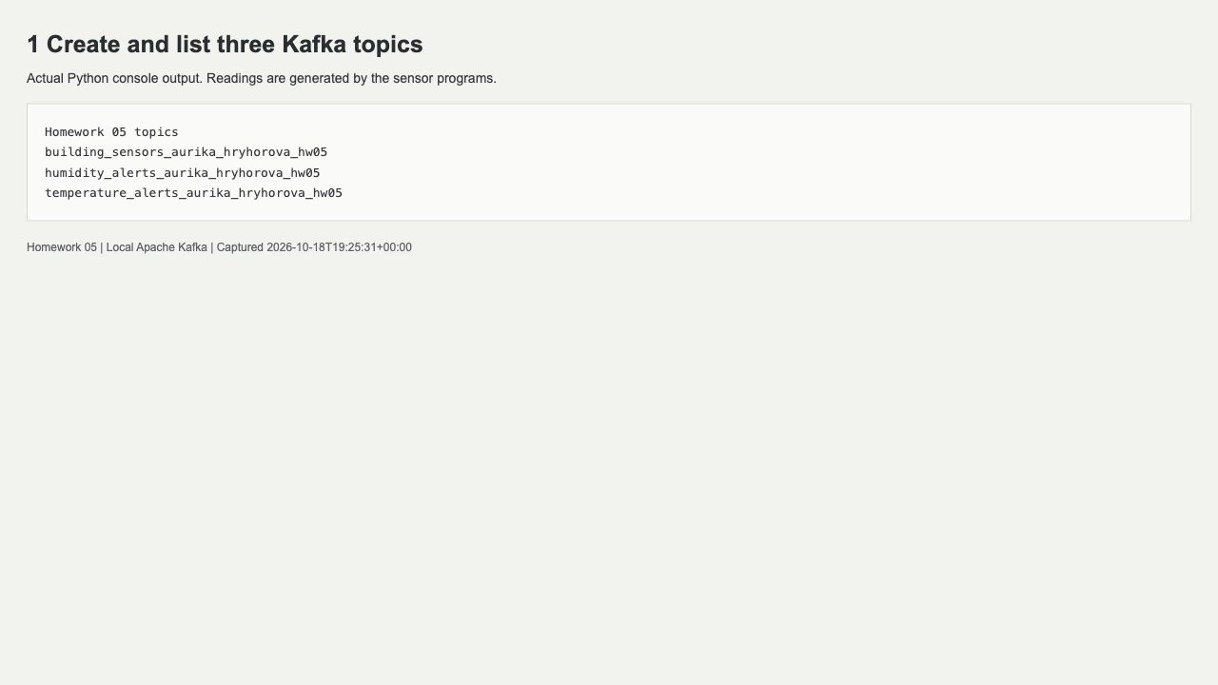
p1_topics.jpg | Actual console output displayed in the local log viewer
Environment: Python 3.12.4, Java 17.0.17, Apache Kafka 4.0.2 and kafka-python 2.2.15. Kafka listens on 127.0.0.1 only. The Apache download checksum was verified.

2 Run two sensors at the same time
Two separate sensor.py processes ran together. PID 13191 used sensor-101 and seed 11. PID 13192 used sensor-202 and seed 22. Each sent 12 readings at two second intervals. The screenshot was taken while both processes were running; their UTC timestamps overlap. Each SENT line confirms a broker acknowledgement.
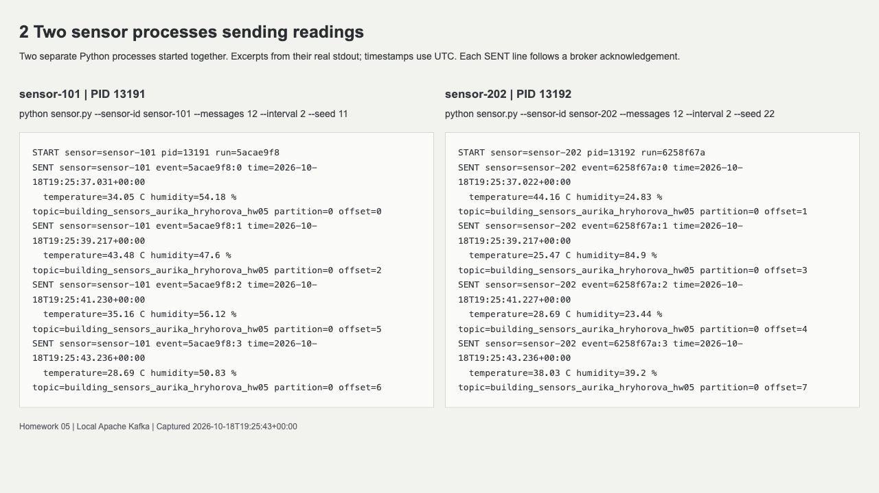
p2_two_sensors.jpg | Actual console output displayed in the local log viewer

3 Receive and filter readings
process_sensors.py reads the sensor topic and checks two independent conditions: temperature > 40 C, and humidity < 20 or humidity > 80 percent. The screenshot shows sensor-101 event 5acae9f8:8 at input offset 17. Its temperature is 44.64 C and humidity is 82.53 percent, so both checks match.
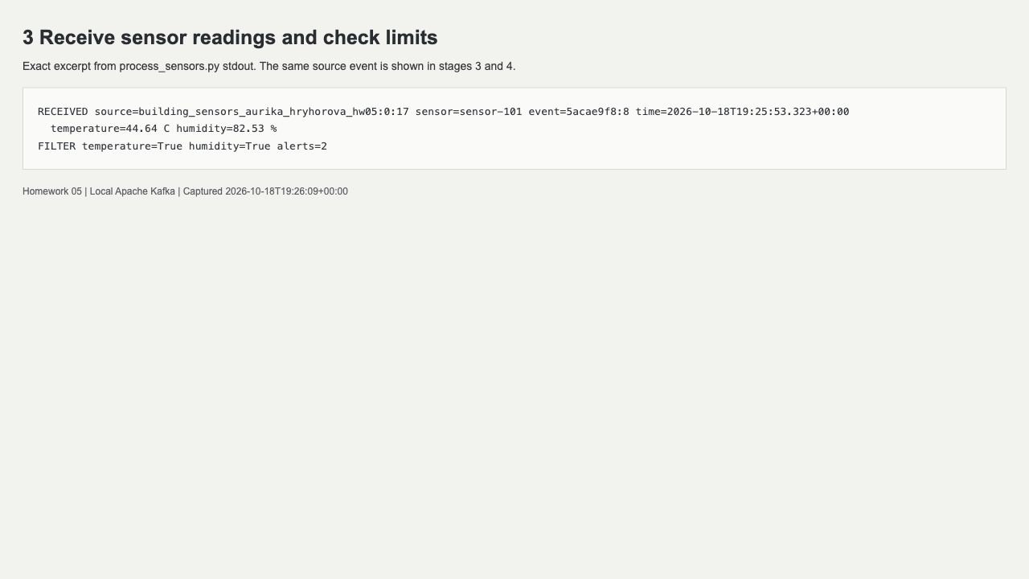
p3_filter.jpg | Actual console output displayed in the local log viewer
Eight boundary cases were checked separately. Exactly 40 C, 20 percent and 80 percent do not trigger their respective alerts. In each full run, 11 readings produced no alert and one reading produced both alerts.

4 Send matching alerts
The same input event created two alerts. Kafka acknowledged the temperature alert at offset 4 in temperature_alerts_aurika_hryhorova_hw05 and the humidity alert at offset 4 in humidity_alerts_aurika_hryhorova_hw05. The processor commits the input offset only after both sends succeed.
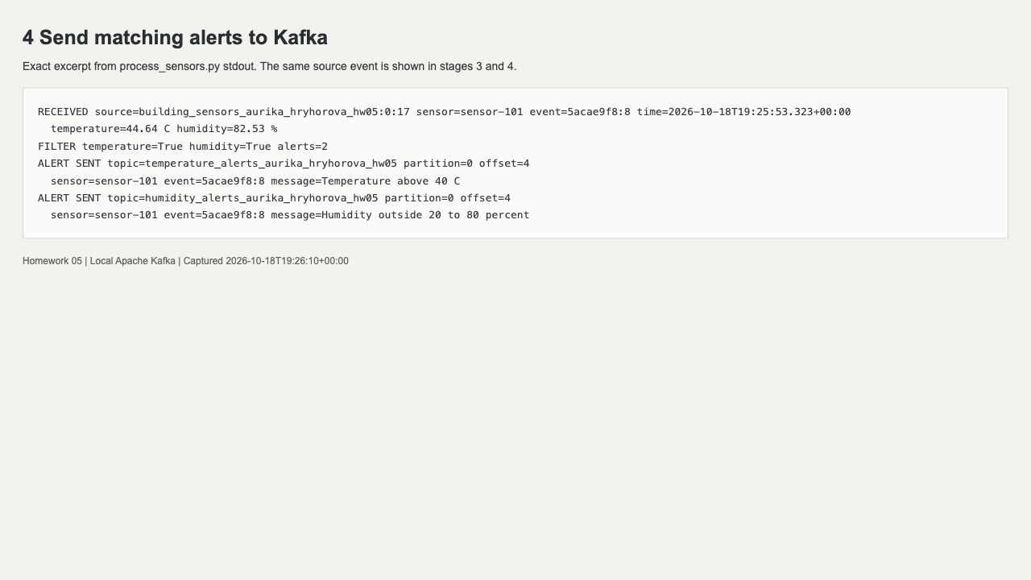
p4_sent_alerts.jpg | Actual console output displayed in the local log viewer

5 Read both alert topics
consume_alerts.py subscribes to both alert topics. The screenshot shows one actual stored warning from each topic and the final count of 14 received alerts. Every alert preserves the sensor ID, original UTC timestamp, temperature and humidity, and adds a warning message and source reference.
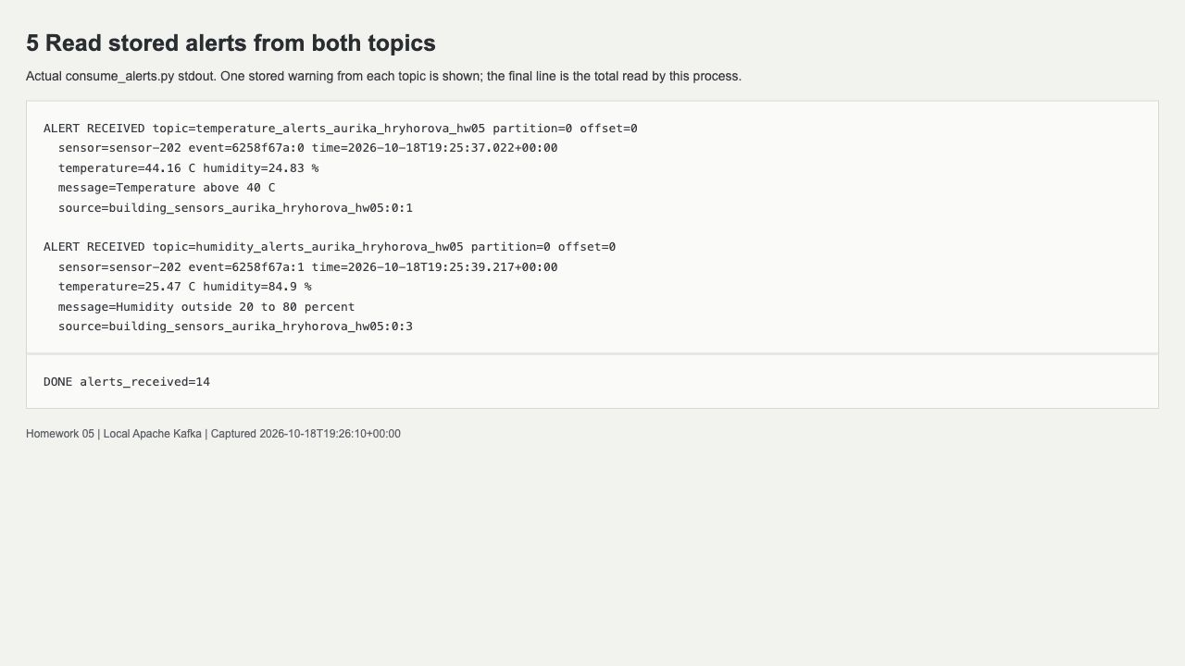
p5_received_alerts.jpg | Actual console output displayed in the local log viewer
Independent consumers read every stored record in both runs. All 24 input readings and all 14 alerts matched an independent calculation. Sensor IDs stayed fixed within each process, values stayed within the required ranges, and no duplicate alerts occurred in these runs.
The pipeline uses at-least-once delivery. A crash between alert delivery and input offset commit can repeat an alert. Crash recovery and broker failover were not tested. Raw logs are kept locally; the screenshots show labelled excerpts without changing the output text.
Sources: Apache Kafka quick start and kafka-python documentation.
https://kafka.apache.org/40/getting-started/quickstart/
https://pypi.org/project/kafka-python/2.2.15/

