User's manual: Spin the bottle with NAO

By: Diego Alejandro Gómez Pardo

Table of contents:

1. Before starting the game
2. Setting up the game
3. Compiling and executing the spin the bottle game
4. Important notes

1. Before starting the game

Before making use of the leg follower robot you have to count with the next content:

I. A NAO robot, which will be the main character in the game. |  | 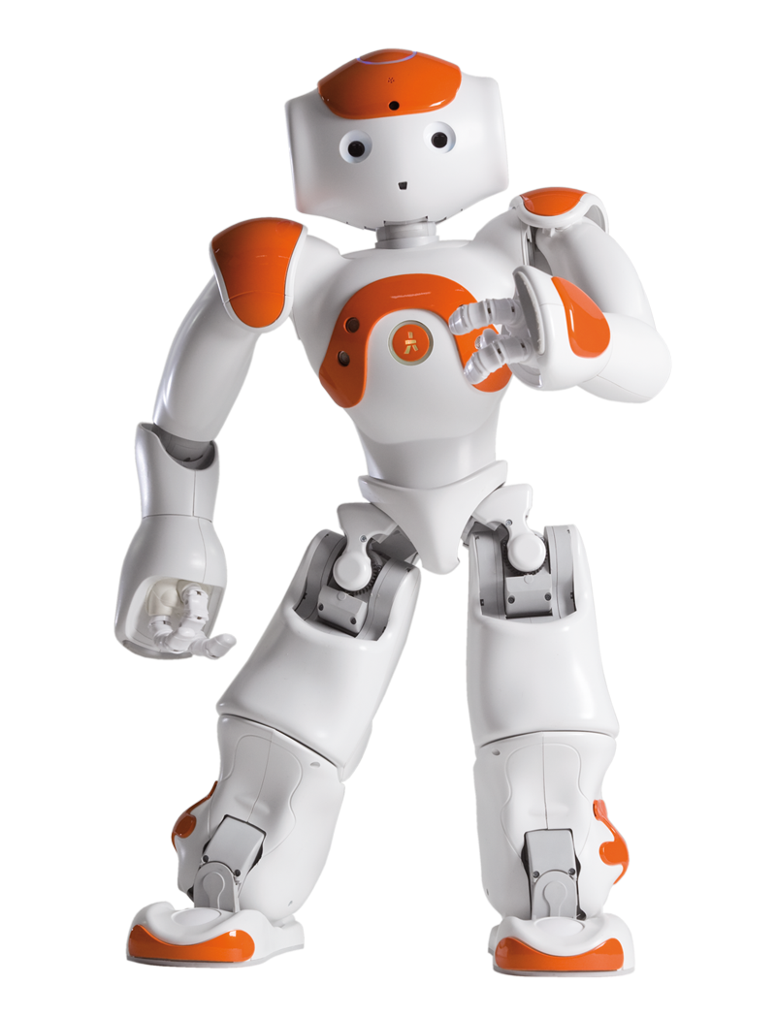 | II. A NAO charger, in case either the robot needs to be charged or the game is played for long time. |  | 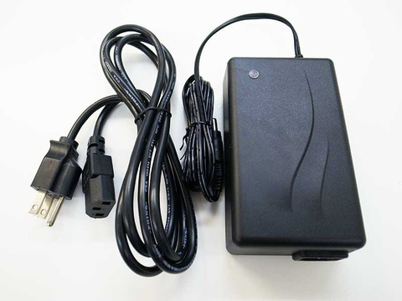
III. A green bottle. It can be a wine, beer or any bottle with a regular shape. It is recommended that this bottle does not have any colored layer on it (if it has, please remove it) |  | 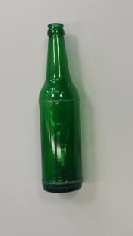 | IV. A big platform like a board and a rough small platform where to spin the bottle (or the default platform which will be shown in the next page in order to guarantee a better playability) |  | 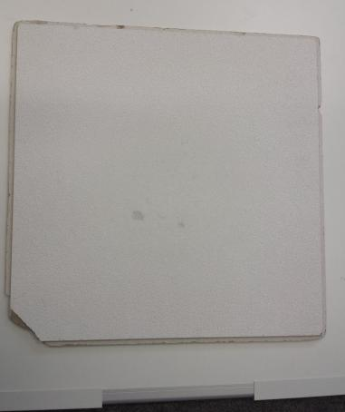
V. A computer with ubuntu 14.04 and ROS Indigo to start the game. |  | 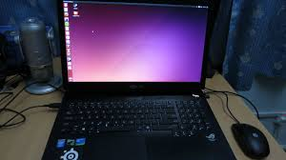 | VI. A group of friends to play with. |  | 

A better platform, more optimized in order to make the game more precise, can be built with a rough material with the following measurements:
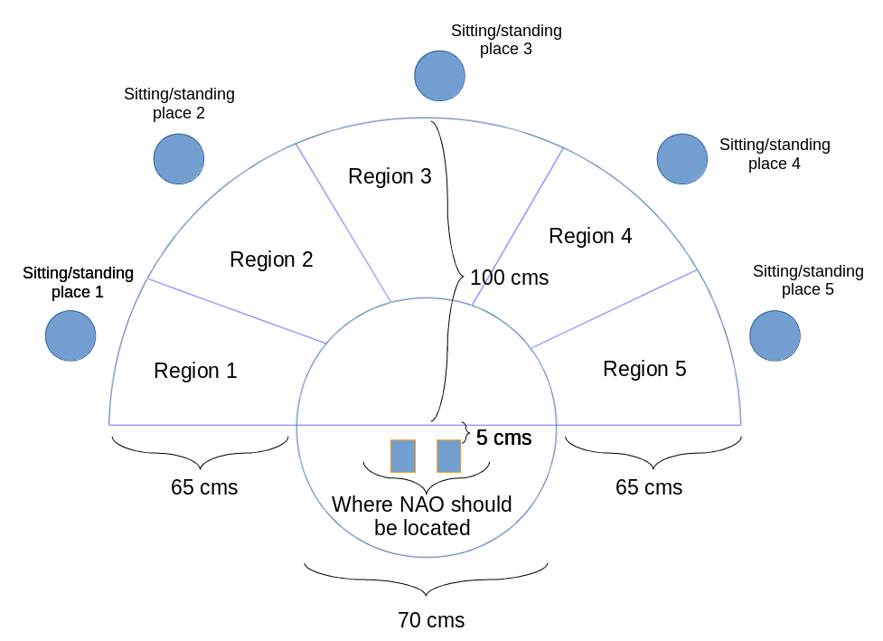
The final result of this will be a platform like this

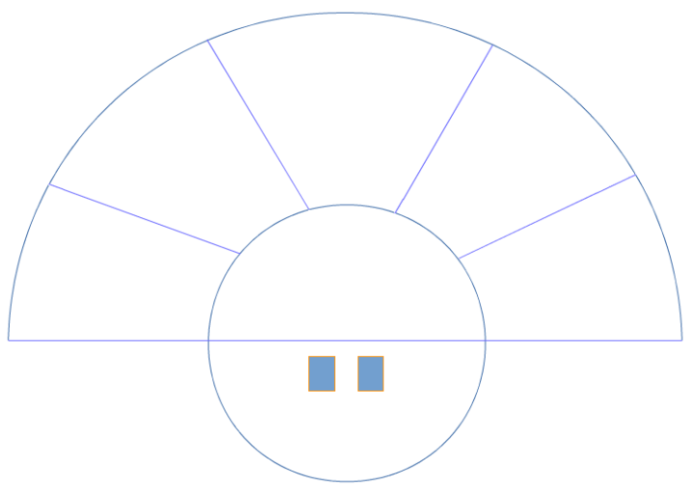
2. Connecting the robot to power and turning it on.

The first thing to do when starting to work with ROS and a robot, you have to connect 4 very important parts with the USB ports expansion: Computer, iRoomba robot and the laser range finder

1. Gently set NAO in a crouching position to ensure stability. Plug the charger to the mains, and plug the charger cable into NAO‘s back. | 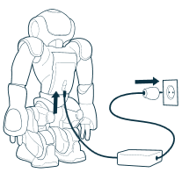
2. Press the Chest button once, The boot process takes approximately one minute. The boot process is completed when NAO says “OGNAK GNOUK” while its Chest button becomes white. | 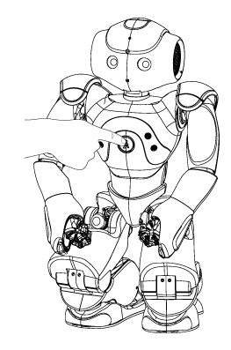
3. Locate NAO in the pre established game platform or 5 centimeters of the big board in the center of it, put also the bottle in the rough part of the platform. | 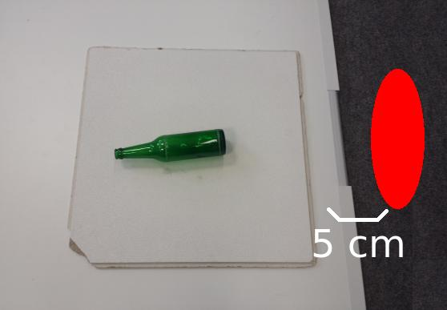
4. Turn your computer ON and ensure that robot as your computer are connected both to the same network in order both can communicate with each other. | 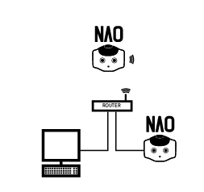

3. Checking the robot program and other important components.

In order to continue with these instructions it is necessary that you have already made the steps explained before (in this third point it is being supposed also that you already have connected and set up your robot and turned your computer on).

In the previous point, the physical part of the robot was checked. Now it's time to check the software part related to the project of the leg follower. In this one there are 2 very important things: The .cpp and .h files which are the files containing the code for the robot, the launch file called launch.xml (inside the robot Baymax in diego/launch.xml) which will send instructions to the robot of publishing topics related to speech, pose control and camera.

In case the program files are not been downloaded, it can be done first creating a ROS workspace, and in the src folder pulling the files from the gitlab webpage with the following link

git pull https://gitlab.ipb.uni-bonn.de/hrl_students/ss15_spin_the_bottle.git

4. Compiling and executing the leg_follower Robot

In order to compile and execute the leg follower robot and supposing that until now, all the software and physical components in order to make the leg follower robot work are available, it is necessary to open the Ubuntu terminal in order to compile and execute the spin the bottle game. There are two ways to open the terminal when you are in Ubuntu:

The first option is looking if the program appears in the desktop left panel. To open it, just click on it.

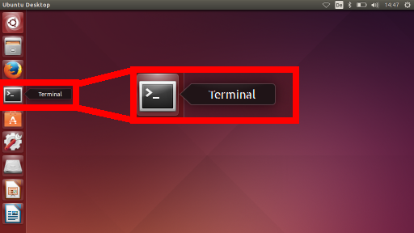

The second option (in case that the console program does not appear in the left panel) is looking for the program in the search option. To do this, on the show applications button (the icon in the top of the left panel) and in the search bar start it is necessary to write (before finishing writing the word, the program will be shown) “terminal”, Ubuntu will show the program as a search result. After clicking on it, the program will be opened.

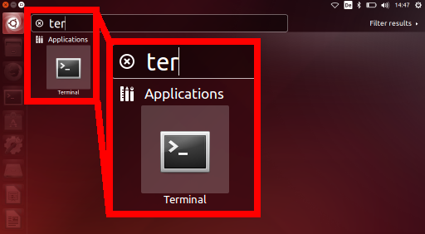

Once the terminal program is open, it is necessary first to compile and source the roomba driver, then the computer program will be compiled, sourced and executed. To proceed with this, it's necessary to start doing the following:

1. When opening the folder ros_worlds which appears in the root of the computer files, write the command cd %your ROSworkspace eg. “Cd Humanoids” (advice: the tab button allows Ubuntu to finish typing where it is wanted to access. This will also help avoiding typos) before pressing the enter button.

2. Now it's necessary to access to the robot itself in order to ask him to publish the topics necessary to run the game of spin the bottle, as example the robot baymax will be used. In order to do this, it is necessary to write the command ssh nao@baymax.local and write the password nao-pass, asked in order to access to the robot console.

3. While being in the robot console it is necessary first to write the command roscore. It is always a must to have a roscore running in order for ROS nodes to communicate.

4. After having activated the roscore, it is time to launch the xml file containing all of the nodes and topics which are wanted to be publishing data. Since a port switch is being used, it is necessary first to change the environment variable ROS_MASTER_URI (eg. export ROS_MASTER_URI=http://baymax.local:11311), and then to write the command roslaunch diego/launch.xml (This is how the configuration baymax is made)

If there is no launch file in the robot, then 3 different rosrun commands in 3 different consoles must be executed (also setting environment once per new console tab/page opened) these commands are:

rosrun naoqi_sensors cameras
rosrun nao_pose pose_controller.py
rosrun nao_speech nao_speech.py

5. after having published the three topics necessary to communicate with the robot, a new console tab/page must be open. Again it is necessary to change the environment variable. After this, it is time to wake NAO up. To do this, the command rosservice call /wakeup. The robot will wake up automatically without the need of doing it through the choreographe program.

6. As a last command, in the same tab/page used before, the command rosrun bottle_recognition subscriber _image_transport:=compressed . This will start the game.

5. Important Notes

It is necessary to run the topic pose_controller.py in the robot in order to allow him to move its joints, otherwise it will not ever be able to point to the person after defining where the bottle moves. When the launch file is executed, this topic is automatically activated.

If there is no bottle, there is no way the game will work. It is also necessary to use a green bottle to start the game since the algorithms of this program are completely focused in that feature in order to work. Probably a dark bottle can work and replace the green bottle, however other bottle colors were not tested.

Try to avoid areas where there is excess of artificial light, NAO has problems to detect the bottle in conditions of extreme artificial light brightness. It is advisable to count with just one source of light such as sunlight or at nights a source of light

Even human eyes have problems to recognize faces when there is a source of light around someone's face and at the same time pointing to oneself. You can test how much can NAO cope with in these situations but there are high probabilities that some or most of the times, a face is not recognized

Check when the stiffness of the robot is too hot, if it is, then make the robot rest for a while and play the game later (in the console, open a new console, set the environment up again and write the command rosservice call /rest). If it is not checked then there are high probabilities that the robot falls on the bottle, causing itself irreparable damages

