Large-Scale Virtual Screening of Enamine 4.6 Millions compounds against Plasmodium Bromodomain PfBDP1
Bakary N’tji Diallo
Le Anh Tuan Nguyen
Laurent Dembélé
Fidèle Ntie-Kang
Abdoulaye Djimde
2026-07-28
Abstract
Malaria control is threatened by the continued emergence of drug-resistant Plasmodium falciparum, creating a need for compounds that act through new parasite targets. P. falciparum bromodomain protein 1 (PfBDP1) regulates genes required for erythrocyte invasion and represents a structurally characterized, parasite-specific target. We performed structure-based virtual screening of 4,671,138 in-stock compounds from the Enamine Screening Collection against the PfBDP1 bromodomain. Docked compounds were prioritized using docking score, physicochemical properties, pan-assay interference alerts, and pose-quality assessment. Five candidates and the co-crystallized ligand I5K were then evaluated using 100-ns molecular dynamics simulations and MM/GBSA endpoint binding-energy estimates. Z985612796 showed the most consistent computational profile, combining low protein and ligand deviations, limited atomic fluctuations, persistent hydrogen bonding, restricted conformational sampling, and a dominant low-energy basin. It also produced the most negative MM/GBSA estimate, −30.70 ± 0.63 kcal/mol, compared with −12.65 ± 0.56 kcal/mol for I5K. Z1723441401 and Z9302730850 also showed favorable calculated interactions but greater conformational heterogeneity. These findings prioritize Z985612796 for further evaluation as a potential PfBDP1-binding candidate. Further experimental binding and functional assays are required to confirm the predicted interaction and determine antimalarial activity.

1. Introduction
Malaria remains a major cause of morbidity and mortality, with the greatest burden concentrated in sub-Saharan Africa (World Health Organization 2025). Plasmodium falciparum, the species responsible for most malaria deaths, has repeatedly evolved resistance to antimalarial drugs, threatening the durability of current treatments (Blasco et al. 2017). Sustained control and eventual elimination therefore require compounds with new mechanisms of action and activity against chemically distinct parasite targets (Burrows et al. 2013, 2017). Target-based discovery can complement phenotypic screening by linking compound selection to a defined parasite protein and by enabling structure-guided optimization of initial hits (Armstrong et al. 2023).
Epigenetic regulation offers a comparatively underexplored source of antimalarial targets. Bromodomains recognize acetylated lysine residues and help translate chromatin modifications into changes in transcription. P. falciparum bromodomain protein 1 (PfBDP1; PF3D7_1033700) is particularly compelling because it is parasite-specific and controls genes required for erythrocyte invasion. Conditional depletion of PfBDP1 disrupts invasion-gene expression, reduces red-blood-cell invasion, and impairs parasite proliferation (Josling et al. 2015). These findings connect PfBDP1 function directly to the pathogenic asexual blood stage and support its investigation as a chemically tractable target.
Recent structural and chemical studies have strengthened this rationale. Small-molecule inhibitors have been shown to bind the PfBDP1 bromodomain with nanomolar affinity, and parasite sensitivity to PfBDP1 perturbation has been confirmed experimentally (Amann et al. 2025). The same study reported the 1.56 Å crystal structure of PfBDP1 bound to the ligand MPM2 (Amann et al. 2024). This high-resolution complex defines an experimentally observed binding site and provides a cognate ligand for validating a molecular-docking protocol. Such structural information makes large-scale virtual screening a practical way to search broad chemical space while prioritizing a manageable set of compounds for experimental testing. Structure-based screening has already yielded candidate inhibitors for other P. falciparum targets (Godara et al. 2024).
Here, we performed a structure-based virtual screen of 4,671,138 in-stock compounds from the Enamine Screening Collection against the PfBDP1 bromodomain. We first assessed whether the docking workflow could recover the crystallographic pose of MPM2, then screened the library using the validated binding site and search settings. Docked compounds were prioritized through score-based ranking, and physicochemical criteria, substructure alerts, and pose-quality checks. This workflow was designed to identify chemically plausible PfBDP1-binding candidates for subsequent molecular-dynamics and free-energy evaluation.

2. Methods

2.1 Study design
We performed a structure-based virtual screen of the Enamine Screening Collection against Plasmodium falciparum bromodomain protein 1 (PfBDP1). The docking workflow comprised ligand and receptor preparation, cognate-ligand redocking, molecular docking, physicochemical filtering, substructure filtering, pose validation, and hit ranking.

2.2 Compound library and ligand preparation
The Enamine Screening Collection archive available on 11 December 2025 contained 4,671,138 in-stock compounds. Beyond its physical availability, this collection was selected for its broad chemical diversity and enrichment in lead-like chemical space (Compound Collections - Enamine, n.d.; Grygorenko 2021). Structures were processed from the supplied SDF archive with RDKit (Landrum et al. 2026). Records that could not be parsed or converted into three-dimensional molecular were excluded.
Explicit hydrogen atoms were added to each retained molecule. Initial three-dimensional conformers were generated with the experimental-torsion knowledge distance-geometry method in RDKit and minimized with the MMFF94 force field. Ligands were then converted to AutoDock PDBQT with Meeko (Santos-Martins et al. 2025). This step assigned AutoDock atom types, partial charges, and rotatable bonds.

2.3 Target preparation
The 1.56 Å X-ray structure of PfBDP1 bound to MPM2 was identified as PDB entry 9HHC. The receptor coordinates were obtained from the PDB-REDO refined structure. The ligand is recorded under chemical component identifier I5K. Chain A was retained as the receptor model. I5K was used as the reference structure for redocking.
PDBFixer was used to replace nonstandard residues, add missing heavy atoms, and add hydrogen atoms at pH 7.4 (Eastman et al. 2017). Crystallographic waters and other heterogens were removed. Hydrogen positions were optimized with Reduce (Laboratory 2026; Word et al. 1999), and the prepared protein was converted to PDBQT with Meeko (Santos-Martins et al. 2025). The receptor was treated as rigid during docking.

2.4 Docking-protocol validation
The protocol was validated by redocking I5K into its crystallographic binding site. The docking box was centered on the geometric center of I5K at (-8.197, 9.886, 17.988) Å and measured 25 × 25 × 25 Å. QuickVina 2.1 was evaluated at exhaustiveness values of 8, 16, 32, 64, 128, and 256 using otherwise identical receptor and box settings (Trott and Olson 2009).
For each setting, nine poses were generated. Heavy-atom root-mean-square deviations (RMSDs) from the crystallographic I5K coordinates were calculated with obrms in Open Babel (O’Boyle et al. 2011). An RMSD below 2.0 Å was defined before analysis as successful recovery of the experimental binding mode. At exhaustiveness 32, the minimum RMSD was 1.019 Å (Supplementary Figure S1), confirming that the search space and docking settings could reproduce the cognate pose. Exhaustiveness 32 was therefore used for the production screen.

2.5 Virtual screening
Prepared Enamine ligands were docked independently against rigid PfBDP1 with QuickVina 2.1 and the AutoDock Vina scoring function (Trott and Olson 2009). The validated center, 25 Å box dimensions, and exhaustiveness of 32 were applied to every compound. Calculations were distributed as single-CPU jobs through the Open Science Pool (OSG 2006). Docking scores were recorded in kcal mol⁻¹, and the lowest-scoring pose of each successfully processed compound was retained for post-docking analysis.

2.6 Post-docking filtering and hit selection
The resulting protein-ligand complexes were evaluated with PoseBusters 0.3.7 to identify chemically or geometrically implausible poses (Buttenschoen et al. 2024). Only compounds with no failed PoseBusters tests were accepted. Passing structures were ranked by docking score. The five highest-priority compounds were selected for subsequent molecular-dynamics simulation and endpoint free-energy calculations.

2.7 In silico ADMET profiling
The five candidates and I5K were profiled from their SMILES strings with ADMET-AI (Swanson et al. 2024). We examined physicochemical descriptors, intestinal absorption and permeability, bioavailability, solubility, P-glycoprotein, cytochrome P450 interactions, AMES mutagenicity, clinical toxicity, drug-induced liver injury (DILI), and hERG inhibition. Molecular weight, lipophilicity, hydrogen bonding, and polar surface area were interpreted as early oral-drug-likeness indicators (Lipinski et al. 1997). Classification outputs were treated as estimated probabilities of the positive dataset label, not experimental measurements. No probability threshold was used to accept or reject compounds. Profiles instead supported qualitative, multi-parameter prioritization aligned with antimalarial target candidate profiles (Burrows et al. 2017; Armstrong et al. 2023).

2.8 Molecular dynamics and MM/GBSA analysis

2.8.1 Molecular dynamics simulations
The protein–ligand complexes obtained from molecular docking were subjected to molecular dynamics (MD) simulations using GROMACS version 2025.1 with the CHARMM36 additive force field (Abraham et al. 2015; Huang and MacKerell 2013). The simulation protocol was consistent with that employed in our previous computational studies (Ahmed et al. 2026; “Application of Bioactive Molecular Networking to Identify Corneal-Cytoprotective Compounds from Dialium Cochinchinense Pierre. Leaves” 2025). Ligand topologies and force-field parameters were generated using the SwissParam server to ensure compatibility with the CHARMM force field (SwissParam, n.d.). Each complex was placed in a triclinic simulation box with a minimum distance of 1.2 nm between the protein surface and the box boundary and solvated using the TIP3P water model. The systems were neutralized and supplemented with 0.15 M NaCl to mimic physiological ionic strength.
Prior to equilibration, each system underwent energy minimization using the steepest descent algorithm for a maximum of 50,000 steps or until the maximum force converged below 1000 kJ mol⁻¹ nm⁻¹. Long-range electrostatic interactions were calculated using the Particle Mesh Ewald (PME) method with a real-space cutoff of 1.2 nm, whereas van der Waals interactions were treated using a force-switch scheme with a switching distance of 1.0 nm and a cutoff of 1.2 nm (Darden et al. 1993). Periodic boundary conditions were applied in all three spatial dimensions.
Following minimization, the systems were equilibrated in two consecutive phases under positional restraints applied to both the protein and ligand. The first equilibration consisted of a 100 ps NVT ensemble, during which the temperature was maintained at 300 K using the V-rescale thermostat with a coupling constant of 0.1 ps. This was followed by a 100 ps NPT equilibration at 300 K and 1 bar, employing the V-rescale thermostat and the C-rescale barostat with an isotropic pressure coupling constant of 2.0 ps (Bussi et al. 2007). Hydrogen-containing bonds were constrained using the LINCS algorithm, allowing a 2 fs integration time step throughout the equilibration stages (Hess et al. 1997).
After equilibration, an unrestrained 100 ns production MD simulation was performed in the NPT ensemble using the same integration time step. Temperature was maintained at 300 K using the V-rescale thermostat, while pressure was controlled at 1 bar using the Parrinello–Rahman barostat with isotropic coupling (Bussi et al. 2007; Parrinello and Rahman 1981). Coordinates and energies were saved every 10 ps, yielding trajectories for subsequent structural and energetic analyses.

2.8.2 Trajectory analysis
Trajectory analyses were performed using the standard built-in GROMACS analysis tools. The structural stability and conformational behavior of each protein–ligand complex were evaluated by calculating the root-mean-square deviation (RMSD), root-mean-square fluctuation (RMSF), radius of gyration (Rg), solvent-accessible surface area (SASA), and intermolecular hydrogen bonds throughout the simulation. Principal component analysis (PCA) was carried out based on the covariance matrix of Cα atomic fluctuations after removal of overall translational and rotational motions. The first two principal components (PC1 and PC2) were subsequently used to construct the projected free-energy landscape (FEL), enabling characterization of the dominant conformational basins sampled during the simulations.

2.8.3 MM/GBSA calculations
The endpoint binding-energy estimates of the protein–ligand complexes were calculated using the gmx_MMPBSA package with the MM/GBSA approach (Valdés-Tresanco et al. 2021). The total MM/GBSA binding-energy estimate (ΔG_MM/GBSA) was calculated as the sum of van der Waals, electrostatic, polar solvation, and nonpolar solvation energy contributions according to the MM/GBSA formalism:
$$ΔG_{MM/GBSA}=ΔG_{gas}+ΔG_{solv}$$
where:
$$ΔG_{gas}=ΔE_{VDW}+ΔE_{ELE}$$
$$ΔG_{solv}=ΔE_{GB}+ΔE_{SURF}$$
ΔEVDW: van der Waals energy contribution
ΔEELE: electrostatic energy
ΔEGB: polar solvation energy
ΔESURF: non-polar solvation energy (Valdés-Tresanco et al. 2021).

3. Results and Discussion

3.1 Selected candidate structures
The five Enamine candidates selected after docking and pose-quality filtering represented structurally diverse chemotypes, whereas I5K served as the crystallographic reference (Figure 1). The candidates differed in molecular size, ring architecture, heteroatom content, substitution patterns, and stereochemical complexity. Z1723441401 and Z31277728 contain several carbonyl and heterocyclic features, while Z9033488415 and Z985612796 include extended aromatic systems. Z9302730850 combines fused heterocycles with a chlorophenyl substituent. I5K is smaller and less structurally elaborate than the screened candidates. This diversity enabled comparison of chemically distinct ligands during molecular dynamics, MM/GBSA estimation, and in silico ADMET profiling against the PfBDP1 bromodomain target in subsequent comparative analyses.
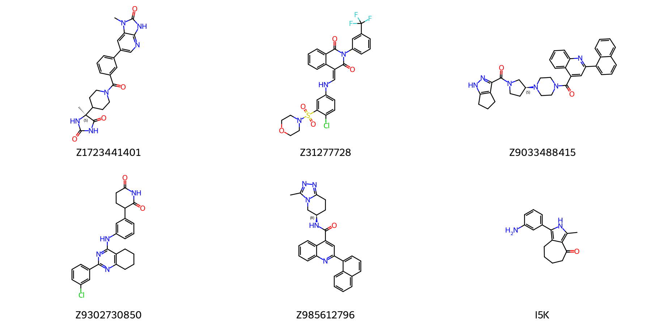
Figure 1: Chemical structures of the five selected Enamine candidates and the co-crystallized reference ligand I5K.

3.2 Molecular dynamics and MM/GBSA analysis

3.2.1 Structural stability and intermolecular interactions
Molecular dynamics simulations were performed to evaluate five candidate compounds in complex with the bromodomain of Plasmodium falciparum bromodomain protein 1, using the co-crystallized ligand I5K as a reference. Each trajectory was propagated for 100 ns and contained 10,001 frames sampled at 10-ps intervals. Unless otherwise stated, time-averaged parameters were calculated over the 20–100 ns interval to minimize the influence of initial structural relaxation.
The I5K-bound complex maintained a mean protein backbone RMSD of 0.152 ± 0.025 nm. Mean protein RMSD values were 0.145 ± 0.021 nm for Z9033488415, 0.168 ± 0.027 nm for Z985612796, 0.213 ± 0.078 nm for Z1723441401, 0.433 ± 0.074 nm for Z31277728, and 0.403 ± 0.067 nm for Z9302730850. The radius of gyration remained within 1.635–1.672 nm across all systems.
I5K exhibited the lowest ligand RMSD at 0.071 ± 0.026 nm, followed by Z985612796, Z9302730850, and Z1723441401 at 0.109 ± 0.013, 0.121 ± 0.009, and 0.128 ± 0.039 nm, respectively. Z31277728 displayed a ligand RMSD of 0.150 ± 0.025 nm. Z9033488415 had the highest ligand RMSD at 0.286 ± 0.014 nm despite its low protein backbone RMSD.
The Z985612796 complex had mean protein and ligand RMSF values of 0.131 ± 0.079 and 0.054 ± 0.030 nm, respectively. Z9302730850 showed the lowest ligand RMSF among the investigated compounds at 0.039 ± 0.018 nm and a protein RMSF of 0.177 ± 0.186 nm. Z9033488415 combined the lowest protein RMSF with the highest ligand RMSF.
Mean Rg values varied by less than 0.04 nm across the systems, while mean SASA values remained between 87.18 and 89.21 nm². Z9302730850 displayed the largest fluctuations in both Rg and SASA. Z985612796 showed small Rg and SASA standard deviations.
The MD-derived descriptors differentiated receptor stability from ligand retention. The narrow radius of gyration range across all systems indicates that the increased protein RMSD observed for the Z31277728 and Z9302730850 bound systems was not associated with global unfolding. These deviations are more consistent with system-dependent conformational rearrangements of the PfBDP1 bromodomain.
Z1723441401 formed the highest mean number of hydrogen bonds at 2.34 ± 1.64. Z985612796 formed 2.17 ± 1.17 hydrogen bonds and retained at least one hydrogen bond in 87.4% of analyzed frames. Z9302730850 averaged 1.93 ± 1.53 hydrogen bonds. I5K and Z31277728 formed fewer persistent hydrogen bonds. Z9033488415 averaged 0.20 ± 0.44 hydrogen bonds and lacked hydrogen bonds in approximately 82% of frames.
Z9033488415 showed a stable protein backbone but the highest ligand RMSD and ligand RMSF, together with limited hydrogen-bond retention. This combination suggests substantial ligand reorientation within the binding pocket. Z9302730850 instead combined the lowest ligand RMSF with greater protein flexibility and larger Rg and SASA fluctuations. Z985612796 combined low protein and ligand deviations, limited fluctuations, stable compactness, and persistent hydrogen bonds, giving it the most consistent stability profile.
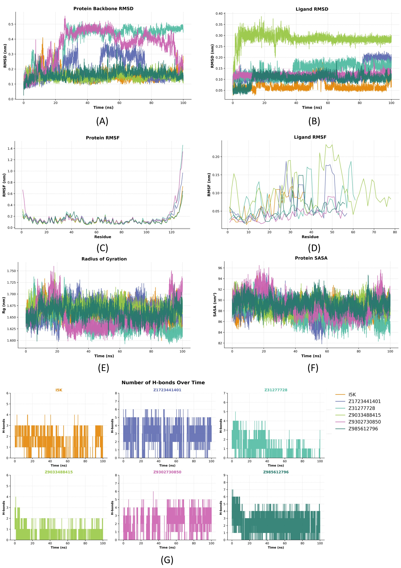
Figure 2: Structural stability, conformational flexibility, and intermolecular interactions of the PfBDP1–ligand complexes during 100 ns molecular dynamics simulations. (A) Protein backbone RMSD. (B) Ligand RMSD. (C) RMSF of PfBDP1. (D) Atom-wise RMSF of the bound ligands. (E) Radius of gyration (Rg). (F) Solvent-accessible surface area (SASA). (G) Number of intermolecular hydrogen bonds between PfBDP1 and the investigated ligands throughout the simulations.

3.2.2 Conformational sampling
Principal component analysis showed that I5K, Z9033488415, and Z985612796 occupied comparatively restricted regions of the plotted conformational space. Z1723441401 sampled a broader ensemble, while Z31277728 and Z9302730850 exhibited the largest dispersion along the principal components.
The free-energy landscapes showed a principal low-energy basin for I5K and Z985612796, although the I5K basin was broader and contained closely related subminima. Z1723441401 populated two major low-energy regions, Z31277728 sampled two well-separated basins, and Z9302730850 displayed at least three distinct low-energy minima. Z9033488415 occupied a relatively concentrated basin.
The concentrated Z9033488415 PCA/FEL basin may represent an alternative binding pose rather than retention of the initial docked orientation. Z9302730850’s relatively rigid ligand was accompanied by broader receptor motions and heterogeneous conformational sampling. Z31277728 also showed substantial protein rearrangement and two well-separated conformational basins. Z1723441401 formed the largest mean hydrogen-bond network, but its two main low-energy regions indicate greater ensemble heterogeneity than observed for Z985612796.
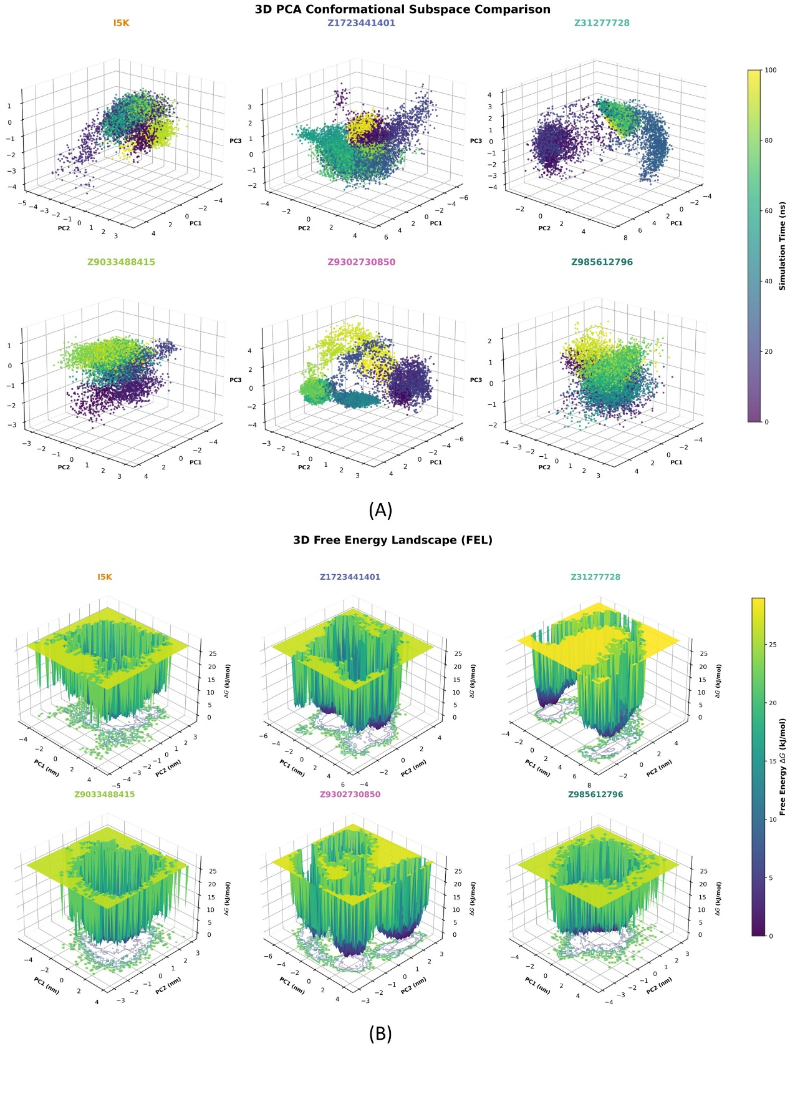
Figure 3: Conformational sampling and free-energy landscapes of the PfBDP1–ligand complexes during 100 ns molecular dynamics simulations. (A) Three-dimensional principal component analysis (PCA) illustrating the conformational space sampled by each PfBDP1–ligand complex along the first three principal components (PC1, PC2, and PC3). (B) Three-dimensional free-energy landscapes (FELs) constructed from the principal components, highlighting the lower projected free-energy states sampled during the simulations.

3.2.3 MM/GBSA binding-energy estimates
Table 1. MM/GBSA energy components of the PfBDP1–ligand complexes.
Ligand | ΔEVDW | ΔEELE | ΔEGB | ΔESURF | ΔGGAS | ΔGSOLV | ΔGMM/GBSA
I5K | -14.59 ± 0.64 | -9.94 ± 0.45 | 14.10 ± 0.60 | -2.22 ± 0.10 | -24.53 ± 1.06 | 11.88 ± 0.51 | -12.65 ± 0.56
Z1723441401 | -31.59 ± 1.11 | -16.02 ± 0.62 | 26.67 ± 0.96 | -4.00 ± 0.14 | -47.60 ± 1.70 | 22.67 ± 0.82 | -24.93 ± 0.89
Z31277728 | -34.49 ± 1.37 | -10.35 ± 0.51 | 27.15 ± 1.11 | -4.44 ± 0.18 | -44.84 ± 1.83 | 22.70 ± 0.94 | -22.13 ± 0.90
Z9033488415 | -28.96 ± 1.26 | 12.85 ± 0.84 | 4.86 ± 1.46 | -3.59 ± 0.16 | -16.11 ± 1.92 | 1.27 ± 1.32 | -14.85 ± 0.66
Z9302730850 | -28.75 ± 1.21 | -18.63 ± 0.81 | 27.43 ± 1.15 | -3.64 ± 0.15 | -47.37 ± 1.99 | 23.79 ± 1.00 | -23.58 ± 1.00
Z985612796 | -40.68 ± 0.81 | -18.35 ± 0.42 | 33.48 ± 0.68 | -5.15 ± 0.10 | -59.03 ± 1.19 | 28.33 ± 0.58 | -30.70 ± 0.63
Unit: kcal/mol.
Z985612796 had the most negative endpoint binding-energy estimate at −30.70 ± 0.63 kcal/mol, compared with −12.65 ± 0.56 kcal/mol for I5K. Z1723441401, Z9302730850, and Z31277728 yielded estimates of −24.93 ± 0.89, −23.58 ± 1.00, and −22.13 ± 0.90 kcal/mol, respectively. Z9033488415 yielded an estimate of −14.85 ± 0.66 kcal/mol.
For Z985612796, the van der Waals and electrostatic contributions were −40.68 and −18.35 kcal/mol, respectively, while the generalized Born polar solvation contribution was 33.48 kcal/mol. Z9033488415 had an electrostatic contribution of +12.85 kcal/mol.
The unfavorable electrostatic component for Z9033488415 suggests that its endpoint estimate was governed mainly by nonpolar contacts. Z31277728 retained a negative endpoint estimate despite its substantial protein rearrangement, while Z1723441401 combined a negative estimate with the largest mean hydrogen-bond network.
The favorable estimate for Z985612796 was driven primarily by its strong van der Waals contribution together with favorable electrostatic interactions. Although these contributions were partly offset by the generalized Born polar solvation penalty, its total endpoint estimate remained more negative than that of I5K under the present model. Across the single-trajectory descriptors, Z985612796 therefore showed the most consistent binding profile. These values should be interpreted as model-dependent endpoint energy estimates rather than experimental binding free energies.

3.3 Predicted physicochemical and ADMET profiles
All six compounds depicted in Figure 1 produced complete ADMET-AI profiles. Z1723441401 had molecular weight 448.5 Da, logP 1.38, QED 0.522, and polar surface area 129.2 Å². It combined high predicted intestinal absorption (0.988), moderate bioavailability (0.706), and low P-glycoprotein (0.228) and CYP-inhibition probabilities (0.007–0.166). Its main predicted liabilities were DILI (0.850), ClinTox (0.582), and borderline hERG inhibition (0.495).
Z9302730850 had molecular weight 446.9 Da and the highest candidate QED (0.554), but logP was 4.94. Predicted bioavailability was 0.885, whereas P-glycoprotein, DILI, and hERG probabilities were 0.865, 0.949, and 0.700, respectively. CYP-inhibition probabilities ranged from 0.092 to 0.671.
Z31277728 and Z9033488415 had molecular weights of 592.0 and 570.7 Da, logP values near 5, and QED values of 0.331. Both showed high DILI, hERG, P-glycoprotein, and multi-CYP probabilities. Z9033488415 had the strongest hERG (0.976), P-glycoprotein (0.969), and CYP3A4 (0.929) signals. Z985612796 was smaller (433.5 Da) but retained high DILI (0.935), hERG (0.795), and P-glycoprotein (0.952) probabilities; its AMES probability was 0.644.
I5K had the most favorable molecular weight (254.3 Da), QED (0.604), and predicted solubility (logS −3.34). However, its AMES probability was 0.726, and CYP1A2, CYP2C19, CYP2C9, and CYP3A4 probabilities were 0.647–0.995. Thus, I5K served as a binding reference rather than a safety benchmark. Across the predicted profile, Z1723441401 provided the most balanced candidate starting point, followed by Z9302730850. All candidates retained liabilities requiring experimental confirmation.
The binding and developability assessments therefore produced different rankings. Z985612796 led the MD/MM/GBSA assessment but retained several predicted safety and transport liabilities. Z1723441401 had a less favorable endpoint binding-energy estimate but the most balanced overall ADMET profile. These complementary criteria support prioritizing both compounds for experimental testing rather than selecting a candidate from binding-energy estimates alone.

3.4 Study limitations and next steps
The analysis used one trajectory per complex, so the reported variation describes frames within individual trajectories rather than uncertainty between independent simulations. The 20–100 ns analysis window also requires stationarity and window-sensitivity assessment because several traces show later transitions. RMSF positions could not be assigned to PfBDP1 residues, and the PCA/FEL analysis requires a common basis, explained variance, and convergence assessment before quantitative comparison.
Ligand parameter quality, simulation settings, MM/GBSA inputs, frame selection, dielectric parameters, and treatment of entropy must also be reported and validated. Independent MD replicas, convergence-aware uncertainty estimates, and experimental binding or functional assays are required before concluding that Z985612796 binds PfBDP1 more strongly than I5K or the other candidates.
Abraham, Mark James, Teemu Murtola, Roland Schulz, et al. 2015. “GROMACS: High Performance Molecular Simulations Through Multi-Level Parallelism from Laptops to Supercomputers.” SoftwareX 1–2 (September): 19–25. https://doi.org/10.1016/j.softx.2015.06.001.
Ahmed, Famim, Farjana Khatun, Le-Anh-Tuan Nguyen, et al. 2026. “Chemico-Pharmacological and Computational Evaluation of Artocarpus Chaplasha; Comparative Anthelmintic and Cytotoxic Potential Between Bark and Seed.” Veterinary Parasitology 343 (April): 110725. https://doi.org/10.1016/j.vetpar.2026.110725.
Amann, Marius, Robin Warstat, Kay Kristin Rechten, et al. 2025. “A Novel Inhibitor Against the Bromodomain Protein 1 of the Malaria Pathogen Plasmodium Falciparum.” ChemMedChem 20 (11): e202500024. https://doi.org/10.1002/cmdc.202500024.
Amann, M., M. Huegle, O. Einsle, and S. Guenther. 2024. Crystal Structure of the Plasmodium Falciparum Bromodomain PfBDP1 in Complex with MPM2. Worldwide Protein Data Bank. https://doi.org/10.2210/pdb9hhc/pdb.
“Application of Bioactive Molecular Networking to Identify Corneal-Cytoprotective Compounds from Dialium Cochinchinense Pierre. Leaves.” 2025. Current Plant Biology 42 (June): 100489. https://doi.org/10.1016/j.cpb.2025.100489.
Armstrong, Jane F., Brice Campo, Stephen P. H. Alexander, et al. 2023. “Advances in Malaria Pharmacology and the Online Guide to MALARIA PHARMACOLOGY: IUPHAR Review 38.” British Journal of Pharmacology 180 (15): 1899–929. https://doi.org/10.1111/bph.16144.
Blasco, Benjamin, Didier Leroy, and David A Fidock. 2017. “Antimalarial Drug Resistance: Linking Plasmodium Falciparum Parasite Biology to the Clinic.” Nature Medicine 23 (8): 917–28.
Burrows, Jeremy N., Stephan Duparc, Winston E. Gutteridge, et al. 2017. “New Developments in Anti-Malarial Target Candidate and Product Profiles.” Malaria Journal 16 (1): 26. https://doi.org/10.1186/s12936-016-1675-x.
Burrows, Jeremy N., Rob Hooft van Huijsduijnen, Jörg J. Möhrle, Claude Oeuvray, and Timothy NC Wells. 2013. “Designing the Next Generation of Medicines for Malaria Control and Eradication.” Malaria Journal 12 (1): 187. https://doi.org/10.1186/1475-2875-12-187.
Bussi, Giovanni, Davide Donadio, and Michele Parrinello. 2007. “Canonical Sampling Through Velocity Rescaling.” The Journal of Chemical Physics 126 (1): 014101. https://doi.org/10.1063/1.2408420.
Buttenschoen, Martin, Garrett M Morris, and Charlotte M Deane. 2024. “PoseBusters: AI-Based Docking Methods Fail to Generate Physically Valid Poses or Generalise to Novel Sequences.” Chemical Science 15 (9): 3130–39.
Compound Collections - Enamine. n.d. https://enamine.net/compound-collections.
Darden, Tom, Darrin York, and Lee Pedersen. 1993. “Particle Mesh Ewald: An N$⋅$log(N) Method for Ewald Sums in Large Systems.” The Journal of Chemical Physics 98 (12): 10089–92. https://doi.org/10.1063/1.464397.
Eastman, Peter, Jason Swails, John D. Chodera, et al. 2017. “OpenMM 7: Rapid Development of High Performance Algorithms for Molecular Dynamics.” PLOS Computational Biology 13 (7): e1005659. https://doi.org/10.1371/journal.pcbi.1005659.
Godara, Priya, K. Sony Reddy, Welka Sahu, et al. 2024. “Structure-Based Virtual Screening Against Multiple Plasmodium falciparum Kinases Reveals Antimalarial Compounds.” Molecular Diversity 28 (6): 3661–81. https://doi.org/10.1007/s11030-023-10770-z.
Grygorenko, Oleksandr O. 2021. “Enamine Ltd.: The Science and Business of Organic Chemistry and Beyond.” European Journal of Organic Chemistry 2021 (47): 6474–77. https://doi.org/10.1002/ejoc.202101210.
Hess, Berk, Henk Bekker, Herman J. C. Berendsen, and Johannes G. E. M. Fraaije. 1997. “LINCS: A Linear Constraint Solver for Molecular Simulations.” Journal of Computational Chemistry 18 (12): 1463–72. https://doi.org/10.1002/(SICI)1096-987X(199709)18:12<1463::AID-JCC4>3.0.CO;2-H.
Huang, Jing, and Alexander D. MacKerell. 2013. “CHARMM36 All-Atom Additive Protein Force Field: Validation Based on Comparison to NMR Data.” Journal of Computational Chemistry 34 (25): 2135–45. https://doi.org/10.1002/jcc.23354.
Josling, Gabrielle A., Michaela Petter, Sophie C. Oehring, et al. 2015. “A Plasmodium Falciparum Bromodomain Protein Regulates Invasion Gene Expression.” Cell Host & Microbe 17 (6): 741–51. https://doi.org/10.1016/j.chom.2015.05.009.
Laboratory, Richardson. 2026. Rlabduke/Reduce. https://github.com/rlabduke/reduce.
Landrum, Greg, Paolo Tosco, Brian Kelley, et al. 2026. Rdkit/Rdkit: 2025_09_6 (Q3 2025) Release. V. Release_2025_09_6. Zenodo, released February 27. https://doi.org/10.5281/ZENODO.18797641.
Lipinski, Christopher A, Franco Lombardo, Beryl W Dominy, and Paul J Feeney. 1997. “Experimental and Computational Approaches to Estimate Solubility and Permeability in Drug Discovery and Development Settings.” Advanced Drug Delivery Reviews 23 (1-3): 3–25.
O’Boyle, Noel M, Michael Banck, Craig A James, Chris Morley, Tim Vandermeersch, and Geoffrey R Hutchison. 2011. “Open Babel: An Open Chemical Toolbox.” Journal of Cheminformatics 3 (1). https://doi.org/10.1186/1758-2946-3-33.
OSG. 2006. OSPool. https://doi.org/10.21231/906P-4D78.
Parrinello, M., and A. Rahman. 1981. “Polymorphic Transitions in Single Crystals: A New Molecular Dynamics Method.” Journal of Applied Physics 52 (12): 7182–90. https://doi.org/10.1063/1.328693.
Santos-Martins, Diogo, Yiran He, Jerome Eberhardt, et al. 2025. “Meeko: Molecule Parametrization and Software Interoperability for Docking and Beyond.” Journal of Chemical Information and Modeling 65 (24): 13045–50. https://doi.org/10.1021/acs.jcim.5c02271.
Swanson, Kyle, Parker Walther, Jeremy Leitz, et al. 2024. “ADMET-AI: A Machine Learning ADMET Platform for Evaluation of Large-Scale Chemical Libraries.” Bioinformatics 40 (7): btae416. https://doi.org/10.1093/bioinformatics/btae416.
SwissParam: A Fast Force Field Generation Tool for Small Organic Molecules - Zoete - 2011 - Journal of Computational Chemistry - Wiley Online Library. n.d. Https://onlinelibrary.wiley.com/doi/abs/10.1002/jcc.21816.
Trott, Oleg, and Arthur J. Olson. 2009. “AutoDock Vina: Improving the Speed and Accuracy of Docking with a New Scoring Function, Efficient Optimization, and Multithreading.” Journal of Computational Chemistry 31 (2): 455–61. https://doi.org/10.1002/jcc.21334.
Valdés-Tresanco, Mario, Mario Valdés-Tresanco, Pedro Valiente, and Ernesto Moreno Frias. 2021. “Gmx_MMPBSA: A New Tool to Perform End-State Free Energy Calculations with GROMACS.” Journal of Chemical Theory and Computation 17 (September). https://doi.org/10.1021/acs.jctc.1c00645.
Word, J.Michael, Simon C. Lovell, Jane S. Richardson, and David C. Richardson. 1999. “Asparagine and Glutamine: Using Hydrogen Atom Contacts in the Choice of Side-Chain Amide Orientation 1 1Edited by j. Thornton.” Journal of Molecular Biology 285 (4): 1735–47. https://doi.org/10.1006/jmbi.1998.2401.
World Health Organization. 2025. Malaria. https://www.who.int/news-room/fact-sheets/detail/malaria.

