**Instructions for creating a REDCap Report to query eligible participants and verify a minimum set of data elements.**

The evaluation questionnaire was designed to address the study objectives while minimizing the time burden on participants and site staff. However, in recognizing that not all participant-reported data elements will be complete, we have identified a minimum set of data elements for a survey to be considered “complete” for reporting purposes (see table below). We provide instructions below for how to create a report in REDCap to track this minimum set of data elements in your instance of REDCap for your internal use.

Sites may use a larger set of data elements to classify participants’ records as complete for incentive purposes, but we request that you use the results of this report to identify “complete” cases and controls in bi-weekly reports. We also request that sites submit all data, regardless of “complete” status for minimum reporting.

1. Select ‘Data Exports, Reports, and Stats’ under the ‘Applications’ menu, and create a new report.

|  |  |  |
| --- | --- | --- |
|  |  |  |

1. Name the report as you see fit. We have provided a suggestion below.

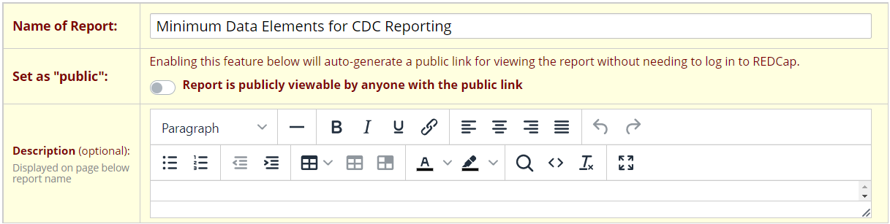

0

1. In STEP 1, you can choose to limit who can view and edit the report.

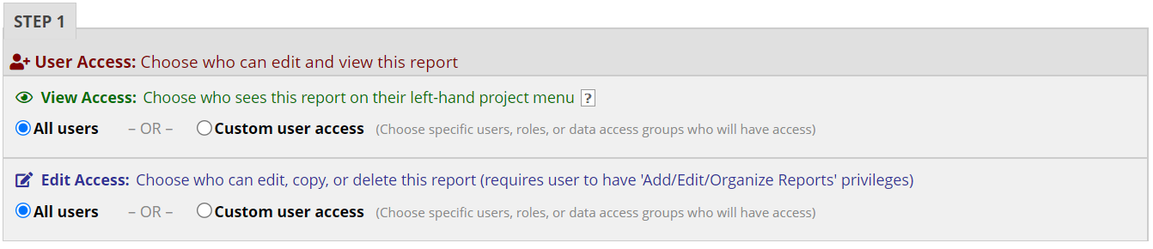

1. In STEP 2, you can select the data elements you would like to appear in the report. The ‘+Quick Add’ is the easiest way to make this selection. See Table 1 below for the set of minimum data elements for reporting. Close the ‘+Quick Add’ window after making the selection.

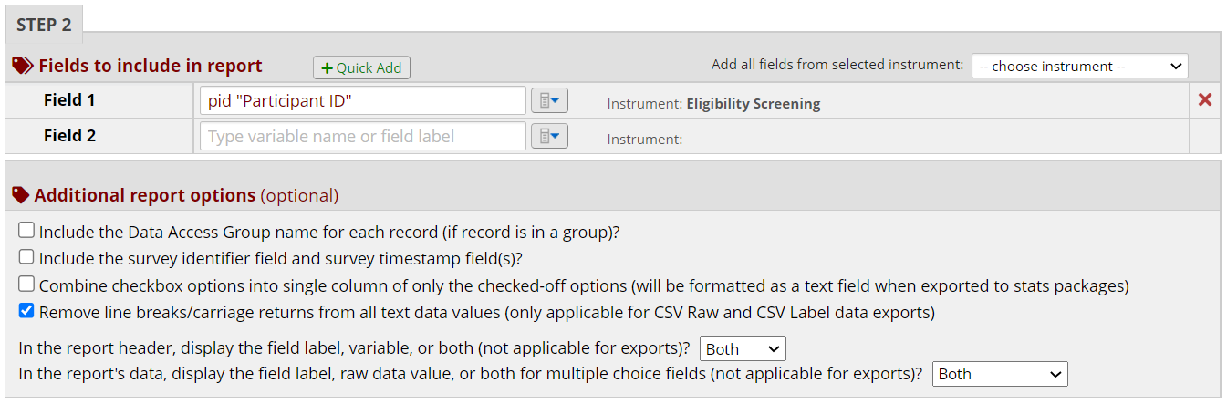

|  |  |  |
| --- | --- | --- |
| **Minimum seta** | **Variable namesb** | **Labels** |
|  | *Eligibility Screening* | |
|  | pid | Participant ID |
|  | *Questionnaire* | |
| X | first_dose_yesno | Have you received a first dose of JYNNEOS monkeypox vaccine? |
|  | first_dose_date | When did you receive your first monkeypox vaccine? If you can't remember the exact date, please provide your best guess. |
| X | second_dose_yesno | Have you received a second dose of JYNNEOS monkeypox vaccine? |
|  | second_dose_date | When did you receive your second monkeypox vaccine? If you can't remember the exact date, please provide your best guess. |
| X | symptoms_yesno | Have you ever had symptoms consistent with monkeypox, such as a rash or skin lesions? |
|  | symptoms_date | What was the date that you first started experiencing symptoms or got a rash or skin lesions? (If you can't remember the exact date, please provide your best guess.) |
| X | Provider_dx | Have you ever been told by a doctor or healthcare provider that you have monkeypox? |
| X | clinic_yesno | Have you ever been told by a doctor or healthcare provider that you have monkeypox? |
|  | clinic_date | Have you visited an STI or HIV clinic, infectious disease clinic, or PrEP clinic between August 19, 2022, and today? |

aIf *participants respond ‘Yes’ to data elements with an associated date field, then they must also enter a date for the record to be classified as ‘complete.’*

*bVariable names needed need to produce the report.*

STEP 2 results. Feel free to modify the additional report options as you see fit.

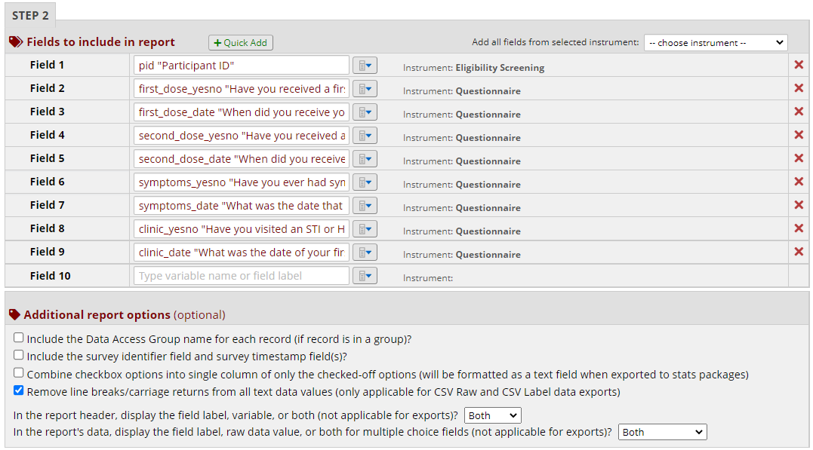

1. In STEP 3, you can filter (restrict) the report to respondents who were eligible on the screening tool by using the logic in the screenshots below.
   1. Click on the calculator-looking icon to enable the dropdown list in 5b.

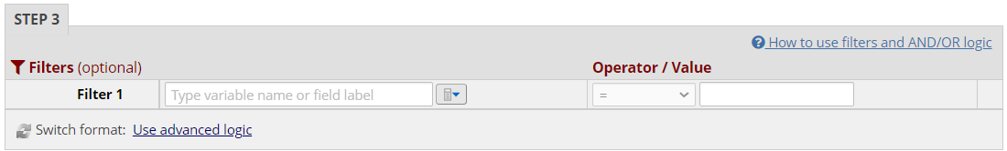

* 1. Select the ‘inelig_stop’ variable from the dropdown list.

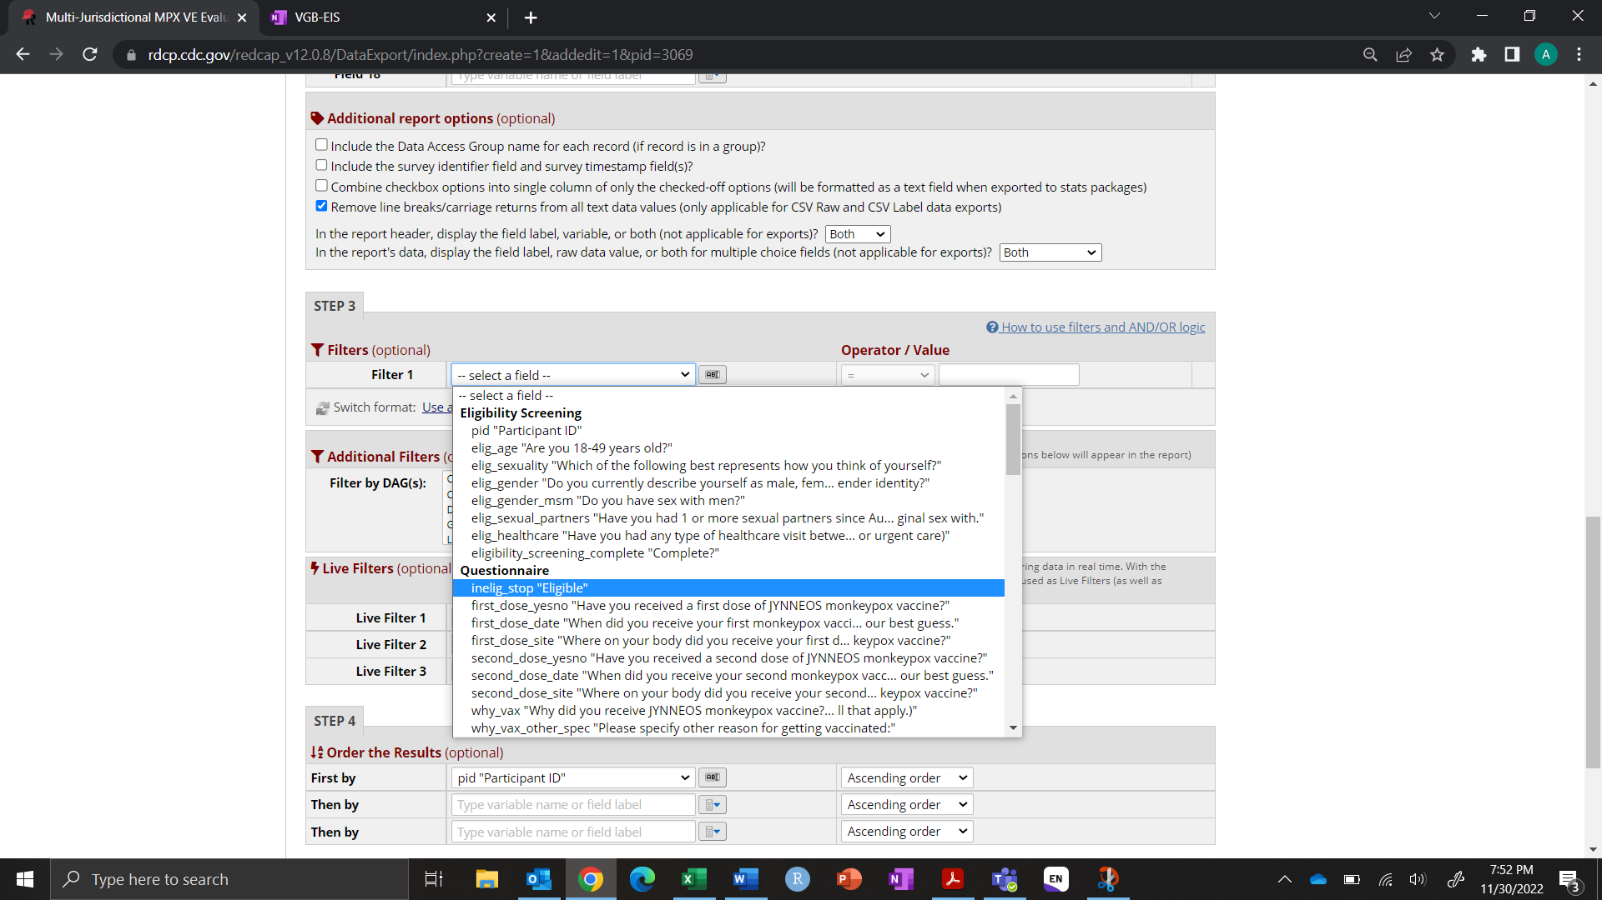

* 1. Under the ‘Operator / Value’ in the ‘Filter 1’ row, select the ‘=’ operator and ‘eligible’ value.

*Note: some sites may have an additional variable about consent. You can add this criterion in Filter 2.*

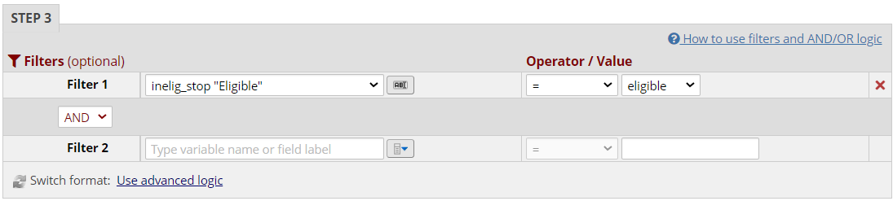

1. Click ‘Save Report’ at bottom of the page and select ‘View report’ to verify the results of your query.

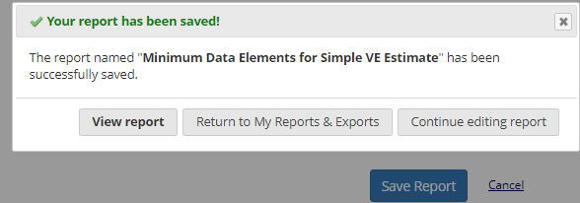

1. There are multiple ways to interact with the result of the query, depending on your needs or interests. You may view it as a line list within REDCap and export it as a CSV. You may also view descriptive statistics and missingness on each data element.
   1. This is an example of the line list in REDCap view (presenting header only). Click on the ‘Export Data’ button to view the line list in Excel/CSV.

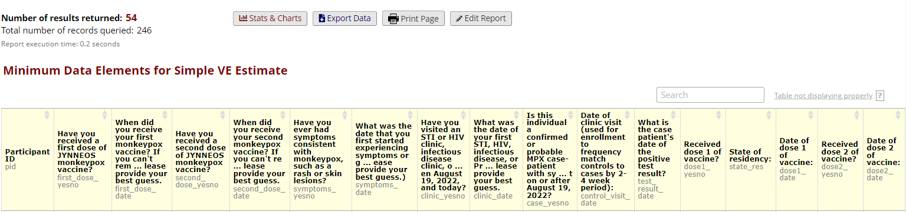

* 1. Click on the ‘Stats & Charts’ button to view descriptive statistics and proportion missing data. To output a list of IDs missing data for a specific data element, click on the number and percentage in the ‘missing*’ box.

