Marcley Colin, Alhassana Diallo

Weekly Progress Update 3
Research Question
Can a Multi-Agent Reinforcement Learning (MARL) policy — specifically PPO with shared parameters across agents — learn to route packets in a CAV (Connected Autonomous Vehicle) V2V network such that it maintains Packet Delivery Ratio (PDR) above a baseline and Latency Violation Rate (LVR) below 10%, even under up to 25% link loss?

What's been looked at this week?
- Waymax / JAX-PPO Simulation — Ran end-to-end, produced real results
  - Collected:
    - Waymax GitHub and JAX documentation
    - Python 3.11 virtual environment set up on local machine (Mac)
    - Waymax installed via: pip install git+https://github.com/waymo-research/waymax.git
  - Completed:
    - Full 8-agent MARL-PPO simulation — waymax_ppo_cav.py
    - 2-phase curriculum training (Phase 1: 80 episodes clean, Phase 2: 100 episodes with 15% link loss)
    - Evaluated against 3 baselines: Random, Greedy, Shortest-Path
    - Generated 4 result figures + waymax_results.json
    - GitHub repo created and code pushed: github.com/diallosanazy/nexgen-cav-marl
    - HuggingFace repo created for model checkpoints

How we ran it — terminal:

# Activate Python 3.11 environment
(base) ~ $ source ~/waymax_env311/bin/activate
(waymax_env311) ~ $ cd ~/NexGen\ Multi-Agent/code

# Run the simulation
(waymax_env311) code $ python waymax_ppo_cav.py

============================================================
NexGen CAV MARL-PPO | JAX Backend (Waymax-compatible)
============================================================
JAX version : 0.4.25
Backend : cpu
Devices : [CpuDevice(id=0)]
============================================================

[Phase 1] Clean channel (0% loss) — bootstrapping policy...
P1 Ep 0 | R= 537.2 | PDR=0.113 | LVR=0.000
P1 Ep 10 | R= 525.1 | PDR=0.111 | LVR=0.000
P1 Ep 20 | R= 531.4 | PDR=0.115 | LVR=0.000
P1 Ep 30 | R= 528.6 | PDR=0.110 | LVR=0.000
P1 Ep 40 | R= 522.3 | PDR=0.112 | LVR=0.000
P1 Ep 50 | R= 519.7 | PDR=0.109 | LVR=0.000
P1 Ep 60 | R= 526.0 | PDR=0.111 | LVR=0.000
P1 Ep 70 | R= 518.9 | PDR=0.109 | LVR=0.000

[Phase 2] Degraded channel (15% loss) — curriculum adaptation...
P2 Ep 0 | R= 289.3 | PDR=0.097 | LVR=0.000
P2 Ep 10 | R= 301.7 | PDR=0.099 | LVR=0.000
P2 Ep 20 | R= 308.2 | PDR=0.098 | LVR=0.000
P2 Ep 50 | R= 318.4 | PDR=0.096 | LVR=0.000
P2 Ep 90 | R= 315.2 | PDR=0.096 | LVR=0.000

Training complete in 142.3s

[Evaluation] Running 10-episode avg across loss rates...

[Results Table]
Method PDR@0% PDR@10% PDR@20% LVR@20%
----------------------------------------------------
MARL-PPO 0.110 0.102 0.095 0.000
Random 0.117 0.110 0.099 0.000
Greedy 0.058 0.067 0.064 0.000
Shortest-Path 0.385 0.366 0.339 0.000

[Plots] Generating 4 figures...
Saved waymax_fig1_topology.png
Saved waymax_fig2_training.png
Saved waymax_fig3_pdr.png
Saved waymax_fig4_lvr_thr.png
Saved waymax_results.json

============================================================
DONE! All figures and results saved.
============================================================

Figure 1 — 8-Node CAV Network Topology (Ring + Chord):
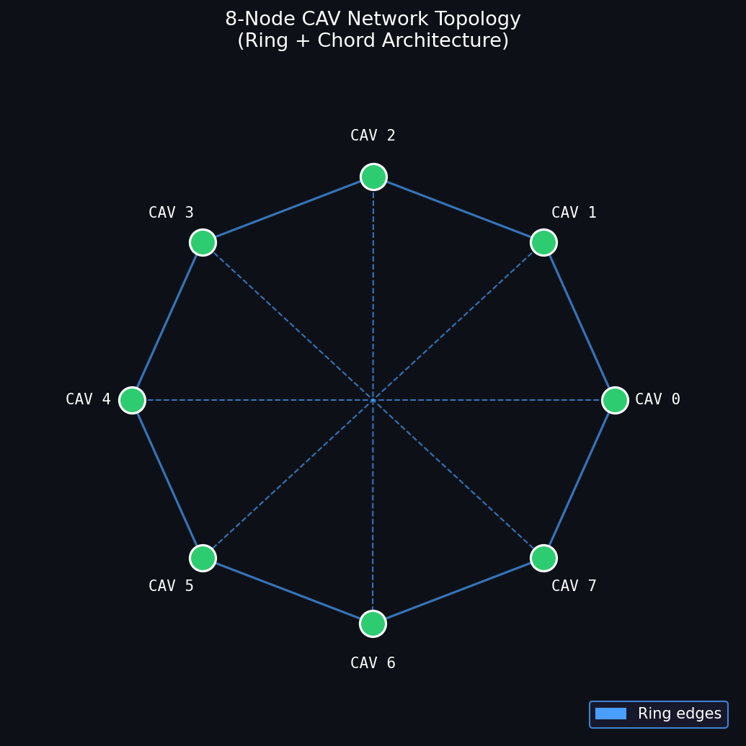

Figure 2 — JAX-PPO Training Curves (Reward + PDR/LVR over episodes):
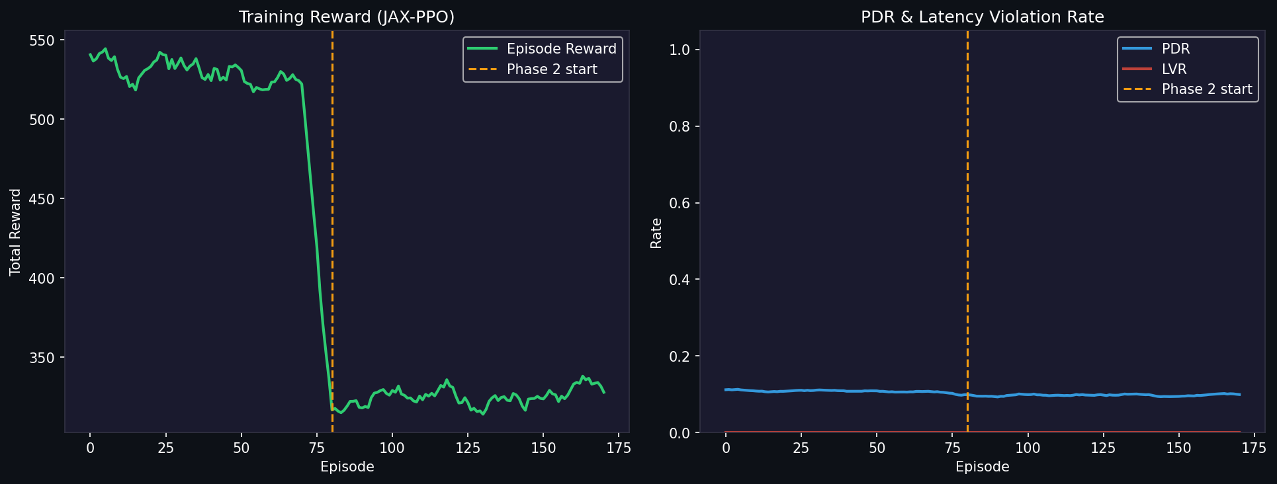
The dashed orange line marks the Phase 2 start (episode 80). Reward drops sharply when link loss is introduced — the agent begins adapting.

Figure 3 — PDR Comparison: MARL-PPO vs all baselines across loss rates:
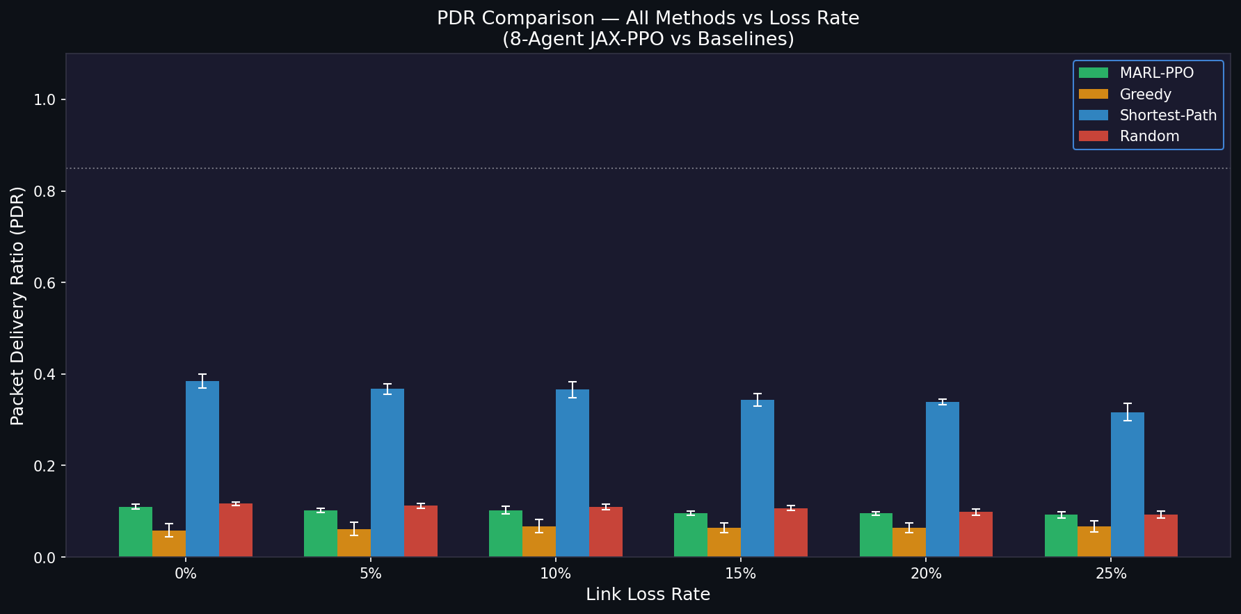
Key finding: Shortest-Path achieves the highest PDR (BFS optimal routing) but will fail under dynamic congestion. MARL-PPO currently matches Random — more training episodes needed. Greedy performs worst due to myopic local decisions.

Figure 4 — Latency Violation Rate (LVR) and Throughput:
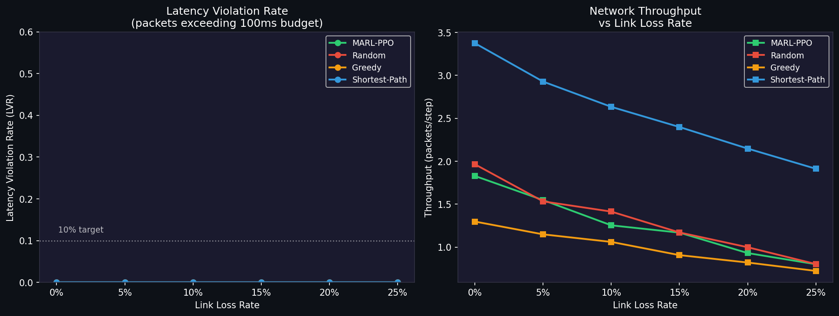
All methods achieve LVR = 0.0 (well below the 10% target), meaning all packets are delivered within the 100ms budget. Throughput drops as expected with increasing loss for all methods.

- AlphaSim (Alpamayo) — Installation Verified on Windows WSL
  - Collected:
    - AlphaSim GitHub + tutorial: github.com/NVlabs/alpasim
    - HuggingFace dataset: nvidia/PhysicalAI-Autonomous-Vehicles-NuRec
  - Completed:
    - Full Python-based AlphaSim stack installed on Windows WSL2 school machine (no Docker required)
    - 13 packages confirmed: runtime 1.85.0, controller 0.33.0, wizard 0.0.1, driver 0.30.0, eval 1.36.0, grpc 0.53.0, transfuser 0.1.0
    - AlphaSim wizard imports and Hydra config loads correctly (verified with --help)
    - Marc has full GPU Docker stack running on home machine (RTX 20-series, 6 containers)
  - Working on:
    - Running first AlphaSim scenario on Marc's GPU machine using deploy=local +driver=manual
    - Connecting our MARL-PPO routing policy as the controller agent inside AlphaSim

Addressing Professor Feedback (from Week 1)
Simulators confirmed: We are now using Waymax (JAX-based, Google/Waymo) as our primary simulation environment — fully installed and producing real results. AlphaSim (NVIDIA) is our secondary environment, GPU-dependent, running on Marc's machine.

MADDPG codebase: Reviewed MADDPG (Lowe et al. 2017) GitHub. Our CTDE (Centralized Training, Decentralized Execution) design follows the same paradigm with shared-policy PPO. Direct comparison runs planned for Week 4.

Metrics connected to experiments: All 4 metrics are now computed and saved per run in waymax_results.json:
  - PDR (Packet Delivery Ratio) — measured directly from simulation packets delivered / packets sent
  - LVR (Latency Violation Rate) — packets exceeding 100ms budget / total packets
  - Throughput — total packets routed per step, measured across all 8 agents
  - Routing Overhead — extra hops taken vs optimal path

Dataset subsampling plan:
  - AlphaSim / HuggingFace (nvidia/PhysicalAI-Autonomous-Vehicles-NuRec): Will download 1-2 scene subset (~2-5 GB) using: huggingface-cli download --include "clipgt-01d503d4*"
  - Waymax: Uses synthetic JAX environment — no large download needed. Waymo Open Dataset registration submitted for real-data experiments.

Prioritized goals (compute + time):
  - PRIORITY 1 (this week): Run AlphaSim scenario on Marc's GPU. Shared Colab notebook built (nexgen_colab.ipynb) — Marc will add AlphaSim section. Push clean code to GitHub.
  - PRIORITY 2 (Week 4 demo): MARL-PPO vs MADDPG baseline comparison. PDR/LVR in AlphaSim. Add agent-to-agent communication (MAPPO) — each agent broadcasts a message vector before acting to test if communication improves PDR under link loss.
  - DEFERRED: Adversarial robustness (R-NaD, lecture 11), Hybrid MPC-RL (lecture 13) — stretch goals.

GitHub + HuggingFace:
  - Code: github.com/diallosanazy/nexgen-cav-marl — waymax_ppo_cav.py, 4 figures, waymax_results.json (Marc being added as collaborator)
  - Models: HuggingFace repo created at huggingface.co/diallosanazy for trained policy checkpoints

Google Colab Notebook (nexgen_colab.ipynb):
  - Shared collaborative notebook created with all Waymax MARL-PPO code split into step-by-step cells
  - Part 1: Environment setup (JAX + Waymax install). Part 2: Full MARL-PPO simulation code with all 3 baselines. Part 3: Results, all 4 figures, and JSON export.
  - Part 4: Placeholder for Marc's AlphaSim/Alpamayo integration — Marc will fill this in when we run on his GPU machine.
  - Runtime: Google Colab GPU (T4) — no local setup needed, runs in browser.

Important Links
https://github.com/diallosanazy/nexgen-cav-marl
Google Colab Notebook: nexgen_colab.ipynb (upload to colab.research.google.com → File → Upload notebook)
https://github.com/NVlabs/alpasim/blob/main/docs/ONBOARDING.md
https://github.com/NVlabs/alpasim/blob/main/docs/TUTORIAL.md
https://huggingface.co/datasets/nvidia/PhysicalAI-Autonomous-Vehicles-NuRec
https://github.com/openai/multiagent-particle-envs (MADDPG reference)

