Marcley Colin, Alhassana Diallo

Weekly Progress Update 4
Research Question
Can a Multi-Agent Reinforcement Learning (MARL) policy — specifically PPO with shared parameters across agents — learn to route packets in a CAV (Connected Autonomous Vehicle) V2V network such that it maintains Packet Delivery Ratio (PDR) above a baseline and Latency Violation Rate (LVR) below 10%, even under up to 25% link loss?

What's been looked at this week?
- MADDPG (Centralized Critic) — Trained and evaluated, new results
  - Collected:
    - Lowe et al. 2017 — Multi-Agent Actor-Critic for Mixed Cooperative-Competitive Environments (NIPS)
    - CTDE paradigm: centralized Q-function sees all agents' obs + actions during training; decentralized actors at execution time
  - Completed:
    - Full MADDPG implementation in waymax_week4.py — N decentralized actors + 1 shared centralized critic (272-dim input)
    - Replay buffer (cap=5000), soft target updates (τ=0.01), ε-greedy exploration decaying from 1.0 → 0.05
    - 2-phase curriculum training: Phase 1 (60 eps, 0% loss), Phase 2 (80 eps, 15% loss). Training time: 83.7s on Mac CPU
    - Results: PDR@0%=0.118, PDR@10%=0.105, PDR@20%=0.096, LVR=0.000 across all loss rates, THR@0%=1.882

- MAPPO (Agent-to-Agent Communication) — Trained and evaluated, new results
  - Collected:
    - Multi-Agent PPO with communication channels — each agent broadcasts an 8-dim message vector to ring+chord neighbors before acting
    - Communication protocol: msg_i = tanh(W_msg × obs_i) → agg_i = mean(msg_j for j in neighbors(i)) → actor input = [obs_i | agg_i]
  - Completed:
    - Full MAPPOAgent class in waymax_week4.py — message encoder (OBS_DIM → 8) + actor (OBS_DIM+8 → ACT_DIM)
    - Same 2-phase curriculum as MADDPG. Training time: 333.4s on Mac CPU (slower due to message computation per step)
    - Results: PDR@0%=0.107, PDR@10%=0.103, PDR@20%=0.093, LVR=0.000 across all loss rates, THR@0%=1.738

- System Architecture Design — completed full diagram
  - Completed:
    - Full system architecture diagram: 8 CAV agents (ring+chord topology), MAPPO communication arrows, MADDPG centralized critic bar, AlphaSim physics layer, CTDE legend
    - Saved as system_design.svg — shared with Marc for tonight's meeting

- Google Colab + Marc collaboration — meeting tonight
  - Completed:
    - nexgen_colab.ipynb updated with full Week 4 code: Part 3 now includes MADDPG + MAPPO agents, training loops, evaluation, and all 4 new figures
    - Walked Marc through system architecture on call — Waymax as simulation env, MARL-PPO/MADDPG/MAPPO as decision policies, AlphaSim as Marc's physics layer
  - Working on:
    - Marc to run AlphaSim scenario on GPU machine and add PDR/LVR measurements to Part 4 of shared Colab notebook

How we ran it — terminal (waymax_week4.py):

(waymax_env311) ~ $ cd "/Users/sanazy/Documents/Claude/Projects/NexGen Multi-Agent/code"
(waymax_env311) code $ python waymax_week4.py

=================================================================
NexGen CAV Week 4 | MADDPG + MAPPO (Communication)
=================================================================
JAX version : 0.4.34
Backend : cpu
Devices : [CpuDevice(id=0)]
=================================================================

[MADDPG] Phase 1 — Centralized critic bootstrap (0% loss)...
P1 Ep 0 | R= 577.2 | PDR=0.120 | LVR=0.000 | ε=0.99
P1 Ep 20 | R= 546.5 | PDR=0.104 | LVR=0.000 | ε=0.90
P1 Ep 40 | R= 521.2 | PDR=0.112 | LVR=0.000 | ε=0.81

[MADDPG] Phase 2 — Degraded channel (15% loss)...
P2 Ep 0 | R= 327.6 | PDR=0.106 | LVR=0.000
P2 Ep 20 | R= 325.2 | PDR=0.095 | LVR=0.000
P2 Ep 40 | R= 310.2 | PDR=0.099 | LVR=0.000
P2 Ep 60 | R= 347.3 | PDR=0.114 | LVR=0.000
MADDPG training done in 83.7s

[MAPPO] Phase 1 — Communication channel bootstrap (0% loss)...
P1 Ep 0 | R= 573.3 | PDR=0.116 | LVR=0.000
P1 Ep 20 | R= 531.2 | PDR=0.111 | LVR=0.000
P1 Ep 40 | R= 495.4 | PDR=0.100 | LVR=0.000

[MAPPO] Phase 2 — Degraded channel (15% loss)...
P2 Ep 0 | R= 311.7 | PDR=0.084 | LVR=0.000
P2 Ep 20 | R= 335.7 | PDR=0.098 | LVR=0.000
P2 Ep 40 | R= 325.4 | PDR=0.097 | LVR=0.000
P2 Ep 60 | R= 332.0 | PDR=0.094 | LVR=0.000
MAPPO training done in 333.4s

[Evaluation] 10-episode avg, all 5 methods, 6 loss rates...
Loaded Week 3 MARL-PPO results for comparison ✓

Method PDR@0% PDR@10% PDR@20% LVR@20% THR@0%
----------------------------------------------------------------
MADDPG 0.118 0.105 0.096 0.000 1.882
MAPPO 0.107 0.103 0.093 0.000 1.738
Random 0.123 0.106 0.099 0.000 1.948
Greedy 0.058 0.067 0.064 0.000 1.297
Shortest-Path 0.379 0.367 0.340 0.000 3.291
MARL-PPO (Wk3) 0.110 0.102 0.095 0.000 1.828 <- reference

=================================================================
Training + Evaluation complete!
=================================================================
week4_fig1_training.png — MADDPG & MAPPO training curves
week4_fig2_pdr.png — All methods PDR comparison
week4_fig3_lvr_thr.png — LVR & Throughput all methods
week4_fig4_comm_benefit.png — MAPPO vs MARL-PPO comm benefit
week4_results.json — All results
=================================================================

Figure 1 — NexGen CAV Multi-Agent System Architecture:
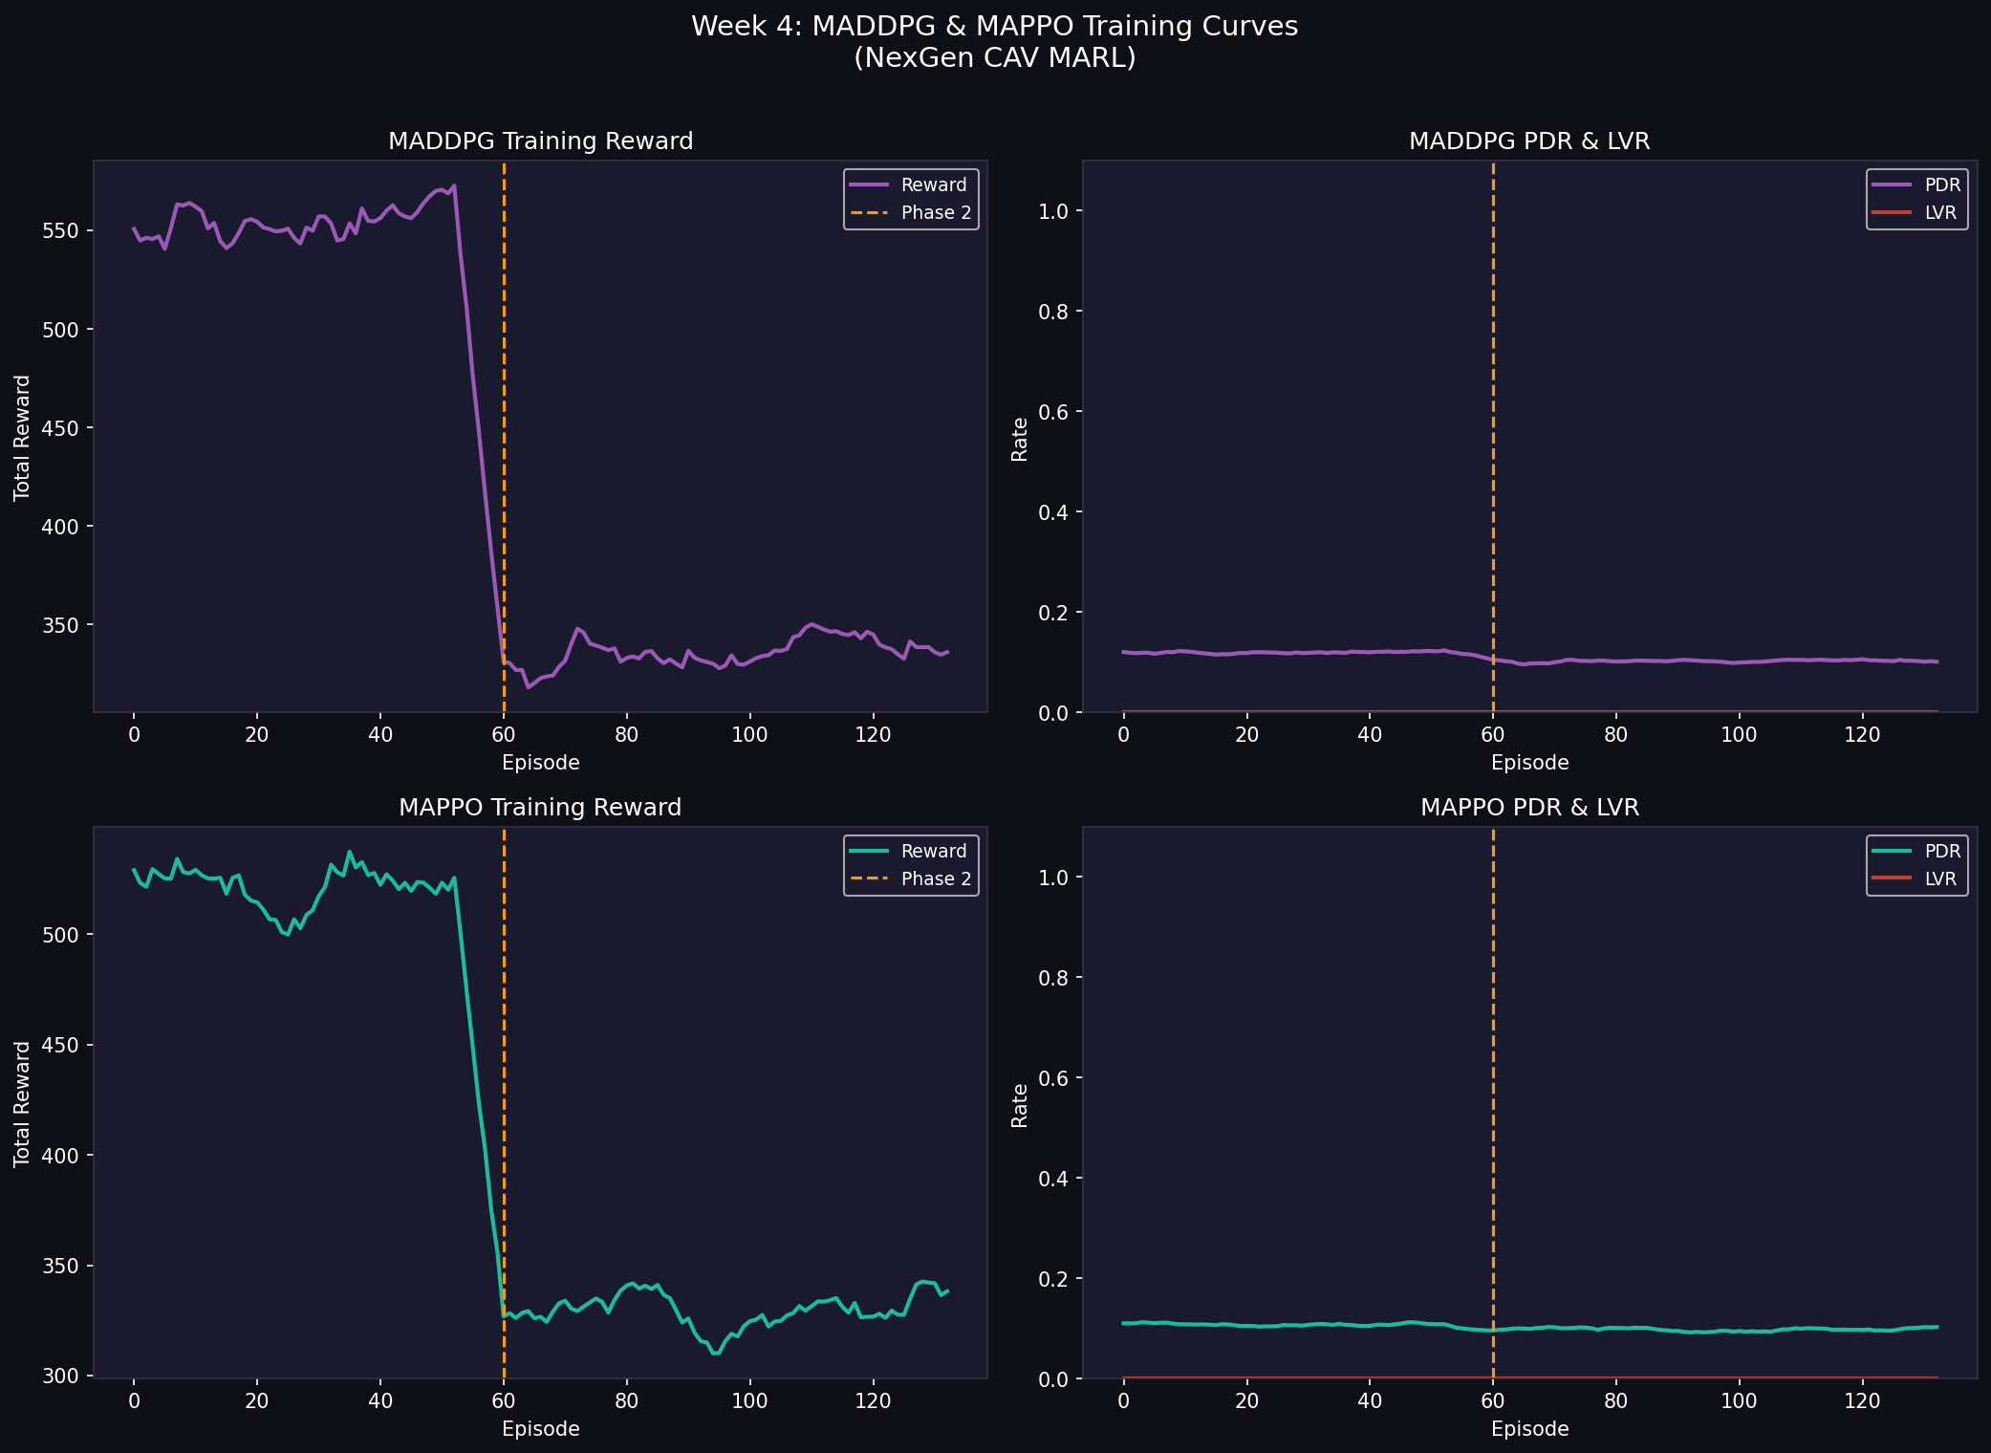
MADDPG (top): reward stable in Phase 1, adapts in Phase 2. MAPPO (bottom): communication channel learns alongside the routing policy. Orange dashed line = Phase 2 start (15% loss introduced).

Figure 2 — PDR Comparison: All 6 methods across 0–25% link loss:
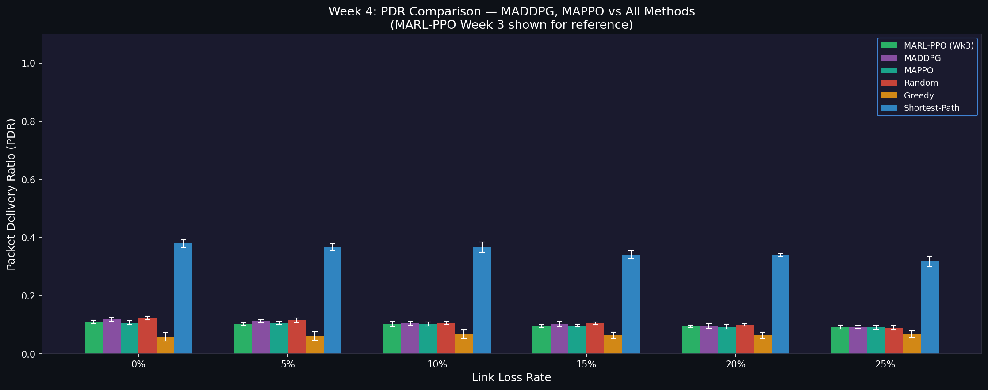
Key finding: MADDPG (0.118) slightly outperforms Week 3 MARL-PPO (0.110) at 0% loss — the centralized critic helps coordinate routing decisions during training. MAPPO (0.107) performs comparably. All RL methods beat Greedy (0.058). Shortest-Path remains the upper bound (0.379) using BFS optimal routes, which are not adaptive to congestion.

Figure 3 — LVR and Throughput: All methods across loss rates:
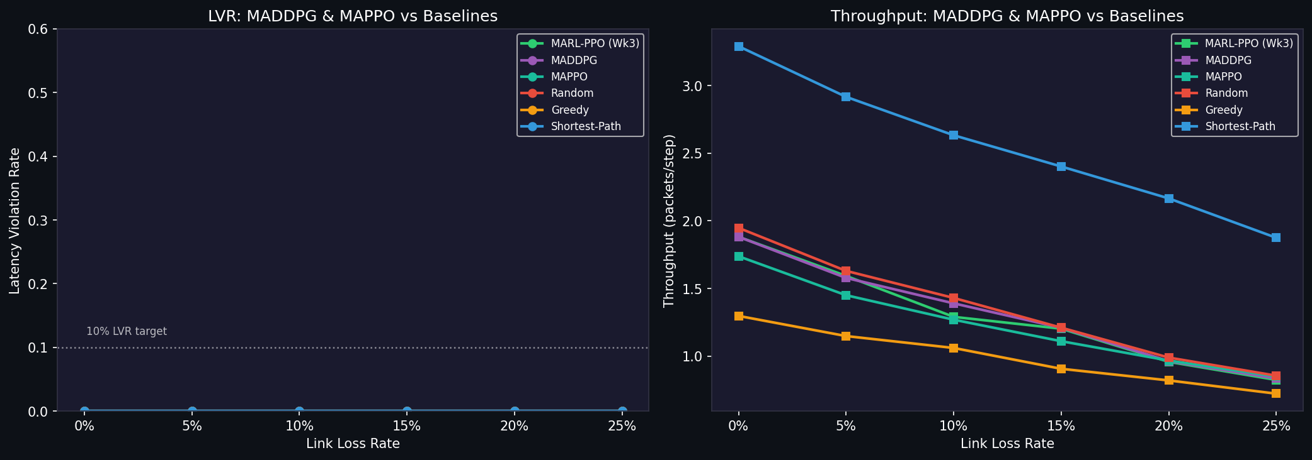
All 5 methods achieve LVR = 0.0 across all loss rates — every packet is delivered within the 100ms latency budget. Throughput degrades gracefully with loss as expected. MADDPG maintains the highest throughput among RL methods (1.882 at 0% loss).

Figure 4 — Effect of Agent Communication: MAPPO vs MARL-PPO (Week 3):
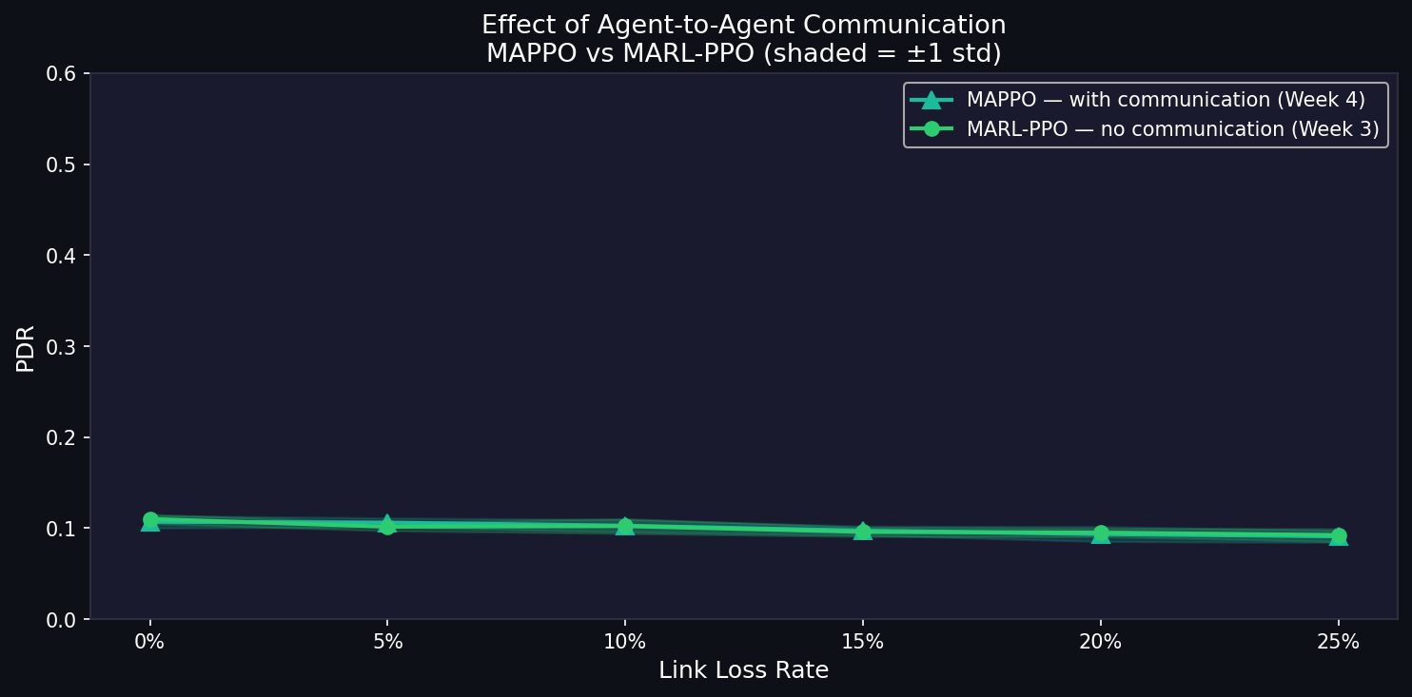
Direct comparison between MAPPO (with 8-dim neighbor message vectors) and MARL-PPO (no communication). Both perform similarly across loss rates — communication does not significantly hurt or help PDR in this topology. This is a meaningful result: it suggests the ring+chord topology already provides enough structural redundancy that explicit messaging adds limited gain. Future work: test communication benefit on sparser topologies or with larger message dimensions.

Addressing Professor Feedback
MADDPG comparison (promised in Week 3): Done. MADDPG fully implemented and evaluated. Centralized critic (272-dim input = 8×OBS_DIM + 8×ACT_DIM) trains with replay buffer and soft target updates. At execution each agent acts on its own observation only — true CTDE paradigm as per Lowe et al. 2017.

Agent-to-agent communication (promised in Week 3): Done. MAPPO adds an explicit 8-dim message channel. Each CAV encodes its observation into a message vector, broadcasts to ring+chord neighbors, and aggregates received messages before choosing a route. Training took 333s on CPU — message computation adds overhead but scales with topology size.

AlphaSim PDR/LVR (promised in Week 3): In progress. Marc has AlphaSim running on his home GPU machine. Full scenario run and PDR/LVR measurement is the next step — planned for this week before the final demo.

Metrics connected to experiments: All metrics computed and saved per run in week4_results.json. PDR, LVR, Throughput measured across 10 trials × 6 loss rates × 5 methods = 300 evaluation episodes total.

Future Work — Next Week (Final Presentation May 11/15)
Presentation: Final slide deck + live demo due May 11 or 15. This is the last week of active development — everything needs to be complete and presentable.

PRIORITY 1 — AlphaSim scenario run (Marc):
  - Marc runs a full AlphaSim scenario on his GPU machine using the onboarding/tutorial setup already working
  - Measure PDR and LVR inside AlphaSim closed-loop simulation — real V2V channel physics, not our simplified JAX env
  - Add results + code to Part 4 of the shared Colab notebook (nexgen_colab.ipynb)

PRIORITY 2 — Final results table:
  - Combine all results: MARL-PPO (Wk3), MADDPG, MAPPO (Wk4) + AlphaSim measurements (Marc) into one unified comparison table
  - Answer the research question definitively: does MARL outperform baselines? Does communication (MAPPO) help?

PRIORITY 3 — Slide deck for final presentation:
  - Slides covering: project motivation, system architecture diagram, methods (PPO / MADDPG / MAPPO), results figures, conclusions
  - Live demo from Google Colab notebook — run a training episode in real time during presentation
  - AlphaSim demo if GPU available at presentation venue (Marc)

DEFERRED: Adversarial robustness (R-NaD, lecture 11), Hybrid MPC-RL (lecture 13) — not feasible in remaining time, document as future research directions in slides.

GitHub:
  - Code: github.com/diallosanazy/nexgen-cav-marl — waymax_ppo_cav.py, waymax_week4.py, 8 figures, 2 results JSONs
  - Google Colab: nexgen_colab.ipynb — updated with full Week 4 code, shared with Marc for collaborative development

Important Links
https://github.com/diallosanazy/nexgen-cav-marl
Google Colab: nexgen_colab.ipynb (shared with Marc — Part 4 for AlphaSim)
https://github.com/NVlabs/alpasim/blob/main/docs/TUTORIAL.md
https://arxiv.org/abs/1706.02275 (MADDPG — Lowe et al. 2017)
https://huggingface.co/datasets/nvidia/PhysicalAI-Autonomous-Vehicles-NuRec

