Agis Diamantis – Registration tab, input weight tab, report, tutorial

Ryan Higgins – Home tab, login tab, registration tab, input weight tab, chart tab, BMI tab

**Introduction**

At first we were trying to find something in the list of examples that maybe we could use as an idea, we thought about solitaire because it was a game but I remember hearing that creating solitaire is actually pretty difficult in the amount of time we had. At one point we had discussed creating some game that you had to move in we had to figure out something that was doable in the amount of time we had. For our project 4, our team decided we wanted to make a weight tracker. With this application the user will be able to create an account, login, input their weight, check their BMI, and look at a chart of all their weight logs. We ultimately came up with this because we did not hear anyone else in the class doing this and we did not see a weight tracker in the list of examples in the assignment PDF.

Below is an example of what the first version of the home page for the website looked like. There is no styling and the links shown either go to blank pages or nowhere.

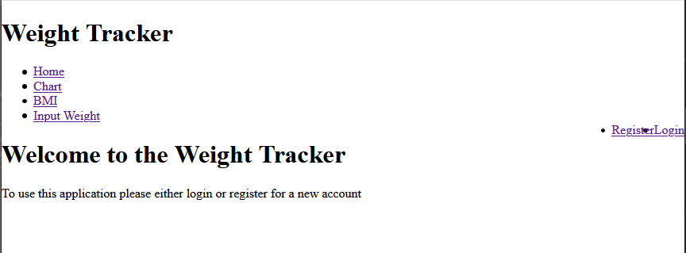

Below is an example of what the final version of the home page looked like.

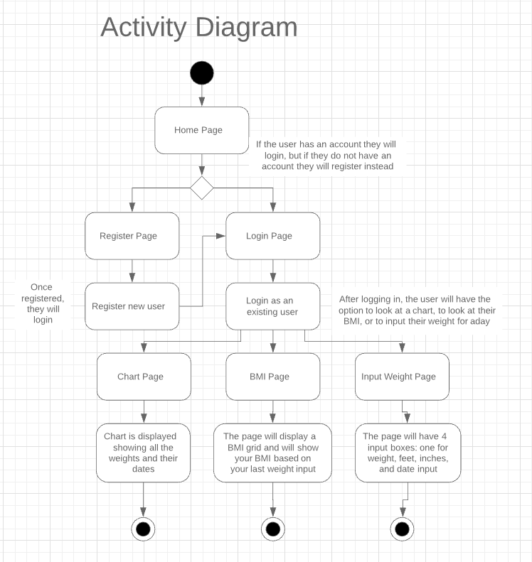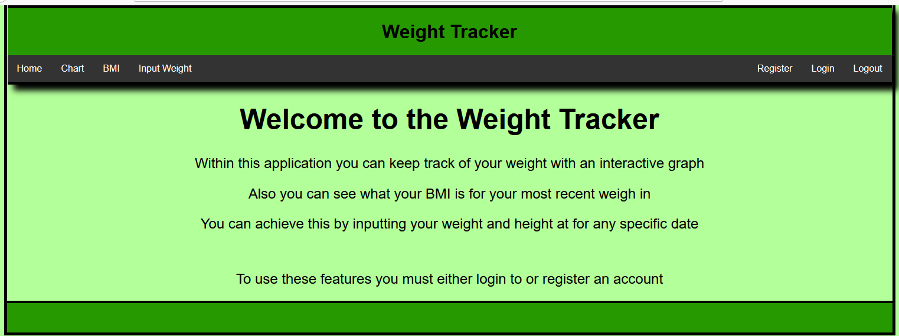

For this project we figured we would be able to use a lot of code that we knew how to use from project 3 since we would still be working with a database and PHP, but we would have to do a couple of new things such as keeping track of who the current user is.

In our home page we decided we wanted to tell the user what our application did and that to use these features they would have to login into their account and if they did not have one, they would register a brand new account and then login. Registering is very easy to do, all a person has to do is create a username, password, and enter their first and last name. Logging in is even easier because all the user has to do is type their username and password. When registering we have a hidden userID that auto-increments when a new user is registered, and this acts as the primary key for the user. The user table will contain a userID (the primary key), username, password, first name, and last name.

Afterwards they have three options to look at a chart of their weight overtime, look at their BMI, and input their weight. If the user does not have any weights the BMI page and the chart page will not display any information. When inputting weight they will enter their weight in pounds, their height in feet and inches, and pick the date from a calendar that they measure themselves. This little calendar input box implemented using jQuery to avoid people from inputting the date in the wrong format.

The BMI page will calculate the most recent weight inputted depending on the date. BMI is calculated by the height divided by the user’s height multiplied by 703. Afterwards using the BMI that was just calculated the code will go through a nested if statement: if their BMI is over 40.1, then they are severely obese; if it is in between 30.1 and 40, then they are obese; if it is in between 25.1 and 30, then they are overweight; if it is in between 18.5 and 25, then they are an optimal weight; if it is in between 17.5 and 18.4, then they are underweight; if it is in under 17.5, then they are severely underweight. On the page, their BMI will be displayed along with what category they fall under and the chart of what a person’s BMI would be depending on how tall they are and how much they weigh.

Finally the chart page will display a line chart showing what the person’s weight at the time they inputted their weight. So long as the user has inputted multiple weights for different dates, then the chart is a great way of seeing how much your weight has changed, whether you are looking to lose weight, gain weight, or are just curious.

This project was great practice for building on the skills needed from project 3. One big difference in the PHP side of things was the need to keep track of a logged in user across pages loads. The first problem we found with this was that the user was indefinitely signed in meaning it never knew when a new user logged in. This was fixed by creating a logout button letting the user logout, letting another user login. As stated above when talking about the input weight tab, there is a “date” section that the user must enter, we wanted to prevent users from entering the date in the wrong format. What we decided to implement to remedy this was a calendar that would drop down when the user would click on the input box, when the calendar appears the user would just make sure they are in the correct month and then pick the appropriate date when they measured their height and weight. The chart was another very new thing for us because we had to use Google’s functions to add a chart. The chart would take all of the dates entered and create a new column relative to when weights were measured and then for the rows there is a relative range of weights from what the user inputted for a day. The Google chart is a line chart that shows the change in weight from the different weight inputs.

Overall, I think there was a lot learned from this project and the previous projects. I am sure that if this class were taken under different circumstances it would have made the course much more fun