PROJECT REPORT

Productivity Improvement of
'The Lighthouse' Wind Farm


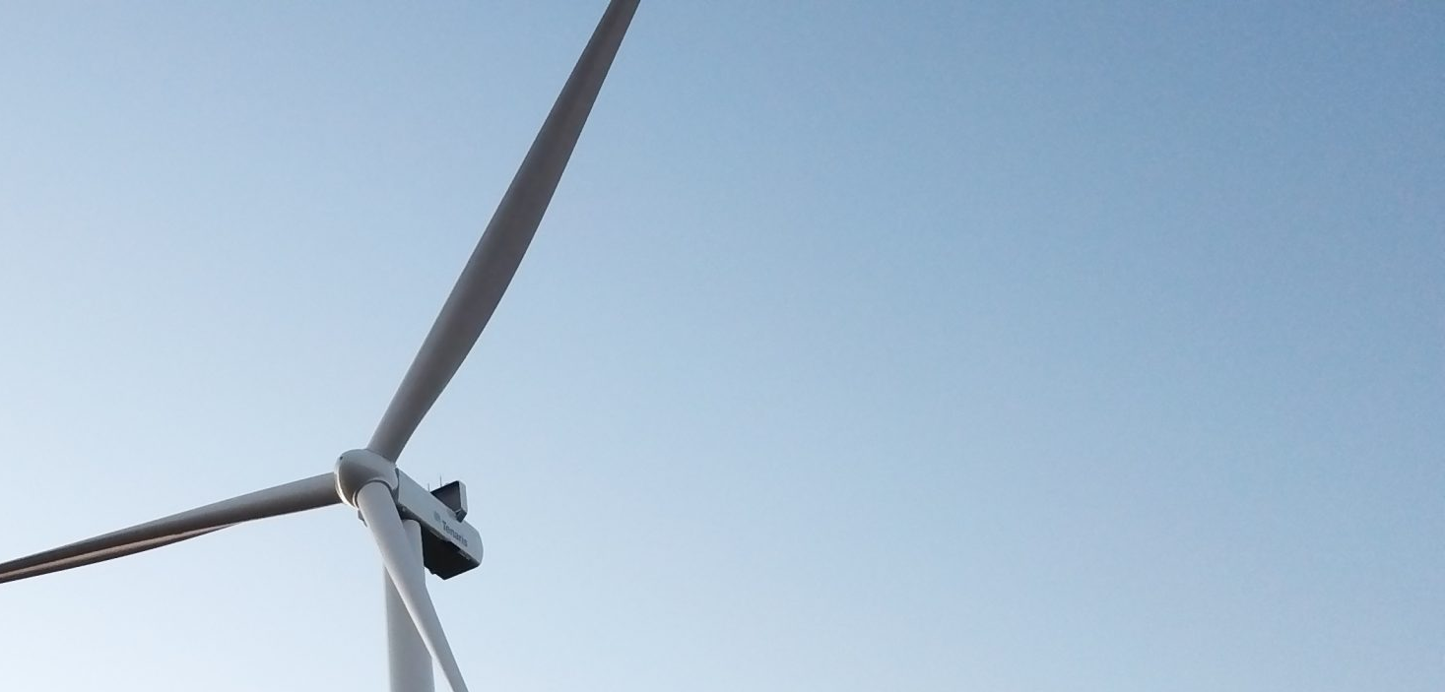


AEROWIND

Bootcamp Data Analytics | Unicorn Academy

Diamela Dego

TABLE OF CONTENTS

1. Project Purpose
1.1 Introduction and Project Context
1.2 Project Selection
1.3 Wind Farm Description
1.4 Project Purpose
1.5 Wind Farm Description (Fleet)
1.6 Issues Identified
1.7 Reason for the Analysis Request

2. Dataset Description
2.1 Production Table
2.2 Maintenance Table
2.3 Weather Table
2.4 Turbines Table
2.5 Prices Table
2.6 Theoretical Curves Table

3. Data Cleaning
3.1 Environments, Languages and Tools
3.2 Schema Transformation and Validation in SQL
3.3 Initial Diagnosis and Database Structure
3.4 Date Standardization
3.5 Duplicate Identification and Treatment
3.6 Null and Physically Meaningless Value Verification
3.7 Cross-Validation and Inter-Table Consistency
3.8 Creation of Clean Tables and Final Model Load

4. Data Modeling
4.1 Table Types
4.2 Table Relationships
4.3 Power BI Model View

5. DAX Measures and Key Visualizations
5.1 DAX Measures Created
5.2 Power BI Visualizations

6. Exploratory Analysis
6.1 Scope and Variables Analyzed
6.2 Energy Performance
6.3 Reliability
6.4 Wind Resource
6.5 Profitability

7. Insights and Conclusions
7.1 General Conclusions
7.2 Technology Impact on Park Performance
7.3 Technical and Business Recommendations
7.4 Relevant Technical Cases
7.5 General Conclusion

1. PROJECT PURPOSE
This section introduces the central objective of the project and establishes the context guiding the development of the data model and performance evaluation of ' The Lighthouse' Wind Farm.

1.1 Introduction and Project Context
Wind energy has consolidated over recent years as one of the most efficient and reliable technologies within the sustainable generation portfolio. Its capacity to convert an abundant natural resource into electricity on a continuous basis positions it as a competitive alternative, especially in regions with strong and regular winds.
Electricity generation from wind requires a wind generator — also called a wind turbine — which converts the kinetic energy of air into mechanical energy and ultimately into electricity.
These types of projects not only contribute to emissions reduction, but also present relevant technical challenges: climatic variability, power curves, mechanical degradation, and maintenance strategies that directly influence the final performance.
In this context, Aerowind requested a comprehensive performance analysis of The Lighthouse Wind Farm, one of its most representative sites due to its combination of favorable environmental conditions and technological diversity in its turbine fleet.
The wind farm includes turbines installed in 2023, 2024, and 2025. Each has different nominal capacities, making it an ideal case to evaluate efficiency, availability, and comparative operational behavior within the same environment.
In summary, the project aims to deliver to Aerowind a complete diagnostic of The Lighthouse Wind Farm's performance, proposing improvement opportunities based on technical analysis, operational reliability criteria, and solid empirical evidence.

1.2 Project Selection
The selection of a wind farm as a case study was not arbitrary. From my background as a Chemical Engineer and my experience in continuous improvement, data analysis, and industrial processes, the energy industry has always represented an area of particular technical and professional interest.
In particular, wind energy combines three key dimensions for a robust analytical approach:

a. A physically modelable process highly dependent on real data
The energy generated can be contrasted against wind speed, air density, and temperature, allowing deviations to be detected.

b. An operating system with multiple interactions
Availability, failures, maintenance events, and seasonality all influence each turbine's performance, requiring consistent multivariate analysis.

c. An industrial environment that demands data-driven decisions
Managing a wind farm demands precise diagnostics to sustain availability, anticipate failures, and validate real vs. expected performance. Proper analysis reduces uncertainty and enables prioritization of interventions with direct operational impact.

1.3 Wind Farm Description
The Aerowind Wind Farm has characteristics that make it a representative and technically interesting case:
- It is a medium-sized wind farm located in Necochea, Buenos Aires, Argentina.
- It operates in a region with marked seasonal variability, allowing analysis of production sensitivity to weather changes.
- Its location, near the coast and exposed to wind regimes, allows study of whether the installed infrastructure is correctly aligned with the real wind resource potential.

Part of the objective is also to assess whether the patterns observed over the years validate the park's location or whether there are indications that its performance could be improved through operational adjustments or design reconsideration.

This wind farm features:
- 10 wind turbines
- 21.9 MW of installed capacity
- 48.2 GWh of energy generated in 2025, the first year with all ten turbines in operation

1.4 Project Purpose
Aerowind has experienced sustained growth in recent years, incorporating turbines of different models and capacities. However, this development was not accompanied by a unified system to record, analyze, and evaluate its key indicators.
Currently, the company lacks structured information on energy production, operational performance, climatic conditions, and corrective and preventive maintenance, which limits its ability to understand the real performance of each turbine and the farm as a whole.
In practice, Aerowind relies on isolated charts manually created in Excel, without a standardized process for data capture, cleaning, or analysis. This makes it difficult to detect losses, compare turbines, identify trends, and make evidence-based decisions.
The objective of this project is to evaluate the integral performance of The Lighthouse Wind Farm using SQL and Power BI and to develop a comprehensive analytical model that enables:

a. Consolidating and cleaning the existing database, unifying weather, production, and operational information.
b. Defining and calculating the main KPIs for the wind farm, including production, efficiency, availability, and performance metrics.
c. Designing an interactive dashboard that facilitates real-time monitoring of farm performance and provides support for tactical and strategic decisions.
d. Providing Aerowind with a reliable, scalable, data-driven tool that replaces manual reports and enables more precise and efficient management of its wind operations.

In summary, this project seeks to transform dispersed data into useful information, offering a solid foundation to improve the performance of The Lighthouse Wind Farm and strengthen Aerowind's analytical capacity going forward.

This project analyzes three essential components:

a. Weather
- Wind speed, temperature, pressure, and humidity.
- Identification of seasonality.

b. Energy Production
- Energy generated per turbine, operative and inactive hours.
- Efficiency KPIs: availability, capacity factor, and performance.

c. Maintenance
- Costs, frequency, and type of intervention.
- Relationship between failures and loss of generated energy.

The project includes cleaning and standardizing the available database, correlating key variables, and developing indicators to support technical decision-making.
From this diagnostic, the goal is to have reliable information for strategic decisions aimed at:
- Optimizing energy generation.
- Reducing operational costs associated with maintenance.
- Anticipating critical behaviors of the farm according to environmental conditions.

1.5 Wind Farm Fleet Description
The wind farm began operations in 2023 with the installation of five turbines. In 2024, two additional turbines were incorporated and, finally, in 2025 the expansion was completed with the installation of three new units. Throughout these stages, different turbine models were used, reflecting a progressive technological evolution of the park.

Turbine models installed:

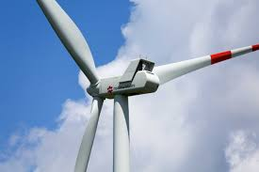
Figure 1. Vestas V100

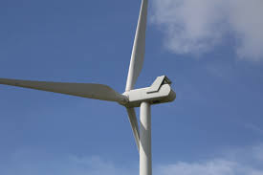
Figure 2. Vestas V110

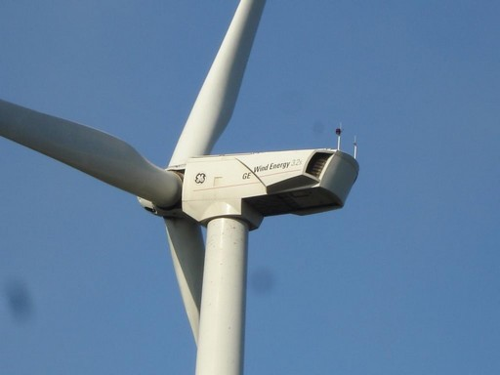
Figure 3. GE -2.5 116
Turbine Name | Type | Installation Year | Nominal Capacity
T01, T02, T03, T04, T05 | Vestas V100 | 2023 | 2,000 kW
T06, T07 | Vestas V110 | 2024 | 2,200 kW
T08, T09, T10 | GE 2.5-116 | 2025 | 2,500 kW

1.6 Issues Identified
During the last years of operation of The Lighthouse Wind Farm, Aerowind identified a series of inconsistencies and anomalous behaviors in its productive and operational performance. Despite having turbines with different technologies and very favorable wind conditions, the farm fails to reach the generation levels the company considers expected for its installed capacity.

The main difficulties detected include:

a. Significant production variability among similar turbines
Aerowind observed marked differences in energy generated by units of the same nominal power, without a clear cause associated with wind, maintenance, or reported failures. This raises doubts about the real efficiency of certain turbines.

b. Inconsistencies in operational records
The company has scattered, partial, or incomplete historical data (production, wind, temperature, shutdowns). This lack of standardization prevents accurate evaluation of availability, maintenance events, and the real capacity factor of the farm.

c. Lack of visibility into recurring failures
Some turbines recorded multiple unplanned shutdowns or irregular behaviors in certain periods, but Aerowind does not have a system that allows identification of patterns or root cause determination from the available information.

d. Difficulty correlating weather conditions with production
The company lacks analyses relating wind speed, temperature, or air density to production, making it impossible to know whether the energy generated is consistent with the theoretical power curve of each turbine.

e. Absence of clear indicators to evaluate overall farm efficiency
The lack of unified KPIs (capacity factor, availability, energy losses, downtime hours, curtailments) limits Aerowind's ability to compare performance, estimate losses, and prioritize improvement actions.

1.7 Reason for the Analysis Request
Given these problems, Aerowind requires a technical study that:
- Integrates and cleans all historical data,
- Allows evaluation of generation consistency with respect to weather conditions,
- Identifies efficiency deviations turbine by turbine,
- Delivers reliable information for operational and maintenance decision-making.

This report is developed to address these information gaps, provide evidence-based diagnostics, and offer a clear picture of the real performance of The Lighthouse Wind Farm. It seeks to answer several questions through a structured analysis of actual park data.

2. DATASET DESCRIPTION
This chapter describes the dataset used as the basis for the wind farm analysis. The work was carried out using raw CSV-format tables containing operational, technical, and environmental information about the farm.

Six raw tables (CSV files) were used as the base:
- Production
- Maintenance
- Weather
- Turbines
- Price
- Theoretical Curves

2.1 Production Table
Contains the production records of all wind turbines in The Lighthouse Wind Farm for the years 2023–2025:

Variable | Type | Description
record_id | id | PK – Unique identification of the production record.
turbine_id | id | Unique identification of the wind turbine.
date | date | Production dates.
generated_energy_kwh | decimal | Energy generated in kWh.
operating_hours | decimal | Operative hours of each turbine.
inactive_hours | decimal | Inactive hours of each turbine.
year | integer | Year.
temperature_c | decimal | Air temperature at the turbine in °C.

2.2 Maintenance Table
Contains the maintenance activity records for all turbines in The Lighthouse Wind Farm for the years 2023–2025:

Variable | Type | Description
maintenance_id | id | PK – Unique identification of the maintenance record.
turbine_id | id | Unique identification of the wind turbine.
maintenance_date | date | Maintenance dates.
maintenance_type | categorical | Type of maintenance.
duration_hs | decimal | Maintenance duration in hours.
cost_usd | decimal | Maintenance cost in USD.
year | integer | Year.
category | text | Failure category of corrective maintenance ('Preventive without failure' for preventive jobs).

2.3 Weather Table
Contains records of weather variables at The Lighthouse Wind Farm location for the years 2023–2025, obtained from the Meteorological Station (MET MAST) installed at the park:

Variable | Type | Description
date | date | Date of weather variable recording.
wind_speed_mps | decimal | Wind speed in m/s.
temperature_c | decimal | Air temperature in °C.
relative_humidity_pct | decimal | Percentage of relative humidity of the air.
pressure_hpa | decimal | Atmospheric pressure in hPa.

2.4 Turbines Table
Contains details of turbines installed between 2023–2025:

Variable | Type | Description
turbine_id | id | PK – Unique identification of the wind turbine.
model | text | Turbine model.
location | text | Turbine location (Wind Farm).
nominal_power_kw | integer | Nominal/theoretical capacity in kW.
installation_date | date | Turbine installation date.

2.5 Prices Table
The prices table contains the sale value of electrical energy expressed in USD/kWh for each period. This information is used as a key input for calculating income and profitability of the wind farm, enabling conversion of generated energy (kWh) into comparable economic results across years and months.

Variable | Type | Description
price_id | id | PK – Unique identification of monthly price.
date | date | Monthly date.
price_kwh_usd | decimal | Sale price of generated energy per month (USD/kWh).

2.6 Theoretical Curves Table
This table describes the expected performance of each turbine model at different wind speeds, establishing the theoretical relationship between wind speed and generated power. This information represents the nominal design performance of the turbines, without considering operational losses, shutdowns, or real operating conditions.
The table is used as a reference to compare actual generated power with theoretical available power, enabling evaluation of the degree of wind resource utilization, identification of performance deviations, and analysis of energy efficiency of each turbine model within the farm.

Variable | Type | Description
model | text | Turbine model.
wind_speed_mps | integer | Wind speed in m/s.
theoretical_power_kw | integer | Theoretical power per model according to wind speed.

In particular, the theoretical curves table does not represent a traditional business dimension, but rather a technical reference dimension, used to describe the theoretical behavior of the system and to allow comparisons between real generation and available energy potential. Its function is to contextualize the facts from a physical standpoint rather than a categorical one.

3. DATA CLEANING
Before proceeding with the exploratory analysis and the construction of the relational model, a comprehensive review of the data schema was performed. The goal was to ensure that all tables met minimum criteria of structure, consistency, and inter-table compatibility, thus enabling reliable subsequent modeling and precise indicator creation.
This stage included validation of column formats, verification of data types, control of keys needed for relationships, and standardization of nomenclature across tables.

3.1 Environments, Languages and Tools
SQL was used for initial quantitative and qualitative validation, while Power BI was used for visual analysis.

Environments:
Environment | Use
MySQL Workbench | Validation, cleaning, and technical queries
Power BI Desktop | Relational modeling, DAX measures, and executive dashboard

Languages:
Language | Description
SQL | Language for querying and managing relational databases.
DAX | Expression language used in Power BI to create calculations on the tabular model.

3.2 Schema Transformation and Validation in SQL
The first step of the project consisted of carrying out a complete audit and sanitization process of the aerowind relational database, which concentrates the operational information of the wind farm: meteorological conditions, production records, maintenance events, and technical characteristics of the turbines.
Since the energy analysis and Power BI models strongly depend on the temporal and physical consistency of the data, an exhaustive SQL cleaning was executed to guarantee integrity, traceability, and technical coherence.

3.3 Initial Diagnosis and Database Structure
Below is the preliminary diagnostic of the weather, production, maintenance, turbines, price, and theoretical_curves tables to evaluate temporal coherence, valid ranges, and general structure. This diagnostic allowed establishing the baseline and directing subsequent cleaning criteria.
Once the raw CSV files were loaded into MySQL, a quantitative and qualitative survey of the table status was conducted.

The objective was to establish:
- Initial record volume.
- Existence of duplicates.
- Presence of critical nulls.
- Values outside physically possible ranges.
- Consistency between tables that should be related by natural keys (date → weather/production, turbine_id → production/maintenance).

This diagnostic allowed dimensioning the level of intervention required before advancing to modeling.

3.4 Date Standardization
Raw tables (RAW) corresponding to each data source were defined: turbines, weather, production, maintenance, energy prices, and theoretical curves. These tables were designed with flexible data types (mainly VARCHAR for dates) to facilitate the initial import of CSV files without loss of information.
Once the data was imported, date normalization was performed, converting text-type fields to DATE format using conversion functions, and then modifying the data type of the corresponding columns.

3.5 Duplicate Identification and Treatment
In order to ensure the temporal integrity of the data and avoid distortions in KPIs, a systematic duplicate analysis was carried out on those field combinations that, by model design, should be unique.

Uniqueness was verified in the following tables:
- Weather: one row per date
- Production: one row per date and turbine_id
- Maintenance: one row per turbine_id and maintenance_date
- Turbines: one row per turbine_id
- Prices: one row per date
- Theoretical curves: one row per wind speed and turbine model

As a result of the analysis, duplicates were only detected in the production table. Multiple records with the same date and turbine_id combination were found, which is incompatible with the model's target granularity: one daily record per turbine.
Analysis of these duplicates showed that they corresponded to partial records of the same day for three turbines (T003 and T005 in 2023, T007 in 2024), with up to four records per turbine and day. Operating and inactive hours were split across the records (together they add up to 24 hours), while each record repeated the full-day energy value, which matches the output of the other turbines of the same model on that day. A daily consolidation process was therefore performed.
Records were grouped by turbine_id and date, applying the following aggregation rules:
- Operating and inactive hours: consolidated using sum, to reconstruct the 24-hour day.
- Generated energy and temperature: consolidated using average, since each partial record repeats the daily energy value and temperature is an environmental measurement.

This way, partial records were unified into a single daily row per turbine, preserving the temporal coherence of the dataset and ensuring consistency for indicator calculation. A consolidated daily table (production_daily) with a consistent daily identifier was generated.

3.6 Null and Physically Meaningless Value Verification
Below, critical nulls and values violating physical or operational constraints were evaluated.

3.6.1 Production Table
a. Null or empty values: None detected.
b. Invalid energy: generated_energy_kwh < 0 or IS NULL.
Note: Null and negative values were searched but not zero values, since an energy value of zero is useful for detecting turbine failures.
A zero value indicates a recorded operational event — the turbine was running (with operative hours recorded) but produced no energy due to external conditions (lack of wind) or specific operational failures.
A NULL value represents absence of data or a measurement/loading error. Result: No invalid energy data detected.
c. Negative energy: No negative energy records detected.
d. Physical operational hours: operating_hours < 0 or > 24; inactive_hours < 0 or > 24; operating_hours + inactive_hours > 24. Result: No out-of-range records detected. After the daily consolidation, 3 turbine-days whose hours did not add up to 24 were deleted.
e. Physical energy limit: generated_energy_kwh greater than nominal_power_kw × 24 (more energy than the turbine can produce at rated power during a full day). Result: 226 turbine-days detected and deleted.

3.6.2 Maintenance Table
a. Null values detected in the category field for preventive maintenance records.
Result: Records where the category field was null for Preventive maintenance type were detected. This does not correspond to a loading error but to a historical system practice: preventive maintenance does not have an associated failure category. These null values were replaced with the standardized category 'Preventive without failure'.
b. Invalid costs and durations: cost_usd IS NULL or <= 0; duration_hs IS NULL or <= 0. Result: Records with negative costs were deleted as loading errors. Null or zero durations were also deleted, as they do not represent valid maintenance tasks.

3.6.3 Weather Table
a. Null or empty values: one missing wind speed value (3 January 2023).
b. Out-of-range temperatures (< -20°C or > 60°C): three values detected, between −31.5°C and −25.2°C in January. They were set to null and the rest of each day's record was kept, so that wind data is not lost.
c. Invalid wind speed (< 0 or IS NULL): no negative values detected; the missing value was kept as null.
d. Relative humidity outside 0–100% and pressure outside 900–1,100 hPa: one value each (−69.6% and 2,005.5 hPa), set to null.

3.6.4 Turbines Table
a. No null or empty values detected.
b. Valid nominal power: One turbine was identified with a nominal power value below zero, which is not coherent with real factory specifications. Since the model and installation year were known, the value was standardized by assigning the corresponding nominal power for the detected case.
c. Installation dates out of range: No out-of-range installation dates detected.

3.6.5 Prices Table
a. Null or empty values: one empty price (May 2023).
b. Invalid price (price_kwh_usd <= 0): one negative price detected (March 2023). Since the monthly price profile repeats every year, both values were imputed with the price of the same month in 2024, so that every month keeps its revenue.

3.6.6 Theoretical Curves Table
a. No null or empty values detected.
b. Negative power or speed: No negative powers or speeds detected.

3.7 Cross-Validation and Inter-Table Consistency
Additionally, expected cardinalities between tables were validated prior to tabular modeling in Power BI. This step was key to ensure the relational structure correctly reflects the operational business logic and that no ambiguous or inconsistent relationships exist.

a. Production associated with non-existent turbines: A referential integrity validation was performed between the production and turbines tables. Result: No production records with non-existent turbines detected.

b. Maintenance associated with non-existent turbines: The same referential integrity validation was applied to the maintenance table. Result: Maintenance records whose turbine_id had no correspondence in the turbines table were detected and deleted to preserve data model coherence.

c. Production prior to turbine installation: No turbine can generate energy before it enters service. Result: 20 inconsistent records were identified and deleted.

d. Maintenance prior to turbine installation: Analogously, no technical intervention can exist on equipment not yet installed. Result: No inconsistencies detected.

e. Weather outside the temporal range of production: All dates recorded in the weather table fall within the temporal range covered by production records. Result: No inconsistencies detected.

3.8 Creation of Clean Tables and Final Model Load
Once all validations, corrections, and deletions on the raw tables were completed, clean tables were created. These consolidate only valid, consistent, and normalized records, ensuring referential integrity, temporal coherence, and data quality. Subsequently, the final model was loaded from these clean tables, establishing an optimized structure for analysis and indicator generation.

4. DATA MODELING
An extended star architecture — or constellation model — was used for this analytical model, involving multiple operational processes.
In this case, the wind farm analysis requires integrating production, maintenance, weather, and technical characteristics data, which demands more than one fact table and shared dimensions. This structure enables a complete analysis of energy performance and the factors influencing operations.

4.1 Table Types
The model consists of:

Fact Tables:
- Production: concentrates records of energy generated and operative hours of each turbine.
- Maintenance: gathers corrective and preventive interventions with their dates, durations, and costs.

Dimension Tables:
- Turbines: records turbines and their installation date.
- Weather: provides relevant meteorological variables to interpret energy performance.
- Price: records the value of energy generated per month.
- Theoretical Curves: includes theoretical power per wind speed for each turbine model.
- Calendar: table generated in Power BI to enable temporal analyses and historical comparisons.

4.2 Table Relationships
The model is structured in Power BI under a constellation architecture, where fact tables relate to different dimensions through primary and foreign keys. Relationships follow 1 → * cardinality, except for weather–calendar (1 → 1, filtering in both directions) and theoretical curves–weather (* → *, by wind speed), ensuring traceability, integrity, and consistent filter flow in the analysis.
In MySQL, the clean tables were created with primary keys and foreign keys to the turbines table, as that layer was used primarily for cleaning, normalization, and data consolidation. The complete set of analytical relationships was defined in Power BI, where the semantic model was built, allowing greater control over filter direction and metric construction.

a. Relationships of the 'production' fact table:

Fact | Dimension | Relationship | Description
production | weather | date 1 → * | Links each generation record with meteorological conditions.
production | turbines | turbine_id 1 → * | Associates each energy generated record with the corresponding turbine.
production | calendar | date, through weather | Enables temporal analyses (day, month, year, seasonality). The calendar filters production through the weather table.

b. Relationships of the 'maintenance' fact table:

Fact | Dimension | Relationship | Description
maintenance | turbines | turbine_id 1 → * | Allows identification of which turbine was serviced and analysis of operational impact.
maintenance | calendar | maintenance_date 1 → * | Facilitates temporal analysis of failures, shutdowns, and preventive tasks.

c. Calendar table creation and relationships:
A dedicated calendar table was created to standardize all temporal variables in the model. By generating a continuous calendar without gaps from the first to the last day of the analyzed period, all time-dependent tables relate correctly.

Related Table | Column in Table | Column in Calendar | Relationship Type
weather | date | Date | 1 → 1 (both directions)
maintenance | maintenance_date | Date | 1 → *
production | date | Date (through weather) | 1 → *

4.3 Power BI Model Overview
The model was organized around two fact tables:

- Production: consolidates generated energy, operating and downtime hours, and enables both time-based and per-turbine analysis.
- Maintenance: records work orders, duration, and cost, supporting availability and failure analysis.
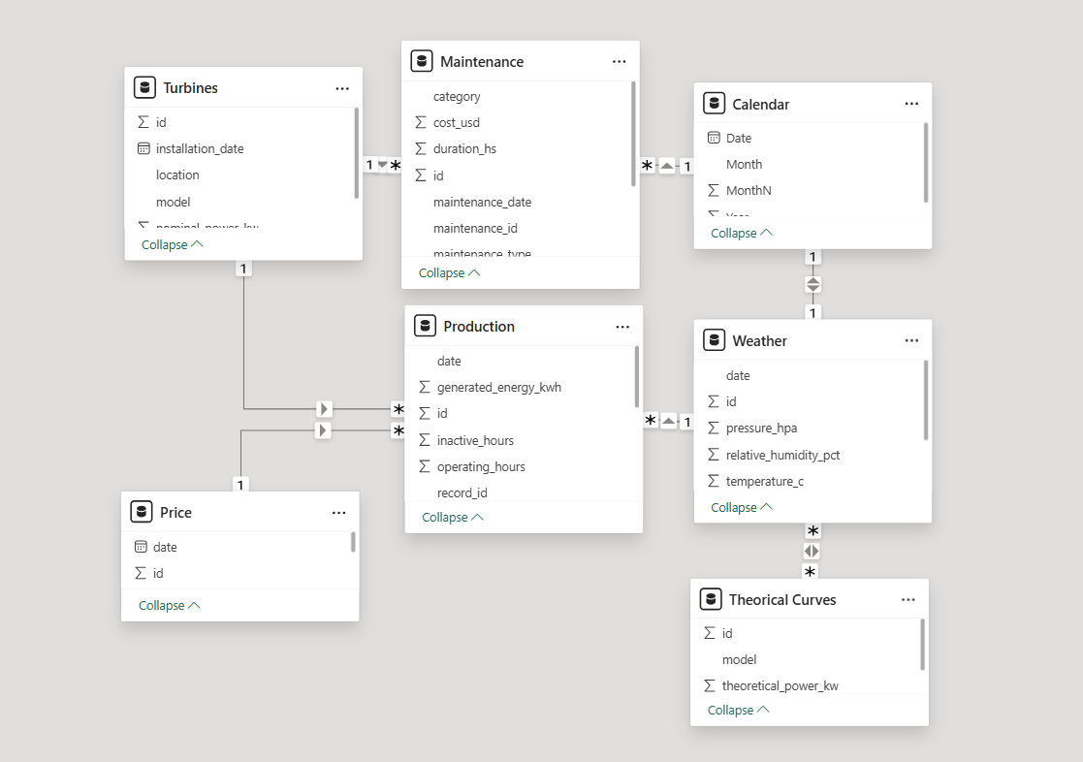

Figure 4. Dimensional relationship between tables.

Both tables relate to dimension tables covering turbines, weather, pricing, and calendar, along with a technical reference table (theoretical curves). Together, they form an analytical schema that preserves referential integrity and enables the joint evaluation of generation output, weather conditions, and operational behavior per turbine.

5. DAX MEASURES AND KEY VISUALIZATIONS
The development of the analytical model in Power BI required creating a set of DAX measures specifically designed to answer business questions, integrate information from multiple tables, and enable visualizations consistent with the real behavior of the wind farm turbines.

5.1 DAX Measures Created

a. Total Energy (GWh and kWh)
Measures total farm production. This is the base metric for evaluating operational performance, comparing periods, and studying the relationship with weather.

b. Real Power (kW)
Represents the electrical power effectively generated by the turbine under real operating conditions, considering wind behavior, mechanical and electrical losses, and limitations imposed by control systems.

c. Theoretical Power (kW)
Corresponds to the power expected from the manufacturer's power curve of each turbine model (theoretical curves table) at the recorded wind speed, rounded to the nearest m/s, without considering losses or operational restrictions.

d. Availability (%)
Evaluates what percentage of time the turbine was operative relative to the total day, meaning it was not stopped for maintenance, failures, or unavailability. Allows quantification of the real productivity of the farm.
Availability = Operative Hours / Total Hours

e. Capacity Factor (%)
The capacity factor measures how much of the installed capacity is actually used. It compares the energy actually generated against the maximum energy possible if every turbine in operation ran at rated power for every hour of the period.
Formally, it is defined as:
$$CF=\frac{Real energy production (kWh)}{\text{Maximum possible energy production (kWh)}\text{)}}$$

Which is equivalent to:

$$CF=\frac{Real energy production (kWh)}{Rated power (kW) × Hours in the period (h)}$$

The capacity factor is a key metric indicating how efficiently a wind turbine operates over time. It is defined as the ratio between the actual electrical energy produced during a specific period and the maximum energy it could have produced had it operated continuously at rated or full capacity throughout that same period.

Maximum possible production is calculated by multiplying the rated capacity (peak power) of each turbine in operation by the number of hours in the period (e.g. 8,760 hours in a year). It reflects how efficiently the wind farm operates relative to its theoretical potential.

Typical capacity factors for onshore wind farms range between 20–35%, depending on wind resource quality and turbine technology mix.

f. Performance (%)
Performance is the main integrating metric of the analysis, combining in a single indicator the key factors that define the global efficiency of each turbine. It is calculated as a weighted combination of availability, capacity factor, and a penalty for corrective maintenance events:

Performance = 0.65 · D + 0.30 · F + 0.05 · P

Where:
- D = Availability,
- F = Capacity Factor,
- P = Corrective maintenance factor: 1 / (1 + number of corrective events), which decreases as corrective events increase.

Performance ranges:
- High performance (80-100): outstanding performance / optimal operation
- Medium (60-80): acceptable operation with room for improvement
- Low (<60): below-expected performance / requires review

g. Total Maintenance Cost (USD)
Evaluates the economic effort invested in sustaining operations.

h. Number of Maintenance Events
Enables counting of maintenance interventions, both corrective and preventive.

5.2 Power BI Visualizations

5.2.1 'Energy Performance' Dashboard
This dashboard evaluates the energy performance of the farm. It integrates the three key operating indicators of the wind farm into a single panel, enabling analysis of monthly behavior, historical annual trends across 2023, 2024, and 2025, and identification of trends, seasonality, and deviations from targets.

Content:
- Monthly and annual capacity factor (%): seasonal and inter-annual evolution of wind resource utilization.
- Monthly and annual availability (%): tracking of farm operational continuity.
- Monthly and annual performance (%): key indicator with traffic light color coding.

5.2.2 'Operational Reliability' Dashboard
This dashboard analyzes maintenance performance of the farm, evaluating frequency, type, and cost of interventions per turbine and per period, and their relationship with operational availability. The focus is on identifying critical equipment, failure patterns, and technical and economic optimization opportunities.

Content:
- Monthly maintenance events: monthly evolution of interventions, differentiating corrective and preventive.
- Maintenance per turbine: comparison of intervention volume per turbine.
- Cost per turbine (USD): distribution of total maintenance cost per equipment and intervention type.
- Maintenance history: annual balance between corrective and preventive.
- Top failure types: most frequent failures impacting operations.
- Availability vs. cost correlation: analysis of the trade-off between operational performance and maintenance expenditure per turbine.

5.2.3 'Wind Resource' Dashboard
This dashboard analyzes the influence of wind speed on energy generation and turbine power. The focus is on understanding the physical-operational relationship between wind resource and real farm performance. It enables validation of expected behavior against theoretical models, detection of improvement opportunities in wind utilization, and explanation of energy performance from a climatic and technical perspective.

Content:
- Wind vs. generated energy scatter: direct relationship between wind speed and energy produced.
- Wind speed and generated energy (monthly): joint evolution identifying wind resource seasonality.
- Real power vs. wind speed scatter: comparison of each turbine's behavior against wind, detecting deviations or performance differences.
- Real power vs. theoretical power: contrast between the park's real curve and the expected theoretical curve.

5.2.4 'Profitability' Dashboard
This dashboard evaluates the economic result of the farm, integrating energy generation, income from energy sales, operational costs, and profit, both monthly and annually.

Content:
- Income from energy sold (USD): monthly evolution of generation-associated income.
- Costs (USD): monthly maintenance costs of the farm.
- Energy generated (kWh / GWh): monthly and total energy production.
- Profit (USD): monthly and cumulative annual economic result.

5.2.5 'Daily Turbine Monitoring' Dashboard
This dashboard presents daily evolution charts of energy generated per turbine for the last available year. It is used as an operational control panel for daily performance tracking of each turbine. Its main objective is to early detect operational anomalies, abrupt production drops, or performance deviations from expected behavior.

Content: One chart per turbine showing the daily evolution of energy generated.

6. EXPLORATORY ANALYSIS
The exploratory analysis constitutes the central stage of the project, where wind farm data is systematically examined to understand real operational behavior, validate consistency across tables, and reveal operational patterns. This initial analysis enabled the identification of trends, detection of anomalies, and provided the foundation for building operational KPIs. The following sections describe each visual and its results, organized by Power BI tab.

6.1 Scope and Variables Analyzed
The analysis was developed for the period 2023–2025, considering different temporal aggregation levels (monthly and annual) and operational disaggregation levels (per turbine).

Main variables analyzed:
- Energy generated (kWh / GWh)
- Capacity factor
- Operational availability
- Wind speed
- Real and theoretical power
- Number and type of maintenance events
- Operational costs, income, and profit

6.2 Energy Performance

6.2.1 Analysis
A favorable evolution of farm performance is observed over the 2023–2025 period. Energy indicators show progressive annual improvement, with sustained increases in both the capacity factor and the overall system performance.
In 2023, the farm presents the lowest values of the analyzed period, with moderate energy performance and marked monthly variability. Indicators reflect initial resource utilization, with peaks concentrated in the middle months of the year and pronounced drops toward the edges of the period.
During 2024, improvement is observed over the previous year, with an increase in annual capacity factor and aggregate performance. The seasonality observed in 2023 is maintained, with higher capacity factor values in 10 of the 12 months, indicating positive evolution of overall farm performance.
In 2025, the last year considered, the farm achieves the highest capacity factor and annual performance values of the analyzed period. Seasonality continues, with peaks in the central months, but the general level of indicators is above previous years. Operational availability remains stable, supporting energy performance improvement without evidencing deterioration in operational continuity.

6.2.2 Key Findings
- Progressive improvement in annual energy performance between 2023 and 2025.
- Performance seasonality remains constant across all three years, with peaks in the central months.
- Operational availability shows stable values with limited inter-annual variations.
- 2025 is the year with the best aggregate energy performance within the analyzed horizon.

6.2.3 Business Questions Addressed

Q1. Is the energy performance improvement sufficient to justify overall farm performance against installed capacity?
Analysis
The improvement is consistent with better utilization of installed capacity. The increase in capacity factor and global performance occurs without significant increases in operational availability, which remains practically constant. This indicates the farm generates more energy per installed MW and per available hour, ruling out that improvement comes from greater operation time.
Conclusion
Yes. The energy performance improvement justifies the overall farm performance against its installed capacity, evidencing more efficient asset utilization without requiring increases in installed power or operational availability.

Q2. Is the increase in capacity factor homogeneous throughout the year or concentrated in specific periods?
Analysis
The increase in capacity factor is not homogeneously distributed throughout the year, but responds to a structural seasonal pattern with peaks concentrated in the winter months. This is consistent with the indicator's definition and with the physics of the wind resource.
The theoretical power available in the wind follows the physical formula:

$$P=\frac{1}{2}⋅ρ⋅A⋅w^{3}$$

Where:
P is power
ρ is air density
A is the rotor swept area
w is wind speed.

Since power is proportional to the cube of wind speed, relatively small increases in average winter speed generate significant increases in energy produced, raising the capacity factor. In summer months, even with similar availability levels, lower average wind speed limits achievable power, reducing the indicator's value.
Conclusion
The capacity factor increase is conditioned by resource seasonality with dominant winter peaks, but the improvement observed in 2025 reflects better wind utilization throughout the entire year, elevating the farm's global energy performance.

Q3. Can the energy performance achieved in 2025 be considered a new baseline for the farm or an isolated peak?
Analysis
The 2025 improvement appears in 11 of the 12 months and keeps the park's characteristic seasonal pattern, so it is not driven by isolated peaks or atypical behaviors. It is, however, a marked step up: the annual capacity factor rises by 5.6 percentage points (from 21.0% to 26.6%), compared with 1.9 points in 2024.
Conclusion
The 2025 energy performance is consistent throughout the year and is not an isolated peak. With only one year at this level, it should be treated as a provisional baseline until it is confirmed by another year of operation.

Q4. Did the new technology (V110 and GE 2.5-116) economically improve the farm?
Analysis
In 2023, the farm operated exclusively with Vestas V100 turbines, with an annual capacity factor of 19.1%. With the V110 units in 2024 it rose to 21.0%, and in 2025, with the GE 2.5-116 units (T008–T010), it reached 26.6%. However, in 2025 all models reached similar values (V100 26.2%, V110 27.7%, GE 2.5-116 26.4%), including the original V100 units.

Year | Technology | Annual Capacity Factor
2023 (V100 only) | Vestas V100 | 19.1%
2024 (with V110) | Vestas V110 added | 21.0%
2025 (with GE) | GE 2.5-116 added | 26.6%

Conclusion
Partially. The capacity factor rose from 19.1% to 26.6%, but the increase occurred in every turbine model, so it cannot be attributed to the new technology. The benefit of the new models is in reliability: higher availability (93.2% for the V110 and 93.7% for the GE 2.5-116, versus 87.3% for the V100 units), fewer corrective events and lower maintenance cost per MWh. This supports prioritizing them in future expansions, to be confirmed with more years of operation of the GE units.

6.3 Reliability

6.3.1 Analysis
The reliability analysis shows differentiated evolution in the maintenance behavior of the wind farm over 2023–2025, both in number of interventions and associated costs.
In 2023, the farm records the lowest number of maintenance events of the period (26, of which 21 corrective) across the five V100 units installed, with a total cost of USD 64.2k. Corrective maintenance predominates, but the overall economic impact is limited, reflecting a contained operational level in terms of intervention.
During 2024, the number of maintenance events (35) and the total cost (USD 74.9k) reach their highest levels, with seven turbines in operation. Corrective maintenance continues to represent the majority of interventions (24 of 35).
In 2025, while the total number of maintenance events continues to increase (45), total cost decreases to USD 57.2k. A shift in the composition of interventions is observed, with preventive maintenance reaching 28 of the 45 events, and cost falls in six of the seven turbines that were already operating in 2024. This suggests improvement in the maintenance scheme efficiency.
The correlation analysis between availability and maintenance cost shows a strong negative relationship (r = −0.87): turbines with higher maintenance costs present lower availability, as corrective interventions concentrate in the least reliable units.

6.3.2 Key Findings
- The number of maintenance events progressively increases between 2023 and 2025.
- The cost peak is recorded in 2024, while in 2025 costs decrease despite a higher number of interventions.
- In 2025, a shift in the maintenance mix is observed, with greater preventive vs. corrective weight.
- Maintenance costs are concentrated in specific turbines: T003 accounts for 22% of the total cost over the three years.
- A strong negative relationship is observed between maintenance cost and availability (r = −0.87).

6.3.3 Business Questions Addressed
Q1. Does maintenance cost evolve proportionally to the number of interventions?

Analysis
The year-over-year comparison indicates that total maintenance cost does not scale proportionally with the number of interventions. In 2025, total cost decreases relative to 2024 despite a higher number of maintenance events.
This is attributable to a structural shift in the maintenance mix toward preventive interventions, which carry lower unit costs than corrective ones (on average USD 432 versus USD 2,858 per event). Corrective maintenance typically entails longer repair times, unplanned spare parts consumption, and unscheduled logistics, all of which drive up cost per event. As preventive activity increases, unplanned failures are reduced, lowering both the frequency and average cost of corrective interventions.
Conclusion
No. Maintenance cost does not scale linearly with intervention volume. The increased weight of preventive maintenance in 2025 reduced the incidence of high-cost corrective events, resulting in lower total expenditure despite greater overall maintenance activity.

Q2. Are we spending on maintenance where it truly impacts farm reliability?
Analysis
Maintenance costs are not homogeneously distributed — they are concentrated in a small subset of turbines. T003 is the highest-cost unit (USD 42.7k, 22% of the total), followed by T005 and T004. The availability vs. cost correlation is strongly negative (r = −0.87): the turbines with the highest maintenance cost are also those with the lowest availability, with T003 at the unfavorable extreme (83% availability). In contrast, newer turbines T008, T009, and T010 show low costs and high availability.
Conclusion
Partially. Maintenance spending is concentrated where failures occur, but in the highest-cost turbines it has not translated into higher availability. The recurrence of T003 as the main cost focal point, followed by T005 and T004, justifies targeted reliability management over these units.

Q3. Are there turbines with recurring corrective failure patterns impacting farm reliability?
Analysis
Turbine T003 presents a recurring pattern of corrective failures across all analyzed years, with recurrence year after year. The Pareto analysis of failure types shows that the largest proportion of corrective events in T003 is associated with overtemperature shutdowns. This repetition suggests a structural condition of the asset, possibly related to the cooling system or aging of temperature-sensitive components.
Conclusion
Yes. Turbine T003 has a recurring corrective failure pattern that directly impacts farm reliability and economic performance. This pattern justifies prioritizing it as a critical asset, focusing predictive maintenance actions and specific technical analysis on the dominant failure modes identified.

6.4 Wind Resource

6.4.1 Analysis
The wind resource analysis for 2023–2025 evaluates how wind variability conditions the farm's energy generation and to what extent performance improvements respond to the available resource or to system efficiency.
Across all three years, a positive relationship between wind speed and generated energy is observed, consistent with expected physical behavior. However, point dispersion shows that for the same wind speed, energy produced is not uniform, indicating the influence of additional factors such as turbine technology, aerodynamic efficiency, and operating conditions.
In 2023, moderate average wind speeds and wide dispersion are observed. During 2024, a similar velocity pattern is maintained but with improved conversion efficiency. In 2025, the wind resource retains comparable seasonal behavior to previous years, with winter maximums, but for similar speeds, generated energy is greater.
Overall, the exploratory analysis shows that the improvement in farm energy performance is not explained by a substantial increase in wind resource, but by more efficient utilization of available wind, particularly visible in 2025.

6.4.2 Key Findings
- The relationship between wind speed and generated energy is positive across all three years.
- The wind regime maintains a stable seasonal pattern with winter maximums.
- For similar wind speeds, generated energy is higher in 2025 than in 2023 across all speed ranges.
- In 2025, real power moves closer to the theoretical curve at wind speeds above 8 m/s (91% of the theoretical power at 8–10 m/s, compared with 65% in 2023).
- Energy performance improvement is not associated with greater wind resource but with better utilization of it.

6.4.3 Business Questions Addressed
Q1. Is the energy generation improvement explained by greater wind resource or greater farm efficiency?
Analysis
Comparative analysis of average wind speeds confirms that the available wind resource remains relatively stable throughout the 2023–2025 period, with no significant structural change in the seasonal regime. However, energy output for equivalent wind speed ranges increases progressively — most markedly in 2025.
The narrowing gap between actual and theoretical power at wind speeds above 8 m/s indicates that the park converts wind into electricity more efficiently over time, independent of any meaningful increase in available resource.
Conclusion
The energy generation improvement is mainly explained by greater efficiency in wind resource utilization, not by a substantial increase in available wind speed.

Q2. Does the farm uniformly harness wind across the entire speed range?
Analysis
Analysis of actual versus theoretical power as a function of wind speed demonstrates that resource utilization is not uniform across the operational range.
Real power exceeds the theoretical value below 8 m/s, because a daily average hides hours with stronger wind, so comparisons in the low speed range are less reliable. From 8 m/s upward, real power falls below the theoretical curve (about 80% of the theoretical value at 8–10 m/s and 55–60% above 10 m/s), while the theoretical curve reaches rated power at around 12 m/s, where turbine control systems (pitch regulation and torque control) cap power extraction to prevent structural and electrical overload.
This behavior defines a physical saturation threshold beyond which additional wind speed increments do not yield proportional energy gains.
Conclusion
No. The farm does not harness the wind resource uniformly across the speed range. The largest gap between real and theoretical power is at high wind speeds, above the rated-power threshold set by turbine design, and the 2025 improvement is also largest from 8 m/s upward.

Q3. Which wind speed range explains most of the park's annual generated energy?
Analysis
Joint analysis of the wind speed frequency distribution and the power curve indicates that the medium wind speed range accounts for the dominant share of annual energy output (6–10 m/s: 59% of the energy generated in 2023–2025). This range combines a high frequency of occurrence with near-peak conversion efficiency, maximizing the contribution to total generation.output. This range combines a high frequency of occurrence with near-peak conversion efficiency, maximizing the contribution to total generation.
High wind speeds, while yielding greater instantaneous power, occur less frequently and are subject to rated power limitations that cap their contribution. Low wind speeds, though frequent, generate little energy due to low conversion efficiency near the cut-in threshold.
Conclusion
Most of the park's annual energy is explained by performance in medium wind speeds, where occurrence frequency is high and system conversion efficiency is maximum. Any improvement in capture, control, or availability within this range has a significantly greater impact than actions focused on wind regime extremes.

Q4. What implications does wind resource behavior have for future expansions or repowering?
Analysis
Given that annual energy generation is predominantly driven by performance at medium wind speeds, future capacity additions should prioritize turbine technologies optimized for efficient conversion in the medium speed range. Increasing rated power for extreme wind conditions offers limited incremental benefit relative to the park's actual resource profile.
Conclusion
Expansion or repowering decisions should be oriented toward technologies with greater aerodynamic efficiency and better performance at medium speeds, aligned with the site's real regime.

6.5 Profitability

6.5.1 Analysis
The profitability analysis shows sustained improvement in the wind farm's economic result over the 2023–2025 period, driven mainly by progressive increases in energy generated and associated energy sales income.
In 2023, the farm presents the lowest annual energy and income levels, with a positive but limited economic result. During 2024, both total energy generated and annual income increase, accompanied by higher operational costs. The income growth surpasses cost growth, resulting in improved annual profit. In 2025, the farm achieves its best economic performance of the analyzed period, with the highest energy generated, income, and annual profit.

6.5.2 Key Findings
- Farm profitability improves sustainably between 2023 and 2025.
- Annual profit increase is strongly associated with increased energy generated.
- Income grows at a faster rate than operational costs.
- Generation seasonality directly translates into income and profit seasonality.
- 2025 is the year of greatest economic profitability for the farm.

6.5.3 Business Questions Addressed
Q1. Is the farm's profit growth driven primarily by higher income or cost reduction?
Analysis
Year-over-year analysis indicates that profit growth is driven mainly by higher revenue: between 2024 and 2025, revenue grew by USD 1.32 million, while lower maintenance costs added USD 18 thousand. Annual profit rose from USD 952k in 2023 to USD 1.54 million in 2024 (+62%) and USD 2.88 million in 2025 (+87%).
Between 2024 and 2025, generated energy and associated revenues increase substantially, following the addition of three new turbines and a higher capacity factor across the fleet. In parallel, total maintenance costs decline (from USD 74.9k to USD 57.2k) despite the expanded fleet and higher maintenance activity, as preventive interventions replace part of the more expensive corrective ones.
Conclusion
Farm profit growth is driven primarily by higher income from greater energy generation, which explains 99% of the increase between 2024 and 2025. Lower maintenance costs, with fewer corrective events, contribute marginally but confirm that the larger fleet did not raise the cost base.

Q2. Does wind resource seasonality directly impact monthly farm profitability?
Analysis
The seasonal pattern observed in energy generation is directly reproduced in monthly revenue and profit figures. Months with higher wind resource and greater generation concentrate the majority of the annual economic result, while lower-generation months yield reduced profitability.
Only one month in the analyzed period shows a negative result: January 2023, the first month of operation and part of the lowest-wind season, when revenue (USD 6.9k) did not cover maintenance costs (USD 13.5k). In every other month, revenues exceed maintenance costs, indicating a cost structure able to absorb seasonal variability.
Conclusion
Yes. Farm profitability is seasonal and directly influenced by wind resource availability. Apart from January 2023, every month shows a positive result, evidencing high economic resilience of the farm against seasonal wind variability.

7. INSIGHTS AND CONCLUSIONS
The integrated analysis of energy performance, reliability, wind resource, and profitability enabled identification of consistent patterns in farm behavior and the impact of technological and operational decisions.

7.1 General Conclusions
The analyzed wind farm shows a positive evolution in energy, operational, and economic performance over the 2023–2025 period. The increase in capacity factor, greater energy generated, and improved economic results evidence more globally efficient performance, particularly in the last year of the evaluated period.
Results show that this evolution comes from the expansion of the fleet (from five to ten turbines) and from a higher capacity factor across all turbine models in 2025, while availability remained stable and costs under control despite the larger fleet. The newer models add higher availability and lower maintenance costs.
In contrast, turbines with operational and economic performance below park average were identified, with T003 standing out as the main critical asset, and to a lesser extent T002 and T004, which show higher maintenance costs and lower relative availability.

7.2 Technology Impact on Farm Performance

Model | Turbines | Nominal Capacity | Observed Effect
V100 (2023) | T001–T005 | 2,000 kW | CF from 19.1% (2023) to 26.2% (2025); lowest availability (87%) and highest corrective rate
V110 (2024) | T006–T007 | 2,200 kW | CF similar to the V100 (27.7% in 2025) with higher availability (93%)
GE 2.5-116 (2025) | T008–T010 | 2,500 kW | CF similar to the rest of the fleet (26.4% in 2025); highest availability (94%) and lowest maintenance cost

7.3 Technical and Business Recommendations

7.3.1 Improvement Strategy for V100 Turbines: Integrated Preventive–Predictive Maintenance
The trend observed in V100 and V110 turbines indicates that a large part of corrective events comes from failures in predictable subsystems (overtemperature, yaw, main bearing vibration, pitch). Since corrective costs directly impact availability, a sensor-based and early warning approach would allow anticipating failures and extending the useful life of critical components.warning approach would allow anticipating failures and extending the useful life of critical components.
The analysis of Vestas V100 turbine performance (particularly T003 and secondarily T002 and T004) shows an imbalance between energy generated and maintenance costs:
- Lower relative generation compared to turbines in the same group.
- Higher frequency of corrective interventions.
- Higher specific cost per MWh above park average.
- Marked variability in monthly availability.
- Increased mechanical stress from repetitive failures in critical subsystems.

Proposed Actions:
- Increase frequency of scheduled inspections — historical failure data shows recurrence in predictable subsystems (overtemperature, yaw, main bearing, pitch).
- Standardize V100-specific checklists to reduce variability and prevent small anomalies from escalating into complex corrective maintenance.
- Schedule lubrication and adjustments based on equivalent operating hours, not fixed intervals.
- Incorporate predictive monitoring tools: vibration sensors in tower, nacelle, and bearings; thermal monitoring in generator; online oil analysis; SCADA signal validation for micro-shutdown tracking.

Expected Impact:
- 20–30% reduction in corrective maintenance events, shifting unexpected failures toward planned interventions.
- Direct reduction in inactive hours, with proportional annual availability improvement.
- Extended useful life of critical components, reducing emergency intervention costs.
- Stabilization of availability and monthly performance, reducing operational variability of the V100 group.

Conclusion: Integration of preventive and predictive maintenance constitutes a low-CAPEX strategy that allows significant improvement of V100 turbine performance, reducing the gap with technologically newer units without requiring replacements.

7.3.2 Technological Standardization Toward GE 2.5-116 Models
The most recently installed turbines (GE 2.5-116) evidence:
- Higher availability (93.7% versus 87.3% for the V100 units)
- Lower rate of recurring failures
- Lower corrective costs
- Better energy/operational cost ratio

From a strategic perspective, advancing toward a more homogeneous fleet would enable:
- Simplifying spare parts inventories
- Standardizing maintenance protocols
- Obtaining better agreements with suppliers
- Reducing the levelized cost of energy (LCOE)

Recommendation: Prioritize the GE 2.5-116 model for future expansions and consider its adoption as the park's technological standard. Adopting this model as the base technology improves availability, reduces failure frequency, and stabilizes maintenance costs. Its capacity factor is similar to the rest of the fleet (26.4% in 2025), and the evaluation should be confirmed as more years of operation become available.

7.3.3 Optimization of Planned Shutdown Scheduling
Monthly generation data shows wind resource peaks during May–September, while months of lower wind concentrate between November and February. This enables a clear strategy:
- Relocate major maintenance and planned shutdowns to low-wind months
- Minimize unavailability during peak season
- Leverage stable meteorological windows for critical elevated work

Expected result: An additional reduction in losses due to unavailability, increasing captured energy without additional investments.

7.4 Relevant Technical Cases

7.4.1 Technical Case – Turbine T003 (Critical)
Context and Justification
From the wind farm reliability analysis, turbine T003 is consistently identified as the asset with the greatest negative impact in terms of maintenance cost and relative availability. T003 recurrently appears at the unfavorable extreme of the maintenance cost vs. availability correlation, as the unit with highest accumulated cost and lowest relative availability in the park.
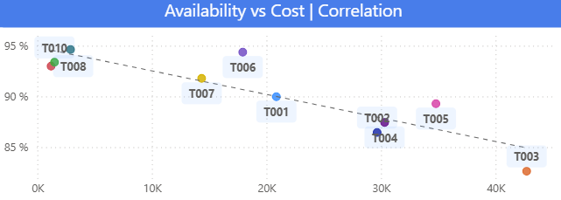
Figure 5. Availability vs cost correlation.

Maintenance and Reliability Behavior
The historical intervention analysis shows T003 concentrates a high number of corrective maintenance events across all three analyzed years (2023–2025), with recurring events year after year. Unlike other park turbines, T003's corrective events do not appear as isolated occurrences but as a repetitive pattern.

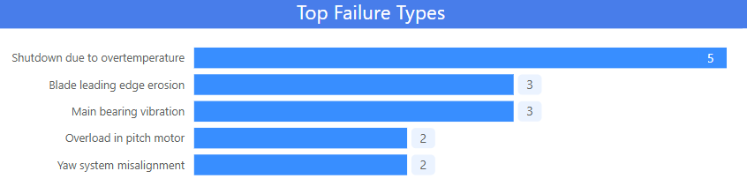
Figure 6. T003 Top Failures

The failure type analysis shows that the largest proportion of corrective events in T003 is associated with overtemperature shutdowns (5 of 15), followed by blade leading edge erosion (3), main bearing vibration (3), pitch motor overload (2) and yaw system misalignment (2).

Economic and Operational Impact
T003 presents the highest accumulated maintenance cost in the park, with a disproportionate weight relative to its contribution. Despite interventions performed, the turbine maintains below-average availability levels, indicating that maintenance spending has limited operational return in terms of reliability.
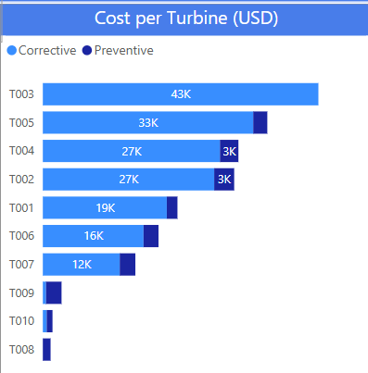
Figure 7. Cost per wind turbine (USD).

Technical Recommendations:
- Prioritize T003 for deep technical analysis focused on thermal management and control subsystems.
- Implement specific predictive maintenance using temperature and vibration monitoring to anticipate failure conditions.
- Evaluate structural interventions (cooling improvements, control adjustments, critical component replacement) oriented toward reducing corrective recurrence.
- Analyze the economic viability of a retrofit or major intervention, considering recurring maintenance cost versus expected benefit in availability.

7.4.2 Technical Case – Turbines T008/T009/T010 (Benchmark)
Context and Justification
In contrast with critical turbines, T008, T009, and T010 stand out within the wind farm for their stable operational behavior, low maintenance cost, and high relative availability. Their consistent performance positions them as an internal benchmark, useful for identifying replicable good technical and operational practices.

Maintenance and Reliability Behavior
The maintenance history of T008, T009, and T010 shows a clear predominance of preventive interventions, with low corrective maintenance incidence. The failure type Pareto analysis confirms these turbines do not appear relevantly among the main contributors to corrective events in the park.

Economic and Operational Impact
T008, T009, and T010 present some of the lowest maintenance costs in the park, consistently remaining in the favorable zone of the maintenance cost vs. operational availability correlation. This combination reflects high efficiency in maintenance budget utilization, with low relative spending and high operational return.

Figure 8. Cost per wind turbine (USD).

Lessons Learned and Replicability:
- Greater emphasis on preventive maintenance reduces the need for costly corrective interventions.
- Operational stability directly translates into lower cost per unit of energy generated.
- The combination of appropriate technology and coherent maintenance strategy generates sustained benefits over time.

The comparison between the critical case (T003) and the benchmark case (T008) demonstrates that improvement in overall farm performance does not depend solely on increasing interventions, but on aligning technology, maintenance strategy, and operating conditions.

7.5 General Conclusion
Based on the results obtained, lines of action emerge aimed at consolidating the improvements achieved and sustaining farm performance over time. The analysis shows the need for differentiated asset management, focusing technical actions on turbines with recurring low performance such as T003, whether through specific adjustments, advanced maintenance strategies, or medium-term replacement evaluations.
In parallel, the positive evolution associated with greater weight of preventive maintenance confirms the advisability of formalizing this approach, using historical information to optimize maintenance planning and budget. The seasonality of wind resource additionally offers an opportunity to reschedule non-critical interventions during lower generation periods, minimizing impact on annual energy produced.
Finally, evidence supports technological standardization toward more reliable models, such as GE 2.5-116 turbines (higher availability, fewer corrective events and lower maintenance cost in their first year of operation), as a criterion for future expansion or renewal decisions, reinforcing a more efficient, predictable, and economically sustainable operational scheme.
Together, these actions allow moving from a reactive to a proactive, data-driven approach, where technical and economic decisions are supported by objective performance, reliability, and cost indicators. This framework facilitates investment prioritization, continuous operational improvement, and greater predictability of the park's economic result, strengthening its competitiveness and adaptability to future growth scenarios or changes in resource conditions.

