Prospect Automation Engine — Architecture Reference
GTM AI & Automation — architecture reference Companion to the Case Study and PRD · FULL VERSION
This document holds the diagrams: the current production architecture, the three-generation evolution, the qualification decision logic, the data flow, and the failure-handling model.

Redacted version. Vendors appear as capability descriptors. The topology, decision logic, and known gaps are unchanged.

1. Current production architecture
Three layers, matching the operating model: the CRM is the system of record, an enrichment-and-research layer does the expensive work, and an activation layer sends.
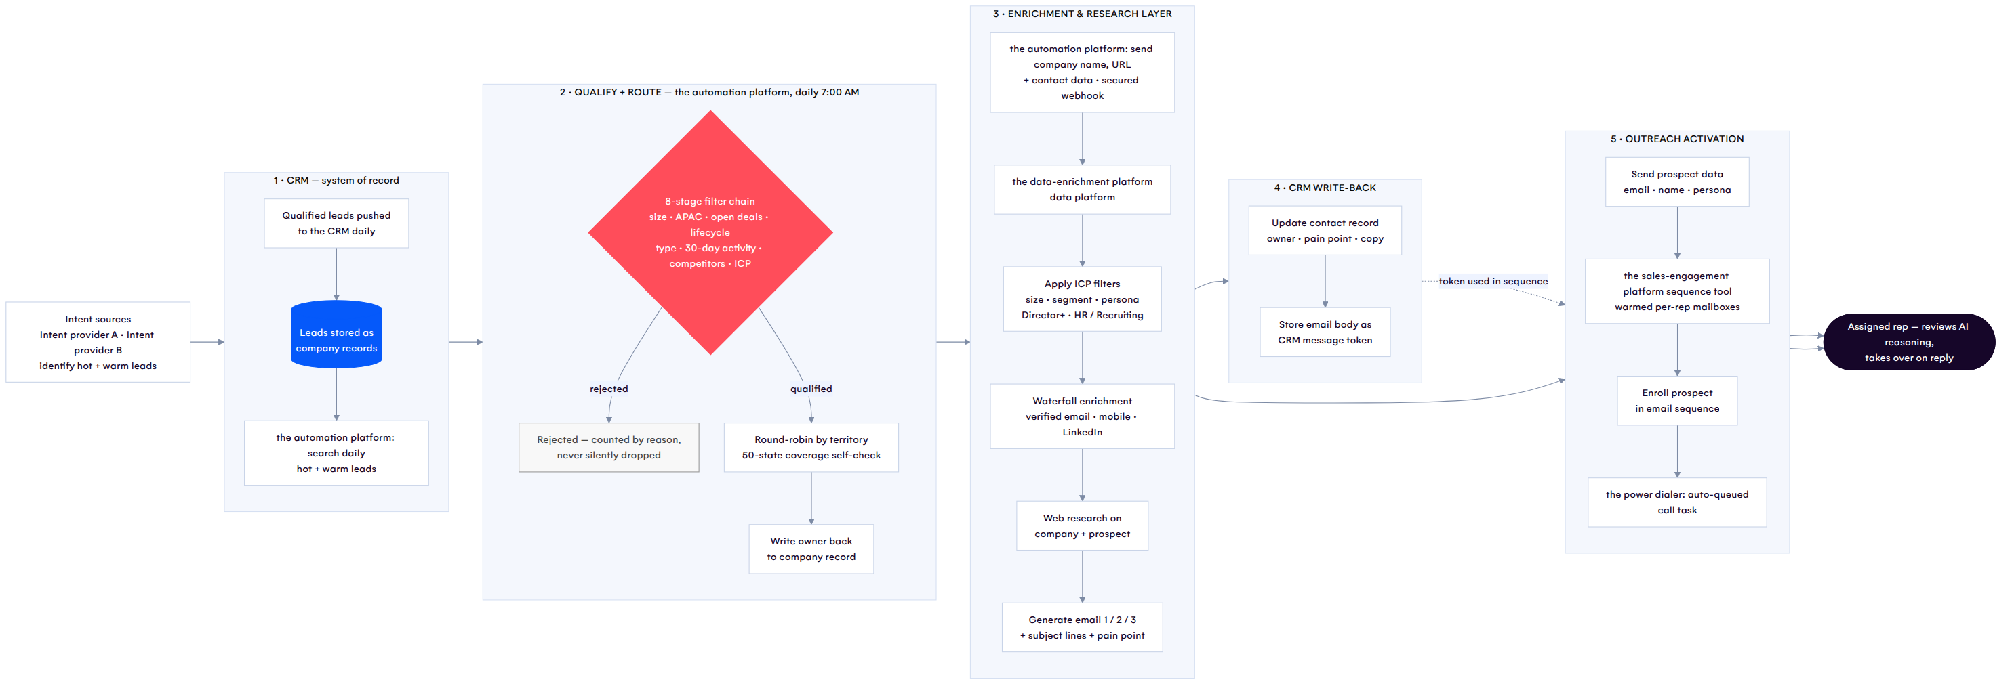
Diagram 1

The same flow in eight steps
- Hot and warm leads are sent from a commercial intent-data provider to the CRM daily, on criteria set in the primary intent provider.
- The an automation platform automation searches the CRM for that day’s hot and warm leads.
- the automation platform sends company names, URLs, and contact data to the data platform (a multi-source data-enrichment platform / a sales-engagement and contact-data platform).
- the automation platform and the enrichment platform enrich the company data against preset filters — ICP size, segment, persona.
- the automation platform and the enrichment platform conduct web research on the prospect and the company.
- the automation platform and the enrichment platform generate a personalized email message based on that research.
- the automation platform and the enrichment platform write the email body back to the CRM, stored as a message token for the sequence.
- the automation platform and the enrichment platform send prospect data — email, name, persona — to the sequence tool, which enrolls them.

2. Architectural evolution — three generations
The shape of the system changed twice. Both changes were responses to diagnosed problems, not preferences.
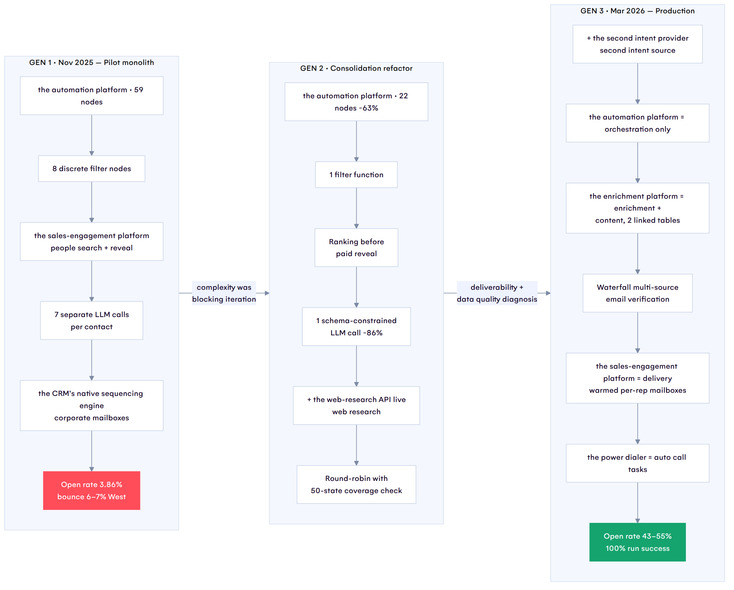
Diagram 2
 | Gen 1 (pilot) | Gen 2 (refactor) | Gen 3 (production)
Workflow nodes | 59 | 22 | orchestration only
LLM calls per contact | 7 | 1 | 1 (in the enrichment platform)
Filter implementation | 8 nodes | 1 function | 1 function
Email sourcing | single source | single source + ranking gate | multi-source waterfall
Web research | none | the web-research API tool | native, in enrichment
Sending | CRM sequences, corporate inbox | same | dedicated warmed mailboxes
Calling | manual tasks | manual tasks | auto-queued via dialer
Intent sources | 1 | 1 | 2
Open rate | 3.86% | — | 43–55%

3. Qualification decision logic
Eight sequential gates. Any single failure disqualifies the company — and every rejection is counted by reason, which is what makes “are we filtering out good leads?” an answerable question.
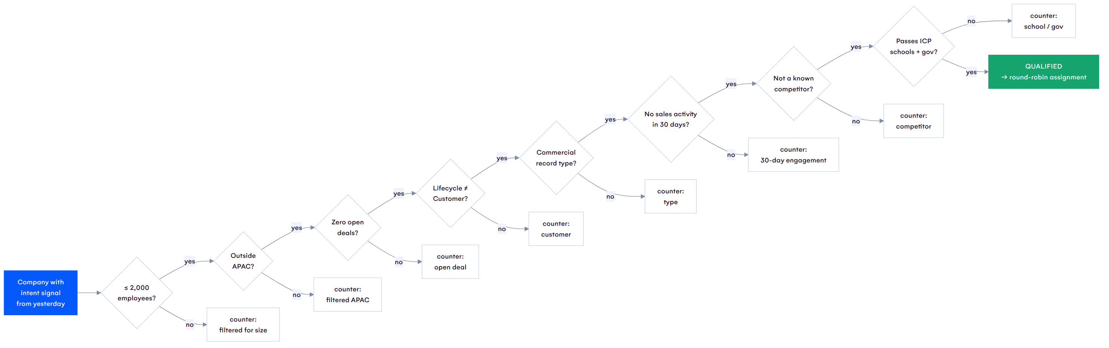
Diagram 3
Why the APAC filter is 150 lines and not one line. Location arrives as free text across four possible fields. The filter normalizes case, punctuation, and whitespace, then matches against full country names, two-letter ISO codes, and regional labels (“APAC”, “Asia Pacific”, “Australasia”, “Oceania”) — with an explicit allowlist that runs first, so US territories (Puerto Rico, Guam, US Virgin Islands, American Samoa, Northern Mariana Islands, DC) can never be excluded as Pacific. That override exists because the naive version silently dropped legitimate US accounts.

4. Routing: guaranteed assignment
The stated design rule in the code is no skips. Every record leaves this function with an owner.
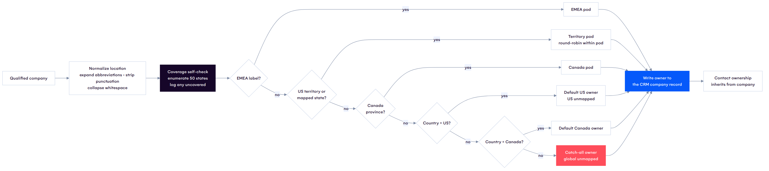
Diagram 4
The red catch-all is the important box. It exists so that a record with an unrecognizable location is assigned to a human rather than disappearing. A dropped lead produces no error message — which is exactly why it needs a structural guarantee rather than vigilance.

5. Contact selection: sniper, not shotgun
Diagram 5
Two design decisions are visible here. Ranking happens before the paid reveal — credits are only ever spent on people the system has already decided are worth contacting. And only the top N per company are ever contacted, deliberately, so the system messages a few right people rather than an entire org chart.

6. Failure handling model
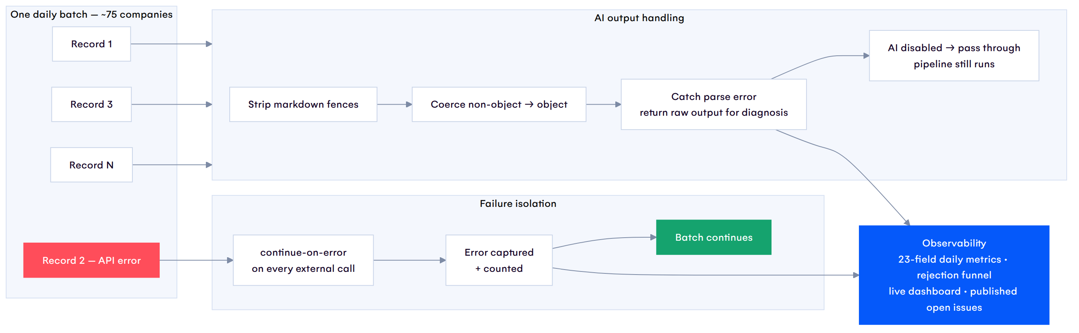
Diagram 6
Three principles. One record’s failure never aborts the batch. Model output is parsed as untrusted input — fences stripped, non-objects coerced, parse errors returned as diagnosable data rather than thrown. And the AI layer is optional: with it disabled, records pass through and the deterministic pipeline still runs.

7. Where money is spent
Worth its own diagram, because “spend late” was a deliberate architectural constraint rather than an optimization applied afterward.
Diagram 7
Everything free happens first. The two genuinely expensive steps sit at positions 7 and 8 of 9 — after qualification has removed unfit companies and after ranking has removed unfit people. In the pilot, the reveal sat earlier in the chain and the system was paying to enrich contacts it was about to discard; moving it was a direct cost reduction.

8. Known gaps in the current architecture
Marked on the diagram, so to speak — the honest annotations.
Gap | Where | Consequence
Audit logging in dry-run mode | Orchestration layer, data-table write | No run-level audit trail is being persisted
Company size + industry blank | Enrichment layer, ICP scoring inputs | Scoring runs on missing data; bad-fit companies pass (4 of 15 on a sampled day)
Second intent source not flowing | Signal layer | Roughly half the intended signal volume is missing
No run-level idempotency key | Orchestration layer | A re-run could duplicate enrollments
EMEA routing built but inactive | Routing | Capacity exists, not switched on
A/B testing framework absent | Content layer | Copy cannot be tested against the open reply-rate problem
Compliance not independently specified | Activation layer | Regional outbound rules assumed via the sending platform, not verified

GTM AI & Automation case file · REDACTED VERSION — cleared for public portfolio use No credential value appears anywhere in this document.

