**TERRAFORM-03_04**

**1) Watch terraform-03 video. and 2)Execute the script shown in video.**

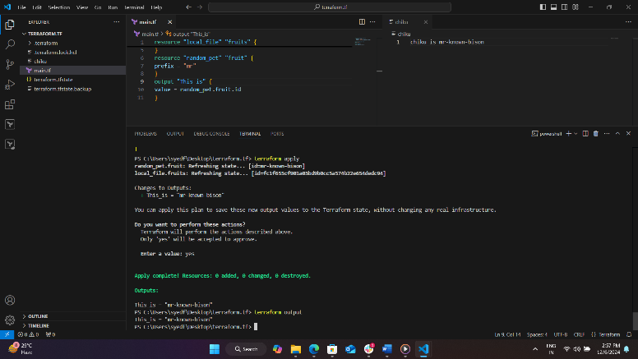 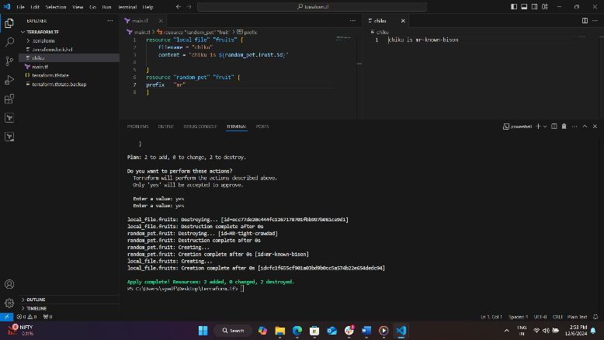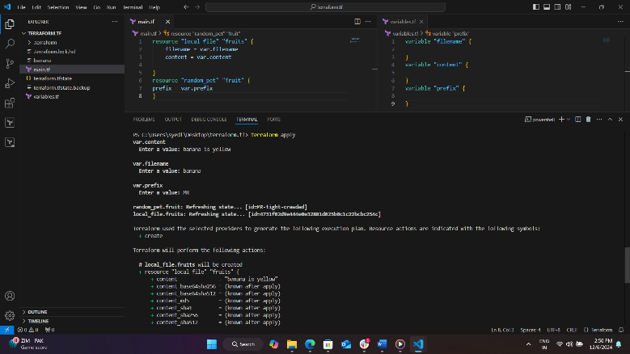 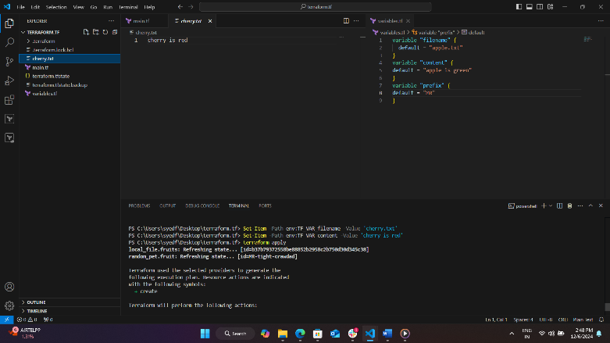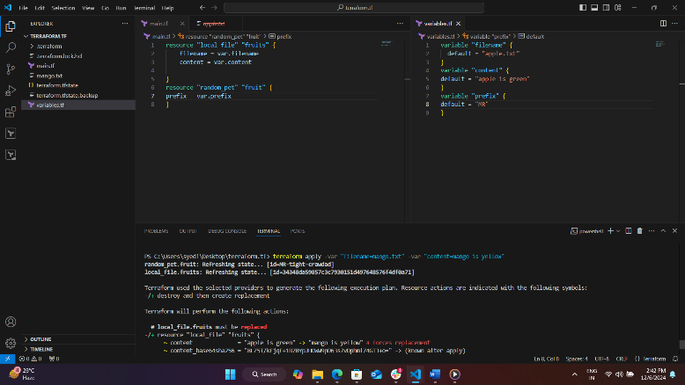 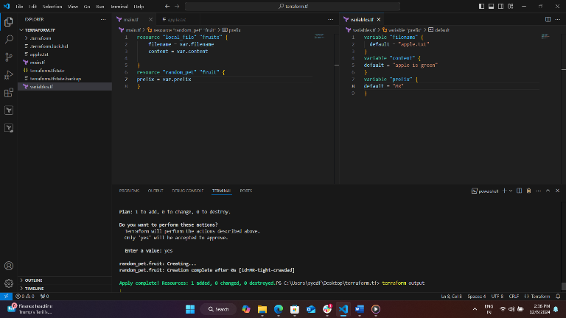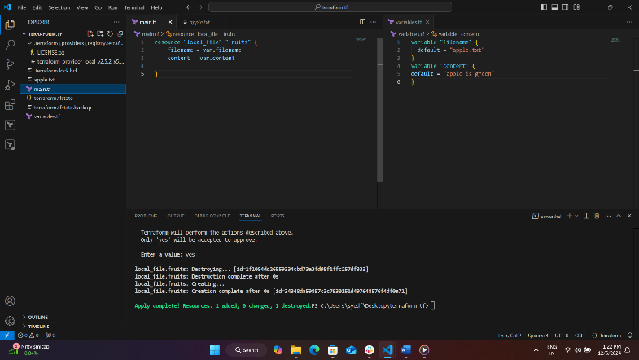

**3) Intergrate terrafrom in jenkins using Terraform plugin.**

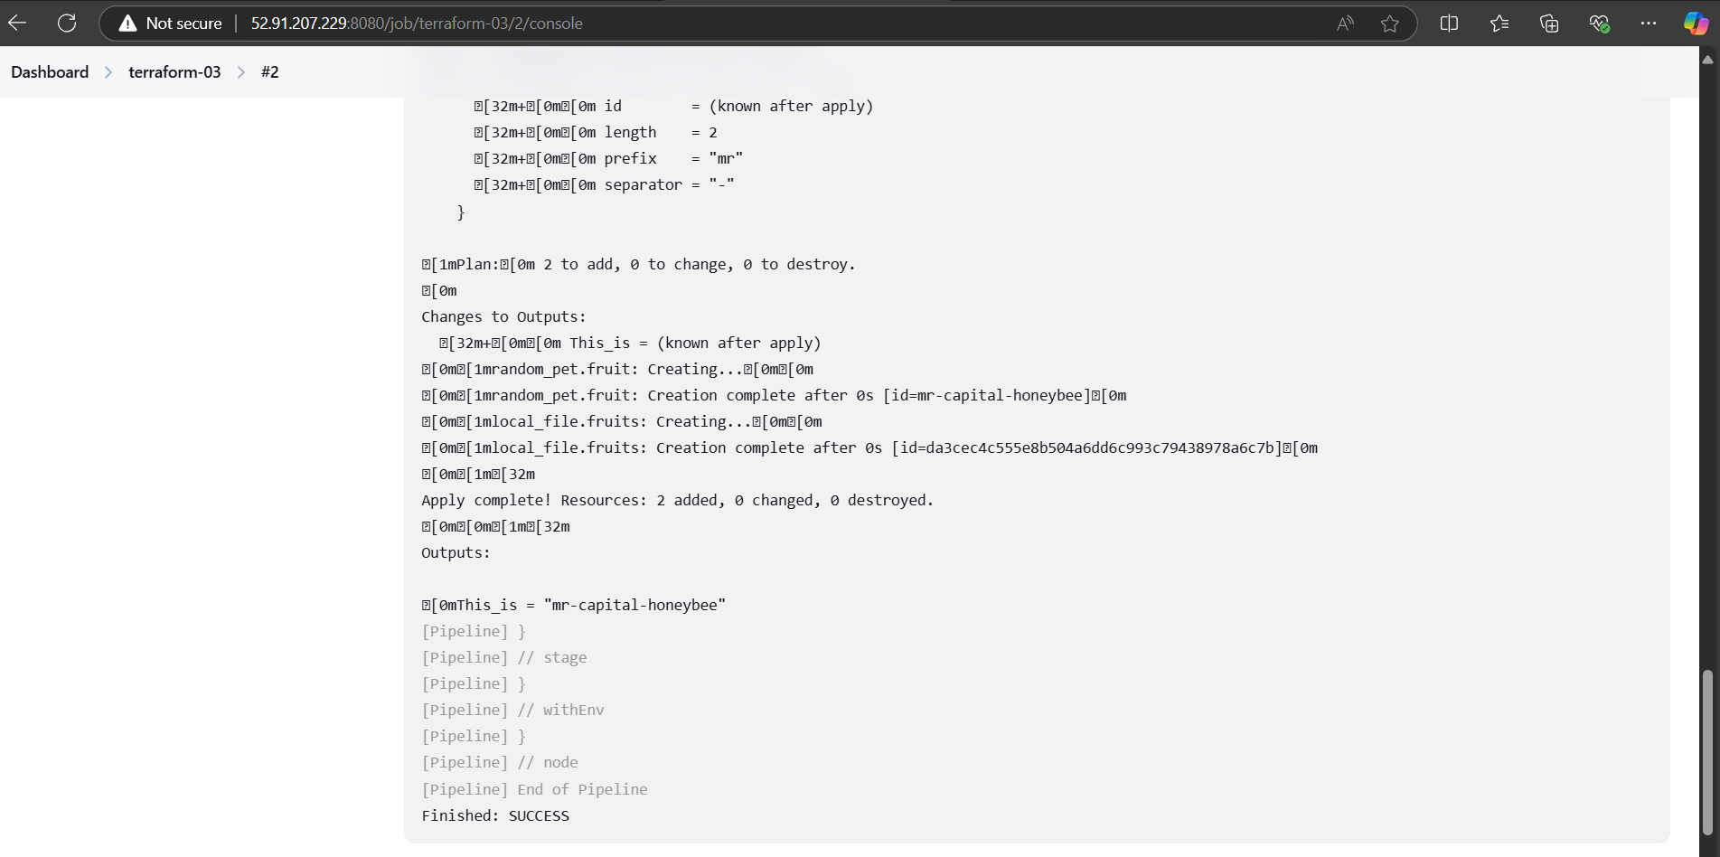

**4) Create one jenkins job using MAVEN PROJECT for the below code with two stages.**

stage 1: Git clone

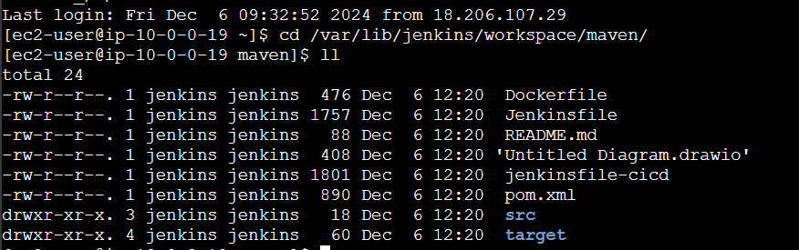

stage 2: Maven Compilation

Code: <https://github.com/betawins/java-Working-app.git>

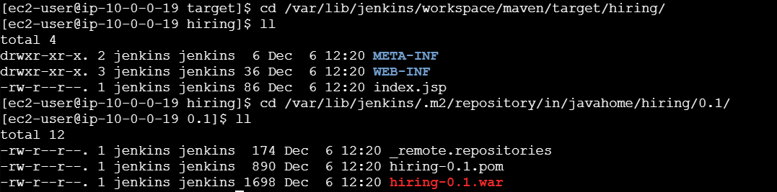

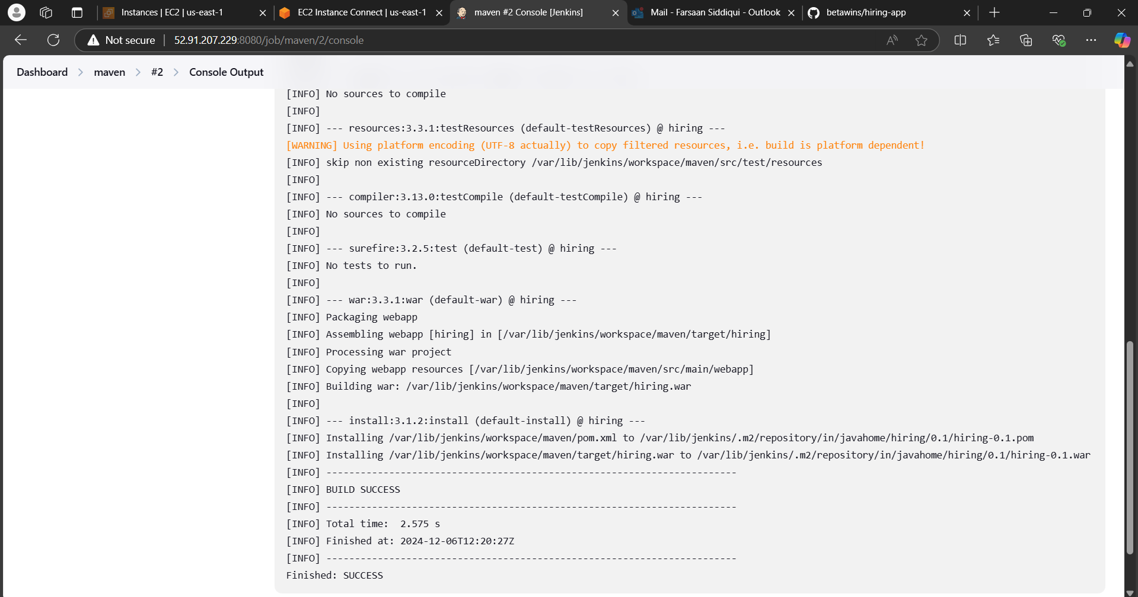

**5) Use the below code and create a parameterized job in jenkins**

**stage 1: Git clone**

**stage 2: Maven Compilation**

**Code: https://github.com/betawins/java-Working-app.git**

>> "New Item" > select "Pipeline" > check the "This project is parameterized" > "Add Parameter" > String Parameter > name= BRANCH > pipeline script

pipeline {

agent any

tools {

maven 'MAVEN' // Name of the Maven installation in Jenkins

}

parameters {

string(name: 'branch', defaultValue: 'main', description: 'Branch to build')

}

stages {

stage('Git Clone') {

steps {

git branch: "${params.branch}", url: 'https://github.com/betawins/java-Working-app.git'

}

}

stage('Maven Compilation') {

steps {

sh 'mvn clean install'

}

}

}

}

>>save > build with parameters >branch = **main** > build

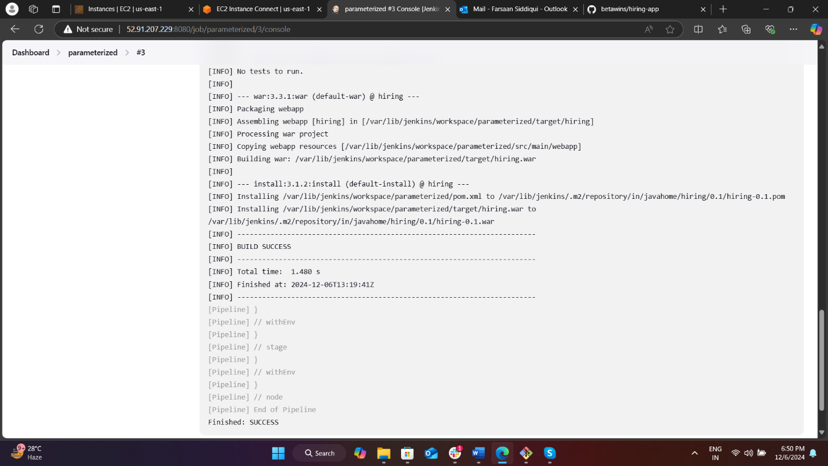

**6) What are the global varaiables in jenkins?**

• env: This variable contains all the environment variables available to the Jenkins job. You can access any environment variable using env.VARIABLE_NAME.

• currentBuild: This variable provides information about the current build, such as the build number, result, and duration.

• params: This variable contains all the parameters passed to the Jenkins job. You can access any parameter using params.PARAMETER_NAME.

• docker: This variable provides access to Docker-related functions, allowing you to interact with Docker containers and images.

• scm: This variable contains information about the source code management (SCM) configuration for the job, such as the Git repository URL and branch.

• pipeline: This variable provides access to the pipeline script itself, allowing you to control the flow of the pipeline.

• node: This variable represents the Jenkins node (agent) on which the job is running.

• steps: This variable provides access to the steps available in the pipeline, such as sh, bat, echo, and more

**7) Watch terraform-04 video 8) Execute the script shown in video.**

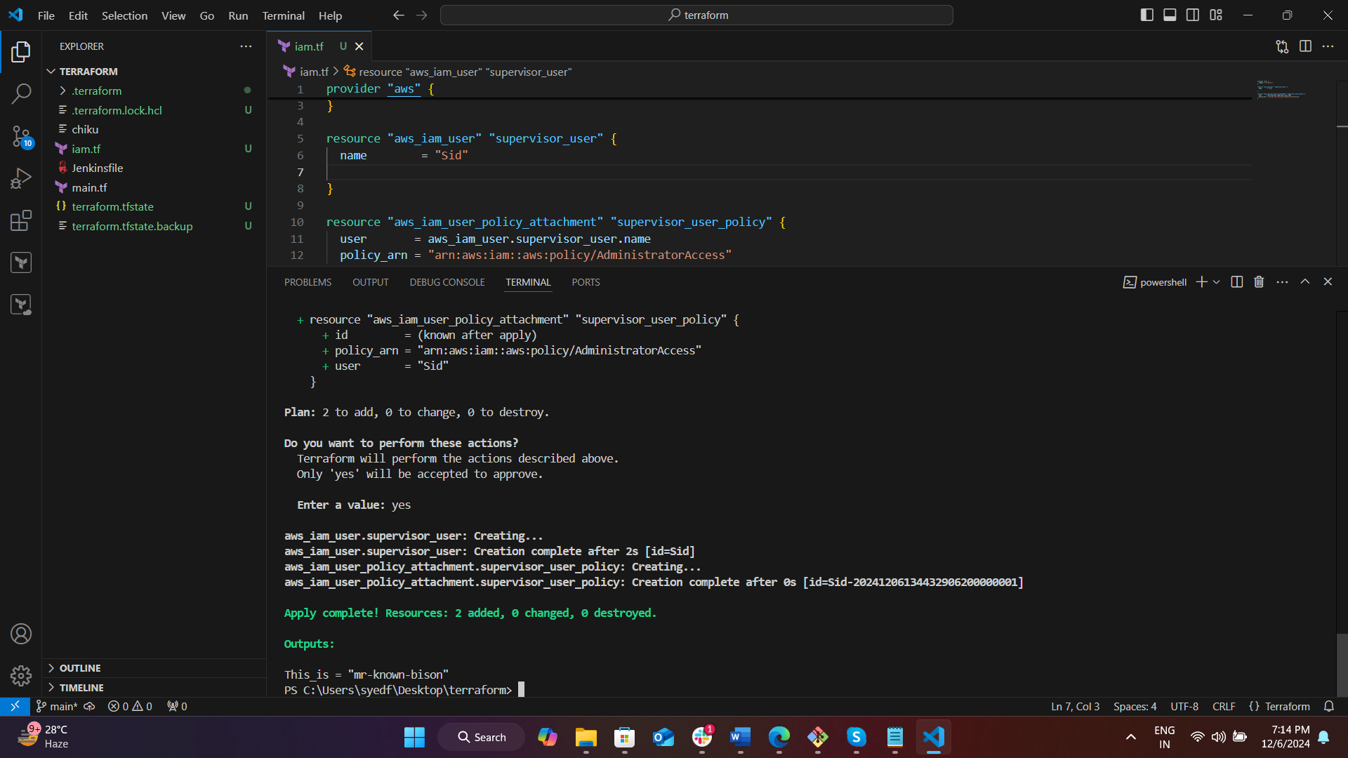 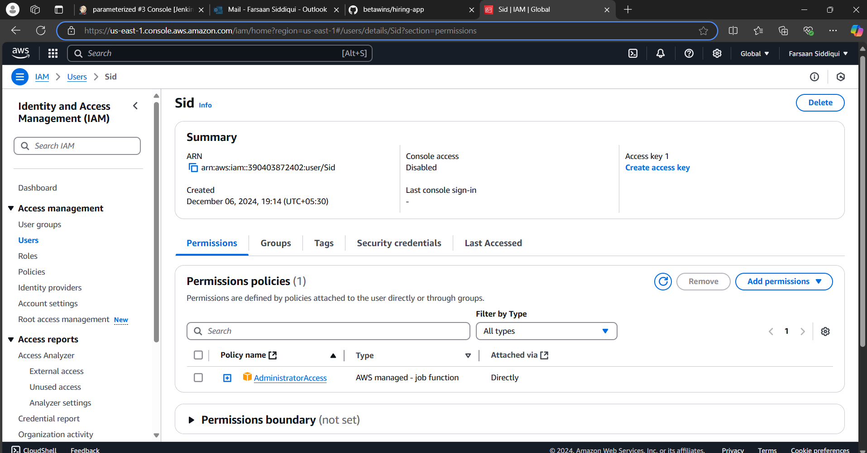

**9) Integrate terrafrom in jenkins using Terraform plugin.**

10) Create CICD pipeline for Nodejs Application.

https://github.com/betawins/Trading-UI.git

**11) Explain 10 Maven commands.**

1. **mvn clean:**This command eliminates the target directory, holding compiled classes and other built artefacts. This promotes an essentially clean build environment.
2. **mvn compile:**Compiles project's source code. Source files are processed and it puts the compiled.class file in the target folder
3. **mvn test:**These instructions run tests by an already applied framework, such as JUnit, because it compiles a piece of test code and subsequently invokes the test cases for its execution.
4. **mvn package:**This one comes to package the compiled code in a distributable manner such as JAR and WAR files, and deposits this into the target directory
5. **Mvn Install:**This command installs that JAR or WAR to the local Maven repository on which other projects can avail that same machine.
6. **Mvn deploy:**This command moves over all packaged code to a given deployment kind of remote repository where these people could access it by multiple developers and projects. There are also other goals where
7. **Mvn site:**This command makes a site for the project, containing reports and documentation; this is viewable in any web browser.
8. **mvn validate:**This command validates the structure of the project, so it makes sure all of the needed information is present.
9. **mvn dependency:tree**:This command will list the dependencies of the project as they are associated with one another in terms of the relationship.
10. **mvn exec:java:**This command runs a Java program within the Maven project. You need to specify the main class to execute.