*Launch one Linux instance in aws*.

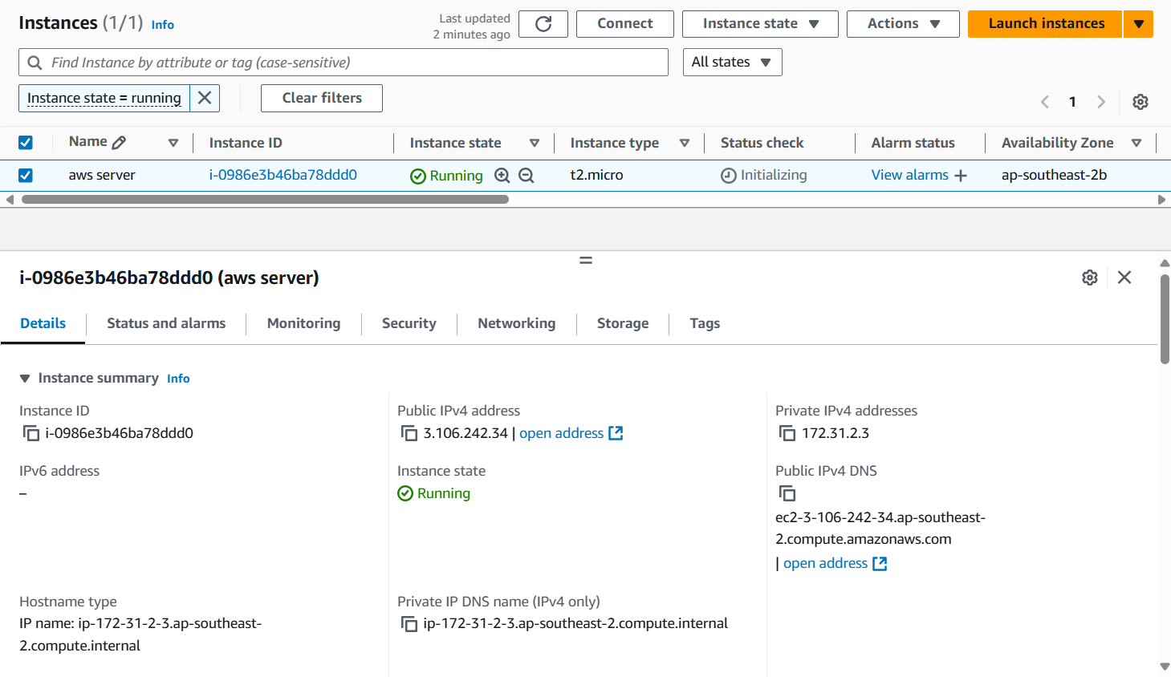

*Ssh login through remote server*

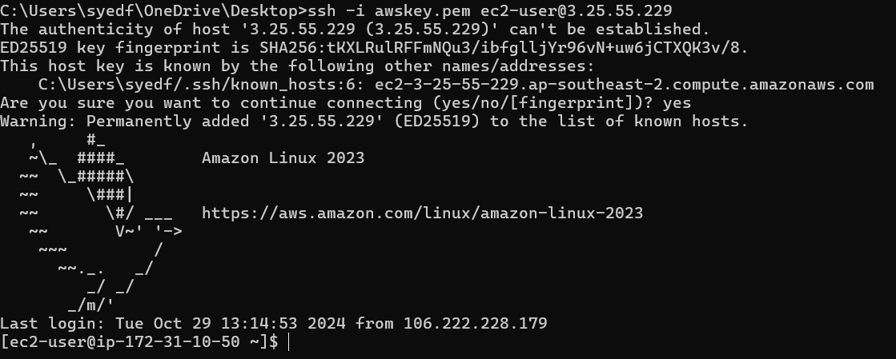

*Create on file with name Techie_horizon*

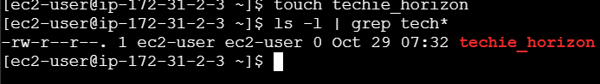

*Install Jenkins in the server created in step 1.*

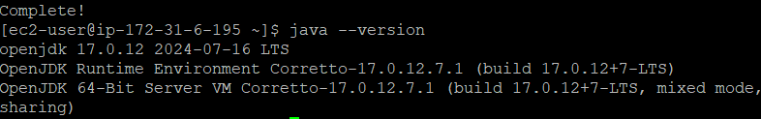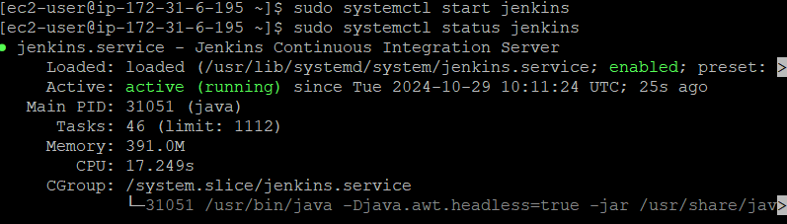

*Install httpd,nginx,Apache Tomcat.*

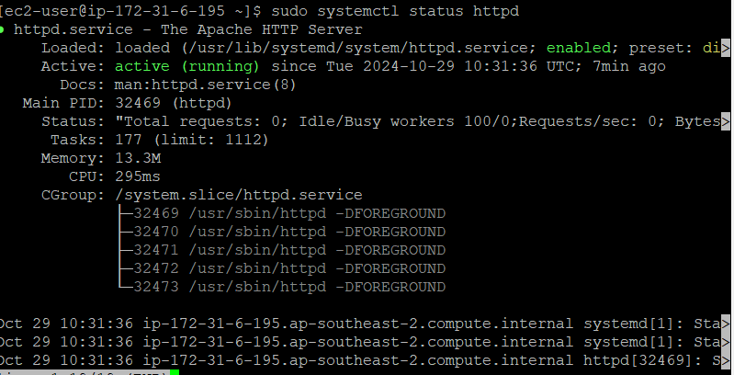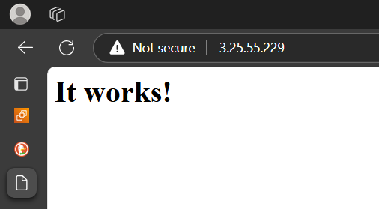

*TOMCAT*



