**terraform**

**>>install terraform from** [**https://developer.hashicorp.com/terraform/install**](https://developer.hashicorp.com/terraform/install)

**>>after download move it to C:\Terraform in the windows machine**

**>>now go to search bar and search for edit system environment variables**

**>>add the evironment variable and select the path as C:\Terraform**

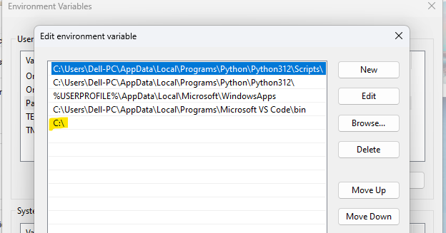

**>>open gitbash and check the with command** terraform -version

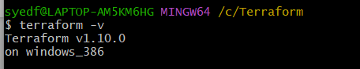

**>>go to visual code studio and add extention hashi corp by installing it**

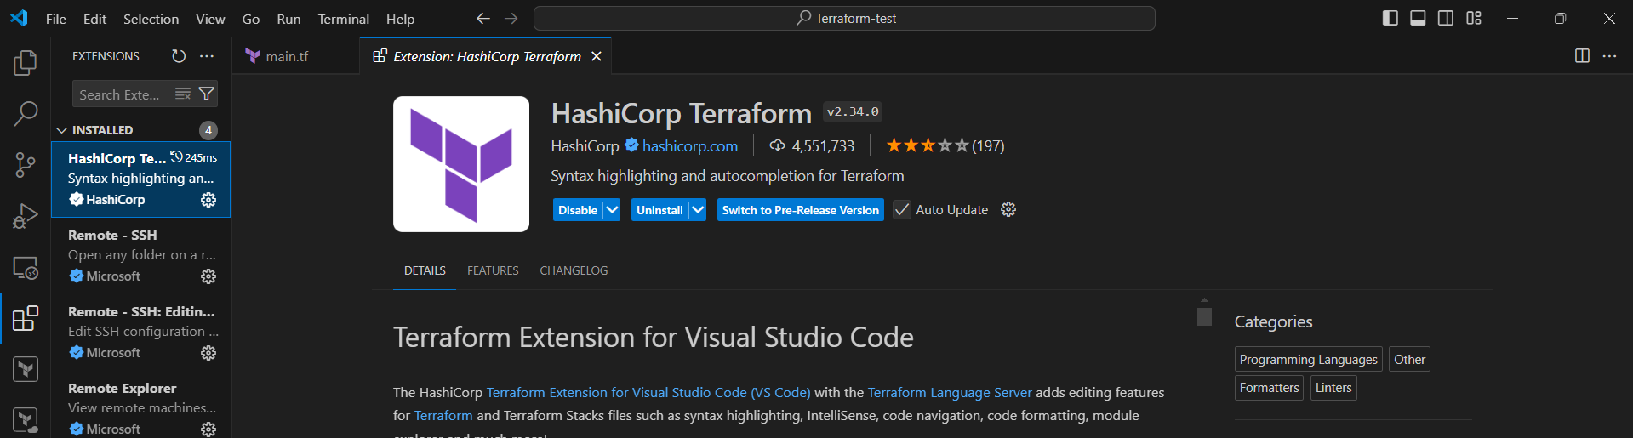

**>>create a folder for all your code**

**>>open it in visual code**

**>>add a file with .tf extention**

**🡪 resource --> Block name**

**🡪local -->provider**

**🡪file -->resource type (What needs to be created)**

**🡪fruits--> it is a logical name to identify by terraform and can be named anything.**

**>> write the basic code**

resource "local_file" "fruits" {

filename = "fruits.txt"

content = "apple , mango , banana"

}

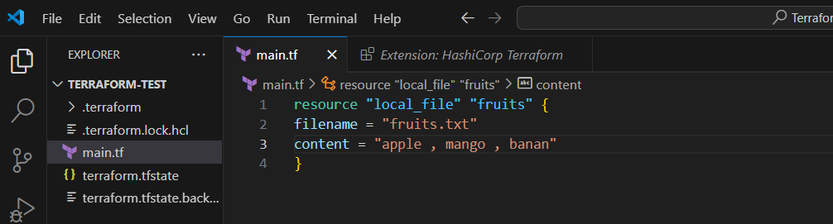

**\*save the code with Ctrl+S**

**Once we have the terraform resource file then we need to perform below commands**

**terraform init -->** to initliaze the repository and download the dependencies

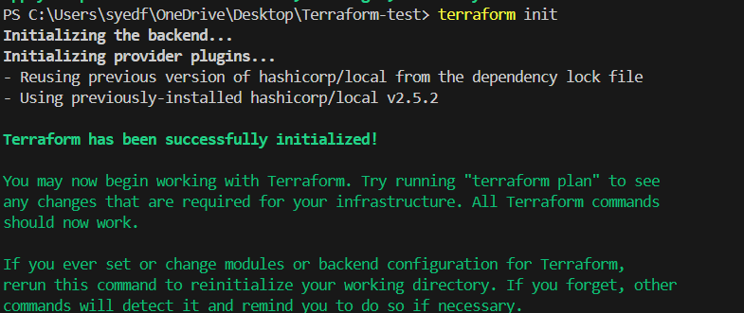

**terraform plan -->** dry run to check how it will be create the respource (It will not actually create them)

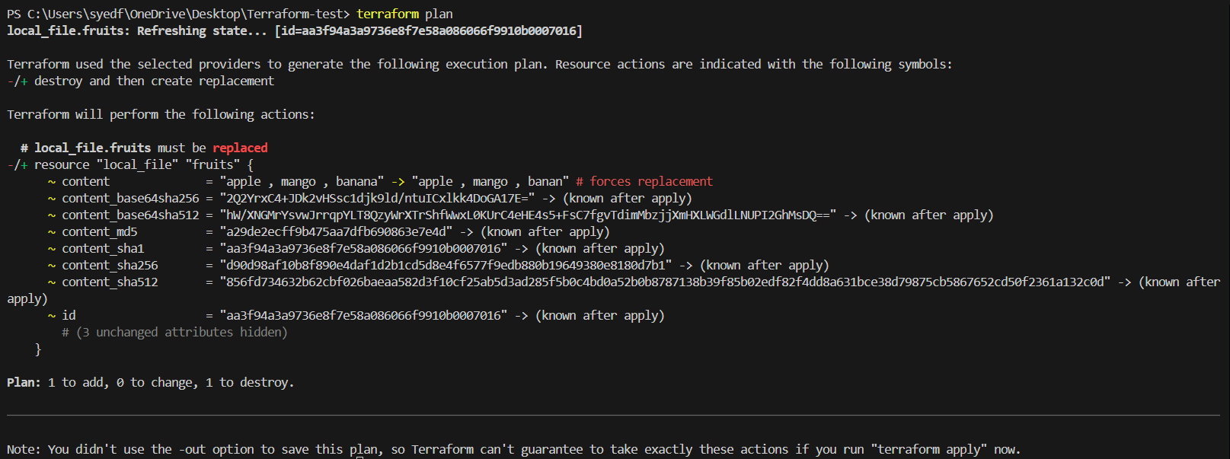

**terraform apply -->** to execute and create the infra based on the configuration

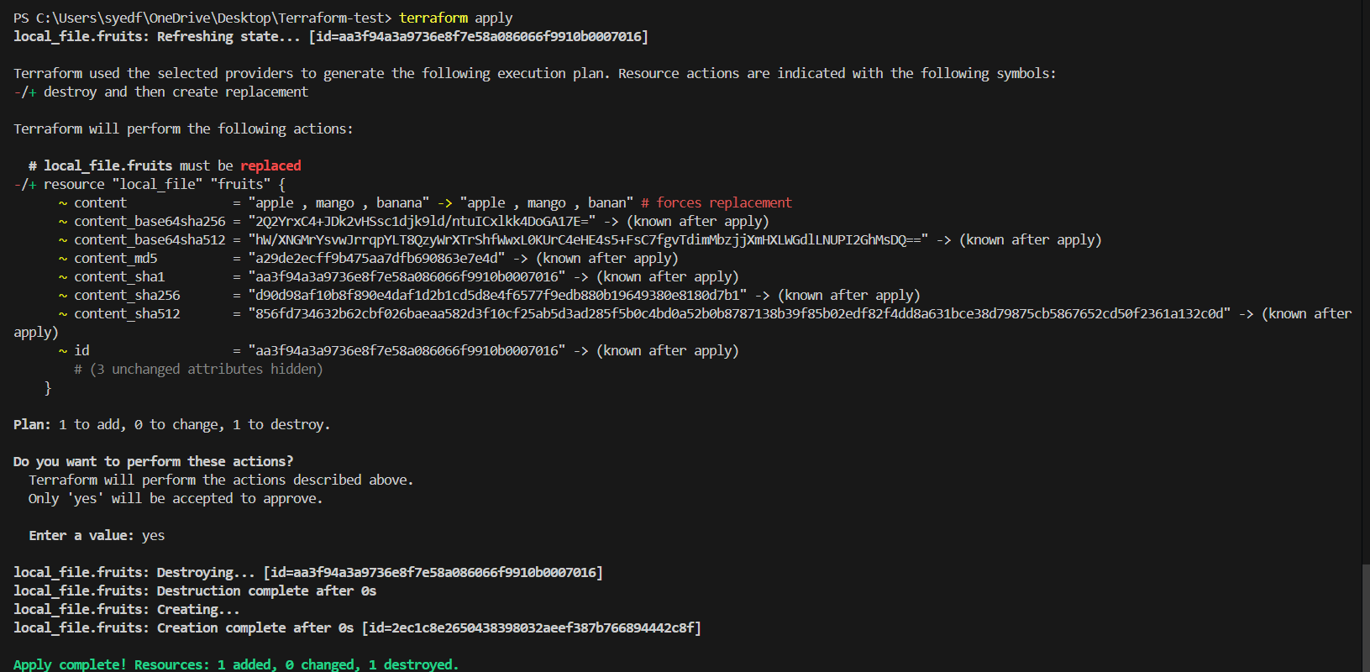

**terraform destroy -->** to remove/delete the existing infra.

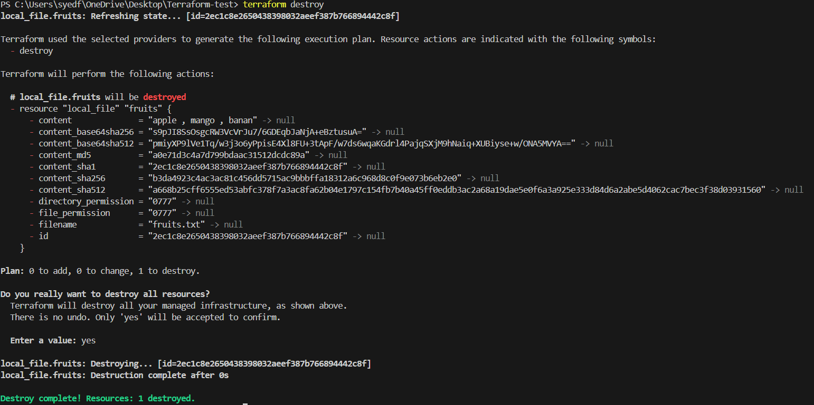

**terraform show -->** to show/get the details of the resources created



**>>integrating terraform with jenkins**

**>>launch an ec2 server and install Jenkins in it**

**>>On Jenkins GUI install Terraform plugin.**

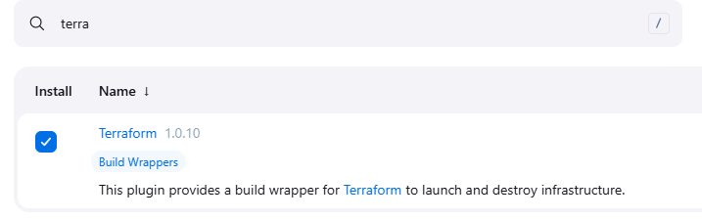

**>>Install terraform on Jenkins server using below commands**

# yum install -y yum-utils shadow-utils

# yum-config-manager --add-repo https://rpm.releases.hashicorp.com/AmazonLinux/hashicorp.repo

# yum -y install terraform

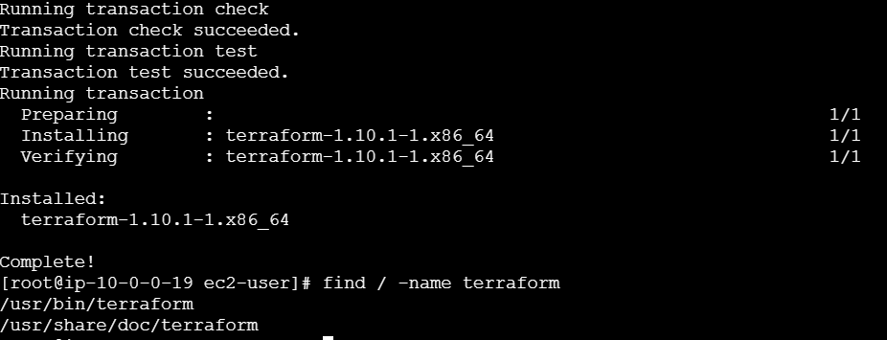

**>>jenkins gui > manage jenkins > tools > scroll down > terraform > add** /usr/bin/terraform

**>>Create a git repository**

**>>Create another file naming** Jenkinsfile **and add the code with the repository url**

pipeline {

agent any

stages {

stage('Clone') {

steps {

git branch: 'main', url: 'https://github.com/diamond-tech/terraform.git'

}

}

stage('Initialize Terraform') {

steps {

sh 'terraform init'

}

}

stage('Execute Terraform Apply') {

steps {

sh 'terraform apply -auto-approve'

}

}

}

}

**>>now push this** main.tf **and** Jenkinsfile **to github**

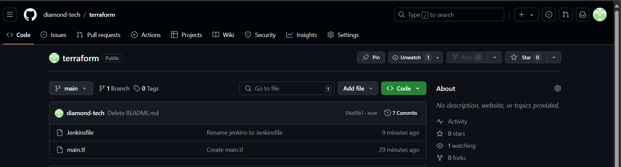

**>>go to jenkins and create a new item**

**new item > select pipeline > pipeline with scm > add git url** <https://github.com/diamond-tech/terraform.git>

**>>build**

**\*(note: make sure the ec2-user file in jenkins server has** global rwx **permissions 777)**

