
Programme Title: | MSc in Data Analytics
Delivery Mode: | PT
Cohort Details: | L9 Certificate in Data Preparation & Visualisation (Sept 2025 SB+cohort)
Module Title(s): | Data Preparation & Visualisation
Assignment Type: | Individual | Weighting(s): | Data Prep & Vis 50%
Assignment Title: | L9Cert_DA_CA2
Lecturer(s): | Muhammad Iqbal  David McQuaid
Submission Deadline Date: | 4th January 2026
Student Name | FO
Student Number: | Sba25
Student Email: | Sba25@student.cct.ie

Declaration By submitting this assessment, I confirm that I have read the CCT policy on Academic Misconduct and understand the implications of submitting work that is not my own or does not appropriately reference material taken from a third party or other source. I declare it to be my own work and that all material from third parties has been appropriately referenced. I further confirm that this work has not previously been submitted for assessment by myself or someone else in CCT College Dublin or any other higher education institution.

Declaration

Abstract
This document analyses electricity and natural gas prices in EU and EEA national markets, with a particular focus on Ireland in comparison with other member states. The study compares household and non-household energy prices in harmonised Eurostat data across energy types, tax treatments, climatic groupings, and time. Exploratory and visual analysis reveal that Irish households consistently face higher energy costs than non-households and EU medians, particularly after 2021. The findings demonstrate that these differences are not driven solely by wholesale market shocks, but by structural cost components embedded in retail prices, including taxes, levies, and network charges. The persistence of these patterns across fuels and over time suggests that Ireland’s energy affordability challenges are structural in nature, shaped by regulatory and policy design rather than short-term market volatility.

Acknowledgements
I would like to express my sincere gratitude to my lecturers, Mr. Iqbal and Mr. McQuaid, for their patience, guidance, and engaging sessions throughout the course. I will miss them and I hope our paths cross again. I also wish to thank Eurostat, whose open-access datasets were essential for conducting this analysis. Finally, but by no means least, to DMK, for always believing in me and standing by me through every challenge. Pura Vida!

Contents
Abstract 2
Acknowledgements 2
Introduction 4
Objective 1: Data Acquisition, Licensing Review, and Dataset Evaluation
Objective 2: Exploratory Data Analysis, Cleaning, and Harmonisation
Objective 3: Development of Visual and Interactive Insights for Decision-Making
Development 4
Phase 1: Data Acquisition and Evaluation………………………………………………….…...….4
Phase 2: Exploratory Data Analysis (EDA)………………………………………………………….5
Phase 3: Data Cleaning, Engineering, and Structuring…………………………………………...5
  - Attributes Reduction and Analytical Focus…………………………………………5
  - Currency Harmonisation and Comparability…………………………………..….5
  - Semantic Clarity and User-Centred Design…………………………………….....5
  - EUR-Filtered Statistics and Missing-Value Patterns……………………………..6
  - Missing Values and imputation………………………………………………………6
  - The Final integration…………………………………………………………...6
Phase 4: Analytical Comparison and Insight Generation …………………………………….7
- How are EU energy prices distributed overall across countries, energy types, and consumer groups, and what does this reveal about variability, skewness, and structural differences in the data?...................................................................................................7
- How do energy prices vary across EU countries by energy type, consumer group, and tax treatment, and are these differences structural rather than marginal?......................7
- Which consumer groups in Ireland: households or non-households, pay the highest energy costs across electricity and gas, and what underlying cost components drive these differences?...........................................................................................................8
- How do electricity and gas prices differ between colder and warmer EU/EEA countries, and what patterns or anomalies emerge when comparing Ireland’s price trends to countries with similar or contrasting climatic energy demands?....................................8
Phase 5: Dashboard Development and Visual Communication…………………………………..9
Conclusion 10

Introduction

The project sets out to explain why the level of energy costs in Ireland is where it is today by looking at electricity and gas prices in both households and non-households and against that in the rest of the EU. It compares price points of where Ireland lies on the EU price scale and what higher costs accrue to key consumer groups, as well as the degree to which prices differ by type of energy. Importantly though, it explains why these differences are there by studying cost components, including taxes and levies. The goal is to move from detecting price levels on the one hand, to understanding the structural factors that impact how energy costs are allocated among consumers in Ireland relative to the EU at large.
Objective 1: Data Acquisition, Licensing Review, and Dataset Evaluation
To acquire multiple Eurostat datasets relating to electricity and gas prices for households and non-households in Ireland and the EU. This includes identifying licensing conditions such as confidentiality flags, GDPR-restricted fields.
Objective 2: Exploratory Data Analysis, Cleaning, and Harmonisation
To carry out a comprehensive exploratory analysis of Ireland’s energy prices compared to the EU and identify patterns, seasonal trends, anomalies, and missing values across countries and years; and to develop a justified data-cleaning and harmonisation strategy that addresses definition discrepancies, confidentiality gaps, and inconsistent reporting frequencies.
Objective 3: Development of Visual and Interactive Insights for Decision-Making
To design visualisations and develop an interactive dashboard, focusing on Ireland’s relative position and identifying why household and non-household trends differ over time.

Development
Phase 1: Data Acquisition and Evaluation
Eurostat datasets were chosen because they reflect harmonised electricity and gas prices for households and non-households in euros, which provide a robust cross-country comparison across both EU and EEA countries. That context is particularly relevant due to Europe’s cold climate, high demand for heating, and strong investment in green energy influencing prices (WMO, 2024; EEA, 2024). All datasets are published under the EU Open Data Licence, which supports transparent and ethical reuse. Although Eurostat provides standard definitions and wide coverage, additional data information such as metadata confirms that some values may be purposefully suppressed for reasons of confidentiality or GDPR and drove the approach of cleaning and harmonising data in subsequent stages.

Phase 2: Exploratory Data Analysis (EDA)
At first, EDA data were riddled with gaps, duplicated columns, and variable names that varied greatly, leading to unreliable raw analysis. Structural checks revealed that missing data differed systematically between variables. The Eurostat metadata proved these gaps were intentional suppressions for confidentiality, not mistakes, thus controlling the meaning of the data. Recognizing what the mixed-variable types can be (ie, categorical, discrete, continuous) was helpful in selecting valid analytical and visual techniques. In general form, EDA demonstrated that proper cleaning and standardisation was required to minimize noise level, and any following analysis would show, based on these, the structural patterns rather than artefacts of the data.
Phase 3: Data Cleaning, Engineering, and Structuring
  - Attributes Reduction and Analytical Focus.
The first and most significant intervention was column reduction. From an initial set of about 25 variables, 12 were retained specifically for analysis. This choice was in line with the principle of analytical relevance, a concept that we have also discussed in class, that keeping variables independent of the research question adds complexity but doesn’t enhance insight. Columns associated with internal identifiers, duplicate descriptor identifiers, confidentiality markers, and unused metadata were subsequently discarded. Doing this made sure that the remaining variables directly supported the comparison of energy prices among countries, energy types, and consumer categories.
  - Currency Harmonisation and Comparability.
A key analytical challenge related to the currency variable, as prices were reported using three standards: NAC, PPS, and EUR. National currencies limit cross-country comparability, while PPS, although useful for macroeconomic analysis, does not support direct price interpretation due to Eurostat adjustments and partial data confidentiality. By contrast, EUR provides a clear and consistent basis for comparing energy prices across countries, including and excluding taxes. Given that the research aims to compare Ireland’s energy prices with those of other European countries, EUR was selected as the most appropriate analytical standard. Unique-value checks were conducted to verify consistency and prevalence across datasets, confirming that EUR represented the majority of relevant observations. This justified the exclusion of NAC and PPS without compromising data integrity. Clean copies of all datasets were created prior to transformation to preserve the original data for traceability (Iqbal & McQuaid, Lecture 2 – EDA).
  - Semantic Clarity and User-Centred Design
Once the structure and currency were harmonised, column names were revised to improve clarity and usability. Technical or ambiguous labels were replaced with intuitive, user-friendly names. This step was driven by the need to support effective plotting and dashboard development. As highlighted in the course’s visualisation material, clear naming reduces cognitive effort and ensures that insights can be understood by both data specialists and non-technical users.
  - EUR-Filtered Statistics and Missing-Value Patterns
Once the data was filtered to EUR-only prices, the datasets became smaller, which was expected and appropriate, as non-comparable values were removed. The descriptive statistics highlighted clear differences across energy types and consumer groups. Household gas prices showed the greatest variation, reflecting the volatility of gas markets and the influence of taxation and supply conditions, while household electricity prices were more stable and consistently reported. In contrast, non-household gas data contained the highest number of missing values, pointing to known challenges in industrial energy reporting. Country-level summaries also revealed zero prices for some smaller or non-EU countries, indicating gaps in reporting rather than true zero-cost energy. Aggregate regions such as the Euro Area and EU-27 were therefore retained to provide a meaningful benchmark for placing Ireland’s prices within the wider European context.
3.5 Missing Values and imputation
Although missing prices were limited in number, their uneven distribution across energy types and consumer groups made row deletion analytically inappropriate, as it would have distorted cross-group comparisons. Country-level median imputation was therefore applied to preserve structural balance, with the median chosen for its robustness to skewed price distributions, particularly in gas markets. Following dataset integration, a negative household electricity price was identified, which is not meaningful in real-world terms. To avoid distortion of statistics and visualisations, this value was treated as invalid, converted to missing, and corrected using the same country-level median approach.
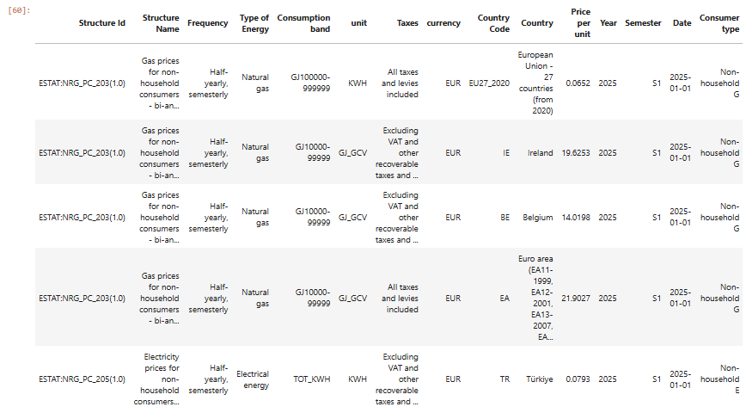
  - The Final integration
Finally, the time variable was engineered into Year, Semester, and a true Date field to support flexible time-based analysis and interactive dashboard filtering. The four cleaned datasets were then combined into a single unified dataset (all_energy). A final exploratory review confirmed internal consistency across energy types and consumer categories, indicating that the data was analytically robust and ready for the analysis and dashboard development phase 4.

Phase 4: Analytical Comparison and Insight Generation
On this phase we will proceed with the visualisations of our data and the raised questions:
- How are EU energy prices distributed overall across countries, energy types, and consumer groups, and what does this reveal about variability, skewness, and structural differences in the data?
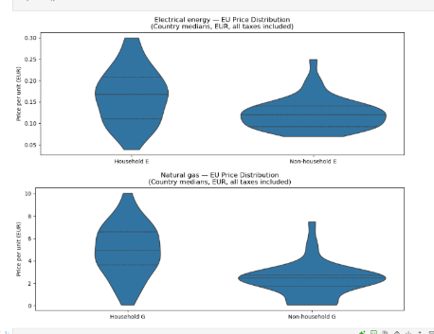
Electricity and gas prices in the EU have different distributional patterns, which are consistent with different structures rather than with marginal market movements. Electricity prices are tight and stable, as a response to regulation harmonisation, market integration and coordinated policy frameworks in the EU. Gas prices, on the other hand, are very dispersed and skewed, particularly amongst households, mainly because they are exposed to global supply shocks, geopolitical risk and uneven national tax regimes. In both fuels households suffer higher and more volatile prices than non-households, revealing structural cost burdens imposed by tariff design and tax incidence rather than the level of consumption. Ireland follows this wider EU trend with household energy costs being structurally elevated rather than temporarily inflated.
2. How do energy prices vary across EU countries by energy type, consumer group, and tax treatment, and are these differences structural rather than marginal?
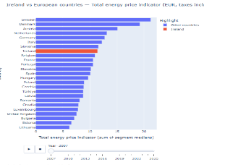
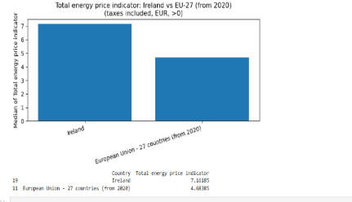
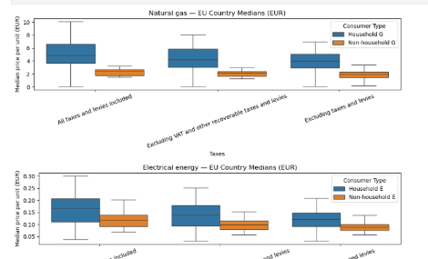
Energy prices in the EU differ systematically and structurally by energy type, consumer group, and tax treatment. Households consistently pay more than non-households for both electricity and gas, largely due to fixed charges, levies, and regulatory costs embedded in retail prices. Gas prices show wider dispersion and volatility than electricity, reflecting exposure to global supply shocks. When taxes are excluded, price differences narrow significantly, confirming that taxes and network charges, not short-term market fluctuations drive most cross-country variation, consistent with course frameworks on regulated energy markets.

3. Which consumer groups in Ireland: households or non-households, pay the highest energy costs across electricity and gas, and what underlying cost components drive these differences?
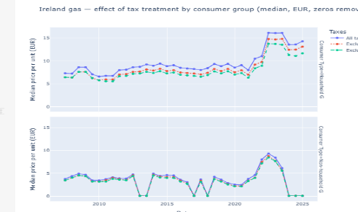
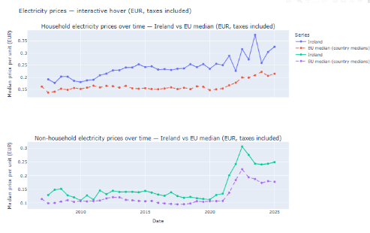
Ireland’s high energy prices are primarily driven by structural cost components rather than market consumption or climate alone. Across electricity and gas, households consistently pay more than non-households due to embedded taxes, levies, and network charges. While international energy shocks intensified prices after 2021, Ireland’s relative position remained elevated, indicating a systemic issue. When taxes are excluded, Irish prices align more closely with EU medians, confirming that policy-driven charges are the dominant factor shaping affordability.
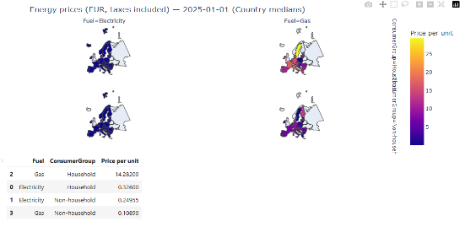
The faceted European choropleth map shows that the price differences in energy within Europe are not homogeneous across consumer demographics or types of energy.

4. How do electricity and gas prices differ between colder and warmer EU/EEA countries, and what patterns or anomalies emerge when comparing Ireland’s price trends to countries with similar or contrasting climatic energy demands?
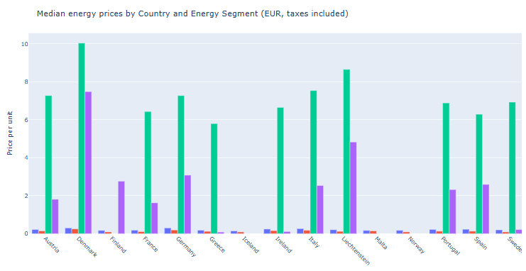
Over the EU/EEA, colder-climate countries have generally higher gas prices than warmer countries due to higher demand for heating and more exposure to winter supply risks. Electricity prices vary less by climate but are higher for households in colder regions. Ireland broadly follows the cold-climate pattern but stands out as an anomaly, with household electricity and gas prices consistently above comparable peers. Missing or sparse data are found in certain countries, especially for non-household categories, indicating disparities in reporting coverage, not actual absence of costs. Altogether, the data shows that climate does affect demand, but that Ireland’s high prices reflect structural elements, especially, taxes, and levies, rather than climate or market conditions alone.
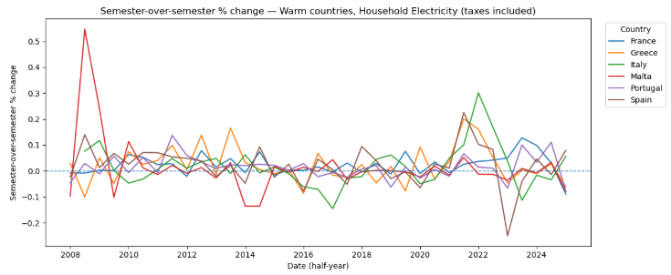
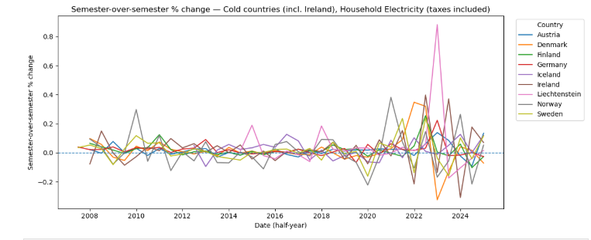
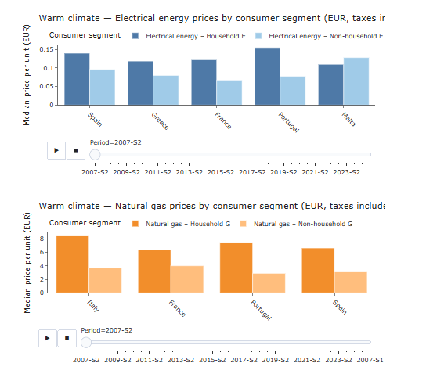
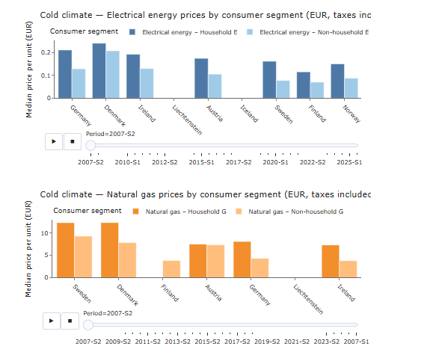
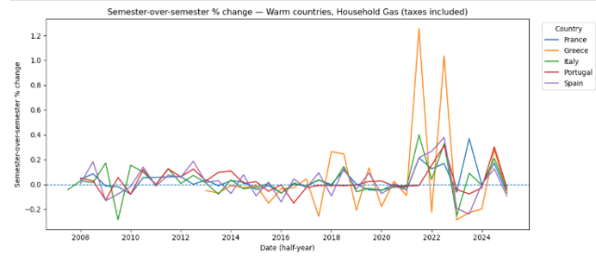
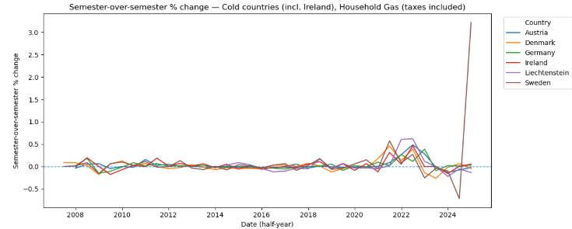
Across the EU/EEA, differences in electricity and gas prices are driven primarily by energy system structure rather than climate alone. Countries such as Norway, Iceland, and Sweden rely predominantly on electricity due to abundant domestic generation (hydro, geothermal, nuclear) and limited gas infrastructure, resulting in stable electricity prices and sparse gas data (Eurostat; IEA). By contrast, Ireland, Germany, Italy, and Spain depend more heavily on gas for heating and power, exposing them to international supply shocks and price volatility, particularly after 2021 (European Commission, 2023). Sweden’s exceptionally high gas prices reflect its small, marginal gas market, where low volumes amplify unit costs rather than high demand. Ireland stands out across both fuels: when taxes and levies are included, household prices exceed EU medians, but converge when excluded, indicating that network charges and policy-driven costs, not fuel markets, are the dominant drivers. Missing data in some countries reflects non-use or confidentiality thresholds, not zero costs (Eurostat methodology).
Phase 5: Dashboard Development and Visual Communication
In this dashboard, we want to support decision-making in understanding why EU energy prices vary, and not just what they look like. It separates market costs from policy-driven components, including levies and network charges, by comparing electricity and gas prices across countries, consumer groups, and tax treatments. Interactive views highlight structural patterns, persistent gaps, and outliers, supporting evidence-based pricing strategies and regulatory decisions. In line with the principles of the course, it prioritises comparability, robust medians, and transparency to take users from description to explanation.

Conclusion
This analysis reveals that Ireland’s energy costs are high not only because of consumption or climate, but due to structural design choices within its energy pricing system. Across electricity and gas, households consistently bear higher costs than non-households, driven primarily by taxes, levies, and fixed network charges rather than market prices. While global energy shocks amplified prices after 2021, Ireland’s relative position remained persistently elevated, confirming that the issue is institutional rather than temporary. By separating market-driven and policy-driven components, the project demonstrates that energy affordability in Ireland is shaped by regulatory structure more than fuel markets.

References
- Eurostats (EEA) 2024, Climate – At a Glance, viewed 5 December 2025, https://www.eea.europa.eu/en/topics/at-a-glance/climate.
- World Meteorological Organization (WMO) 2024, World Meteorological Organization Official Website, viewed 4 December 2025, https://wmo.int/.
European Commission 2025, Eurostat Energy Price Statistics, viewed 3 December 2025, https://ec.europa.eu/eurostat.
- European Commission 2025, Gas prices for household consumers (NRG_PC_202), Eurostat, viewed 4 December 2025, https://ec.europa.eu/eurostat.
- European Commission 2025, Gas prices for non-household consumers (NRG_PC_203), Eurostat, viewed 4 December 2025, https://ec.europa.eu/eurostat.
- European Commission 2025, Electricity prices for household consumers (NRG_PC_204), Eurostat, viewed 4 December 2025, https://ec.europa.eu/eurostat.
- European Commission 2025, Electricity prices for non-household consumers (NRG_PC_205), Eurostat, viewed 4 December 2025, https://ec.europa.eu/eurostat
- Iqbal, M, and McQuaid, D. 2025, Introduction to Data Statistics, Lecture presentation. CCT College Dublin.
- Iqbal, M. and McQuaid, D, 2025, Lecture 2: Exploratory Data Analysis (EDA). Lecture presentation. CCT College Dublin.
- Iqbal, M. & McQuaid, M. (Year). The 9 Principles of Design. CCT College Dublin.
- Iqbal, M. & McQuaid, M. (Year). What Visualisation Should I Use?. CCT College Dublin.
- Iqbal, M. & McQuaid, M. (Year). Lecture 3 – Data Pre-processing and Feature Rescaling. CCT College Dublin.
- European Commission, Energy Prices and Costs: https://energy.ec.europa.eu/data-and-analysis/energy-prices-and-costs_en
- International Energy Agency (IEA) Country Profiles: https://www.iea.org/countries
- Tufte, E.R. (2001) The visual display of quantitative information. 2nd edn. Cheshire, CT: Graphics Press.
- Few, S. (2012) Show me the numbers: designing tables and graphs to enlighten. 2nd edn. Burlingame, CA: Analytics Press.
- Knaflic, S.N. (2020) Storytelling with data: let’s practice!. Hoboken, NJ: Wiley.

