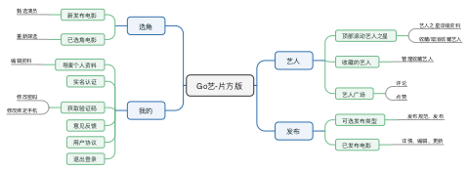

Table of Contents

2

2

2

2

2

2

2

2

2

2

2

2

2

2

2

2

2

2

2

2

2

2

2

2

2

2

2

2

2