Notion AR: Turning 2D Notes into 3D Spatial Ideas
DECO2300 Design Concept Report | Meta Quest 3 AR Application Redesign

Application Redesign and Concept
This concept redesigns Notion as an augmented reality workspace for existing Notion users, including students, adult productivity users, designers, artists and architecture students. This redesign focuses on visual note taking transforming designs from 2D to 3D, specialising in early design exploration rather than trying to replace every Notion feature. The target place for running this will be the Meta Quest headset, using mixed reality passthrough, surface detection and hand tracking.
A user places a Notion note onto a real flat surface such as a table or a wall, sketches simple 2D shapes or design outlines they want to transform, then places both hands flat and lifts upward to “raise” the drawing into a 3D recreation. The object can then be pinched and repositioned within the AR workspace. The current concept will start small with things like shapes, easy drawings and adding the special movement, with more complex editing left for future development.
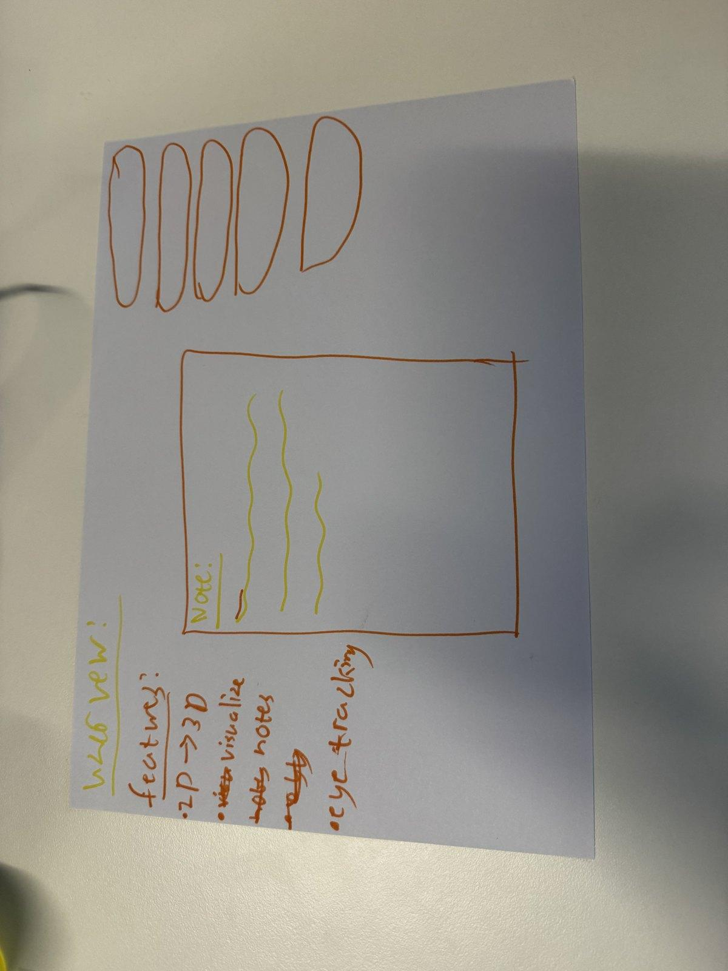 | 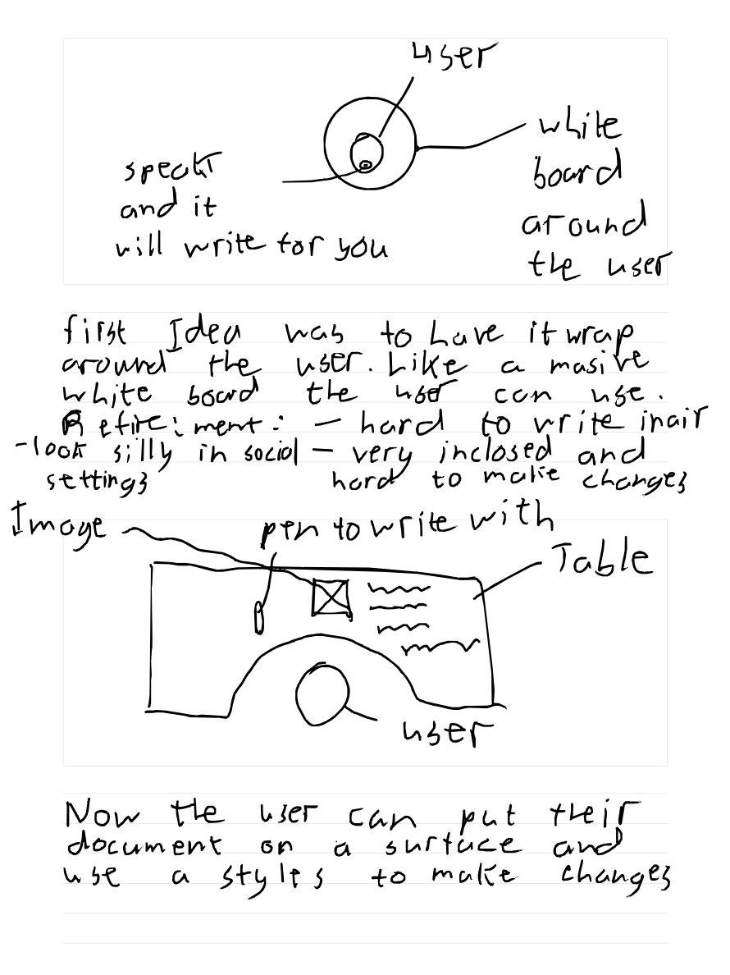
Figure 1: Main prototype: 2D sketch/house raised into a 3D spatial object. | Figure 4: Storyboard: initial wrap around whiteboard idea evolved into a table based Notion workspace.

User Tasks and Goals
Task | Interaction | User goal
1. Select and place note | L-shaped hand gesture opens a document list with Notion page previews. The user picks up a page and places it on the table, where it opens as an AR canvas. They can also inspect the page by just holding it and looking at the document. | Access existing Notion content and create a grounded workspace.
2. Draw 2D design | The user sketches simple shapes, outlines, or early design ideas on the note. | Capture visual ideas quickly before modelling.
3. Lift into 3D | The user places both hands flat and lifts upward, raising the sketch into a 3D object. | Move from flat thinking to spatial understanding.
4. Move object | The user pinches the 3D object and moves it around the AR workspace. | Inspect and arrange the object in the note.

XR Interactions and Affordances
- Surface detection for identifying usable surfaces for the note, making the digital workspace feel physical and understandable for the user.
- The L-shaped hand gesture creates a quick document selection interaction that is specific to hand tracked AR.
- The two hand lifting gesture makes the 2D to 3D transformation feel like the user is physically pulling the sketch out of the surface. Gesture tracking will be used to identify movements and gestures.
- Pinch movement lets the user reposition and inspect the object in space.

Ideation and Prototype Refinement
The storyboard shows how the concept evolved. The first idea was a large wrap-around whiteboard that surrounded the user and could convert speech into writing. This was refined because it could look socially awkward, feel enclosed and make editing difficult especially in the air. The concept then shifted to a surface based workspace where the document is placed onto a surface and edited with a stylus along with hand interaction. This refinement made the idea more practical, more grounded in the user’s real environment and easier to connect to Notion documents. The final concept keeps the table workspace and adds the stronger XR interaction of raising a 2D drawing into a 3D object.
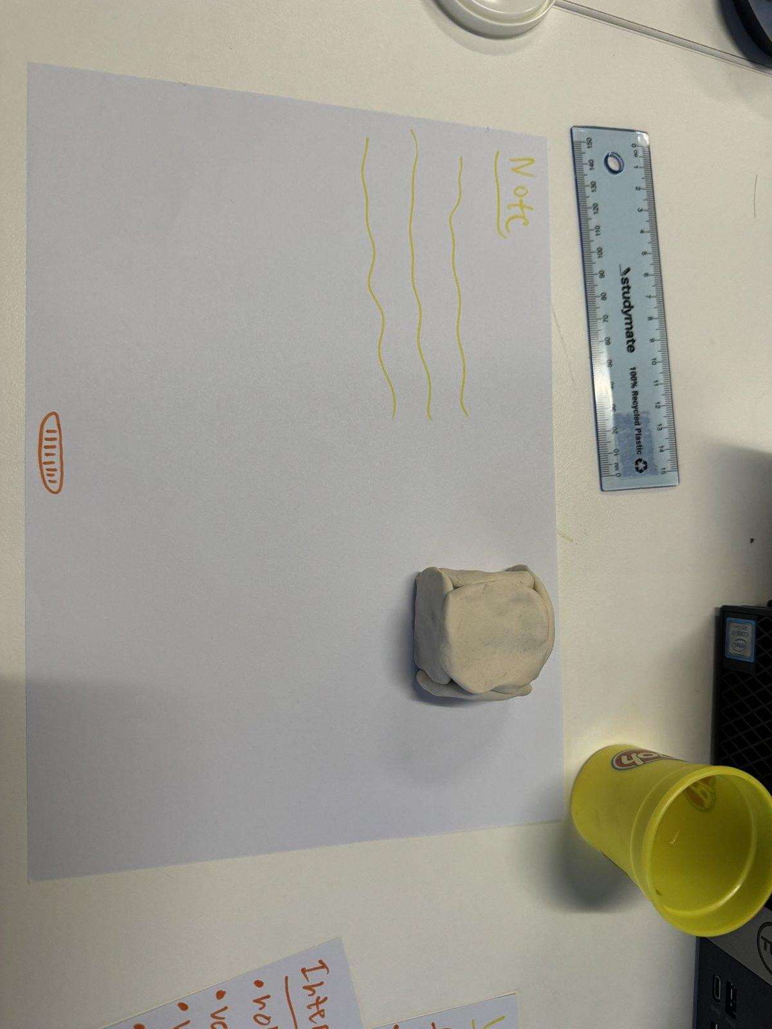 | 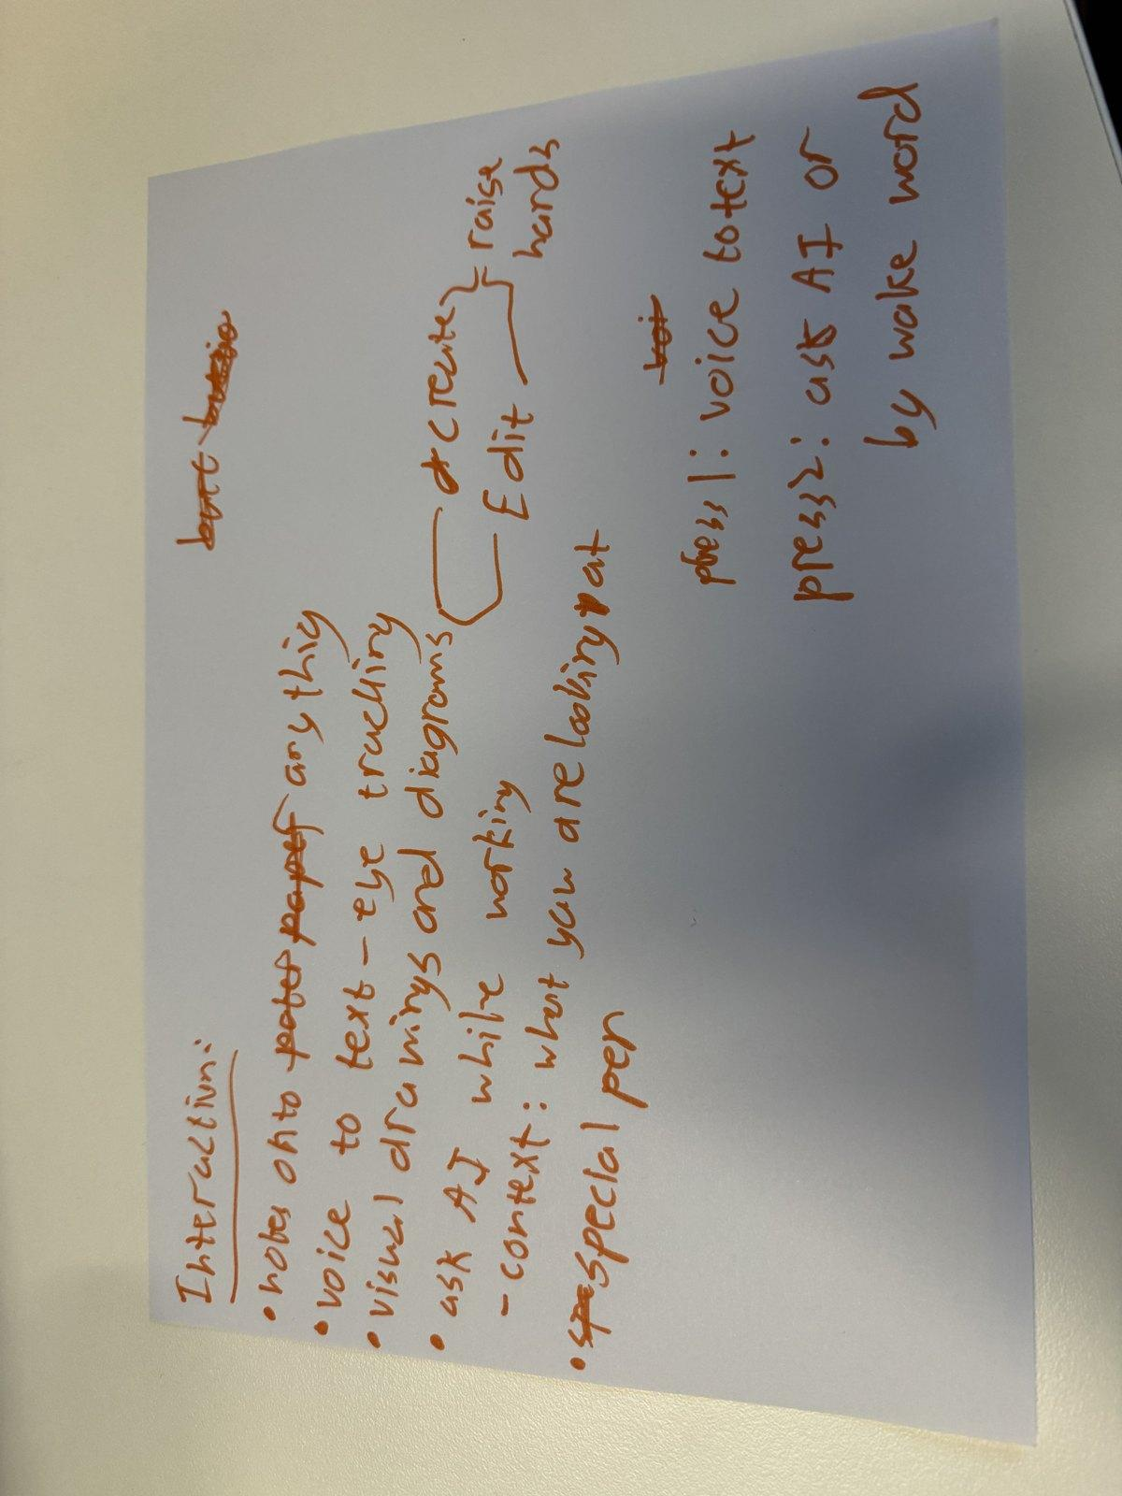
Figure 2: Table prototype: note canvas anchored to a physical surface. | Figure 3: Interaction flow: note selection, surface placement, lift, and pinch movement.

Initial Testing Plan
Participants would complete one scenario: make the L gesture, place a notion page, draw a simple shape, raise it into 3D and move it by pinching the object. Testing would focus on whether the 2D to 3D feature feels useful and whether the table makes the workspace easier to understand.
What to test | Assumption | Data collected
2D to 3D transformation | Raising a sketch into 3D will support visual design thinking. Will improve complexity of the design in an interactive way. | Usefulness rating, participant comments, confusion points.
Table workspace | A real surface will make the AR workspace easier to understand and use. | How easy it is to use rating, placement errors, observation notes.
L gesture + pinch | Users are able to understand how to move and place documents. | Task success or failure, ease of use notes.

Refer to the GitHub Repository for the collection of photos and documents regarding this assignment.

