Setup a Java EE application

Install a Tomcat Webserver:

* Go to tomcat.apache.org and download it
* You can use whichever version, just pay attention to the Java version compatibility
* I used Tomcat 9 (<https://tomcat.apache.org/download-90.cgi>)
* Unzip the archive; you will find installation instructions in RUNNING.txt

Create a JavaEE project in IntelliJIDEA:

File -> New Project -> Maven Project (Maven is a tool that we use to manage dependencies; IntellJ has a bundled version, so you should not need to install it)

Set the Java JDK that you want to use, then click on Next

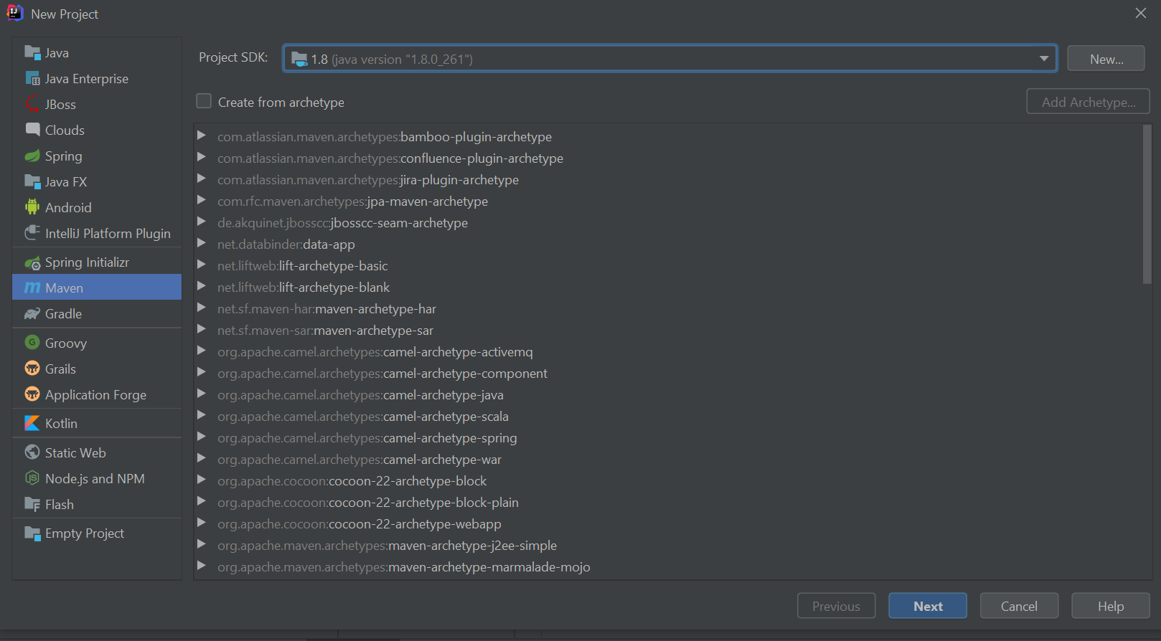

Configure the project name and location, then click on Finish

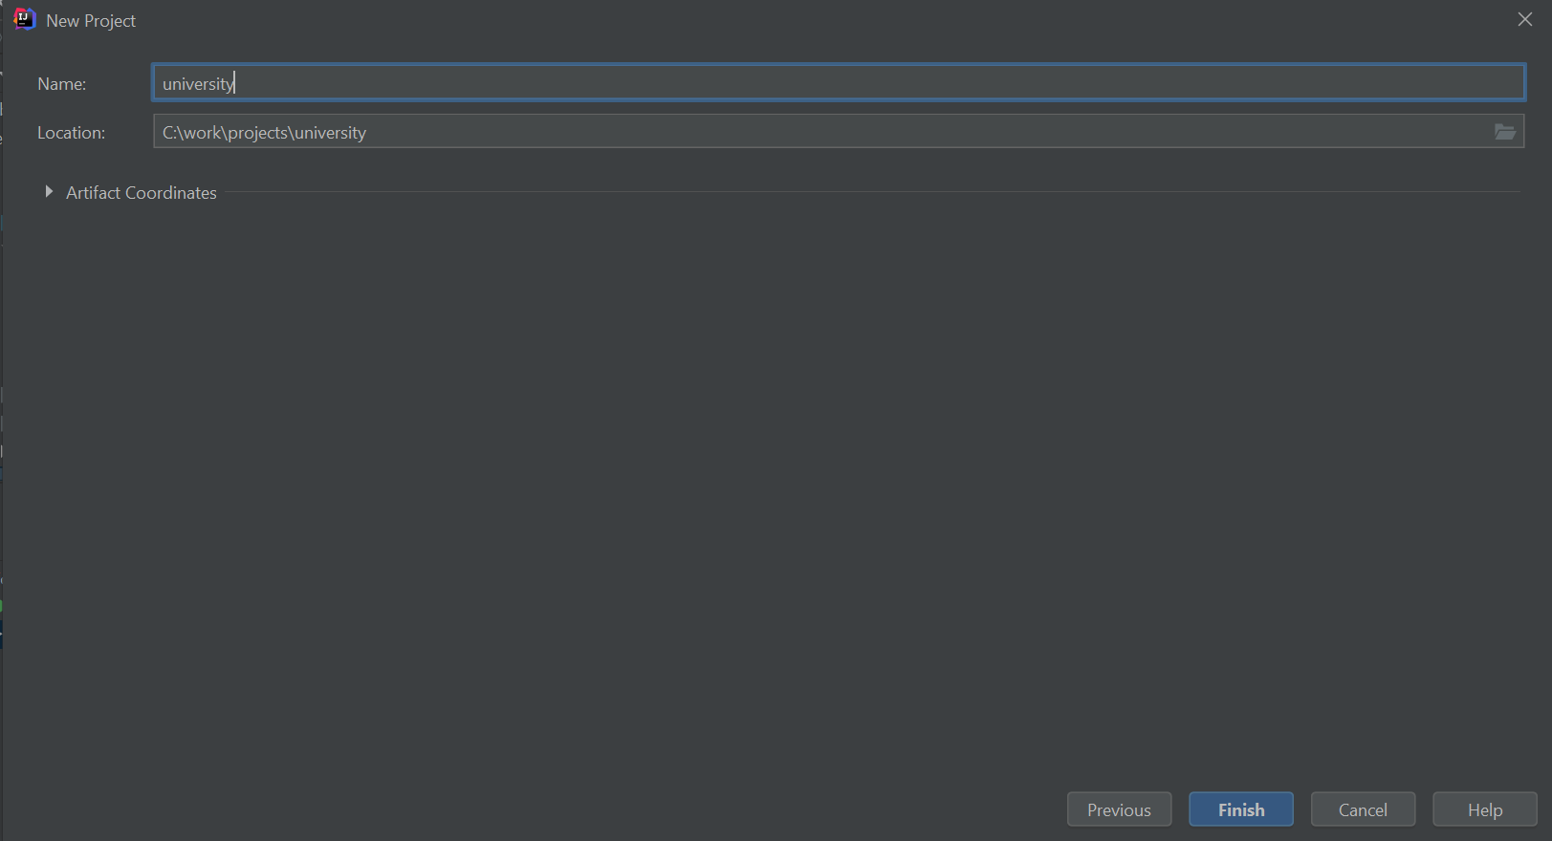

Create a Run configuration

Click on add Configuration -> “+” -> Select Tomcat Server -> Local

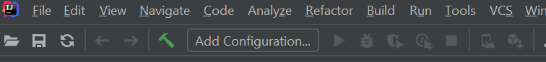

Make the following configurations to the Run Configuration (note: the URL should automatically be filled once you finish configuring everything)

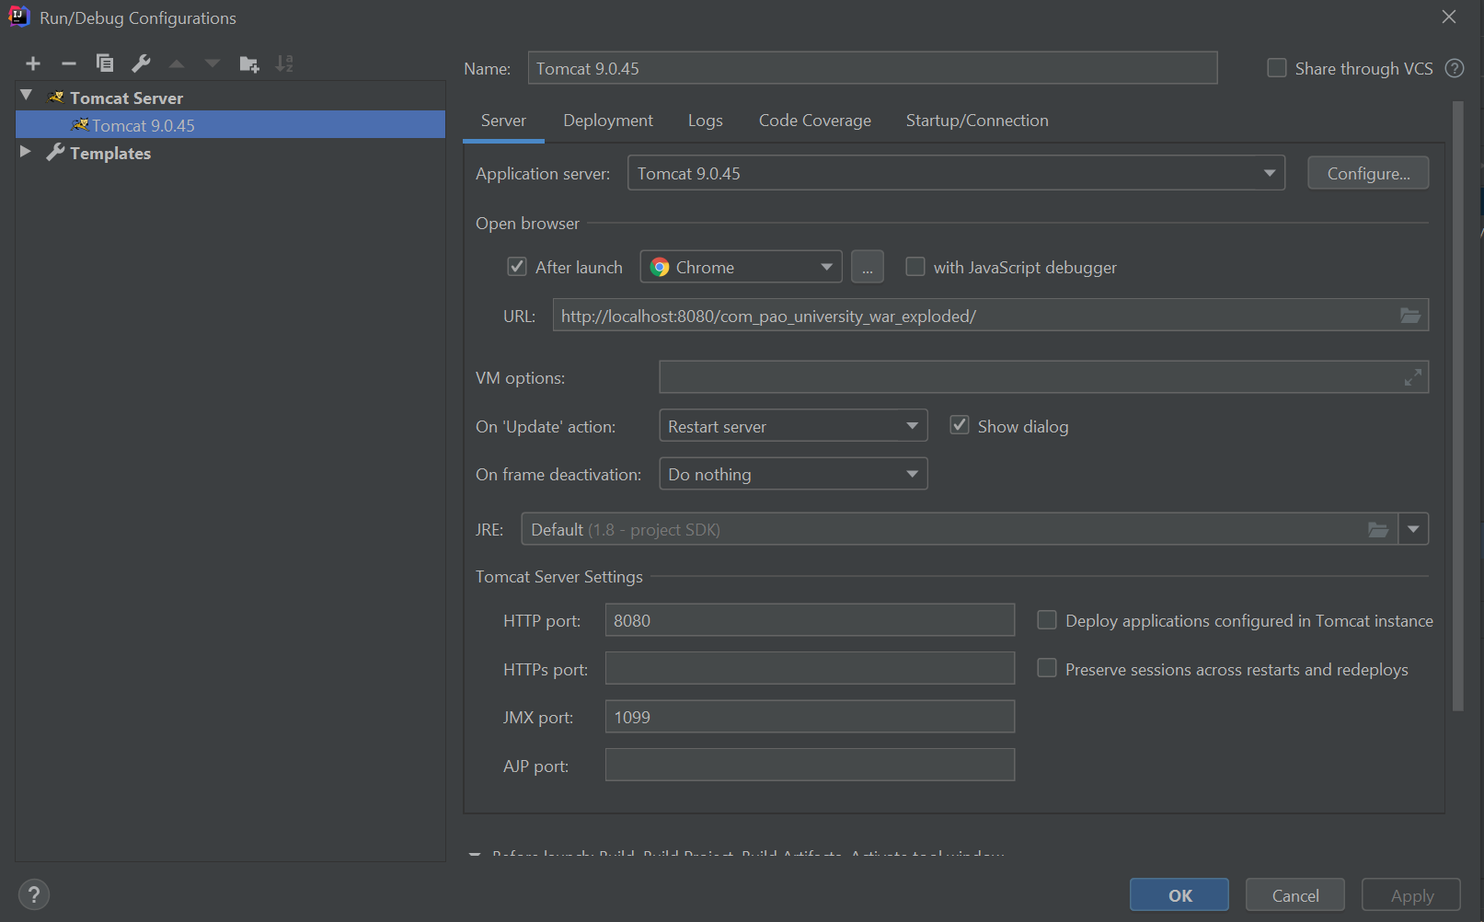

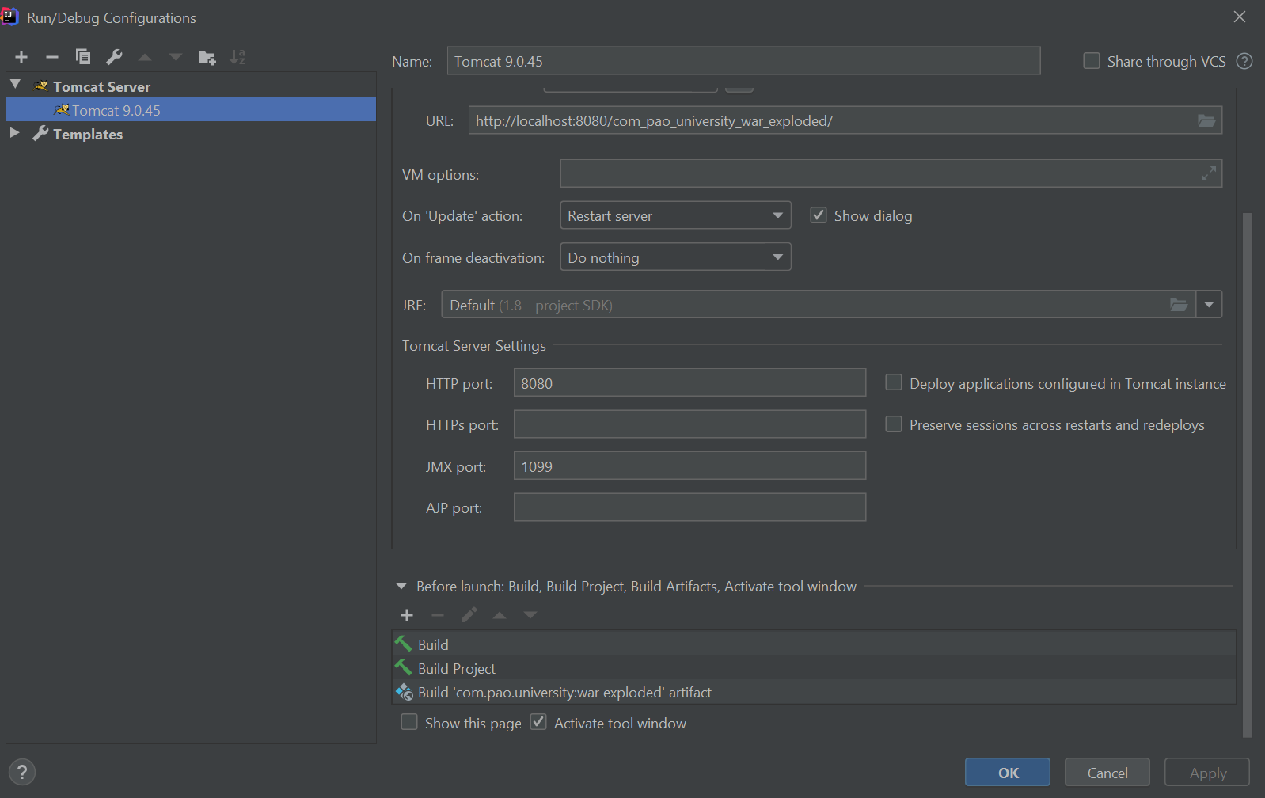

In the project, you should have a pom.xml file generated already by IntelliJ. Add the following packaging tag, as following:

<groupId>org.example</groupId>  
<artifactId>com.pao.university</artifactId>  
<version>1.0-SNAPSHOT</version>  
<packaging>war</packaging>

In project structure, under artifacts:

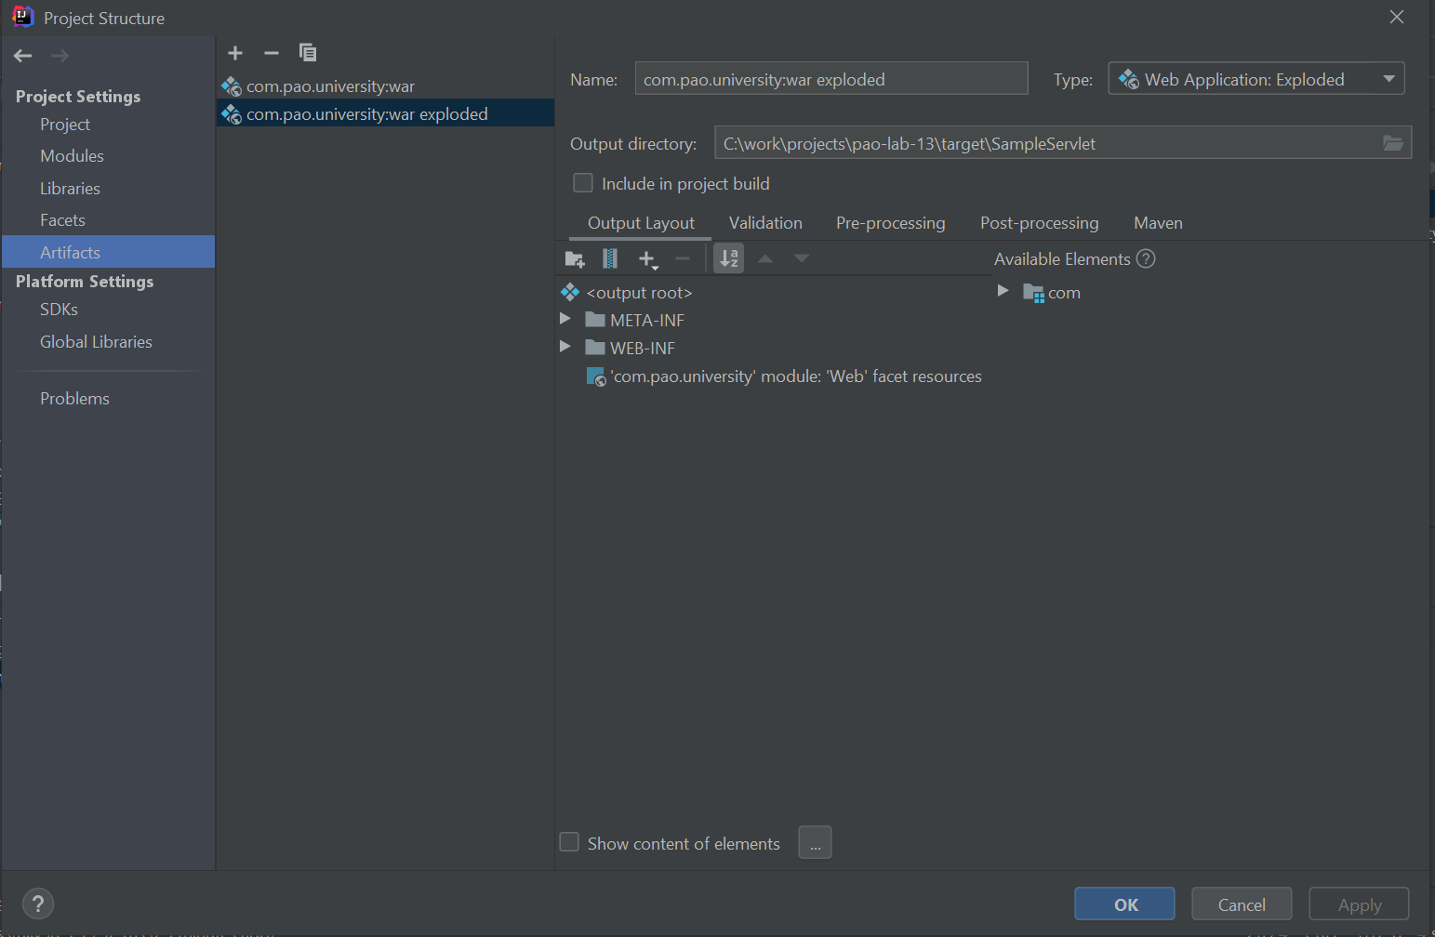

Simple web application using Servlets, JSP and IntelliJ tutorial:

https://medium.com/@kasunpdh/sample-java-web-application-using-servlets-and-jsp-5621cad2f582