Arts Festival Scheduler

(AFS)
Developed by Diana Carrier
Last edited January 23 2015

Adding Entries
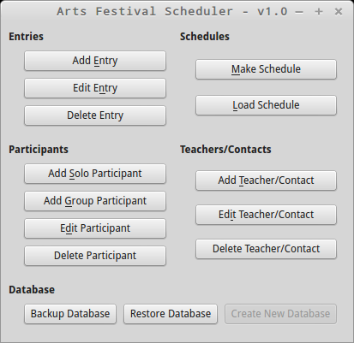
Clicking “Add Entry” will open this dialog:
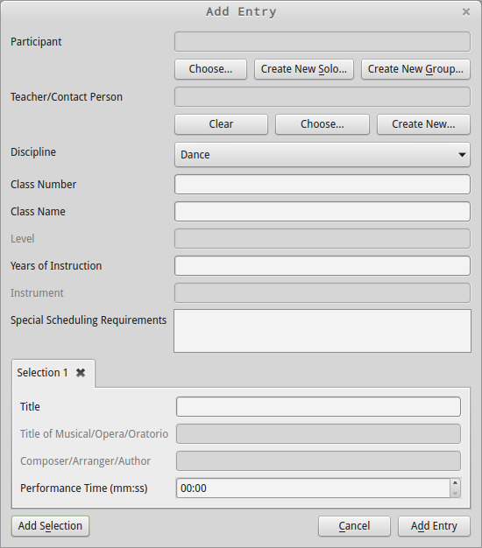
Adding Participants and Teachers have their own sections in this document and will not be covered here.
- Clicking Choose Participant will bring up the Choose Participant dialog, pictured in the Edit Participants section. The chosen Participant's name will appear in the text box.
- Clicking Choose Teacher will bring up the Choose Teacher dialog, pictured in the Edit Teachers section. The chosen Teacher's name will appear in the text box. The Clear button can be used to remove the Teacher.
- Discipline is located on the top center of the received entry form. Setting this will disable irrelevant fields (i.e. Instrument is irrelevant for any discipline other than Instrumental).
- Class number is of the format “ABC 1234”. Note: The space is very important, though there can be any amount of letters and numbers so long as there is at least one of each. Capitalization will be fixed automatically and Class Name will be filled automatically only if the Class Number is found in the syllabus file. If Class Name remains empty, the Class Number is invalid, and the entry will not be submitted to the database.
- Level refers to Discipline grade level, if applicable (not school grade).
- Years of Instruction, Instrument, and Schedulling Requirements are labelled the same on the entry forms.

Selections
Disciplines such as Band and Choral may have multiple Selections (songs) per entry. To add additional Selection tabs, click the Add Selection button in the bottom left corner.
- Title is a required field. No error checking is done on it, so be sure to spell and capitalize it correctly as this is what will be printed in the book!
- Title of Musical/Opera/Oratorio is only valid for Vocal and Choral.
- Composer/Arranger/Author is an optional field, but if present will be printed so be sure to spell and capitalize it correctly!
- Performance Time is a required field. It must be greater than 00:00, which is formatted as minutes:seconds.
Clicking Add Entry in the bottom right will perform some error checking and validation. If the Teacher field is left blank, the program will ask for confirmation that this is correct, since all communication goes through the Teacher, but there may not be one for Speech entries. If all is well a message box will pop up saying that the Entry was successfully added to the database. If not, it will display an error showing which field(s) are incorrect.

Edit Entries
Clicking Edit Entry will bring up this dialog:
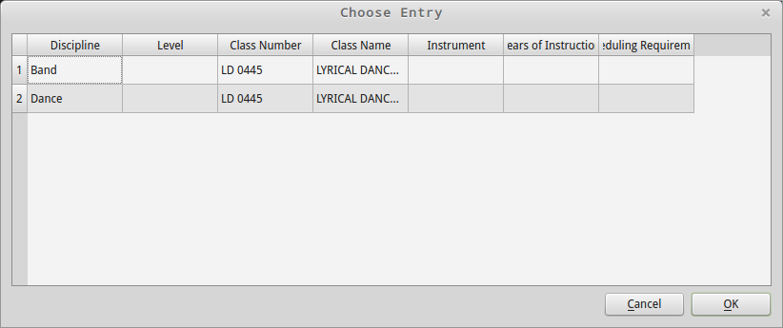
Highlight an Entry by clicking anywhere on the row and then click OK. Entries begin sorted by most recently entered. They can be sorted differently by clicking on the column headers. Clicking OK will bring up a dialog similar to Add Entries with all the available information filled in and can be edited and submitted in the same way. Note: Unfortunately Participant and Teacher names are not able to be shown at this time, but the information is still stored in the database and can be edited. This will be corrected in the future.

Add Participants
Definitions: A “solo” participant refers to a single person. A “group” participant refers to everything from a duet up to a school group. This distinction was made because different information is required for each. Note: A Group Participant may have references to Solo Participants. Also note: Groups are not directly attached to their Teachers. Groups reference their Teacher via the Entry. This allows the same Group to have different Teachers depending on the performance (i.e. Dance, school vocal choirs).
Clicking Add Participant in the bottom right will perform error checking and validation before submission to the database and will alert you of any errors.

Solo Participants
A Solo Participant can be added in one of two ways. The first is from the main window:
The second is while adding/editing an Entry:
Clicking either of these will bring up the Add Solo Participant dialog:
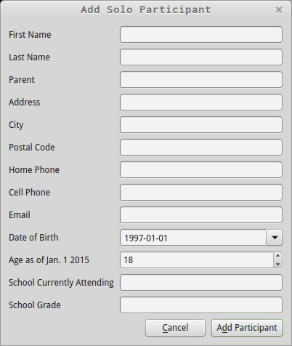
- First and Last Name are required. Some basic format checking is done on these fields before submission to the database, and the program will ask for confirmation before continuing.
- Date of Birth defaults to January 1 18 years ago (from the current year). Setting this field will automatically change the Age field.
- Age is calculated as of January 1 of the current year. Setting this will not change the Date of Birth, allowing for entry forms that ask for age but not birthdate. The program handles any discrepencies between Age and Date of Birth.

Group Participants
A Group Participant can be added in one of two ways. The first is from the main window:
The second is while adding/editing an Entry:
Clicking either of these will bring up the Add Group Participant dialog:
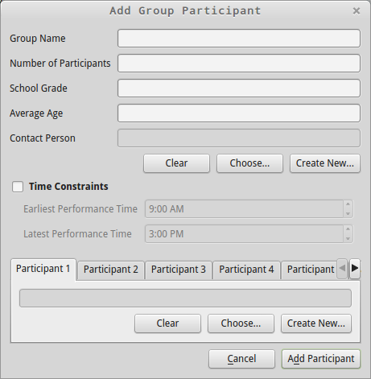
- Group Name required. Some basic format checking is done on this field before submission to the database, and the program will ask for confirmation before continuing.
- Number of Participants should only be filled if the individuals are not listed below.
- Contact Person is very similar to a Teacher, but is used in cases where there is no Teacher (i.e. Speech). See the section on Teachers for more details.
- Only check Time Constraints if they are given on the entry form. The program will try to use these when creating the schedules and having unneccessary contraints may mess up the algorithm.
- Group Participants may reference up to 6 Solo Participants. See the section on Solo Participants for more details.

Edit Participants
Clicking Edit Participant will bring up this dialog:
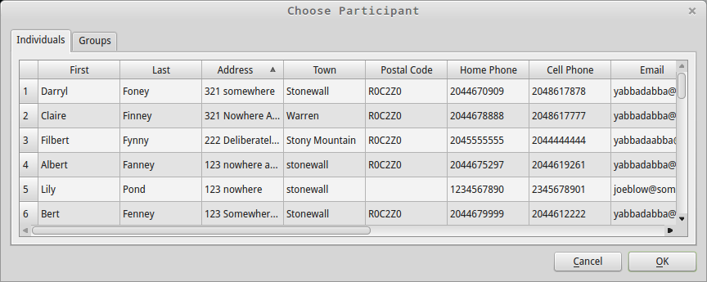
Select whether you want to edit a Solo or Group Participant with the tabs at the top. Participants begin sorted by most recently added. They can be sorted differently by clicking on the column headers. Select a participant by clicking on the row, then OK, to bring up the appropriate edit dialog. This will be identical to the add dialog with the information filled in.

Add Teachers/Contacts
The program treats Teachers and Contact persons the same way, since they perform the same function as far as it's concerned.
A Teacher/Contact can be added in one of two ways. The first is from the main window:
The second is while adding/editing an Entry:
Clicking either of these will bring up the Add Teacher/Contact dialog:
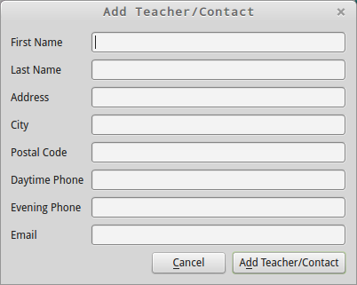
- First and Last Name are required. Some basic format checking is done on these fields before submission to the database, and the program will ask for confirmation before continuing.
- If Email is left blank the program will ask for confirmation before continuing since that's the desired form of contact.

Edit Teachers/Contacts
Clicking Edit Teacher/Contact will bring up this dialog:
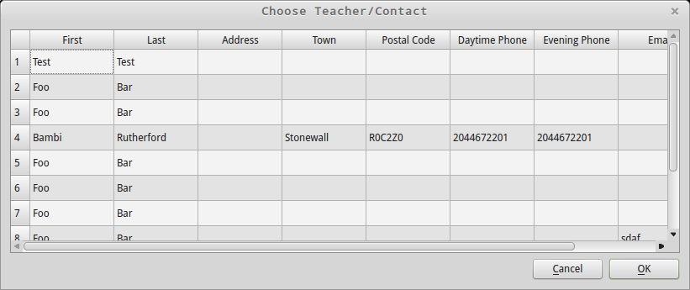
Highlight a Teacher/Contact by clicking anywhere on the row and then click OK. Tey begin sorted by most recently entered. They can be sorted differently by clicking on the column headers. Clicking OK will bring up a dialog similar to Add Teacher/Contact with all the available information filled in and can be edited and submitted in the same way.

Backup Database
Clicking the Backup Database button automatically creates a database backup file named AFS-YYYY-MM-DD-HH-MM-SS.bak in the Arts Festival Scheduler\Database folder. The program will inform you if it was successful or an error if it was not.

Restore Database
This will backup the current database and restore the most recent backup. In future this will be improved to allow the user to select a backup.

