Chicago 311 Service Requests Pipeline
Data Engineering Project Documentation

1. Executive Summary
This project is an incremental data pipeline — Apache Airflow for orchestration, DuckDB as the local warehouse, and dbt for transformation and testing — that ingests Chicago's 311 Service Requests from the Socrata open-data API, models them into a star schema, and answers one operational question: where is the city falling behind on service response times, and is it getting better or worse? As of this write-up the warehouse holds 7,065,148 service requests, ingested daily and incrementally since 2023-01-01, modeled into a fact table, five dimensions (one of them a full SCD Type 2 history of ward-map changes), and three marts that directly answer the project's deliverable questions on resolution time, duplicate complaints, and the 2023 ward redistricting.

2. Dataset Description
- Source: Chicago Data Portal (Socrata), "311 Service Requests" dataset, id v6vf-nfxy — data.cityofchicago.org/Service-Requests/311-Service-Requests/v6vf-nfxy/about_data
- Size ingested: 7,065,148 rows, ~37 raw columns per row, covering 2023-01-01 through the present (the source updates in near real time).
- Update frequency: the Airflow DAG runs @daily and pulls only rows with created_date greater than the last stored watermark — true incremental extraction, not a full re-download.
- Scoping decision: extraction starts at 2023-01-01 (the DAG's default watermark) rather than the source's full history back to ~2018. This keeps the initial paginated backfill (50,000 rows/page) tractable within the project timeline, while still spanning the 2023-05-15 ward redistricting date needed for the required SCD Type 2 dimension — the pipeline has real data on both sides of the boundary it needs to model.

3. Architecture Overview
The pipeline is a linear, eight-stage Airflow DAG (chicago_311_ingest), scheduled @daily with catchup=False, so it always processes only the newest data on each run. DuckDB is organized into three schemas following the medallion pattern:
Layer | Contents
bronze | raw_service_requests (loaded by Airflow), community_areas + ward_versions (loaded by dbt seed)
silver | stg_311_requests (a dbt view: trim/cast/normalize, no business logic), snap_service_requests_status (a dbt snapshot: SCD2 history of the full request row)
gold | fct_311_requests, 5 dimensions, dim_ward (SCD2), and 3 deliverable marts — all dbt models

Airflow is the only component that runs on a schedule; dbt has no scheduler of its own here — it only executes when an Airflow task invokes it as a subprocess (dbt seed / run / snapshot / test / docs generate). The trigger sequence is:
extract >> load >> dbt_seed >> transform_staging >> dbt_snapshot >> transform_marts >> validate >> dbt_docs_generate
dbt_snapshot sits between the two halves of the dbt transform deliberately: it needs stg_311_requests (built by transform_staging) to already exist, and fct_311_requests (built by transform_marts) needs dim_ward already updated, since the fact table joins to it directly on the ward's validity interval.
The watermark that drives incremental extraction is stored in a DuckDB control table (bronze.extraction_control), not an Airflow Variable, so the pipeline's state lives entirely inside the warehouse it manages. A custom Docker image (Dockerfile) bakes dbt/duckdb/pandas in at build time, rather than installing them into each container at every start.

4. Data Modeling Explanation
Entities, grain, and why that grain was chosen:
Table | Grain (one row =) | Why this grain
gold.fct_311_requests | one 311 service request (sr_id) | the source system's own natural, unambiguous unit
gold.dim_service_request_type | one request-type category | small (108 rows), stable, reused across millions of requests
gold.dim_location | one exact address (street number/direction/name/type) | needed at address level specifically to detect Q2's "same-location" duplicates; a coarser grain (zip/ward) would create false positives
gold.dim_community_area | one of Chicago's 77 community areas | matches the city's own fixed geographic areas; groups the Q1 results
gold.dim_date | one calendar day, 2015-01-01 through 2030-12-31 | a conformed calendar dimension, role-played three times (created_date_day, last_modified_date_day, closed_date_day)
gold.dim_ward (SCD2 snapshot) | one ward, one map-version-in-effect period | ward boundaries changed in 2023 — the grain must include the era, or history collapses into whichever map is current
silver.snap_service_requests_status (SCD2) | one request, one status-as-of period (full row) | captures every status transition over time, not just the current status

Relationships between tables
- fct_311_requests joins dim_service_request_type on sr_short_code, and dim_location on the 4-part address key (street_number, street_direction, street_name, street_type).
- fct_311_requests joins dim_community_area on community_area for lineage completeness, though the dimension's descriptive name column is not pulled into the fact table — it is already available directly in the dimension.
- fct_311_requests joins dim_ward on ward together with a validity interval (dbt_valid_from ≤ created_date < dbt_valid_to), not equality alone — ward is not a unique key in dim_ward (each ward has one row per map-version era), so the interval is required to resolve exactly one matching row.
- fct_311_requests joins dim_date three times under three different aliases (a "role-playing" dimension) — once each for created_date_day, last_modified_date_day, and closed_date_day.
The required SCD Type 2 dimension is dim_ward, built as a dbt snapshot (check strategy on map_version). Chicago redrew its ward boundaries effective 2023-05-15; a request's ward number needs to be interpreted against the map in effect at created_date, not today's map, or historical ward-level reporting silently misattributes pre-2023 requests. Because this pipeline started running years after the redistricting, a live dbt snapshot alone could only ever observe the current map as a baseline — see Section 10 for how the pre-2023 history was backfilled.

5. Project Structure Walkthrough
Path | Contents
dags/ingest_dag.py | The Airflow DAG: extract, load, dbt_seed, transform_staging, dbt_snapshot, transform_marts, validate, dbt_docs_generate.
dbt_project/models/staging/ | stg_311_requests — trim/cast/normalize only, no business logic.
dbt_project/models/marts/ | Dimensions, the incremental fact table, and the three deliverable-question marts.
dbt_project/snapshots/ | SCD2: dim_ward (ward map version) and snap_service_requests_status (full-row status history).
dbt_project/seeds/ | community_areas.csv and ward_versions.csv (redistricting reference dates).
dbt_project/macros/ | generate_schema_name override, so models land in silver/gold instead of main_silver/main_gold.
dbt_project/tests/ | Custom SQL tests: closed_date >= created_date, lat/long inside Chicago's bounding box.
scripts/backfill_dim_ward.py | One-time script to seed dim_ward's pre-2023 SCD2 history.
raw/ | Landed Parquet files from each extract run (git-ignored).
warehouse.duckdb | The DuckDB database file (git-ignored).
docs/project_documentation.docx | This document.
docker-compose.yml | Airflow webserver + scheduler + Postgres metadata DB.
Dockerfile | Bakes dbt/duckdb/pandas into the Airflow image at build time, instead of per-container pip installs.
README.md | Setup and run instructions.

6. Airflow DAG Explanation
DAG id: chicago_311_ingest. Schedule: @daily, catchup=False, max_active_runs=1 (a new DagRun never starts before the previous one has fully finished — DuckDB allows only one read-write connection at a time, so overlapping runs would race for the file lock). Default retries: 1.
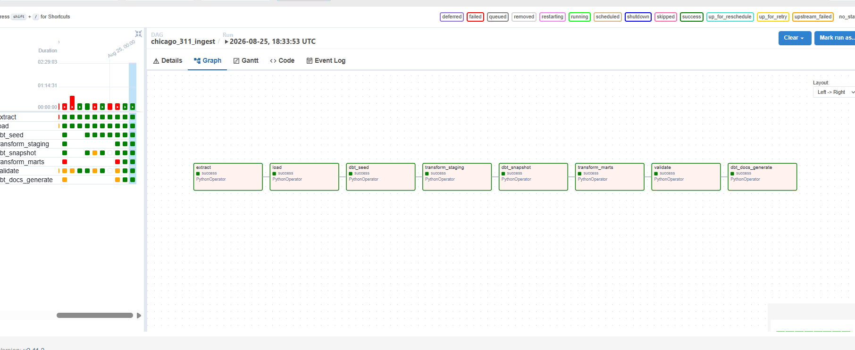

Task | What it does
extract | Pages Socrata with $where=created_date>:watermark (50k rows/page, retries with backoff), writes each page to raw/ as Parquet. Watermark advances after every page.
load | Upserts into bronze.raw_service_requests: DELETE the incoming sr_numbers, then INSERT — re-running the same execution never creates duplicates.
dbt_seed | Loads community_areas and ward_versions — must run before any model that references them.
transform_staging | dbt run --select staging — (re)builds only the stg_311_requests view, with today's fresh data.
dbt_snapshot | dbt snapshot — appends history to gold.dim_ward and silver.snap_service_requests_status. Runs after staging (needs the fresh view) and before marts (fct joins to dim_ward).
transform_marts | dbt run --exclude staging — dimensions, the incremental fact table, and the 3 marts.
validate | dbt test — 23 tests. A hard failure fails the DAG run; known dirty data uses severity: warn.
dbt_docs_generate | dbt docs generate — refreshes the catalog/lineage. Runs last, after validate, so docs always describe a tested state.

Dependencies: each task depends explicitly on the one before it, in the strict linear chain shown above — visible as a straight line in the Airflow Graph View.

7. dbt Lineage and Tests
dbt docs generate runs cleanly against the project (9 models, 2 snapshots, 2 seeds, 1 source, 23 data tests) and produces a browsable lineage graph.
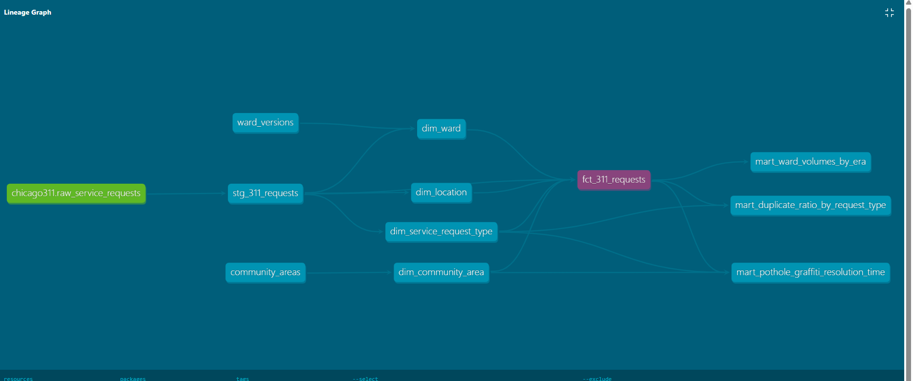

Test | Severity | Why it exists
unique / not_null: sr_id | error | Primary key of every request — must be unique and present before anything downstream trusts it.
not_null: created_date | error | Drives incremental logic and every date-based mart.
accepted_values: status | error | Domain rule — catches a new, unmapped source value immediately.
not_null: community_area | warn | Known dirty data (~0.1% of rows) — real Socrata rows ship without a community area.
assert_closed_date_after_created_date | warn | Custom SQL test. Domain rule: a request can't close before it opens — 1 known legacy row violates this.
assert_lat_long_within_chicago_bbox | error | Custom SQL test. Catches geocoding errors (lat 41.6–42.05, long -87.95 to -87.5).
relationships: sr_short_code -> dim_service_request_type | error | Every fact row must resolve to a known request-type dimension row.
relationships: location_id -> dim_location | warn | Known incomplete/ungeocoded addresses in the source.
unique/not_null on every dimension key | error | Dimension natural/surrogate key integrity.

8. How to Run (from a clean DuckDB file)
Full details are in README.md; summary:
Step | Command / action
1 | New-Item warehouse.duckdb -ItemType File (placeholder so Docker mounts a file, not a directory)
2 | docker-compose build (bakes dbt/duckdb/pandas into the image once)
3 | docker-compose up -d (starts Postgres, airflow-init, webserver, scheduler)
4 | Open http://localhost:8085 (admin/admin); register the Socrata token as connection socrata_default (optional)
5 | Unpause and trigger chicago_311_ingest — the first run backfills from 2023-01-01
6 | python scripts/backfill_dim_ward.py — once, after the first DAG run, before the second scheduled run

9. Answers to the Deliverable Questions

Q1. Which community areas have the slowest median resolution time for pothole/graffiti requests, and has it improved or worsened year-over-year?
Model: gold.mart_pothole_graffiti_resolution_time — median days from created_date to closed_date, pivoted by year, ranked by the median across all four years combined (overall_median_days), not a median-of-medians.
Community area | 2023 | 2024 | 2025 | 2026 | Overall
O'Hare | 8.2 | 6.9 | 22.0 | 8.2 | 10.9
Edison Park | 6.8 | 12.0 | 19.7 | 6.5 | 10.1
Norwood Park | 4.1 | 8.9 | 21.0 | 6.9 | 8.6

Interpretation: resolution time varies far more by community area than by any citywide trend. O'Hare, Edison Park, and Norwood Park are consistently the slowest overall, all spiking sharply in 2025 — there is no single citywide “improving”/“worsening” answer; it is genuinely area-specific.

Q2. Which request types have the highest ratio of reopened/duplicate complaints (same location, same type, within a short window)?
Model: gold.mart_duplicate_ratio_by_request_type — same location_id, same sr_short_code, filed within 14 days of an earlier request, computed with LAG() (a self-join took 5+ minutes on 7M rows; the window function gives the same answer in ~2 seconds). 311IOC and Aircraft Noise Complaint are excluded — bucketed onto 81 and 13 fixed addresses respectively, which produced a false ~99.9% duplicate rate before exclusion.
Request type | Total requests | Duplicate %
Liquor Establishment Complaint | 295 | 45.8%
Divvy Bike Parking Complaint | 11,658 | 45.7%
Open Fire Hydrant Complaint | 25,014 | 43.9%
Traffic Signal Out Complaint | 96,859 | 41.0%
City Vehicle Sticker Violation | 16,395 | 35.9%

Interpretation: fire hydrants and pothole/parking-related requests dominate the high-duplicate list, consistent with how visible, physically persistent issues are actually reported — many residents independently flag the same problem before it's fixed.

Q3. Do ward-level request volumes look different when requests are attributed to the ward in effect at the time versus the current ward map, for the years spanning the 2023 redistricting?
Model: gold.mart_ward_volumes_by_era. Documented limitation: there is no ward-boundary geometry/crosswalk available in this project, so individual historical requests cannot be re-projected onto the other map. What the model answers honestly instead: whether each ward's own reported daily rate shifted at the 2023-05-15 boundary, adjusted for the citywide trend (excess_pct_change_vs_citywide), after excluding 311IOC and Aircraft Noise Complaint (the same fixed-address artifacts as Q2).
Ward | Avg/day old_map | Avg/day new_map | Ward % change | Citywide % change | Excess vs. citywide
43 | 29.8 | 51.5 | +73.0% | +29.7% | +43.3
44 | 20.7 | 34.1 | +64.6% | +29.7% | +34.9
39 | 39.3 | 63.0 | +60.1% | +29.7% | +30.4
14 | 52.1 | 58.7 | +12.6% | +29.7% | -17.1

Interpretation: ward-level volumes do look different across the redistricting, and not uniformly — wards 43, 44, and 39 grew far faster than the citywide trend, while ward 14 (and wards 12, 34) grew noticeably slower. Because the underlying boundary geometry isn't available, this can't distinguish “this ward's area actually changed” from “the same area just started generating more or fewer requests” — but the size and direction of the excess change is a legitimate, data-grounded signal worth following up with an actual GIS boundary comparison if that data becomes available.

10. Challenges and Lessons Learned

1. dim_ward couldn’t observe its own history
The pipeline started running years after Chicago's 2023-05-15 ward redistricting, so a live dbt snapshot could only ever record the current (“new_map”) state as a baseline — it has no way to retroactively produce the old_map -> new_map transition dbt snapshots are designed to capture over time. Resolved with a one-time Python script (scripts/backfill_dim_ward.py) that directly inserts the historical rows a continuously-running snapshot would have produced since 2015, matching dbt's own snapshot table schema exactly, so ordinary dbt snapshot runs continue seamlessly afterward.

2. The daily DAG never actually ran dbt seed or dbt snapshot
Manual testing with “dbt build” made the pipeline look complete, but a review of the DAG's transform task showed it only ever called “dbt run”, and validate only called “dbt test”. Neither “dbt seed” nor “dbt snapshot” was wired into any Airflow task — the SCD2 history requirement was, in production, entirely inert. Fixed by adding explicit dbt_seed and dbt_snapshot tasks in dependency-correct order.

3. A self-join for Q2 took 5+ minutes on 7 million rows
The literal “same location, same type, within a short window” requirement was first implemented as a self-join on (location_id, sr_short_code) with a date-range condition. DuckDB has no index to prune that range comparison, so it behaved like a filtered cross-join per group and took over 5 minutes. Replaced with a single LAG() window function over (location_id, sr_short_code) ordered by created_date — mathematically equivalent for a “within N days of the immediately preceding request” check, and runs in about 2 seconds.

4. Airflow containers reinstalled dbt/duckdb/pandas on every start
_PIP_ADDITIONAL_REQUIREMENTS was being used to install extra Python packages, which the official Airflow image documentation itself flags as “for quick testing only.” Every container (airflow-init, airflow-webserver, airflow-scheduler) reinstalled the same ~15 packages from scratch on every start — slow, and occasionally slower than the webserver's health-check grace period, which could make a plain “docker-compose up -d” look like it “doesn't work.” Fixed by moving the dependencies into a dedicated Dockerfile, built once.

5. Two request types silently dominated both the ward-volume and duplicate-ratio marts
An early version of the ward-volumes mart (Q3) produced wards 28 and 41 with 15–30x more daily requests than every other ward. Tracing it down: ward 28's total was 96% “311 Information Only Call” rows coming from just 81 distinct addresses; ward 41's total was 95% “Aircraft Noise Complaint” rows coming from just 13 addresses near O'Hare — almost certainly automated noise-monitor submissions rather than organic public complaints. The same two request types were later found to produce a false ~99.9% “duplicate” rate in Q2, for the identical reason: too many requests crammed onto too few fixed addresses. Both request types were excluded from both marts specifically, with the exact row/address counts documented in each model's header comment as the evidence for the exclusion.

