

devswiss.ch
Kühlewilstrasse 6, Englisberg, Switzerland
info@devswiss.ch

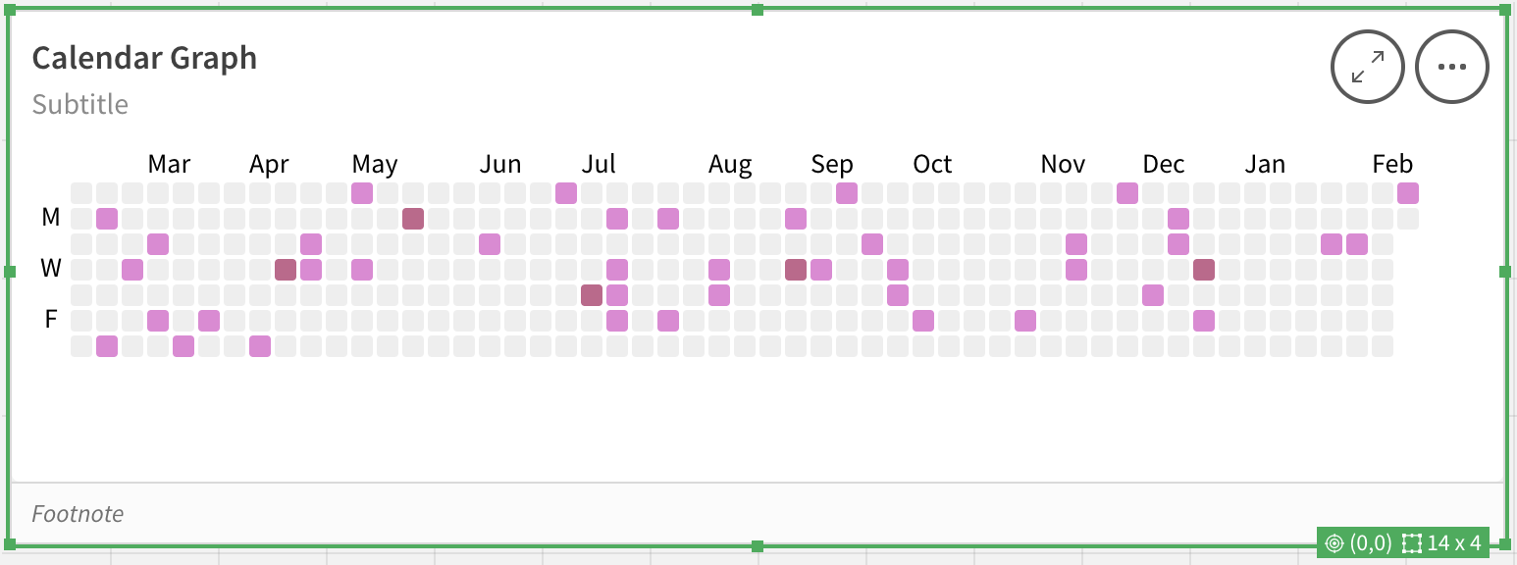
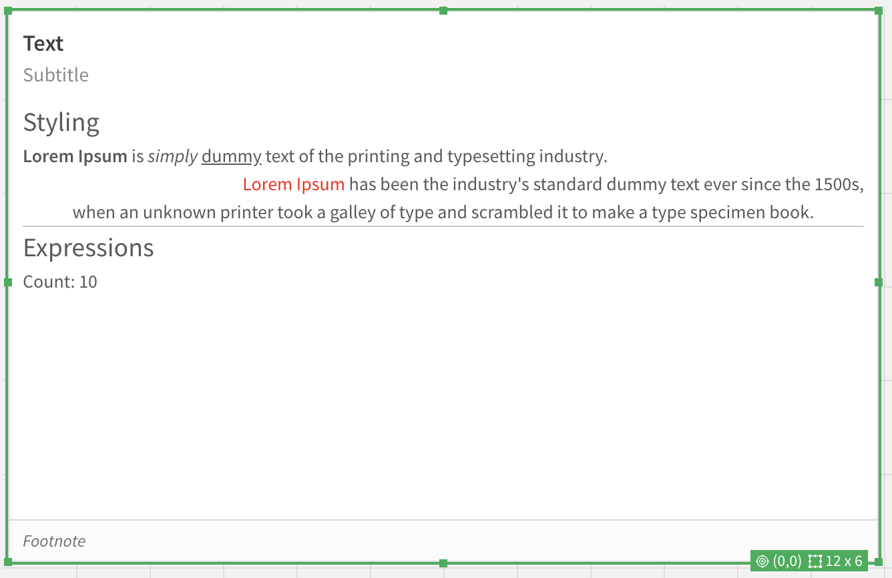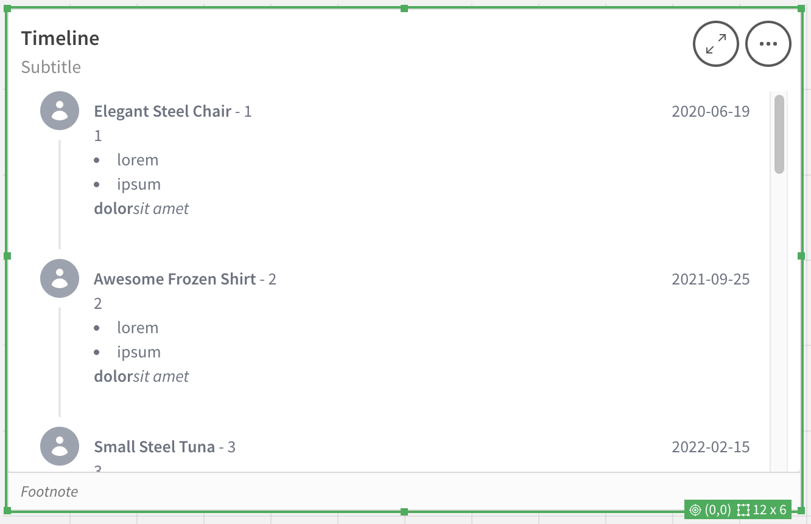

License
These extensions are licensed to MSD Switzerland for use in MSD MER Region.
For more information contact info@devswiss.ch

Setup
To install, first click on the Navigation button (top right corner).

Then, in the dropdown, select the Management Console.
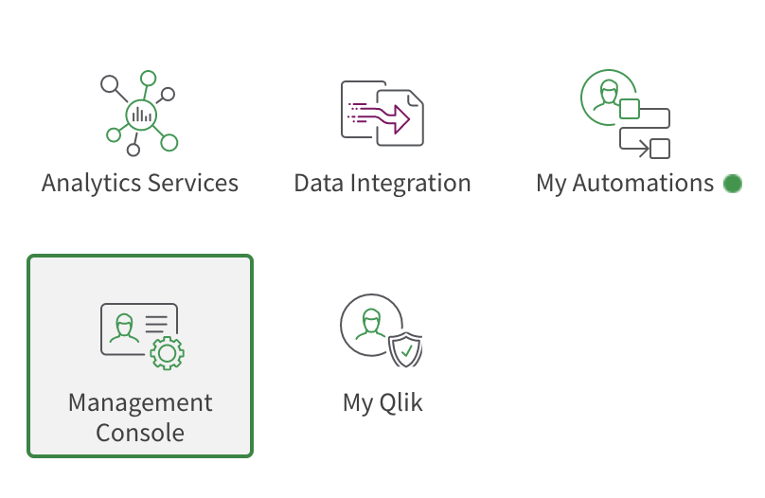
After that, find the Extensions section.
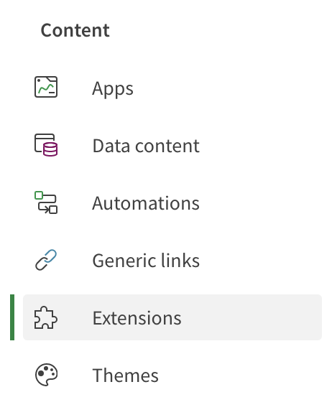
In there, find the Add button.

Now you can upload the zip files (one at a time).
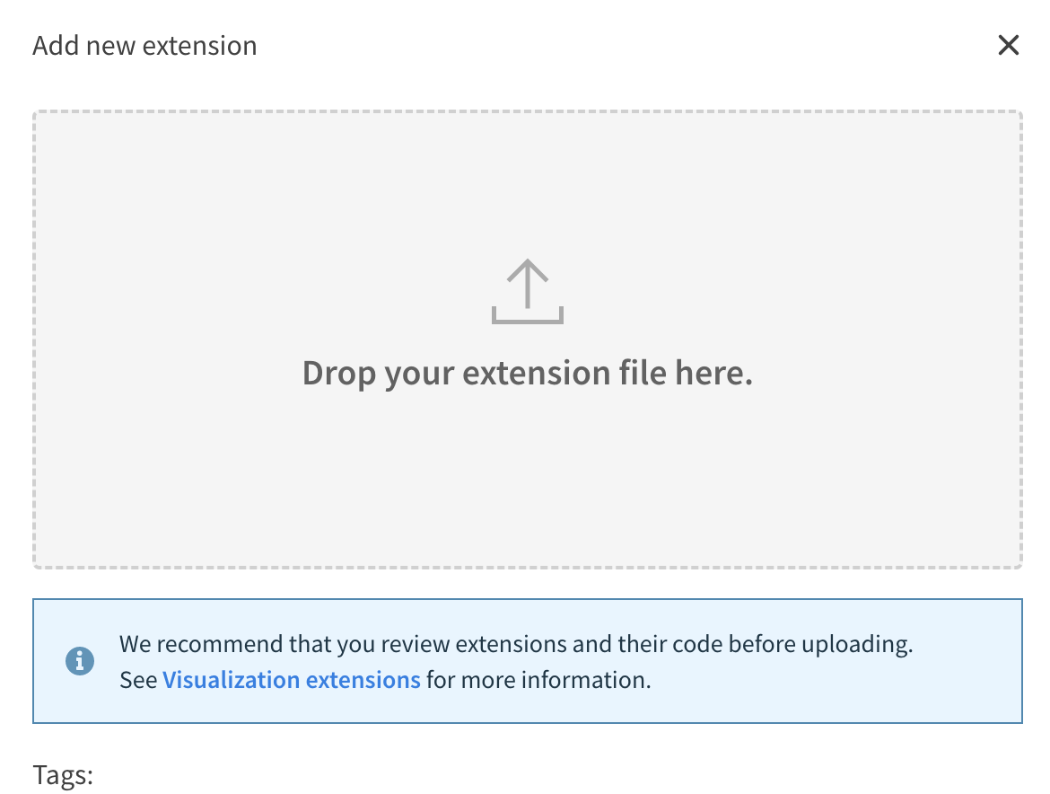
If everything went through, you should see the extensions in the list.
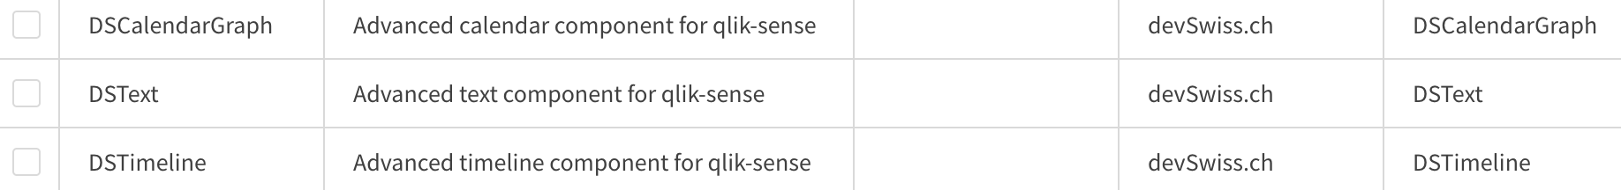
DSCalendarGraph

Sample data
[DSCalendarGraph]:
LOAD * INLINE [
dscg_id, dscg_date, dscg_product, dscg_name, dscg_zip, dscg_amount, dscg_color
1, 2022-10-16T02:11:49.573Z, Rustic Plastic Car, Homer Gibson, 27636-3238, 714.70, #A56F3D
2, 2022-12-31T22:49:21.438Z, Rustic Plastic Ball, Arthur Becker, 77724, 118.30, #DAB7EE
3, 2022-10-22T14:32:10.734Z, Rustic Fresh Shirt, Jackie Waelchi, 32192, 372.92, #4D6ADA
4, 2022-08-12T22:10:17.407Z, Gorgeous Frozen Fish, Theodore Jacobi, 99744-2978, 99.28, #1C2326
5, 2023-02-21T20:37:25.797Z, Sleek Rubber Hat, Paul Lakin, 42540-3388, 817.07, #F6746D
6, 2023-02-11T03:53:32.326Z, Rustic Bronze Ball, Vera Schinner, 80805, 850.10, #ED853C
7, 2022-09-16T05:10:44.107Z, Oriental Fresh Shirt, Martin Kovacek, 94128, 787.82, #BCCC7A
8, 2022-10-27T08:51:23.002Z, Awesome Wooden Gloves, Mr. Kevin Stracke, 22846-8586, 858.37, #0C09CC
9, 2022-12-19T08:35:58.096Z, Bespoke Rubber Hat, Verna Crona, 88747-2295, 810.70, #AD4B5F
10, 2022-07-27T06:58:43.510Z, Licensed Bronze Shirt, Jeannie Olson, 93991-5959, 459.19, #F2249E
];

Inputs
This extension requires at least two dimensions.
First one should be the date. Others are then shown in the tooltips.
As of v1.5.0 you can also specify the color dimension using the Label field (on color dimension) and Color Label (below Appearance section).

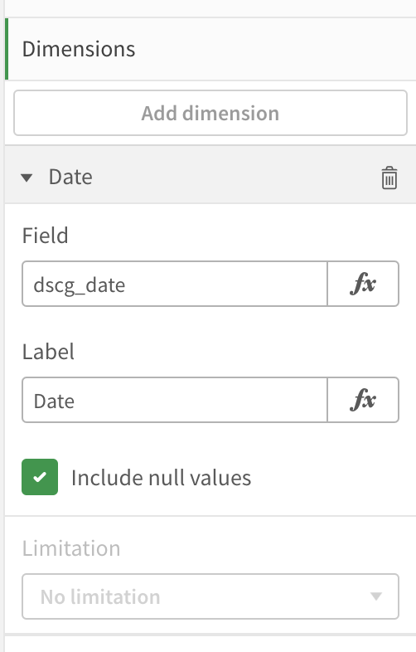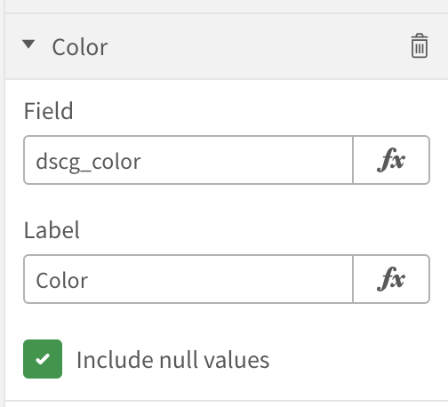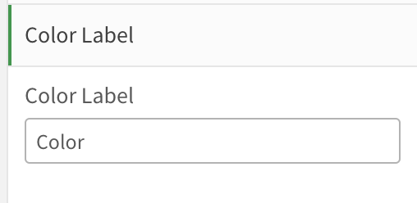

You can specify the background color of the pane, using Background color, default color of the boxes using Rectangle Color and color of the Axis text by using Axis Color
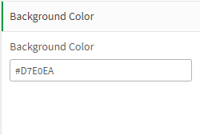
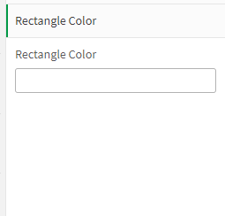
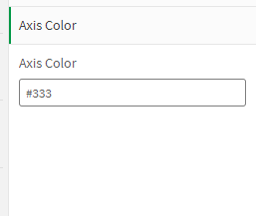

Output

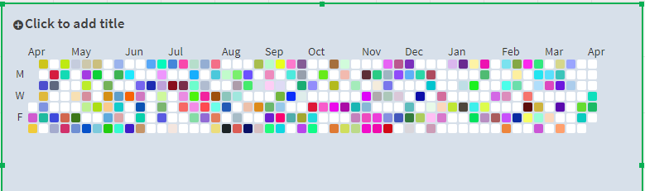
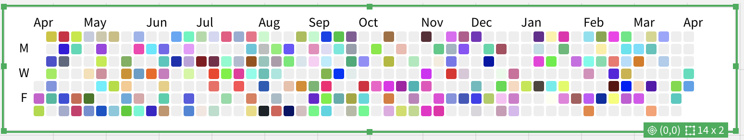

DSText

Sample inputs
'
<h1 style="font-size: 20px">Styling</h1>
<b>Lorem Ipsum</b> is <i>simply</i> <u>dummy</u> text of the printing and typesetting industry.
<p style="text-align: right"><span style="color: red">Lorem Ipsum</span> has been the industry''s
standard dummy text ever since the 1500s,</p>
<p style="text-align: center">when an unknown printer took a galley of type and scrambled it to make
a type specimen book.</p>
<hr/>
<h1 style="font-size: 20px">Expressions</h1>
<p>Count: ' & Count(dscg_id) & '</p>
'

Inputs
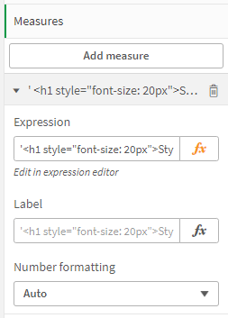

The extension can be used to show numbers by specifying the measures.

Output
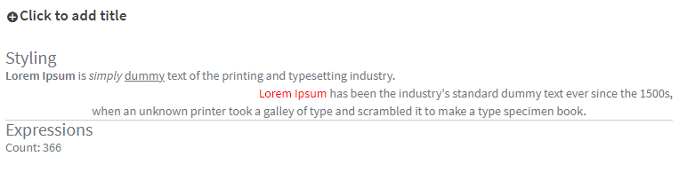

DSTimeline

Sample data
[DSTimeline]:
LOAD * INLINE [
id, purchase_date, product_name, image, color
1, 2021-01-04T03:00:07.723Z, Ergonomic Plastic Computer, a.png, #2CBCAC
2, 2022-10-08T21:48:44.355Z, Ergonomic Plastic Chips, b.png, #5556E1
3, 2021-03-13T10:34:22.348Z, Awesome Plastic Chips, c.png, #2CBCAC
4, 2021-11-04T02:40:55.974Z, Refined Plastic Gloves, a.png, #5556E1
5, 2022-01-27T18:15:23.839Z, Unbranded Fresh Pizza, b.png, #2CBCAC
6, 2023-01-31T02:16:07.906Z, Tasty Wooden Chair, c.png, #5556E1
7, 2022-12-10T02:06:02.837Z, Refined Metal Chair, a.png, #5556E1
8, 2023-01-03T05:43:59.359Z, Practical Rubber Fish, b.png, #2CBCAC
9, 2020-11-06T22:40:12.530Z, Modern Concrete Table, c.png, #5556E1
10, 2022-06-03T07:49:05.262Z, Rustic Concrete Keyboard, a.png, #2CBCAC
];

Sample inputs
Thumbnail
'/api/v1/apps/' & DocumentName() & '/media/files/' & image

Inputs
This extension takes one or more dimensions.
As of v2.6.0 it also supports custom thumbnails via thumbnail dimension using the Label field (on thumbnail dimension) and Thumbnail Label (below Appearance section).

You must specify a date dimension and have to specify the label of the date dimension in Timeline Area > Timeline Date label.
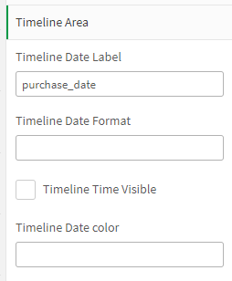
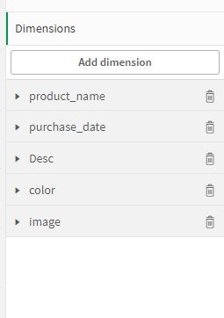

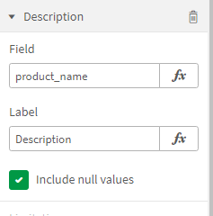
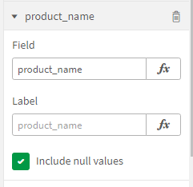
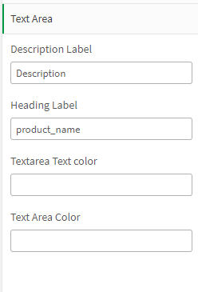
You can add a heading to text area by specify the label of the dimension in Textarea > Heading Label, can add a dimenison as description by specifying the dimension label in Textarea > Description Label,
you can also specify the background color and text color of the text area. Example colors: #fefefe, #eeeeee.
You can specify the color for heading underline and timeline thumbnail border using color related dimension and Theme color label
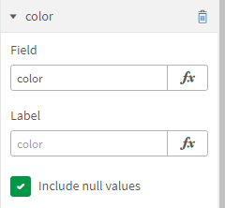
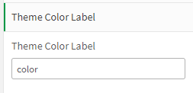
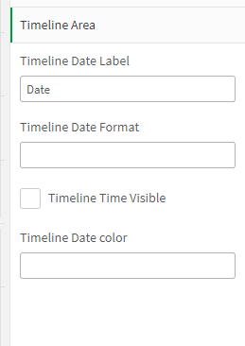
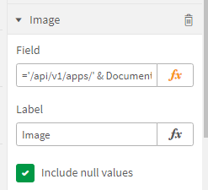
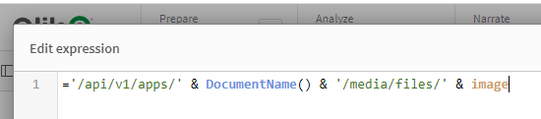
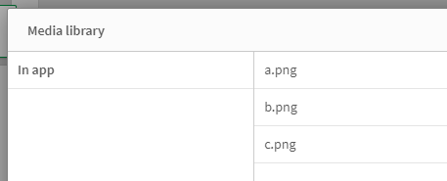
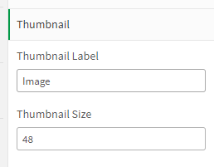
you have the option to specify the format of date. Default is yyyy-mm-dd. An option to hide the time element of the date.
Thumbnails:
Any dimesnion with valid url can be used for thumbnails and specify the label of it in the Thumbnail > thumbnail label with a size. If the dimesnion has just the file name with file uploaded to Media library, have to use '/api/v1/apps/' & DocumentName() & '/media/files/' & image Click on fx to add it. where image is the dimension name. And rest will be same.

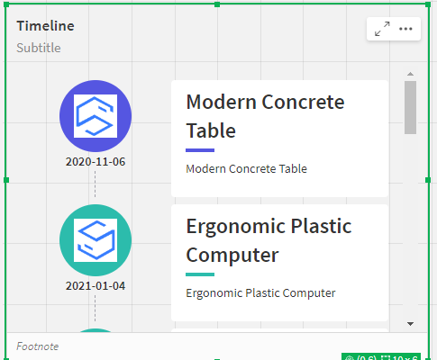
Output
