

# [devswiss.ch](http://devswiss.ch)

Kühlewilstrasse 6, Englisberg, Switzerland

[info@devswiss.ch](mailto:info@devswiss.ch)

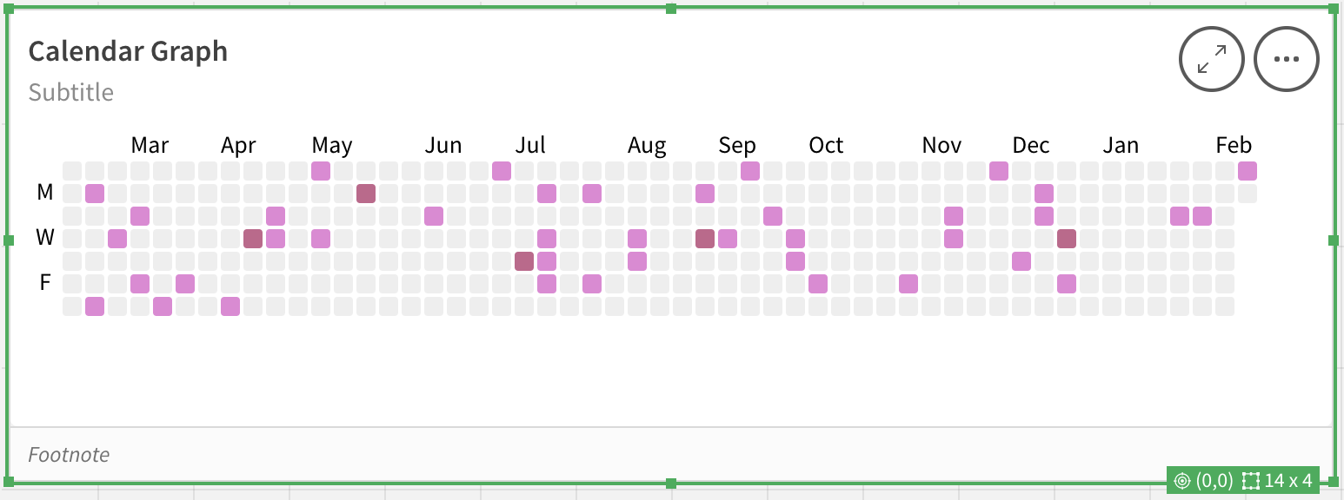

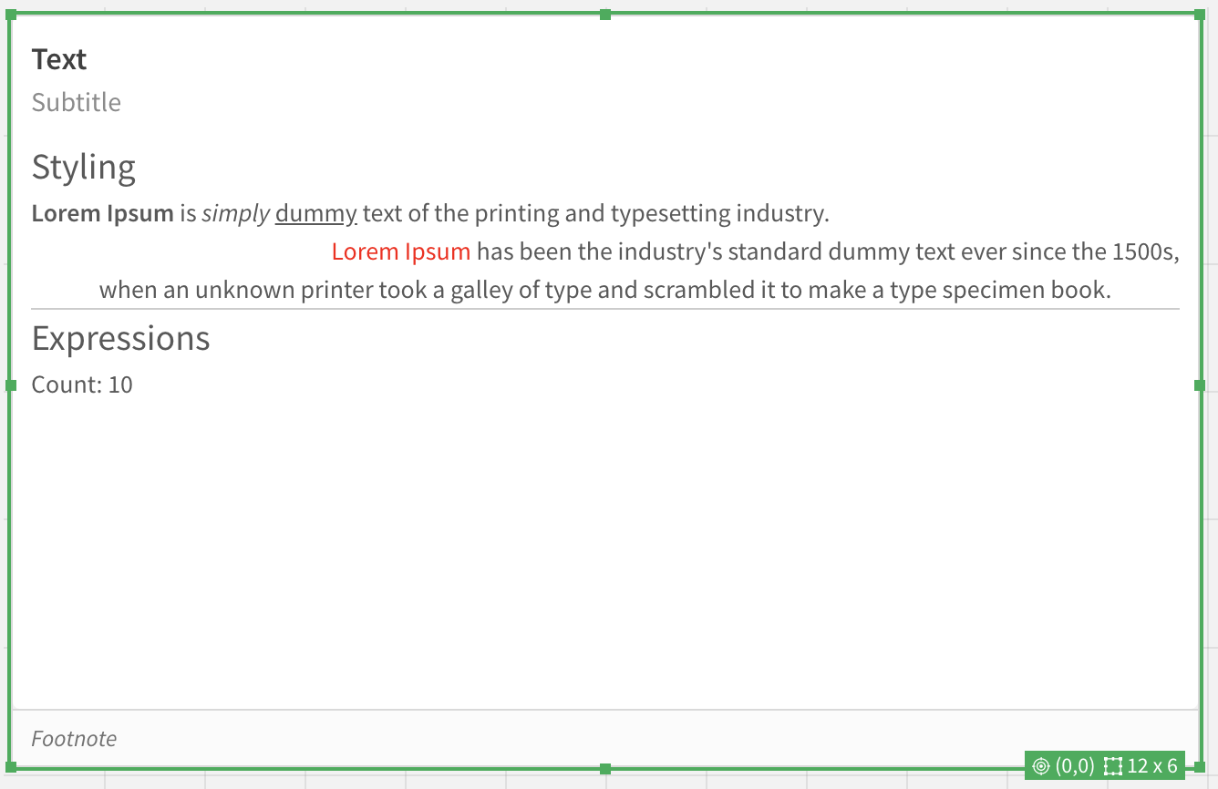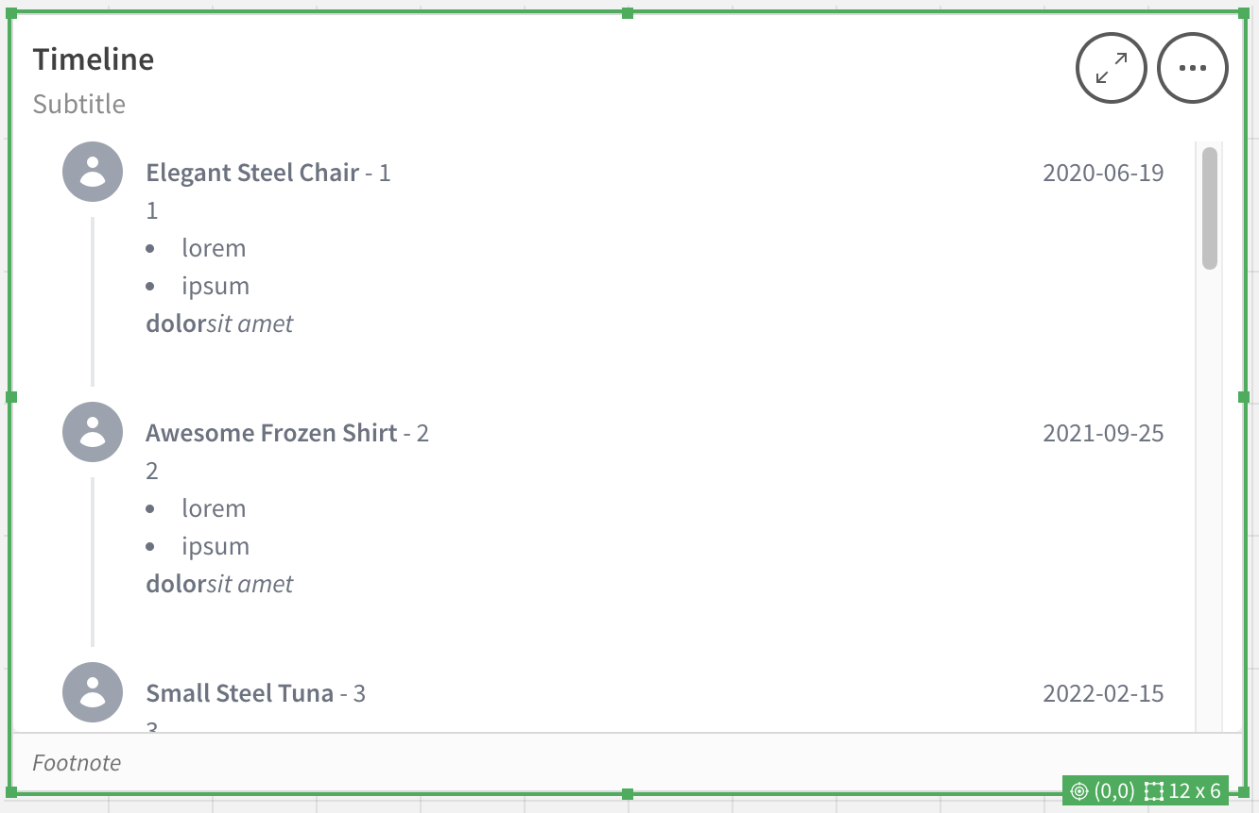

## License

These extensions are licensed to MSD Switzerland for use in MSD MER Region.

For more information contact info@devswiss.ch

## Setup

To install, first click on the *Navigation* button (top right corner).



Then, in the dropdown, select the *Management Console*.



After that, find the *Extensions* section.

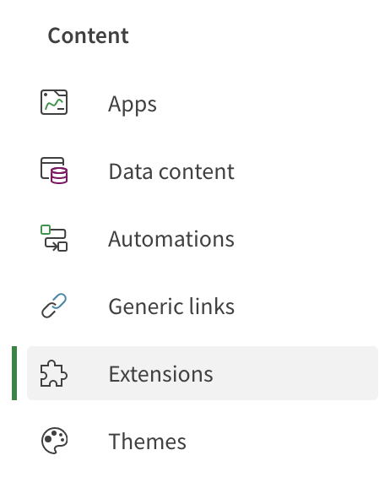

In there, find the *Add* button.



Now you can upload the zip files (one at a time).

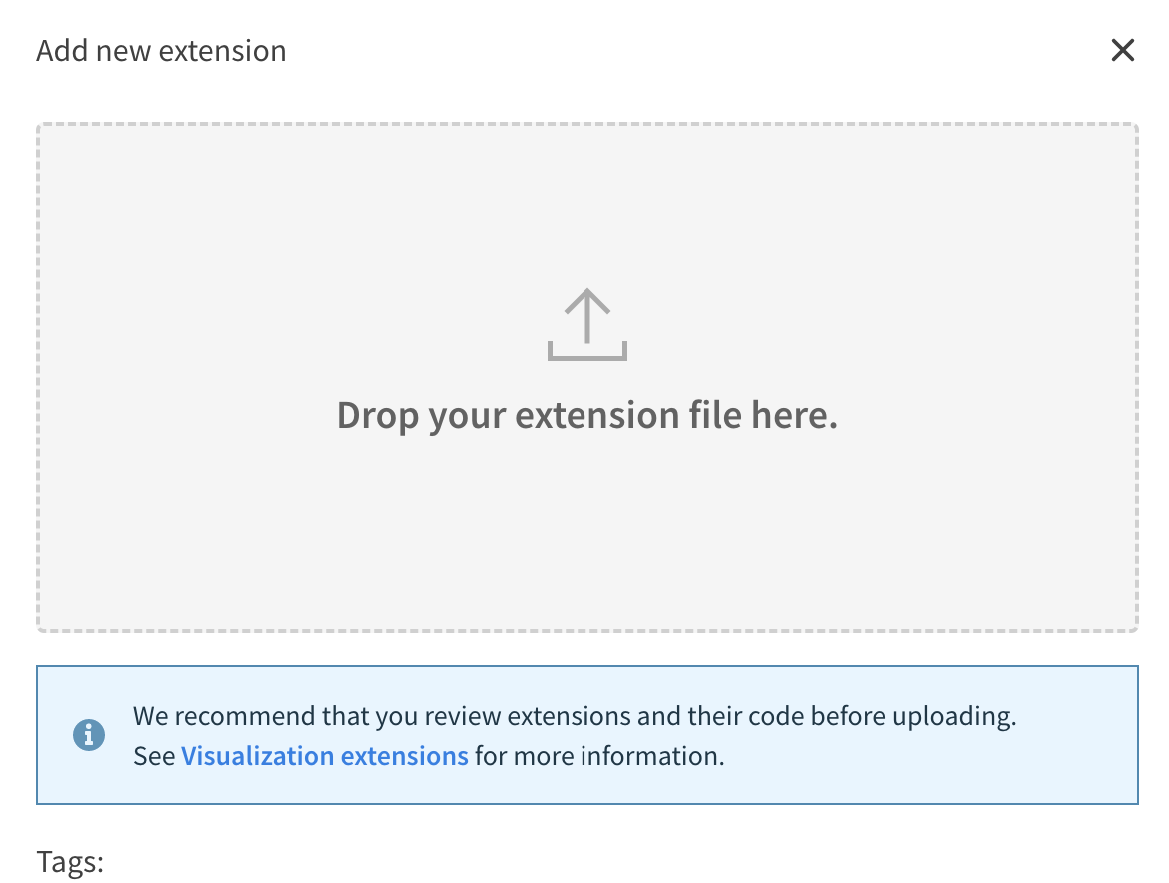

If everything went through, you should see the extensions in the list.

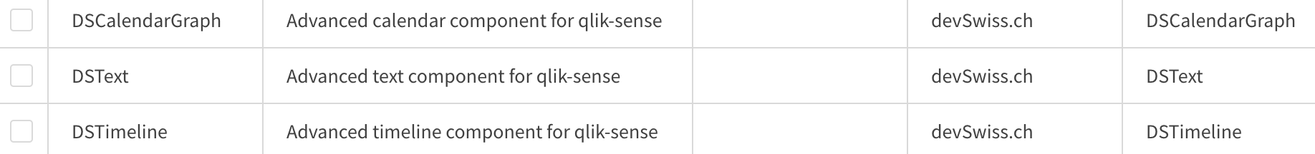

# DSCalendarGraph

## Sample data

**[DSCalendarGraph]:**

**LOAD * INLINE [**

**dscg_id, dscg_date, dscg_product, dscg_name, dscg_zip, dscg_amount, dscg_color**

**1, 2022-10-16T02:11:49.573Z, Rustic Plastic Car, Homer Gibson, 27636-3238, 714.70, #A56F3D**

**2, 2022-12-31T22:49:21.438Z, Rustic Plastic Ball, Arthur Becker, 77724, 118.30, #DAB7EE**

**3, 2022-10-22T14:32:10.734Z, Rustic Fresh Shirt, Jackie Waelchi, 32192, 372.92, #4D6ADA**

**4, 2022-08-12T22:10:17.407Z, Gorgeous Frozen Fish, Theodore Jacobi, 99744-2978, 99.28, #1C2326**

**5, 2023-02-21T20:37:25.797Z, Sleek Rubber Hat, Paul Lakin, 42540-3388, 817.07, #F6746D**

**6, 2023-02-11T03:53:32.326Z, Rustic Bronze Ball, Vera Schinner, 80805, 850.10, #ED853C**

**7, 2022-09-16T05:10:44.107Z, Oriental Fresh Shirt, Martin Kovacek, 94128, 787.82, #BCCC7A**

**8, 2022-10-27T08:51:23.002Z, Awesome Wooden Gloves, Mr. Kevin Stracke, 22846-8586, 858.37, #0C09CC**

**9, 2022-12-19T08:35:58.096Z, Bespoke Rubber Hat, Verna Crona, 88747-2295, 810.70, #AD4B5F**

**10, 2022-07-27T06:58:43.510Z, Licensed Bronze Shirt, Jeannie Olson, 93991-5959, 459.19, #F2249E**

**];**

## Inputs

This extension requires at least two dimensions.

First one should be the date. Others are then shown in the tooltips.

As of v1.5.0 you can also specify the color dimension using the Label field (on color dimension) and Color Label (below Appearance section).

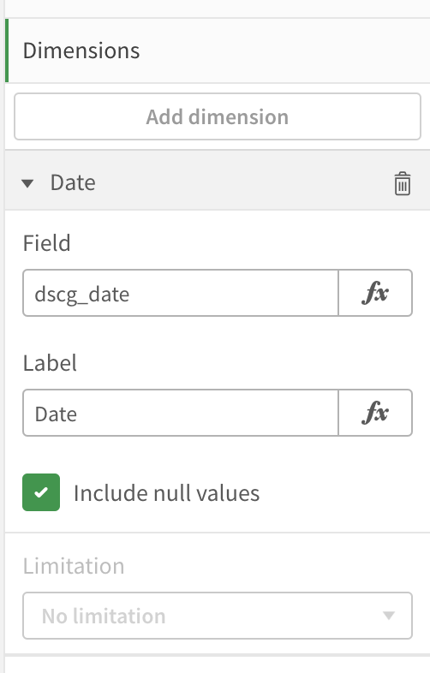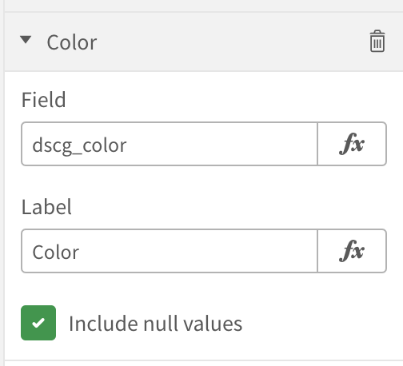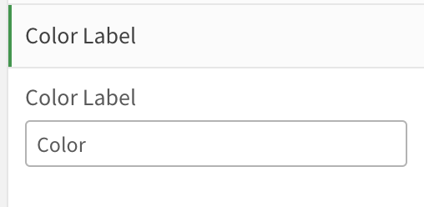

## Output

## Screenshot 2023-03-02 at 11.38.49.pngScreenshot 2023-04-06 at 16.29.22.png

# DSText

## Sample inputs

**'**

**<h1 style="font-size: 20px">Styling</h1>**

**<b>Lorem Ipsum</b> is <i>simply</i> <u>dummy</u> text of the printing and typesetting industry.**

**<p style="text-align: right"><span style="color: red">Lorem Ipsum</span> has been the industry''s standard dummy text ever since the 1500s,</p>**

**<p style="text-align: center">when an unknown printer took a galley of type and scrambled it to make a type specimen book.</p>**

**<hr/>**

**<h1 style="font-size: 20px">Expressions</h1>**

**<p>Count: ' & Count(id) & '</p>**

**'**

## Inputs

This extension also only has one input of *String* type.

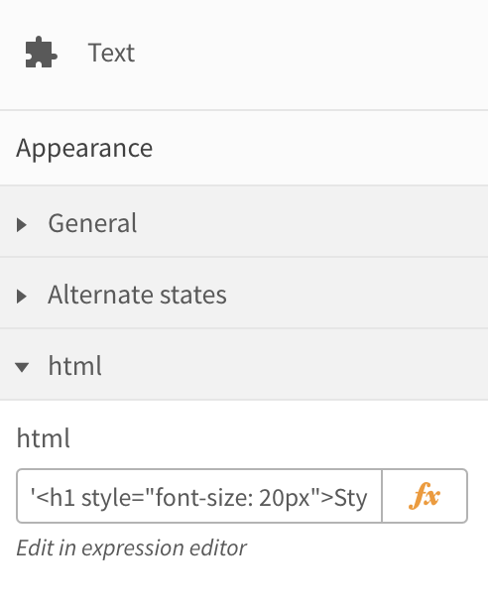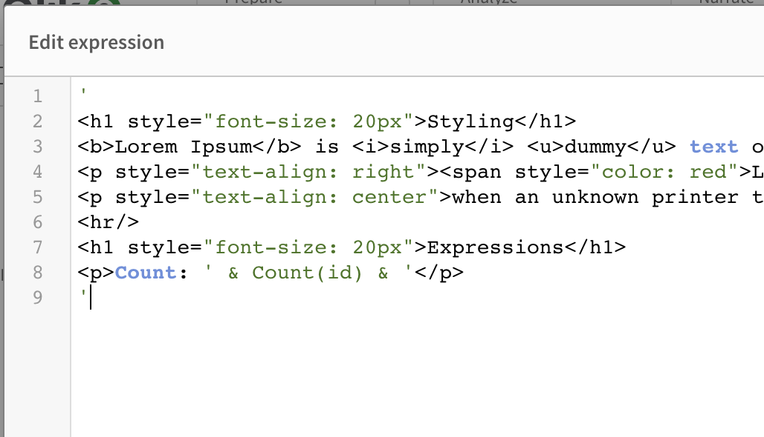

## Output



# DSTimeline

## Sample data

**[DSTimeline]:**

**LOAD * INLINE [**

**id, purchase_date, product_name, image**

**1, 2021-01-04T03:00:07.723Z, Ergonomic Plastic Computer, a.png**

**2, 2022-10-08T21:48:44.355Z, Ergonomic Plastic Chips, b.png**

**3, 2021-03-13T10:34:22.348Z, Awesome Plastic Chips, c.png**

**4, 2021-11-04T02:40:55.974Z, Refined Plastic Gloves, a.png**

**5, 2022-01-27T18:15:23.839Z, Unbranded Fresh Pizza, b.png**

**6, 2023-01-31T02:16:07.906Z, Tasty Wooden Chair, c.png**

**7, 2022-12-10T02:06:02.837Z, Refined Metal Chair, a.png**

**8, 2023-01-03T05:43:59.359Z, Practical Rubber Fish, b.png**

**9, 2020-11-06T22:40:12.530Z, Modern Concrete Table, c.png**

**10, 2022-06-03T07:49:05.262Z, Rustic Concrete Keyboard, a.png**

**];**

## Sample inputs

Description

**='<b>' & product_name & '</b> - ' & id & '<br/>' & id & '<ul class="list-inside list-disc"><li>lorem</li><li>ipsum</li></ul><b>dolor</b><i>sit amet</i>'**

Date

**='<p class="text-right">' & Date(purchase_date, 'YYYY-MM-DD') & '</p>'**

Thumbnail

**'/api/v1/apps/' & DocumentName() & '/media/files/' & image**

## Inputs

This extension takes one or more dimensions.

As of v2.6.0 it also supports custom thumbnails via thumbn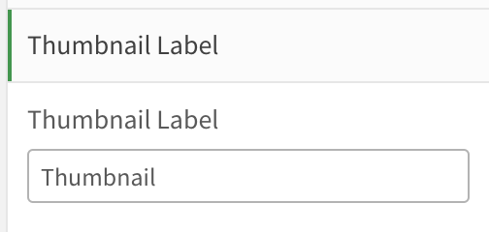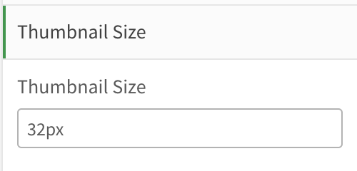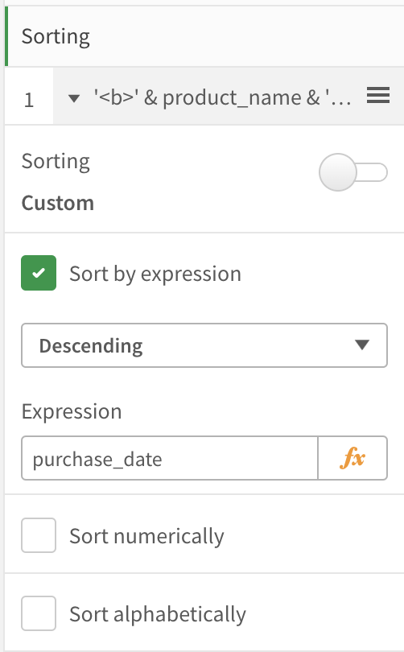ail dimension using the Label field (on thumbnail dimension) and Thumbnail Label (below Appearance section).

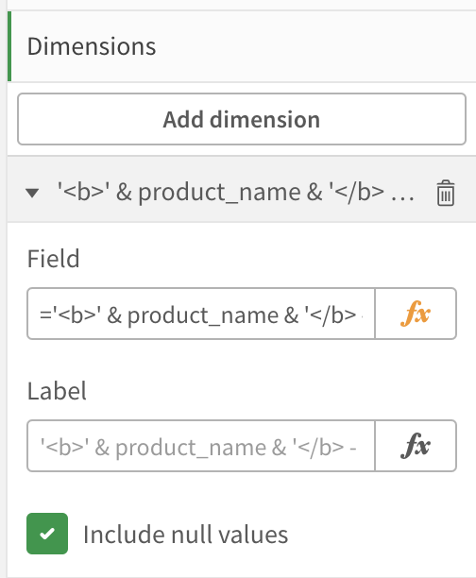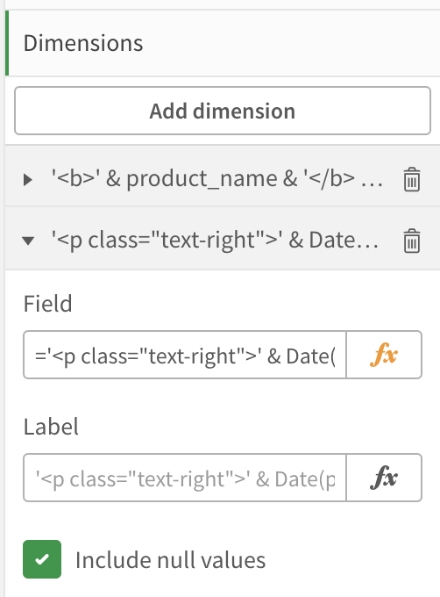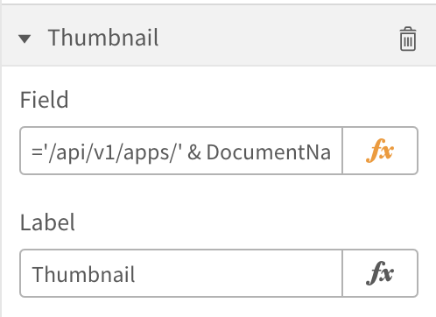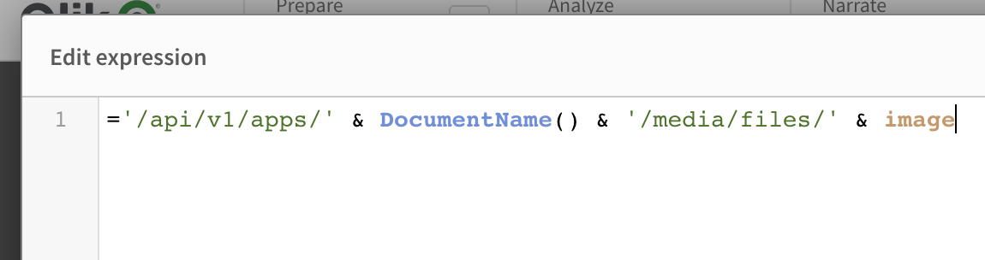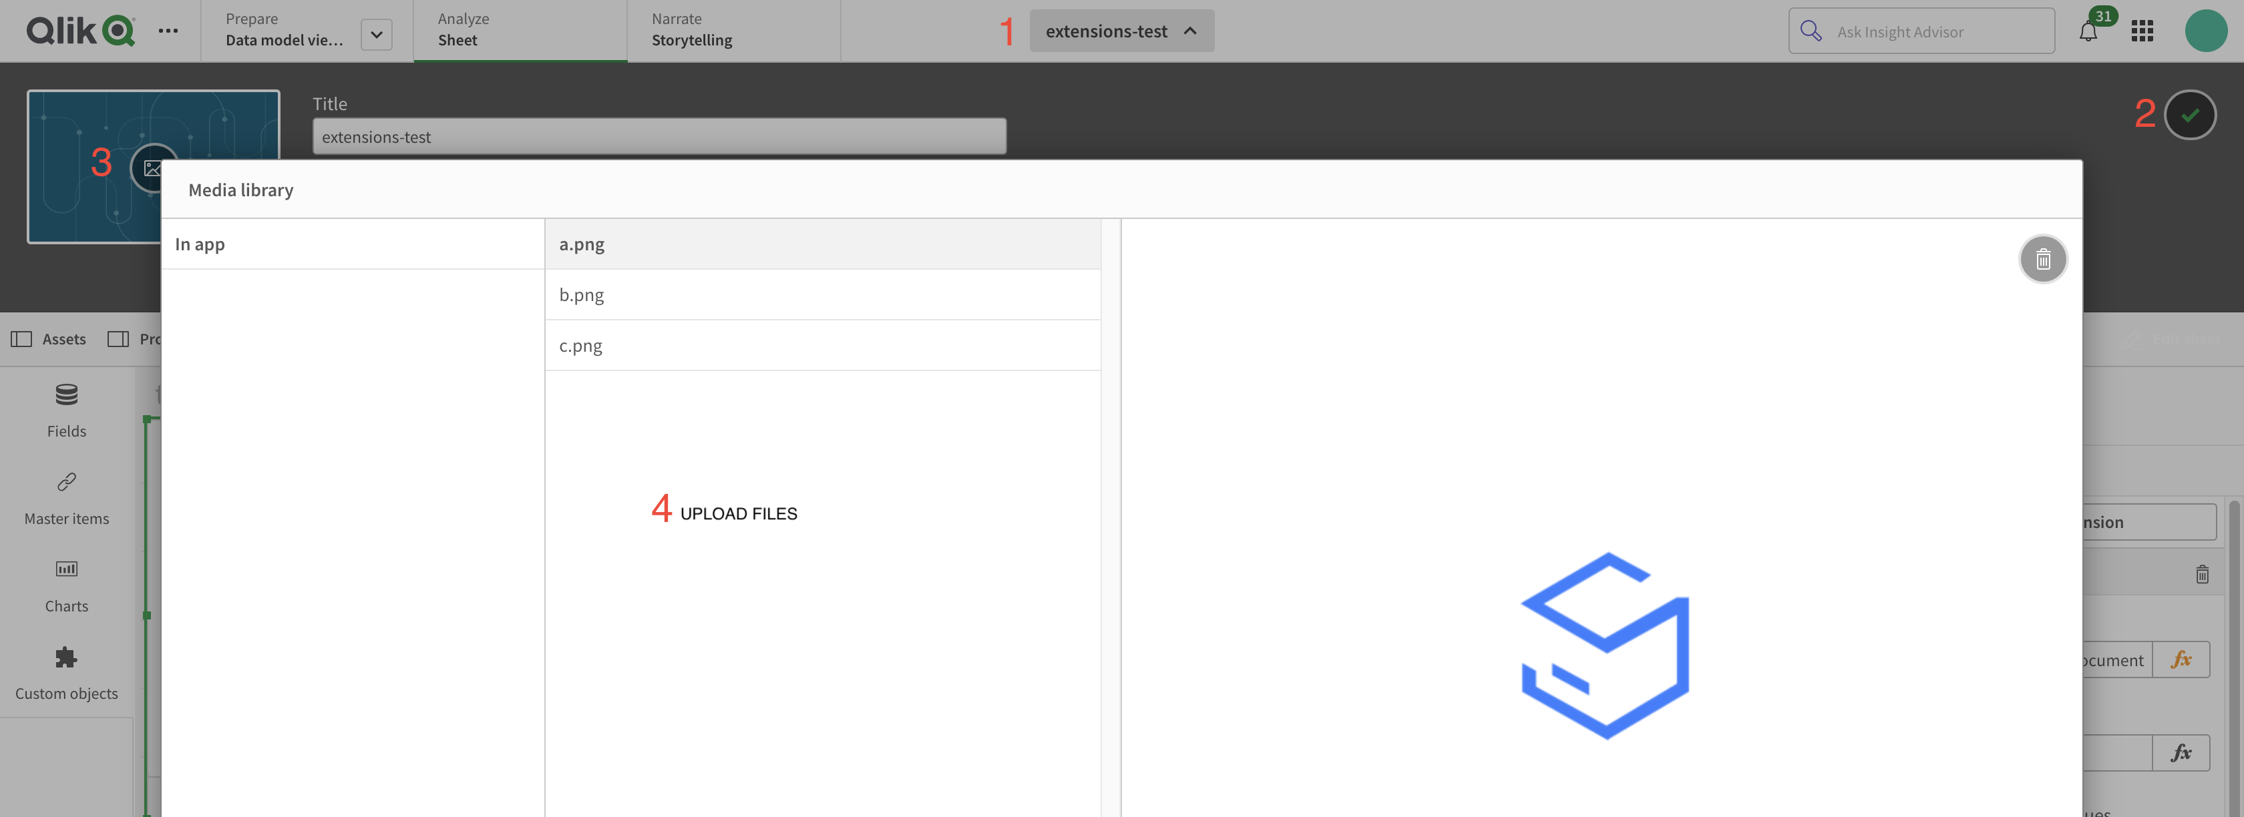

## Output

