|  |  |
| --- | --- |
| Your GBS Score | Your Certification |
| **[SCORE]** | **[CERT]** |
|  |  |
|  | [DESCRIPTION1] [DESCRIPTION2] |

You achieved an $cert and can now start thinking about how to strengthen your skills for even $score_heights performance. Overall, your results are commendable, with your average GBS score $score above the Cohort Average. Your best scores were $user_top_module_1 and $user_top_module_2. $user_top_module_2 and $user_top_module_2 are areas where further focus is needed. We hope you use this feedback as an opportunity to continue investing in yourself and achieve even greater success professionally

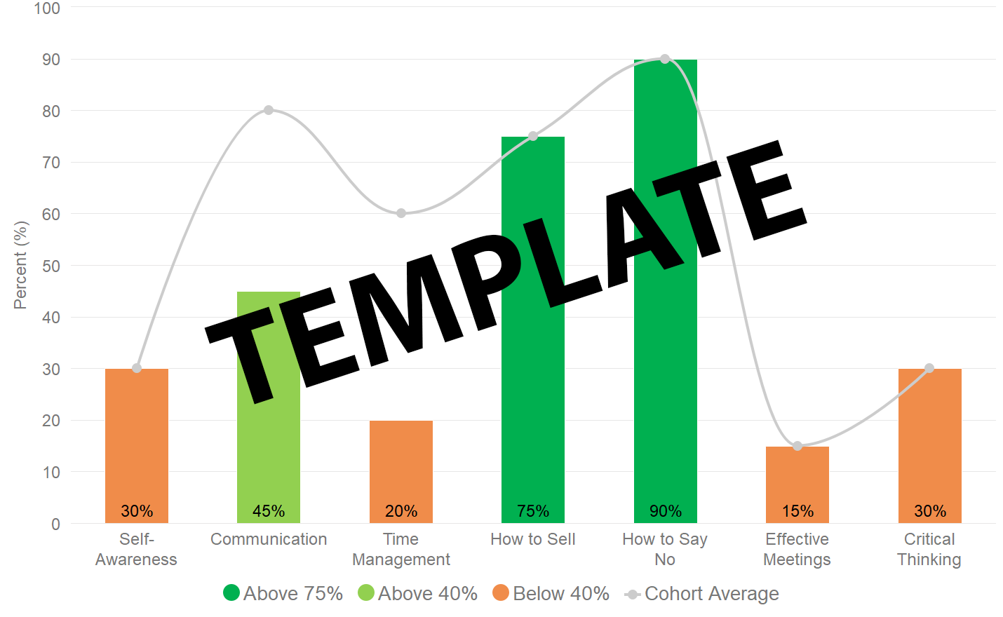

|  |
| --- |
| Chart 1: This chart illustrates your score in each module as well as the average score achieved by your Cohort. Scores are a total of multiple choice and open text questions within GBS. |

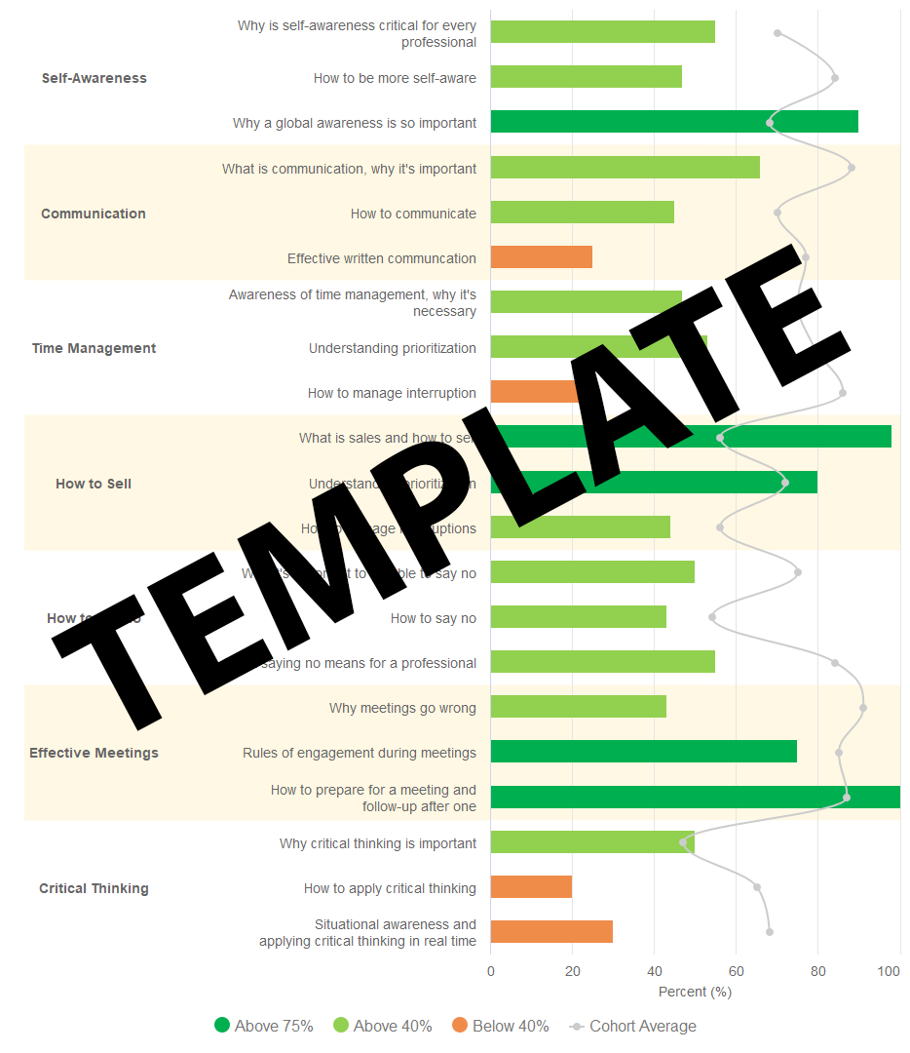

|  |
| --- |
| Chart 2: This chart provides insight into your relative strengths and weaknesses within a topic. Use it to identify concepts that you are strong in and areas you need to work on. |

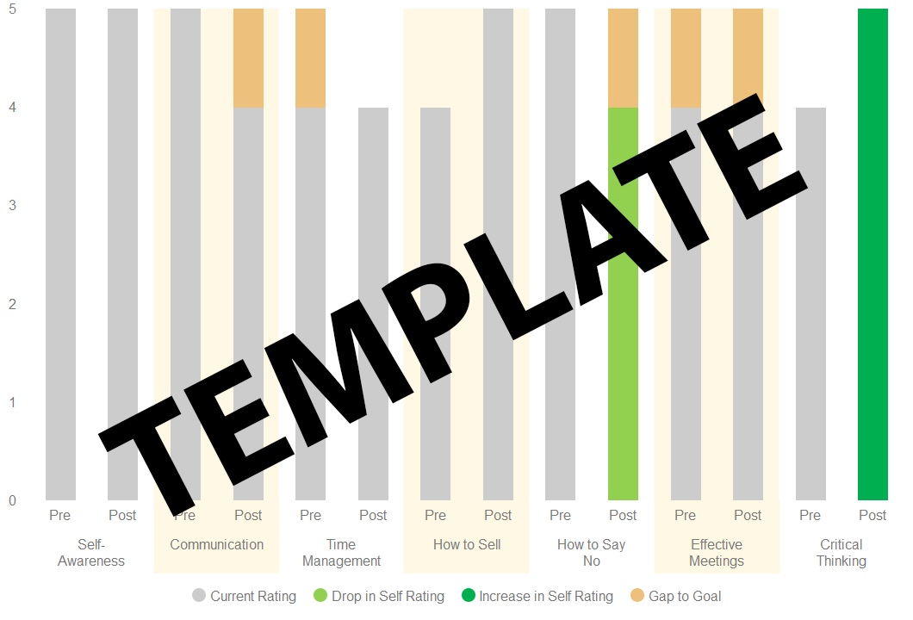

|  |
| --- |
| Chart 3: This chart compiles data from the questionnaires at pre- & post-completion and tracks how your self-rating of current skills and the goal you want to achieve changed as you progressed through the course. It’s designed to help you reflect on current skill levels, goals, and to better understand what gaps need to be covered.   * Rating your current skill levels progressively higher (shown in the darker green where applicable) means you believe you’ve improved. If this is true - aim higher! * If the trend shows you rate your current skill level lower (shown in lighter green where applicable), this can indicate improving self-awareness as you are being more realistic and aspiring in your goals. * Gap-to-goal is the difference between the skill level you’d like to be at and current skill level. You should always be learning and improving your skills and so, having a gap of 0 is undesirable! * Rating your current skill level 5 implies you don’t believe any improvement is needed – or possible! * If you are rating yourself highly, but the scores in the modules show weakness in the same skill – it’s time to seek feedback to see if you have a blind spot that needs addressing. |

RECOMMENDATIONS

With the Global Business Skills course completed, it’s time to start implementing new tools, knowledge and skills to help you be more successful - professionally and personally. You've covered a lot of ground - what new habits and behaviours can you cultivate to become more effective? We have some personal recommendations for you to get started on.

* Lorem ipsum dolor sit amet, augue electram ex, aeque mandamus per id, ex per elaboraret reprehendunt. Mei doming eripuit referrentur ne. Eu nonumes dolores mentitum sit, labore nonumes id pro. Cu semper perfecto quo. An prima diceret verterem cum, soluta altera mollis at vel. Has quodsi verear signiferumque cu, justo minim harum ei vis. Idque tantas cum eu.
* Vis diam dicta aperiam ne. Vis ad ludus atomorum forensibus, est dolore constituam ea. Vel graeci aliquando cu, in vix quando ponderum, te mazim molestiae nec. Sit id timeam euismod.
  + Usu te reque quando explicari.
  + Indoctum signiferumque no his, duo illum mundi animal ut.
  + Cu semper perfecto quo.
* Ut his etiam periculis definitionem. Te vel vidisse interesset. Eu vix omnium molestiae adversarium, duis ridens utroque no sea. Pri aliquam incorrupte honestatis ea. Ne unum nihil graece usu, animal vivendum vulputate vix et. Electram disputando eu ius.In munere urbanitas sea, salutandi disputationi ut vis. Putent temporibus et vis. Est sententiae reprimique ei. An esse lorem appareat eos, his no platonem salutandi, sea eu eros lorem.

|  |  |  |  |  |  |  |  |  |  |  |  |  |
| --- | --- | --- | --- | --- | --- | --- | --- | --- | --- | --- | --- | --- |
| **Certification Levels**   |  |  |  |  | | --- | --- | --- | --- | | **None** | **Completion** | **Merit** | **Distinction** | |  |  |  |  | | 1 or more modules < 40% | All modules >= 40% | All modules >= 40%  At least 5 >= 75% | All modules >= 75% |   **Cohort Performance**  Charts 1 and 2 provide comparative data on how the rest of your Cohort performed – use it as a guide to understand where you where you stand relative to others in your cohort.  This learning program is about individual and team-based skill upgrades and so, it is important to understand how your team/cohort is progressing toward being a collective, high-performance organization. |