Health System Application

Use-Case Model

Version 1.0

Revision History

|  |  |  |  |
| --- | --- | --- | --- |
| **Date** | **Version** | **Description** | **Author** |
| 19/03/2018 | 1.0 | Initial functionality ideas. | Bucur Diana |
|  |  |  |  |
|  |  |  |  |
|  |  |  |  |

Table of Contents

1. Use-Cases Identification 4

2. UML Use-Case Diagrams 5

# Use-Cases Identification

Use case 1: Add a patient (Hospitalization process)

Level: Sub-function

Primary actor: Nurse

Main success scenario:

- patient arrives at hospital

- a nurse opens the application, enters her/his ID and passwords (logs in)

- enters the relevant data to fill the medical file

- adds the new patient in the database

Extensions: in the scenario presented above, some possible failures would be:

- problems with the log in (ex. nurse forgets ID and/or password)

- incorrect data entered in the medical file

- error encountered when accessing the database

Use case 2: Call a nurse

Level: user-goal level

Primary actor: Patient

Main success scenario:

- the patient open the application, enters her/his ID and password (log in)

- pushes a button according to their needs and a nurse is summoned automatically

- on the screen appears the name of the nurse that is going to respond to the call and come to solve the problem

Extensions: in the scenario presented above, some possible failures would be:

- problems with the log in (ex. the patient forgets ID and/or password)

- the wrong button is pushed

- connection problem and the nurse is not made aware of the call

Use case 3: Update health status

Level: sub-function

Primary actor: Nurse

Main success scenario:

- a nurse opens the application, enters her/his ID and passwords (logs in)

- selects the update health status option from the application’s UI

- selects a patient for which the change is required

- enters the new data and pushes the update button.

Extensions: in the scenario presented above, some possible failures would be:

- problems with the log in (ex. the patient forgets ID and/or password)

- the wrong patient is selected

- incorrect data entered

- error encountered when accessing the database

# UML Use-Case Diagrams

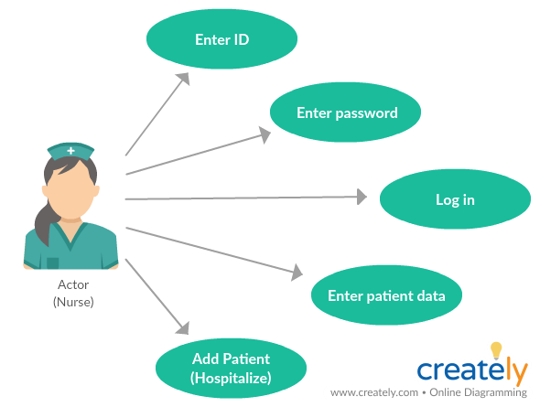

Use case 1: Add a patient

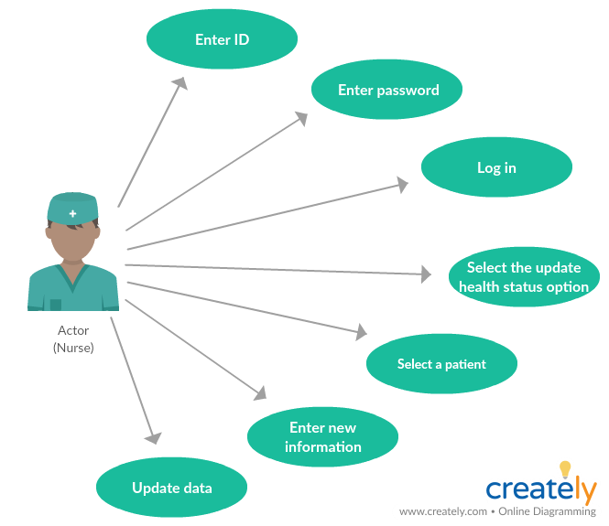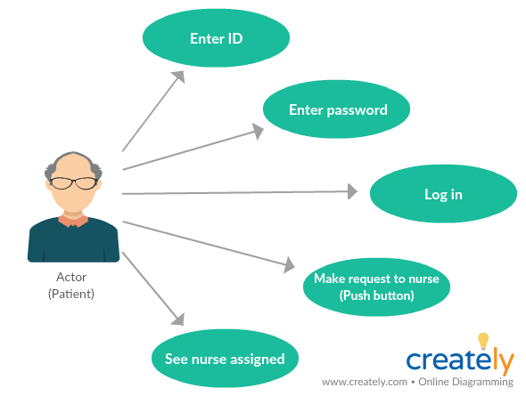

Use case 2: Call a nurse



Use case 3: Update health status